HANDSHAKE PROBLEM

Fifteen people are at a party. If each person shakes hands with everyone else (JUST ONCE), how many handshakes are there in all?

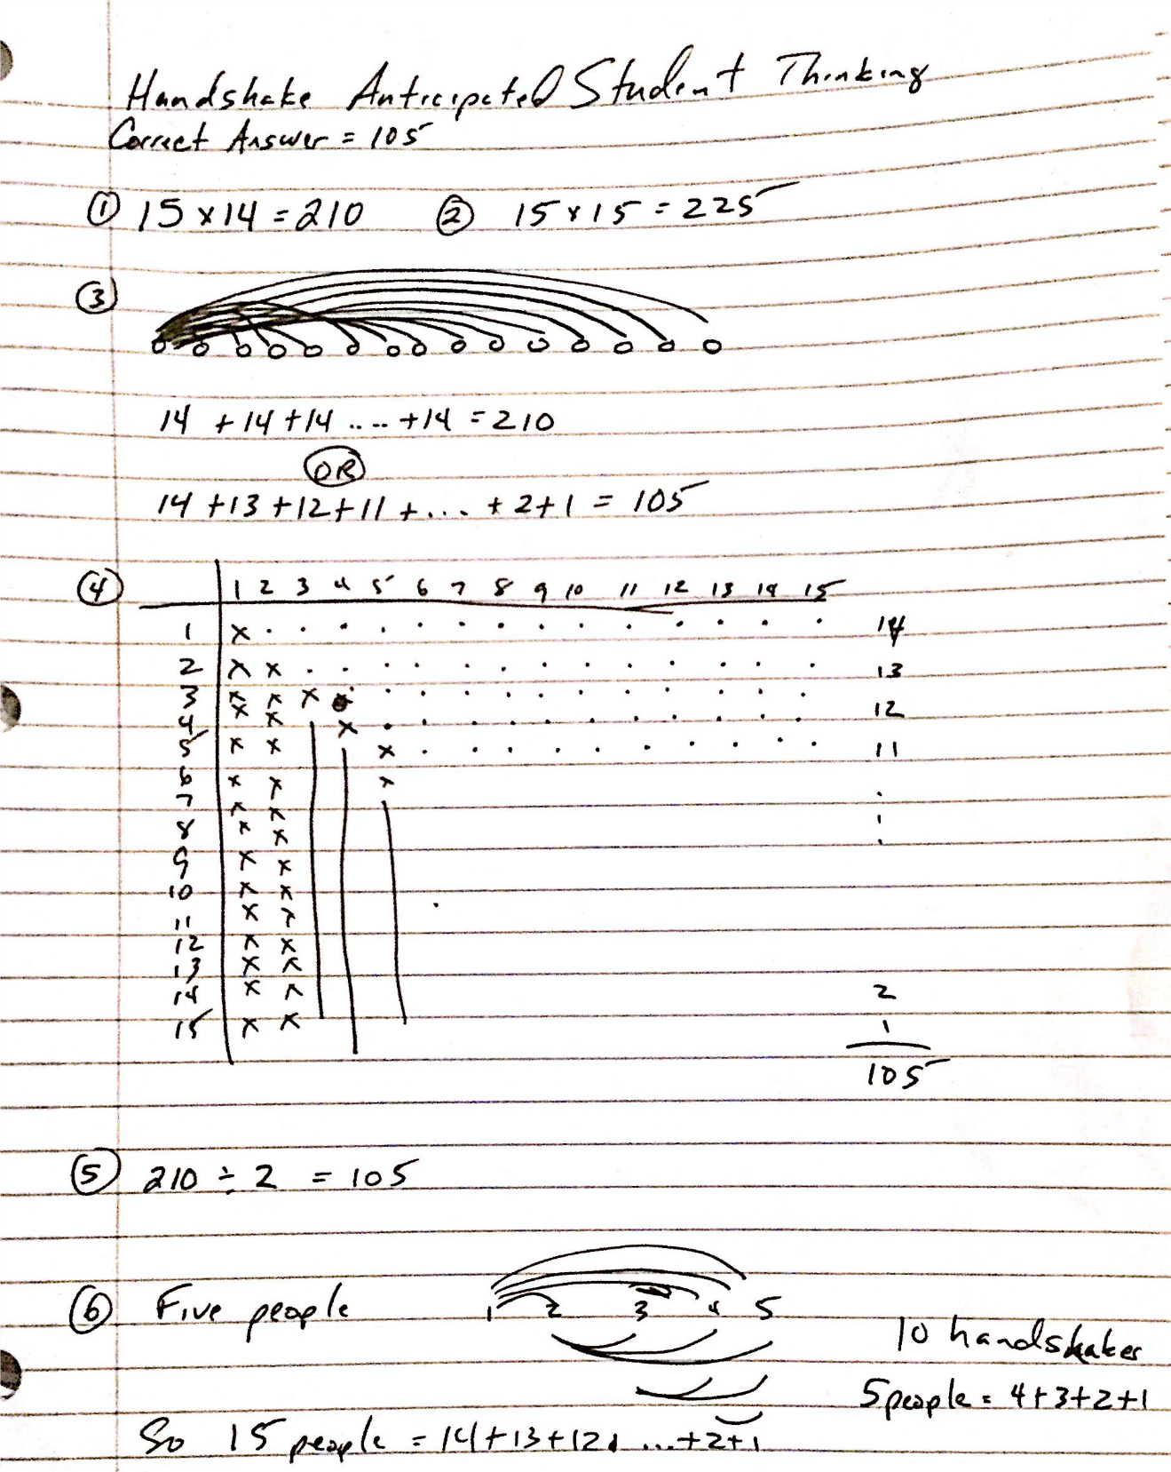

BARREL PROBLEM

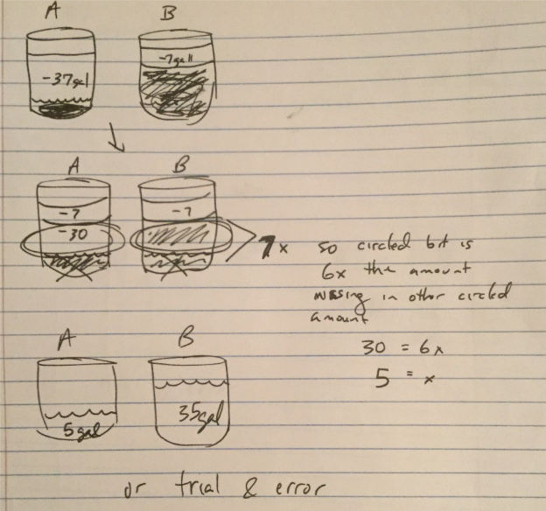
Two barrels contain equal quantities of honey. From one barrel, 37 gallons of honey are drawn. From the other barrel, 7 gallons of honey are drawn. The quantity remaining in one barrel is now seven times that remaining in the other barrel. How much did each barrel contain at first?

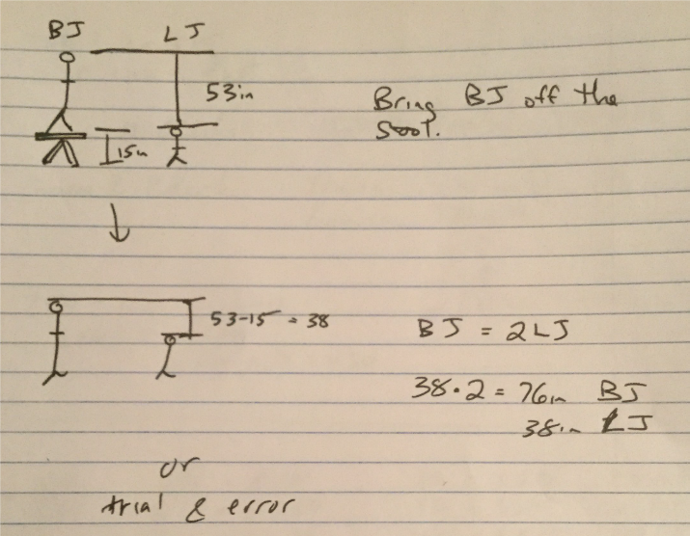
BIG JIM/LITTLE JIM PROBLEM
When Big Jim stands on a bench that is 15 inches high, the top of his head is 53 inches above the top of Little Jim’s head. Big Jim’s height is twice that of Little Jim’s height. How tall is Big Jim? How tall is Little Jim?

THELMA AND LOUISE
On a 750 mile road trip Thelma drove 110 miles more than Louise. How far did each person drive?
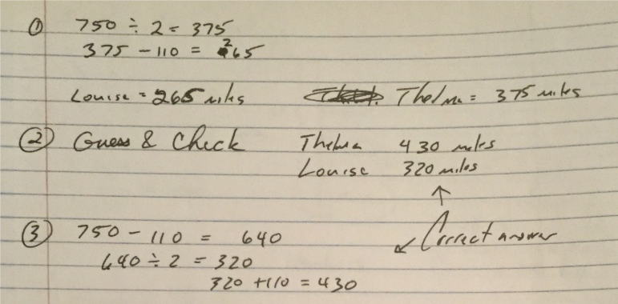

ALLOWANCE PROBLEM

Mark gets $1.85 a week for an allowance. He always gets 16 coins. The coins are always nickels, dimes, and quarters. How many of each type of coin does he receive?
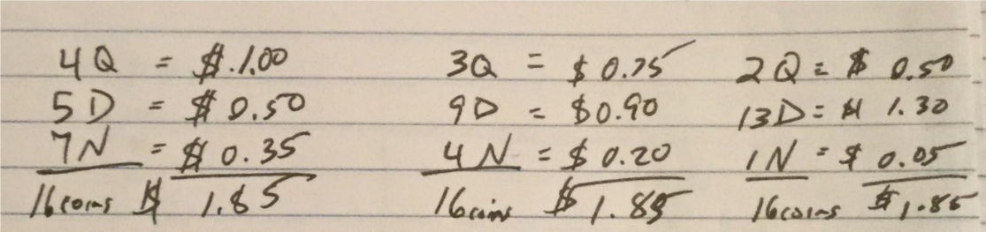

PARKING TICKET PROBLEM

People who are illegally parked in downtown Orlando may be issued $15 or $20 parking tickets. At the end of the week, Officer Bob had issued 41 parking tickets that totaled $655 in fines. How many $15 tickets and how many $20 tickets did Officer Bob write?

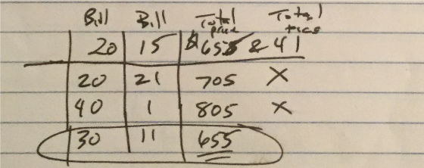

MARSHA & CAROL’S AGE
The sum of Carol and her daughter Marsha’s age is 64. The difference in their ages is 28. How old is each person?
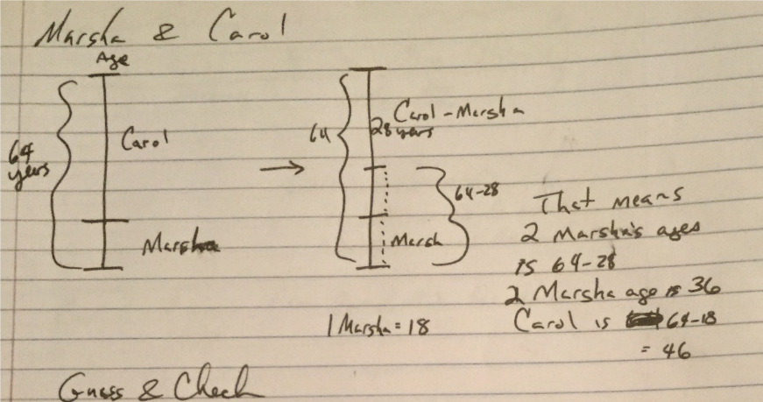

WHAT’S THE SUM PROBLEM (FIRST GRID)
What is the sum of all the numbers in the table? Try to do it without adding each of the numbers one by one.
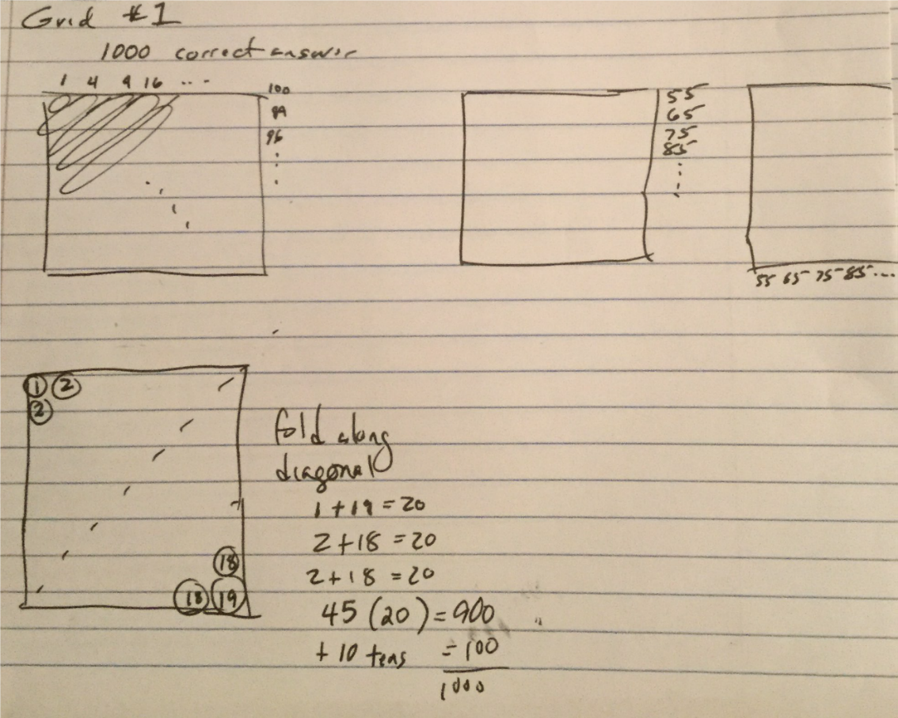
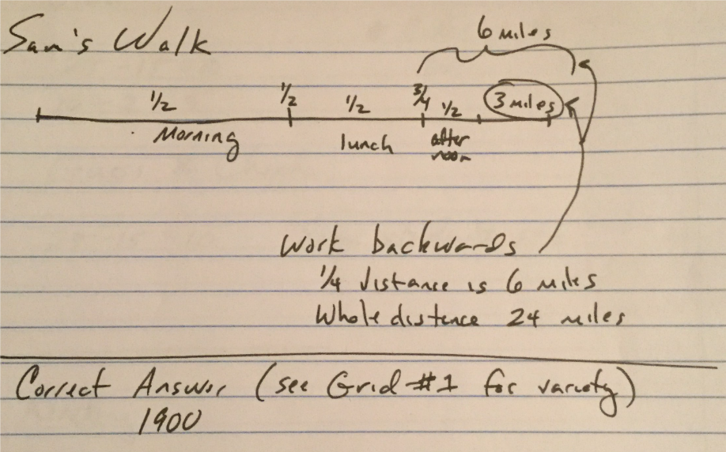
SAM’S WALK PROBLEM
Sam took a long on his treadmill. He walked half of the total distance in the morning. After lunch, he walked 1/2 of the remaining distance. In late afternoon he walked half the distance that was left. After dinner he walked the last 3 miles. How far did Sam walk altogether?

WHAT’S THE SUM PROBLEM (SECOND GRID)
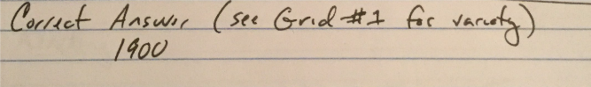
What is the sum of all the numbers in the table? Try to do it without adding each of the numbers one by one.
CIDER PROBLEM
A bottle and cider together cost 25¢. The cider alone costs 15¢ more than what the bottle costs. How much does the bottle alone cost?
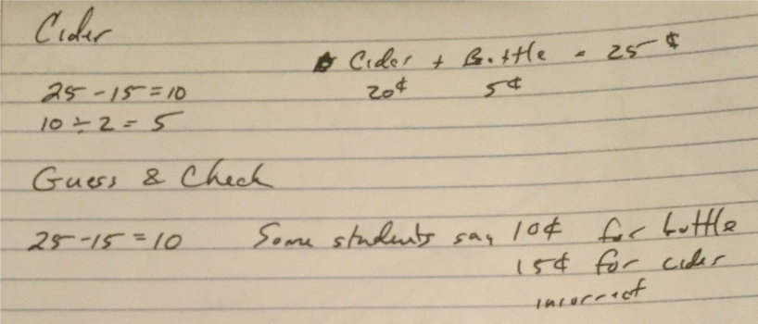

READING ASSIGNMENT PROBLEM
Ann’s teacher assigned one page of reading for Monday night. On each of the following days for the rest of the week, he assigned three times as many pages as on the previous night. At the end of the week, all of the pages of the book had been assigned. How many pages were in the book?

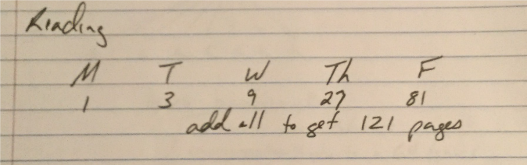

DOTS PROBLEM

Draw five more figures that could reasonably follow in the sequence below. Describe your pattern.

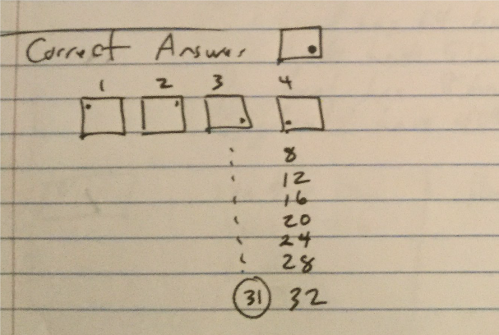

Ghouls Problem
8 ghouls each had 8 hands. Each hand had 8 warts and each wart had 8 hairs. How many hairs were there?
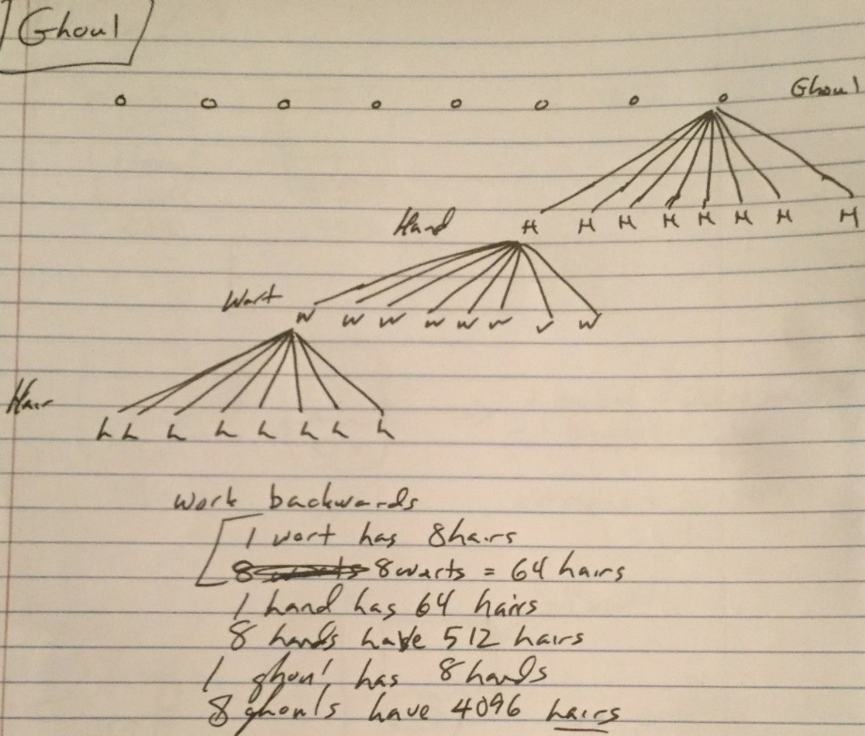
Pier Problem
Eric and Brian go fishing off the pier. Together they catch 17 small fish. Brian catches 5 more than Eric. How many do they each catch?
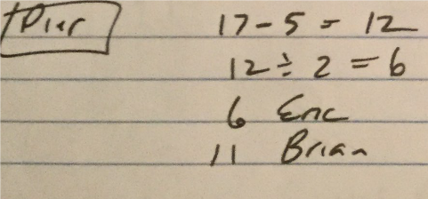
Horseshoe Problem

Eight people sign up for a horseshoe tournament. Each one must play every other contestant at least once. What is the least number of games that could be played?
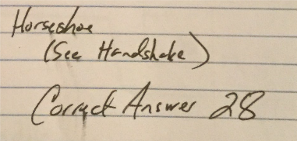

HONEY AND KEROSENE PROBLEM
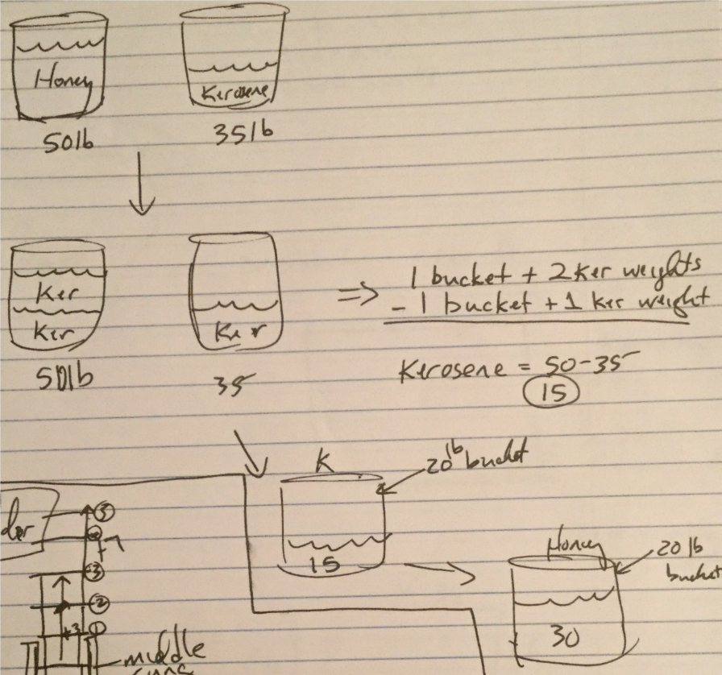
A bucket of honey weighs 50 pounds. The same bucket with kerosene in it weighs 35 pounds. If honey is twice as heavy as kerosene, how much does the empty bucket weigh?

LADDER PROBLEM
A fireman stood on the middle rung of a ladder directing water into a burning building. As the smoke lessened, he stepped up three rungs and continued his work from that point. A sudden flare-up forced him to go down five rungs. Later he climbed up seven rungs to the top of the ladder and entered the building. How many rungs does the ladder have?
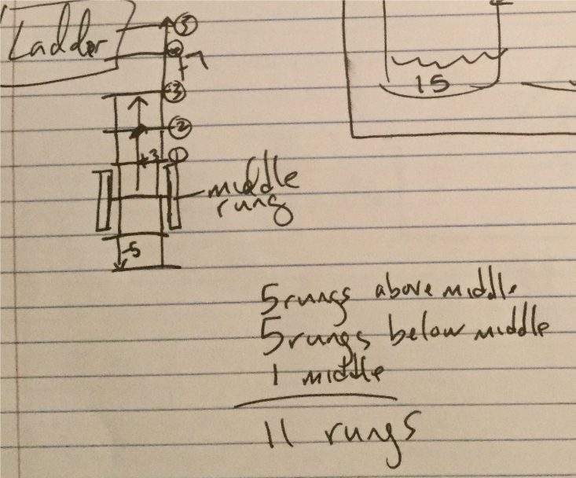

CARD GAME PROBLEM
A card game for 2-6 players has a deck of cards that can always be divided evenly among all the players. What is the smallest possible number of cards that can be in the deck?
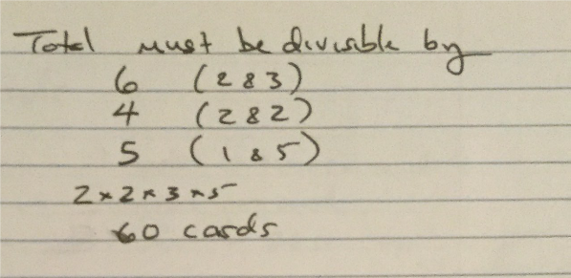

Pumpkin Patch Problem
The perimeter of a pumpkin patch is 120 feet. If the length is 8 feet more than the width, what are the dimensions of the pumpkin patch?
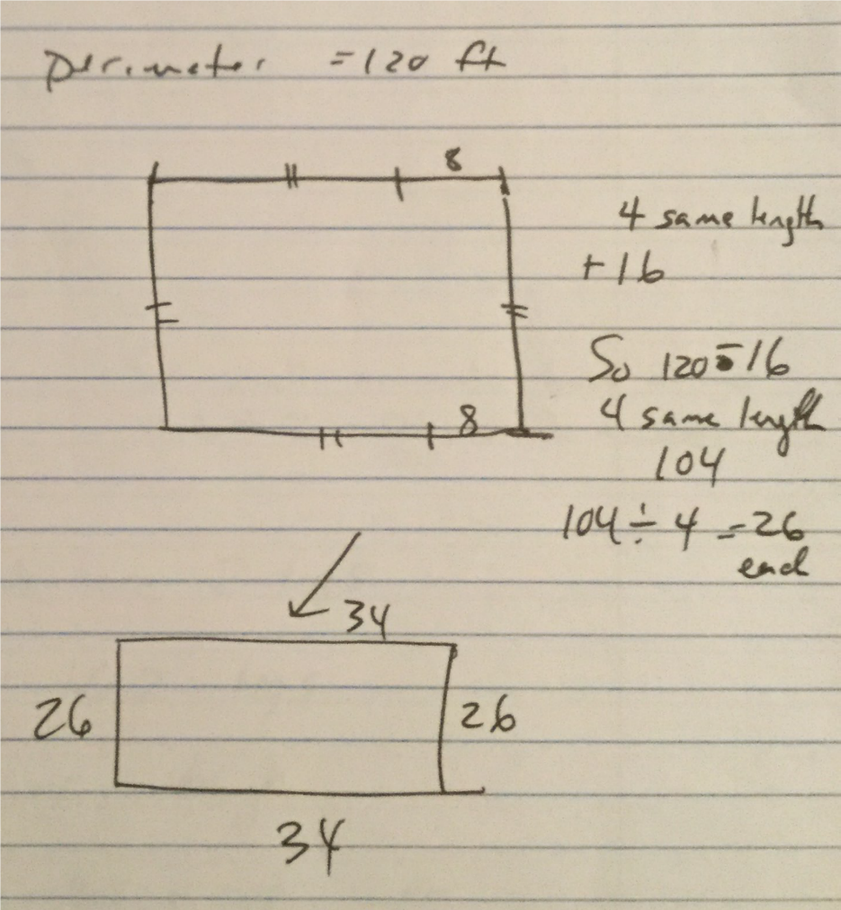

An Apple a Day Problem
The Green family believes the old saying, "An apple a day keeps the doctor away." The 5 members of the Green family each eat an apple at least 5 times a week. How many apples do they eat in a year?
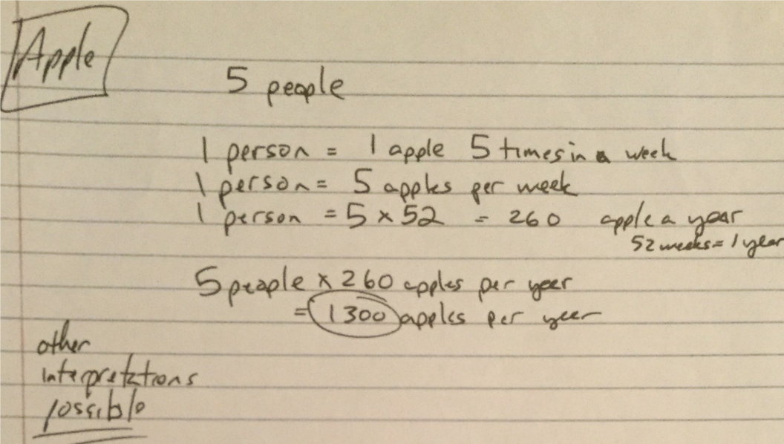
COWS AND CHICKENS PROBLEM
A farmer was asked how many cows and chickens she has. The farmer replied, “Between the cows and the chickens, there are 162 eyes and 270 feet. How many cows does she have? How many chickens does she have? (NOTE: Chickens have 2 feet and cows have 4 feet.)

