Formative Assessment Template
Task on Second Page

Angles Formative Assessment 1: Solving Equations and Angles
Link to Formative Assessment (if applicable): Adapted from Utah Middle School Math Project (but actual formative assessment included below): https://eq.uen.org/emedia/file/04e4c5cf-8993-47e1-8fbf-ab041db84974/1/8Ch10Student_Workbook.pdf (pg. 20)
Framework Cluster & Content Standards  What content standards can be addressed by this formative assessment?  8.G.5 Use informal arguments to analyze angle relationships  - Recognize the relationships between interior and exterior angles of a triangle  - Recognize the relationships between the angles created when parallel lines are cut by a transversal  - Recognize the angle-angle criterion for similarity of triangles  - Solve real-world and mathematical problems involving angles | Mathematical Practice Standards  What practice standards can be addressed by this formative assessment?  3, 5, 6  MP 3 Construct viable arguments and critique the reasoning of others  MP 5 Use appropriate tools strategically  MP 6 Attend to precision.
Learning Targets
What learning targets will be assessed?
- Determining angle measures using the relationships between angles created by parallel lines and transversals
- Solving equations using relationships between angles created by parallel lines and transversals
Timing: After Task 1 and After Solving Equations with Variables on Both Sides, could be during or after a lesson on the parallel line-transversal angle relationships
Anticipated Solutions and Possible Conceptions

Page 1: Angles 2, 5, 7 = 55⁰, Angles 1, 3, 6, 8 = 125⁰
Page 2: a) x = 40 b) x = 7 c) x = 9 d) x = 5 Think: Answers will vary, but should relate to the equal angles being used to create equality relationships in equations

The first page is similar to the final page of Task 1, and any student struggles would probably be related to a misunderstanding of the relationships between vertical angles, linear pairs, or the parallel line-transversal angle relationships. If students struggle with the corresponding, alternate interior, and alternate exterior relationships, remind them about vertical angles and linear pairs as a basis for seeing the relationships.

On page 2, students could struggle with the conceptual relationship between equal angle measures and the algebraic equations. Reminding students about equal values, equal expressions, and that they are trying to determine the x value that will create equal angle measures can hopefully clarify those relationships. Other struggles could come from the mechanics of solving equations with variables on both sides. Referring to the tasks and lessons on equations can help with these, but the concepts should be integrated - the rationale for the module was to use angles to provide a clear mathematical application for the equations.

Solving Equations and Angles

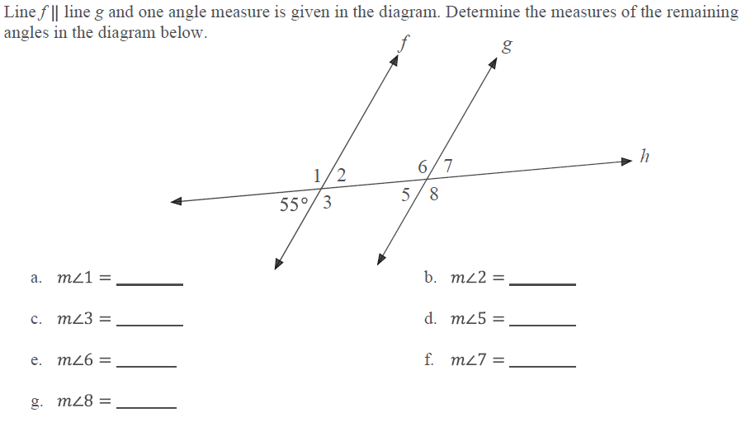

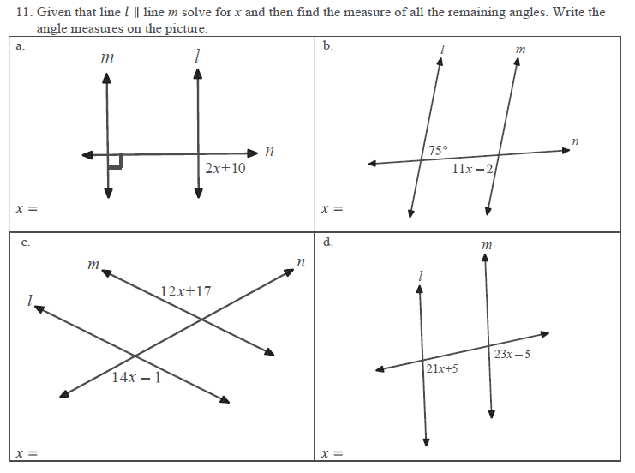

Think: How do the angle measures you determined on the front related to the equations and angles you solved on the back? How did you know how to solve the problems on the back?

Angles Formative Assessment 2: Find the Angle
Link to Formative Assessment (if applicable): https://www.illustrativemathematics.org/content-standards/8/G/A/5/tasks/59
Framework Cluster & Content Standards  What content standards can be addressed by this formative assessment?  8.G.5 Use informal arguments to analyze angle relationships  - Recognize the relationships between interior and exterior angles of a triangle  - Recognize the relationships between the angles created when parallel lines are cut by a transversal  - Recognize the angle-angle criterion for similarity of triangles  - Solve real-world and mathematical problems involving angles | Mathematical Practice Standards  What practice standards can be addressed by this formative assessment?  2, 6, 7  MP 2 Reason abstractly and quantitatively.  MP 6 Attend to precision.  MP 7 Look for and make use of structure.
Learning Targets
What learning targets will be assessed?
- Students will apply the Triangle Sum Theorem (interior angles of a triangle add to 180⁰) to determine missing angle measures in triangles.
- Students will understand that the Triangle Sum Theorem applies to all triangles, regardless of size or orientation.
Timing: This assessment can be given at any time after learning the Triangle Sum Theorem, particular right before or after Task 3 where they prove the theorem.
Anticipated Solutions and Possible Conceptions
The solution is 122°. Full explanation available from Illustrative Mathematics at: https://www.illustrativemathematics.org/content-standards/8/G/A/5/tasks/59

With at least 13 triangles in the image having at least 39 interior angles, students could struggle with determining which angle measures they know and which angle measures they need to determine. Some students might just start finding random angles and hope to hit on the correct combination. For students who understand the theorem (and can accurately determine the missing third angle measure in a triangle), the issue could be with the failure to immediately recognize what angle measure is asked for and what triangle(s) they’ll need to focus on. This could be a literacy/annotation issue, and it can be addressed with annotation and problem-solving strategies.

Other students might struggle with the naming/recognition of given angles. That is a mathematical issue, as students can be remediated on how angles are names and what intersections they represent based on the names.

