Comparing Functions Task 1: Card Sort: Linear Functions
Framework Cluster | Functional Reasoning/System Unit
Standard(s) | NC.8.F.2 Compare properties of two linear functions each represented in a different way (algebraically, graphically, numerically in tables, or by verbal descriptions).  MP 2 — Reason Abstractly and Quantitatively  MP 3 — Construct Viable Arguments and Critique the Reasoning of Others
Materials/Link | Computers, https://teacher.desmos.com/activitybuilder/custom/5785081e72fcab925a4ef95f
Learning Goal | To use properties of linear functions to sort functions in different groups from a variety of representations.
Task Overview: This activity asks students to notice and use properties of linear functions to make groups of three. Different properties will lead to different groupings by different students. Later, the task ask students to make conjectures about different groupings – why might another student have grouped the cards in a particular way?
Prior to Task: Students need to be able to identify and describe key features from a graph, table, and an equation.
Teaching Notes
Task launch:
- Begin a short discussion about similarities/differences using a “Which One Doesn’t Belong?” activity from http://wodb.ca/graphs.html, Graph 18. This task will ask students to look at more than one representation at a time to determine what they have in common and what is different.
Directions:
- Use the teacher dashboard to monitor student progress, and to look for common sorting strategies. The dashboard may also help you pair students together for conversations about how they sorted the cards.
- Make sure you complete this card sort yourself, in the role of a student, to acquaint yourself with the different questions students will answer and possible misconceptions. Additionally, Desmos provides a “Teacher Guide” with tips for implementing the activity.
Possible Strategies/Anticipated Responses:
This card sort has no answer key, as students are expected to sort the cards and defend their groups based on their rationale. Some potential ways students could create groups are by representation (all the graphs together), by nature of the y-intercept (positive, negative, zero), by slope (positive, negative, zero), and possibly others. Initially, students might not know or use the correct mathematical vocabulary for the various characteristics, but these can be added through monitoring small group and whole class discussion.

Student sheets begin on next page. (no student sheet needed)

Comparing Functions Task 2: Comparing Functions
Framework Cluster | Functional Reasoning/System Unit
Standard(s) | NC.8.F.2 Compare properties of two linear functions each represented in a different way (algebraically, graphically, numerically in tables, or by verbal descriptions).  MP 3 — Construct Viable Arguments and Critique the Reasoning of Others  MP 5 — Use Appropriate Tools Strategically  MP 7 — Look For and Make Use of Structure
Materials/Link | Have graph paper available. Copy of task from http://www.openmiddle.com/comparing-functions/
Learning Goal | To compare, understand, and explain the concept of rate of change by determining ordered pairs that form a linear function with a greater rate of change than a given linear graph.
Task Overview:
Using the Integers 0-9 (and each integer only once), students will generate five ordered pairs that represent a linear function that has a greater rate of change than the given graph. Students will try to find more than one solution.
Prior to Task: Students should know what rate of change is and be able to find linear rate of change from a graph.
Teaching Notes:
Task launch: Give students the task sheet, and ask them to write in words and/or draw on the graph a line with a greater rate of change than the given graph. Lead a brief discussion, asking how they know visually that a line would have a greater rate of change. Smith and Stein 5 Practices for facilitating tasks can help teachers monitor and lead a productive discussion getting to the concept of visual rate of change.
Directions:
- You could allow students to work in pairs and/or groups for support. Either have students write their solutions on the board as they find them, or ask groups to see how many solutions they can determine in a given amount of time (to give all groups the opportunity to find the answers). As solutions are shared, any student/group can challenge solutions with mathematical reasoning
- After students determine the solution, ask them to describe their approach to the task. Possible questions could be: “What did you try first? Did you notice any patterns as you tried coordinates and plotted points?”
- If students get stuck ask leading questions such as, “How do you determine the slope from a graph? What is the equation of the graph? Could you use the equation of the graph to help you write an equation with a greater slope? Could a table help you?”
- A potential follow up question could ask students why there is not an infinite number of solutions and what would have to change about the task to allow for an infinite number of solutions.

Correct Answers:
4 solutions, they are:
f(x)= {(0,1),(2,3),(4,5),(6,7),(8,9)}
f(x)= {(1,0),(3,2),(5,4),(7,6),(9,8)}
f(x)= {(0,5),(1,6),(2,7),(3,8),(4,9)}
f(x)= {(5,0),(6,1),(7,2),(8,3),(9,4)}
[Look for: Students who want to use numbers more than once or try to use less than 5 ordered pairs.]

NOTE: The answers ARE included on the PDF print-out if it is created from the Openmiddle site, so please be sure to remove them before handing out to students.

Student sheets begin on next page.

Comparing Functions
Directions: Using the Integers 0-9 (and each integer only once), generate five ordered pairs that represent a linear function that has a rate of change greater than line in the graph below:
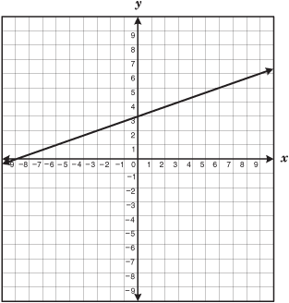
(___,___) (___,___) (___,___) (___,___) (___,___)
How many different ones are there?

Openmiddle.com

Comparing Functions Task 3: Summer Vacation
Cluster | Functional Reasoning/System Unit
Standard(s) | NC.8.F.2 Compare properties of two linear functions each represented in a different way (algebraically, graphically, numerically in tables, or by verbal descriptions).  MP 2 — Reason Abstractly and Quantitatively  MP 4 — Model With Mathematics
Materials/Link | Student task sheet. Have graph paper available.
Learning Goal | Use key features of functions to compare from different representations to solve problems.
Task Overview
Students will analyze linear functional relationships representing trips that friends make to Disneyland. All of the relationships are given using different representations - graph, table, written description, and equation. Students will compare properties of the functions, examining rates of change and intercepts in the real-world context of distance, time, and speed, to solve problems.
Prior to Task: Students should be able to determine key features from a graph, table, an equation as well as verbal representation.
Teaching Notes
Task launch: Have students talk about their favorite summer vacation spot. Ask questions leading up to the task, i.e., “What if your extended family wanted to go to the same place but lived in different areas? How could you mathematically figure out who will get there fastest? Who will travel the greatest distance? Shortest distance?”
Directions:
- Student should work in pairs and/or groups for mathematical discourse. Allow them to use poster paper to display their reasoning and present their findings comparing the four different functions. Students could examine the representations using a gallery walk to see how other students compared the functions.
- As an extension, have students figure out how fast they would need to go (if they remained at a constant speed) to beat Phoebe’s Family to Disneyland from where they live. Is this possible? Why or why not? They would need to research the distance to calculate the answer to this question, and they could look up the speeds of airplanes as well is that is necessary.
Correct Answers:
a) Phoebe’s Family is closest, from the graph, we see that Phoebe’s Family lives 45 miles from Disneyland (Michael’s Family lives 95 miles from Disneyland, Bobby’s Family lives 120 miles from Disneyland, and Stan’s Family lives 80 miles from Disneyland) so Bobby’s Family is farthest.
b) Bobby’s Family is traveling fastest speed (Bobby’s Family travels 60 mph, Michael’s Family travels 55 mph, Stan’s Family travels 75/1.5 or 50 mph). We don’t know the exact speed at which Phoebe’s Family travels but we know that their speed is less than 45 mph – they live 45 miles away and it takes them over an hour to get there. Therefore Phoebe’s family is slowest.
c) Phoebe’s Family will arrive first. To determine the time it takes each family to get to Disneyland, divide the total distance traveled by the speed. It takes Michael’s Family approximately 1.7 hours (95/55), Bobby’s Family 2 hours (120/60), Stan’s Family 1.6 hours (80/50), and we can see on the graph that it takes Phoebe’s Family under 1.2 hours. Therefore Bobby’s family will arrive last.

Students will go about comparing these functions in various ways, and the explanations will bring out their understanding of the functions and the different representations. Some students might choose to graph all of the functions, some might choose to determine the rate of change for each function individually, some might determine points and create a table for each function, and others could write an equation for each function. The gallery walk and whole class discussion could bring out their understanding and misconceptions.

Student sheet begins on next page.

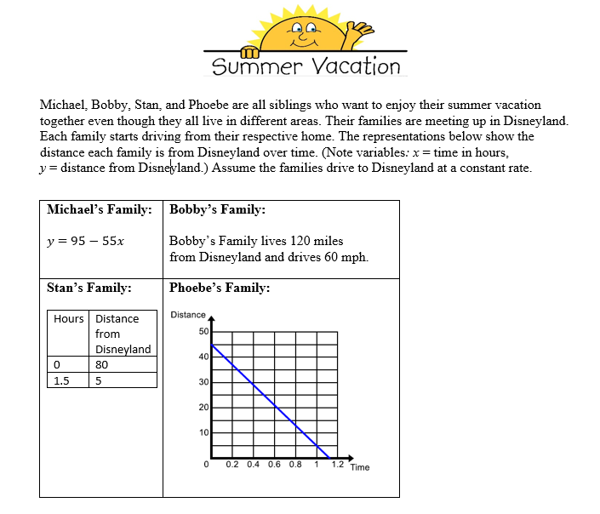
- Determine which family lives the closest and which lives the farthest from Disneyland. Justify your answer.

- Whose family is traveling at the fastest speed? Slowest? Explain your reasoning.

- Determine which family will arrive first and which family will arrive last to Disneyland. How do you know?

Comparing Functions Task 4: Battery Charging
Cluster | Functional Reasoning/System Unit
Standard(s) | NC.8.F.2 Compare properties of two linear functions each represented in a different way (algebraically, graphically, numerically in tables, or by verbal descriptions).  MP 1 — Make Sense of Problems and Persevere in Solving Them  MP 4 — Model With Mathematics
Materials/Link | Student task sheet. Have graph paper available.  https://www.illustrativemathematics.org/content-standards/8/F/A/2/tasks/641 (original source)
Learning Goal | Given a verbal description and a table compare properties of linear functions and use this information to solve a problem.
Task Overview: This task has students engaging in a simple modeling exercise, taking verbal and numerical descriptions of battery life as a function of time and writing down linear models for these quantities. To draw conclusions about the quantities, students have to find a common way of describing them.
Prior to Task: Students should be able to determine key features from a verbal description and a table in order to compare the two.
Teaching Notes: The battery charge of both devices can be modeled with linear functions. The wording describing the MP3 player suggests a linear function since it uses a constant rate of change. The table of values for the video game player shows a constant rate of change for the first 30 minutes. It is a reasonable assumption that the battery will continue to charge at the same rate. However, it is an assumption on our part, and this could come out in the task launch or discussion.
Task launch:
- Engage students in a discussion about using technology but all of a sudden it loses its charge. What do you do if you are getting ready to leave to go somewhere? How much time do you ask your parents to wait before your technology is charged?
Directions:
- Group students and ask them to work together to complete the task, possible displaying answers on chart paper for a gallery walk as in Task 3. See the link above for other ideas for implementing this task, including Smith and Stein 5 Practices for facilitating tasks.
- For a post-task discussion, students could discuss any similarities and differences between the previous task (the vacation to Disneyland) and the current task. Potential questions include: What representations were most appropriate for each and why? How do the characteristics (intercepts and rates of change) of the functions relate to the real-world context in each?

Possible answers:
One way is finding and using equations:(students could use other ways):
- The MP3 player charges at a rate of 12 percentage points every 15 minutes, which is equal to 0.8 percentage points per minute. If we let y be battery charge of the device (in percentage points) we have: y=0.8t+40, where t is measured in minutes. We know that the video game player is initially 20% charged and from the table we see that the charge increases by an additional 12 percentage points every 10 minutes, or 1.2 percentage points per minute. So for this function we get: y=1.2t+20. Sam’s family is planning to leave the house 60 minutes after Sam started charging his devices. We are looking for the charge when t=60:MP3 player: y=0.8⋅60+40=88 % charged video game player: y=1.2⋅60+20=92 % charged.
- To answer this question, we need to find the values of t for which each function has output value 100. MP3 player: Solving 100=0.8t+40 for t we have, t=75 minutes. Video game player: Solving 100=1.2t+20 for t we have t=67 minutes. So if Sam’s family could wait just 15 more minutes, Sam could have both devices fully charged for the car trip.

Student sheet begins on next page or is available from: https://www.illustrativemathematics.org/content-standards/8/F/A/2/tasks/641

Battery Charging
illustrativemathematics.org
Task
Sam wants to take his MP3 player and his video game player on a car trip. An hour before they plan to leave, he realized that he forgot to charge the batteries last night. At that point, he plugged in both devices so they can charge as long as possible before they leave.

Sam knows that his MP3 player has 40% of its battery life left and that the battery charges by an additional 12 percentage points every 15 minutes.

His video game player is new, so Sam doesn’t know how fast it is charging but he recorded the battery charge for the first 30 minutes after he plugged it in.
time charging (minutes) | 0 | 10 | 20 | 30
Video game player battery charge (%) | 20 | 32 | 44 | 56

- If Sam’s family leaves as planned, what percent of the battery will be charged for each of the two devices when they leave? Explain.

- How much time would Sam need to charge the battery 100% on both devices?

