Congruence Formative Assessment 1
Link to Formative Assessment (if applicable):
Cluster & Content Standards  What content standards can be addressed by this formative assessment?  Reasoning about Similarity and Transformations  8.G.2 Use transformations to define congruence.  - Verify experimentally the properties of rotations, reflections, and translations that create congruent figures.  - Understand that a two-dimensional figure is congruent to another if the second can be obtained from the first by a sequence of rotations, reflections, and translations.  - Given two congruent figures, describe a sequence that exhibits the congruence between them. | Mathematical Practice Standards  What practice standards can be addressed by this formative assessment?  2. Construct viable arguments and critique the reasoning of others.  5. Use appropriate tools strategically.  6. Attend to precision.
Learning Targets
What learning targets will be assessed?
- Given two figures that are congruent, determine the sequence of transformations that shows the congruence between the figures.
- Perform a series of transformations to show that two figures are congruent.
Timing: Teachers may want to use this formative assessment after students have completed any of the three congruence tasks. Students will need graph paper.

Anticipated Solutions and Possible Misconceptions (Progression)
Answers and sequences will vary.
Remind students to incorporate at least one rotation or reflection to avoid one big translation.
Remind students to reflect over the x- or y-axis and not just any horizontal or vertical line on the coordinate plane.
Remind students to rotate in 90 degree increments either counterclockwise or clockwise.
Monitor student work to verify coordinates and that students are not reversing the x- and y-coordinates when graphing.

Congruence Formative Assessment 1

Give students the coordinates for a pair of congruent figures on the coordinate plane (see examples below). Have each student describe a sequence of transformations that will map one figure to the other. Have them exchange papers and use another student’s sequence of transformations to confirm that the given figures are congruent.

Possible Points to Give:

- Triangle ABC: A(-5, 2) B(-3, 1) C(-1, 5) Triangle DEF: D(5, -4) E(3, -5) F(1, -1)
- Square ABCD: A(-4, 3) B(-4, 8) C (-9, 3) D( -9, 8) Square EFGH: E(-1, -6) F(-1, -1) G(-6, -6) H(-6, -1)

Congruence Formative Assessment 2
Link to Formative Assessment (if applicable):
Cluster & Content Standards  What content standards can be addressed by this formative assessment?  Reasoning about Similarity and Transformations  8.G.2 Use transformations to define congruence.  - Verify experimentally the properties of rotations, reflections, and translations that create congruent figures.  - Understand that a two-dimensional figure is congruent to another if the second can be obtained from the first by a sequence of rotations, reflections, and translations.  - Given two congruent figures, describe a sequence that exhibits the congruence between them. | Mathematical Practice Standards  What practice standards can be addressed by this formative assessment?  4. Model with mathematics.  5. Use appropriate tools strategically.
Learning Targets
What learning targets will be assessed?
- Recognize that a transformation or a series of transformations that maps a figure onto another figure confirms congruence.
- Perform a series of transformations to show that two figures are congruent.
Timing: Teachers may want to use this formative assessment after students have completed any of the three congruence tasks.
Anticipated Solutions and Possible Misconceptions (Progression)
A single rotation around the center of the shape will map one arrow onto the next. Note this is a little more than a 90° rotation.
Some students may want to use more than one rigid transformation. They may try to slide and then rotate.

Congruence Formative Assessment 2

How can you show that the arrows in the recycling symbol are congruent to each other? Explain.

Congruence Formative Assessment 3
Link to Formative Assessment (if applicable): https://eq.uen.org/emedia/file/42717e33-c9be-4d7c-984a-ecf6cd262570/1/8Ch9Student_Workbook.pdf (Page 52)
Cluster & Content Standards  What content standards can be addressed by this formative assessment?  Reasoning about Similarity and Transformations  8.G.2 Use transformations to define congruence.  - Verify experimentally the properties of rotations, reflections, and translations that create congruent figures.  - Understand that a two-dimensional figure is congruent to another if the second can be obtained from the first by a sequence of rotations, reflections, and translations.  - Given two congruent figures, describe a sequence that exhibits the congruence between them. | Mathematical Practice Standards  1. Make sense of problems and persevere in solving them.  5. Use appropriate tools strategically.  6. Attend to precision.
Learning Targets
What learning targets will be assessed?
- Given two figures that are congruent, determine the transformation or sequence of transformations that shows the congruence between the figures.
- Perform a transformation or a series of transformations to show that two figures are congruent.
Timing: Teachers may want to use this formative assessment after students have completed any of the three congruence tasks.
Anticipated Solutions and Possible Misconceptions (Progression)
Part a.
Answers may vary.
Figures 1 and 2 are congruent; a translation of Right 4 and Up 3 can be performed to map Figure 1 onto Figure 2.
Figures 1 and 3 are congruent; a rotation of 90° clockwise can be performed to map Figure 1 onto Figure 3. Students could also perform a rotation (90° clockwise and translation (Left 3, Up 4) on Figure 2 to map to Figure 3 if they have shown that Figures 1 and 2 are congruent.
Figures 1 and 4 are congruent; a rotation of 180° clockwise (or counterclockwise) and a translation of Up 4 can be performed to map Figure 1 onto Figure 4.
Students might simply trace the figures to show congruence or state that they have the same shape and size; remind them of the definition of congruence in terms of rigid transformations (two figures are congruent if and only if there exists one, or more, rigid motions which will map one figure onto the other).
Part b.
Answers will vary.
Students may list a single transformation or a series of transformations from the other Figures instead of Figure 1 to prove their additional figure is congruent. Verify with them whether or not this shows that their additional figure is congruent to Figure 1 and ask how they know.

Congruence Formative Assessment 3 (The Utah Middle School Math Project)

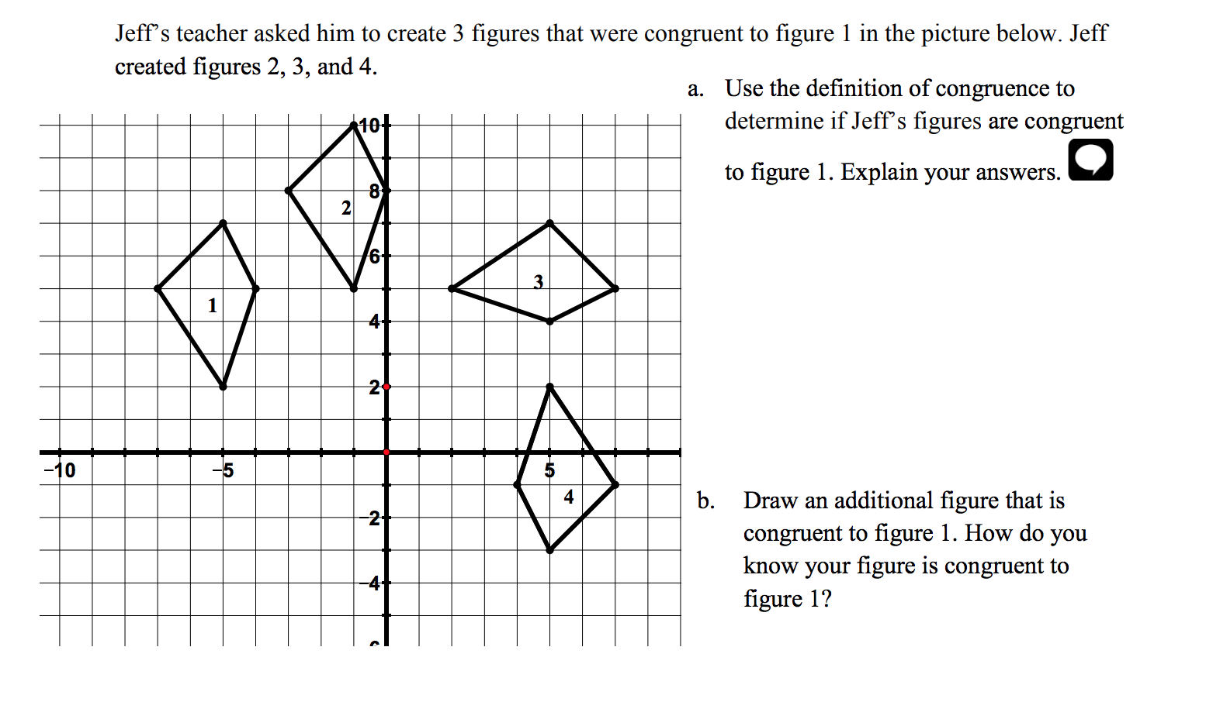

Congruence Formative Assessment 4
Link to Formative Assessment (if applicable): http://www.openmiddle.com/transformations-three-sequences/
Cluster & Content Standards  What content standards can be addressed by this formative assessment?  Reasoning about Similarity and Transformations  8.G.2 Use transformations to define congruence.  - Verify experimentally the properties of rotations, reflections, and translations that create congruent figures.  - Understand that a two-dimensional figure is congruent to another if the second can be obtained from the first by a sequence of rotations, reflections, and translations.  - Given two congruent figures, describe a sequence that exhibits the congruence between them. | Mathematical Practice Standards  What practice standards can be addressed by this formative assessment?  1. Make sense of problems and persevere in solving them.  5. Use appropriate tools strategically.
Learning Targets
What learning targets will be assessed?
- Determine and perform a sequence of transformations that takes a preimage to an image.
Timing: Teachers may want to use this formative assessment after students have completed any of the three congruence tasks, but most likely more so in the beginning of introducing congruence.
Anticipated Solutions
Answers and sequences will vary. Correct sequences must involve a reflection and most will also include a rotation (although not necessary).
Students may struggle with the fact that the images are not on a coordinate plane, remind them that this task is not about specific locations of vertices, but rather about the transformations that map the preimage to the image. Provide graph paper and tracing paper as tools.

Congruence Formative Assessment 4

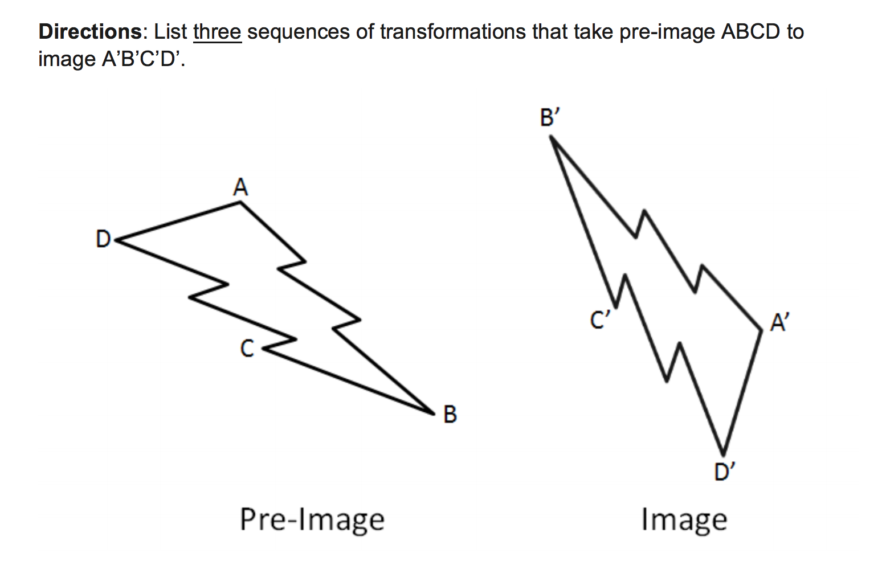

Sequence 1:

Sequence 2:

Sequence 3:

openmiddle.com/transformations-three-sequences/ Robert Kaplinsky

