Congruence Task 1
Framework Cluster | Reasoning about Similarity and Transformations
Standard(s) | 8.G.2 Use transformations to define congruence.  - Verify experimentally the properties of rotations, reflections, and translations that create congruent figures.  - Understand that a two-dimensional figure is congruent to another if the second can be obtained from the first by a sequence of rotations, reflections, and translations.  - Given two congruent figures, describe a sequence that exhibits the congruence between them.
Materials/Link | Cardboard Shapes (enough for each 2-3 students), Large 1 inch Graph Paper with Pre Drawn Figures (enough for 2-3 students), Tracing Paper
Learning Goal | To use a series of rigid transformations to map a given shape onto another given shape. This is the pre-work necessary to discuss congruency. The term “congruency” is not introduced in this lesson but builds toward it in the third lesson.
Task Overview: Students will physically move shapes in a coordinate plane. It is important for students to use concrete materials to experience rigid transformations in a physical movements. The focus of this task is the conceptual development of the idea of congruence through a hands-on task. Students will experiment with a sequence of transformations on a figure. If students can find the sequence of transformations that maps the figure to the other, then they can confirm that the preimage and image figures are congruent.
Prior to Task: Students will need prior knowledge and previous experience with rigid transformations.
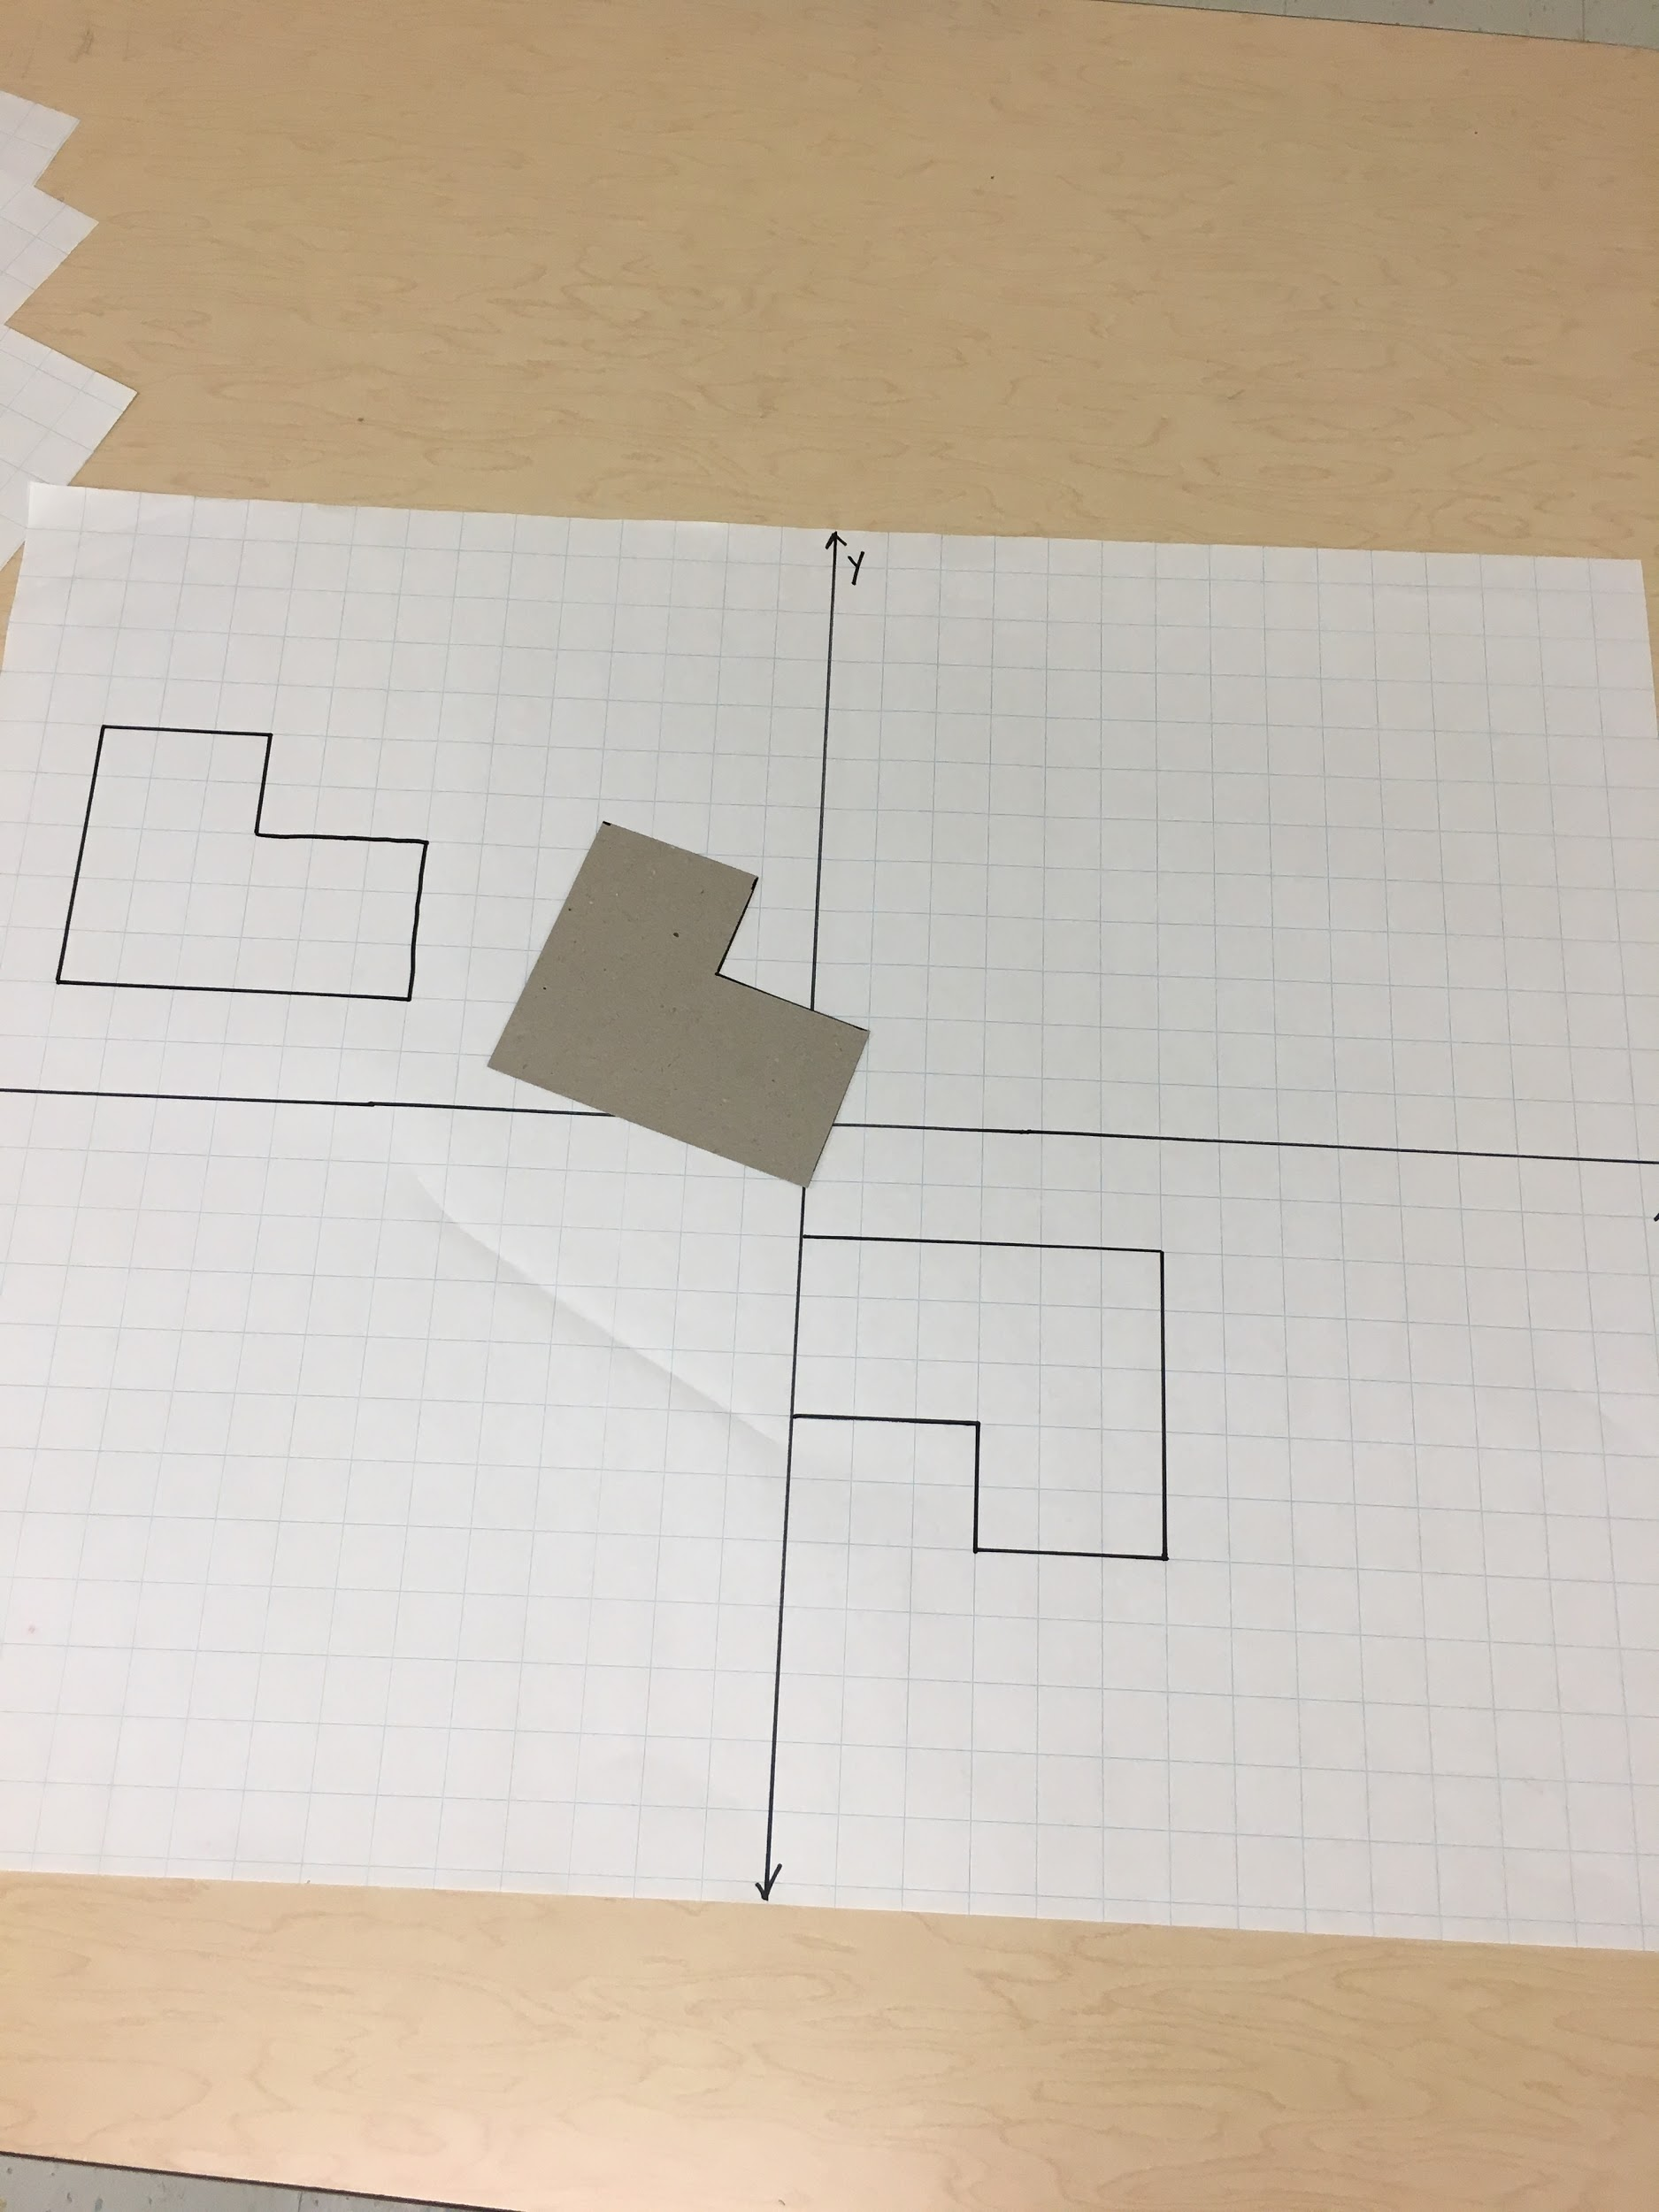
Teaching Notes: Teachers will need to prepare cardboard shapes and coordinate planes. Thin cardboard or thick cardstock can be used. Laminating the shapes and the coordinate planes is recommended. Recommendation: use one color for the preimage and one color for the image when drawing images on the graph paper.

Task Launch:
Up to this point, students have only performed single transformations. Share with students that they are now going to need more than one transformation to map a preimage to its image. Videos from Robert Kaplinsky’s How Did They Make Ms. Pacman? lesson can be used to introduce the idea of a series of transformations.

Directions:
- Create groups of 2-3 students.
- Give each group a cardboard shape that corresponds to the large graph paper and the large graph paper sheet.
- Instruct students that their goal is to create a sequence of rigid transformations that will map the preimage to the image.
- Encourage students to write down transformations as they try them to track their sequences along with any transformation sequence that may not work.
- Once students have their sequence of transformations, the teacher can check their sequence or they could trade their sequence with another group who had the same shapes or a different group. Students can critique the reasoning of others.
- If groups finish early, challenge students to find a different sequence. Ask, can you find a sequence with less transformations?

Possible Strategies/Anticipated Responses:
- Students may try to map the shapes using only one transformation; it’s okay to let students struggle with this for a little while. If students do not figure out that they need more than one transformation, ask “What do you notice?” questions and redirect students.
- Students may simply try to move the shape without thinking about the mathematics of the transformations. Remind them to record their rigid transformations as they go through the process.
- Students may try to reflect over an x = or y = line instead of the x or y axis. At this point, students most likely will not know equations of vertical and horizontal lines. Remind students that all reflections will be over the x or y axis unless enrichment is warranted.
- Students may try to rotate around a point different from the origin, such as a vertex. Remind students that all rotations will be around the origin in 90° increments unless enrichment is warranted.

Answers will vary. There are multiple sequences, but here are possible solutions for the possible sets listed below.

Set 1  Reflect over the x-axis.  Translate 7 units to the right. (x, y) → (x + 7, y + 0)  Reflect over the y-axis.  ----------------------------------------------------------------------------------------  Reflect over the y-axis.  Reflect over the x-axis.  Translate 7 units to the left. (x, y) → (x - 7, y + 0) | Set 2  Rotate 90° clockwise.  Translate 3 units down. (x, y) → (x + 0, y - 3)  -----------------------------------------------------------------------------------------  Translate 3 units down. (x, y) → (x + 0, y - 3)  Rotate 90° clockwise.  Translate 3 units to the right and 3 units down. (x, y) → (x + 3, y - 3)
Set 3  Reflect over the x-axis.  Translate 15 units right and 15 units up. (x, y) → (x + 15, y + 15)  ----------------------------------------------------------------------------------------  Reflect over the y-axis.  Rotate 180° Clockwise or Counterclockwise  Translate 15 units up and 15 units right. (x, y) → (x + 15, y + 15) | Set 4  Translate 8 units right and 7 units down. (x, y) → (x + 8, y - 7)  Rotate 90° clockwise.  Translate 3 units right and 8 units down. (x, y) → (x + 3, y - 8)  ----------------------------------------------------------------------------------------  Translate 2 units right and 10 units down. (x, y) → (x -2, y - 10)  Rotate 90° clockwise.  Translate 6 units right and 14 units down. (x, y) → (x + 6, y - 14)

There is not a Student Task Sheet for this Task.

Possible Sets:
Set 1  Preimage: (-7, 2), (-7, 5), (-10, 5), (-10, 7), (-13, 7), (-13, 2)  Image: (0, -2), (0, -5), (3, -5), (3, -7), (6, -7), (6, -2)  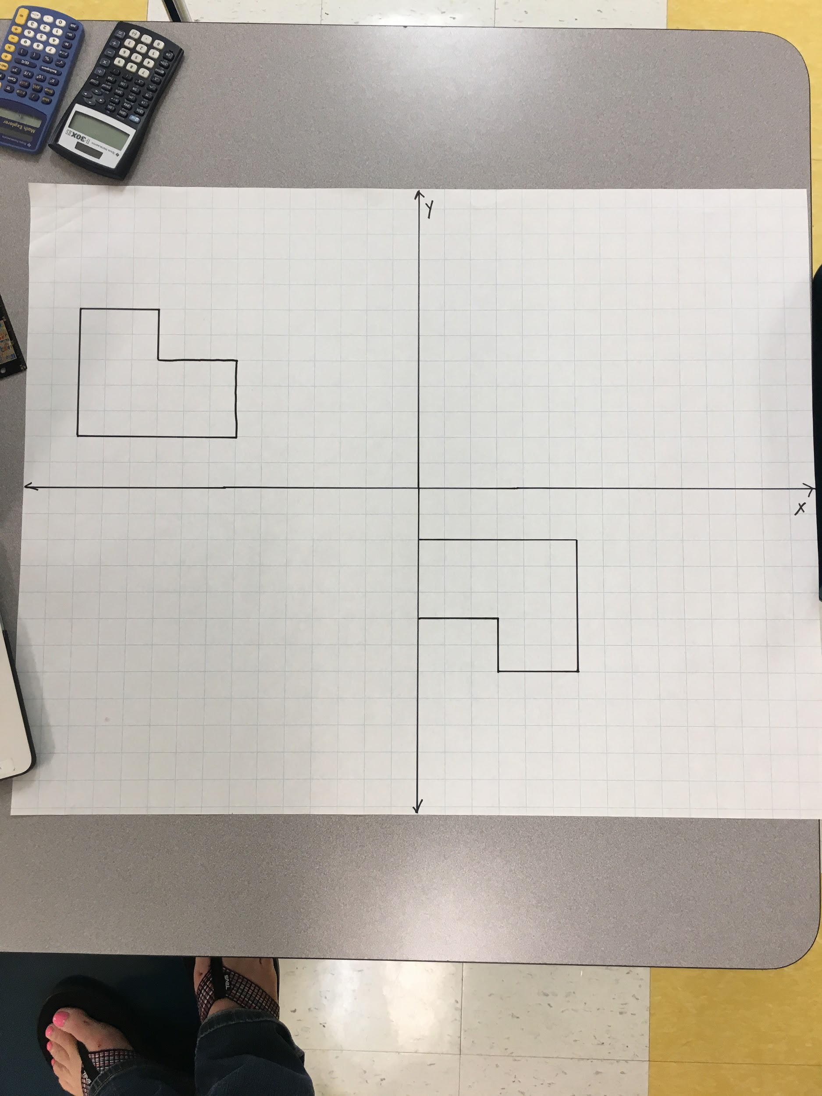 | Set 2  Preimage: (-2, 2), (-5, 2), (-5, 8), (-4, 8), (-4, 6), (-2, 6)  Image: (2, 2), (8, 2), (8, 1), (6, 1), (6, -1), (2, -1)  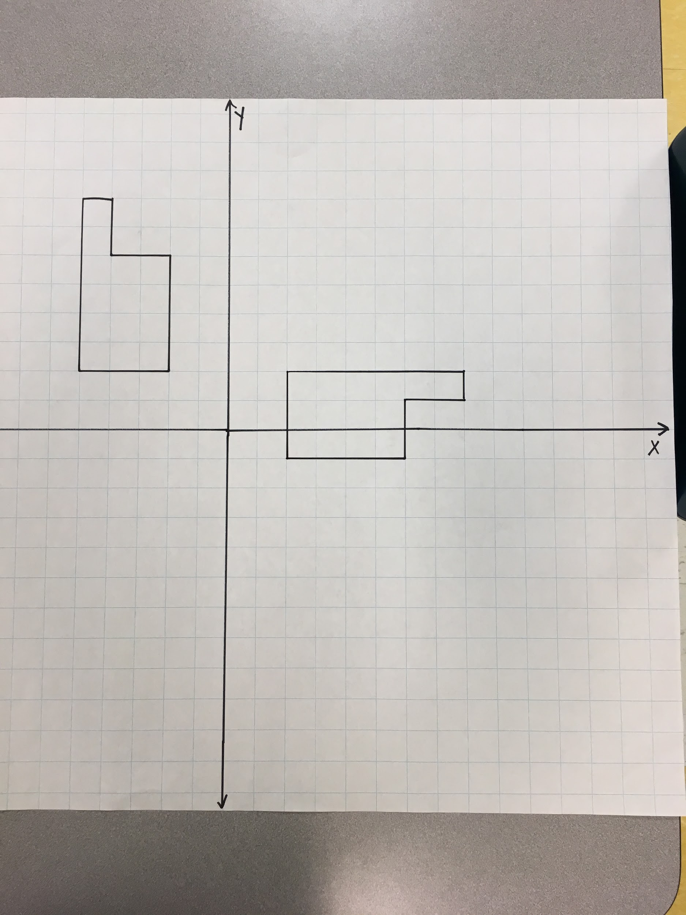
Set 3  Preimage: (-5, 8), (-5, 10), (-7, 13), (10, -13), (-10, 8)  Image: (5, 2), (5, 7), (10, 7), (10, 5), (8, 5), (8, 2)  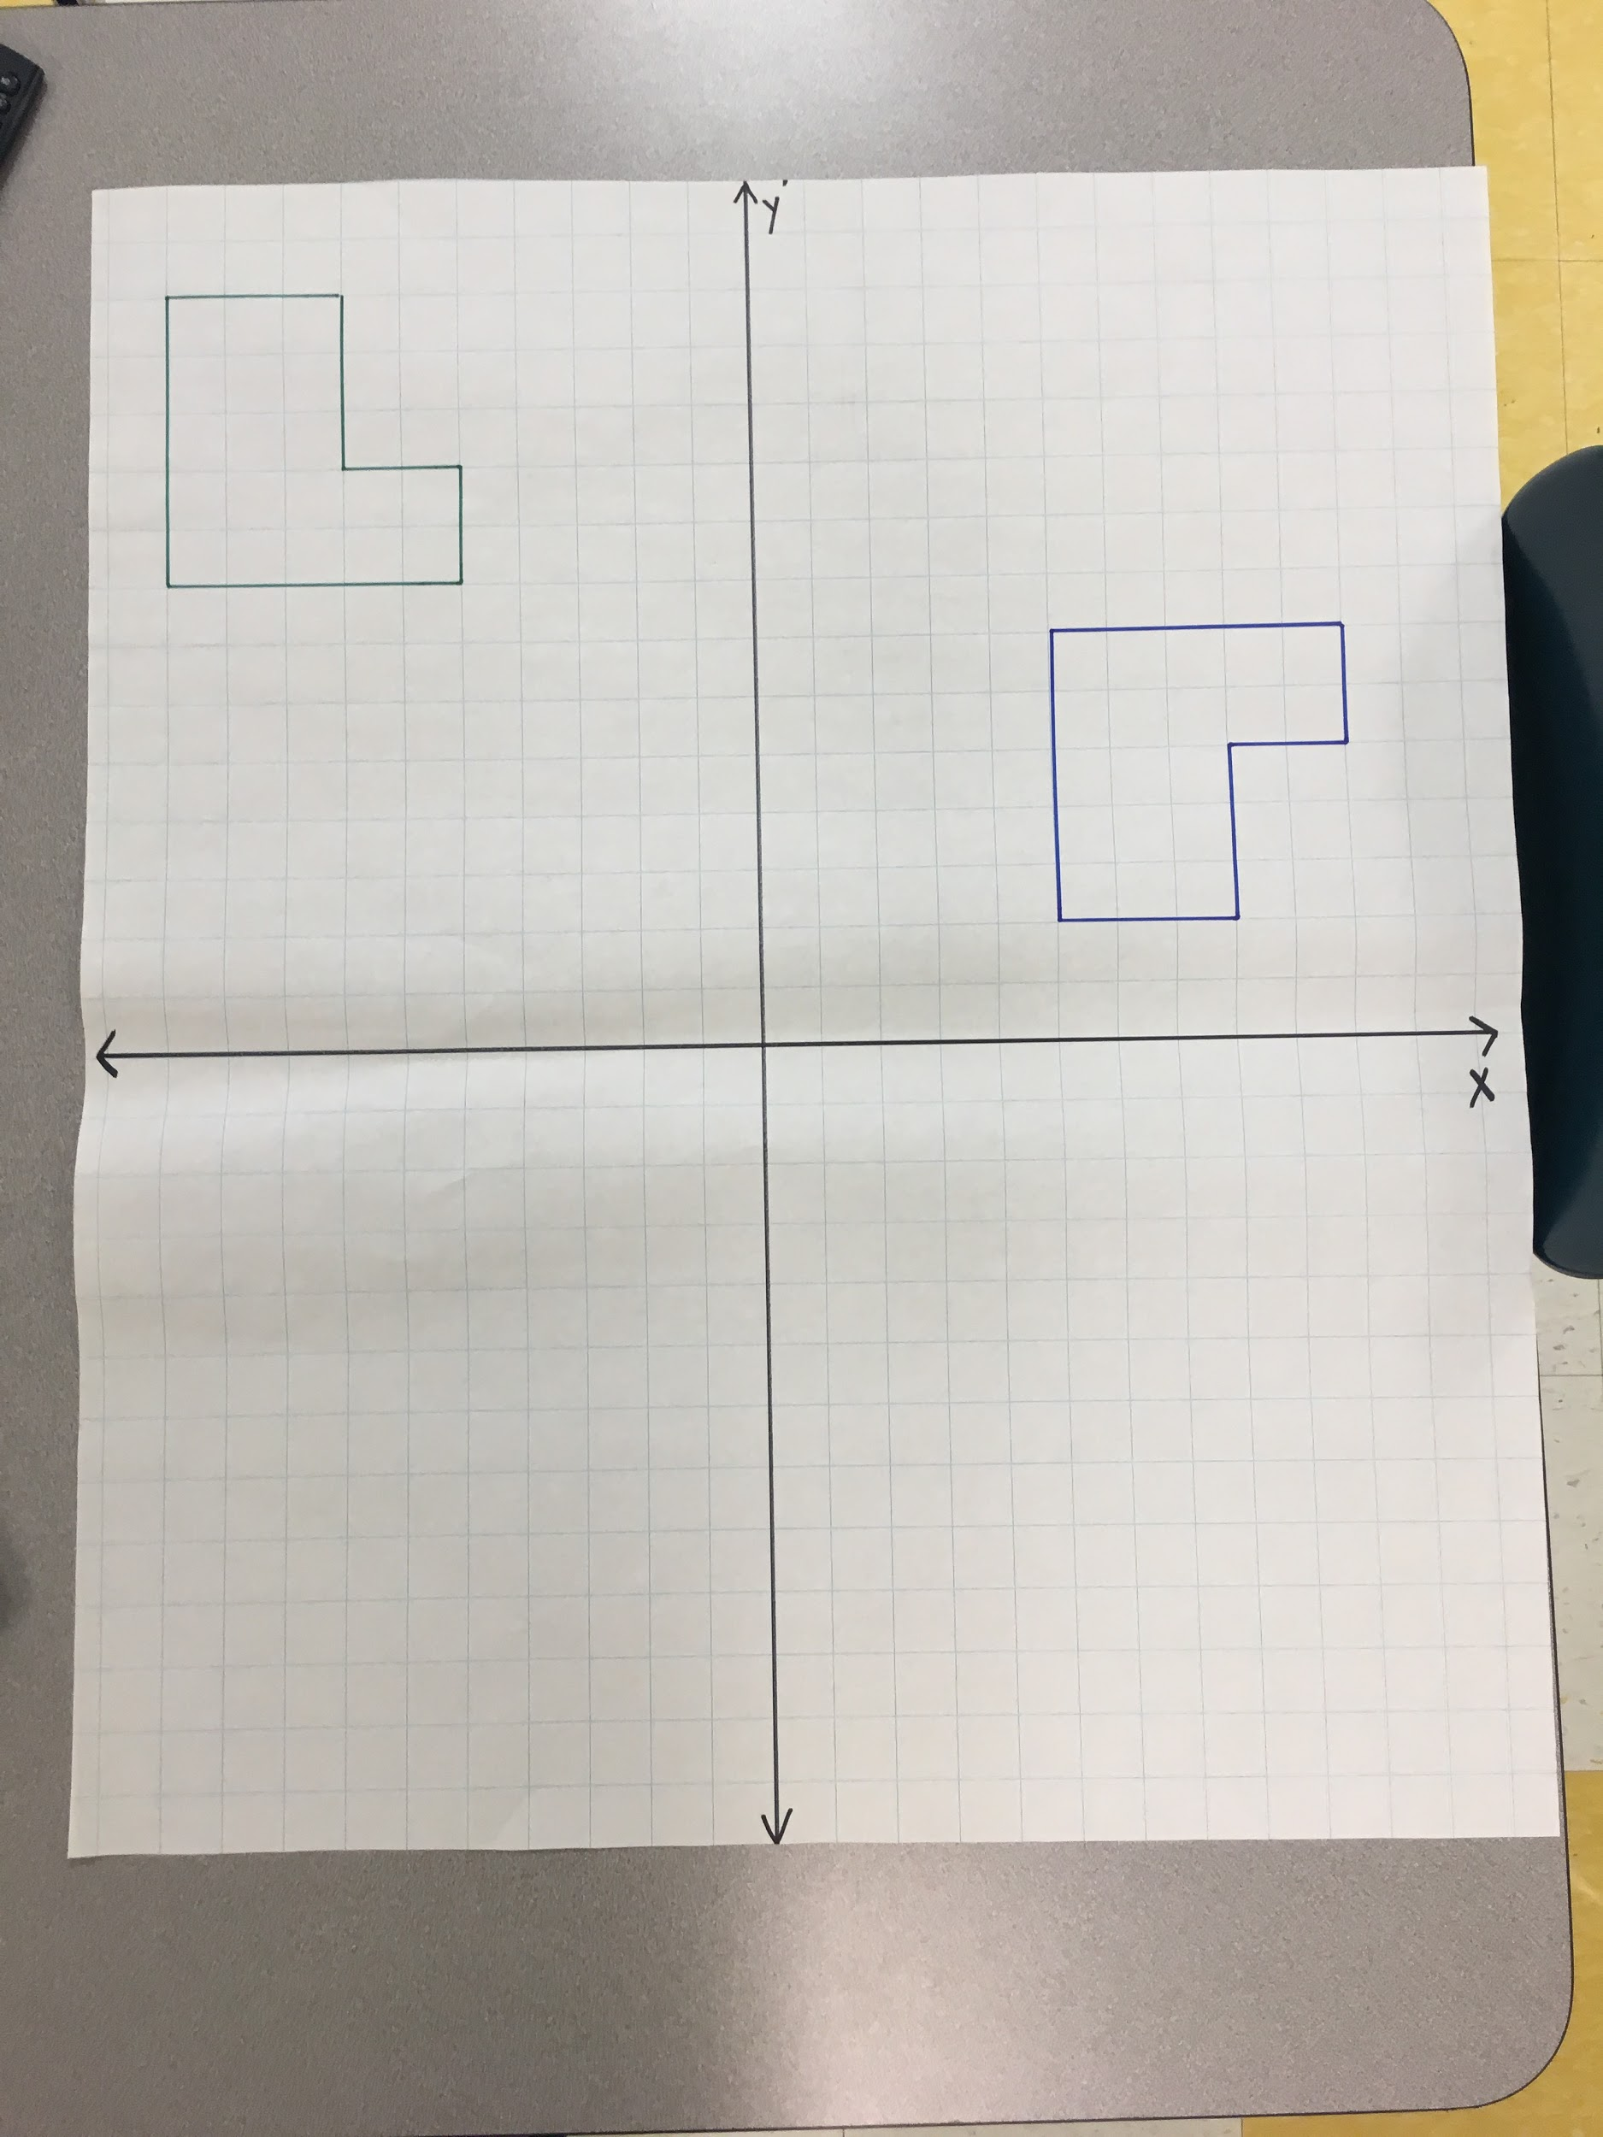 | Set 4  Preimage: (-2, 10), (-2, 12), (-8, 12), (-8, 7), (-5, 7), -5, 10)  Image: (3, -8), (3, -11), (6, -11), (6, -14), (8, -14), (-8, 8)  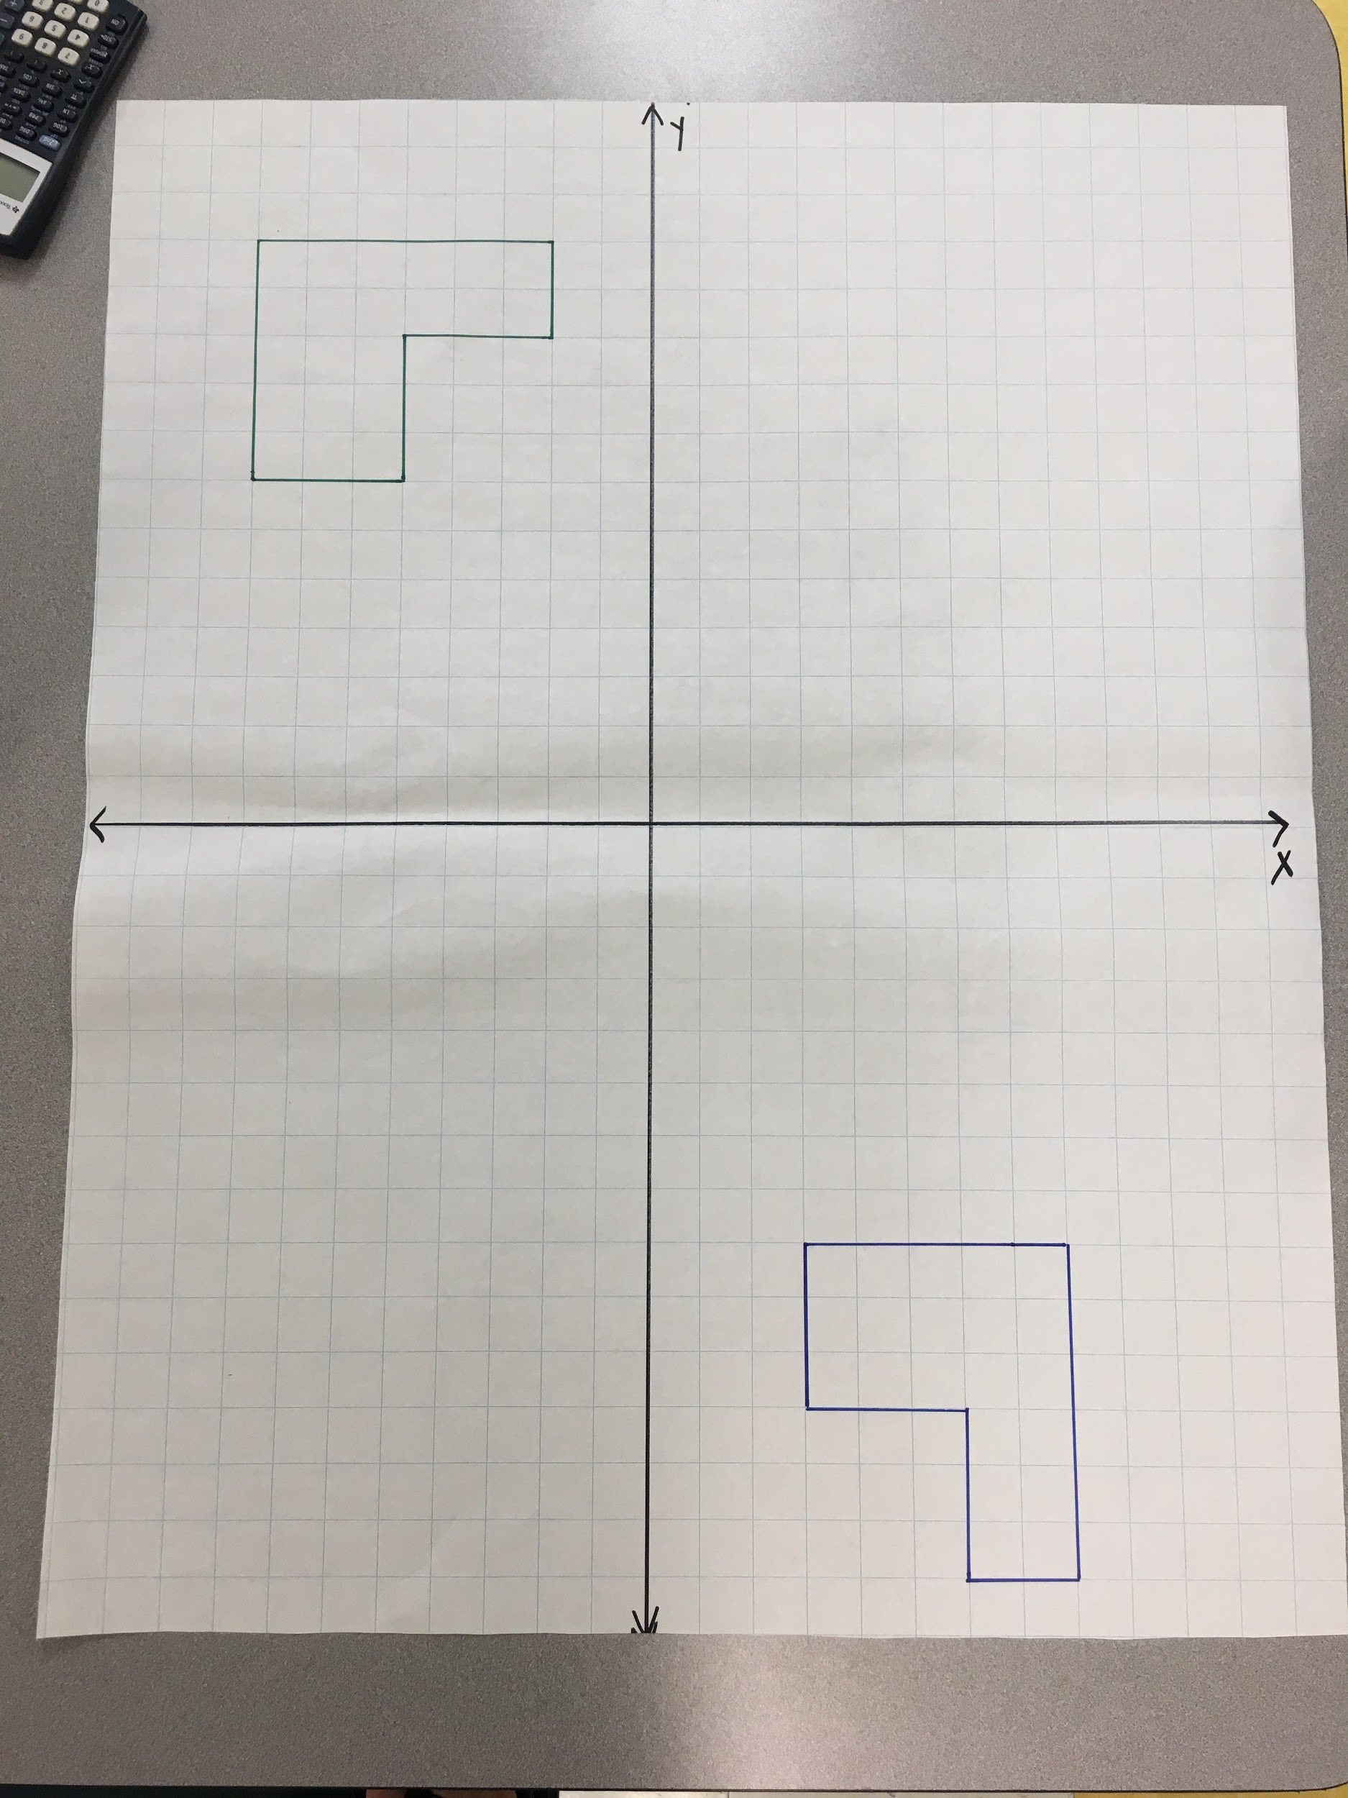

Congruence Task 2
Framework Cluster | Reasoning about Similarity and Transformations
Standard(s) | 8.G.2 Use transformations to define congruence.  - Verify experimentally the properties of rotations, reflections, and translations that create congruent figures.  - Understand that a two-dimensional figure is congruent to another if the second can be obtained from the first by a sequence of rotations, reflections, and translations.  - Given two congruent figures, describe a sequence that exhibits the congruence between them.  8.G.3 Describe the effect of dilations about the origin, translations, rotations about the origin in 90 degree increments, and reflections across the x-axis and y-axis on two-dimensional figures using coordinates.
Materials/Link | Copy of the Task, Ruler, Tracing Paper, Colored Pencils  Original Source: https://eq.uen.org/emedia/file/42717e33-c9be-4d7c-984a-ecf6cd262570/1/8Ch9Student_Workbook.pdf (PDF Pages 40-42)
Learning Goal | To perform a sequence of transformations and determine what one transformation would lead to the same results. This is the pre-work necessary to discuss congruency. The term “congruency” is not introduced in this lesson but builds toward it in the third lesson.
Task Overview: The focus of this task is the conceptual development of the idea of congruence. Students will perform a sequence of transformations on a figure and then determine what one transformation would lead to the same results. If students can find the sequence of transformations that maps one figure to the other, then they can confirm that the preimage and image figures are congruent.
Prior to Lesson: Students will need prior knowledge and previous experience with rigid transformations.
Teaching Notes:
Problem 1:
- Students may mix up the x- and y-axes.
- If teacher does not model Problem 1, discuss the prime notation.
- Encourage students to use a ruler for precision.
- If students struggle with part c., encourage the use of tracing paper and ask students about what transformations they know.
Problem 2 (Can be used for extension/enrichment):
NC expectation for reflections are over the x- and y-axes. Teachers will need to draw in the x = 1 line or discuss with students where this will be on the coordinate plane.
- Students may mix up the x- and y-axes.
- Students may not know what a “coordinate rule” is if this language has not been used prior.
Problem 3:
- Students may determine that a rotation of 180° will lead to the same results as the sequence of transformations in part a. and part b. However, this question is not asked.
Problems 4, 5, 6:
- Students may not know how to begin; remind students that this is similar to the cardboard shapes task.
- Encourage the use of tracing paper and ask students about what transformations they know.
- Allow for productive struggle.
Problem 7 (Can be used for extension/enrichment):
- Possible enrichment. Students will need to reflect across the y = 2 line. They may not know the equation, but may be able to describe in words, such as reflect over the triangle’s base.

Task Launch: Provide students with the task sheet, a ruler, colored pencils and tracing paper. Let students know that they will be performing a provided sequence of transformations and then they will determine if there is one transformation that will lead to the same results as the provided sequence.

Directions:
- Decide if students will work individually, in pairs or in small groups.
- Decide if the teacher will need to model Problem 1.
- Instruct students to follow the directions on the task sheet.
- Encourage the use of color for each transformation.
- Monitor the room for questions and misconceptions, checking student progress.
Possible Strategies/Anticipated Responses:
Answer Key: https://eq.uen.org/emedia/file/3747c340-cf27-469c-b320-648e9aed316c/1/8Ch9Parent_Manual.pdf (PDF Pages 38-40)

Throughout this lesson, students will see that there are multiple ways to describe the rigid motion or sequence of rigid motions that carry one object to another. Students will have the opportunity to consider the different approaches taken by others, compare the approaches, and identify correspondences between the different approaches.

Student task sheets begin on next page.

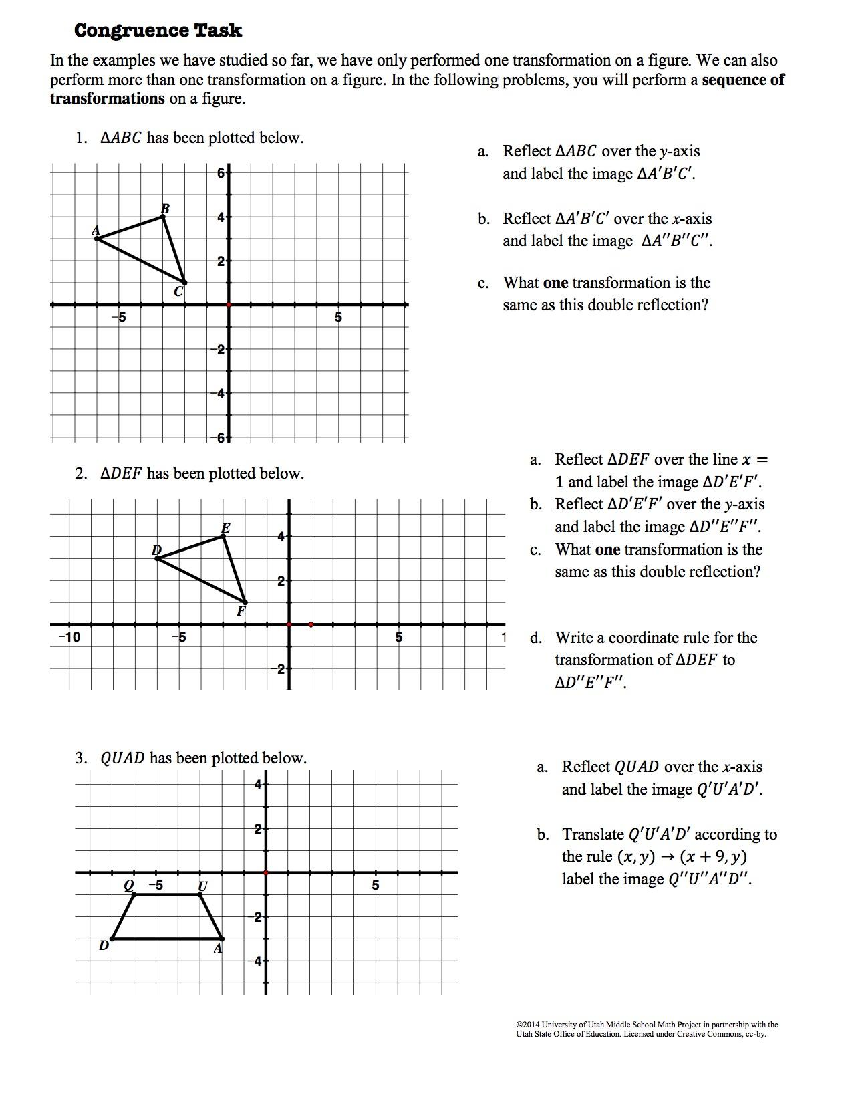
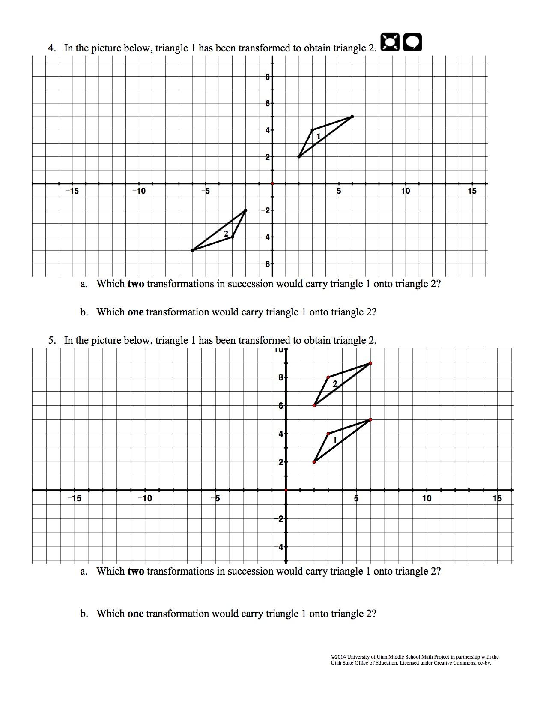
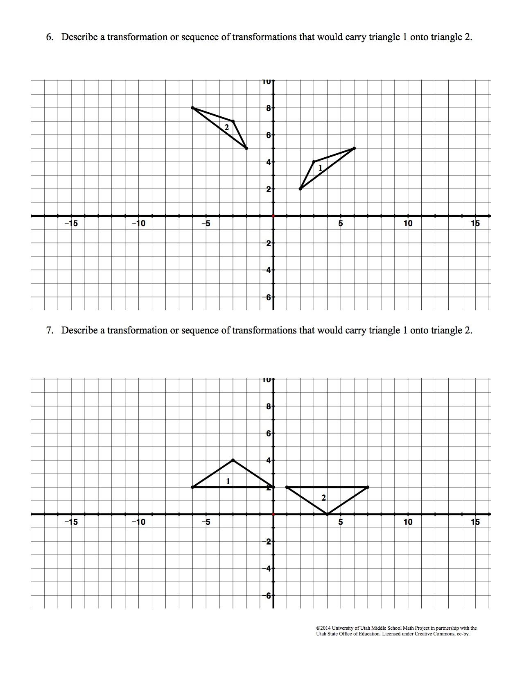
Congruence Task 3
Framework Cluster | Reasoning about Similarity and Transformations
Standard(s) | 8.G.2 Use transformations to define congruence.  - Verify experimentally the properties of rotations, reflections, and translations that create congruent figures.  - Understand that a two-dimensional figure is congruent to another if the second can be obtained from the first by a sequence of rotations, reflections, and translations.  - Given two congruent figures, describe a sequence that exhibits the congruence between them.
Materials/Link | Copy of the Task, Ruler, Tracing Paper  https://eq.uen.org/emedia/file/42717e33-c9be-4d7c-984a-ecf6cd262570/1/8Ch9Student_Workbook.pdf (PDF Pages 47-51)
Learning Goal | To define congruence in terms of transformations. To identify properties of a figure that can or cannot change during a rigid motion.
Task Overview: The focus of this task is the conceptual development of the idea of congruence. Students will determine sequences of transformations that carry one figure onto another to prove congruence. Students will identify corresponding parts in congruent figures. Students will determine if two figures are congruent based on the resulting image after a given rigid or non-rigid transformation.
Prior to Lesson: Students will need prior knowledge and previous experience with rigid transformations.
Teaching Notes: There are a lot of vocabulary words and symbols in this lesson; however it is not necessary to pre-teach the vocabulary. Use the lesson to introduce vocabulary and symbols. At the end of the lesson, provide a lesson summary about congruence. A figure is congruent to another if the second can be obtained from the first by a sequence of rigid motions (rotations, reflections, and translations).

Task Launch: Provide students with the task sheet, a ruler, colored pencils and tracing paper. Remind students that they have been performing sequences of transformations in prior tasks. In this lesson, students will use these sequences to prove that two figures are congruent. Begin with Problem 1 to launch the task.

Directions:
- Decide if students will work individually, in pairs or in small groups.
- Decide this will be guided instruction or independent instruction.
- Encourage the use of color for each transformation.
- Monitor the room for questions and misconceptions, checking student progress. To prepare for a whole-class discussion, teacher can use Smith and Stein 5 Practices to help guide discussion.
Possible Strategies/Anticipated Responses:
Answer Key: https://eq.uen.org/emedia/file/3747c340-cf27-469c-b320-648e9aed316c/1/8Ch9Parent_Manual.pdf (PDF Pages 45-49)
Problem 2: Reflection over the y-axis and a Translation left 4 units is another possible answer. Reflection over the x-axis, 180° Rotation and a Translation left 4 units is another possible answer.
Student task sheets begin on next page.
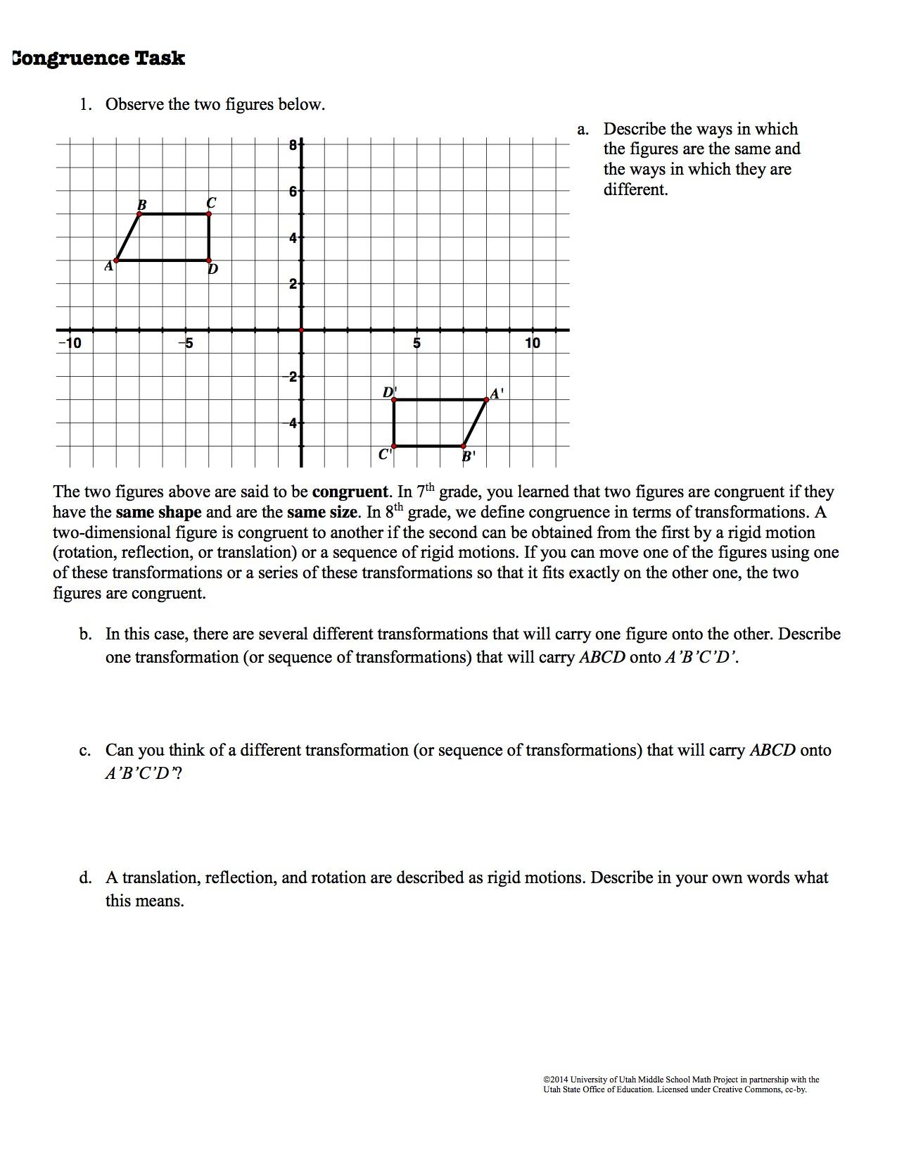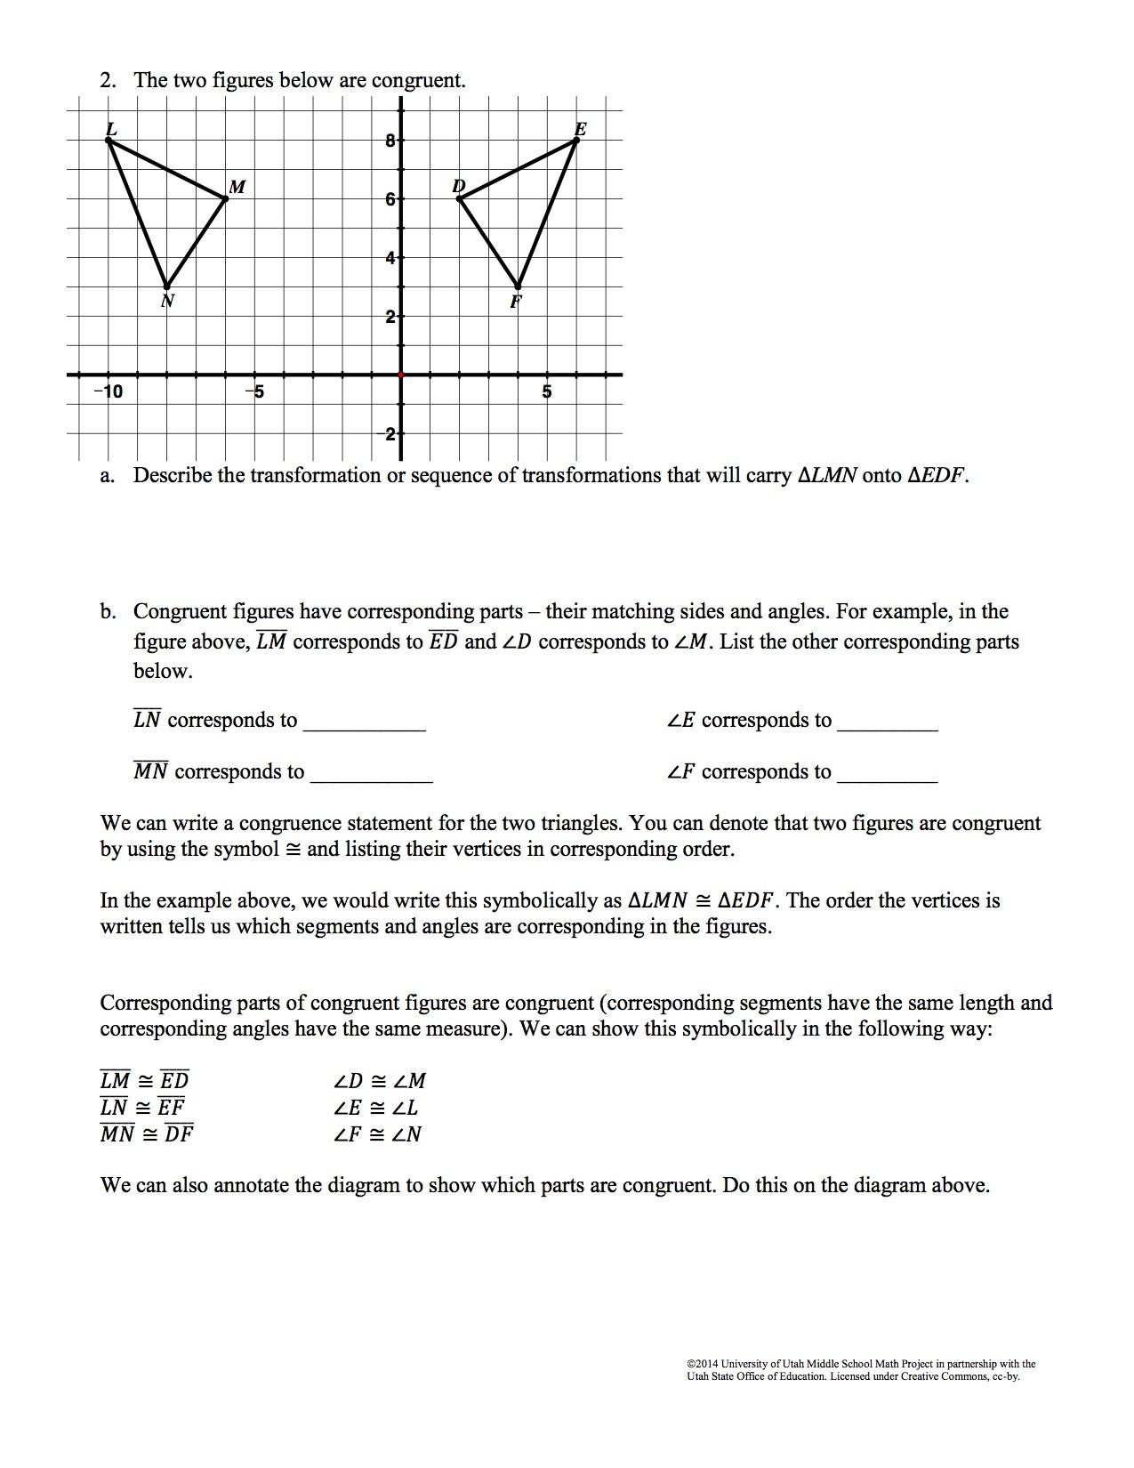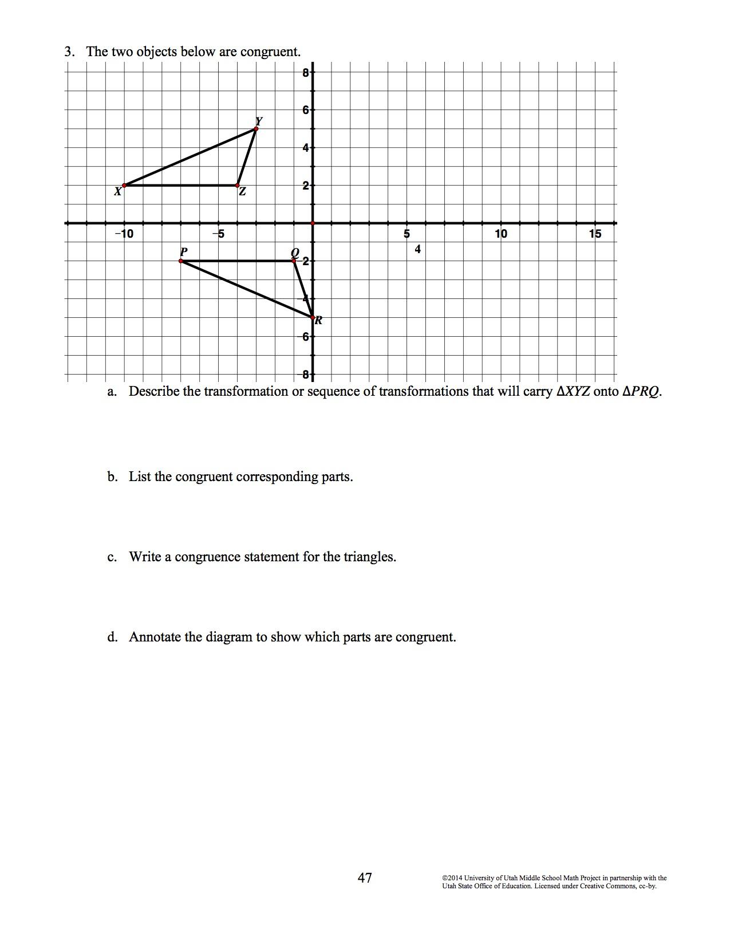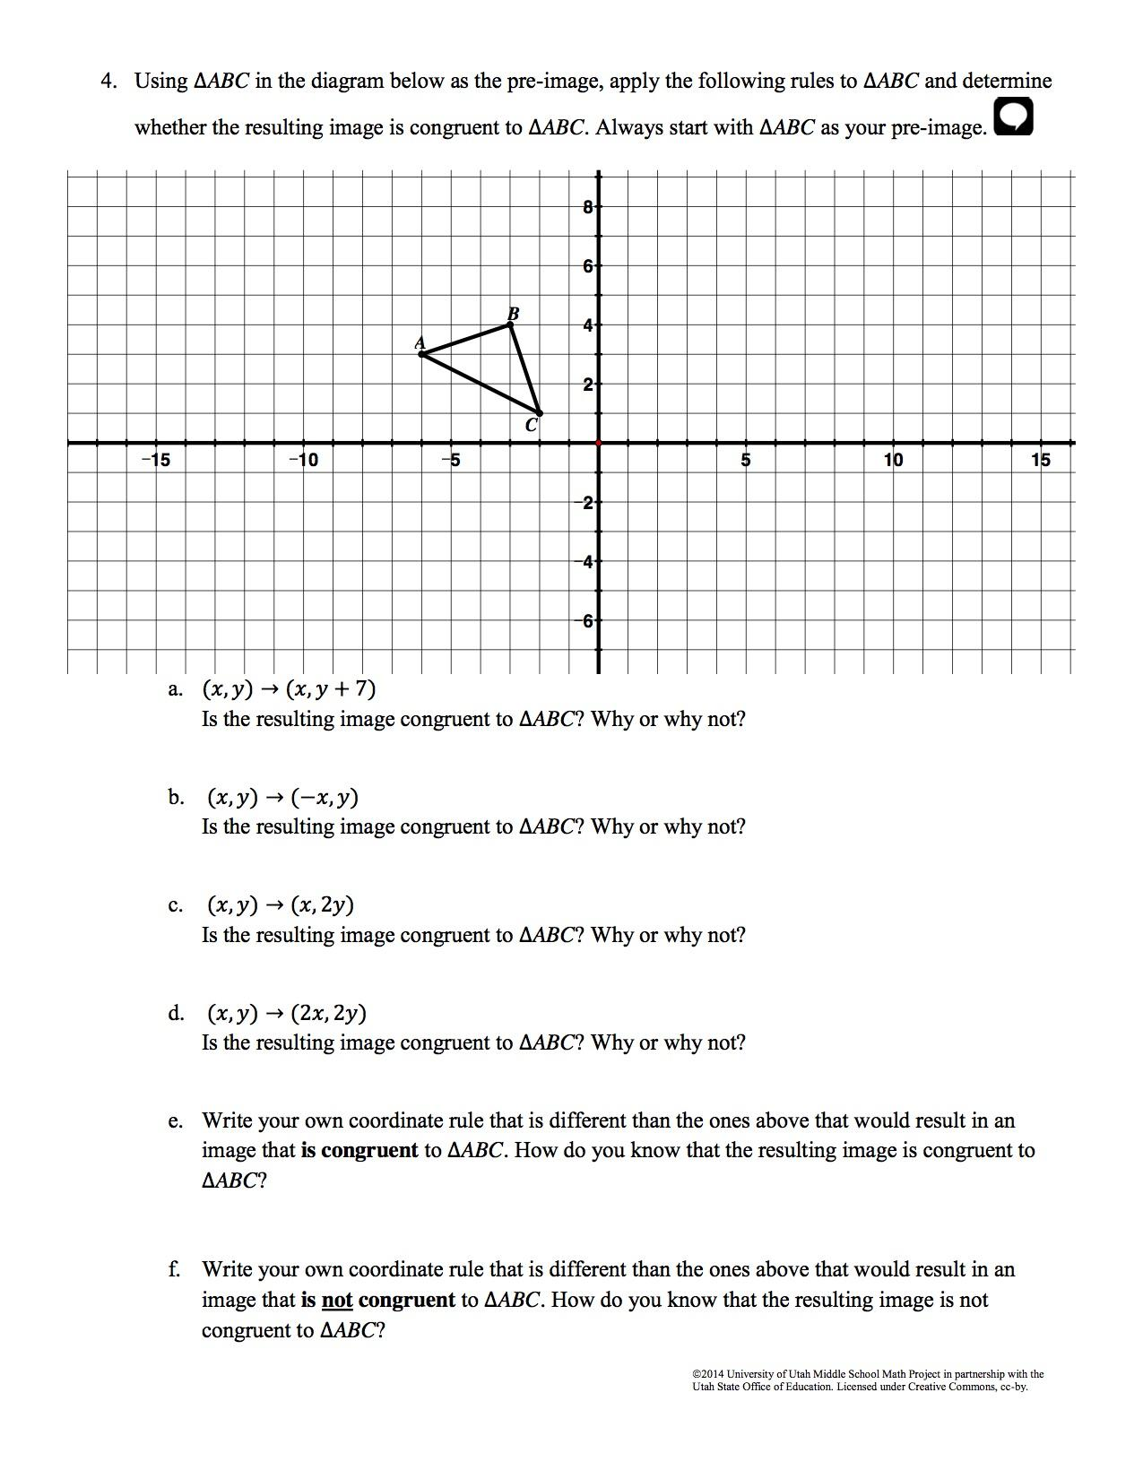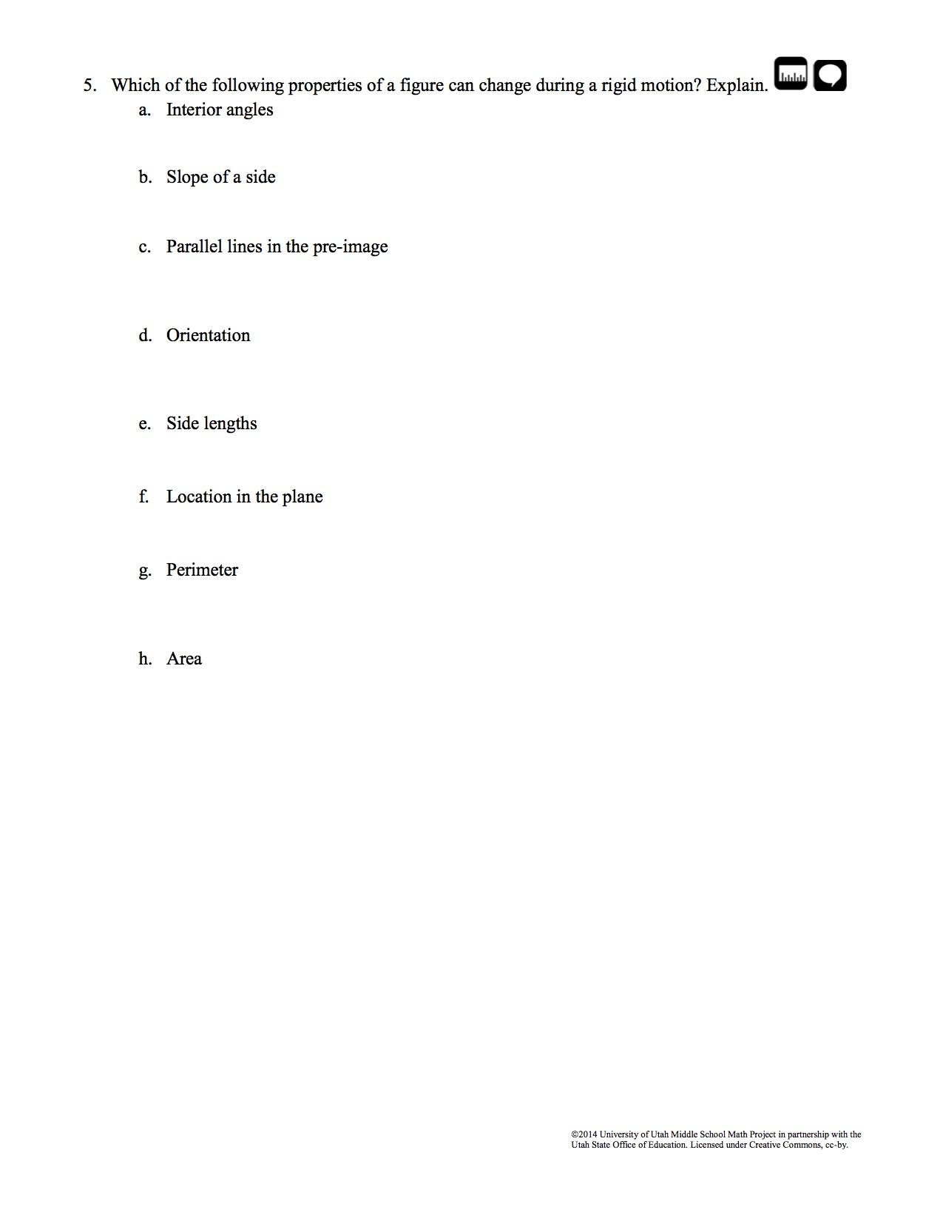

Congruence Task 4
Framework Cluster | Reasoning about Similarity and Transformations
Standard(s) | 8.G.2 Use transformations to define congruence.  - Verify experimentally the properties of rotations, reflections, and translations that create congruent figures.  - Understand that a two-dimensional figure is congruent to another if the second can be obtained from the first by a sequence of rotations, reflections, and translations.  - Given two congruent figures, describe a sequence that exhibits the congruence between them.  8.G.3 Describe the effect of dilations about the origin, translations, rotations about the origin in 90 degree increments, and reflections across the x-axis and y-axis on two-dimensional figures using coordinates.
Materials/Link | Copy of the Task, Ruler, Tracing Paper  https://www.illustrativemathematics.org/content-standards/8/G/A/3/tasks/1232
Learning Goal | To show two triangles are congruent using a sequence of rigid transformations.
Task Overview: Students will perform a sequence of transformations and identify a sequence of transformations that maps one triangle to another triangle. Students will then determine if the two triangles are congruent, understanding that if two figures are congruent, there is a series of rigid motions that maps one figure onto another. Students examine whether or not it matters in which order these transformations are applied.
Prior to Lesson: Students will need prior knowledge and previous experience with rigid transformations.
Teaching Notes:
See commentary at https://www.illustrativemathematics.org/content-standards/8/G/A/3/tasks/1232

Task Launch: If students have completed all tasks in this series, introduce the task as a summary/synthesis of what they have previously learned.

Directions:
- Provide students with the task.
- State that they will prove that the two triangles are congruent using what they have previously learned.
- Encourage the use of color for each transformation.
- Monitor the room for questions and misconceptions, checking student progress. Teacher can use Smith and Stein 5 Practices to lead whole class discussion after the student discussions
Possible Strategies/Anticipated Responses:
See commentary at https://www.illustrativemathematics.org/content-standards/8/G/A/3/tasks/1232

Student task sheets begin on next page.
