Task 1 - Making a Border
Framework Cluster | Reasoning with Expressions
Standard(s) | NC.7.EE.1  Apply properties of operations as strategies to:  • Add, subtract, and expand linear expressions with rational coefficients.  • Factor linear expression with an integer GCF.  NC.7.EE.2  Understand that equivalent expressions can reveal real-world and mathematical relationships. Interpret the meaning of the parts of each expression in context.
Materials/Link | Paper/pencil and graph paper
Learning Goal | Students will write expression to make sense of real world problems and will recognize equivalent expressions.
Task Overview

Students will use real world problems about garden borders to generate and use equivalent expressions. Students will also be given the opportunity to determine if some forms of expressions are easier to use in certain contexts.

Teaching Notes:

Task Launch:
- Introduce the task
- Give students 3-5 minutes to work individually on decided which of the 3 expressions are correct
- Allow students 2-3 minutes to share in their small groups (3-4 students)
- Discuss student reasoning as a whole class
- See if students have any answers to the question “How can you determine if two expressions are equivalent?” but there is no need for a formal response at this time.

Facilitating the Task
- Select a student to read the task about the square garden border or have them read to each other in pairs
- After making sure students understand the picture, give them time to work on questions 1-4 independently. Monitor student responses as they work
- After sufficient time, allow small groups to discuss their answers and strategies for 1-4. While students are doing this begin thinking which students you will select to share their work during the whole class discussion.
- Facilitate the whole class discussion. Possible questions to ask:
  - What is similar in the different strategies?
  - Can you show me how the picture relates to the drawing?
- Have students look at Jose’s garden. Check for understanding regarding the “x” inch border
- Give students time to work independently on this problem and then have small group discussions.
- Re-visit the question “How can you determine if two expressions are equivalent?”

Making a Border

In earlier grades, you learned that the perimeter is the distance around a figure. Given the shape below, we can write the perimeter, P, using different representations.

P = W + L + W + L P = 2W + 2L P = 2(W + L)

Justify why these are all valid ways to represent the perimeter of the rectangle.

These are called equivalent expressions. How can you determine if two expressions are equivalent?

Problem One
Landscapers often put some type of border around flower beds and gardens to add visual appeal. Borders and Beyond takes orders for square flower beds of different sizes. For example, the flower bed to the right has side lengths of 4 feet and is surrounded by square tiles that are 1 foot squares.

- How many square tiles are needed to surround the flower bed with sides of 4 ft.?

- How many square tiles would be needed for square flower beds with side lengths of 3 ft., 5 ft., 7 ft., and 10 ft.? Show your work.

- How many square border tiles will you need to surround a flower bed with the side length of s?

- Can you write a different expression than you did in number 3?

- Explain how you know two expressions are equivalent.

Problem 2
Jose has decided to build a garden in his backyard. The garden was 10 ft. long and 8 ft. wide. He has placed a border around the garden. The border is made up of square tiles that are x inches wide.

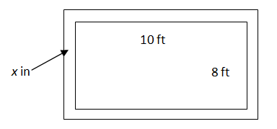

- If the border tiles are 3 inches wide, what would be the perimeter of the garden, including the border? What if the tiles are 5 inches wide? Show your work or explain your reasoning.

- Write two or more equivalent expressions for the perimeter of the garden including the border tiles with a side length of “x” inches.

- How do you know your expressions are equal?

- Jose finally decides to use tiles that are 8.5 inches wide. Which expression would you use to solve for the perimeter and why?

Possible Strategies/Anticipated Responses:
Launch:
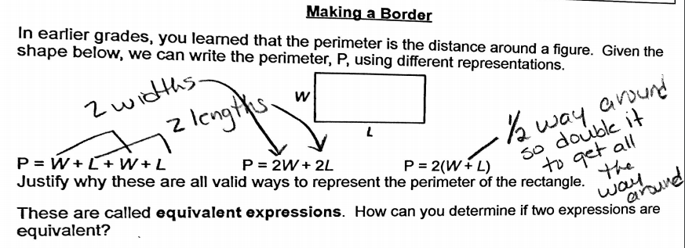
- 20 tiles
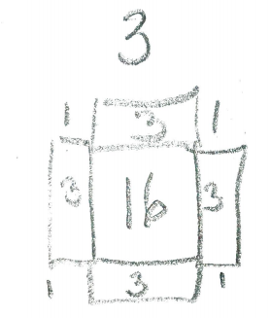
2. Students may come up with short-cuts on how to draw the pictures. This helps them see a pattern as well.

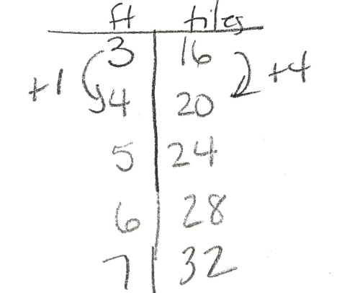
Students may make a table from their drawings and see that every time a foot is added 4 more tiles are added as well.

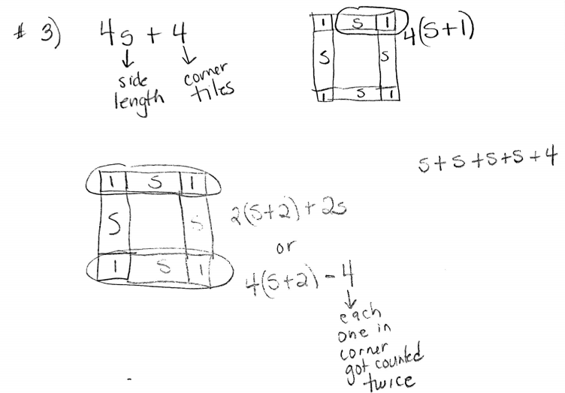

5. I can substitute a number in each expression for x and get the same thing.
I can simplify the expressions by combining like terms and using the distributive property.

Problem Two Students may struggle with this section since the units are not the same for the garden and border.
1.
- 38 feet or 456 inches. Some students may realize that 6 inches is added to each side. That is equivalent to .5 feet. Their math may look like this: 10.5 + 10.5 + 8.5 + 8.5 or 2(10.5) + 2 (8.5) or 2(10.5 + 8.5) all of which gives 38 feet.
- Some students may convert everything to inches and their numbers will be 130 and 104.
- Others may use the fractions 10 6/12 and 8 6/12. Watch for students turning the inches into a decimal, ex. 10.3 or 10.6.
- Some students may label the picture and add like terms. 10 ft. + 10 ft. + 8 ft. + 8 ft. = 36 feet. Then add all the inches 3 + 3 + 3 + 3 +3 +3 +3 + 3 = 24 inches which is 2 feet. 36 feet + 2 feet = 38 feet.
- The same strategies can be used for the second part of this question when the tiles are 5 inches wide. Answer should be 39 ⅓ foot, 39 feet 4 inches.
2. This problem requires students to think about all the dimensions in the same unit.
- 120 + 120 + 96 + 96 + x + x + x + x + x + x + x + x = 432 + 8x (using inches)
- 2(120) + 2(96) + 8x
- $\frac{x}{12 }$+ $\frac{x}{12 }$+ $\frac{x}{12 }$+ $\frac{x}{12 }$+ $\frac{x}{12 }$+ $\frac{x}{12 }$+ $\frac{x}{12 }$+ $\frac{x}{12 }$+ 10 + 10 + 8 + 8 = $\frac{8}{12}$x + 36 (using feet)
3. I can simplify them all to the same thing or I can substitute the same value in each one and get the same answer.
4. I would use a simplified expression so I only have to complete 2 steps.

Task 2 - Garden Areas
Framework  Cluster | Reasoning with Expressions
Standard(s) | NC.7.EE.1  Apply properties of operations as strategies to:  • Add, subtract, and expand linear expressions with rational coefficients.  • Factor linear expression with an integer GCF.  NC.7.EE.2  Understand that equivalent expressions can reveal real-world and mathematical relationships. Interpret the meaning of the parts of each expression in context.
Materials/Link | Paper/pencil  Student Sheets
Learning Goal | Students will understand how the parts of an expression affect the area of the figure.
Task Overview

Students will work with expressions by finding perimeter and area. Students will also begin comparing expressions to understand the meaning of each part.

Teaching Notes:
Task Launch:
- Draw the following on the board or project it for students and give them the information that follows.

6 ft.
11 ft.

Sandra’s garden last year was a 6 foot square. This year she has added 11 feet to its length but has not changed the garden’s width. What is the area of Sandra’s new garden? Be sure to show your work so you can explain it to a classmate.
- Give students time to work independently and then share responses with classmates.
- Possible questions to ask:
  - Did everyone in your group find the area the same way?
  - After hearing each person’s response, were some easier than others?
  - Regardless of how each of you solved the problem, did you all get the same answer?

Facilitating the Task
- Instruct students to work on Problem One independently.
- Have students share answers in small groups (3-4) and monitor to student responses. Begin selecting students to share.
- Facilitate the whole class discussion. Possible questions to ask and teaching points to address:
  - How did you know Michael’s was the same as Shelby’s?
  - How did you know William’s was not equivalent to the other two?
  - What does William’s expression represent?
  - Students have been exposed to the distributive property in earlier grades and this is a good place for that vocabulary to appear.
  - This is also a good place to distinguish between factored form and expanded form.
- Present Problem Two
- Allow students to work in small groups (3-4) and monitor to student responses. Monitor and begin selecting student responses to share.
- The section on Michael’s garden should be accessible to most learners since it is walks students through finding the area of each section. It is recommended that you use William’s and/or Shelby’s for the whole class discussion.
- Facilitate the whole class discussion. Possible questions to ask and teaching points to address once selected students have shown work on the board:
  - Which expressions are in factored form?
  - Which expressions are in expanded form?
  - Vocabulary to use: commutative property, distributive property, factored form, expanded form
  - Do you think there will be scenarios when the factored form is easier? Explain.
  - Do you think there will be scenarios when the expanded form is easier? Explain.
- Problems 3 and 4 could easily be used as exit tickets or informal assessment.

Garden Areas

Problem One
Michael, William, and Shelby were discussing the area of the figure below. Each wrote an expression to represent the area of the garden.
4
9
d

Michael 4(d + 9) William 4d + 9 Shelby 9d + 36.

Who do you agree with? Is there anyone you disagree with? Be ready to defend your responses.

Problem Two
Many people like to divide their gardens into sections based on what they are going to plant. For example, one section may be for beans, another for tomatoes, etc.

Michael is going to plant tomatoes and peppers in his garden.

10
x
15
peppers
tomatoes
Write an expression for each of the following:

- The area of the section Michael will use for peppers

- The area of the section Michael will use for tomatoes

- The area of the entire garden

William is also going to plant tomatoes and peppers in his garden.

15
x
10
peppers
tomatoes
4. Write two different expressions that could be used to represent the area of William’s garden.

5. How do you know the two expressions are equivalent?

Shelby wants to grow a garden that has the ingredients for salsa. Her garden is pictured below.

3
x
8
15
cilantro
onions
peppers
tomatoes
6. Write two different expressions that could be used to represent the area of Shelby’s garden.

7. How do you know the two expressions are equivalent?

Problem Three
Three of the expression below are equivalent. Explain which one is not equivalent to the other three.

4(x + 1) 2 + (2x + 10) 2x + 2(x+2) 4(x+2) - 4

Problem Four

Miyah know she wants a garden with the area of 24x + 18. Draw and label at least 2 gardens that would give Miyah the desired area.

Possible Strategies/Anticipated Responses:

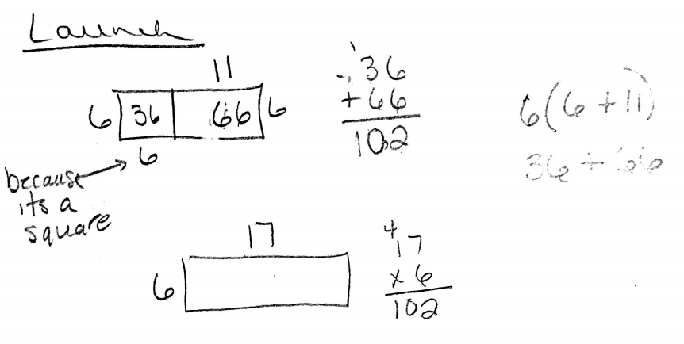

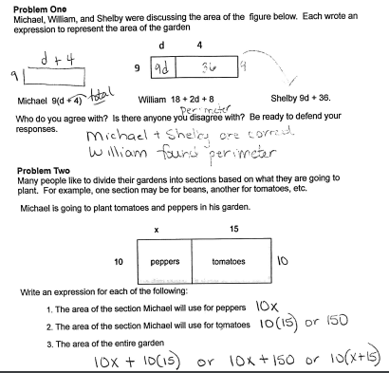

4. 15x + 15(10) 15x + 150 15(x+10)

5. I can simplify
I can substitute a value for x into each and see that they are equal
Ex. 15(2) + 15(10) = 30 + 150 = 180
15(2) + 150 = 30 +150 = 180
15(2+10) = 15( 12) = 180

6.

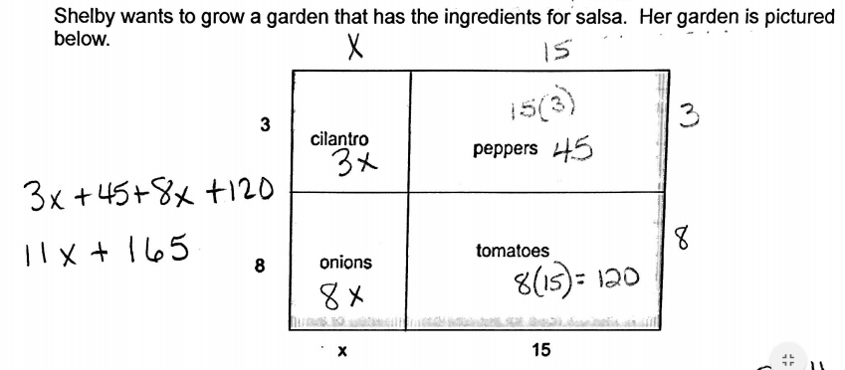
Combine 8 and 3 to get a side length of 11 and combine x + 15 to get the other side length.
Multiply 11(x+15)

7. I can use the distributive property on 11(x+5) and get 11x + 165 which I got by simplifying 3x + 45 + 8x + 120

I could also choose a value for x and substitute it in each expression. I know they are equal because I get the same total

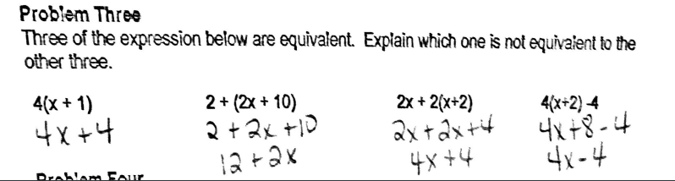

Problem Four
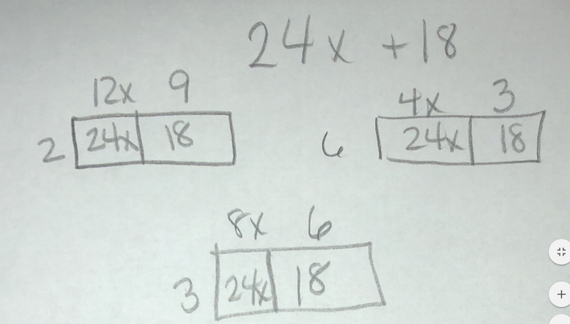

Task 3 - Track Fundraiser
Framework  Cluster | Reasoning with Expressions
Standard(s) | NC.7.EE.1  Apply properties of operations as strategies to:  • Add, subtract, and expand linear expressions with rational coefficients.  • Factor linear expression with an integer GCF.  NC.7.EE.2  Understand that equivalent expressions can reveal real-world and mathematical relationships. Interpret the meaning of the parts of each expression in context.
Materials/Link | Paper/pencil
Learning Goal | Students will write, simplify, and combine expressions to solve real-world problems.
Task Overview
Students will use pledge plans for a fundraiser to write expressions. They will then use various properties to simplify and combine expressions.
Teaching Notes:

Launch:
- Have students read scenario in pairs. Check for understanding.
- Give students 2-3 minutes to generate expressions for each student in the problem
- Have students share responses
- Possible questions to ask students:
  - Why does Chris’s expression not have a variable?
  - What does the 2.50 mean in Jill’s expression? What about the 2?
  - Try to get an students to understand that the coefficients are the amount per mile and that the constants are the “donations”
Facilitating the Task
- Give individuals or partners adequate time to answer questions 1-6 (approx. 10-15 minutes)
- Question 2 may need some clarification. Students must look at the chart and see how many sponsors each student got in order to complete this question
- As students work, monitor solutions and strategies and begin selecting student responses to be shared. Key responses in this section are 3-5
- Possible questions and/or points to be made:
  - In problem 1 is it necessary to combine like terms? What is the advantage or disadvantage?
  - For problem 4, “How do you know they are equivalent” “How could you prove it?”
  - For problem 6, “How would you calculate the money using the expression from #3? #4”
- Give students time to work on 7 and 8. It is important to make sure students do these correctly before completing the remainder of the problems.
  - Look for various strategies for 10% and 50%.
  - Note what students do for ⅓. Do they multiply? Do they divide?
  - Discuss and share responses to 7 and 8
- Give students time to work on #9
  - Be sure to note student reasoning for parts a and b. You may have to ask students which part of the expression they looked at.
  - Check calculations for part c

Track Fundraiser

Carolina Middle School wants to build a track around their football field. To raise money the students are going to collect pledges from sponsors for the number of miles, m, walked during the fundraiser. Below are the pledge plans for 3 students:

Chris is going to collect $15 regardless of miles walked
Jill is going to collect $2 then $2.50 per mile
Tripp is going to collect $3 for every mile walked

Write an expression that represents how much money each student will collect from each sponsor.

To help get students motivated, the school is giving away prizes for teams of students that raise the most money.

- If Chris, Jill and Tripp work together, write an expression for the amount of money they will earn as a team. Remember to let m stand for miles walked

Below is a summary of how many sponsors each team member collected:

Team Member | Number of Sponsors
Chris | 8
Jill | 15
Tripp | 10

2. Write an expression that indicates how much money each team member will collect based on the number of sponsors.

Chris

Jill

Tripp

3. Write an expression that represents the total amount of money the team will collect after walking m miles.

4. Write an equivalent expression and explain why it is equivalent.

5. What information does the new expression represent about the situation?

6. Suppose each person walked 10 miles. Which expression (from 3 or 4 above) would you use to calculate the team’s total? Explain your reasoning.

Maria, Jamiya, and Frank have also formed a team for the fundraiser.

Maria collected 10% less than Chris
Jamiya collected $\frac{1}{3}$less than Chris
Frank collected 50% more than Tripp

7. Write an expression to represent each person’s pledge plan. Simplify any expressions you can.

8. Write an expression for the amount of money Maria, Jamiya and Frank will earn per sponsor as a team. Remember to let m stand for miles walked

9. Look back at your expressions from questions 1 and 8.

- Can you predict which team will earn more money if they each team member got 1 sponsor and each member walked 1 mile? Explain your reasoning.

- Can you predict which team will earn more money if they each team member got 1 sponsor and each member walked 5 miles?

- Check your prediction by calculating each team’s total for 5 miles walked.

Possible Strategies/Anticipated Responses:

Launch:
Chris - 15 some kids may say 15m
Jill - 2 + 2.50m or 2.50m +2
Tripp - 3m

Lesson:
- 15 + 3m + 2 + 2.50 some kids may combine like terms 17 + 5.50m
- Chris 8(15) or 120
Jill 15(2 + 2.50m) or 30 + 37.50m
Tripp 10(3m) or 30 m

3. Most kids will use their answers from 2 and just add in order 120 + 30 + 37.50m + 30 m
Some may continue to use the expressions that have not been simplified.

4. 150 + 67.50m

5. The 150 represents $150 in donations and the $67.50 is the total the team will collect
per mile

6. Most kids will prefer the expression from #4. Their justification could be they only have to plug the value of m in once. Some kids may say it depends on number of miles and how easy the math is.

7. Maria 15 - 0.1(15) 15 - 1/10(15) 15 - 1.5 13.50
Jamiya 15 - ⅓(15) 15 - 5 10
Frank 3m + .5(3m) 3m + ½(3m) 3m + 1.5m 4.5m

8. Some may just add each of the first responses above
We hope they add simplified versions and get 13.5 + 10 + 4.5m or 23.5 + 4.5 m

9a. Some will say team 1 (17 + 5.5m) because they get more per mile
Some will say team 2 (23.5 + 4.5m) because they get more in donations
Team 2 is correct because if you plug 1 in for miles you get $28 vs. 22.5 for team 1
B. Some will say team 1 (17 + 5.5m) because they get more per mile
Some will say team 2 (23.5 + 4.5m) because they get more in donations
Some may try to reason that there is a dollar difference per mile but there is a $6.50 difference between the donations. So you would have to walk more than 6 miles for team 1 to make more

