Fraction Frenzy
Frameworks Cluster | Reasoning with Factors and Multiples
Standard(s) | NC.6.NS.4 Understand and use prime factorization and the relationship between factors to:  - Find the unique prime factorization for a whole number.  - Find the greatest common factor of two whole numbers less than or equal to 100.  - Use the greatest common factor and the distributive property to rewrite the sum of two whole numbers, each less than or equal to 100.  - Find the least common multiple of two whole numbers less than or equal to 12 to add and subtract fractions with unlike denominators.  SMP 1 Make sense of problems and persevere in solving them.  SMP 2 Construct viable arguments and critique the reasoning of others  SMP 4 Attend to precision  SMP 6 Use appropriate tools strategically.  SMP 7 Look for and make use of structure.
Materials/Links | - Copy of student handout for each student  - Markers (if desired; see #1 in the teacher directions to decide)  - Fraction tiles (rectangular, not fraction circles), online Fraction Tiles (http://www.abcya.com/fraction_percent_decimal_tiles.htm), or teacher-made fraction strips, printed from page 5 of this lesson.
Learning Goals | - Students will add and subtract fractions with unlike denominators by creating equivalent expressions with a common denominator using a visual model (fraction tiles).  - Students will understand there are multiple ways to model adding and subtracting fractions with unlike denominators, but regardless of the common denominator used, the resulting sum or difference will always be equivalent.
Task Overview:
This activity will require students to use fraction tiles to create equivalent fractions they will use to add and subtract fractions.
Prior to Lesson:
- In 5th grade, students added and subtracted “related fractions,” which are fractions with one denominator a multiple of the other denominator (such as halves, fourths, and eighths; or thirds and sixths). This lesson extends that understanding to any denominators up to 12.
- Review vocabulary: denominator, LCM (least common multiple), equivalent fractions
- Prepare fraction tiles or technology for every student
Teaching Notes:
Task launch:
- Ask students to use fraction tiles (either manipulatives or using the online tool) to model $\frac{2}{3}$. Keeping the fraction tiles on their desk/screen, ask them to show another fraction that is equivalent to $\frac{2}{3}$. Students may choose sixths, ninths, or twelfths (note that ninths are not available on commercially made fraction bars or on the online tool)., but do not specify which denominator to use. Have students talk to their shoulder buddy about how they modeled the equivalent fraction. Discuss why some students may have a different fraction from their other classmates.
- Ask students to use fraction tiles (either manipulatives or the online tool) to model $\frac{3}{4}$. Once students have been given a moment to do that, ask students to subtract $\frac{1}{4}$. Have students talk to their shoulder buddy about the solution and how they solved. Get students to focus on common denominators.
- An additional method to support students in finding equivalent fractions is to use the sheet found on page 5 of this plan without cutting it. Students can then line up a ruler or other straight edge with the fraction they want to find equivalence for and then look down the ruler’s edge to see where another fraction lines up with it. Most commercially made fraction tiles do not include sevenths, ninths, and elevenths, so using the fraction tiles sheet may be necessary for some students who are still working to solidify their understanding of equivalent fractions and common denominators.
Directions:
- Introduce the task to students. Explain that they should use fraction tiles to model all possible equivalent fractions for each fraction before adding or subtracting, whether the denominators could be used as a common denominator or not. Then have them transfer their models to paper using markers, if desired. If drawing the fraction bars will be too time consuming or cumbersome for your students, ask them to use the information from their fraction bar models to write of the equivalent fractions possible for each problem (with denominators up to 12, as that is the upper limit of fraction bar denominators).
- Give students ample time to complete. When possible (given the original denominators in the problem), encourage students to solve the problem multiple ways using different common denominators. Circulate the room as students work, making note of which common denominator(s) students chose to use for each problem, so that you can be intentional when asking students to share their work and thoughts during the Summarize portion of the lesson.
- Summarize the lesson by providing an opportunity for students to share their solutions, focusing on different solutions for the same problems, comparing answers (including eliciting students’ thinking on why it is possible to have more than one way to rewrite the problem using a common denominator, resulting in two “different” answers, with all of the ways being correct), and discussing why all students should have written the same problem for ¾ – ⅔ , using twelfths as the denominator (fraction tiles limited the possible common denominator to 12). Consider using the Class Discussion Planner (https://tinyurl.com/discussion-planner) as a guide.
- Optional extension ideas:
- Challenge students to create an addition or subtraction problem that doesn’t have sixths (or eights, or twelfths, or any denominator you choose) as a denominator in the problem, but has sixths (or the other denominator you chose) as the denominator in the answer (when simplified).
- Challenge students to create their own addition and subtraction problems that have the same answer, using fractions with unlike denominators.

Consider using the Defending Denominators formative assessment to assess how students are progressing on creating common denominators for the purpose of adding and subtracting fractions. After providing sufficient practice, this task can be followed by the Two Way Street task.
Lesson plan template adapted from Taking Action: Implementing Effective Mathematics Teaching Practices, NCTM, 2017
Student sheets begin on next page.

Name __________________________________________________________ Date __________________________
Fraction Frenzy
Student Recording Sheet
Directions: Model each fraction as many ways as possible using fraction tiles. Then, determine one model you can use to solve the problem. Model the fraction and problem in the box below.
$$\frac{3}{4}-\frac{1}{ 2 }$$
Fraction: $\frac{3}{4}$ | Fraction: $\frac{ 1 }{2}$ | Problem: $\frac{3}{4}-\frac{1}{ 2 }$

$$\frac{2}{3}+\frac{1}{6}$$
Fraction: | Fraction: | Problem:

$${\frac{5}{6}}_{}– \frac{1}{2}$$
Fraction: | Fraction: | Problem:

$$\frac{2}{3}+\frac{1}{2}$$
Fraction: | Fraction: | Problem:

$$\frac{3}{4}-\frac{2}{3}$$
Fraction: | Fraction: | Problem:

Explain how you used fraction bars to add and subtract fractions with unlike denominators.

Do you think there are multiple ways to model how to subtract $\frac{3}{4}-\frac{1}{6}$using fraction tiles? Explain your reasoning

Subtract: $\frac{5}{6}-\frac{5}{9}$

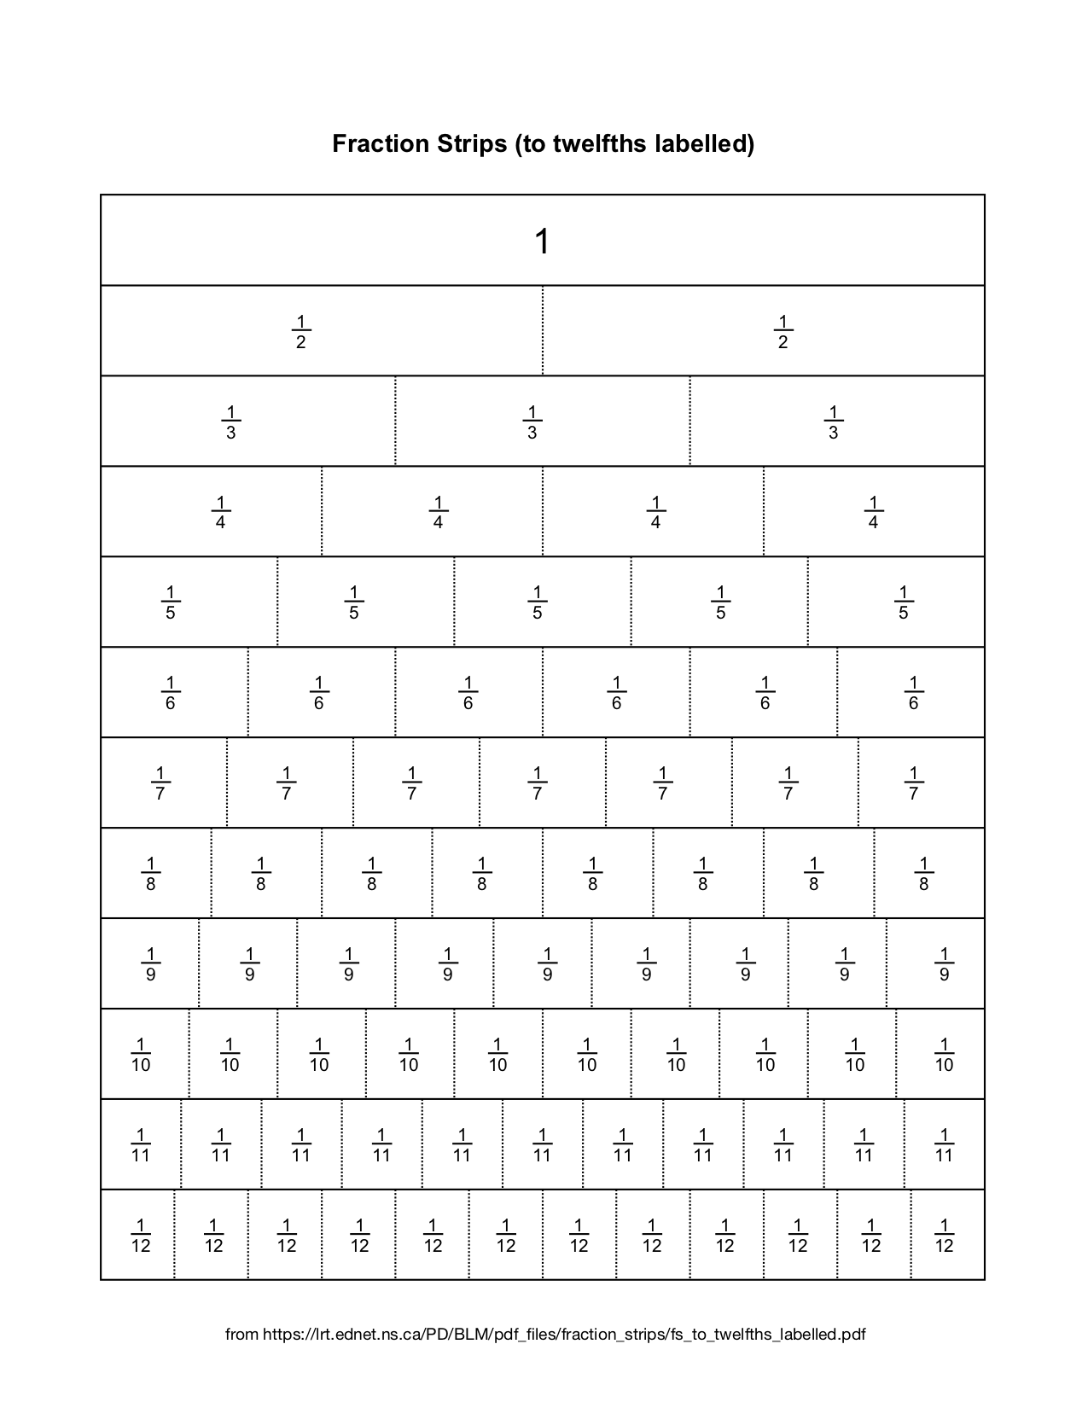

Possible Strategies/Anticipated Responses:
Solutions:
- $\frac{3}{4}-\frac{1}{2}=\frac{3}{4}-\frac{ 2 }{4}=\frac{1}{4} or \frac{ 6 }{8}-\frac{ 4 }{8}=\frac{2}{8} or \frac{ 9 }{12}-\frac{ 6 }{12}=\frac{3}{12}$
- $\frac{2}{3}+\frac{1}{6} = \frac{4}{6}+\frac{1}{6}=\frac{5}{6} or \frac{8}{12}+\frac{2}{12}= \frac{10}{12}$
- ${\frac{5}{6}}_{}– \frac{1}{2} = \frac{5}{6} – \frac{3}{6}=\frac{2}{6} or \frac{10}{12}-\frac{6}{12}=\frac{4}{12}$
- $\frac{2}{3}+\frac{1}{2}=\frac{4}{6}+\frac{3}{6}=\frac{7}{6} or \frac{8}{12}+\frac{6}{12}=\frac{14}{12}$
Note: the last equation only lists one method of solving using a common denominator, due to the limitation of modeling with fraction bars.
- $\frac{3}{4}-\frac{2}{3}=\frac{1}{12}$

Example Student Work:
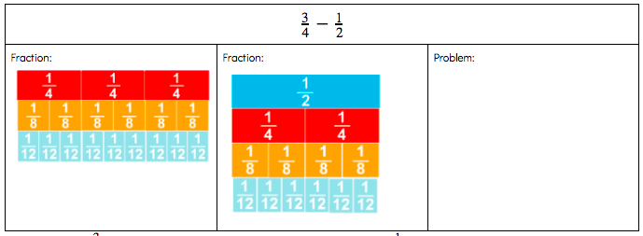
After modeling $\frac{3}{4}$with the fourths, eighths, and twelfths and modeling $\frac{1}{2}$with the halves, fourths, eighths, and twelfths, students should see they can complete the problem by using the fourths, eighths, and twelfths. Students should use one of these models to solve the problem.

- Encourage students to make the models so they see the different ways and flexibility to solve the problems.
- If students need more practice, provide practice (using LCD less than or equal to 12) they can complete before moving to the discussion questions.
- For the last discussion question, students will not be able to use their fraction tiles, as the LCM is 18. While this common denominator is outside the range of the standard’s upper limit of 12, this is intentional. Use this opportunity to determine if students recognized patterns using the tiles and can apply the pattern to unfamiliar situations. This should provide formative feedback to determine if students are ready to move forward to adding and subtracting unlike denominators in which one is not a multiple of the other.

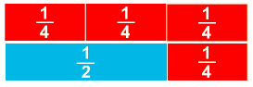
In this model students can see that $\frac{3}{4}$can be modeled with a $\frac{1}{2}$and $\frac{1}{4}$. Using the bottom row students can now literally take away (subtract) the$\frac{1}{2}$piece from$\frac{3}{4}$to see that the answer is $\frac{1}{4}$.

- A common error is adding or subtracting the denominators as well as the numerators. One goal of this task is to show students why that does not work. You can help these students by having them replace fraction tiles in the $\frac{3}{4}$model with the $\frac{1}{2}$piece.

Two Way Street
Frameworks Cluster | Reasoning with Factors and Multiples
Standard(s) | NC.6.NS.4 Understand and use prime factorization and the relationship between factors to:  - Find the unique prime factorization for a whole number.  - Find the greatest common factor of two whole numbers less than or equal to 100.  - Use the greatest common factor and the distributive property to rewrite the sum of two whole numbers, each less than or equal to 100.  - Find the least common multiple of two whole numbers less than or equal to 12 to add and subtract fractions with unlike denominators.  SMP 1 Make sense of problems and persevere in solving them.  SMP 4 Model with mathematics.
Materials/Links | - One recording sheet per student (if desired - see direction #1 for details)  - Have Fraction Tiles available for students to use. If commercially produced Fraction Tiles are not available, fraction strips can be printed from page 3 of this lesson.  - Copy paper, scissors, and markers
Learning Goal | Students will understand there are multiple ways to approach subtracting fractions and mixed numbers..
Task Overview:
This task will require students to use multiple strategies for modeling subtracting mixed numbers, and explaining their strategies.
Prior to Lesson:
- Students should be able to find common denominators for any fractions with unlike denominators (up to 12).
- It is not necessary that students have mastered an algorithm for subtracting fractions.
- Review vocabulary: numerator, denominator, least common multiple (LCM), mixed number, improper fraction
- Teach students how to model their thinking when working with fractions.
  - This includes using fraction models, number lines, and drawings when working with fractions. Students should be able to show that two fractions are equivalent. This can be done with fraction models by placing one fraction on top of another and seeing they are same length. In the example below, you can see that $\frac{1}{4}$is equivalent to $\frac{2}{8}$and $\frac{3}{12}$.
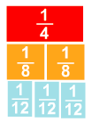
- Consider playing a game to practice finding the LCM of numbers 1-12.
  - One possible game could be LCM race. With students in groups of 4 and each having their own whiteboard, give students two numbers to find the LCM of. Give students 20 seconds to come up with the LCM. Display a timer to set the tone of a game show. After the 20 seconds have all students hold up their boards. Every group that all members get the LCM correct should earn 1 point. Play at least 6 rounds. Other variations of the game is to number off the players in the group and ask that a certain number hold up their boards. For example “If you are a two, hold up your board.” Other possible games could be Around the World and Kahoot. Students who have access to computers could use other online practice sites (such as IXL.com) as well to practice this skill at the beginning of the lesson.
Teaching Notes:

The focus of this lesson is using and connecting multiple strategies for subtracting mixed numbers, so the denominators in the question are fairly accessible to most students (thirds and fourths). However, if your students are ready for more challenging unlike denominators, consider to changing at least one of the denominators to 7, 9, or 11. The standard’s limitation on denominators is specific to the denominators in the fractions being added or subtracted, not the common denominator.

Note: In addition to fraction tiles, another method to support students in finding equivalent fractions is to use the sheet found on page 4 of this plan without cutting it. Students can then line up a ruler or other straight edge with the fraction they want to find equivalence for and then look down the ruler’s edge to see where another fraction lines up with it.

Directions:
- Pose the question from the handout to your students. You may use the recording sheet for students to show their thinking; however, you could also project the question and have them do their work on a separate sheet of paper.
- Give students ample time to brainstorm ways to model the problem. After thinking through possible solution methods yourself, see Possible Strategies/Anticipated Responses at the end of this document for some possibilities.
- Share out.
As students are working through this problem you may want to address the question of if the mixed numbers must be converted into improper fractions to solve.

This lesson is the second in a series of tasks on adding and subtracting fractions with unlike denominators. It should be used after Fraction Frenzy and before Bake Off!

Lesson plan template adapted from Taking Action: Implementing Effective Mathematics Teaching Practices, NCTM, 2017

Student sheets begin on next page.

Name _________________________________________________________ Date __________________________

Two Way Street
Student Recording Sheet

Use 2 different strategies to solve this problem:

$$2\frac{2}{3}-1\frac{3}{4}$$

Write a justification explaining and comparing the strategies.

Possible Strategies/Anticipated Responses:
- If a group of students are struggling, you can suggest that they consider modeling using fraction models, fraction bars, or a number line. Give one suggestion based on how the students have best understood modeling fractions and whole numbers from previous lessons, number talks, etc.
- At some point, students will have to find a common denominator for any solution strategy. The least common denominator is 12, but other common multiples could be used.
- When using a number line, students can decompose the numbers in whichever way they would like using the same denominator--for example, they could subtract the whole first to get to $1\frac{2}{3}$and then subtract 3/4 from there. In the example shown, ¾ is subtracted ¼ at a time.
- If students realize that subtraction finds the difference, which is the distance, between two numbers, they may use an open number line strategy. By plotting the approximate location of both the minuend and the subtrahend (minuend – subtrahend = difference), they may make “jumps” from the subtrahend to the minuend, and find the sum of the jump distances to find the difference between the two values. Note: this strategy can be particularly helpful for students who struggle with the common algorithm for subtracting mixed numbers, as students only have to add the “jumps”, not subtract, to find the difference.
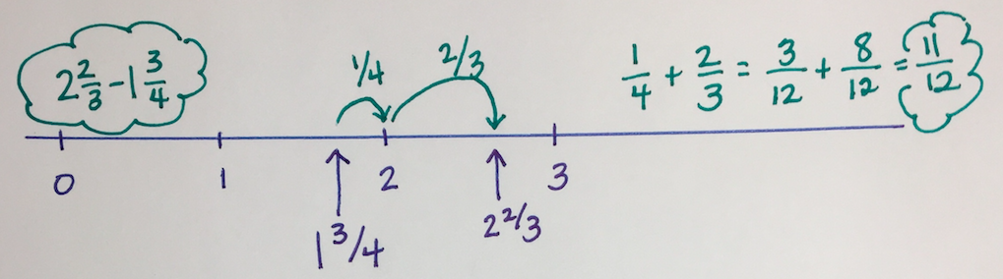

- When using fraction tiles, students should have the opportunity to manipulate the tiles to help determine that 12 is an appropriate common denominator. Note the similarities and differences between the open number line strategy above and the fraction tile model below. Identify the tiles that are modeling the minuend and subtrahend; then identify groups of tiles that represents the “jumps” made. 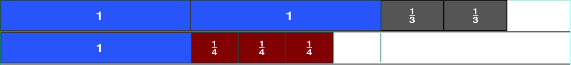
- If students choose to use the standard algorithm, allow flexibility in problem solving – instead of renaming both fractions as improper fractions from the start, they could take one away from each and solve the problem $1\frac{2}{3}-\frac{3}{4}$. This maintains the distance (which is also the difference) between the two numbers. Some students may attempt to take this one step further and subtract ¾ from 1, which has the potential to cause confusion because that results in ¼ which would then have to be added to ⅔. This, however, is 3/12+8/12, which is equal to 11/12. If any students use this strategy, consider using fraction tiles to visually model the steps, then note the connection to the open number line strategy: (see next page)

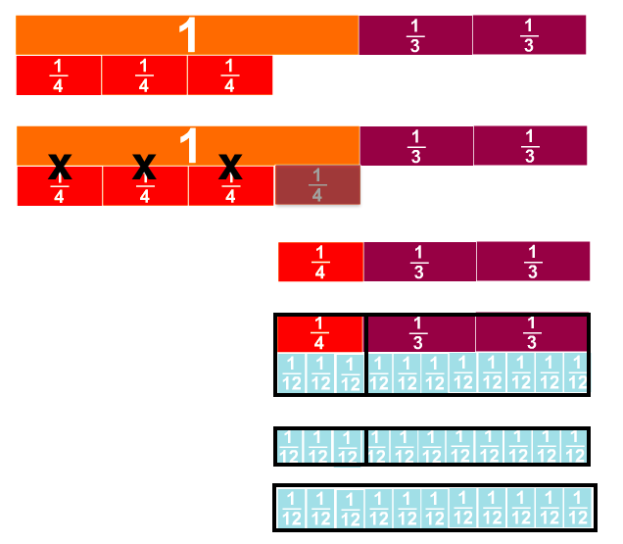

The model at the top show the values after 1 has been subtracted from each number:

Then subtract ¾ from 1:

After subtracting ¾, there is ¼ left (that was originally part of the 1), along with the ⅔ that was there from the start (as part of 2⅔)

To combine the ¼ and ⅔, a common denominator (12) is needed.

¼ + ⅔ has been changed to 3/12 + 8/12

3/12 + 8/12 = 11/12

- If students finish early, encourage them to come up with additional strategies.

Bake Off!
Frameworks Cluster | Reasoning with Factors and Multiples
Standard(s) | NC.6.NS.4 Understand and use prime factorization and the relationship between factors to:  - Find the unique prime factorization for a whole number.  - Find the greatest common factor of two whole numbers less than or equal to 100.  - Use the greatest common factor and the distributive property to rewrite the sum of two whole numbers, each less than or equal to 100.  - Find the least common multiple of two whole numbers less than or equal to 12 to add and subtract fractions with unlike denominators.  SMP 1 Make sense of problems and persevere in solving them.  SMP 2 Construct viable arguments and critique the reasoning of others.  SMP 5 Attend to precision.  SMP 7 Look for and make use of structure.
Materials/Links | - Game Board and game pieces for each student  - Fraction Game Cards or fraction dice (if this option is used, there will be no subtraction of mixed numbers)  - Calculators - one for every pair of students  - Student Recording Sheet (Optional)
Learning Goal | Students will become more fluent in using the algorithm for subtracting fractions and mixed numbers with like and unlike denominators up to 12.
Task Overview:
This game will give students practice subtracting fractions and mixed numbers with unlike and unlike denominators up to 12..
Prior to Lesson:
- Students need to refresh their memory of ordering and comparing the value of fractions. (Reviewing this could also serve as a formative assessment on students’ ability to order fractions prior to the Integer and Rational Number Reasoning Cluster.)
- Students should know how to find common denominators for fractions with denominators less than or equal to 12, and should be able to use the algorithm for subtracting fractions.
- Make one copy of the recording sheet for each student and plan student partner assignments in advance
- Prepare 1 Game board, 1 set of game cards, and 2 game pieces for each partner group.
  - To prepare the game cards, cut out each card and place in a Ziplock bag or small basket.
  - To prepare the game pieces, cut out each piece.
Teaching Notes:
Task launch:
- Have students review ordering fractions by placing fractions on a number line. Begin with benchmark numbers of 0, 1, 2, and 3 shown on the number line, then use some of the fractions from the game cards to order on the number line.
- Encourage strategies such as comparing to ½, comparing denominators if the numerators are the same, comparing numerators if denominators are the same, and comparing the distance away from 1.

Directions:
- Explain the game scenario and rules (from the game board) to students, and be sure that students know they need to record all work on their recording sheet.
- To maximize the practice for all students, consider allowing both players to select a card or roll the fraction die at the beginning of each turn, so that they can both work on subtracting at the same time.
- At the end of each turn, the opponents should check the accuracy of each other’s work; if any mistakes are found, opponents should help each other find and fix mistakes.
- As students play the game, monitor students’ work as you circulate the room, being sure that you review the work they have previously written on their recording sheets. Watch for common mistakes (see Possible Strategies/Anticipated Responses section after the student handouts for details and examples).
Consider asking students the following questions as you circulate the room:
- How did you determine where to place your game piece?
- How did you decide what common denominator to use?
- What is one fraction card you would not like to draw, and why?
- What is one fraction card you would like to draw, and why?
- What fraction would you need to draw in order to win?
- Are there any combinations of two (or three, or four…) fractions that you would like to draw?
- What is one fraction card you would not like for your partner to draw?
- Why can you not subtract the numerators and the denominators to find the difference when subtracting two fractions?
- As pairs of students are coming to the end of their games, consider asking the students how they decided if they had enough flour to make the recipe with the flour amount shown on the cards they drew.
- After students have played the game, summarize their strategies through a whole-group discussion of what methods they used to be more efficient at playing the game, and any other questions from the list in #4 that might engage students and lead to better discourse. Consider using the Class Discussion Planner (https://tinyurl.com/discussion-planner) to guide your discussion.
This task is the third in a series of tasks. It should be used following Fraction Frenzy and Two Way Street.
Lesson plan template adapted from Taking Action: Implementing Effective Mathematics Teaching Practices, NCTM, 2017
Student sheets begin on next page.

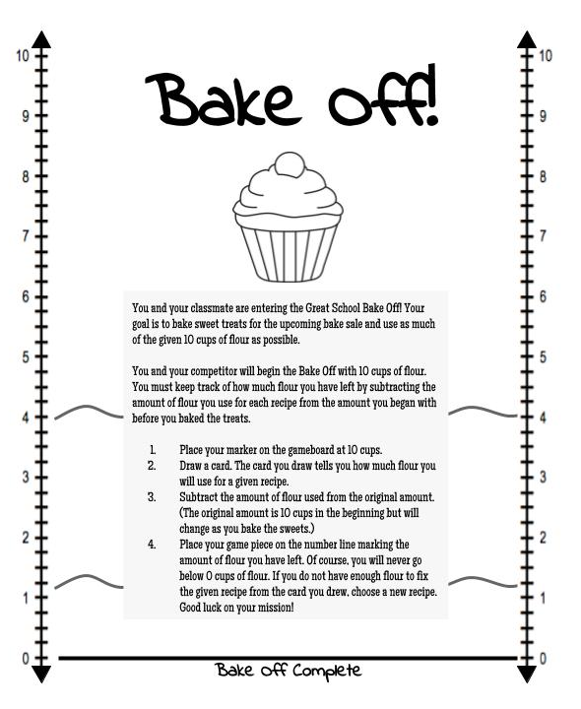
Bake Off!
Game Cards

$$\frac{1}{2}$$ | $$\frac{1}{4}$$ | $$\frac{1}{6}$$ | $$\frac{1}{8}$$ | $$\frac{1}{12}$$
$$1\frac{1}{2}$$ | $$\frac{2}{4}$$ | $$\frac{1}{3}$$ | $$\frac{3}{8}$$ | $$\frac{3}{12}$$
$$1\frac{1}{8}$$ | $$\frac{3}{4}$$ | $$\frac{2}{3}$$ | $$\frac{5}{8}$$ | $$\frac{5}{12}$$
$$1\frac{3}{4}$$ | $$2\frac{1}{2}$$ | $$\frac{5}{6}$$ | $$2\frac{2}{3}$$ | $$\frac{7}{12}$$

Bake Off!
Game Pieces

Name _________________________________________________________ Date __________________________
Bake Off!
Student Recording Sheet

____________ - ____________  Amount of Flour Before Recipe Amount of Flour for Recipe  Work:  Amount of Flour Remaining: ___________ | ____________ - ____________  Amount of Flour Before Recipe Amount of Flour for Recipe  Work:  Amount of Flour Remaining: ___________
____________ - ____________  Amount of Flour Before Recipe Amount of Flour for Recipe  Work:  Amount of Flour Remaining: ___________ | ____________ - ____________  Amount of Flour Before Recipe Amount of Flour for Recipe  Work:  Amount of Flour Remaining: ___________
____________ - ____________  Amount of Flour Before Recipe Amount of Flour for Recipe  Work:  Amount of Flour Remaining: ___________ | ____________ - ____________  Amount of Flour Before Recipe Amount of Flour for Recipe  Work:  Amount of Flour Remaining: ___________
____________ - ____________  Amount of Flour Before Recipe Amount of Flour for Recipe  Work:  Amount of Flour Remaining: ___________ | ____________ - ____________  Amount of Flour Before Recipe Amount of Flour for Recipe  Work:  Amount of Flour Remaining: ___________

Possible Strategies/Anticipated Responses:
- Students’ solutions and responses will vary throughout the game.
- Some students may struggle to find common denominators. Consider allowing these students to use a multiplication table and giving them fraction tiles (either physical or online) so they can physically build the equivalent fractions. Printable fraction bars can be found at: https://www.math-salamanders.com/image-files/printable-fraction-strips-up-to-twelfths-bw.gif.
- Students may add or subtract the numerators and the denominators, whether there are common denominators or not. If you notice this, consider revisiting the Fraction Frenzy task.
  - For example, students may do the following:
  - By having them create common denominators, the math becomes accurate. This is also a good opportunity to point out that if the denominators were subtracted as well as the numerators, the difference would be 1/0, which does not make sense.
  - Another example:
  - In this case, common denominators show that in that problem the math is incorrect, but it also shows that they can’t take their turn (note that this is because they don’t have enough flour, not because finding the difference is impossible.) :
- When subtracting with mixed numbers, common mistakes are:
  - regrouping incorrectly (in the first example, exchanging one whole for 4/4, but forgetting to add the ¼ from the original number; in the second example, regrouping using the steps that might be used when regrouping with whole numbers, by adding 10 to the numerator -- notice that the difference in this example is the same as the minuend, or starting number, which is not possible.)
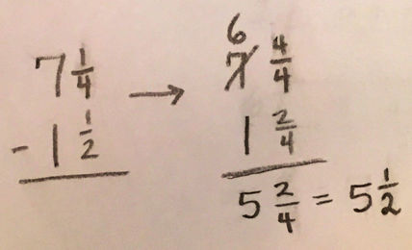 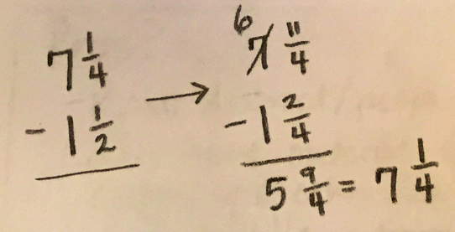

  - regrouping when it isn’t needed (which does not result in an incorrect answer, but may indicate a reliance on applying an algorithm whether it is needed or not):
  - not regrouping when needed, but then subtracting “upside down” when the larger fraction is the subtrahend).
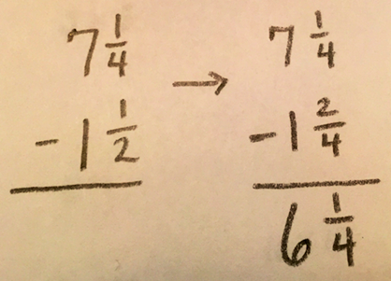
- Students may struggle placing their game piece on the number line after every turn, especially for fractions with denominators that are not 2 or 4. Placing the game piece correctly is not required to play the game, but you can use this as a formative assessment piece for future clusters.
- Be aware that students should not have very large denominators. All fractions can be rewritten with a common denominator of 24 or less.

