Inequalities Formative Assessment 1: Which Solution Is Correct?
Cluster & Content Standards  What content standards can be addressed by this formative assessment?  Reasoning About Equations & Angles  8.EE.7 Solve real-world and mathematical problems by writing and solving equations and inequalities in one variable.  - Recognize linear equations in one variable as having one solution, infinitely many solutions, or no solutions.  - Solve linear equations and inequalities including multi-step equations and inequalities with the same variable on both sides. | Mathematical Practice Standards  What practice standards can be addressed by this formative assessment?  3 - Construct Viable Arguments and Critique the Reasoning of Others  6 - Attend to Precision  7 - Look For and Make Use of Structure
Learning Targets
What learning targets will be assessed?
- Students understand the process and can solve multi-step inequalities with variables on both sides.
Timing: This would most appropriately assess student understanding after Task 2 when students explore solving inequalities.
Anticipated Solutions Responses (Progression)

Correct Response: Rob is correct. Dereck made mistakes forgetting to distribute in the first step, combining -6 and 2 incorrectly in the second step, and rewriting the inequality at the end of the problem.

Anticipated Responses: Students could struggle with the precision aspect of this assessment, as the mistakes are easy to miss with operations with negatives, distributing, and the direction of the inequality. The student explanations will be very important for assessing understanding, as students could demonstrate that they understand the concept of solving the inequalities but miss one of the other mathematical concepts. If this is the case, it will be easy to determine what the corrective action is, in addition to reminding students to attend to precision.

Student sheet on next page.

Inequalities Formative Assessment 1

Rob and Dereck both submitted work and solutions to an inequality. However, they came up with two different solutions. Who is correct? Who is incorrect? For the student who is incorrect, identify their mistake. Justify your answers with a written explanation.

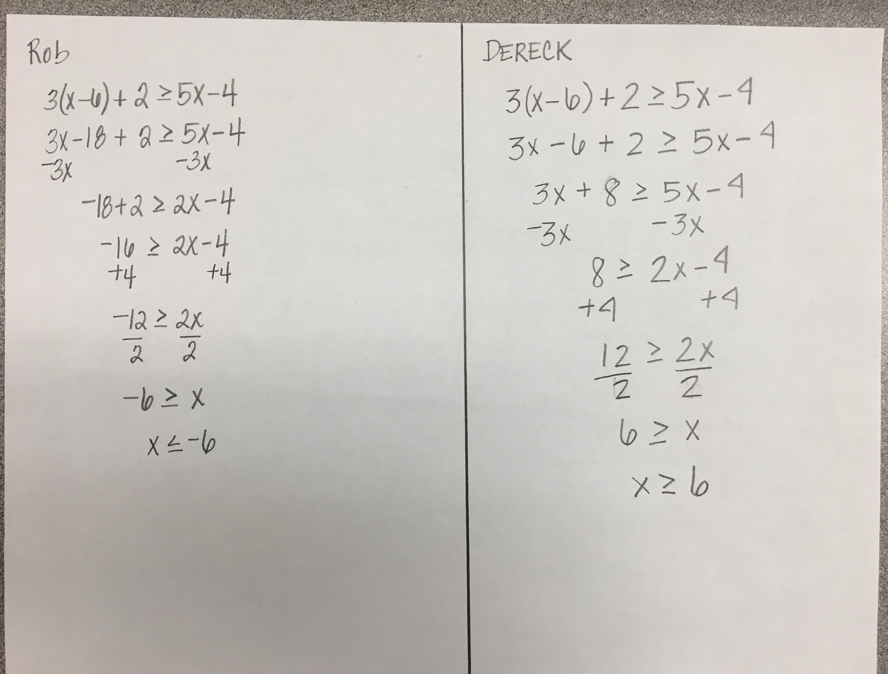

Inequalities Formative Assessment 2: Positive, Negative, Both, or No Solutions?
Link to Formative Assessment (if applicable): https://drive.google.com/file/d/1TDL9CNQ7qvb4LQfVq6XtXcTC5TKo6mUH/view?usp=sharing
(Adapted from Illustrative Mathematics: https://www.illustrativemathematics.org/content-standards/8/EE/C/7/tasks/550
Cluster & Content Standards  What content standards can be addressed by this formative assessment?  Reasoning About Equations & Angles  8.EE.7 Solve real-world and mathematical problems by writing and solving equations and inequalities in one variable.  - Recognize linear equations in one variable as having one solution, infinitely many solutions, or no solutions.  - Solve linear equations and inequalities including multi-step equations and inequalities with the same variable on both sides. | Mathematical Practice Standards  What practice standards can be addressed by this formative assessment?  2 - Reason Abstractly and Quantitatively  3 - Construct Viable Arguments and Critique the Reasoning of Others  8 - Look For and Express Regularity in Repeated Reasoning
Learning Targets
What learning targets will be assessed?
- Students will determine the signs of solutions to inequalities.
Timing: This assessment can be used during or after instruction related to Task #1 about the structure of inequalities and their solutions.
Anticipated Solutions:
a. 3x > 5 has positive solutions. x is greater than a positive number, so all solutions must be positive.
b. 5z + 7 < 3 has negative solutions. Since z is less than a negative number, all solutions are negative.
c. 7 − 5w > 3 has positive and negative solutions, so both. Since w is less than a positive number, there are some positive solutions, and every negative number is a solution.
d. 4a < 9a has positive solutions, with every positive number being a solution. For any positive number, multiplying by 9 will be a greater result than multiplying by 4. However, for any negative number, multiplying by 9 will be a smaller result on the number line than multiplying by 4.
e. y > y + 1 has no solution. There is no number y that you can add 1 to and have the answer be less than y.

Students who are still unclear on the infinite solutions to inequalities could struggle with seeing how the solutions go across zero when less than a positive or greater than a negative. Encourage students who are struggling with this to graph the solutions on the number line to see the answers visually. Further commentary is included in the link to the task.

Student sheet on next page.

Inequalities Formative Assessment 2

Determine whether these inequalities have positive solutions, negative solutions, both, or no solution. Explain your reasoning for each.

a. 3x > 5
b. 5z + 7 < 3
c. 7 − 5w > 3
d. 4a < 9a
e. y > y + 1

