Inequalities Task 1: Greater Than?
Framework Cluster | Reasoning about Equations & Angles
Standard(s) | 8.EE.7 Solve real-world and mathematical problems by writing and solving equations and inequalities in one variable.  - Recognize linear equations in one variable as having one solution, infinitely many solutions, or no solutions.  - Solve linear equations and inequalities including multi-step equations and inequalities with the same variable on both sides.  SMP 1 Make sense of problems and persevere in solving them.  SMP 2 Reason abstractly and quantitatively.  SMP 8 Look for and express regularity in repeated reasoning.
Materials/Link | Copy of the Task Link: http://www.mathematicsvisionproject.org/uploads/1/1/6/3/11636986/m1_mod4_te_52016f.pdf (Pages 25-28)
Learning Goal | To reason about inequality relationships.
Task Overview: The purpose of this task is to challenge students to reason about inequality relationships. Students are given an inequality statement and two other expressions. Students are asked to decide which of the two expressions are greater based on the inequality statement.
Prior to Lesson: Students will need prior knowledge and previous experience with one and two-step inequalities. Students will need to know and understand what each of the inequality symbols mean.
Teaching Notes:

Task Launch: Let the students know that they are about to work several logic puzzles. Use the example problem to launch the task. Teachers might want to add to the example problem by using the Statement x = -8. This will spark the discussion about how it depends on the possibilities as to which expression is greater.

Directions: The document has lots of ideas for the launch, small group work on the task, and whole-class discussion - teachers are encouraged to preview the link above before teaching. Other ideas to stimulate movement and discourse are:
- Movement/Discourse Activity: For the first couple of problems, have students choose an answer and go to one side of the room or the other based on their response. The two sides of the room can discuss their answer within their groups, leading to a debate between the answers on which is correct.
- In pairs, each individual student could work on half the problems. Then, the students could explain their response to their partners, including the rationale.
Possible Strategies/Anticipated Responses:

Answers:
- x - y
- x
- x
- 1
- Cannot be determined. Answer depends whether n is a positive or negative integer.
- x + a
- x - a
- Cannot be determined. Answer depends whether x is a positive or negative number.
- Cannot be determined. Answer depends whether x is a positive or negative number.
- Cannot be determined.
- n, only when n is not equal to one. For the inequality to be true, n must be greater than or equal to one.

For the answers where the answer cannot be determined, some students could get frustrated by the fact that either answer could be correct. Remind students that the inequality signs have a range of answers and can be different based on signs. Additionally, operating with variable expressions often confuses students. Students can substitute numbers to try to find the answer, but allow them to discover that strategy on their own through productive struggle. Also, ensure that discussions bring out the need to try several values (including positive and negative) to ensure that their answer is correct.

Student task sheets begin on next page.

How Great Thou Art!

For each situation you are given a mathematical statement and two expressions beneath it.

      - Decide which of the two expressions is greater, if the expressions are equal, or cannot be determined.
      - Write and equation and explain your reasoning.

EXAMPLE:
Statement: x = 15
Which is greater? Equal? Cannot tell? x – 5 or 2x - 9?
ANSWER as a class.

        - Statement: y < x
Which is greater? Equal? Cannot tell? x – y or y - x

        - Statement: 3x + 7 < 10
Which is greater? Equal? Cannot tell? x or 1

        - Statement: 10 – 2x < 20
Which is greater? Equal? Cannot tell? -5 or x

        - Statement: 4x ≥ 29
Which is greater? Equal? Cannot tell? 7.5 or x

        - Statement: 4x ≤ 0
Which is greater? Equal? Cannot tell? 1 or x

Adapted from MVP (Mathematics Vision Project: www.mathematicsvisionproject.org)

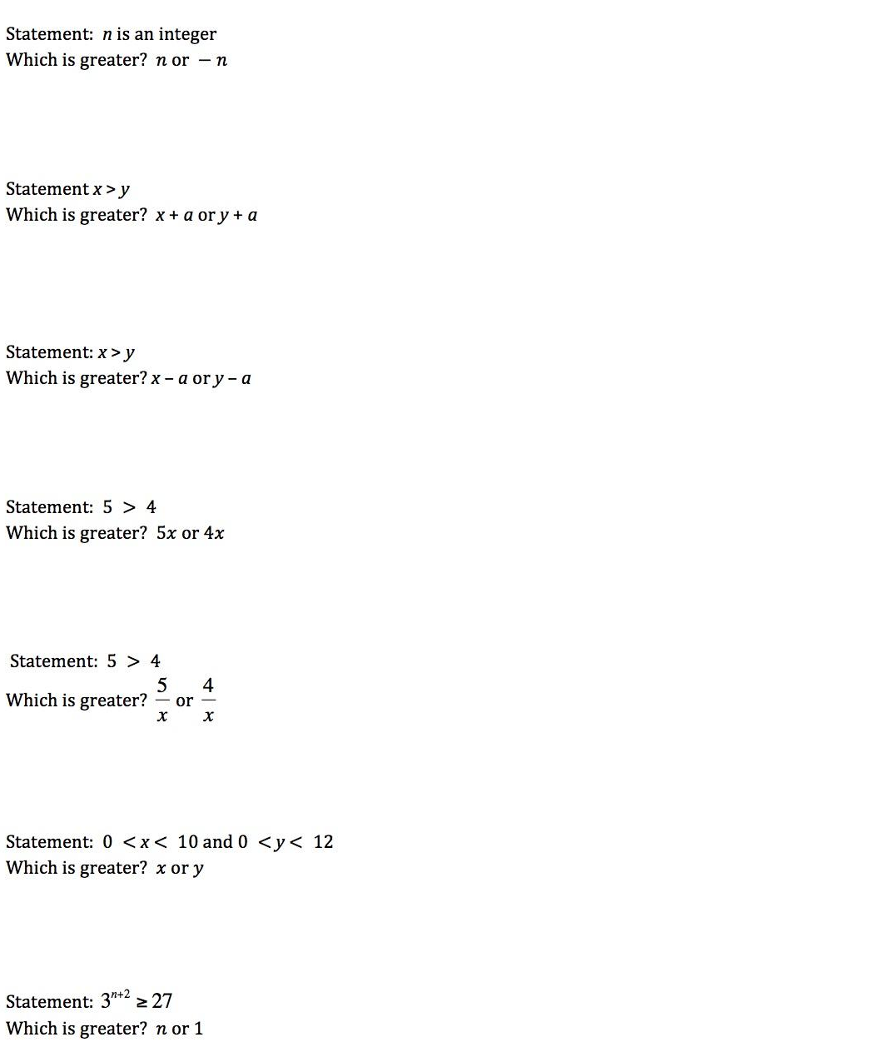

Adapted from MVP (Mathematics Vision Project: www.mathematicsvisionproject.org)

Inequalities Task 2: Which Inequalities Are Easiest and Hardest to Solve?
Framework Cluster | Reasoning about Equations & Angles
Standard(s) | 8.EE.7 Solve real-world and mathematical problems by writing and solving equations and inequalities in one variable.  - Recognize linear equations in one variable as having one solution, infinitely many solutions, or no solutions.  - Solve linear equations and inequalities including multi-step equations and inequalities with the same variable on both sides.
Materials/Link | Copy of student task sheet for each student Link: https://drive.google.com/file/d/19dsizWel76lo1p6M3SLLAota1_-G_jjt/view?usp=sharing  Modified from Open Up Resources, Grade 8, Lesson 4.6, Activity 6.3: https://im.openupresources.org/8/teachers/4/6.html#activity-3
Learning Goal | Students will solve linear inequalities with variables on both sides, including those where they need to use the distributive property, combine like terms, and “switch the inequality sign.”
Task Overview: This task presents 10 inequalities and asks students to choose which would be the hardest and easiest to solve. Then, they solve some of them, discussing the processes necessary for determining the solution.
Prior to Lesson: Students should understand the general process of solving 1 and 2 step inequalities. Also, it will help if students have experience solving equations with variables on both sides.
Teaching Notes:

Task Launch: Preview solving inequalities by reviewing solving equations with variables on both sides. Have a discussion around the question: “What are the differences between solving equations with variables on one side and variables on both sides? Why do those differences occur?”

Directions: See task sheet for expanded directions on the implementation and synthesis discussion for the activity. Some guiding questions that can help throughout the task:
- “For inequality A, what could we do to eliminate the fraction?” (Multiply each side by the common denominator of 6. Then the terms will all have integer coefficients.)
- “Which other inequalities could we use this strategy for?” (Any inequalities that had fractions, such as B, C, E, and G.)
- “What steps do you need to do to solve inequality D? Which other inequalities are like this one?” (There is a lot of distributing and collecting like terms. F and H also have to distribute several times.)
- “What other strategies or steps did you use in solving the inequalities?”
Possible Strategies/Anticipated Responses:
Some students might need a reminder about “flipping the inequality sign,” and using the number line to show students why that rule applies will help them remember in the future. Additionally, the discussion around which inequalities are “easiest” to solve will help illustrate a lot of the processes, such as when to distribute, when to combine, when to use inverse operations, and when to distribute vs. divide by a coefficient. This task will help present a lot of the concepts associated with solving inequalities, and it can also be treated as a way to disguise a practice activity in a fun, debate-centered way.
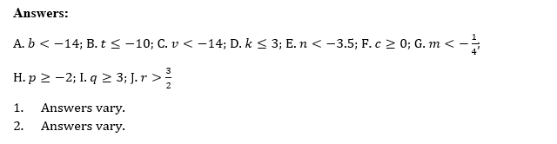

Student task sheets begin on next page.

