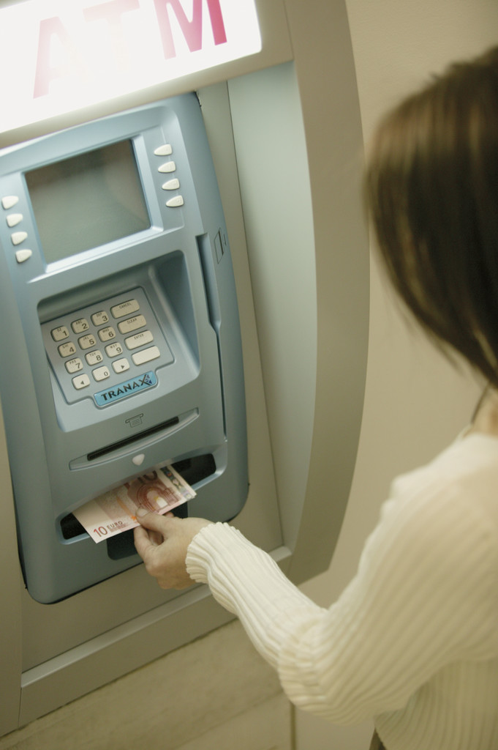

Authors:

Michelle Stephan, Ed.D.

Michelle.stephan@uncc.edu

George McManus

George_McManus@scps.k12.fl.us

Jennifer Smith

Jenniferd_Smith@scps.k12.fl.us

Ashley Dickey

Ashley_Dickey@scps.k12.fl.us

Contributors: This unit could not have been written without the support of our Principal Robin Dehlinger, Assistant Principal Tonya Fennell and the parents and students at Lawton Chiles Middle School.

*Common Core State Standards*

The intent of this instructional sequence is to teach integer addition and subtraction for understanding and in a manner consistent with the Common Core State Standards. Teaching in a standards-based environment means not only attending to the content but also the eight mathematical practices outlines in the Standards:

1. *Make sense of problems and persevere in solving them*
2. *Reason abstractly and quantitatively*
3. *Construct viable arguments and critique the reasoning of others*
4. *Model with mathematics*
5. *Use appropriate tools strategically*
6. *Attend to precision*
7. *Look for and make use of structure*
8. *Look for and express regularity in repeated reasoning*

*Classroom environment*. To accomplish these practices with this instructional sequence it is important to establish a classroom environment in which students feel obligated to explain their reasoning, ask questions when they do not understand, critique and understand the reasoning of others, and use mistakes as sites for learning opportunities. It is also imperative that the teacher poses problems and encourages students to persevere in solving them. The role of the teacher in this environment is to listen to students as the work on problems, encourage them to persevere when stuck, and orchestrate productive whole class discussions in which the mathematical ideas of the sequence become public for debate. The teacher does not tell students how to solve the problems, but rather encourages them to work either independently or with each other until they have some type of solution, whether right or wrong.

*Modeling mathematics*. The instructional sequence was designed so that students are introduced to negative numbers within the realistic context of finance. Throughout the sequence, the tasks and their wording change to encourage students to create their own models for reasoning about integers. The problems are sequenced to help students move from the concrete, realistic context of working with net worth, debts and assets toward the more quantitative, abstract, symbolic operations. The tasks encourage students to observe patterns and structures to curtail their thinking into more efficient operations. A vertical number line is presented as a tool for students to use throughout the sequence as a means of organizing and modeling their integer work.

*Classroom Organization.* Typically the class period is organized in a Launch, Explore, Discussion (LED) cycle or several cycles. The teacher begins the class period by launching the task for the day, typically taking less than five minutes.

The ***launch*** may consist of a bellwork, followed by the teacher reminding students of their discussion yesterday and ending with introducing the problem(s) for the day.

There are minutes set aside for ***student exploration***, typically 5-20 minutes depending on the problem. We have found it helpful to allow for a few minutes of independent think-time followed by partner conversation, but any arrangement is fine. During explore time, the teacher’s role is NOT to help students who are stuck find an answer. In fact, if students do not have a way the teacher should encourage them to work with a partner. The teacher’s main role during explore time IS to collect data on the way students are solving the problem so that she can know how to lead the follow up discussion.

The class debriefs their work in a whole class ***discussion*** led by the teacher. Because the teacher has collected data on student reasoning, she knows who she will call on to present and in what order. Often times, the discussion session begins with the teacher listing all the different answers students have constructed to a problem on the board. She can then ask students to decide which answer or answers they believe are correct and then have the authors of those answers defend them. During this conversation the teacher is making sure that students are attempting to understand their classmate’s arguments, ask questions when they do not understand, critique the solution, determine whether they have a different way, and contribute when they have a more sophisticated or efficient method.

There are other formats that can be just as effective as the LED cycle and teachers must decide which teaching formats have been effective in their own practice.C:\Documents and Settings\mstepha1\Local Settings\Temporary Internet Files\Content.IE5\IZ0SHP1C\MC900441938[1].wmf

*Oprah Winfrey Net Worth*

LAUNCH

When you come into school that morning, google Oprah Winfrey and Net Worth to find a site that lists the net worth of various celebrities. Show a few celebrities’ net worths and ask students what they think net worth means. Gather a few ideas, then ask students what things they think go into figuring out Oprah’s net worth. They may offer items such as cash, penthouse, OWN network, school in Africa, etc. Write these contributions on the left side of the board in a column. Rarely do students offer that she might have debts. Ask students if they think Oprah has debt and ask them to list things they think give her debt. Record these items on the right side of the board. When you have a fairly decent list of items in both categories, tell students that the things that Oprah owns are called assets. Put the term asset on the top of the column as its label along with “what she owns” in parentheses next to the term. Ask students if they know the word associated with the other column and label it debts (what you owe). Ask students to copy this in their notebooks. Tell students that both what you own and what you own are things that are considered when a person calculates their net worth. Do NOT tell them how to calculate it.

NOTES:

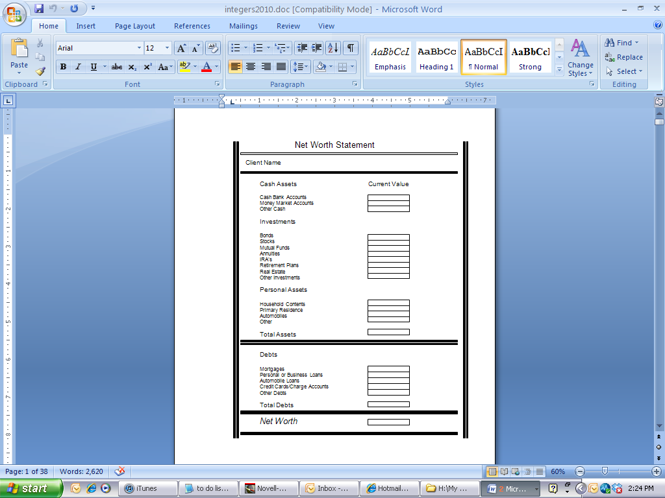

**Anticipated Student Thinking:**

*Words they may circle:*

*Money market*

*Investments*

*Bonds*

*Mutual funds*

*IRAs*

*Mortgages*

*They may ask the difference between credit, debit, and gift cards.*

**Big Mathematical Idea(s):** None

**Rationale:** Students get to know the finance context a bit more.

**Teacher Notes:**

LAUNCH: Make up a story about your financial advisor who gave this to you to fill out in order to be able to help you plan your financial future. Ask students to go through the sheet and notice the words. Circle those words with which they are unfamiliar.

EXPLORE:

DISCUSSION: Ask students to name unfamiliar words. Do not discuss all unfamiliar words but pick a few. For words like mortgage, some students might be able to describe their meaning. Do not tell students how to find Net Worth from this sheet! Ask them what net worth means to them. Students might say “how much you are worth” or “how much money you have.” While the second one is incorrect, don’t discuss it much.

Tell students they are going to use sheets like this to determine people’s net worth.

**Anticipated Student Thinking:**

* *Add assets and place $305 in the box, add debts and put $190 in box. Find the difference: $115 (CINDY), BOBBY is $5.*
* *Students may make errors in their adding and subtracting.*
* *Students may add assets and debts together to get net worth.*
* *Some may argue that Bobby is worth more because his assets are WAY bigger than Cindy’s assets.*
* *Some may argue that Cindy is worth more because she has less debts than Bobby ($190 versus $1700)*
* *Some may argue that Bobby is worth less because he is worth $5 versus $115.*

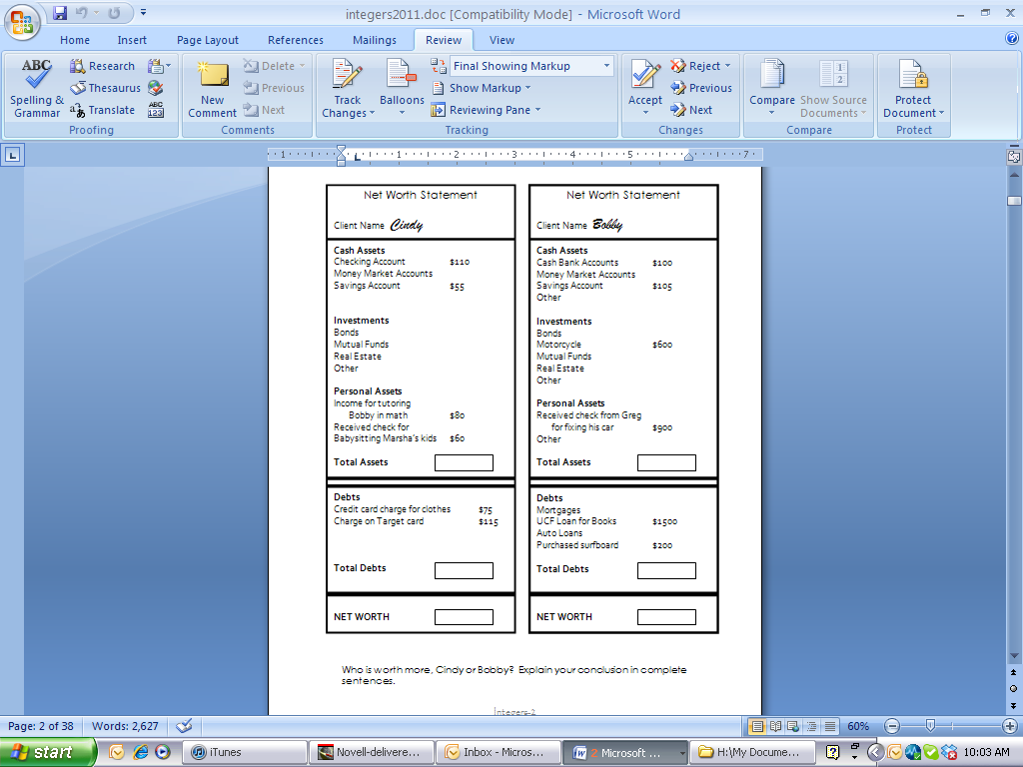

**Big Mathematical Idea(s):** Net worth as the *combination* of Total Assets and Total Debts

**Rationale:** How do students combine assets and debts to determine net worth?

**Teacher Notes:**

LAUNCH: Tell students they are about to get a portion of two people’s net worth statements. Ask a student to read the goal of the task at the bottom.

EXPLORE: Students may ask you to tell them how to figure out net worth. Tell them to work with their partners to figure out something that make sense. For student thinking, see box. Do not fix students’ wrong answers unless they are making silly calculational mistakes. Tell students to check their arithmetic with their partners. Definitely do not correct erroneous conclusions (Bobby versus Cindy)

DISCUSSION: Ask for students to put up their hands if they think Bobby is the correct choice. Raise hands if they think Cindy is. Project the problem on the board and ask students to fill in the blanks for TA and TD for both people. Give students 2-3 minutes to make arithmetical corrections. Ask students to defend their positions, but especially call on those that think Bobby is worth more because of his assets. Also make sure that students who argue for Cindy because she has less debts are heard. Both students are incorrect and are reasoning about net worth as its individual components rather than thinking of net worth as a **combination** of assets and debts. Make certain that this idea comes out strongly if students reason that way.

**Anticipated Student Thinking:**

* Total the assets, total the debts, find the difference
* Most diversity comes from finding the difference for Brad:

1. 600,000

-790,000

-190,000

Ss treat each place value as single digit subtraction problems (e.g., 0-0). When they get to 0-9 they reverse it to 9-0 and 7-6 (backwards).

1. 600,000

-790,000

-210,000

Ss treat as traditional subtraction algorithm until they get to 5-7. They reverse the order and do 7-2.

1. 790,000

-600,000

-190,000

Ss use traditional algorithm and then know that debts overwhelm assets so it must be negative.

Students might argue that Angelina is worth more because she has more debt ($850,000) than Brad ($790,000).

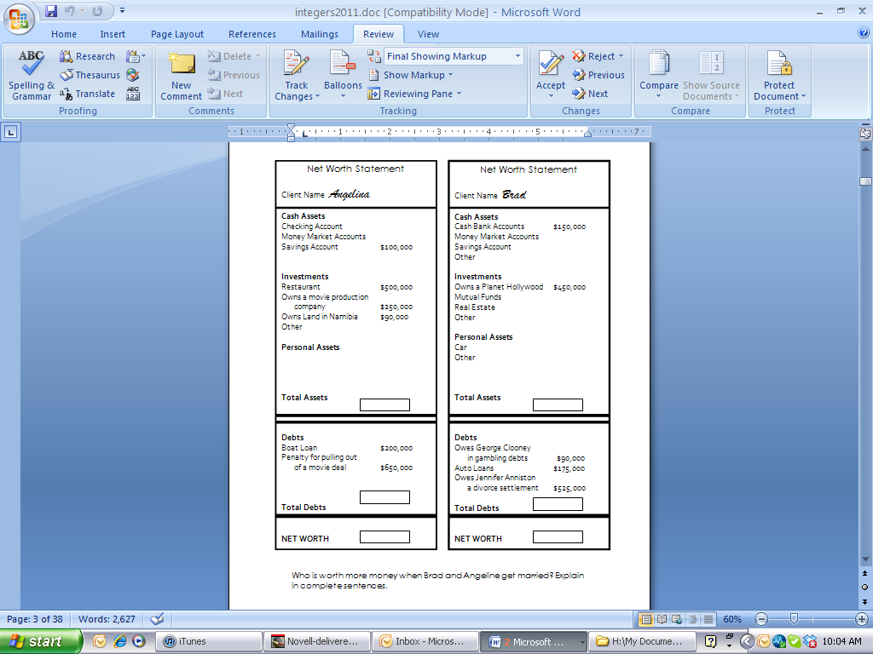

10

5

**Big Mathematical Idea(s):** Negative net worth as debts overwhelming assets; different algorithms for combining assets and debts

**Rationale:** How do students combine assets and debts to determine negative net worth?

**Possible Metaphors/Gestures:** Payoff idea

**Teacher Notes:** Begin with students putting their conclusions on the board (Brad vs. Angelina). Have students defend their position. Students might reject Brad being worth more because, although Angelina has more debt than Brad she also has more assets which, when you combine them, lead to her being worth more. Students might bring in the idea of *payoff* saying that if Angelina pays off all her debts with her assets, she will have more leftover. It is crucial to capitalize on the pay off idea for this and other tasks.

For the discussion about how much Brad is worth, some students might say he is worth *nothing* (because he is in the negative). Watch for that language. Others will counter that and say he is worth less than nothing.

Students will also say Brad is worth -190,000 versus -210,000. What is most important for this discussion is that students know that the amount is negative, not positive. That means they have a sense that when your debt outweighs your assets, your net worth is negative. That is the most crucial idea here, not the correct/incorrect algorithm. The algorithms seen in examples 1 and 2 above are incorrect (#1 does not work for every amount, just problems with certain characteristics). Students who use a correct algorithm (#3) do not have any way to justify it except to draw on previous somewhat meaningless algorithms (“You’re always supposed to put the big number on top). Rather than spend too much time on the correct answer here, move on by saying that it is too difficult right now to determine the right answer, but we are going to work on that in the next couple of days.

**Anticipated Student Thinking:**

Do students put items we consider assets in the debts portion and vice versa?

Do students put matching assets and debts? For example, purchasing a motorcycle gives you a debt of $3000 but also gives you the asset of a $3000 motorcycle.

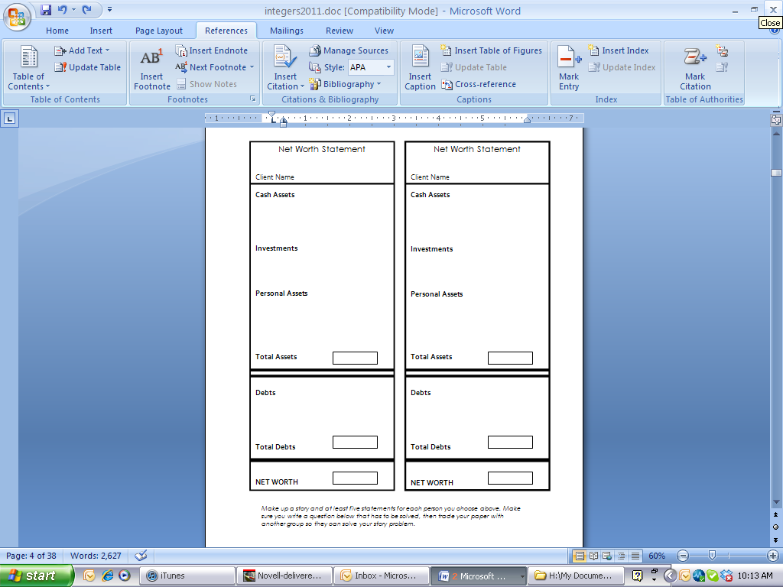

**Big Mathematical Idea(s):** None

**Rationale:** Do students put real-world items in the right category of assets and debts?

**Possible Metaphors/Gestures:**

**Teacher Notes:** This can be done a variety of ways. Individual students can fill these out, leaving the rectangles blank so that other students can solve it. Or small groups can collaborate to create a group paper and let other groups solve theirs.

**Anticipated Student Thinking:**

*Students may agree with Sam because they only find the difference between the total assets and total debts without recognizing that the debts overwhelm assets so Spongebob is a worth -500.*

*Students may agree with Sid.*

*Students may agree with Sue. Sue is right but for the wrong reason. Spongebob does not have more debt than Mr. Krebs ($14,500 versus $15,900).*

*Students may agree with both Sid and Sue because they are not looking at the evidence.*

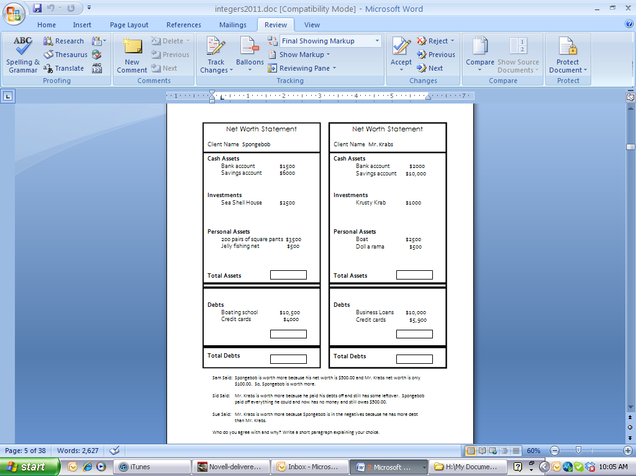

**Big Mathematical Idea(s):** Net worth as an abstract quantity composed of assets and debts

**Rationale:** Do students make net worth judgments based only upon total assets or total debts rather than net worth?

**Possible Metaphors/Gestures:** Pay off; up and down movement of arms

**Teacher Notes:**

You might begin this discussion by putting all three names up on the board (Sam, Sid, Sue) and getting tally marks for those who agree with each person. Then, begin by asking a student who has chosen a person from the least number of tally marks to given their reasoning. Remember that the big idea here is that the net worth is composed of both assets and debts and decisions of worth cannot be made by looking at debts or assets alone. In addition, if students are using the term “payoff”, have them contribute to the discussion to promote that imagery.

**Anticipated Student Thinking:**

Students may invent different strategies for finding net worths on this problem.

1. Some students may start from the first number (1000) and subtract 15,000 to get (-14,000), then “subtract” another 45,000 to get -59,000 and then “add” 60,000 to get 1000.We can call that a linear method because it is one after the other in line.
2. Some students may collect all assets together to find total assets (61,000), collect all debts together to get total debts (70,000), and find the difference.
3. Some students may “cancel out” opposites like +60,000 and -15,000 & -45,000 combined. Left with 1000.

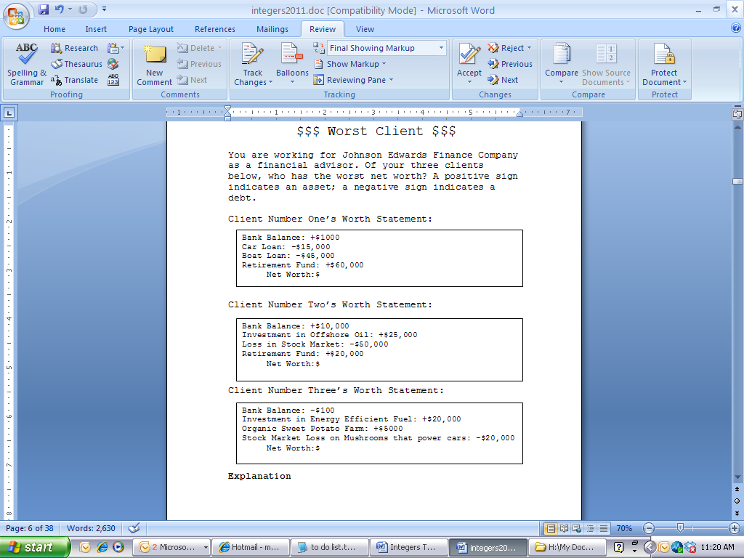

**Big Mathematical Idea(s):** Students’ strategies for finding net worth

**Rationale:** Movement towards more abstract symbols of + and –

**Possible Metaphors/Gestures:**

**Teacher Notes:** Begin by having students offer which person they chose as having the worst net worth. Have students then defend their choices. Most will pick Client One, so start there. Ask someone to present their strategy for finding net worth of Client One. Ask anyone if they had a different way. Ask until all three ways (and others??) are on the board. Save the Cancel Out method until the end since it will be new for most students! Have students name it and post it on the word wall. Later you can define it as additive inverses.

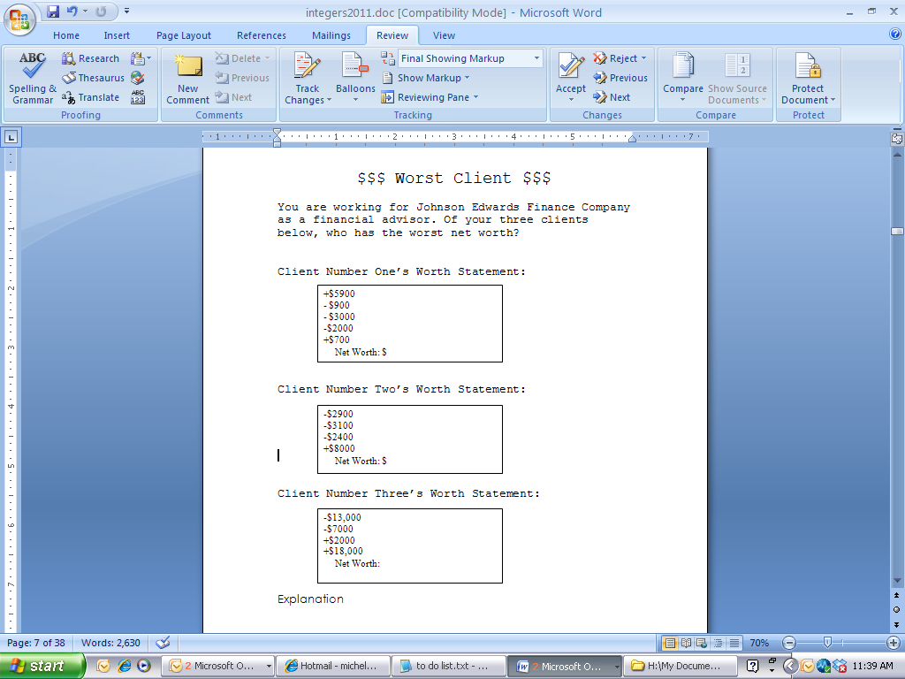

**Anticipated Student Thinking:**

Students may use the “linear method”, total assets/total debts method or cancellation method to obtain the net worths of the clients.

Students may argue that Client number 3 is the worst because they are worth nothing. Other students might counter that Client 2 is the worst because she is worth less than nothing.

**Big Mathematical Idea(s):** Students’ strategies for finding net worth; negative net worth as debts overwhelming assets

**Rationale:** Which is worse, 0 or negative net worth?

**Possible Metaphors/Gestures:** pay off

**Teacher Notes:** Find out which clients are viewed as the worst in terms of net worth by getting tally marks on the board. Get the correct net worth values on the board for each Client by asking a student for the answer and explanation. Make sure that all students agree with the answers before moving on. Once all three correct net worths are filled in on the board, ask students to defend their choice. Some may argue for Client 3 versus Client 2.

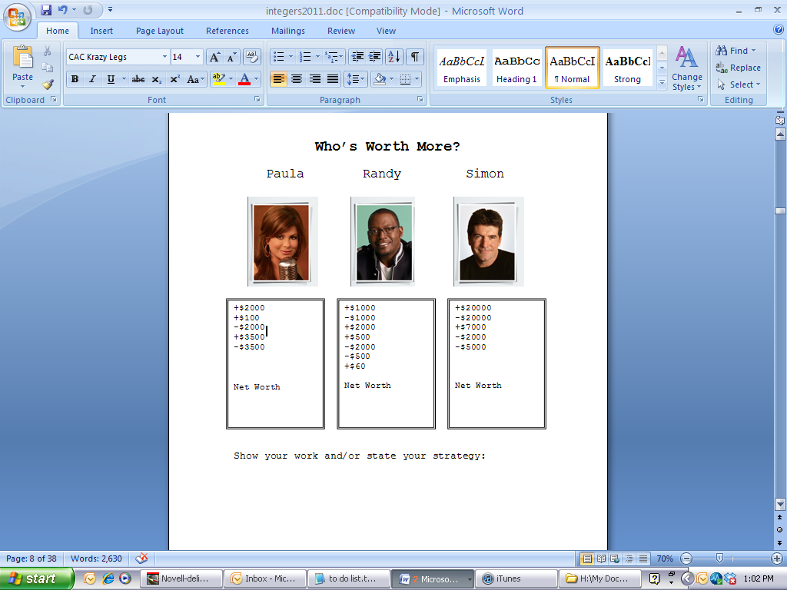

**Anticipated Student Thinking:**

Students may use the “linear method”, total assets/total debts method or cancellation method to obtain the net worths of the clients.

**Big Mathematical Idea(s):** Finding net worth

**Rationale:** The numbers are arranged to attract students to use the cancellation method or invent it if it hasn’t arisen in class yet.

**Possible vocabulary:** Additive inverse

**Possible Metaphors/Gestures:** payoff; cancelling

**Teacher Notes:** Ask students which person is worth the most and then have them defend by showing their strategies. Ask who has the quickest way to calculate net worth and call on someone with the cancellation method.

**Anticipated Student Thinking:**

Students might say $5000 because they add the two amounts together.

Students might say $1000 because they do the traditional algorithm 3000-2000.

Students might say -$5000 because they are thinking about how much money Mary Ann needs to catch up to Gilligan.

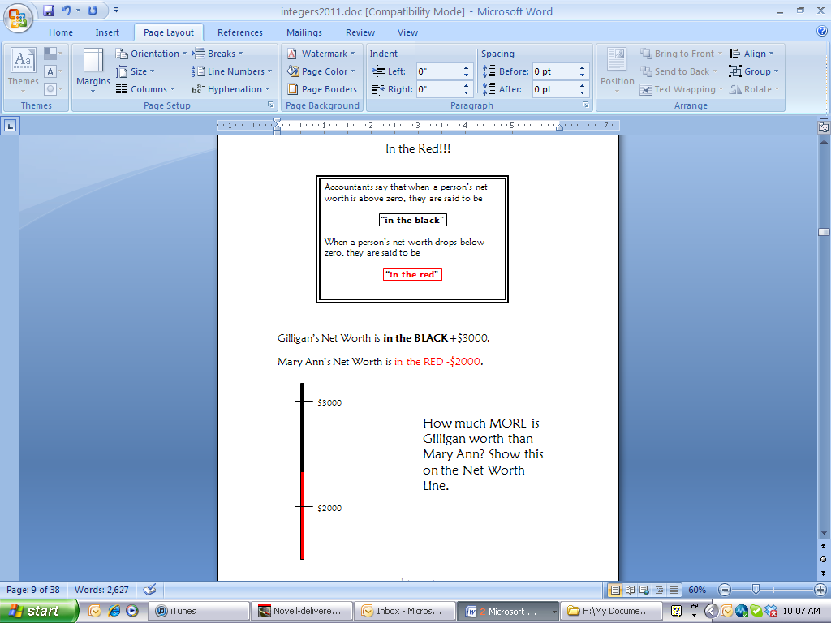

**Big Mathematical Idea(s):** Comparing net worth (no longer finding it); strategies for finding difference

**Rationale:** How do students structure the space between two integers? Introduction of vertical number line (VNL)

**Possible Metaphors/Gestures:** Payoff idea; Up and down movement with arms

**Teacher Notes:** Ask students to put their answers on the board. Get a variety of answers up there. Ask students with $1000 to go first and justify their answer. This should begin a debate, especially when you ask who agrees. Notate students’ thinking on the VNL by drawing:



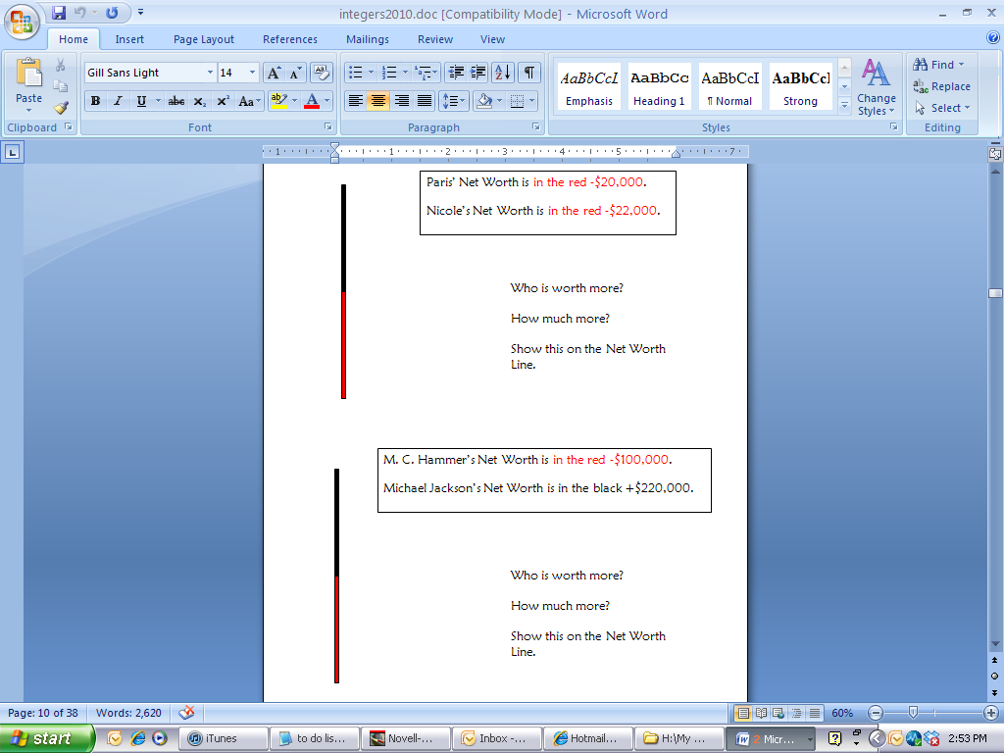

**Anticipated Student Thinking:**

Students might begin Paris/Nicole by placing 22,000 at the top of the black line and 22,000 at the bottom of the red.

Other students might place both numbers in the red but 22,000 above 20,000.

Others might correctly place 22,000 below 20,000 in the red.

Answers are typically $2000.

**Big Mathematical Idea(s):** Comparing net worth (no longer finding it); strategies for finding difference; order of integers

**Rationale:** How do students structure the space between two integers?

**Possible Metaphors/Gestures:** Payoff idea; Up and down movement with arms; In the hole, In the red, A reflection line

**Teacher Notes:** Begin with students who solve this problem by placing 22,000 at the top of the black line and 20,000 at the bottom. Ask students to analyze this picture and make comments. Ask students who placed 22,000 above 20,000 (yet both in the red) to go next and discuss this. Students’ metaphors might come out very strongly here like 22,000 is below 20,000 because she is more “in the hole”, more “in the red”, more “in debt”. It’s like a reflection line across 0; just fold it up.

**Anticipated Student Thinking:**

Students may misplace/misorder numbers on the number line.

Students may not use the VNLs and mentally structure the space between two numbers both correctly and incorrectly.

Students may invent a conjecture about a strategy for solving the difference between two integers (when both numbers are same sign/in the same color, you just subtract; when the two numbers are in different colored regions/different sign, you add the two)

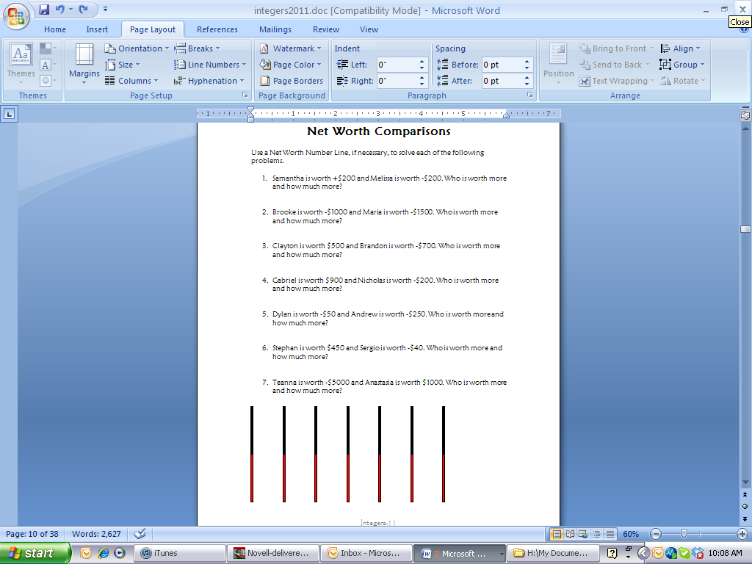

**Big Mathematical Idea(s):** Comparing net worth; strategies for finding difference; order of integers; possible conjectures

**Rationale:** How do students structure the space between two integers?

**Possible Metaphors/Gestures:** Payoff idea; Up and down movement with arms

**Teacher Notes:** As students are finishing their exploration time, have 7 students come to the board and symbolize their solutions on the number lines. Pick students who have right and wrong answers, particularly wrong ones that did not utilize the VNL. When exploration time is complete, have the students defend their board work.

After discussion and verification by students, if a student hasn’t already announced that they have a conjecture, call on someone you noticed created a conjecture. If no one did, ask if anyone has noticed a pattern to the way these problems are solved…do you think this will always work?

**Anticipated Student Thinking:**

Students might say that this task is impossible. Since the debts and assets are covered, they are unable to calculate total assets and total debts.

Some students try to guess the total assets and total debts amounts so that they can make some calculations.

Some students will say that the new net worth is -$18,000 because losing an asset makes your net worth go down $8000.

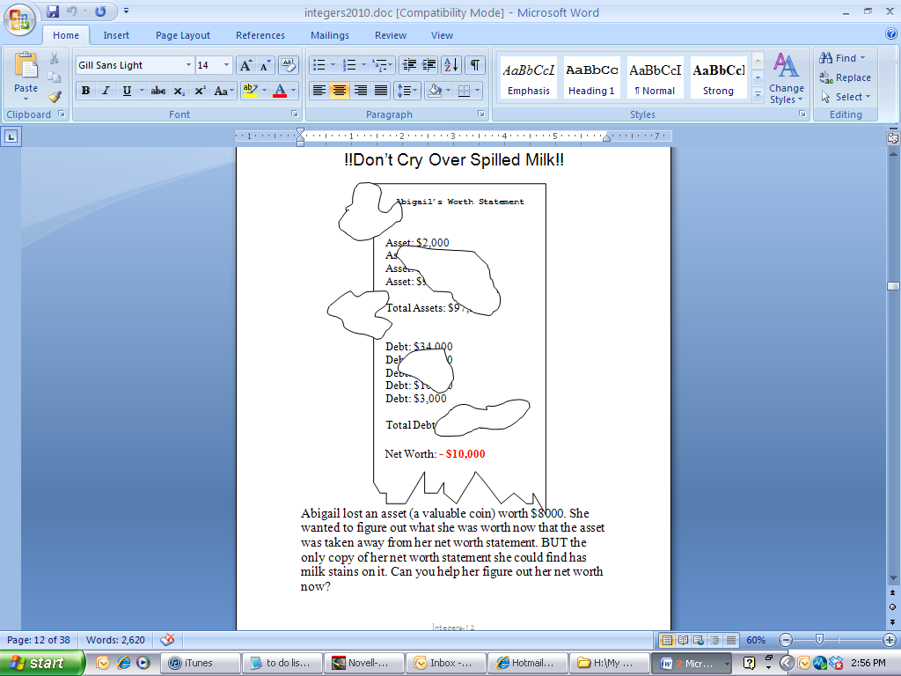

**Big Mathematical Idea(s):** Net worth as an object that can be changed

**Rationale:** Introduction of transaction idea; pre-assessment of transactions

**Possible Metaphors:**

**Teacher Notes:** This activity is given primarily as an assessment to see if students have “objectified” net worth and can take it for granted that it is the combination of assets and debts. One doesn’t need to know the actual asset and debt amounts to know that the net worth can go up or down if something happens to an asset or debt. Have students who think this task is impossible share their reasoning. Other students can contribute. The teacher can have a copy of Abigail’s unstained net worth template (having $8000 as an asset) as a reference device during this discussion.

**!!??Good or Bad Decision??!!**

***Which of the following students made bad decisions about their finances?***

**Ann**: She took away an asset of (+$200) from her net worth statement

**Bradley**: He added an asset of (+$3000) to his net worth statement

**Christian**: He took away an asset of (+$50) from his net worth statement

**Devon**: He added a debt of (-$650) to his net worth statement

**Ernie**: He took away a debt of (-$5400) from his net worth statement

**Fran**: She took away an asset of (+$201) from her net worth statement

**Gracie**: She added a debt of (-$67) to her net worth statement

**Herbert**: He took away an asset of (+$450) from his net worth statement

**Anticipated Student Thinking:**

Students generally have no difficulty with these problems.

Many students will say that Ernie made a bad decision because anything involving a debt is bad.

**Big Mathematical Idea(s):** The effect that transactions have on net worth

**Rationale:** Making meaning for transactions and then writing them in symbols

**Possible Metaphors:**

**Teacher Notes:** Ask students to decide which decisions are good or bad. Also, define these decisions as transactions (an event that occurs and changes your net worth, like Abigail losing her $8000 ring). After students agree with all of these transactions (especially Ernie’s), show students the way that mathematicians symbolize them. For example, you might say that mathematicians write Ann’s transaction as –(+200), with the first sign signaling an action “take away” or “add”. Then, the put the asset or debt in parentheses with a sign that signals whether it is an asset (+) or a debt (-). Show them also how to write Bradley’s +(+3000). If you decide it is needed, you can show them one or two more. Then, ask them to write the remaining students’ transactions the way mathematicians would. Discussion their solutions.

**Anticipated Student Thinking:**

Students will write +(+7500) for India but be confused about Jackie’s. There are multiple ways that students might symbolize Jackie’s and others like his.

+(+6000) +(+6000)

+(+12,000)

+(12,000)

+2(+6000)

Natalie’s might prompt students to create more efficient ways of symbolizing because they don’t want to write out 20 transactions of –(-20)

**!!??Good or Bad Decision??!!**

***Which of the following students made bad decisions about their finances?***

**India**: She took away an asset of (+$7500) from her net worth statement

**Jackie**: He added two assets of (+$6000) to his net worth statement

**Kathy**: She took away six assets of (+$50) from her net worth statement

**Levon**: He added four debts of (-$650) to his net worth statement

**Miguel**: He took away a debt of (-$530) from his net worth statement

**Natalie**: She took away 20 debts of (-$20) from her net worth statement

**Oscar**: He added 17 debts of (-$70) to his net worth statement

**Penelope**: She took away an asset of (+$4530) from her net worth statement

**Big Mathematical Idea(s):** The effect that transactions have on net worth

**Rationale:** Making meaning for transactions and then writing them in symbols; introduce multiplication (sets of debts)

**Possible Metaphors:**

**Teacher Notes:** Ask students to decide whether these are good or bad transactions and to try to write them the way mathematicians would. During explore time, look for the different ways that students write the “multiple” transactions (e.g., Oscar +17(-70) or +(-70)+(-70)+(-70) 17 times or +(-1190)). Have discussions about how each of these is all the same as each other, but mathematicians generally use the first and third way as efficient symbolizing. If all you get is the second strategy, you might ask who has a more efficient way to write this.

If you get the symbols with only one sign, ask students to decide for which problems is it acceptable to leave the sign off and which ones change the meaning.

**Anticipated Student Thinking:**

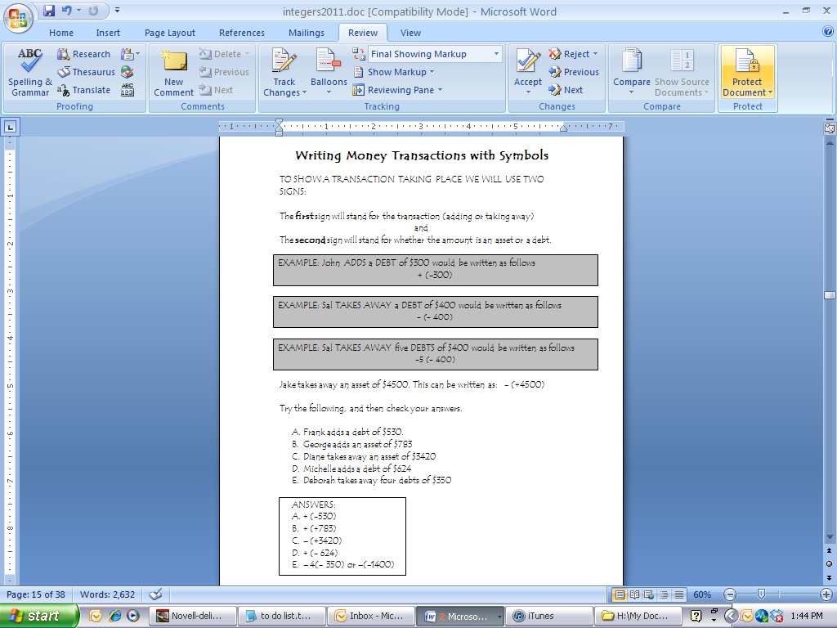

**Big Mathematical Idea(s):** the effect that transactions have on net worth

**Rationale:** Making meaning for transactions and then writing them in symbols

**Possible Metaphors:**

**Teacher Notes:** Tell students that this page is like a typical textbook page. If they forget what the symbols mean, they can always come back to this page to try to understand. Have the students read through it until it says “Try the following.” Have them cover up the answers and attempt A-E and then check their answers.

Using the words ADD, TAKE AWAY, DEBT and ASSET, describe each transaction below:

1. – (+300)
2. + (-340)
3. + (+534)
4. + 7(342)
5. – (-7344)
6. –3 (+1200)
7. –19 (890)
8. + (- 6832)
9. – 12(- 566)
10. – 1

**Anticipated Student Thinking:**

Students may interpret multiplication problems as the following:

#4 adding $7 asset and a $342 asset

These students do not recognize the 7 as a multiplier instead of an asset

Students may not know how to write a transaction in words for those that are not written with two signs (e.g., #10)

**Big Mathematical Idea(s):** Making meaning out of transactions (multiplication); what effect do transactions have on net worth

**Rationale:** Students had been writing the symbols for transactions, now they go backwards: given the symbol what is the meaning of the transaction; efficiency of writing symbols; possible conjecture

**Possible Metaphors:**

**Teacher Notes:** During explore time, roam the room to see which problems students have the most difficulty with. Encourage students to persevere even if they do not have a way. Do not tell them how to write the problems. In whole class discussion, begin with an easy problem, like #1 just to make certain everyone is on the same page. Then, ask students which ones they had difficulty with and begin having students debate their answers. Discuss the entire page and get the answers on the board for everyone to copy down. If time, go back to number 6 and ask if there is a quicker way to write this answer with less numbers and signs. This can begin the conversation that will be on the next page.

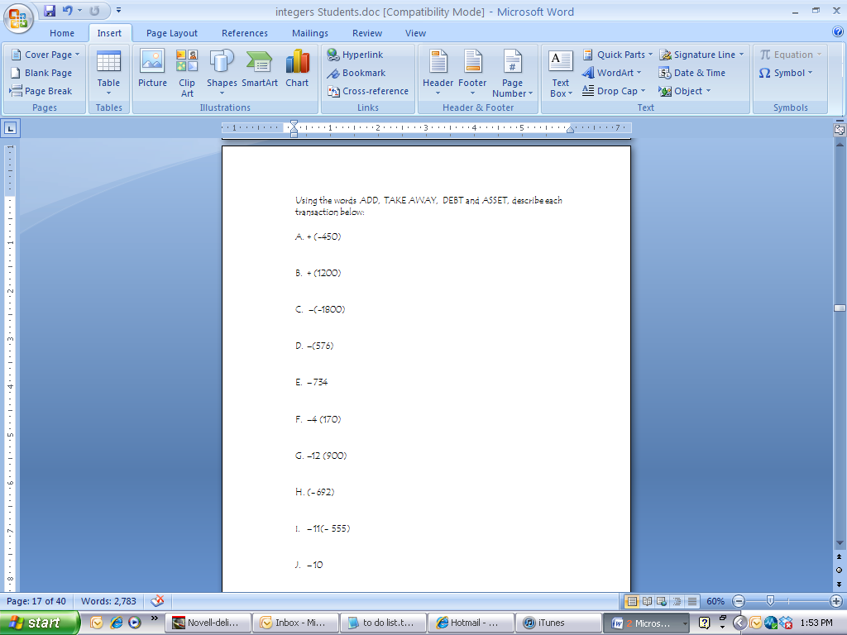

**Anticipated Student Thinking:**

Students may interpret multiplication problems as the following:

#4 adding $7 asset and a $342 asset

These students do not recognize the 7 as a multiplier instead of an asset

Students may not know how to write a transaction in words for those that are not written with two signs (e.g., #10)

**Big Mathematical Idea(s):** Making meaning out of transactions (multiplication); what effect do transactions have on net worth; how to make sense of an expression containing less than two signs.

**Rationale:** Students had been writing the symbols for transactions, now they go backwards: given the symbol what is the meaning of the transaction; efficiency of writing symbols; possible conjecture

**Possible Metaphors:**

**Teacher Notes:** During explore time, roam the room to see which problems students have the most difficulty with. Encourage students to persevere even if they do not have a way. Do not tell them how to write the problems. In whole class discussion, begin with an easy problem, like #1 just to make certain everyone is on the same page. Then, ask students which ones they had difficulty with and begin having students debate their answers. Discuss the entire page and get the answers on the board for everyone to copy down. If time, go back to number 6 and ask if there is a quicker way to write this answer with less numbers and signs. This can begin the conversation that will be on the next page.

Rewrite the following transactions in its simplest form (e.g., one sign and one number if possible):

* 1. – (+700)
  2. + (-360)
  3. - 2(+600)
  4. +5 (300)
  5. –4 (-7000)
  6. – 2(+1200)
  7. – 1(890)
  8. + (- 6800)
  9. – 3(- 400)
  10. – (-1)

**Anticipated Student Thinking:**

Some students may write an up or down arrow as their sign. Do not discourage this:

E.g., -(+700) = 700

Others may write -700 or down 700

Students might continue to misinterpret the multiplier as a debt or asset

Some students might struggle with something like number 7 which only uses one sign.

**Big Mathematical Idea(s):** Making meaning out of transactions (multiplication)

**Rationale:** what effect do transactions have on net worth; efficiency of writing symbols; possible conjecture

**Possible Metaphors:**

**Teacher Notes:** In your class discussion of the answers, someone may offer a conjecture that resembles the rules for multiplication, if it hasn’t come up already. Students may notice that opposite signs always make your net worth go down and same signs make it go up. Capitalize on this conjecture by posting it around the room.

For those students who used arrows, encourage them during whole class discussion to use the mathematically adopted signs.

Another name for transactions is “multiplication.” For the problems below, multiply (rewrite the following transactions in its simplest form):

1. +(+200)
2. +20 (-40)
3. - (+574)
4. - (382)
5. – 6(-12)
6. – 2(+1200)
7. – (90)
8. + 3(-62)
9. – 2(- 550)
10. – 4(-4)

**Anticipated Student Thinking:**

Some students may write an up or down arrow as their sign. Encourage them to write it with both arrows and signs.

E.g., -(+574) =  574 and -574

Students might write 574 without any sign.

Students might continue to misinterpret the multiplier as a debt or asset

**Big Mathematical Idea(s):** Making meaning out of transactions (multiplication)

**Rationale:** What effect do transactions have on net worth; efficiency of writing symbols; possible conjecture

**Possible Metaphors:**

**Teacher Notes:** In your class discussion of the answers, some students may still have difficulty interpreting the number in front of the parenthesis as a multiplier. Ask students to help them understand this issue. You might also let students know that they are performing integer multiplication when they write the results of a transaction with one sign and one number.

**Anticipated Student Thinking:**

Students may find the net worth by adding all assets, adding all debts and finding the difference.

Students may go one at a time through the list, e.g., 200 + 145 is 345. Then 345 – 200 is 145, etc.

Some students might notice numbers that are additive inverses of each other and cancel them with each other.

For #2 most students will have no difficulty noticing that this transaction will be good for the net worth.

#3 may find students actually putting a $500 asset on James’ worth statement next to #8 and recalculating (!) net worth all over again.

Some students may be able to take the net worth they found in #1 and just add $500 to it without recalculating anything (e.g., $795 + $500 = $1295).

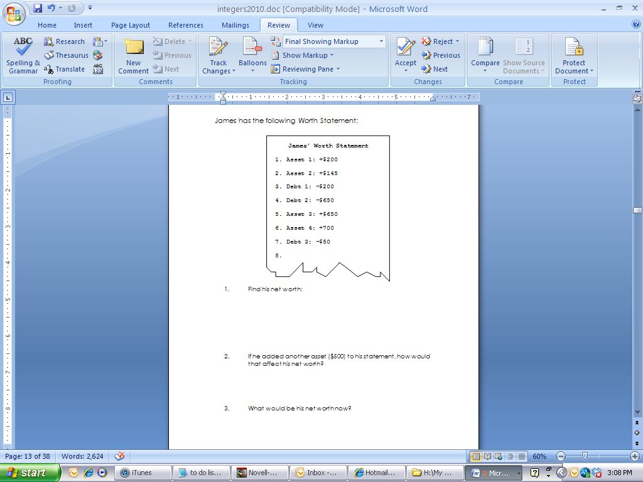

**Big Mathematical Idea(s):** The effect oftransactions on net worth

**Rationale:** How do students think about the result of a transaction on a net worth?

**Possible Metaphors/gesture:** pay off/up and down arm movements

**Teacher Notes:** Begin this conversation by asking students what they got for number one. Ask students who have gotten an incorrect answer to work with their partners for 2 minutes to fix number one. The big idea is no longer about how to find net worth; it is about finding a new net worth once a transaction occurs, so do not focus class time on number one.

Ask students what their thinking to number two is.

Ask students who solved it the long way (recalculating net worth) to share their thinking first. Since it takes a while to refigure the answer, ask the class who has a quicker or more efficient way. Some might share that they did the cancellation method, which is quicker. Really highlight those students who merely took 795 and added 500. Some students might question why that works; so look for those students and let others justify the method.

**Anticipated Student Thinking:**

Students may find the net worth by adding all assets, adding all debts and finding the difference.

Students may go one at a time through the list

Some students might notice numbers that are additive inverses of each other and cancel them with each other.

For #2 some students will have no difficulty noticing that this transaction will be good for the net worth; some students will.

#3 may find students actually putting a $650 debt on Frank’s worth statement recalculating (!) net worth all over again. Some may actually cross the 650 debt off the statement and recalculate.

Some students may be able to take the net worth they found in #1 and just add $650 to it without recalculating anything (e.g., $1000 + $650 = $1650).

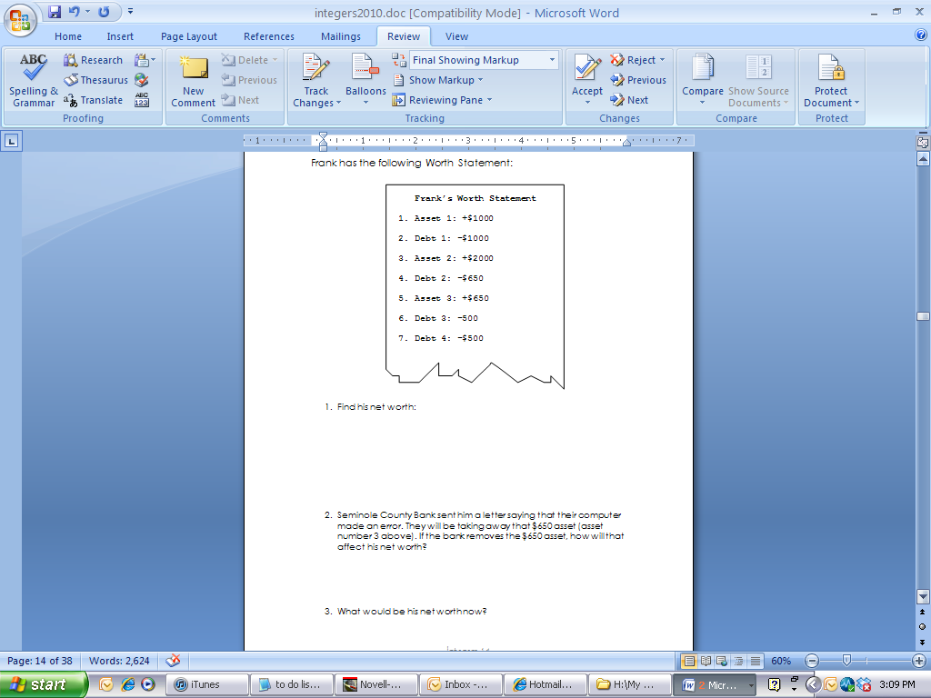

**Big Mathematical Idea(s):** The effect oftransactions on net worth

**Rationale:** How do students think about the result of a transaction on a net worth?

**Possible Metaphors/gesture:** pay off/up and down arm movements

**Teacher Notes:** Begin this conversation by asking students what they got for number one. Ask students who have gotten an incorrect answer to work with their partners for 2 minutes to fix number one.

Ask students what their thinking to number two is. This might generate some discussion with some people saying that since it is a take away, her net worth would go down.

Ask students who solved it the long way (recalculating net worth) to share their thinking first. Since it takes a while to refigure the answer, ask the class who has a quicker or more efficient way. Some might share that they did the cancellation method, which is quicker. Really highlight those students who merely took 1000 and added 650. Some students might question why that works; so look for those students and let others justify the method.

**Anticipated Student Thinking:**

Students may find the net worth by adding all assets, adding all debts and finding the difference.

Students may go one at a time through the list

Some students might notice numbers that are additive inverses of each other and cancel them with each other.

For #2 some students will have no difficulty noticing that this transaction will be good for the net worth; some students will.

#3 may find students actually putting a $3000 debt on Kim’s worth statement recalculating (!) net worth all over again. Some may actually cross the 3000 debt off the statement and recalculate.

Some students may be able to take the net worth they found in #1 and just add $650 to it without recalculating anything (e.g., -$500 + $3000 = $2500).

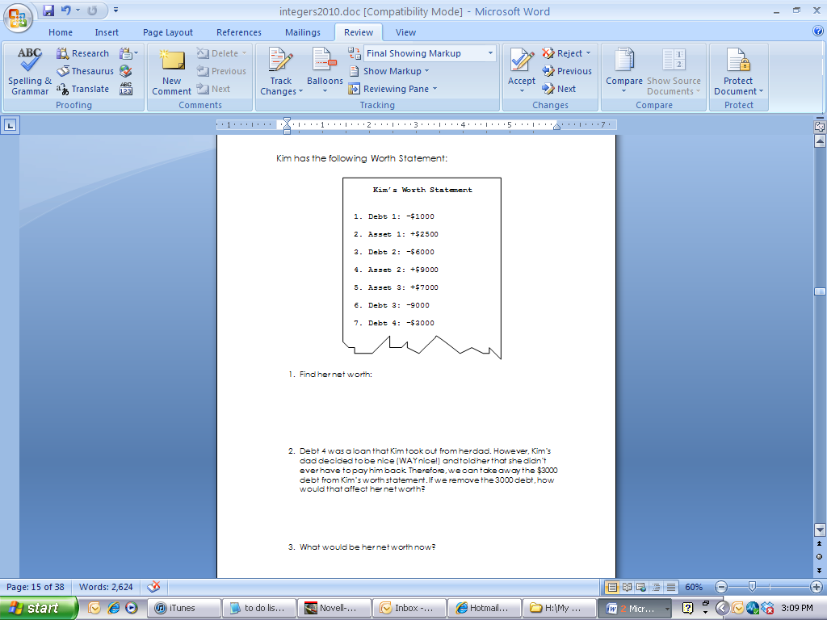

**Big Mathematical Idea(s):** The effect oftransactions on net worth

**Rationale:** How do students think about the result of a transaction on a net worth?

**Possible Metaphors/gesture:** pay off/up and down arm movements

**Teacher Notes:** Begin this conversation by asking students what they got for number one. Ask students who have gotten an incorrect answer to work with their partners for 2 minutes to fix number one.

Ask students what their thinking to number two is. This might generate some discussion with some people saying that since it is a take away, her net worth would go down.

Ask students who solved it the long way (recalculating net worth) to share their answer first (don’t focus on this long as you want to encourage students to move to more efficient ways). Some might share that they did the cancellation method. Really highlight those students who took -500 and added 3000. Some students might get 3500 and others might get 2500. Ask students to use a VNL to prove which solution is correct.

Transaction

-(-2000)

Transaction

+(-1000)

Transaction

-(+1000)

Transaction

+(-4000)

Transaction

-(+4000)

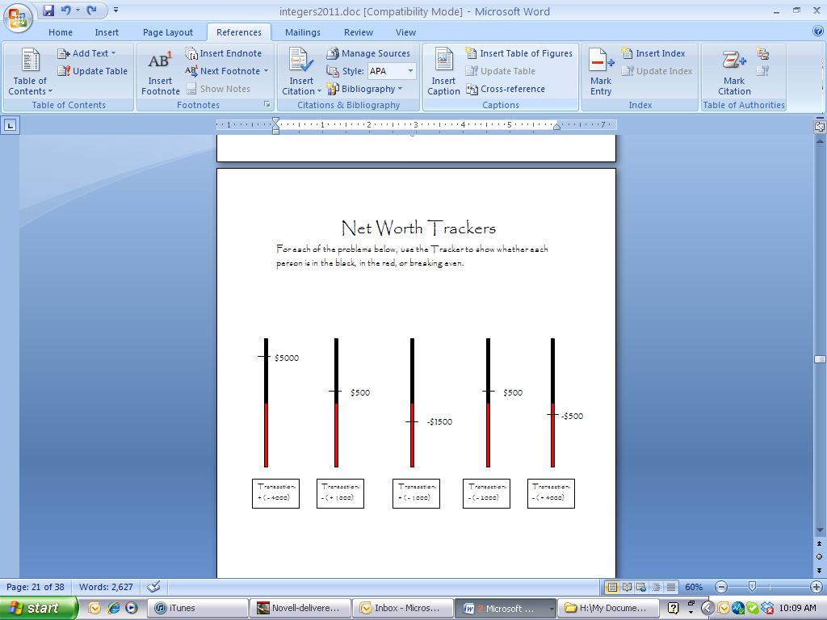

**Big Mathematical Idea(s):** Structuring the integer space with transactions

**Rationale:** How do you use a VNL to help structure transactions

**Possible Metaphors/gesture:** pay off/up and down arm movements

**Teacher Notes:** You might begin the class by showing students a VNL with the net worth of $5000 notated on it. Then, ask students what would happen if the person spent $1000. Students will most likely say his net worth would now be $4000. You can notate this on the number line with a vertical downward jump. Tell students that the problems we are going to solve today involve starting with a net worth on the number line, some type of transaction occurs, and they are to figure out the new net worth by showing their jumps on the number line.

Whole class discussion should focus on students’ answers and strategies for finding new net worths. One way of doing this is that, as students complete their answers, have them put their VNL on the board. If you notice two different answers for the same problem, have those students put their VNLs on the board side by side for students to analyze.

**Anticipated Student Thinking:**

Students may only use addition or subtraction without the number line. If so, they may get incorrect answers.

Many students will go through zero and reference paying off as their rationale. Some students may travel the incorrect way (up when it’s down).

Encourage students to record their work on the number line, especially if they’re getting answers that are different than partners.

Transaction

-(+2000)

Transaction

-(-500)

Transaction

+(-7000)

Transaction

-(-6000)

Transaction

+(+1000)

**Anticipated Student Thinking:**

Students may only use addition or subtraction without the number line. If so, they may get incorrect answers.

Many students will go through zero and reference paying off as their rationale. Some students may travel the incorrect way (up when it’s down).

Encourage students to record their work on the number line, especially if they’re getting answers that are different than partners.

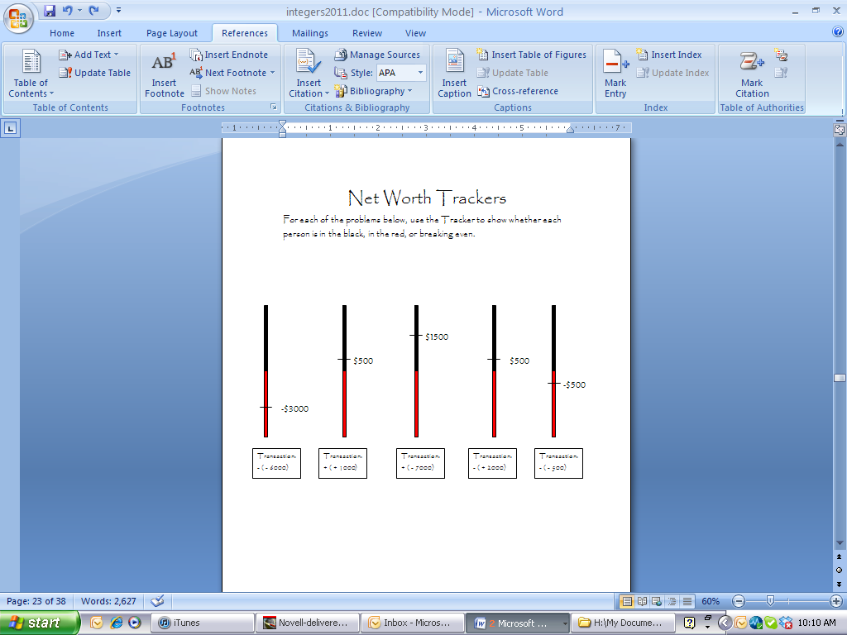

**Big Mathematical Idea(s):** Structuring the integer space with transactions

**Rationale:** How do you use a VNL to help structure transactions

**Possible Metaphors/gesture:** pay off/up and down arm movements

**Teacher Notes:** Whole class discussion should focus on students’ answers and strategies for finding new net worths. One way of doing this is that, as students complete their answers, have them put their VNL on the board. If you notice two different answers for the same problem, have those students put their VNLs on the board side by side for students to analyze.

**Anticipated Student Thinking:**

Students may record their thinking incorrectly or go up when they are supposed to go down.

Students who use a number line will probably go through zero when the opportunity arises.

Some students will make silly mistakes by overlooking the negative sign on the original net worth.

Nancy has a net worth of $5000! A debt of $3000 is TAKEN AWAY. Is this good or bad? What is her net worth now! Draw your own Net Worth Trackers to help you figure these out, if you need them.

* 1. Donald has a net worth of -$5000! A debt of $3000 is TAKEN AWAY. Is this good or bad? What is his net worth now!
  2. Meagan has a net worth of -$4300! A debt of $3000 is ADDED. Is this good or bad? What is her net worth now?
  3. Melanie has a net worth of +$600! A debt of $1000 is ADDED. Is this good or bad? What is her net worth now!
  4. Todd has a net worth of +$10,000! An asset of $3000 is ADDED. Is this good or bad? What is his net worth now!
  5. Monica has a net worth of -$7400! An asset of $3000 is TAKEN AWAY. Is this good or bad? What is her net worth now!
  6. Andrea has a net worth of +$2200! A debt of $3000 is ADDED. Is this good or bad? What is her net worth now!

**Big Mathematical Idea(s):** Structuring the integer space with transactions

**Rationale:** How do you use a VNL to help structure transactions; word problems

**Possible Metaphors/gesture:** pay off/up and down arm movements

**Teacher Notes:** Whole class discussion should focus on students’ answers and strategies for finding new net worths. One way of doing this is that, as students complete their answers, have them put their VNL on the board. If you notice two different answers for the same problem, have those students put their VNLs on the board side by side for students to analyze.

After each question is verified, you might ask students to write the entire number sentence. For example, problem a can be written as -5000-(-3000)=-2000.

**Anticipated Student Thinking:**

Other than silly errors, students may not write number sentences correctly.

Encourage students to use a VNL when they are stuck or have a different answer than other students.

Write number sentences for the following changes that occur to Alice’s net worth (Use a net worth tracker if you need to):

1. Net Worth: $1500

Transaction: Adds a debt of $600

1. Net Worth: $600

Transaction: Adds a debt of $1100

1. Net Worth: - $400

Transaction: Adds a debt of $450

1. Net Worth: - $550

Transaction: Adds an asset of $1900

1. Net Worth: $1250

Transaction: Adds an asset of $350

1. Net Worth: $1600

Transaction: Adds a debt of $400

1. Net Worth: $800

Transaction: Takes away a debt of $200

Write number sentences for the following changes that occur to Alice’s net worth (Use a net worth tracker if you need to):

1. Net Worth: - $2000

Transaction: Adds an asset of $600

1. Net Worth: - $1800

Transaction: Adds a debt of $1200

1. Net Worth: - $2600

Transaction: Takes away a debt of $300

1. Net Worth: - $2000

Transaction: Takes away a debt of $500

**Big Mathematical Idea(s):** Structuring the integer space with transactions

**Rationale:** How do you use a VNL to help structure transactions; transition of symbolizing

**Possible Metaphors/gesture:** pay off/up and down arm movements

**Teacher Notes:** Whole class discussion should focus on students’ answers and strategies for finding new net worths. One way of doing this is that, as students complete their answers, have them put their VNL on the board. If you notice two different answers for the same problem, have those students put their VNLs on the board side by side for students to analyze. Have students analyze the solutions and number sentences to verify them for correctness.

**Anticipated Student Thinking:**

Other than silly errors, students may not write number sentences correctly.

Encourage students to use a VNL when they are stuck or have a different answer than other students.

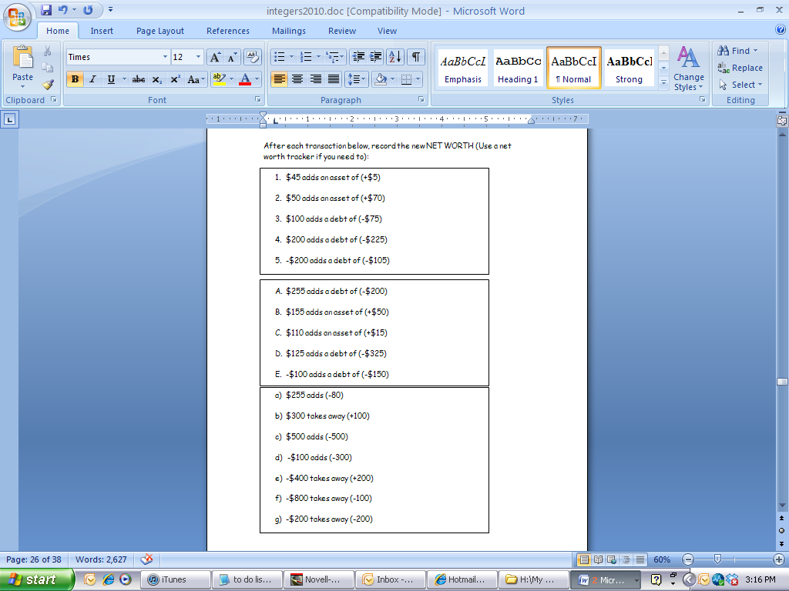

**Big Mathematical Idea(s):** Structuring the integer space with transactions

**Rationale:** How do you use a VNL to help structure transactions

**Possible Metaphors/gesture:** pay off/up and down arm movements

**Teacher Notes:** Whole class discussion should focus on students’ answers and strategies for finding new net worths. One way of doing this is that, as students complete their answers, have them put their VNL on the board. If you notice two different answers for the same problem, have those students put their VNLs on the board side by side for students to analyze.

After each question is verified, you might ask students to write the entire number sentence. For example, problem 1 can be written as 45 + (+5) = 50.

**Anticipated Student Thinking:**

Other than silly errors, students may not write number sentences correctly.

Encourage students to use a VNL when they are stuck or have a different answer than other students.

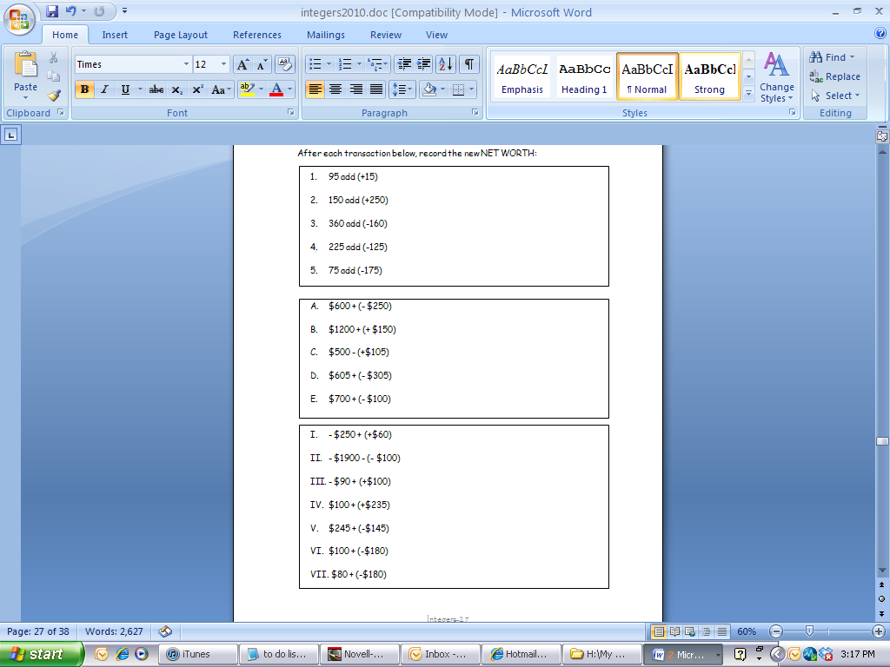

**Big Mathematical Idea(s):** Structuring the integer space with transactions

**Rationale:** How do you use a VNL to help structure transactions; transition of symbolizing

**Possible Metaphors/gesture:** pay off/up and down arm movements

**Teacher Notes:** Whole class discussion should focus on students’ answers and strategies for finding new net worths. One way of doing this is that, as students complete their answers, have them put their VNL on the board. If you notice two different answers for the same problem, have those students put their VNLs on the board side by side for students to analyze.

After each question is verified, you might ask students to write the entire number sentence. For example, problem 1 can be written as 95 + (+15) = 110.

**Anticipated Student Thinking:**

Some students may say adding a debt of 3000 and taking away an asset of 3000. Encourage them to write the transaction in symbols.

Some students might put - (-3000)

Some students might get creative and write more than one transaction: +(-1000) +(-2000) OR   
+(-1000)+-(1000)+(-1000)

Various other multiple transactions

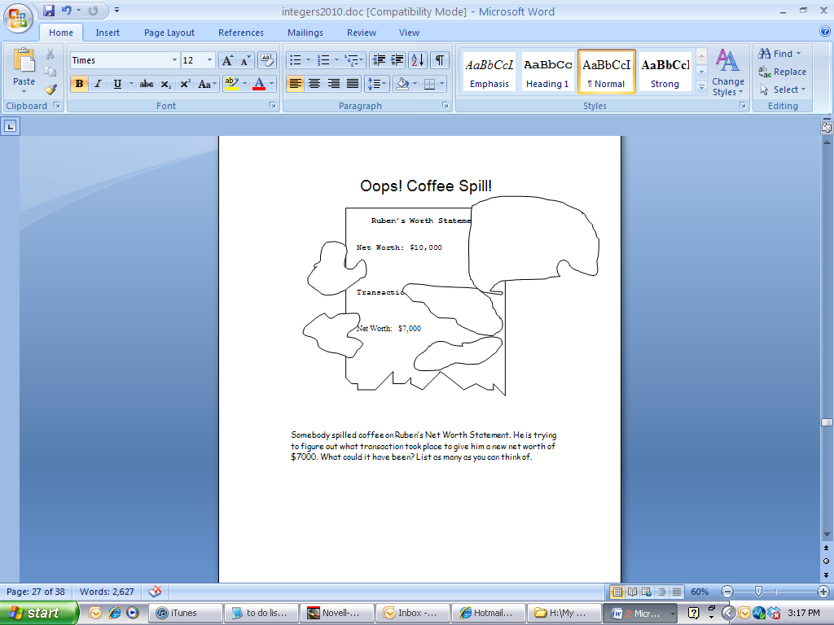

**Big Mathematical Idea(s):** structuring the space of possible transactions

**Rationale:** Missing addend/subtrahend tasks

**Possible Metaphors:**

**Teacher Notes:** When you launch this task tell students that you will be looking for some interesting transactions so that it might spur students to go beyond single transactions. While walking around, look for those that involve multiple transactions. As you see some interesting ones, ask students to put them on the board. Make sure that the simplest ones are on the board as well as those that can be re-written in multiplication symbols (like, +(-1000) +(-1000) +(-1000) can be rewritten as +3(-1000). For whole class discussion, begin with the simplest transactions, both correct and incorrect. If no one offers -(-3000), offer it as the teacher and see if it is rejected. Then, ask students to meet with their small groups to analyze all the remaining answers and list on their papers which ones are valid. Tell them to be prepared to justify their choices. When students are done working with small groups, poll students and the answers that most questioned can be targeted first. There is no need to defend every one unless students ask for it. If someone came up with a solution that can be rewritten multiplicatively, do so.

**Anticipated Student Thinking:**

Some students may say adding an asset of 2000 and taking away a debt of 2000. Encourage them to write the transaction in symbols.

Some students might put - (+2000)

Various other multiple transactions

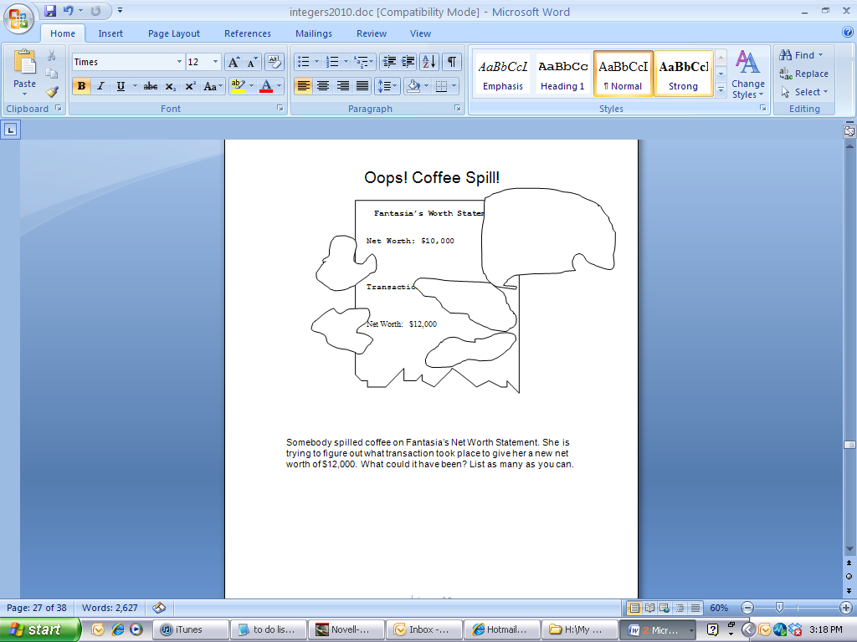

**Big Mathematical Idea(s):** structuring the space of possible transactions

**Rationale:** Missing addend/subtrahend tasks

**Possible Metaphors:**

**Teacher Notes:** While walking around, look for those that involve multiple transactions. As you see some interesting ones, ask students to put them on the board. For whole class discussion, begin with the simplest transactions, both correct and incorrect. If no one offers -(+2000), offer it as the teacher and see if it is rejected. Then, ask students to meet with their small groups to analyze all the remaining answers and list on their papers which ones are valid. Tell them to be prepared to justify their choices. When students are done working with small groups, poll students and the answers that most questioned can be targeted first. There is no need to defend every one unless students ask for it. If someone came up with a solution that is written multiplicatively, make sure it is put on the board for analysis. You can write their transactions as full number sentences if it seems appropriate, e.g., 10,000 - (-2000) = 12,000

**Anticipated Student Thinking:**

Some students may say taking away an asset of 3000 because they do not notice that the original net worth is negative.

The fact that the original net worth is negative may throw off students’ transactions. Encourage them to use a number line to model their thinking.

Various other multiple transactions

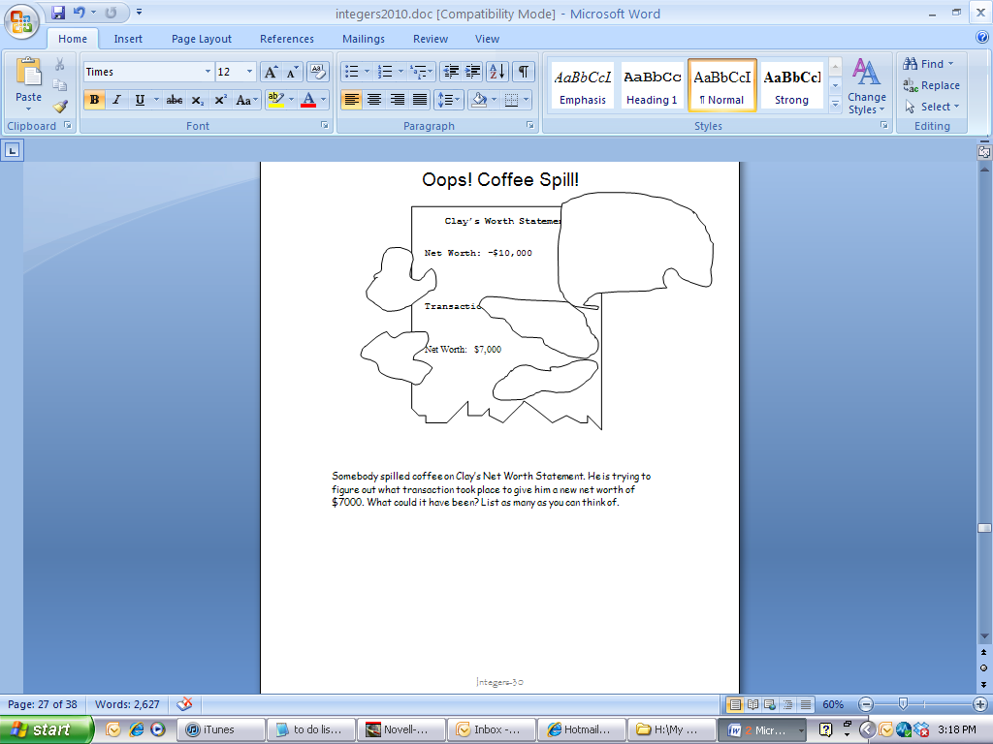

**Big Mathematical Idea(s):** structuring the space of possible transactions

**Rationale:** Missing addend/subtrahend tasks

**Possible Metaphors:**

**Teacher Notes:** While walking around, look for those that involve multiple transactions and wrong answers due to disregarding or misinterpreting the negative beginning net worth. As you see some interesting ones, ask students to put them on the board. Then, ask students to meet with their small groups to analyze all the remaining answers and list on their papers which ones are valid. Tell them to be prepared to justify their choices. When students are done working with small groups, poll students and the answers that most questioned can be targeted first. There is no need to defend every one unless students ask for it. For whole class discussion, begin with the simplest transactions that deal with the incorrect answers due to a negative net worth. If someone came up with a solution that is written multiplicatively, make sure it is put on the board for analysis. You can write their transactions as full number sentences if it seems appropriate, e.g., -10,000 + (+17,000) = 7,000. You will probably need to encourage students to use the VNL in their explanations so people can understand why the missing addend is 17,000 and not 3000.

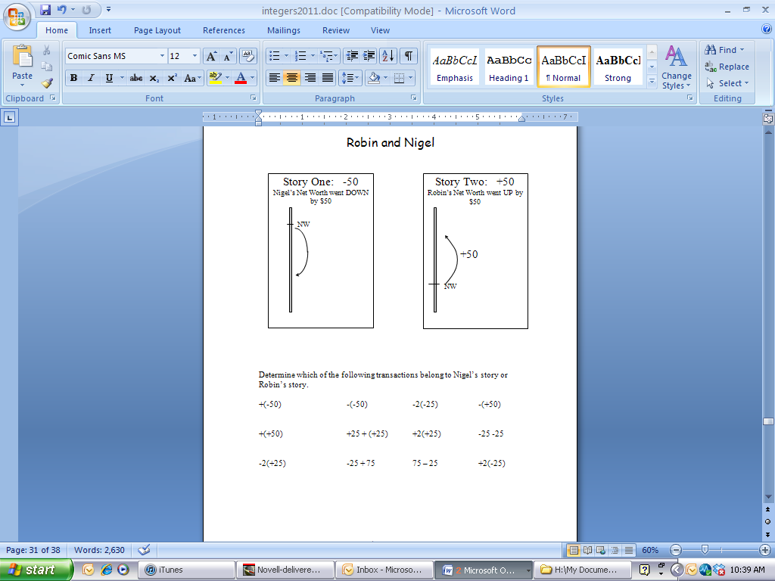

**Anticipated Student Thinking:**

Students’ difficulties usually lie with the following transactions:

-25 - 25

-25 + 75

75 – 25

If the expression does not include two signs, students have difficulty interpreting the situation.

**Big Mathematical Idea(s):** equivalence of integer quantities/expressions

**Rationale:** Students must learn to interpret problems with only one sign

**Possible Metaphors:** good decision/bad decision; going up or down

**Teacher Notes:** Ask students to meet with their groups after some individual time and circle the expressions for which they have questions. To begin whole class discussion start with the first expression and ask if anyone had it circled. If no, then ask for the answer. If there is no debate, then move through the list in the same manner. It may help to use a VNL on some of those more difficult expressions.

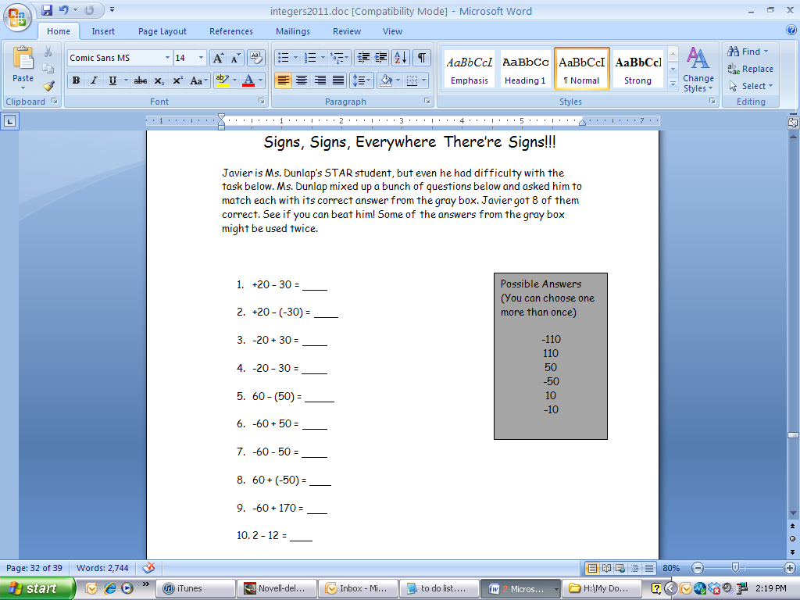

**Anticipated Student Thinking:**

Students’ difficulties will revolve around how to interpret the middle sign. Is the negative sign in number one a take away or a debt? That will be the question that students ask you. Encourage students to create their own meaning for these symbols. Ask them to draw a VNL and start with the beginning number as a net worth and then decide what happens.

**Big Mathematical Idea(s):** meaning of the negative sign (take away or negative)

**Rationale:** Students must learn to interpret problems with only one sign

**Possible Metaphors:** good decision/bad decision; going up or down

**Teacher Notes:** Begin by having students talk with their partners about their answers before whole class discussion. Go through each one of them during whole class having students justify and debate their understanding. Encourage students to justify their reasoning or resolve debates by drawing on a VNL.

**Anticipated Student Thinking:**

Encourage students to use a VNL or at least imagine one in their mind to solve these problems.

The most difficult will be h and i because they contain only one sign in the transaction.

For each problem below, state the person’s beginning NET WORTH, whether the change is a good or bad change, and their new NET WORTH.

* 1. 17 + (-5)
  2. -23 + (+11)
  3. 250 + (-250)
  4. 325 – (-100)
  5. -117 + (-23)
  6. -50 – (-50)
  7. -154 + (-26)
  8. 153 + (524)
  9. 619 – (235)

**Big Mathematical Idea(s):** Solving integer addition/subtraction

**Rationale:** Using pure number sentences

**Possible Metaphors:**

**Teacher Notes:** Ask students to check their answers with their partners once they have finished their independent time. Then, they are to go through and circle any that they have questions about. To begin whole class discussion start with the first expression and ask if anyone had it circled. If no, then ask for the answer. If there is no debate, then move through the list in the same manner. It may help to use a VNL on some of those more difficult expressions.

**Anticipated Student Thinking:**

Encourage students to use a VNL or at least imagine one in their mind to solve these problems.

Solve the following problems:

1. -45 + (-16)
2. -4 + 2 + (-5)
3. -5 + (-5)
4. 10 + 24 + (-12)
5. 22 – (-10)
6. -3 + 4 – (-23) –10

Solve the following problems:

1. 20 – 5
2. 18 + 7
3. -17 + 7
4. -20 + (-3)
5. 25 – (-10)
6. -25 – (-20)
7. -100 – 50
8. -45 + 70
9. 20 + (-35)
10. -45 + (-20)

**Big Mathematical Idea(s):** Solving integer addition/subtraction

**Rationale:** Using pure number sentences

**Possible Metaphors:**

**Teacher Notes:** Ask students to check their answers with their partners once they have finished their independent time. Then, they are to go through and circle any that they have questions about. To begin whole class discussion start with the first expression and ask if anyone had it circled. If no, then ask for the answer. If there is no debate, then move through the list in the same manner. It may help to use a VNL on some of those more difficult expressions.