Interpreting Slopes and Y-Intercepts of Proportional and Non-Proportional Relationships
Task 1: Investigating Proportional and Non-Proportional Relationships
Framework Cluster | Functional Reasoning
Standard(s) | NC.8.F.4 Analyze functions that model linear relationships.  - Understand that a linear relationship can be generalized by y = mx + b.  - Write an equation in slope-intercept form to model a linear relationship by determining the rate of change and the initial value, given at least two (x, y) values or a graph.  - Construct a graph of a linear relationship given an equation in slope-intercept form.  - Interpret the rate of change and initial value of a linear function in terms of the situation it models, and in terms of the slope and y-intercept of its graph or a table of values.
Materials/Links | Worksheets
Learning Goal(s) | - Understand that the meaning of the y-intercept in context is the initial value of a linear relationship  - Know that when the initial value of a linear relationship is zero, the situation is proportional.
Task Overview: In this activity, students draw on prior knowledge of proportional and non-proportional relationships to notice and make connections between the initial value of a real-world situation and the y-intercept of the graph (as seen in a table and on the graph). By the end of the task, students should be able to understand that the meaning of the y-intercept in context is the initial value of a linear relationship, and when the initial value is zero, the situation is proportional.

This is the first of three tasks in which students learn to interpret both the slope and y-intercept of a linear model in context. This task focuses on graphs, tables, and verbal descriptions, and does not include equations. The next task will focus on interpreting rate of change and slope in context. The final task will focus on interpreting both slope and y-intercept together, and will include equations.
Prior to Task: Students should already be familiar with slope intercept form of a linear equation, and be able to identify from a graph and a table whether a relationships is proportional or not (7.RP.2)

A warm up to review identifying proportional and non-proportional relationships from tables and graphs would give students entry to the activity.
Teaching Notes:
Task launch:
- Inform students that they will be working independently to investigate more deeply into a topic they have already studied. Prompt them to begin working on the problem (independently, in pairs, or groups depending on your preference and the needs of the class) and let them know they will need to be prepared to justify their answers to the whole class by the end of the task.
Directions:
- After students complete the task independently or in pairs/groups, facilitate a group discussion to review the last 3 questions on the task. One possible question: If no videos have been downloaded yet, why is there a cost for one of the plans but not for the other plan? The teacher can use Smith and Stein 5 Practices to monitor student work and lead a discussion after the small-group work.

Possible Strategies/Anticipated Responses: Students should be able to fill in the tables using repeated addition and may notice that they can use multiplication. They should graph the points in the table and may connect them with a line.

Plan 1: A flat rate of $7 per month plus $2.50 per video viewed | Plan 2: $4 per video viewed
Table:  Videos Downloaded Cost  0 $7.00  1 9.50  2 12.00  3 14.50  4 17.00 | Table:  Videos Downloaded Cost  0 $0  1 4  2 8  3 12  4 16
Graph: | Graph:
Which of the situations is proportional and linear? Which is non-proportional and linear? Explain how you know.
Students should identify Plan 1 as proportional, and plan 2 as non-proportional. Justifications could be that the graph is linear and passes through the origin (0, 0) or that the unit rate is constant when it is calculated from the values in the table.

Student sheets begin on next page.

What Do You Notice About Proportional and Non-Proportional Relationships?
Name:__________________________________________________ Date: __________________

For each of the situations below, fill in the table and graph the values from the table. Label the axes of your graphs.
Video Streaming Plans
Plan 1: A flat rate of $7 per month plus $2.50 per video viewed | Plan 2: $4 per video viewed
Table:  Videos Downloaded Cost  0  1  2  3  4 | Table:  Videos Downloaded Cost  0  1  2  3  4
Graph: | Graph:
Which of the situations is proportional and linear? Which is non-proportional and linear? Explain how you know.

Filling a Pool

Pool 1: A pool that starts out empty is filled at a rate of 1.5 ft. per hour. | Pool 2: A pool that had 3 ft. of water in it is filled at a rate of 1 ft. per hour.
Table:  Hours Height of Water  0  1  2  3  4 | Table:  Hours Height of Water  0  1  2  3  4
Graph: | Graph:
Which of the situations is proportional and linear? Which is non-proportional and linear? Explain how you know.

- How could you tell from a description, without creating the graph or the table, whether a situation is proportional or non-proportional linear?

- For each of the two pools being filled above, explain what the y-intercept means in the context of the problem.

Interpreting Slopes and Y-Intercepts of Proportional and Non-Proportional Relationships
Task 2: Baseball Cards
Framework Cluster | Functional Reasoning
Standard(s) | NC.8.F.4 Analyze functions that model linear relationships.  - Understand that a linear relationship can be generalized by y = mx + b.  - Write an equation in slope-intercept form to model a linear relationship by determining the rate of change and the initial value, given at least two (x, y) values or a graph.  - Construct a graph of a linear relationship given an equation in slope-intercept form.  - Interpret the rate of change and initial value of a linear function in terms of the situation it models, and in terms of the slope and y-intercept of its graph or a table of values.
Materials/Links | Handouts and baseball card cut outs
Learning Goal(s) | - Understand that the rate of change and initial value of a linear model correspond to the slope and y-intercept in a linear equation written in slope-intercept form, y = mx + b.  - Be able to solve problems about real-world situations using the slope-intercept form of an equation.
Task Overview: This activity helps students connect the initial value and rate of change of a model to the slope and y-intercept in a linear equation written in slope-intercept form, y = mx + b. The 5 cards in the handout below could be printed out as a manipulative or displayed on a projector. This activity lends itself to rich group or whole-class discussions by asking students which card they would rather have after a certain amount of time (1 year, 3 years, etc.), or if they only have a specified amount of money to spend on a card ($5, $9, etc.) and to justify their answer.
Prior to Task: Students should be familiar with the slope-intercept form of a linear equation and should have completed the previous task.

A warm up to review the slope-intercept form of an equation will provide an entry point into the activity.
Teaching Notes:
Task launch:
- Distribute or display the 5 baseball cards. Explain that each equation represents the value of the card after 0, 1, 2, 3, and 4 years. Ask students to pick which card they would prefer to have and to be able to explain why. Have them hold up the card they want.
Directions:
- Choose two students who chose different cards to stand up and justify their answers. Facilitate a class discussion and decide who has the “best” card and why. Start helping students use vocabulary while interpreting meaning of the initial value (the original cost of the card), and the meaning of the slope (the amount the value increases or decreases each year).
- Continue to have a class discussion by asking questions such as: Which card would you rather have after a certain amount of time (1 year, 3 years, etc.), or if they only have a specified amount of money to spend on a card ($5, $9, etc.). Justify your answer.
- Have students answer the questions on the worksheet independently, in pairs, or in groups and discuss.

Possible Strategies/Anticipated Responses: Students may substitute numbers into the equations to determine the cards’ values or use what they learned in the previous lesson (connected to prior knowledge) to identify the initial value and rate of change from the equation.
- Which card(s) had the greatest initial value at purchase (at 0 years)?
Since all of the models are in slope-intercept form, Cards C and D have the greatest initial values at $10 each.
- Which card(s) are decreasing in value each year? How can you tell?
Cards A and D are decreasing in value, as shown by the negative values for rate of change in each equation.
- Which card(s) is increasing in value the fastest from year to year? How can you tell?
Card B is increasing in value the fastest from year to year. Its model has the greatest rate of change.
- If you were to graph the equations of the resale values of Card B and Card C, which card’s graph line would be steeper? Explain.
The Card B line would be steeper because the function for Card B has the greatest rate of change; the card’s value is increasing at a faster rate than the other values of other cards.
- Write a sentence explaining the 0.9 value in Card C’s equation.
The 0.9 value means that Card C’s value increases by 90 cents per year.
- Write a sentence explaining the value 4 in Card B’s equation.
The 4 value means that Card B’s value started at $4 (or that the collector paid $4 for the card originally)

Students might confuse the slope and y-intercept of the equations, as the equations are written in “y = b + mx” form instead of “y = mx + b.” Encourage students to think about the rate of change as the multiplicative relationship - drawing on lessons from the previous task - so it is the coefficient, regardless of its location in the equation. You can also have them rewrite the equations using the commutative property to show how they the two forms are actually the same equation.

Student sheets begin on next page.

Collecting Baseball Cards
Name:__________________________________________________ Date: __________________

Adapted from: https://www.engageny.org/resource/grade-8-mathematics-module-6-topic-lesson-2

In 2008, a collector of sports memorabilia purchased specific baseball cards as an investment. Let y represent each card’s resale value (in dollars) and x represent the number of years since purchase. Each card’s resale value after 0, 1, 2, 3, and 4 years could be modeled by linear equations as follows:

Card A  $$y=5-0.7x$$ | Card B  $$y=4+2.6x$$ | Card C  $$y=10+0.9x$$ | Card D  $$y=10-1.1x$$ | Card E  $$y=8+0.25x$$

Practice Questions:
- Which card(s) had the greatest initial value at purchase (at 0 years)?
- Which card(s) are decreasing in value each year? How can you tell?
- Which card(s) is increasing in value the fastest from year to year? How can you tell?
- If you were to graph the equations of the resale values of Card B and Card C, which card’s graph line would be steeper? Explain.
- Write a sentence explaining the value 0.9 in Card C’s equation.
- Write a sentence explaining the value 4 in Card B’s equation.

Printable Cards: (Print and give to individual students or to groups)

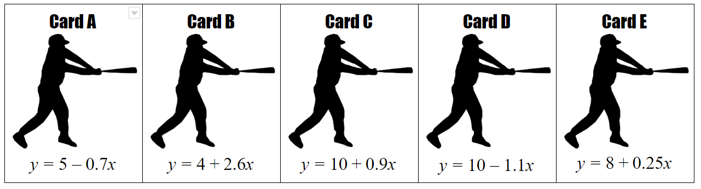

Interpreting Slopes and Y-Intercepts of Proportional and Non-Proportional Relationships
Task 3: Card Sort
Framework Cluster | Functional Reasoning
Standard(s) | NC.8.F.4 Analyze functions that model linear relationships.  - Understand that a linear relationship can be generalized by y = mx + b.  - Write an equation in slope-intercept form to model a linear relationship by determining the rate of change and the initial value, given at least two (x, y) values or a graph.  - Construct a graph of a linear relationship given an equation in slope-intercept form.  - Interpret the rate of change and initial value of a linear function in terms of the situation it models, and in terms of the slope and y-intercept of its graph or a table of values.
Materials/Links | Card sort cards, and scissors if needed. (Can be given as handouts that the students cut individually, or pre-cut and laminated on card stock for reusable sets)
Learning Goal(s) | - Understand the meaning of the rate of change and initial value of a linear function based on the context of a scenario.
Task Overview: The goal of this activity is for students to understand the meaning of the rate of change and initial value of a linear function based on the context of a scenario. In this card sort, students will connect the verbal description of a scenario with the matching equation and graph. The card sort can be easily differentiated (page 1 is easier with clear descriptions and whole numbers, while page 2 is harder with decimals and negative slopes). All the cards can be given together, or the matching can be done in parts: first match the scenario to its equation, then hide the equations and match the scenario to its graph, then match all three together.
Prior to Task: Students should be familiar with the slope-intercept form of a linear equation and should be able to identify the slope and y-intercept of a function from a graph and from an equation from the previous two tasks. Students should know that the slope is rate of change and that the y-intercept is the initial value. A warm up about graphing linear equations in slope-intercept form will give students an entry point.
Teaching Notes:
Task launch:
- Instruct students to cut out cards (if not pre-cut). To help scaffold the activity, first ask students to match verbal description cards to the equation cards. Help students connect this initial task to the baseball card activity from the previous task.
Directions:
- Students work independently, in pairs, or small groups. Assist students in getting started with one correct match if they have trouble getting started.
- The teacher copy of the uncut card handout serves as an answer key, but it may be useful to add letters to the corners of the cards for easier checking. Circulate and check their matches.
- A potential extension could ask students to write and explain their reasoning for the matches.
- Pose questions to groups or the class as a whole to facilitate understanding and discussion:
  - What representation of a linear function that we have used previously would help you make matches or check the matches you have already made? (tables)
  - What can you look for in the description that will tell you the y-intercept of the line? What can you look for that will tell you the slope?
  - If a line has a negative slope, what does that tell you about the scenario? A positive slope?

Possible Strategies/Anticipated Responses:
Use the teacher version below as the answer key. Students may not match the cards correctly due to misidentifying either the slope or the y-intercept as well as the signs (positive or negative) of the slope and y-intercept. Also, on the second page, students could mix up the slope and y-intercept of the equation not given in y = mx + b form.

Student sheets begin on next page.

Interpreting Slope and Y-Intercept Card Sort (Student Version)

A movie streaming service charges $15 per month plus $4 per movie streamed. | $$y=15x$$ | 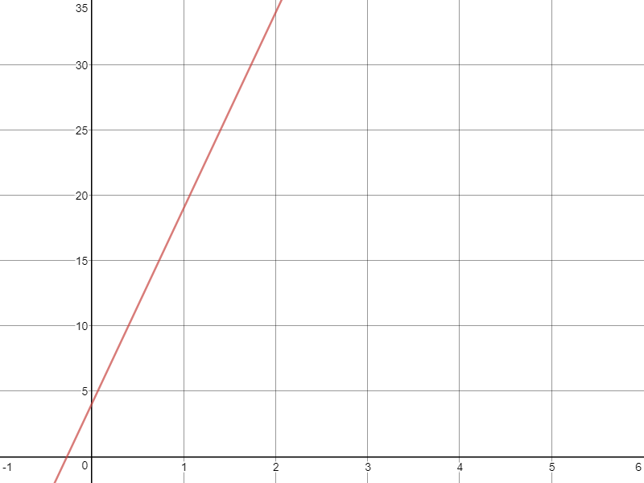
A pool has 4 inches of water in it and is being filled at a rate of 15 inches per hour. | $$y=4x$$ | 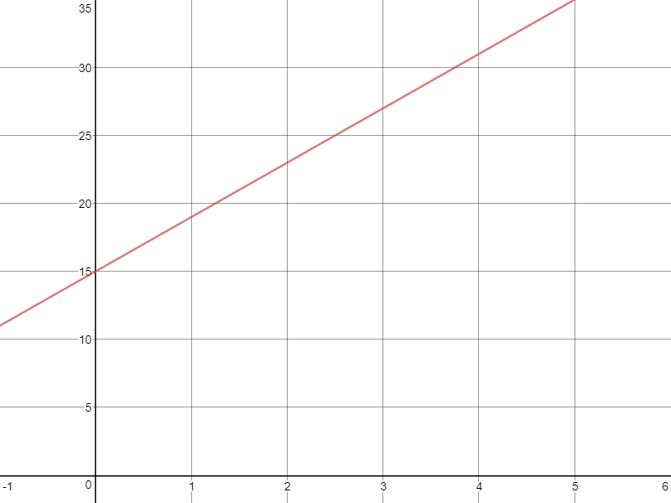
A movie streaming service charges $4 per movie streamed. | $$y=15x+4$$ | 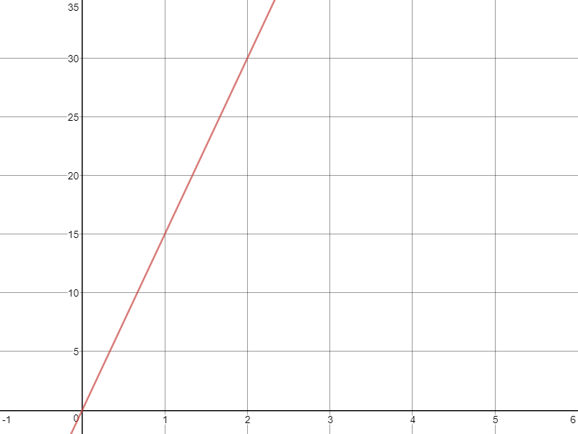
A pool that starts out empty is being filled at a rate of 15 inches per hour | $$y=4x+15$$ | 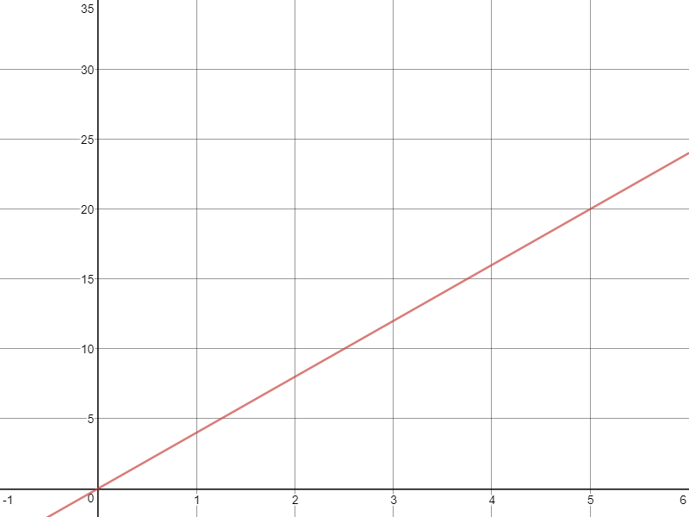
A scuba diver starts out at the surface of the water and descends at a rate of 1.5 ft. per second. | $$y=1.5x$$ | 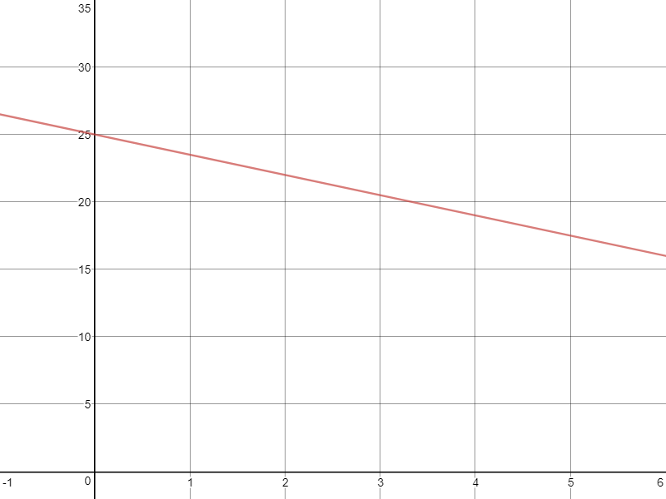
A sunflower is planted as a seed and grows at a rate of 1.5 inches per week once it sprouts from the ground. | $$y= -1.5x$$ | 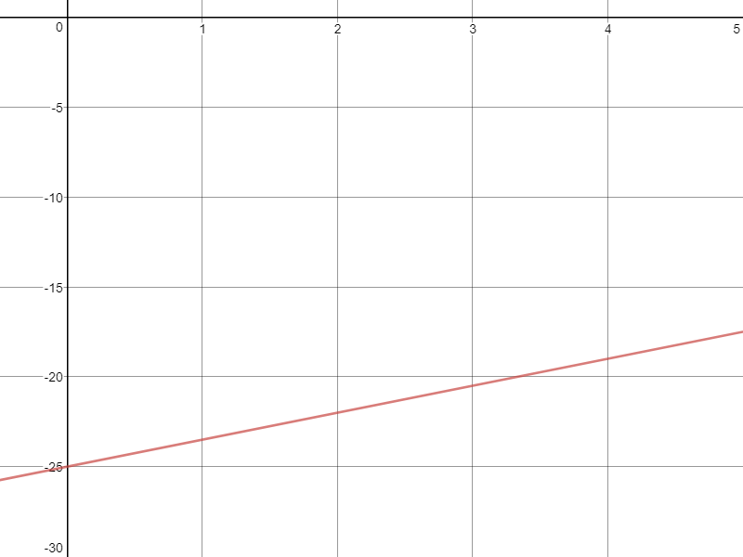
The temperature in a town in Alaska starts at -25 degrees and rises at a rate of 1.5 degrees every hour | $$y=25-1.5x$$ | 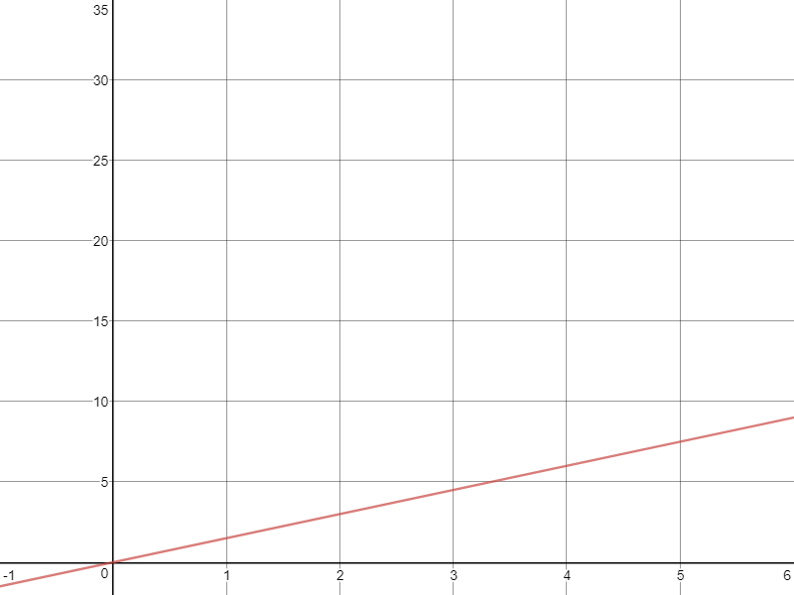
A gift card for iTunes starts out with $25 on it and the card is used to pay for song downloads that cost $1.50 each. | $$y=1.5x -25$$ | 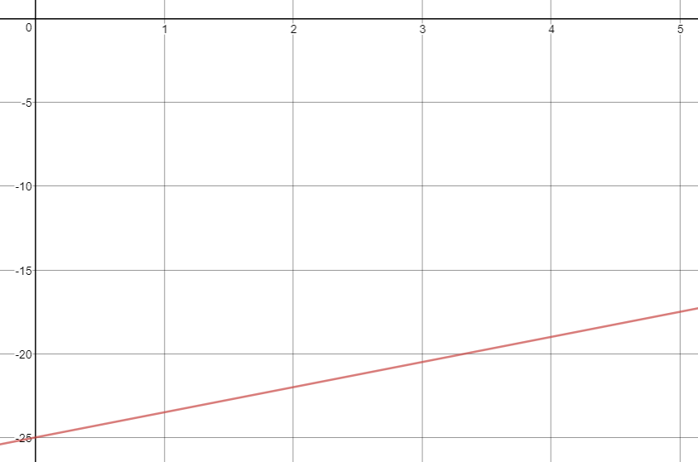

Card Sort - Teacher Version/Answer Key
A pool has 4 inches of water in it and is being filled at a rate of 15 inches per hour. | $$y=15x+4$$
A movie streaming service charges $15 per month plus $4 per movie streamed | $$y=4x+15$$
A pool that starts out empty is being filled at a rate of 15 inches per hour | $$y=15x$$
A movie streaming service charges $4 per movie streamed | $$y=4x$$
A gift card for iTunes starts out with $25 on it and the card is used to pay for song downloads that cost $1.50 each. | $$y=25-1.5x$$
The temperature in a town in Alaska starts at -25 degrees and rises at a rate of 1.5 degrees every hour | $$y=1.5x -25$$
A sunflower is planted as a seed and grows at a rate of 1.5 inches per week once it sprouts from the ground. | $$y=1.5x$$
A scuba diver starts out at the surface of the water and descends at a rate of 1.5 ft. per second. | $$y= -1.5x$$

