Solving Problems Using the Line of Best Fit - Formative Assessment 1
Link to Formative Assessment (original): https://www.illustrativemathematics.org/content-standards/8/SP/A/3/tasks/1370
Cluster & Content Standards  8.SP.3 Use the equation of a linear model to solve problems in the context of bivariate data | Mathematical Practice Standards  What practice standards can be addressed by this formative assessment?  3. Reason abstractly and quantitatively
Learning Targets
What learning targets will be assessed?
- Model linear relationships represented as data in tables or on a scatterplot using linear equations.
- Interpret the slope and y-intercept of the line of best fit in context.
- Make predictions using a line of best fit.

Timing: During or after completing the tasks for solving problems using the line of best fit.
Anticipated Solutions:

a. 46.6 airports
b. (iv)
c. (vi)
d. 700 thousand
Students will have to be mindful of the units to correctly answer parts of this problem. They must also have a thorough understanding of slope and y-intercept in context and may mix the two up, or interpret them incorrectly. For part d) students are likely to confuse the answer to this question with the slope of the line.

Note: The original Illustrative Mathematics task gives the rate of change using individual people in the population, not millions of people, and therefore uses scientific notation to represent the rate of change. In the 8th grade frameworks, we teach line of best fit before scientific notation, so the task has been adapted for our North Carolina frameworks.

Solving Problems Using the Line of Best Fit
Formative Assessment 1

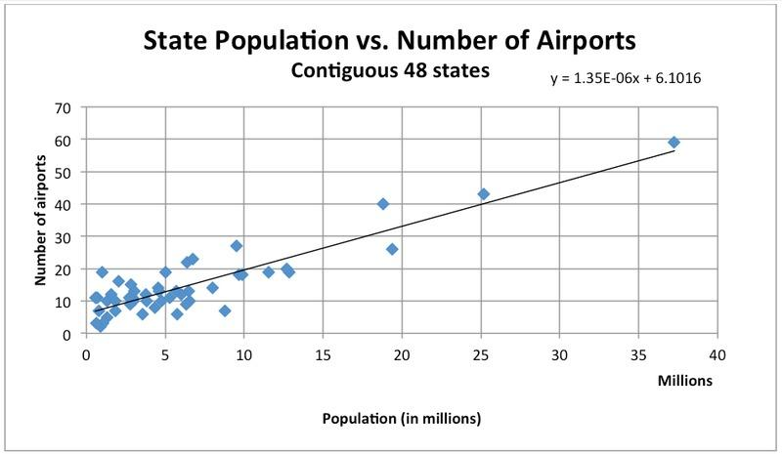
US Airports: The scatter plot shows the relationship between the number of airports in a state and the population of that state according to the 2010 Census. Each dot represents a single state.

LaToya uses the function y=1.35x+6.1 to model the relationship between the number of airports, y and the population in a state, x, in millions of people.
- How many airports does LaToya’s model predict for a state with a population of 30 million people?
- What does the number 6.1 that appears in LaToya’s function mean in the context of airports vs. populations? (Select one.)
  - The average number of airports in a state is 6.1.
  - The model predicts a population of 6.1 people in a state with no airports.
  - The model predicts 6.1 airports in a state with no people.
  - The model predicts that 6.1 states have no airports.
  - The model predicts 6.1 more airports, on average, for each additional person in a state.
  - The model predicts 6.1 fewer airports, on average, for each additional person in a state.
- What does the number 1.35 that appears in LaToya’s function mean in the context of airports vs. populations? (Select one.)
  - The average number of airports in a state is 1.35
  - The model predicts 1.35 airports in a state with no people.
  - The model predicts 1.35 people in a state with no airports.
  - The model predicts that 1.35 states have no airports.
  - The model predicts 1.35 more airports, on average, for each additional million people in a state.
  - The model predicts 1.35 fewer airports, on average, for each additional million people in a state.
- Fill in the following newspaper headline based on this relationship:
On average, a state in the contiguous 48 US states has 1 additional airport for every __________________ additional people.

Adapted From: https://www.illustrativemathematics.org/content-standards/8/SP/A/3/tasks/1370
Solving Problems Using Line of Best Fit - Formative Assessment 2
Link to Formative Assessment (original):
https://www.illustrativemathematics.org/content-standards/8/SP/A/2/tasks/1558
Cluster & Content Standards  8.SP.3 Use the equation of a linear model to solve problems in the context of bivariate data | Mathematical Practice Standards  What practice standards can be addressed by this formative assessment?  3. Reason abstractly and quantitatively
Learning Targets
What learning targets will be assessed?
- Model linear relationships represented as data in tables or on a scatterplot using linear equations.
- Interpret the slope and y-intercept of the line of best fit in context.
- Make predictions using a line of best fit.

Timing: During or after completing the tasks for solving problems using the line of best fit.
Anticipated Solutions and Possible Conceptions:

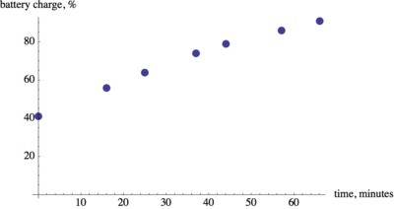
- Identify the independent and dependent variable in this situation, and then make a scatter plot of the data
Independent - Time since he plugged the laptop in Dependent - % charged
(students may choose different variables - x and y, or b and t, etc.)

- Draw a line that fits the data and find the equation of the line in slope-intercept form.
Possible answer: b=0.76t+43.
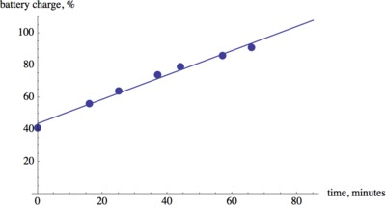
- Explain the meaning of the slope of the equation in the context of the problem.
The slope of 0.76 means that every minute the percentage charge of the battery increases by 0.76%
- Explain the meaning of the y-intercept of the equation in the context of the problem.
The y-intercept is the percentage the battery was at the time it was plugged in. Teachers: you may want to use this question to facilitate a discussion about why the model differs from the actual data.
- At what time was the battery 50% charged?
Students can use the line of best fit and see at what time it will reach an output value of 50%. This happens about 81 minutes after the computer was plugged in. We can also use the equation to solve 0.76t+43=100 for t to obtain t=81 minutes. Teachers: You can use this question to help students see that there are two different ways to answer this question, and one method may be used to verify that the calculation from the other method is correct.
- When can Jerry expect to have a fully charged battery?
We can extend the line of best fit and see at what time it will reach an output value of 100%. This happens about 75 minutes after the computer was plugged in. We can also use the equation to solve 0.76t+43=100 for t to obtain t=75 minutes. Teachers: You can use this question to help students see that there are two different ways to answer this question, and one method may be used to verify that the calculation from the other method is correct.

Solving Problems Using the Line of Best Fit
Formative Assessment 2

Laptop Battery Charge
Jerry forgot to plug in his laptop before he went to bed. He wants to take the laptop to his friend's house with a full battery. The picture show screenshots of the battery charge indicator after he plugs in the computer at 9:11 a.m.
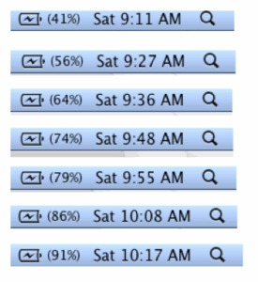
- Identify the independent and dependent variable in this situation, and then make a scatter plot of the data.
- Draw a line that fits the data and find the equation of the line in slope-intercept form.
- Explain the meaning of the slope of the equation in the context of the problem.
- Explain the meaning of the y-intercept of the equation in the context of the problem.
- At what time does your model predict the battery was 50% charged?
- When can Jerry expect to have a fully charged battery? Explain.

Adapted From: https://www.illustrativemathematics.org/content-standards/8/SP/A/3/tasks/1370

