Solving Problems Using the Line of Best Fit
Task 1: How Big Is Your Pig
Framework Cluster | Functional Reasoning
Standard(s) | 8.SP.3 Use the equation of a linear model to solve problems in the context of bivariate data
Materials/Links | Handouts, Rulers, Calculators
Learning Goal(s) | - Model linear relationships represented as data in tables or on a scatterplot using linear equations.  - Interpret the slope and y-intercept of the line of best fit in context.  - Make predictions using a line of best fit...
Task Overview: In this activity, students draw on prior knowledge of linear equations, including interpreting slope and y-intercept in context and finding the line of best fit of bivariate data, to solve a problem. Students are asked to create a model relating girth of a pig to its weight, interpret the parts of the model, and use it to predict the weight of an unusually large pig.
Prior to Task: Students should already be familiar with drawing a scatter plot and finding the equation of a line of best fit for a data set (8.SP.2). They should also be able to interpret the meaning of slope and y-intercept of a linear model (8.F.4)

A warm up to review interpreting slope in context would help students connect to prior learning.
Teaching Notes:
Task launch:
- Show students the Youtube video about a large pig contest, and discuss with them different ways a farmer could weigh a pig, especially if they don’t have a large enough scale. https://www.youtube.com/watch?v=0mbw-4G7frk

Directions:
- Give students the handout and tell them that they are going to use math to approximate the weight of a large pig. They can work individually, in pairs, or in small groups.
- Circulate to monitor progress of individuals and groups. If students are working in pairs or small groups, stress sentence starters (I agree because…, Next we would…, etc.) to encourage discourse.
- After students have had a chance to attempt the questions on side two of the handout, facilitate a class discussion to go over the answers, the meaning of the slope, and how to use a line of best fit to make predictions. Smith and Stein’s 5 Practices for Orchestrating Mathematical Discourse can help structure the task and discussion.

Correct answers:

- Create a scatterplot of the data
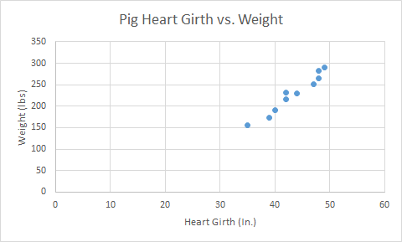

b) Draw a line of best fit on the scatterplot. Write the equation of the line in slope-intercept form.
y = 9.57x - 186.84
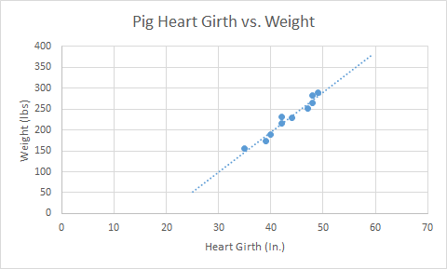

c) Explain what the slope of your model means in the context of the problem.

For each inch that the heart girth increases, the weight of the pig increases by about 9.57 pounds.

d) Explain two different ways you could estimate the weight of a pig with a heart girth of 45 inches.

Find the point on the graph of the linear model where heart girth (x) is 45 and read the weight value (y), or use the equation of the linear model, substituting in 45 for x and finding y. Answer: 243.81

e) If a pig weighs about 300 lbs., how big would you expect its heart girth to be? Explain your answer.

50.9 inches Students may find the point on the graph where the weight is 300 lbs. or they may plug 300 in to the equation and solve.

f) Estimate Ziggy’s weight and explain how you got your answer.
Ziggy weighs 339.51 lbs.

g) Compare your answer to several of your classmate’s answers. Why is it possible to have more than one correct answer?

Students should have answers that are comparatively close. They should recognize that each person may have drawn a different line of best fit and therefore their estimations will be slightly different.

Student sheets begin on next page.

How Big is Your Pig?

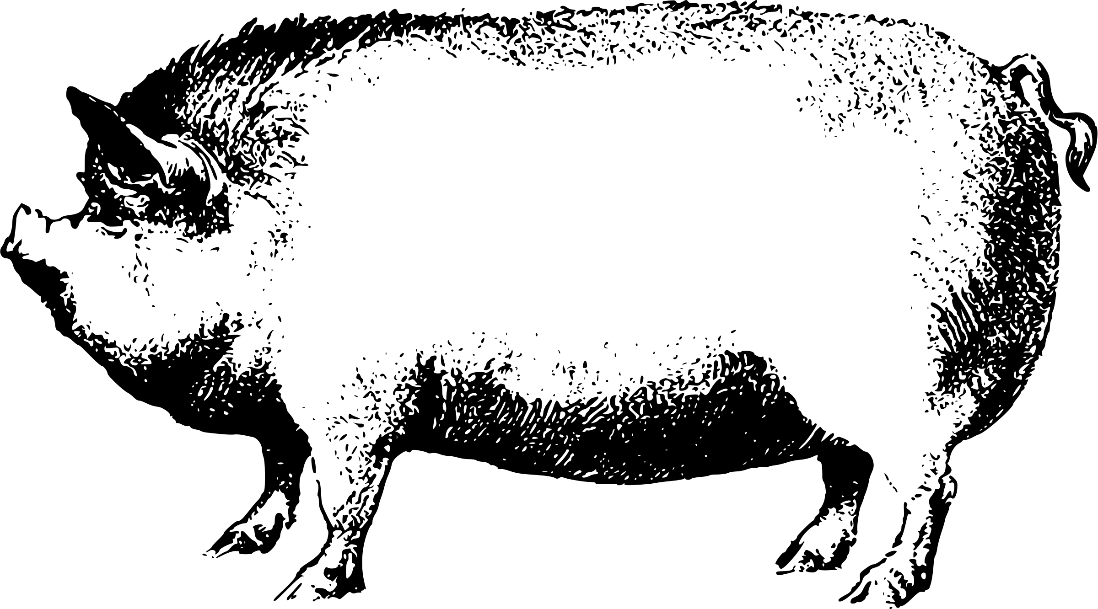
This year, your prize-winning pig Ziggy is bigger than ever and you want to know how much he weighs. But, it’s hard to weigh a pig! How will you find a scale large enough? Will you bring the giant scale to your farm on a giant truck? How will you get Ziggy on the scale?

Lucky for you, you can estimate his weight using your math skills! You know that a pig’s heart girth (the distance around the pig, right behind his/her front legs) is related to the pig’s weight. Below is the data for the heart girth and weight of 10 other pigs. Ziggy’s heart girth is a whopping 55 inches. Complete the following problems to use data below to predict how much Ziggy weighs.

Heart Girth (in) | Weight (lbs.) |  | Heart Girth (in) | Weight (lbs.)
42 | 216 |  | 42 | 321
49 | 290 |  | 44 | 230
40 | 190 |  | 48 | 283
35 | 156 |  | 47 | 252
39 | 174 |  | 48 | 265
- Create a scatterplot of the data.

- Draw a line of best fit on the scatterplot. Write the equation of the line in slope-intercept form.

- Explain what the slope of your model means in the context of the problem.

- Explain two different ways you could estimate the weight of a pig with a heart girth of 45 inches.

- If a pig weighs about 300 lbs., how big would you expect its heart girth to be? Explain your answer.

- Estimate Ziggy’s weight and explain how you got your answer.
Ziggy weighs ___________________.

- Compare your answer to several of your classmate’s answers. Why is it possible to have more than one correct answer?

Solving Problems Using the Line of Best Fit
Task 2: Lines of Best Fit Desmos Activity
Framework Cluster | Functional Reasoning
Standard(s) | 8.SP.3 Use the equation of a linear model to solve problems in the context of bivariate data
Materials/Links | Computers, scrap paper, and calculators  Desmos activity: https://teacher.desmos.com/activitybuilder/custom/5b577af30ec47f17ef564591
Learning Goal(s) | - Model linear relationships represented as data in tables or on a scatterplot using linear equations.  - Interpret the slope and y-intercept of the line of best fit in context.  - Make predictions using a line of best fit.
Task Overview: In this online activity, students practice and extend what they learned in the “How Big is Your Pig?” activity to interpret the slope of a line of best fit in context and use the line of best fit to make predictions. In this activity, students are asked to use the equation of the line of best fit to calculate a prediction and use a graph to verify their answer.
Prior to Task: Students should already be familiar with drawing a scatter plot and finding the equation of a line of best fit for a data set (8.SP.2). They should also be able to interpret the meaning of slope and y-intercept of a linear model (8.F.4). They should have been introduced to using line of best fit as a model for a set of data in the previous activity.

A warm up to review how to use a linear model to calculate a specific point would help students recall a skill they need to complete the task. For instance, you may want to ask students to calculate how much a baseball card would be worth after 10 years if the value of the card, y, can be modeled by the equation y=7.50+1.3x, where x is the number of years since it was purchased.
Teaching Notes:
Task launch:
- After you have logged into teacher.desmos.com and created a class code for the following activity https://teacher.desmos.com/activitybuilder/custom/5b577af30ec47f17ef564591, tell students they will be completing an online assignment and have them go to student.desmos.com and use the class code to log in to the activity. They can begin the first two exploration slides as an activating activity to begin thinking about best-fit lines on a graph.

Directions:
- Direct students to log into the activity on their devices. It is recommended that students work individually on this task, but if each student does not have a device then they can work in pairs. They should have scrap paper and calculators to help them with the task.
- Pause the activity after all the students have completed slide 3. Anonymize the students and then use the “overlay” feature to let students compare the class answers as a whole. Use this as a chance to remind students about finding lines of best fit and make sure all students have a line that fits the data well.
- The first problem in the activity is self-checking, so circulate and monitor students as they finish the task to the end
- Monitor student progress, and display answers to slides to facilitate discussion as needed.
- For the final Snapchat question, a class competition to see “who got the closest” could help spur discussion and excitement about how to draw the lines and use them for predictions.
- The Teacher Guide presented as part of the Desmos activity also gives strategies for effective pedagogy for this activity.

Possible Strategies/Anticipated Responses:
- The first question on the activity is self-checking. Students should get an output value around 20, but answers will vary widely depending on the line of best fit they chose.
- The prediction for Snapchat users in 2020 should be around 300 million, and 2025 should be around 445 million. Answers will vary depending on their line of best fit. Help remind students about the importance of the units for finding the correct answer, as some students may respond with 300 instead of 300,000,000.
- The actual best-fit equation, using linear regression, is y = 39.81x + 53.08. For the year 2020, there are about 292 million users, and for the year 2025, there are about 491 million users. (Note: Students are NOT expected to use the graphing calculator to calculate the line - that was just to find the “actual” answer to either determine a competition winner or satisfy student curiosity.)
- Use the anonymize feature and a projector to show students the various answers. Discuss reasons for differences, and if any of the answers are unreasonable. Give students the opportunity to correct their models and calculations.

No student sheets needed for this activity.

