Task 1 - Summer Spending
Framework  Cluster | Reasoning with Rational Numbers
Standard(s) | NC.7.NS.1 Apply and extend previous understandings of addition and subtraction to add and subtract rational numbers, using the properties of operations, and describing real-world contexts using sums and differences.
Materials/Link | - Summer Spending sheet for each student  - (optional) Calculators for students not able to access the content due to struggles with computation
Learning Goal | - Understand that positive numbers can represent money received and negative numbers can represent money that is paid.  - Interpret positive and negative numbers in a money context.
Task overview
Given a list of transactions, students will add positive and negative dollar amounts to determine an ending balance.
Prior to lesson
- Students have previous experience using operations with positive and negative integers. This lesson will require them to begin performing addition and subtraction with positive and negative rational numbers using the context of money.
Teaching Notes
Task Launch:
Present the following to students:

Using three integers, addition and subtraction, write an expression that equals -5.

Allow students to work in pairs to come up with as many solutions as possible. Give students an opportunity to share their solutions as well as their thinking.

Directions:
- Give students a couple minutes to individually brainstorm and write down some ways they spend money. Then ask students to share responses. If students don’t come up with many examples, prompt them with some suggestions and/or ask them to consider ways other teenagers may spend money.
- As a class, brainstorm and write down some ways teenagers can make money.
- Before giving students the Summer Spending sheet, remind them of the importance of showing their thought processes on paper.
- Allow students to work in pairs to complete the Summer Spending sheet. Students should be able to complete without the use of a calculator. However, if a student is struggling with computation, allow them to use a calculator. Do not allow computation by hand to get in the way of understanding the content.

Summer Spending

At the end of May, Tatiana had $83.00 in her bank account. Throughout the month of June, she made the transactions listed in the chart below. Evaluate her spending to answer the questions below.

Date | Transaction | Balance
June 1 |  | 83.00
June 3 | Gets paid for babysitting $30.00
June 6 | Eats out with friends $10.75
June 8 | Goes to the movie $13.50 & buys a new shirt $36.83
June 14 | Gets paid for babysitting $20.00
June 17 | Goes out for pizza $11.27
June 22 | Goes shopping with some friends $82.65
June 25 | Gets paid for babysitting $30

- What was Tatiana’s balance at the end of June? Explain your reasoning.

- On what date was her balance the greatest? How much money did she have on this date?

- On what date was her balance the least? How much money did she have on this date?

- Write an expression showing how you can determine Tatiana’s balance using only addition.

- Explain what it means to have a negative balance.

- If Tatiana’s spending habits continue following the same pattern, will her balance at the end of August be positive or negative? Explain how you know.

- What is the fewest number of times Tatiana will need to babysit in order to ensure she has enough money to have a positive balance at the end of August?

Anticipated Responses/Strategies:

- Some students will fill in the table with daily expenses and deposits, keeping a running balance. Others may add all credits ($80) and all debits ($155) and then add them to balance. Either way students should get $8.
- If students didn’t keep a running total in number 1, they will have to go back and do so.
June 6 had the highest balance of $102.25
- June 22 and $-8
- 83 + 30 + (-10.75) + (-13.50) + (-36.83) + 20 + (-11.27)+ (-82.65) + 30
- A negative balance means you went into debt, it means you spent more than you have
- Students that added all credits and all debits in number one may have an easier time with this.
They can easily see that more money was spent than deposited and predict a negative balance.
Some will say since she had a positive balance at the end of June and predict a positive balance.
- Some students may see Tatiana averaged about $25 per time babysitting. She had $80 credit and $155 debit which is a $75 difference. That would mean she would need to babysit about 3 more times.

Task 2 - Money and Debts
Framework  Cluster | Reasoning with Rational Numbers
Standard(s) | NC.7.NS.1 Apply and extend previous understandings of addition and subtraction to add and subtract rational numbers, using the properties of operations, and describing real-world contexts using sums and differences.
Materials/Link | Lesson from OpenUp Resources Grade 7 Lesson 5.4  - (optional) Calculators for students not able to access the content due to struggles with computation
Learning Goal | - Understand that positive numbers can represent money received and negative numbers can represent money that is paid.  - Interpret positive and negative numbers in a money context.
Task overview
In this lesson, students are introduced to using negative numbers in the context of money to represent debts or debits.

It is common to use money contexts to represent signed numbers. One point that often gets overlooked is that it is a convention that we do this, rather than a necessity. Any situation in which we use a negative number to represent a debt (for example), we could equally well just use a positive number and distinguish it by calling it a debt. The reason we use signed numbers in this context is that it allows us to represent a whole class of problems with the same expression. For example, if a person has $50 in the bank and writes a $20 check, we can represent the balance as 50−20. If they had written an $80 check, we can still write the balance as 50−80, as long as we have adopted the convention that negative numbers represent what the person owes the bank (and assuming the bank allows overdrafts). Using a mathematical structure (the signed numbers) to represent a context (a checking account balance) is an example of modeling with mathematics (MP4).
Prior to lesson
- Students have begun to perform addition and subtraction with positive and negative rational numbers using the context of money.
Teaching Notes

Activity 4.1 Task Launch
There are many ways to think about debt, and the way the lender views it differs the way from the borrower does. This warm-up introduces the idea that we can represent a debt with a signed number. From the perspective of the person who owes money, the debt is usually viewed as a negative number. From the perspective of the bank, it may be viewed as a positive number.

Launch
- Arrange students in groups of 2. Ask students, "Priya is buying concert tickets for her and her friends with the money she earns at her part-time job. This month, she has earned $135. Can she buy three $50 tickets for a concert?"
- Ask students to discuss with a partner for 1 minute.
- Explain that sometimes we can borrow money from a bank to buy things we cannot afford at the time, and then pay the money back to the bank in the future. Give students time for partner discussion followed by whole-class discussion.

Student-Facing Task Statement
Priya wants to buy three tickets for a concert. She has earned $135 and each ticket costs $50. She borrows the rest of the money she needs from a bank and buys the tickets.
- How can you represent the amount of money that Priya has after buying the tickets?
- How much more money will Priya need to earn to pay back the money she borrowed from the bank?
- How much money will she have after she pays back the money she borrowed from the bank?

Activity 4.2 Cafeteria Food Debt:
In this activity, students solve problems about debts that can be represented with addition and subtraction equations. Some problems ask students to calculate the balance after the transaction and some questions ask students to calculate the amount of the transaction, given the starting and ending balances. Students draw number lines to represent each problem.

The series of questions involves a running balance after deposits and withdrawals are made. Students may represent this by drawing a new diagram for each question, or by adding on to the same diagram. Either approach will work.

The focus in this activity is on writing a new equation to represent each situation, and on creating a diagram to represent the situation. If students struggle, encourage them to think about what they have already learned about adding and subtracting integers, and assure them that they can use that understanding to reason about money. If students might struggle with the computations, consider providing access to a calculator to take the focus off of computation.

Launch
Remind students that a deposit is money paid into an account. If students do not read carefully, they may not realize that they are expected to write an equation and create a diagram for each question, and only record a numerical answer. Ensure they understand what they are expected to do before they begin working.
Give students quiet work time followed by whole-class discussion.

Student-Facing Task Statement
At the beginning of the month Kiran had $24 in his school cafeteria account. Use a variable to represent the unknown quantity in each transaction below and write an equation to represent it. Then, represent each transaction on a number line. What is the unknown quantity in each case?
- In the first week he spent $16 on lunches. How much was in his account then?
- Then he deposited some more money and his account balance was $28. How much did he deposit?
- Then he spent $34 on lunches the next week. How much was in his account then?
- Then he deposited enough money to pay off his debt to the cafeteria. How much did he deposit?
- Explain why it makes sense to use a negative number to represent Kiran's account balance when he owes money.

Activity 4.3 Bank Statement
In this activity, students see that withdrawals, in addition to debts, can also be represented using negative numbers. Students continue using addition and subtraction to solve problems about debt. While solving the last problem, students may begin wondering about multiplying and dividing signed numbers, which will be addressed in the next several lessons.

You may wish to ask students to pause after the first question for discussion. The decision about which numbers to represent with positive versus negative values hinges on whether you are thinking from the perspective of the person or the perspective of the account. Point out that the final balance is represented with a negative number to show that the person owes the bank money (this should be brought out in the launch). Therefore, from the perspective of the account, deposits are positive values and withdrawals are negative values. It would be possible to proceed either way, but it will facilitate discussion later if everyone uses the same convention as a result of work on the first question.

As students work, monitor for students who are expressing their reasoning as addition and subtraction equations or expressions.

Launch
Display the bank statement image for all to see, without the questions. Ask students to think of two things they notice and two things they wonder. Give students 1 minute of quiet think time. Select a few students to share. Make sure students understand the meaning of deposit and withdrawal.

Give students quiet work time followed by whole-class discussion.

Student-Facing Task Statement
Here is a bank statement.
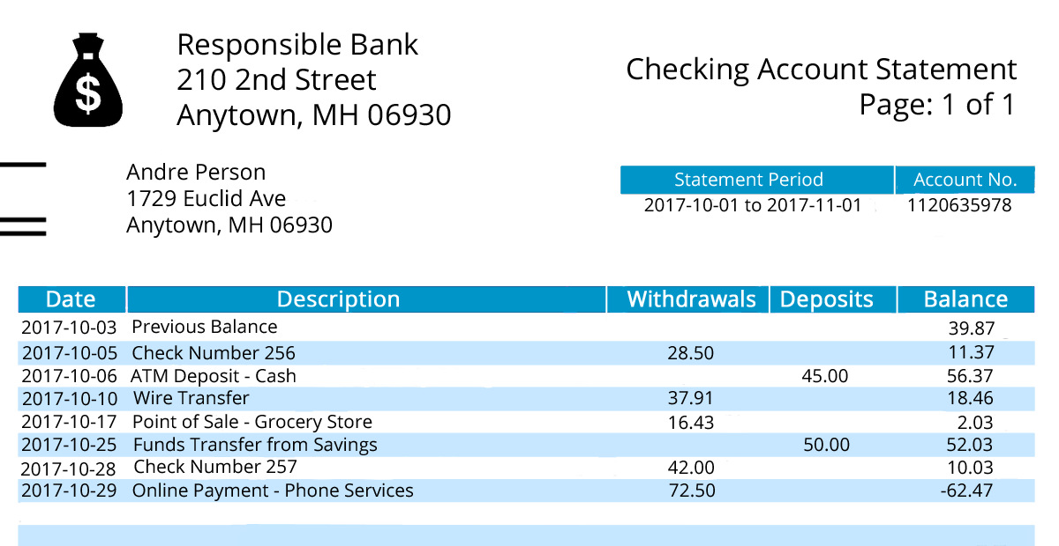
Money Bag Copyright Owner: security_man License: Public Domain Via: openclipart.org

- If we put withdrawals and deposits in the same column, how can they be represented?
- Andre withdraws $40 to buy a music player. What is his new balance?
- If Andre deposits $100 in this account, will he still be in debt? How do you know?

"Are you ready for more?"
The national debt of a country is the total amount of money the government of that country owes. Imagine everyone in the United States was asked to help pay off the national debt. How much would each person have to pay?

Activity 4.4 Cool Down (formative assessment)
Student-Facing Task Statement
- Clare has $150 in her bank account. She buys a bike for $200. What is Clare's account balance now?
- If Clare earns $75 the next week from delivering newspapers and deposits it in her account, what will her account balance be then?

For complete lesson materials as well as teaching tips for students with disabilities and English learners, visit the lesson website at OpenUp Resources https://im.openupresources.org/7/teachers/5/1.html.

Anticipated Responses/Strategies

Activity 4.1
Answers vary. Sample response:
- Since Priya owes the bank money, this could be represented by a negative number, -$15.
- Priya needs to earn $15 more. Sample explanations:
  - Because 150−135=15.
  - Because -15+15=0.
- Some students will say Priya will have $0 after she pays the money back. This assumes she will only work long enough to earn the money needed. Others could argue that we can’t determine that because we don’t know how much she earned.

Actvivity 4.2
Answers vary. Sample responses:
- 24+(-16)=n; n=8
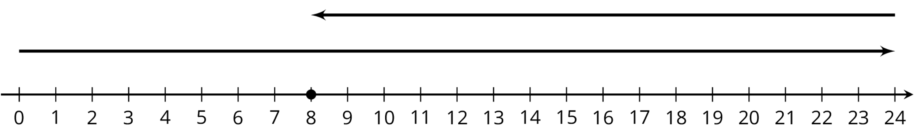

- 8+m=28; m=20
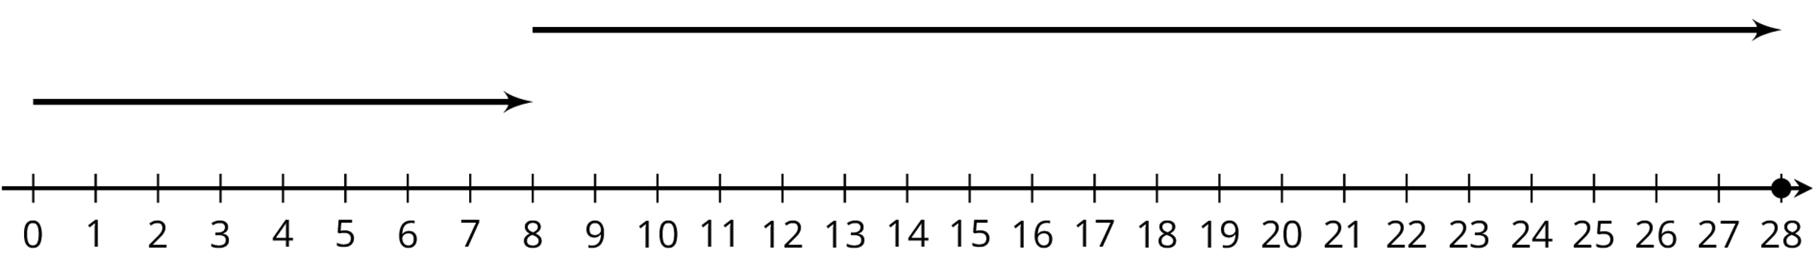

- 28+(-34)=p; p=-6
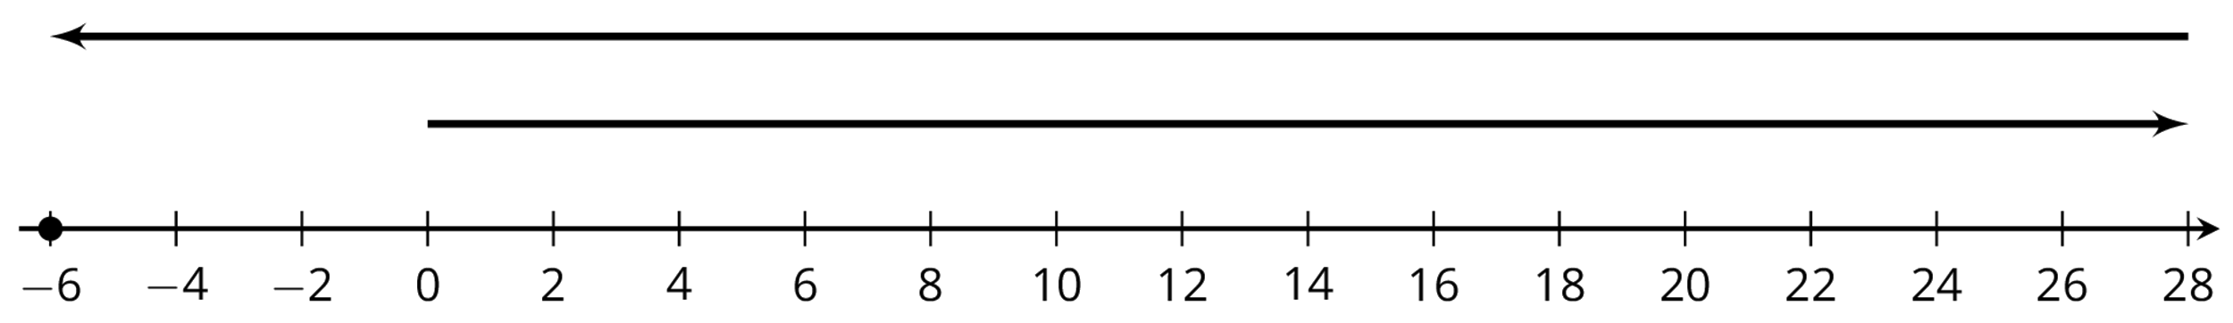

- (-6)+q=0; q=6
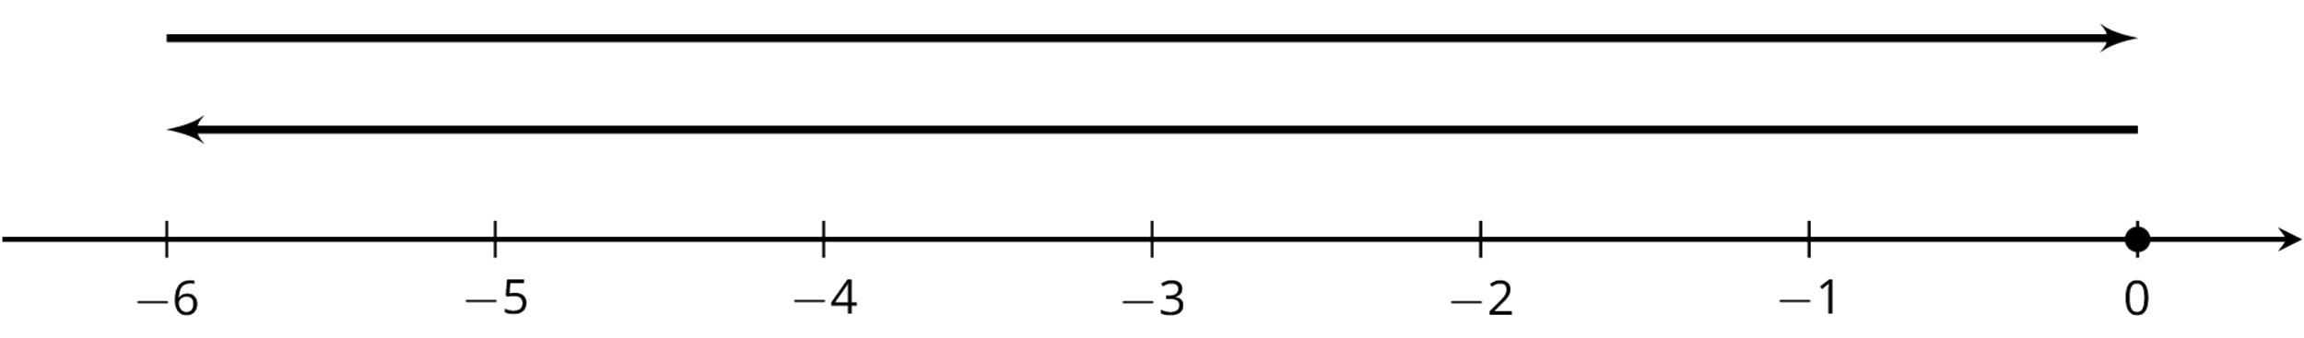
- It makes sense that his balance is negative because he must pay back a positive amount of money to get to zero and stop owing money.

Anticipated Conceptions
Some students may struggle to write an equation for each problem. Prompt them to identify what amount is unknown in each situation.

Activity Synthesis
The most important thing for students to understand is that all the rules they have learned for adding and subtracting signed numbers still work when applied to the context of negative amounts of money.
Review each of the following types of computations and discuss how they apply to the school cafeteria situations:
- Adding numbers with the same sign
- Adding numbers with opposite signs
- Adding opposites makes 0
- Subtracting as addition with a missing addend
- Subtracting as adding the additive inverse

Actvity 4.3
- We could use negative numbers to represent the withdrawals.
- Andre’s new balance will be -$102.47, because -62.47+(-40)=-102.47. Some students may take 40 from the -62.47 and get -22.47
- Yes, he will still be in debt. Sample explanations:
  - Because -102.47+100=-2.47
  - Because |-102.47|>|100|

"Are you ready for more?" Student Response
Answers vary as the population and national debt of the United States changes. If the population of the United States is about 326 million and the national debt is about $19.9 trillion, each person would have to pay about $61,000.

Activity Synthesis
The most important thing for students to understand is that the rules for adding and subtracting signed numbers can help them solve problems about debts.

Select students to share their solutions. Ask students to indicate whether they agree, disagree, or have any clarifying questions.

Lesson Synthesis
Main learning points:
- We can use positive numbers to represent payments into a bank account (deposits) and negative numbers to represent money taken out of an account (withdrawals).
- We can also use a negative balance to represent debt (owing money).
- We can use the additive inverse to quickly find how much money is needed to reach a balance of zero.
Discussion questions:
- What words do we use to mean "money added into" or "money taken out of" an account?
- How can we represent owing money?
- Why does it make sense to use negative numbers to represent debt?
- How can we tell how much money is needed to pay off a debt?

Activity 4.4
- Clare's balance is -$50.
- Clare's new balance is $25.

Task 3 - Applying the Properties of Operations
to Add and Subtract Rational Numbers
Framework  Cluster | Reasoning with Rational Numbers
Standard(s) | NC.7.NS.1 Apply and extend previous understandings of addition and subtraction to add and subtract rational numbers, using the properties of operations, and describing real-world contexts using sums and differences.
Materials/Link | EngageNY Grade 7 Mathematics Module 2, Topic A, Lesson 9
Learning Goal | - Apply properties of operations as strategies to add and subtract rational numbers.
Task overview
- Students use properties of operations to add and subtract rational numbers without the use of a calculator.
- Students recognize that any problem involving addition and subtraction of rational numbers can be written as a problem using addition and subtraction of positive numbers only.
- Students use the commutative and associative properties of addition to rewrite numerical expressions in different forms. They know that the opposite of a sum is the sum of the opposites; for example, -(3-4) = -3+4
Prior to lesson
- Students have previous experience using operations with positive and negative integers.
Teaching Notes
Task Launch:
- Students will complete a timed fluency exercise.
Directions:
- Students will complete three exercises as an exit ticket. All instructions are included in the teacher materials at the EngageNY link above. (https://www.engageny.org/resource/grade-7-mathematics-module-2-topic-lesson-9)

