Task 1 - “Sign” Your Name
Framework  Cluster | Reasoning with Rational Numbers
Standard(s) | NC.7.NS.1 Apply and extend previous understandings of addition and subtraction to add and subtract rational numbers, using the properties of operations, and describing real-world contexts using sums and differences.  SMP 6 Attend to precision.  SMP 8 Look for and express regularity in repeated reasoning.
Materials/Link | NC DPI Lessons for Learning pg. 8-11  - “Sign” Your Name handout  - Internet access to create a class Wordle of student names; http://www.wordle.net/  - (optional) Additional number lines for students whose name value is greater than the range on the number line provided.
Learning Goal | Students will use a number line to add and subtract integer values between -12 and 13.
Task overview
Given a table where each letter of the alphabet is assigned an integer value between -12 and 13, students will complete various tasks including finding the “value” of their name. Students will also integrate technology using the online tool Wordle.
Prior to lesson
- In 6th grade students learned to add and subtract integers between -20 and 20 using number lines and other models.
- Students should have an understanding that absolute value is the distance from zero on a number line.
Teaching Notes
Task Launch:
Show students the integer Wordle and discuss why some words appear larger and others appear smaller. Tell them that the activity today will allow them to create a class Wordle and they will mathematically determine the size of their names in the Wordle.
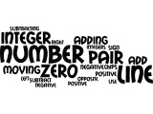
Directions:
- Provide students a copy of the “Sign” Your Name handout.
- Students should complete each question of the task to practice using a number line when adding integers.
- At the end of the lesson allow students to design a Wordle on the computer with the names of all students in the class.(http://www.wordle.net/)
- Use the absolute value of each student’s first name. Have each student type their first name in the Wordle the number of times that equals the absolute value of their name. Print out the class Wordle and display.
  - Example: JULIE = -3 + 8 + (-1) + (-4) + (-8) = -8; |-8| = 8
  - DAN = -9 + (-12) + 1 = -20; |-20| = 20
  - ALISAN = -12 + (-1) + (-4) + 6 + (-12) + 1 = -22; |-22| = 22
  - NANCY = 1 + (-12) + 1 + (-10) + 12 = -8; |-8| = 8
Julie will type her name 8 times in the Wordle program. Dan will type his name 20 times, Alisan 22 times and Nancy 8 times. The student whose name has the largest absolute value will appear the largest in the Wordle. The student whose name has the smallest absolute value will appear the smallest in the Wordle.
- Now have the students create a Wordle that will display the true value of their first name. Student names that have negative values will be typed in backwards to represent the additive inverse value. Since we cannot type a name in Wordle a negative amount of times, the issue of negatives will be addressed by adding one more than the absolute value of the smallest valued name.
  - Using the example above, ALISAN has the smallest valued name at -22. The absolute value of -22 is 22 then add one more to obtain a new value of 23. Adding 23 to each student’s first name value will ensure that the student with the lowest name value will appear as the smallest in the Wordle which will be equal to 1. This same rule will now be applied to all students in the class. Thus, JULIE now has a value of -8 + 23 or 15; DAN will be -20 + 23 or 3; ALISAN is now -22 + 23 or 1, and NANCY is now -8 + 23 or 15.
  - The amount added to each student’s name value will depend on the smallest value in each class. The end result should be that the student with the lowest name value will enter their name in the Wordle one time. Use the same process as in the previous Wordle by having students type their name in the Wordle program with their new value.
  - A cool twist is to have the students whose first name was originally negative (before adding 23 as in our example), type their name in backwards so that is will be clear on the Wordle that their name value was in fact negative.

Questions to Pose
Before:
- Can you predict which student’s name in our class will have the highest value when we apply the given code? Can you predict who will have the lowest valued name?
- What is your reasoning for your predictions?
During:
- What patterns did you notice when adding integers on the number line?
- Can we make some general rules for adding integers, those with like signs and those with different signs?
- Would the order of the values in a name matter when finding the total?
After:
- How does your name size on the absolute value Wordle compare to your name size on the adjusted true value Wordle?
- What is the reasoning for the change in your name size?
- What is the reasoning for some names being typed in backwards?

Student materials on following page

“Sign” your Name
Letter Value  A -12  B -11  C -10  D -9  E -8  F -7  G -6  H -5  I -4  J -3  K -2  L -1  M 0 | Letter Value  N 1  O 2  P 3  Q 4  R 5  S 6  T 7  U 8  V 9  W 10  X 11  Y 12  Z 13
Use the values for each letter in the charts above to find the amounts described below. Do not use a calculator. Use the provided number line and/or show your thinking.

- The value of your first name:

- The value of your middle name, if applicable:

- The value of your last name:

- The value of your entire name:

- The absolute value of your first name:

- The absolute value of your middle name, if applicable:

- The absolute value of your last name:

- The absolute value of your full name:

- The value and absolute value of your teacher’s last name:

Task 2 - Interpreting Negative Numbers
Framework  Cluster | Reasoning with Rational Numbers
Standard(s) | NC.7.NS.1 Apply and extend previous understandings of addition and subtraction to add and subtract rational numbers, using the properties of operations, and describing real-world contexts using sums and differences.
Materials/Link | Lesson from OpenUp Resources Grade 7 Lesson 5.1  - pre-printed slips, cut from copies of the blackline master  - Print and cut up slips from the Rational Numbers Card Sort blackline master. Prepare 1 copy for every 3 students. Students will need copies of both sets 1 and 2. Keep the slips from set 1 (Integers) separate from set 2 (Rational numbers that are not integers) for each group. Consider using different colors of paper so sets 1 and 2 are easier to separate.
Learning Goal | - Students will locate rational numbers on the number line, interpret positive and negative numbers in context and compare rational numbers.  - I can compare rational numbers.  - I can use rational numbers to describe temperature and elevation.
Task overview
In this lesson, students review what they learned about negative numbers in grade 6, including placing them on the number line, comparing and ordering them, and interpreting them in the contexts of temperature and elevation (MP2). The context of temperature helps build students’ intuition about signed numbers because most students know what it means for a temperature to be negative and are familiar with representing temperatures on a number line (a thermometer). The context of elevation may be less familiar to students, but it provides a concrete (as well as cultural) example of one of the most fundamental uses of signed numbers: representing positions along a line relative to a reference point (sea level in this case). The number line is the primary representation for signed numbers in this unit, and the structure of the number line is used to make sense of the rules of signed number arithmetic in later lessons.
Prior to lesson
- Students have previous experience ordering positive and negative integers using a number line.
Teaching Notes

Activity 1.1 Task Launch
The purpose of this warm-up is to remind students about negative numbers. The context of a weather thermometer works like a vertical number line. Students do not need to understand comparative temperatures in Celsius and Fahrenheit. The activity is written with temperatures in Celsius; however, the activity would work the same if the thermometer was labeled in Fahrenheit. These two different systems for measuring temperature is an opportunity to remind students that what counts as zero is arbitrary and was chosen by someone as some point. If desired, explain to students that 0° Celsius is the freezing point of fresh water and 0° Fahrenheit is based on the freezing point of saltwater.

Display the thermometer image for all to see. Explain that degrees Celsius is a way of measuring temperature, like degrees Fahrenheit—but it has a different zero point. Students may already know that 0° Celsius is based on the freezing point of water and 0° Fahrenheit on the freezing point of brine, but these were chosen by people; there’s no reason they had to be this way. Give students 1 minute of quiet think time to examine the picture before they start writing.
Student-Facing Task Statement
Here is a weather thermometer. Three of the numbers have been left off.
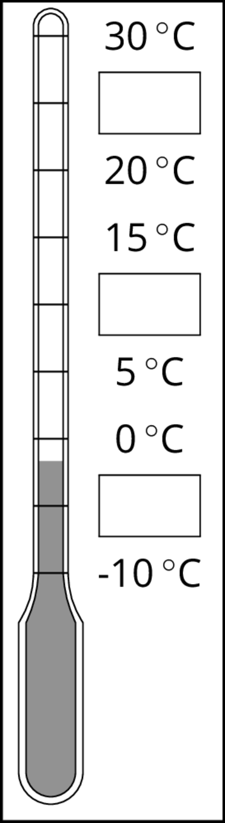

- What numbers go in the boxes?

- What temperature does the thermometer show?

Lesson Directions:
The lesson is comprised of 5 activities. Directions are included in the teacher materials and listed below.

Activity 1.2 Fractions of a Degree
In this activity, students return to the context of a thermometer to examine rational numbers that are not integers. Students compare and interpret the signed numbers to make sense of them in the context (MP2), including comparing a temperature that is not pictured to the temperatures that are pictured.
- Remind students of the warm-up problem about a weather thermometer. Instruct them to estimate when necessary.

Student-Facing Task Statement
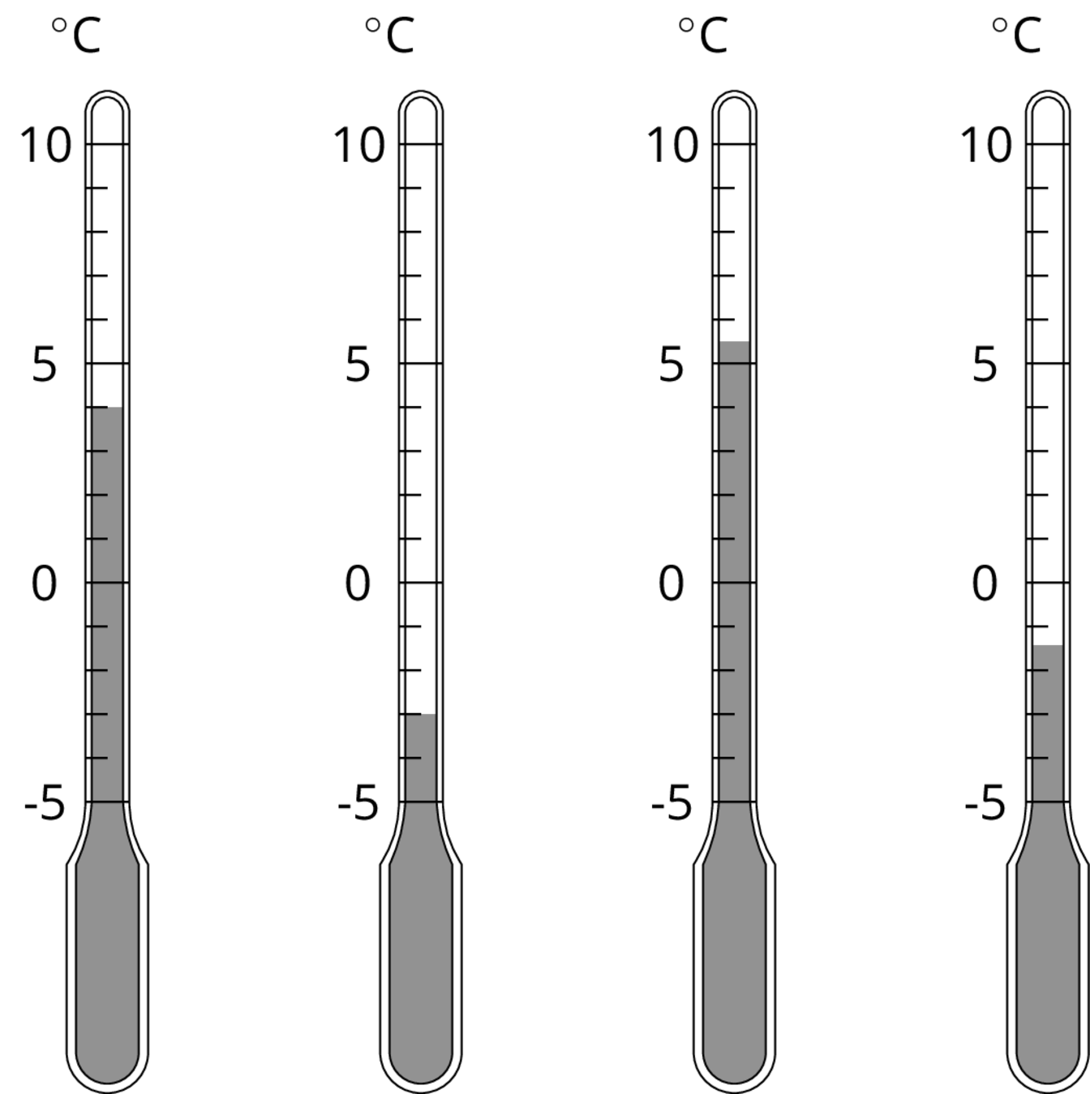
- What temperature is shown on each thermometer?

- Which thermometer shows the highest temperature?

- Which thermometer shows the lowest temperature?

- Suppose the temperature outside is -4∘C. Is that colder or warmer than the coldest temperature shown? How do you know?

Activity 1.3 Seagulls Soar, Sharks Swim
The purpose of this activity is for students to continue interpreting signed numbers in context and to begin to compare their relative location. A vertical number line shows the heights above sea level or depths below sea level of various animals. The number line is labeled in 5 meter increments, so students have to interpolate the height or depth for some of the animals. Next, they are given the height or depth of other animals that are not pictured and asked to compare these to the animals shown.

As students work, monitor for whether they are expressing relative distances in words, for example “3 meters below,” or if they are expressing the same idea with notation, as in -3 meters. Both are acceptable; these ideas are connected in the discussion that follows (MP2). Also monitor for students who notice that there are two possible answers for the last question.

Launch
Display the image for all to see. Tell students to measure the height or depth of each animal's eyes, to the nearest meter. Remind students that we choose sea level to be our zero level, in the same way that we chose a zero level for temperature.
Student-Facing Task Statement
Here is a picture of some sea animals. The number line on the left shows the vertical position of each animal above or below sea level, in meters.
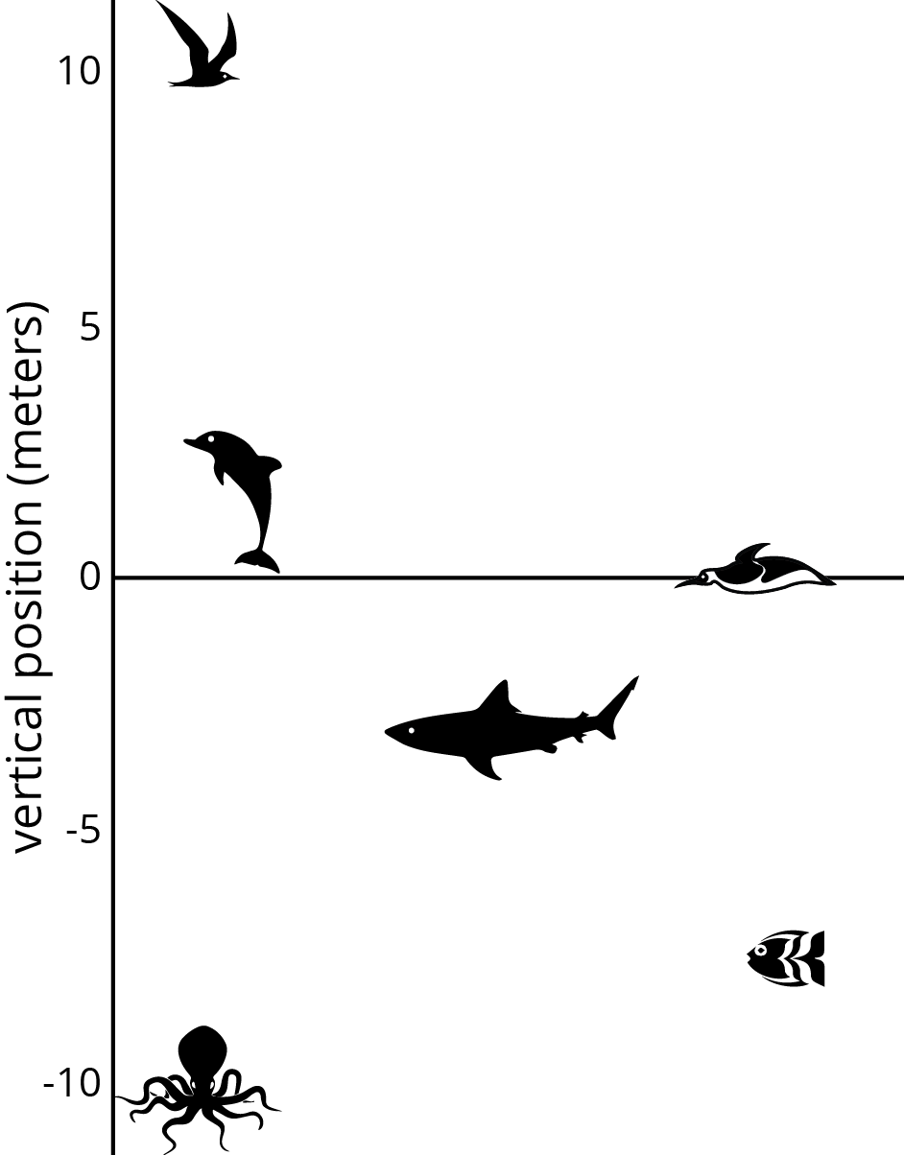

- How far above or below sea level is each animal? Measure to their eye level.

- A mobula ray is 3 meters above the surface of the ocean. How does its distance from the surface of the ocean compare to the vertical distance from the eyes of:
The jumping dolphin? The flying seagull? The octopus?

- An albatross is 5 meters above the surface of the ocean. How does its distance from the surface compare to the vertical distance from the eyes of:
The jumping dolphin? The flying seagull? The octopus?

- A clownfish is 2 meters below the surface of the ocean. How does its distance from the surface compare to the vertical distance from the eyes of:
The jumping dolphin? The flying seagull? The octopus?

- The vertical distance of a new dolphin from the dolphin in the picture is 3 meters. What is its distance from the surface of the ocean?

"Are you ready for more?"
The north pole is in the middle of the ocean. A person at sea level at the north pole would be 3,949 miles from the center of the earth. The sea floor below the north pole is at an elevation of approximately -2.7 miles. The elevation of the south pole is about 1.7 miles. How far is a person standing on the south pole from a submarine at the sea floor below the north pole?

Optional (but recommended) Activity 1.4 Card Sort: Rational Numbers
This activity reviews ordering integers first, and then rational numbers second. Many of the numbers also have their additive inverse in the set, which can help students use the structure of the number line to order the numbers.

The previous activities in this lesson used vertical number lines to help students make sense of negative numbers being below 0. It is important that students also feel comfortable working with horizontal number lines. As students work on ordering these slips, it is likely they will automatically make the transition to using a horizontal orientation. Watch for any groups that continue to use a vertical orientation and prompt them to consider whether they have really ordered their numbers from least to greatest.

Monitor for students who specifically compare the magnitudes of numbers and translate that into the correct number order (such as 2.5 > 2 so -2.5 < -2) are using the structure of the number line (MP7); ask them to share their reasoning in the whole-class discussion.

Launch
Arrange students in groups of 3. Distribute the first set of cards (integers) to each group. Instruct the students to put the cards in order from least to greatest. When a group has finished ordering the first set, give them the second set (rational numbers that are not integers) and have them add these in the correct locations.

Student-Facing Task Statement
- Your teacher will give your group a set of cards. Order the cards from least to greatest.

- Pause here so your teacher can review your work. Then, your teacher will give you a second set of cards.

- Add the new set of cards to the first set so that all of the cards are ordered from least to greatest.

Activity 1.5 Signed Numbers

Student-Facing Task Statement
Here is a set of signed numbers: 7, -3, 12, -0.8, 0.8, -110, -2

- Order the numbers from least to greatest.
- If these numbers represent temperatures in degrees Celsius, which is the coldest?
- If these numbers represent elevations in meters, which is the farthest away from sea level?

Anticipated Responses/Strategies:
Activity 1.1
Student Response
- 25, 10, -5
- About -2℃
Anticipated Conceptions
Some students may think the missing number between 0 and -10 needs to have a magnitude larger than -10, such as -15, because on the positive side of the number line, numbers increase in magnitude as you go up.

Activity Synthesis
Ask students to share their responses for the first question and explain their reasoning. After each response, ask students to indicate if they agree or disagree. If all students are in agreement, record and display the missing temperatures for all to see. If they disagree, have students explain their reasoning until they reach an agreement.
Ask students to share their responses to the second question. Because the thermometer is labeled in 5 degree increments, we have to estimate the temperature between 0∘ and −5∘. Ask students to explain their reasoning and record and display possible responses for all to see. Highlight student responses that include the following ideas:
- The location of negative numbers below 0.
The distance between numbers on the vertical number line.

Activity 1.2
- 4℃, -3℃, 5.5℃, -1.5℃
- The third thermometer
- The second thermometer
- It is colder because -4 < -3.
Anticipated Conceptions
Some students may struggle to estimate the temperature on the last thermometer, since it is between two markings. Ask them to tell what the temperature would be for the lines directly above and directly below the thermometer's level. Then ask what temperature would be halfway in between those two numbers.
Some students may struggle with comparing -4℃ to the temperatures shown on the thermometers. Prompt students to point out where -4℃ would be on the thermometer that is showing -3℃.

Activity Synthesis
Ask one or more students to share their response for the temperature for each thermometer. When discussing the last question, first have students explain their reasoning until they come to an agreement that -4℃ is colder than -3℃. Then, if not brought up in students’ explanations, introduce the notation -4 < -3 and remind students that this is read, "Negative 4 is less than negative 3." Explain that -4 is farther away from zero than -3 is, and point to the location of -4 on a thermometer to show that is it below -3. On the negative side of the number line, that means -4 is less than -3. Familiarity with less than notation will be useful for describing their reasoning in the next activity.

Activity 1.3
- Seagull is at 10 m. Dolphin is at 3 m. Octopus is at -10 m. Shark is at -3 m. Fish is at -7 m. Penguin is at 0 m.
- The mobula ray is
  - 0 m above the dolphin
  - 7 m below the seagull
  - 13 m above the octopus
- The albatross is
  - 2 m above the dolphin
  - 5 m below the seagull
  - 15 m above the octopus
- The clownfish is
  - 5 m below the dolphin
  - 12 m below the seagull
  - 8 m above the octopus
- Either 0 m or 6 m, depending on whether the new dolphin is 3 m above or below the dolphin in the picture.

Anticipated Conceptions
If students measure to the top or bottom of the animal, remind them that we are using the eyes of the animal to measure their height or depth.

Some students may struggle to visualize where the albatross, seagull, and clownfish are on the graph. Consider having them draw or place a marker where the new animal is located while comparing it to the other animals in the picture.
"Are you ready for more?" Student Response
About 7,897 miles.

Activity Synthesis
The main point for students to get out of this activity is that we can represent distance above and below sea level using signed numbers. The depths of the shark, fish, and octopus can be expressed as approximately -3 m, -6 m, and -7.5 m respectively, because they are below sea level.

Signed numbers can also be used to represent the relative vertical position of different pairs of animals. Have selected students share their responses and reasoning for how the heights of the albatross, seabird, and clownfish compare to the dolphin, seagull, and octopus. Record and display their verbal descriptions using signed numbers. For example, if a student says the albatross is 7 meters below the seagull, write "-7".
Finally, ask whether students noticed the ambiguity in the last question (about the height of the new dolphin). Ask such a student to explain why there are two possible answers to the last question.

Activity 1.4
- -23, -10, -9, -7, -6, -4, -3, -2, -1, 0, 1, 2, 3, 5, 8, 10, 11, 15, 22, 23
- No answer needed.
- -23, -2238, -313, -10, -9, -7.7, -7, -6, -556, -4, -3, -83, -2.5, -2, -98, -1, -14, 0, 14, 1, 98, 2, 2.5, 83, 3, 5, 556, 7.7, 8, 10, 313, 11, 15, 22, 2238, 23

Anticipated Conceptions
Some students may struggle with ordering the negative numbers. For example, they may put -2.5 to the right of -2 since they are used to seeing 2.5 to the right of 2. Help students visualize a number line and figure out which number should be farther away from 0.

Activity Synthesis
Select students to share their strategies when sorting. Highlight strategies that used the magnitudes of a number and its additive inverse.

Discuss:
- Which numbers were the hardest to order? Why?
- How did you decide where to put the fractions?
- How is, for example, -98 related to 98?

Introduce the convention that number lines are usually drawn horizontally, with the negative numbers to the left of 0. If any groups put their slips in order vertically, considering having them reposition their slips to match the orientation of a horizontal number line. Make sure students understand the meaning of the term “opposite” and absolute value notation.

Activity 1.5
- -3, -2, -0.8, -110, 12, 0.8, 7
- -3
- 7

For complete lesson materials as well as teaching tips for students with disabilities and English learners, visit the lesson website at OpenUp Resources https://im.openupresources.org/7/teachers/5/1.html.

Task 3 - Using Positive and Negative Numbers in Context
Cluster | Reasoning with Rational Numbers
Standard(s) | NC.7.NS.1 Apply and extend previous understandings of addition and subtraction to add and subtract rational numbers, using the properties of operations, and describing real-world contexts using sums and differences.  SMP 1 Make sense of problems and persevere in solving them.  SMP 2 Reason abstractly and quantitatively.  SMP 7 Look for and make use of structure.  SMP 8 Look for and express regularity in repeated reasoning.
Materials/Link | Mathematics Assessment Project - Using Positive & Negative Numbers in Context  - Each student will need a copy of the assessment task Temperature Changes and Temperature Changes (revisited), a copy of the Temperature Scale, a mini whiteboard, a pen, and an eraser.  - Each small group of students will need a set of cut-up cards from the sheets City Temperatures and Changes in Temperature, a glue stick, and a large sheet of paper for making a poster.  - The teacher will need one copy of the cut-up cards Introduction to Negative Numbers.
Learning Goal | Students will order, compare, add and subtract positive and negative integers.
Task Overview
Students will be expected to order, compare, add, and subtract positive and negative integers. Particular attention is paid to the use of negative numbers on number lines to explore the structures:
Starting temperature + Change in temperature = Final temperature
Final temperature – Change in temperature = Starting temperature
Final temperature – Starting temperature = Change in temperature
Prior to lesson
- Students have previous experience using operations with positive and negative integers.
- The students will begin with a pre-assessment to determine current understanding.
Teaching Notes:
This lesson provides students the opportunity to add and subtract integers in the context of temperature changes. Students will work individually and collaboratively to complete the task. Teachers should expect students to demonstrate understanding not only through computational fluency but also through sound reasoning.

All teaching and student materials are located on the Mathematics Assessment Project website http://map.mathshell.org/download.php?fileid=1625.

