Task 1 - Introducing Multiplication of Positive and Negative Integers
Framework  Cluster | Reasoning with Rational Numbers
Standard(s) | NC.7.NS.2 Apply and extend previous understandings of multiplication and division.  - Understand that a rational number is any number that can be written as a quotient of integers with a non-zero divisor.  - Apply properties of operations as strategies, including the standard algorithms, to multiply and divide rational numbers and describe the product and quotient in real-world contexts.  - Use division and previous understandings of fractions and decimals.  - Convert a fraction to a decimal using long division.  - Understand that the decimal form of a rational number terminates in 0s or eventually repeats.
Materials/Link | - Lesson from Connected Math Project 2 Accentuate the Negative Investigation 3  - (optional) blank number lines can be provided
Learning Goal | - Students will use a number line to develop a relationship between repeated addition and multiplication with integers.  - Develop and use algorithms for multiplying integers.
Task overview
This task uses the context of a relay race with repeated constant running speeds, distance and time to help students develop algorithms for multiplication. Students will use their intuition from the context to complete multiplication number sentences in cases involving negative numbers. They then generalize that reasoning to context-free multiplication.
Prior to lesson
- Students will have used a number line to add and subtract positive and negative rational numbers.
Teaching Notes
Task Launch:
Show students the following image:
At the Rio Olympics in 2016, South African Wayde van Niekerk broke American Michael Johnson’s world record in the men’s 400 meter race. Van Niekerk ran the race in 43.03 seconds.

American Florence Griffith Joyner still holds the women’s 100 meter record she set in 1988. She ran that race in 10.62 seconds.

How long would it take each runner to run 1,000 meters at his or her record speed?

Directions:
- Present students with the following image from the student materials:
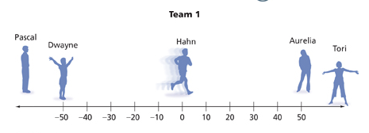
- Discuss the problem situation and be sure all students understand the context of the number relay race.
- Have students walk through a simulation. Ask clarifying questions to ensure understanding.
  - How far does each racer run?
  - Explain the first leg of the relay.
- Do 1a. in problem A with the students.
  - What does 5 meters per second mean?
  - Which way is he running? Left or right? Positive or negative?
  - What number sentence could you write to show where Hahn will be 10 seconds later?
  - What do the 5 and the 10 stand for?
  - Suppose Hahn were running 5 meters per second to the left. How would this change the number sentence?
  - What do the -5, 10 and -50 indicate?
- Allow students to work in pairs then move to small groups.
- Make sure students are writing complete mathematical sentences.
- If students are struggling, summarize problem A before going on to problem B.
- If students have not done any work with chipboards (this may have occurred in 6th grade), you may have to work through problem B together.
- Students should work on problems C, D, & E in pairs or small groups.
- Some students may not get to the conceptual understanding in problem E. If that is the case, let those students share their responses and reasoning for problem C. This will build confidence and support learning.
Summarize:
- Have students share their number sentences for problem A. Analyze how the addition and multiplication sentences are related. With part 2 ask:
  - What number sentences did you write for part 2?
  - What does 5 x 4 mean?
  - What does multiplication mean?
- Draw students’ attention to patterns with the combinations of positive and negative signs. For problem A part 3:
  - What number sentences did you write for part 3?
  - Here you have a positive times a negative. Why is the result negative?
  - What does 8 x (-6) mean?
- As students describe their number sentences, note the sign patterns.
  - In problem A part 5, you have a negative direction and a negative time. Why does it make sense that this means Tori is at a positive position on the racing field?
- Have students present their algorithms.
  - What is happening when you multiply a positive number by a negative number? A negative times a negative?
  - If you had a negative times a negative times a negative would the results be negative or positive?
  - Is multiplication commutative for negative numbers?

Student materials below
Multiplication Patterns With Integers

The math department at Everett Middle School sponsors a contest called the Number Relay Race. A number line measured in meters is drawn on the school field. Each team has five runners. Runners 1, 3, and 5 stand at the −50-meter line. Runners 2 and 4 stand at the 50-meter line.

For Team 1:
- Hahn starts and runs from −50 to 50. He tags Aurelia.
- Aurelia runs back from 50 to −50. She tags Dwayne.
- Dwayne runs from −50 to 50. He tags Tori.
- Tori runs from 50 to −50. She tags Pascal.
- Pascal runs from −50 to the finish line at position 0.

Team 2 does the same with its 5 runners. Both teams line up on the same number line and start the race at the same time.

The team whose final runner reaches the 0 point first wins.

Problem A
- Write and solve a number sentence for each situation. Use positive numbers for running speeds to the right, and use negative numbers for running speeds to the left. Use positive numbers for time in the future, and use negative numbers for time in the past. (Note: Each runner runs at a constant speed.)
  - Hahn passes the 0 point running 5 meters per second to the right. Where will he be 6 seconds later?

  - Aurelia passes the 0 point running to the left at 6 meters per second. Where will she be 8 seconds later?

  - Dwayne passes the 0 point running 4 meters per second to the right. Where was he 6 seconds earlier?

  - d. Tori passes the 0 point running to the left at 5 meters per second. Where was she 7 seconds earlier?

- Determine whether the answer to each situation in part (1) is to the left or right of zero.

Problem B
Kalman wants to use red and black chips to model the relay race. He draws the following chip board to represent Aurelia's part of the race. How does this chipboard relate to your work on Aurelia's part of the relay race? Explain.

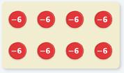

Problem C
- After studying the relay race problem, some students started looking for number patterns to see if what they found in the race made sense. How do the products change as the numbers multiplied by 5 decrease?
5 x 3 = 15 5 x 2 = 10 5 x 1 = 5 5 x 0 = 0

- Predict the following products. Explain your reasoning.
  - 5 x ( − 1 ) =
  - 5 x ( − 2 ) =
  - 5 x ( − 3 ) =

Problem D
- Find each product. How do the products change as the numbers multiplied by −4 decrease?
  - − 4 x 3 =
  - − 4 x 2 =
  - − 4 x 1 =
  - − 4 x 0 =

- Predict the following products. Explain your reasoning.
  - − 4 x ( − 1 ) =
  - − 4 x ( − 2 ) =
  - − 4 x ( − 3 ) =

Problem E
- The product −4(−12) represents the location of a runner in the Number Relay. What question does the product answer? What location does it specify?

- The product 4(−12) represents the location of a runner in the Number Relay. What question does the product answer? What location does it specify?

- How do the locations in parts (1) and (2) relate to each other?

Anticipated Responses/Strategies
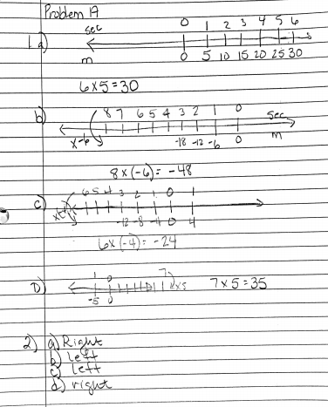
Sometimes it is difficult for students to get started on this task due to limited exposure to a double number line. You may have to help some students get started.
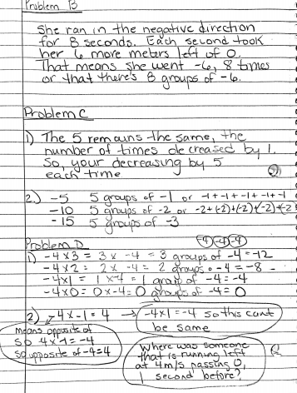
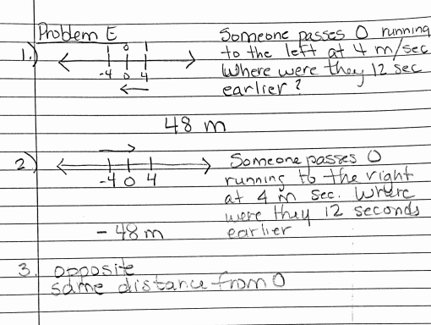

Possible conceptions and/or understanding
- The lesson makes the connection between repeated addition and multiplication. When writing number sentences, be sure students are writing multiplication sentences and not repeated addition sentences.
- Students may write expressions instead of complete number sentences.
- Clarification may be needed for part 4 of problem A. Students may not understand the representation of a negative number in regards to time. Remind them in the context of this problem, negative numbers are used to represent time in the past.

Task 2 - Multiplication of Rational Numbers
Cluster | Reasoning with Rational Numbers
Standard(s) | NC.7.NS.2 Apply and extend previous understandings of multiplication and division.  - Understand that a rational number is any number that can be written as a quotient of integers with a non-zero divisor.  - Apply properties of operations as strategies, including the standard algorithms, to multiply and divide rational numbers and describe the product and quotient in real-world contexts.  - Use division and previous understandings of fractions and decimals.  - Convert a fraction to a decimal using long division.  - Understand that the decimal form of a rational number terminates in 0s or eventually repeats.
Materials/Link | - Lesson adapted from Connected Math Project 2 & 3 Accentuate the Negative Investigation 3  - (optional) blank number lines can be provided
Learning Goal | - Students will examine number patterns to confirm the algorithm for multiplication.
Task overview
Students will look at patterns of integer multiplication as another way to confirm how the signs should behave in multiplication situations with integers.
Prior to lesson
- In the last task, students developed an algorithm for multiplying positive and negative integers.
Teaching Notes
Task Launch:
- Display the series of equations for students to observe, including the next three in the series.
5 x 5 = 25
5 x 4 = 20
5 x 3 = 15
5 x 2 = 10
5 x 1 = 5
5 x 0 = 0
Ask students the following:
- What patterns do you notice?
- How do the products change as the numbers multiplied by 5 get smaller?
Predict 5 x (-1), 5 x (-2) and 5 x (-3). Explain your reasoning.
Write the next four equations in the pattern.

Questions:
- What patterns do you notice?
- How do the products change as the numbers multiplied by 5 get smaller?

- Which of the following products will have the same value?
4 x 5 4 x (−5) −4 x 5 −4 x (−5)

Directions:
- Allow students to work in pairs or small groups to complete the task.
- As students work, pay attention to the patterns they are noticing.
- Continuously ask students to explain their reasoning. Ensure they are noticing the patterns which will help them make connections and develop the appropriate algorithms.

Summarize:
Have students share their observations and solutions explaining why they are reasonable and how they fit the patterns noticed.
As the following questions:
- If one factor is 0, what will the product be? Is this always true?
- Multiplying two positive factors resulted in a positive product. Is this always true? Does a positive factor times a positive factor always give a positive product?
- Multiplying a positive factor by a negative factor resulted in a negative product. Is this always true? Does a positive factor times a negative factor always give a negative product?
- What is the sign of the product when two negative factors are multiplied? Is this always true?
- When you multiply three numbers together, how do you look at the signs to predict the sign of the product?
- Regardless of their signs, is the numerical value of the product of two numbers always the product of the two numbers?
- How do you find the sign of the product?

Multiplication of Rational Numbers

Problem A
      - What do the examples in each group below have in common?

Group 1 | Group 2 | Group 3
4 x 3 | 4 x (−3) | −4 x (−3)
5.1 x 1 | −5.1 x 1 | −5.1 x (−1)
3 x 4½ | 3 x ( − 4½) | − 3 x ( − 4½)

2. Find the products in each group above.

3. Write and solve two additional problems for each group.

Problem B
Find the products in each group below. Is multiplication commutative?
2 × 3 and 3 × 2
− 2 × ( − 3 ) and − 3 × ( − 2 )
− 2 × 3 and 3 × ( − 2 )

Problem C
- Describe an algorithm for multiplying two positive rational numbers.

- Describe an algorithm for multiplying a positive rational number and a negative rational number.

- Describe an algorithm for multiplying a negative rational number and a negative rational number.

Problem D
- For each product, predict the sign. Then find the product.
  - 7 x (−8) x (−3)

  - −12 x (−5) x (−4)

  - ½ x (−2/3) x 3

- Explain how you used what you know about multiplying two rational numbers to multiply three rational numbers.

Problem E
- Predict whether the sign of each product is positive or negative. Explain your reasoning.
  - 2 x 3 x 4 x 5

  - 2 x (−3) x 4 x 5

  - 2 x (−3) x 4 x (−5)

  - −2 x (−3) x 4 x (−5)

  - −2 x (−3) x (−4) x (−5)

- Find each product in part (1). Check whether your predictions are correct.

- Explain how to determine whether a product will be positive or negative.

Anticipated Responses/Strategies
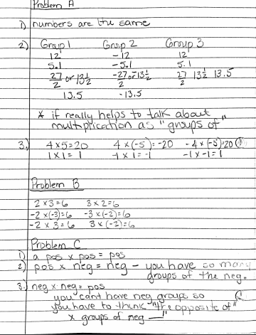
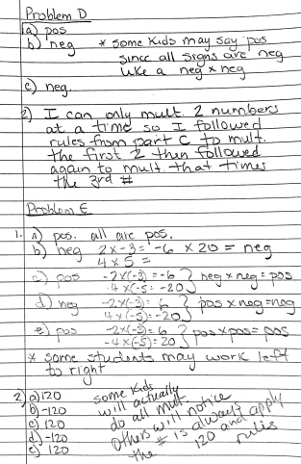

Possible conceptions and/or understanding
- Students may struggle with multiplying a negative by a negative. If so, point them back to the number sentences. Ask them to consider what the number sentence is saying and what seems reasonable.
- When multiplying positive and negative numbers, students may focus too much on the signs and not pay attention to the multiplication. Remind students the product of the numbers remains the same. Redirect them to what they know about absolute value and remind them the absolute value of the solution is the product of the absolute value of the factors.

Task 3 - Division of Rational Numbers
Cluster | Reasoning with Rational Numbers
Standard(s) | NC.7.NS.2 Apply and extend previous understandings of multiplication and division.  - Understand that a rational number is any number that can be written as a quotient of integers with a non-zero divisor.  - Apply properties of operations as strategies, including the standard algorithms, to multiply and divide rational numbers and describe the product and quotient in real-world contexts.  - Use division and previous understandings of fractions and decimals.  - Convert a fraction to a decimal using long division.  - Understand that the decimal form of a rational number terminates in 0s or eventually repeats.
Materials/Link | - Lesson adapted from Connected Math Project 2 & 3 Accentuate the Negative Investigation 3  - (optional) blank number lines can be provided
Learning Goal | - Recognize and solve problems involving multiplication and division found in fact families.  - Develop algorithms for dividing rational numbers.
Task overview
- Students will explore division of rational numbers using the relationship between multiplication and division found in fact families.
Prior to lesson
- Students have developed an algorithm for multiplying rational numbers.
Teaching Notes
Task Launch:
Write the following on the board:
36 ➗4 = 9
- What does this sentence mean? (This equation means there are 36 things that are put into 4 groups of equal size and there will be 9 things in each group - sharing reasoning. Or it can be thought about as putting 36 things into groups of 4 and finding there are enough to make 9 groups of 4 - grouping reasoning.)
- How are the operations of multiplication and division related?
- If multiplication and division are opposite operations that undo each other, what number sentence would undo the sentence 3 x 12 = 36?
Once students are making sense of this relationship, remind students they used fact families to write related addition and subtraction sentences in order to make sense of subtracting integers. Explain they will use fact families and their understanding of the relationship between multiplication and division to do this task. They will also find patterns that will help them predict the quotient of any two numbers.

Directions:
- As students work, listen to the patterns they are noticing. If they are struggling, you might stop them after problem A to summarize what they have done and patterns they have noticed.
- As students share their solutions and reasoning, allow for disagreements and the conversations stemming from them. Make sure students are demonstrating their reasoning with examples.
- Facilitate a conversation to help students generalize rules for dividing positive and negative rational numbers. Look for opportunities to talk about fact families and the relationship between multiplication and division.
- Use questions such as these to facilitate discussion:
  - How did you decide if the quotient is positive or negative?
  - How are multiplication problems related to division problems?
  - How can you use your algorithm for multiplication to decide whether the quotient is positive or negative?
  - Why is the rule “a negative divided by a negative is positive” reasonable?
  - How can you find the quotient when you divide a negative number by a positive number?
  - How can you find the quotient when you divide a positive number by a negative number?
  - We have found addition and multiplication are commutative. Is division commutative?
Student materials follow

Division of Rational Numbers

You know there is a relationship between addition and subtraction facts. A similar relationship exists between multiplication and division. For any multiplication fact, we can write another multiplication fact and two different related division facts. Here are three examples of rational-number fact families.
Remember you can write 15 ➗ 3 as a fraction, $\frac{15}{3}$

Example 1 | Example 2 | Example 3
5 x 3 = 15 | 6 • (−3) = −18 | 4.5 • (−2) = −9
3 x 5 = 15 | −3 • 6 = −18 | −2 • 4.5 = −9
15 ÷ 3 = 5 or $\frac{15}{3}$ = 5 | − 18 ÷ ( − 3 ) = 6 ​ or $\frac{-18}{-3}$= 6 | − 9 ÷ ( − 2 ) = 4.5 or $\frac{-9}{-2}$ = 4.5
15 ÷ 5 = 3 or $\frac{15}{5}$= 3 | − 18 ÷ 6 = (-3) ​ or $\frac{-18}{6}$= -3 | − 9 ÷ 4.5 = -2 or $\frac{-9}{4.5}$ = -2

Fact families help to clarify why division by zero is impossible. If 15 ÷ 0 = a, then a · 0 = 15 and 15 ÷ 0 = a are in the same fact family.
- How does a fact family show that 15 ÷ 0 = a cannot be a true statement for any value of a?

Problem A Use what you know about fact families and multiplication to rewrite, if necessary, and find the missing value. Then find the missing value.
- −6 × (−13) =
- 6 × (−13) =
- × (−9) = 108
- 8 × = −48

Problem B The team in the number relay problem runs another relay. Write division sentences that express your answers to the questions below.
- Dwayne goes from 0 to 15 meters in 5 seconds. At what rate (meters per second) does he run?

- Pascal reaches −12 meters only 3 seconds after passing 0. At what rate does he run?

- Aurelia passes 0 running to the right at a rate of 5 meters per second. When did she leave the point −50? When did she leave the point −24?

- Tori wants to reach the point −40, running to the left at 8 meters per second. How long will it take her from the time she passes 0?

Problem C
- What do the examples in each group have in common?
Group 1 | Group 2 | Group 3
12 ÷ 3 | 12 ÷ (−3) | −12 ÷ (−3)
4.5 ÷ 9 | −4.5 ÷ 9 | −4.5 ÷ (−9)
2¼ ÷ ½ | 2¼ ÷ (− ½) | −2¼ ÷ (−½)

- Find the quotients in each group above.

- Write and solve two additional problems for each group.

- Describe an algorithm for dividing rational numbers.

Problem D
- Find the quotients in each group below. Is division commutative?
  - − 2 ÷ 3 and 3 ÷ ( − 2 )
  - − 12 ÷ ( − 4 ) and − 4 ÷ ( − 12 )
  - 16 ÷ 8 and 8 ÷ 16
- Give two other examples to support your answer to part (1).

Problem E
- Zero is the additive identity for addition. For example, 0 + a = a, where a is a rational number. Explain in words what this means. Provide an example.

- Is there a multiplicative identity n such that a · n = a for any rational number a? Explain.

Problem F
- Each rational number has an additive inverse. For example, a + (−a) = 0, where a is a rational number. Explain in words what this means. Provide an example.

- Is there a multiplicative inverse b, such that a × b = 1, for each rational number a? Explain.

Problem G Use properties of multiplication and division to find each value. State which properties you use.
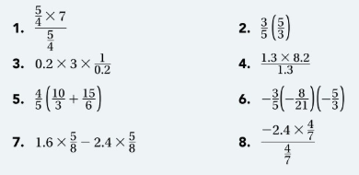

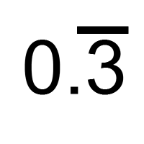
Problem H Recall that some fractions have decimals that terminate. For example, 3/4 = 0.75. Other fractions have decimals that repeat. For example, 1/3 = 0.333… = . The 3 repeats.

- State whether each fraction will terminate or repeat. Then write each fraction as a decimal.
  - ⅖
  - ⅜
  - − ⅚
  - 35/10
  - 8/−9
  - − 3/−11

- List two other fractions that will terminate and two that will repeat. Give their decimal representations.

Note on Notation You know that a rational number is any number that you can write in the form p/q, where p and q are integers and q ≠ 0. When a rational number is negative, the negative sign can be associated with the numerator, the denominator, or the entire fraction. For positive integers a and b,
−a/b = a/−b = − a/b

For example, suppose a = 6 and b = 2.
−6/2 = 6/−2 = −6/2 = −3

Anticipated Responses/Strategies

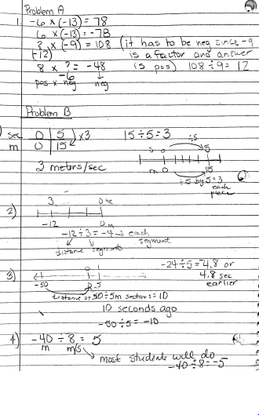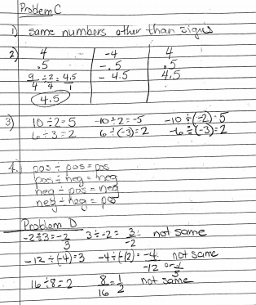
Problem E
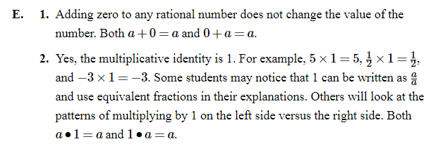

Problem F
