Task 1 - I Have, Who Has
Cluster | Reasoning with Rational Numbers
Standard(s) | NC.7.NS.1 Apply and extend previous understandings of addition and subtraction to add and subtract rational numbers, using the properties of operations, and describing real-world contexts using sums and differences.  NC.7.NS.3 Solve real-world and mathematical problems involving the four operations with rational numbers. (NOTE: Computations with rational numbers extend the rules for manipulating fractions to complex fractions.)
Materials/Link | - I Have, Who Has cards printed and cut apart - one per student  - There are blank cards in case the teacher needs to make more so each student will have one.  - Suggestion: Print on cardstock and laminate. These are good to have on hand for a quick review throughout the year.
Learning Goal | Students will apply previous learning to add and subtract positive and negative integers without the use of a calculator.
Task overview
Students will be playing the game I Have, Who Has
Prior to lesson
- Students will have learned to add and subtract positive and negative integers
Teaching Notes
Task Launch:
Give the students the following and allow them to work in pairs to come up with as many solutions as possible.

Directions: Using the numbers 1 to 9 at most once each time, fill in the blanks to make the statement true:
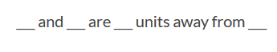
(one possible solution 3 and 7 are 2 units away from 5)

Directions:
- Explain the rules of the game to students. Tell them this is a mental math exercise and they should respect wait time.
- Give every student at least one card. If necessary, some students may have more than one card. All cards must be distributed.
- Choose one student to start. They will read the “Who has” part of the card.
- The student with the answer must respond I Have _____, then read the “Who has” part of his/her card.
- This continues until the first student answers with the I Have part of his/her card.
Suggestion
You may want to have each student keep a running total on a piece of paper or on a white-board to monitor engagement.

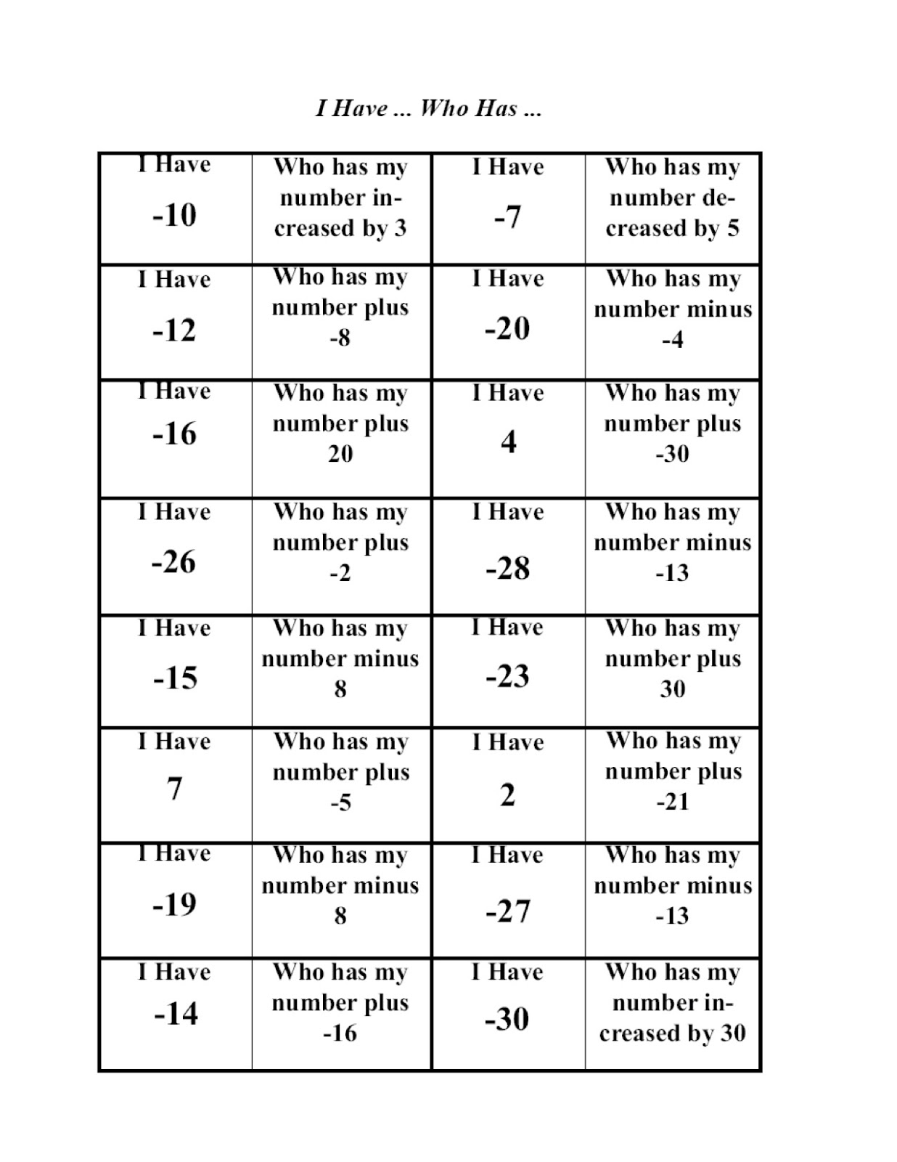
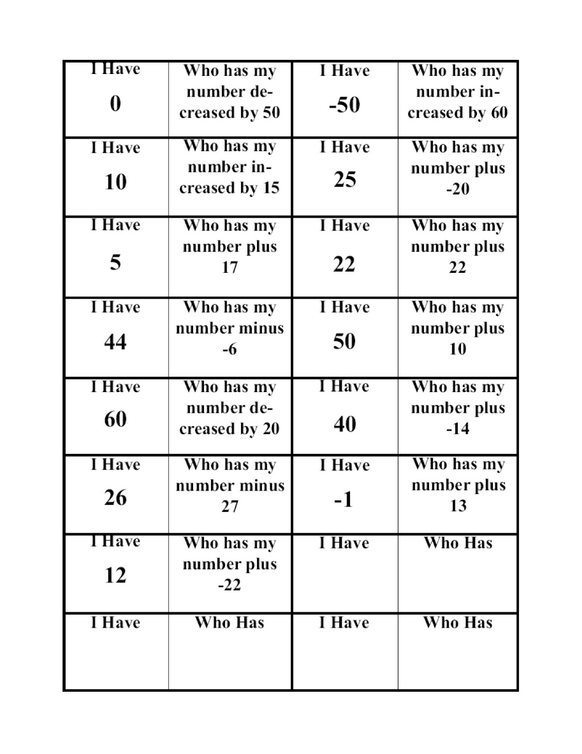

Task 2 - The Integer Product Game
Cluster | Reasoning with Rational Numbers
Standard(s) | NC.7.NS.3 Solve real-world and mathematical problems involving the four operations with rational numbers. (NOTE: Computations with rational numbers extend the rules for manipulating fractions to complex fractions.)
Materials/Link | Each pair of students needs:  - One game board  - Two paper clips  - Colored markers or chips (2 colors)  Suggestion: Print game boards on cardstock and laminate. These are good to have on hand for a quick review throughout the year.  If digital devices are available, students can play online here:  http://media.pearsoncmg.com/curriculum/math/cmp3/activities/A82388/index.html
Learning Goal | - Students will apply multiplication and division algorithms in the Integer Product Game.
Task overview
Students will play the Integer Product Game either online or on paper. The game requires students to multiply and divide positive and negative integers and have an understanding of factors.
Prior to lesson
- Students have developed algorithms for adding, subtracting, multiplying, and dividing integers.
Teaching Notes
Task Launch:
Give the students the following and allow them to work in pairs to come up with as many solutions as possible.

Using the numbers 1 to 9 at most once each time, fill in the blanks to make the equality true:
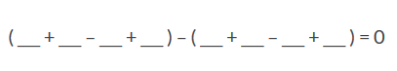
Directions:
- Explain the rules of the game.
- Allow students to play several rounds of the game.
- Encourage them to look for strategies for picking factors and products.
- Have students answer the questions on the student sheets.
- Allow time for students to share their responses, particularly about strategies used.
- If there is time, allow students to play more rounds of the game.

Rules
- Player A puts a paperclip on a number in the factor list.
- Player B puts the other paper clip on any number in the factor list, including the number chosen by Player A. Player B then marks the product of the two factors on the product grid.
- Player A moves either one of the paper clips to another number. He or she then marks the new product with a different color than Player B.
- Each player takes turns moving a paper clip and marking a product. A product can only be marked by one player.
- The winner is the first player to mark four squares in a row (up and down, across, or diagonally).
  - What product would give the least number?
  - What product would give the greatest number?

Student materials below

The Integer Product Game

-36 | -30 | -25 | -24 | -20 | -18
-16 | -15 | -12 | -10 | -9 | -8
-6 | -5 | -4 | -3 | -2 | -1
1 | 2 | 3 | 4 | 5 | 6
8 | 9 | 10 | 12 | 15 | 16
18 | 20 | 24 | 25 | 30 | 36

-6 -5 -4 -3 -2 -1 1 2 3 4 5 6

The Integer Product Game

Play the Integer Product Game with positive and negative factors. Look for strategies for picking the factors and products.

- What strategies did you find useful in playing the game? Explain.

- What pair(s) of numbers from the factor list will give each product?
  - 5

  - −12

  - 12

  - −25

- Your opponent puts a paper clip on −4. List five products that you can form, assuming they are not marked. Tell where you would need to put your paper clip in each case.

- Describe the moves to make in each case.
  - The paper clips are on −5 and −2. You want a product of −15.

  - The paper clips are on −3 and −2. You want a product of −6.

  - Your opponent will win with 24. What numbers should you avoid with your paper clip moves?

- Mia thinks the game could also be called the Division Game. Explain why Mia might think this.

Anticipated responses/strategies:

Part A
- Even products have more factors
- Signs really don’t matter in selecting factors
- If my partner made an positive product, I tried to make a negative in the beginning and vice versa
- If my partner made an odd product, I tried to make and even and vice versa
- I tried to start with a product that had the most factors
Part B
- 1,5 and -1,-5
- -2, 6 and 2, -6 and -3,4 and 3, -4
- 2,6 and -2,-6 and -3,-4 and 3,4
- -5,-5
Part C
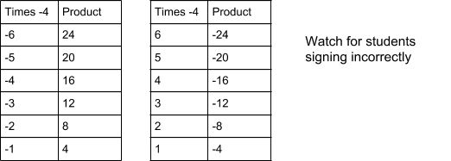

Part D

- Move the clip to 3
- Move the clip on -3 to 3 or move the clip from -2 to 2
- 6,4,3,-6,-4,-3 - They are factors of 24

Task 3 - Tasks Around the Room
Cluster | Reasoning with Rational Numbers
Standard(s) | NC.7.NS.3 Solve real-world and mathematical problems involving the four operations with rational numbers. (NOTE: Computations with rational numbers extend the rules for manipulating fractions to complex fractions.)
Materials/Link | - Task cards printed, cut apart and numbered  - Clipboards (one per student) or student notebooks, whichever is least cumbersome and easy to carry around the room  - Suggestion: Print on cardstock and laminate. These are good to have on hand for a quick review throughout the year.
Learning Goal | - Students will solve real-world mathematical problems involving the four operations with rational numbers.
Task overview
The students will travel around the room solving various tasks. The tasks require students to write a numerical expression and solve using all four operations with rational numbers.
Prior to lesson
- Students have developed algorithms for adding, subtracting, multiplying and dividing rational numbers.
Teaching Notes
Task Launch:
Give the students the following and allow them to work in pairs to come up with as many solutions as possible.

Directions: Using the numbers -5 to 5 at most once each, write an expression that will have the greatest (or least) absolute value.
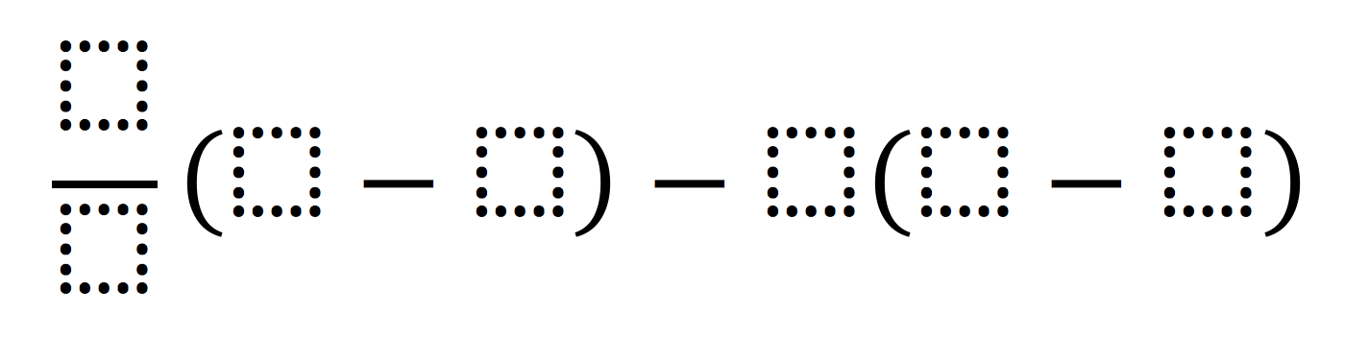
Directions:
- Before students arrive, place the task cards in various locations around the room. If possible, leave enough space for students to work.
- Students can work individually or in pairs.
- Explain to students there are various tasks located around the room. They will be moving around the room to solve.
- Students should solve the task on their own paper or in notebooks (teacher preference).
- Assign students a number to start with and tell them to move sequentially. For example, if a student begins with #14, they will move to #15 next. This should help keep too many students from being at the same card at once.
- Monitor students to ensure they are creating numerical expressions that represent the problem accurately.

Student materials below

Write a numerical expression that models your solution and then write a complete sentence stating your answer.  The temperature rose 13 ̊ F between noon and 5:00 p.m. and then fell 7̊ F from 5:00 p.m. to 10:00 p.m. If the temperature at noon is 75̊ F, what would the temperature be at 10:00 p.m.? | Write a numerical expression that models your solution and then write a complete sentence stating your answer.  Paola was standing on top of a cliff 35 feet above sea level. She watched her friend Juan jump from the cliff to a depth of 12 feet into the water. How far apart are the two friends? | Write a numerical expression that models your solution and then write a complete sentence stating your answer.  Eli left school and walked 5 blocks south. Chloe left school and walked the same distance north. How far apart did the two friends end up?
Write a numerical expression that models your solution and then write a complete sentence stating your answer.  Daniel and his mother flew from Miami, Florida to Maine to visit family. When they left Miami, the temperature was 84°. When they arrived in Maine it was –7°. What was the temperature change Daniel and his mother? | Write a numerical expression that models your solution and then write a complete sentence stating your answer.  The Panthers got possession of the football on their own 35 yard line. They ran for an 8 yard gain. The next play was a 13 yard loss. What is their field position after the two plays? | Write a numerical expression that models your solution and then write a complete sentence stating your answer.  Caroline has $85 in her bank account. After she went shopping, she looked at her account again and she had –$16. How much did she spend shopping?
Write a story problem you could model with positive and negative numbers, then model and solve. | Write a numerical expression that models your solution and then write a complete sentence stating your answer.  Mr. Jenkins lives in Michigan. When he leaves for work one wintry morning, the temperature is −4° C. By the time he comes home, the temperature has increased 25°. What is the temperature when he comes home? | Write a numerical expression that models your solution and then write a complete sentence stating your answer.  Sam borrowed $7 from his brother every week for 5 weeks. What is Sam’s financial situation with his brother at the end of the 5 weeks?

Write a numerical expression that models your solution and then write a complete sentence stating your answer.  Erika borrowed $5 each from 6 different friends. How much money does Erika owe her friends altogether? | Write a numerical expression that models your solution and then write a complete sentence stating your answer.  The temperature decreased 2º per hour for six hours. How many degrees did the temperature decrease after six hours? | Write a numerical expression that models your solution and then write a complete sentence stating your answer.  During a shark week special, a diver descended 2.5 feet every minute. How many feet will he descend in 10 minutes?
Write a numerical expression that models your solution and then write a complete sentence stating your answer.  During a trivia contest, a team receives 50 points for every correct answer and loses 45 points every time they get a question incorrect. After a new game of 30 questions, the team misses 16 questions. How many points did they have at the end of the game? | Write a numerical expression that models your solution and then write a complete sentence stating your answer.  An oven temperature dropped 225º in 25 minutes. If the temperature dropped at a constant rate, how many degrees per minute did the temperature drop? | Write a numerical expression that models your solution and then write a complete sentence stating your answer.  You are playing Fortnite and you have 75 wood, 29 brick and 34 metal. It takes 10 of each material to build a wall. You can’t mix materials in building a wall. How many walls can you build?
Write a numerical expression that models your solution and then write a complete sentence stating your answer.  Tracy is ordering a new pair of eyeglasses. The frames she wants cost $88.70. Transition lenses cost $78.00. Her insurance says that they will pay $100 of the cost, and 20% of the remaining amount. How much will Tracy have to pay? | Write a numerical expression that models your solution and then write a complete sentence stating your answer.  Amanda wants to run 26.2 miles, the distance of a marathon, in a month. She plans to run ¾ of a mile each day. How many days will she need to run? Will she be able to reach her goal? | Write a numerical expression that models your solution and then write a complete sentence stating your answer.  Matthew is working for the city maintenance department. He will be painting railings throughout town. He gets paid $0.60 for every foot of railing that he paints. If Matthew paints an average of 45 yards of railing a week, how much can he earn in 9⅗ weeks?

Write a numerical expression that models your solution and then write a complete sentence stating your answer.  A deep freezer can change the internal temperature of a 12 pound roast by −1.8° F every 10 minutes. How much will the temperature of the roast change in 2¾ hours? | Write a numerical expression that models your solution and then write a complete sentence stating your answer.  Chip is ordering 5 dozen donuts for his wife’s birthday party. He wants ¼ of the donuts to be glazed with chocolate frosting and sprinkles, and ⅓ of the donuts to have cream filling. The rest of the donuts will be plain glazed. The plain glazed donuts cost $0.17 each, and the other donuts cost $0.28 each. How much will Chip have to pay for all the donuts? | Write a numerical expression that models your solution and then write a complete sentence stating your answer.  Leslie wants to buy new carpet for her bedroom. She measured the dimensions of her bedroom and found that it was 14¾ feet by 11⅝ feet. Installation will cost $63.50. If Leslie wants to spend no more than $800 on carpet, including installation, how much can she afford to pay for each square foot?

Anticipated strategies/responses:

75 + 13 - 7 or 75 + 13 + (-7)  The temperature at 10:00 pm is 81 degrees. | 35 - (-12) or 35 + 12  The friends are 37 feet apart. | 5 - (-5) or 5 + 5  The friends are 10 blocks apart.
84 - (-7) or -7 - 84  The temperature dropped 91 degrees.  Students may have trouble interpreting the -91 vs the 91 | 35 + 8 + (-13) or 35 + 8 -13 or 35 - 5 or 35 + (-5)  The panthers are at the 30 yard line. | 85 - (-16)  Caroline spent $101.  Incorrect: 85-16 or 85 + -16
Answers will vary | -4 + 25  The temperature is 21 degrees. | -7 x 5 or -7 + -7+ -7+ -7+ -7  Same owes his brother $35.  Some students may do 7 x 5 with the understanding same would be in debt $35
-5 x 6 or -6 + -6 + -6 + -6 + -6 + -6  Erika owes $30 total.  Some students may do 5 x 6 with the understanding same would be in debt $30 | 26.2 ¾ or 26.2 0.75  It will take her 35 days to get all the miles in. She can’t do that because there is not a month with 35 days.  Some students may not know how to interpret the answer 34.93333…. | 45 x 3 x 0.60 x 935  45 x 3 x 0.60 x 9.6  Matthew will make $777.60.
-1.8 x (2 ¾ 16 )  -1.8 x (2.75 16 )  -1.8 x (165 10)  The roast temperature will drop about 29.7 degrees.  Some students may think the 12 needs to be used and multiply by it as well. | 14 (60)(.28) + ⅓ (60)(.28) + 512(60) (.17)  The donuts will cost $14.05.  Some students may try to make all fractions decimals.  Some may figure out the number of donuts and mentally. Ex. ⅓ of 60 is 20  Some students may use 5 in the equation instead of 60. | (800 - 63.50) (14 34x 11 58)  Leslie can pay about $4.29 per square foot.  Students may forget parenthesis. They may also use one form of all numbers ex .all decimals or fractions.  Students may struggle with interpreting the partial square feet.

