Formative Assessment for Probability Cluster
Assessment One

Framework Cluster & Content Standards  What content standards can be addressed by this formative assessment?  NC.7.SP.5 Understand that the probability of a chance event is a number between 0 and 1 that expresses the likelihood of the event occurring.  NC.7.SP.7 Develop a probability model and use it to find probabilities of simple events.  - Develop a uniform probability model by assigning equal probability to all outcomes and use the model to determine probabilities of events. | Mathematical Practice Standards  What practice standards can be addressed by this formative assessment?  MP1 Make sense of problems and persevere in solving them.  MP2 Reason abstractly and quantitatively.
Learning Targets
What learning targets will be assessed?
- Express the probability of a chance event as the ratio of successes for the event out of all possible outcomes of the event
- Recognize that the probability of an event can be expressed using terminology such as impossible, likely, equally as likely as unlikely, or certain
  - a probability of 0 indicates an impossible event
  - a probability near 0 indicates an unlikely event
  - a probability around 1/2 indicates an event that is as equally as likely as unlikely
  - a probability near 1 indicates a likely event
  - a probability of 1 indicates a certain event
- Recognize that the probability of a simple event occurring and the probability of the event not occurring are complements of each other (and the sum of these probabilities is 1)

Timing: Before instruction

Assessment One

A bucket contains 4 black cubes, 1 white cube, and 2 orange cubes. A cube is selected at random from the bucket.

- What is the probability that each color is selected from the bucket?

P(black) =

P(white) =

P(orange) =

P(blue) =

- How likely is each event in #1?

- What is the sum of the probabilities?

P(black) + P(white) + P(orange) =

- What is the sum of the probability of selecting a black marble and the probability of not selecting a black marble?

Possible Student Strategies/Anticipated Responses

A bucket contains 4 black cubes, 1 white cube, and 2 orange cubes. A cube is selected at random from the bucket.

- What is the probability that each color is selected from the bucket?

P(black) = 4/7

P(white) = 1/7

P(orange) = 2/7

P(blue) = 0

Some students may express the probabilities as decimals or percents.

P(black) = 4/7 = 0.57 = 57%

P(white) = 1/7 = 0.14 = 14%

P(orange) = 2/7 = 0.29 =29%

- How likely is each event in #1?
The probability of selecting a black cube is about as likely as it is unlikely since 4/7 is a little more than ½ or 0.5 or 50%. Selecting a white or orange cube is very unlikely but still possible since the probability of selecting a white marble is less than 0.25 or 25%, and the probability of selecting an orange is a little more than 0.25 or 25%. Some students may point out that it is more likely to choose an orange than a white, but the probability of selecting a black is greater than choosing a white or orange. It is impossible to select a blue cube since there are no blue cubes; the probability of selecting a blue cube is 0.

- What is the sum of the probabilities?

P(black) + P(white) + P(orange) = 4/7 + 1/7 + 2/7 = 7/7 = 1

Some students may find the sum using decimals or percents.

P(black) + P(white) + P(orange) = 0.57 + 0.14 + 0.29 = 1

P(black) + P(white) + P(orange) = 57% + 14% + 29% = 100%

- What is the sum of the probability of selecting a black marble and the probability of not selecting a black marble?

7/7 or 1. The sum of the probability of selecting a black marble and the probability of not selecting a black cube is the same as #3. P(black) + P(white) + P(orange) = 4/7 + 1/7 + 2/7 = 7/7 = 1.

Formative Assessment for Probability Cluster
Assessment Two

Framework Cluster & Content Standards  What content standards can be addressed by this formative assessment?  NC.7.SP.5 Understand that the probability of a chance event is a number between 0 and 1 that expresses the likelihood of the event occurring.  NC.7.SP.7 Develop a probability model and use it to find probabilities of simple events.  - Develop a uniform probability model by assigning equal probability to all outcomes and use the model to determine probabilities of events. | Mathematical Practice Standards  What practice standards can be addressed by this formative assessment?  MP1 Make sense of problems and persevere in solving them.  MP2 Reason abstractly and quantitatively.
Learning Targets
What learning targets will be assessed?
- Express the probability of a chance event as the ratio of successes for the event out of all possible outcomes of the event
- Recognize that the probability of an event can be expressed using terminology such as impossible, likely, equally as likely as unlikely, or certain
  - a probability of 0 indicates an impossible event
  - a probability near 0 indicates an unlikely event
  - a probability around 1/2 indicates an event that is as equally as likely as unlikely
  - a probability near 1 indicates a likely event
  - a probability of 1 indicates a certain event
- Recognize that the probability of a simple event occurring and the probability of the event not occurring are complements of each other (and the sum of these probabilities is 1)

Timing: Before instruction

Assessment Two

A gumball machine contains 20 gumballs. There are 12 pink, 3 green, and 5 yellow gumballs in the machine.

- If one gumball is randomly selected from the machine, is the probability of selecting a pink gumball closer to 0 or 1? Explain.

- If one gumball is randomly selected from the machine, is the probability of selecting a green gumball closer to 0 or 1? Explain.

- If one gumball is randomly selected from the machine, is the probability of selecting a yellow gumball closer to 0 or 1? Explain.

- A gumball machine contains 25 gumballs. It contains 12 green, 6 purple, 2 orange, and 5 yellow gumballs. If one gumball is randomly chosen, how likely is it to select a green gumball? Explain.

Possible Student Strategies/Anticipated Responses

A gumball machine contains 20 gumballs. There are 12 pink, 3 green, and 5 yellow gumballs in the machine.

- If one gumball is randomly selected from the machine, is the probability of selecting a pink gumball closer to 0 or 1? Explain.

The probability of selecting a pink gumball is 12/20 (or 0.6 or 60%). This is closer to 1 since 12/20 is greater than ½ (or 0.5 or 50%). Students may also explain that the probability of choosing a pink gumball is more than likely but not certain.

- If one gumball is randomly selected from the machine, is the probability of selecting a green gumball closer to 0 or 1? Explain.

The probability of selecting a green gumball is 3/20 (or 0.15 or 15%). This is closer to 0. Some students may describe the exact distance from 0 on the number line or may explain that the probability is less than 1/2 (or 0.5 or 50%). Students may also explain that the probability of getting a green is not likely but not impossible.

- If one gumball is randomly selected from the machine, is the probability of selecting a yellow gumball closer to 0 or 1? Explain.

The probability of selecting a yellow gumball is 5/20 (or 0.25 or 25%). This is closer to 0. Some students may describe the exact distance from 0 on the number line or may explain that the probability is less than 1/2 (or 0.5 or 50%). Students may also explain that the probability of getting a yellow is not likely but not impossible.

- A gumball machine contains 25 gumballs. It contains 12 green, 6 purple, 2 orange, and 5 yellow gumballs. If one gumball is randomly chosen, how likely is it to select a green gumball? Explain.

The probability of selecting a green gumball is 12/25 (or 0.48 or 48%). 12/25 is approximately equal to ½ (or 0.5 or 50%). Since 12/25 (or 0.48 or 48%) is approximately equal to 1/2 (or 0.5 or 50%) it is about as likely as it is unlikely to select a green gumball. Some students may reason that while it is almost as likely as it is unlikely to select a green gumball, it is slightly less likely than likely.

Formative Assessment for Probability Cluster
Assessment Three

Framework Cluster & Content Standards  What content standards can be addressed by this formative assessment?  NC.7.SP.5 Understand that the probability of a chance event is a number between 0 and 1 that expresses the likelihood of the event occurring.  NC.7.SP.7 Develop a probability model and use it to find probabilities of simple events.  - Develop a uniform probability model by assigning equal probability to all outcomes and use the model to determine probabilities of events. | Mathematical Practice Standards  What practice standards can be addressed by this formative assessment?  MP1 Make sense of problems and persevere in solving them.  MP2 Reason abstractly and quantitatively.  MP8 Look for and express regularity in repeated reasoning.
Learning Targets
What learning targets will be assessed?
- Express the probability of a chance event as the ratio of successes for the event out of all possible outcomes of the event
- Recognize that the probability of an event can be expressed using terminology such as impossible, likely, equally as likely as unlikely, or certain
  - a probability of 0 indicates an impossible event
  - a probability near 0 indicates an unlikely event
  - a probability around 1/2 indicates an event that is as equally as likely as unlikely
  - a probability near 1 indicates a likely event
  - a probability of 1 indicates a certain event
- Recognize that the probability of a simple event occurring and the probability of the event not occurring are complements of each other (and the sum of these probabilities is 1)

Timing: After instruction

Task adapted from: Lappan, G., Phillips, E. D., Fey, J. T., & Friel, S. N. (2014). Connected Mathematics Project: What do you expect? Boston, MA: Pearson.

Assessment Three

A bag contains 36 marbles. There are 18 green, 2 red, 9 purple and 7 blue marbles in the bag. A marble is randomly selected from the bag.

- What is the probability that each color is selected from the bag?
P(red) =

P(green) =

P(purple) =

P(blue) =

- What is the sum of the probabilities in #1?

P(red) + P(green) + P(purple) + P(blue) =

- What is the probability of selecting a yellow marble from the bag?

- What is the probability that a green marble is not selected?

- What is the sum of the probability of selecting a green marble and the probability of not selecting a green marble?

- What is the sum of the probabilities for all possible outcomes for any situation? Explain your reasoning.

Possible Student Strategies/Anticipated Responses

A bag contains 36 marbles. There are 18 green, 2 red, 9 purple and 7 blue marbles in the bag. A marble is randomly selected from the bag.

- What is the probability that each color is selected from the bag?
P(red) = 2/36 or P(red) = 0.06 or P(red) = 6%

P(green) = 18/36 or P(green) = 0.5 or P(green) = 50%

P(purple) = 9/36 or P(purple) = 0.25 or P(purple) = 25%

P(blue) = 7/36 or P(blue) = 0.19 or P(blue) = 19%

- What is the sum of the probabilities in #1?

P(red) + P(green) + P(purple) + P(blue) = 2/36 + 18/36 + 9/36 + 7/36 = 36/36 = 1 or

P(red) + P(green) + P(purple) + P(blue) = 0.06 + 0.5 + 0.25 + 0.19 = 1 or

P(red) + P(green) + P(purple) + P(blue) = 6% + 50% + 25% + 19% = 100% = 1

- What is the probability of selecting a yellow marble from the bag?

P(yellow) = 0

- What is the probability that a green marble is not selected?

P(green marble is not selected) = P(red) + P(purple) + P(blue) = 2/36 + 9/36 + 7/36 = 18/38

Some students may also recognize that they can subtract the probability of selecting a green from 1.
P(green marble is not selected) = 1 – P(green) = 1 – 18/36 = 36/36 – 18/36 = 18/36

- What is the sum of the probability of selecting a green marble and the probability of not selecting a green marble?

P(green) + P(green marble is not selected) = 18/36 + 18/36 = 36/36

- What is the sum of the probabilities for all possible outcomes for any situation? Explain your reasoning.

The sum of the probabilities for all possible outcomes for any situation is 1.
Formative Assessment for Probability Cluster
Assessment Four

Framework Cluster & Content Standards  What content standards can be addressed by this formative assessment?  NC.7.SP.6 Collect data to calculate the experimental probability of a chance event, observing its long-run relative frequency. Use this experimental probability to predict the approximate relative frequency.  NC.7.SP.7 Develop a probability model and use it to find probabilities of simple events.  - Develop a uniform probability model by assigning equal probability to all outcomes and use the model to determine probabilities of events. | Mathematical Practice Standards  What practice standards can be addressed by this formative assessment?  MP1 Make sense of problems and persevere in solving them.  MP2 Reason abstractly and quantitatively.  MP4 Model with mathematics.  MP7 Look for and make use of structure.
Learning Targets
What learning targets will be assessed?
- Make predictions about the likelihood of a chance event before conducting an experiment
- Approximate the probability of a chance event by collecting data on the chance process that produces it and observing its long-run relative frequency, and predict the approximate relative frequency given the probability
- Compare predictions before an experiment is conducted to experimental probability to consider refining conjectures
- Consider variation

Timing: After instruction

Task adapted from: Lappan, G., Phillips, E. D., Fey, J. T., & Friel, S. N. (2014). Connected Mathematics Project: What do you expect? Boston, MA: Pearson.

Assessment Four

Marie likes to have corn with dinner. Her parents want to make sure she is eating a balanced diet and prefer for her to eat a vegetable that has more nutrients, like spinach. They decide to leave it up to chance. Each day in April, Marie flips a coin. If the coin lands on heads, she will have corn. If the coin lands on tails, she will eat spinach.

- Make a prediction about how many days Marie can expect to eat corn in April. Explain your reasoning.

- Conduct an experiment to test your prediction. Using a fair coin, flip a coin 30 times. Record your results.

- As you collect more data, what do you notice about the percent of flips that are heads?

- Based on your results, what percent of the total number of flips is heads? How about tails?

- Combine the data that you collected with your classmates.
  - What percent of the total number of flips is heads? How about tails?

  - What do you notice about the percent of flips that are heads? Tails?

- Based on your results how many days do you expect Marie to eat corn in April? Explain.

- Compare your predictions in #1 and your response to #6. In what way, if any, would you refine your prediction from #1? Explain.

Record your results in the table.
Day | Result (H or T) | # H so far | Fraction of H so far | % of H so far
1
2
3
4
5
6
7
8
9
10
11
12
13
14
15
16
17
18
19
20
21
22
23
24
25
26
27
28
29
30
Possible Student Strategies/Anticipated Responses

Note: As an alternative to or in addition to tossing a fair coin (in #2), students might simulate flipping a fair coin using software or applets.

Marie likes to have corn with dinner. Her parents want to make sure she is eating a balanced diet and prefer for her to eat a vegetable that has more nutrients, like spinach. They decide to leave it up to chance. Each day in April, Marie flips a coin. If the coin lands on heads, she will have corn. If the coin lands on tails, she will eat spinach.

- Make a prediction about how many days Marie can expect to eat corn in April. Explain your reasoning.

Answers will vary. Some students may predict that Marie will eat corn 15 times during April. They may reason that since it is equally likely as it is unlikely that she will eat corn the probability that she will eat corn is 1/2 (or .5 or 50%); since there are 30 days in April, half of thirty is 15. Others may provide predictions such 12, 13, 14, 16, or 17 days indicating that the probability is close to 15 but may not be exactly 15. Other students may provide an interval, like between 13 and 16 or 12 and 17, using the same reasoning.

- Conduct an experiment to test your prediction. Using a fair coin, flip a coin 30 times. Record your results.

Before students conduct their experiment, you may want to decide how students will organize the data that they collect. Data may be organized in a table such as the one below:

Day | Result (H or T) | # H so far | Fraction of H so far | % of H so far
1 | H | 1 | 1/1 | 100%
2 | H | 2 | 2/2 | 100%
3 | T | 2 | 2/3 | 67%
4 | T | 2 | 2/4 | 50%
5 | T | 2 | 2/5 | 40%
6 | T | 2 | 2/6 | 33%
7 | T | 2 | 2/7 | 29%
8 | H | 3 | 3/8 | 38%
9 | T | 3 | 3/9 | 33%
10 | H | 4 | 4/10 | 40%
11 | H | 5 | 5/11 | 45%
12 | T | 5 | 5/12 | 42%
13 | H | 6 | 6/13 | 46%
14 | H | 7 | 7/14 | 50%
15 | T | 7 | 7/15 | 47%
16 | H | 8 | 8/16 | 50%
17 | H | 9 | 9/17 | 53%
18 | H | 10 | 10/18 | 56%
19 | T | 10 | 10/19 | 53%
20 | T | 10 | 10/20 | 50%
21 | H | 11 | 11/21 | 52%
22 | T | 11 | 11/22 | 50%
23 | T | 11 | 11/23 | 48%
24 | H | 12 | 12/24 | 50%
25 | T | 12 | 12/25 | 48%
26 | H | 13 | 13/26 | 50%
27 | T | 13 | 13/27 | 48%
28 | H | 14 | 14/28 | 50%
29 | T | 14 | 14/29 | 48%
30 | T | 14 | 14/30 | 47%

Answers will vary. The table above shows the results of an actual experiment, where the data was collected from flipping a fair coin 30 times.

- As you collect more data, what do you notice about the percent of flips that are heads?

Answers will vary. Students may notice that the percent of flips that are heads is close to 50% as they collect more data. Some students may notice that after a small number of flips that the number/fraction/percent of heads varies more greatly than after many flips. For example, in the first ten flips, the percent of heads varies from as low as 33% to as high as 100%. However, after 13 flips, the percent of getting a heads is very close to 50% (46% to 56%) for the remaining flips.

- Based on your results, what percent of the total number of flips is heads? How about tails?

Answers will vary. In this case, the percent of flips resulting in heads is 47%, and the percent of flips resulting in tails is 53%.

- Combine the data that you collected with your classmates.
  - What percent of the total number of flips is heads? How about tails?

  - What do you notice about the percent of flips that are heads? Tails?

Answers will vary. As in #3, students may notice that the percent of flips that are heads is close to 50% as they combine class data. Students may also notice that the percent of flips that land on heads varies less as class data is combined as compared to the variation they observed after a small number of coin flips in #2.

- Based on your results how many days do you expect Marie to eat corn in April? Explain.

While answers will vary as they did in #1, students should reason that Marie will eat corn 15 days during April or a number of days close to 15 (likely responses will be between 13 and 16 days). They will likely explain that based on their experimental probability (or as a result of their experiment and/or combined class data) that the coin landed on heads 50% of the time, or some number close to 50%.

- Compare your predictions in #1 and your response to #6. In what way, if any, would you refine your prediction from #1? Explain.

Answers will vary.

Formative Assessment for Probability Cluster
Assessment Five

Framework Cluster & Content Standards  What content standards can be addressed by this formative assessment?  NC.7.SP.8 Determine probabilities of compound events using organized lists, tables, tree diagrams, and simulation.  - Understand that, just as with simple events, the probability of a compound event is the fraction of outcomes in the sample space for which the compound event occurs.  - For an event described in everyday language, identify the outcomes in the sample space which compose the event, when the sample space is represented using organized lists, tables, and tree diagrams. | Mathematical Practice Standards  What practice standards can be addressed by this formative assessment?  MP1 Make sense of problems and persevere in solving them.  MP2 Reason abstractly and quantitatively.  MP4 Model with mathematics.
Learning Targets
What learning targets will be assessed?
- Use an organized lists, tables, tree diagrams, or other representation to represent the sample space for a compound event
- Recognize that the probability of a compound event is the ratio of outcomes for which the compound event occurs out of all possible outcomes of the compound event
- Compare the probabilities of more than one compound event and determine which is more likely to occur

Timing: Before instruction

Assessment Five

Suppose you spin each spinner one time.

Spinner A | Spinner B
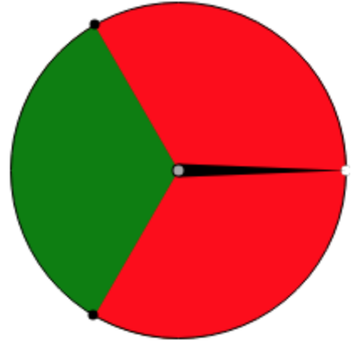 | 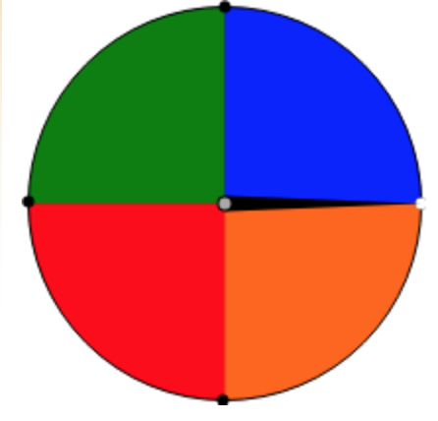

- Use an organized list, table, or tree diagram to show all the possible outcomes.

- Find the probability of each event:
  - P(get at least one green) =
  - P(get at least one red) =
  - P(get at least one blue) =
  - P(get at least one white) =
  - P(get at least one orange) =

- Which of the following is more likely?
  - The probability of getting two green or the probability of getting a blue and a red (order doesn’t matter)?
  - The probability of getting at least one blue or the probability of getting two of the same color?

Possible Student Strategies/Anticipated Responses

- Use an organized list, table, or tree diagram to show all the possible outcomes.

Examples of possible ways to represent the sample space, all possible outcomes of the experiment.

First Spin | Second Spin | Outcome
red | green | red, green
red | blue | red, blue
red | orange | red, orange
red | red | red, red
green | green | green, green
green | blue | green, blue
green | orange | green, orange
green | red | green, red
red | green | red, green
red | blue | red, blue
red | orange | red, orange
red | red | red, red

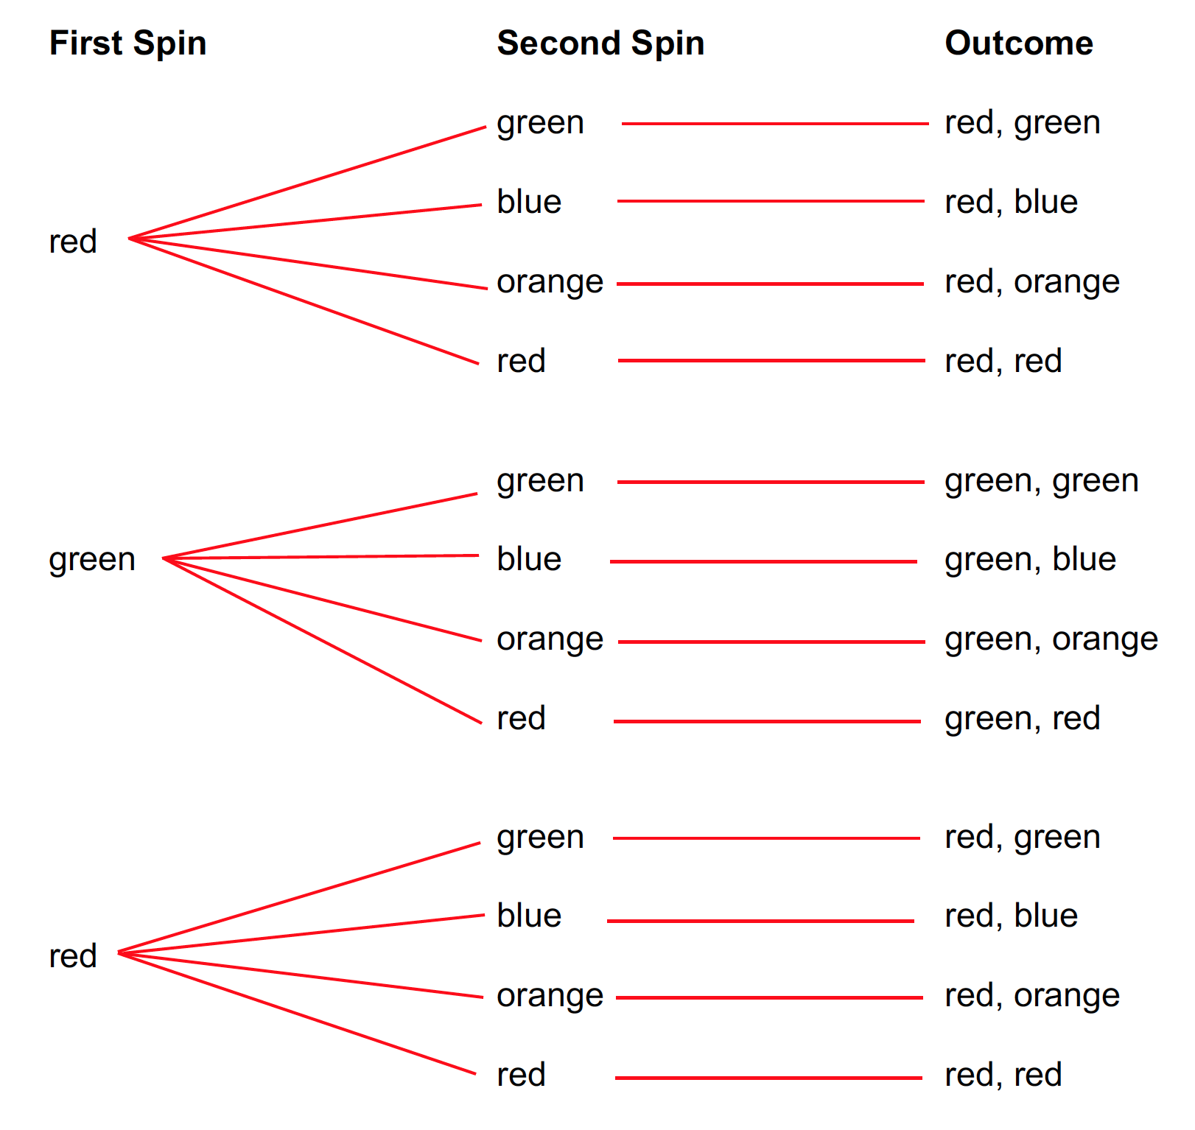

Some studnets

Some students may list only one red and green for the first spinner which will change the probability. Using this solution, a nice discussion about “weighted” probabilities may arise.

- Find the probability of each event:
  - P(get at least one green) = 6/12
  - P(get at least one red) = 9/12
  - P(get at least one blue) = 3/12
  - P(get at least one white) = 0
  - P(get at least one orange) = 3/12

- Which of the following is more likely?
  - The probability of getting two green or the probability of getting a blue and a red (order doesn’t matter)?

The probability of getting two green is 1/12, and the probability of getting a blue and a red is 2/12. So, the probability of getting a blue and a red is more likely.

  - The probability of getting at least one blue or the probability of getting two of the same color?

The probability of getting at least one blue is 3/12, and the probability of getting two of the same color is 3/12. Thus, both are equally as likely since they have the same probability.

Formative Assessment for Probability Cluster
Assessment Six

Framework Cluster & Content Standards  What content standards can be addressed by this formative assessment?  NC.7.SP.8 Determine probabilities of compound events using organized lists, tables, tree diagrams, and simulation.  - Understand that, just as with simple events, the probability of a compound event is the fraction of outcomes in the sample space for which the compound event occurs.  - For an event described in everyday language, identify the outcomes in the sample space which compose the event, when the sample space is represented using organized lists, tables, and tree diagrams. | Mathematical Practice Standards  What practice standards can be addressed by this formative assessment?  MP1 Make sense of problems and persevere in solving them.  MP2 Reason abstractly and quantitatively.  MP3 Construct viable arguments and critique the reasoning of others.  MP4 Model with mathematics.
Learning Targets
What learning targets will be assessed?
- Use an organized lists, tables, tree diagrams, or other representation to represent the sample space for a compound event
- Recognize that the probability of a compound event is the ratio of outcomes for which the compound event occurs out of all possible outcomes of the compound event
- Compare the probabilities of more than one compound event and determine which is more likely to occur

Timing: After instruction

Assessment Six

Anna, Jamie, and Keisha want to play a game. They decide to leave the decision about who will go first up to chance and agree to use spinners that they made in their math class. Each person will get two spins and can spin each spinner once or one spinner twice. To win, you must get a green on one spin and red on the other. The order of the spin does not matter. Anna decides she wants to spin Spinner A twice. Jamie decides to spin Spinner B twice. Keisha decides she will spin Spinner A and Spinner B once. Who has the better strategy for winning? Explain.

Spinner A | Spinner B
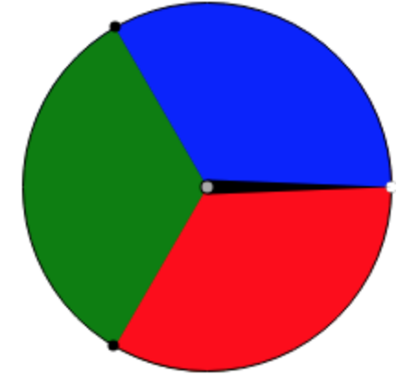

Possible Student Strategies/Anticipated Responses

Anna has the best strategy for winning, followed by Keisha and then Jamie. The probability that Anna will get a green on one spin and a red on the other is 2/9 (or 0.22 or 22%). The probability that Keisha will get a green on one spin and a red on the other is 2/12 (or 0.17 or 17%). The probability that Jamie will get a green on one spin and a red on the other is 2/16 (or 0.13 or 13%).

Sample Space for Anna’s Strategy | Sample Space for Keisha’s Strategy
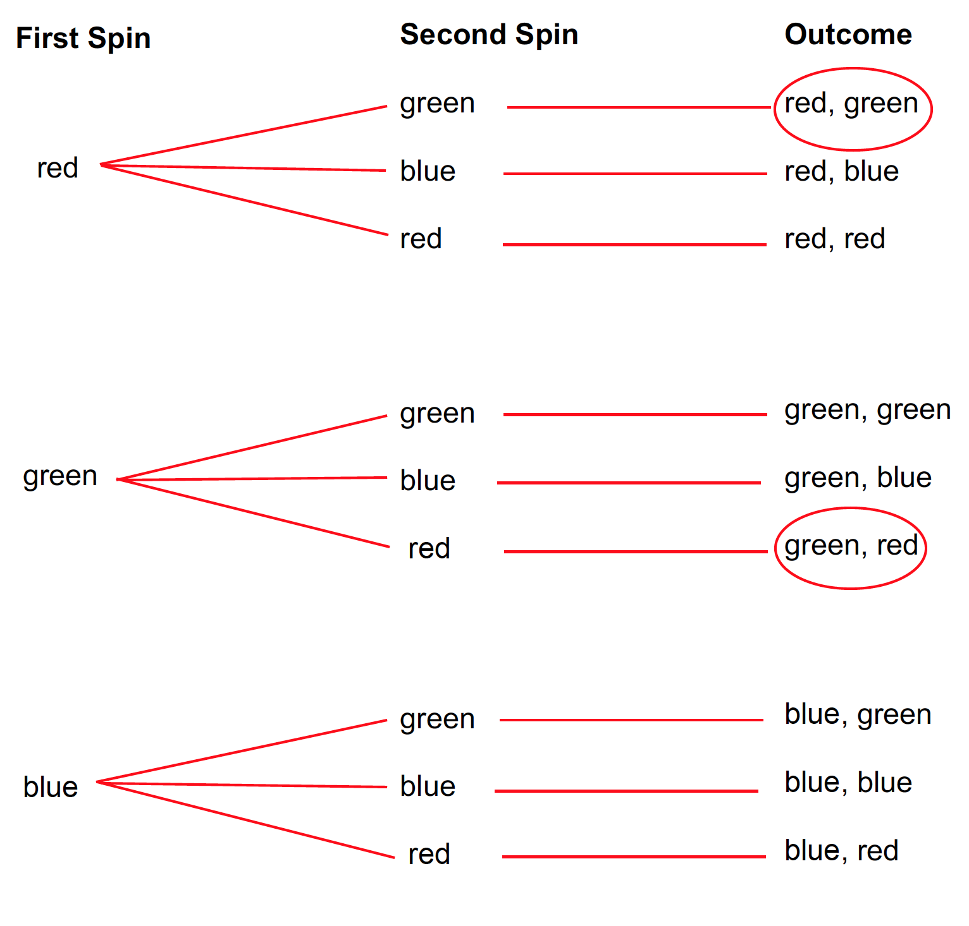  P(Anna will win) = 2/9 (or 0.22 or 22%) | 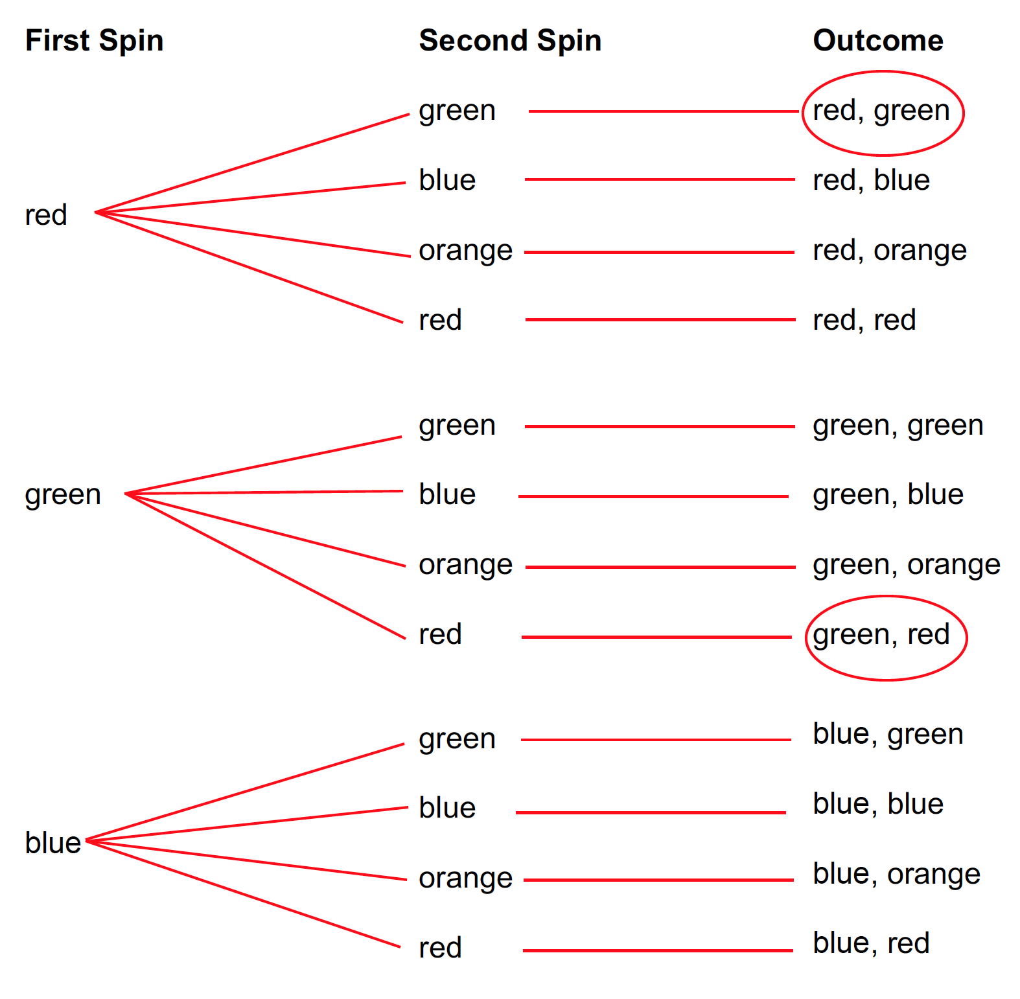  P(Keisha will win) = 2/12 (or 0.17 or 17%)
Sample Space for Jamie’s Strategy
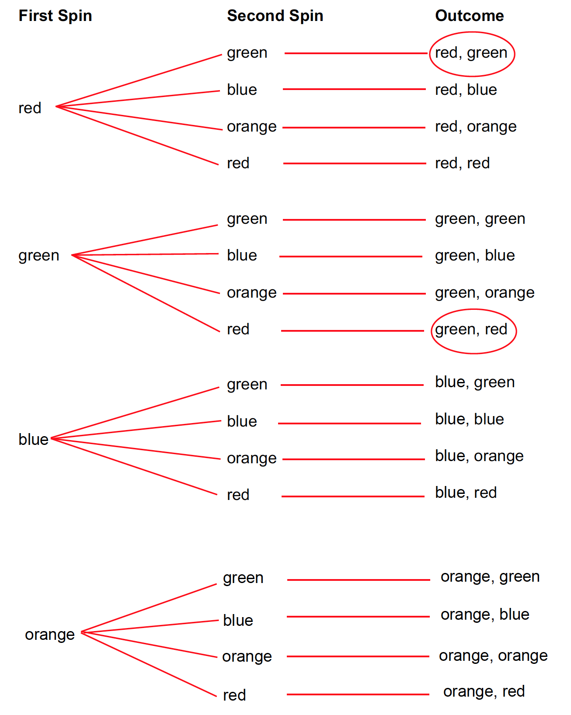 P(Jamie will win) = 2/16 (or 0.13 or 13%)
Formative Assessment for Probability Cluster
Assessment Seven

Framework Cluster & Content Standards  What content standards can be addressed by this formative assessment?  NC.7.SP.8 Determine probabilities of compound events using organized lists, tables, tree diagrams, and simulation.  - Understand that, just as with simple events, the probability of a compound event is the fraction of outcomes in the sample space for which the compound event occurs.  - For an event described in everyday language, identify the outcomes in the sample space which compose the event, when the sample space is represented using organized lists, tables, and tree diagrams. | Mathematical Practice Standards  What practice standards can be addressed by this formative assessment?  MP1 Make sense of problems and persevere in solving them.  MP2 Reason abstractly and quantitatively.  MP3 Construct viable arguments and critique the reasoning of others.  MP4 Model with mathematics.
Learning Targets
What learning targets will be assessed?
- Use an organized lists, tables, tree diagrams, or other representation to represent the sample space for a compound event
- Recognize that the probability of a compound event is the ratio of outcomes for which the compound event occurs out of all possible outcomes of the compound event
- Compare the probabilities of more than one compound event and determine which is more likely to occur

Timing: After instruction

Task adapted from: Lappan, G., Phillips, E. D., Fey, J. T., & Friel, S. N. (2014). Connected Mathematics Project: What do you expect? Boston, MA: Pearson.

Assessment Seven

Tara and Rick want to create a game that involves rolling a number cube twice. They decide that the game will be played between two players who will take turns rolling the number cube. Player A wins a point if the product of the two rolls is even. Player B wins a point if the product of the two rolls is odd. Tara thinks that the game favors Player A, and Rick thinks the game favors Player B. Who do you agree with? Explain. It may be helpful to use an organized list, table, or tree diagram to show all the possible outcomes of the product of rolling a number cube twice.

Possible Student Strategy

Students may reason that the game is unfair. Tara is correct that the game highly favors Player A. The probability that the product of the two rolls is odd is 9/36, and the probability that the product of the two rolls is even is 27/36.

Example of possible table to organize all the possible outcomes of playing the game.

First Roll | Second Roll | Outcome | Product | First Roll | Second Roll | Outcome | Product
1 | 1 | 1, 1 | 1 (odd) | 4 | 1 | 4, 1 | 4 (even)
1 | 2 | 1, 2 | 2 (even) | 4 | 2 | 4, 2 | 8 (even)
1 | 3 | 1, 3 | 3 (odd) | 4 | 3 | 4, 3 | 12 (even)
1 | 4 | 1, 4 | 4 (even) | 4 | 4 | 4, 4 | 16 (even)
1 | 5 | 1, 5 | 5 (odd) | 4 | 5 | 4, 5 | 20 (even)
1 | 6 | 1, 6 | 6 (even) | 4 | 6 | 4, 6 | 24 (even)
2 | 1 | 2, 1 | 2 (even) | 5 | 1 | 5, 1 | 5 (odd)
2 | 2 | 2, 2 | 4 (even) | 5 | 2 | 5, 2 | 10 (even)
2 | 3 | 2, 3 | 6 (even) | 5 | 3 | 5, 3 | 15 (odd)
2 | 4 | 2, 4 | 8 (even) | 5 | 4 | 5, 4 | 20 (even)
2 | 5 | 2, 5 | 10 (even) | 5 | 5 | 5, 5 | 25 (odd)
2 | 6 | 2, 6 | 12 (even) | 5 | 6 | 5, 6 | 30 (even)
3 | 1 | 3, 1 | 3 (odd) | 6 | 1 | 6, 1 | 6 (even)
3 | 2 | 3, 2 | 6 (even) | 6 | 2 | 6, 2 | 12 (even)
3 | 3 | 3, 3 | 9 (odd) | 6 | 3 | 6, 3 | 18 (even)
3 | 4 | 3, 4 | 12 (even) | 6 | 4 | 6, 4 | 24 (even)
3 | 5 | 3, 5 | 15 (odd) | 6 | 5 | 6, 5 | 30 (even)
3 | 6 | 3, 6 | 18 (even) | 6 | 6 | 6, 6 | 36 (even)

