Foolish Fouls
Framework  Cluster | Probability Cluster
Standard(s) | NC.7.SP.8 Determine probabilities of compound events using organized lists, tables, tree diagrams, and simulation.  - Understand that, just as with simple events, the probability of a compound event is the fraction of outcomes in the sample space for which the compound event occurs.  - For an event described in everyday language, identify the outcomes in the sample space which compose the event, when the sample space is represented using organized lists, tables, and tree diagrams.  - Design and use a simulation to generate frequencies for compound events.  MP1 Make sense of problems and persevere in solving them.  MP2 Reason abstractly and quantitatively.  MP3 Construct viable arguments and critique the reasoning of others.  MP4 Model with mathematics.
Materials/Links | - Student sheets  - Simulations can be conducted with hands-on objects such as spinners, graphing calculators, or software/applets. Below are some resources that be useful:  - Spinner template (precede Student sheets)  - Graphing calculator directions (precede Student sheets)  - Shodor’s Interactive Spinner: http://www.shodor.org/interactivate/activities/BasicSpinner/  - Illuminations Adjustable Spinner: https://www.nctm.org/Classroom-Resources/Illuminations/Interactives/Adjustable-Spinner/
Learning Goal(s) | - Make a prediction about the likelihood of a compound event  - Design and conduct a simulation to determine the experimental probability of a compound event  - Use an area model to determine the theoretical probability of a compound event  - Compare the experimental and theoretical probabilities of a compound event
Task Overview:
Students will consider the likelihood of scoring 0, 1, or 2 points in a 2-shot free throw situation. They will make predictions about the likelihood of each compound event, simulate the situation 20 times, calculate experimental probabilities, calculate theoretical probabilities using an area model, and compare their experimental and theoretical probabilities.

Task adapted from: Lappan, G., Fitzgerald, W. M., Fey, J. T., Friel, S. N., & Phillips, E. D. (2009). Connected Mathematics Project: What do you expect? Boston, MA: Pearson.
Teaching Notes:
Task launch:
- Have students read the scenario that describes Emma’s 2-shot free throw situation.
- Ask students to describe the possible points that Emma can make and the ways each can occur.
- After you are sure students understand the scenario, ask students to predict which is most likely to occur: scoring 0, 1, or 2 points. Encourage students to explain their reasoning.
Directions:
- Assign students to work in pairs or trios for this task.
- In pairs/trios, tell students to discuss how they would devise a plan to simulate the situation.
- As a whole class, discuss possible ways that situation can be simulated. Students can use technology, such as software and applets to simulate this situation. Graphing calculators can also be used. Without technology, students can use a 10-sided number generator (number cube), spinners, and other devices. You may want to decide ahead of time how the students will conduct the simulation. If not, be sure to make sure each pair/trio has a sensible plan for conducting the simulation. A template for possible spinners and directions for using a graphing calculator precede the Student sheets.
- Allow student pairs/trios to conduct their simulations and calculate their experimental probabilities.
- Some students may have not have had previous experiences using an area model to determine theoretical probabilities. Therefore, they may need guidance understanding how to use this representation. You may also choose to do this part as a whole class and allow students to work on #7 in their pairs/trios.
- As a whole class, have some pair/trios discuss how they used the area model, if this was not done as a whole class.
- As a whole class, have some pairs/trios discuss the comparisons of their experimental and theoretical probabilities.
- If time permits, you could combine/pool class data and determine the experimental probabilities for the class and compare this to the theoretical probability.

CHALLENGE: If this problem goes well, you can challenge students by asking them to think about a one and one foul situation (If you make the first shot, you get a second shot; if you miss the first shot, you do not get a second shot).

Student sheets begin on next page.

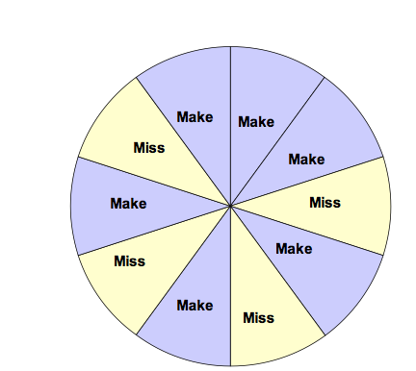
Spinner Templates for 2-shot Foul

Calculator Directions (TI-83 or TI-84) for 2-shot Simulation

Calculator Directions | Screen Shot
1. Clear all lists.  Press 2nd and +.  Select #4:ClrAllLists.  Press ENTER.  Press CLEAR (after displays done). | 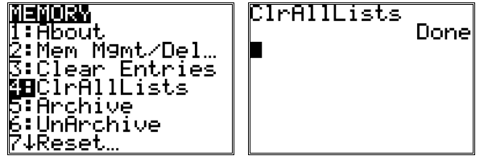
2. Select a list.  Press STAT.  Select #1:Edit…  Press ENTER. | 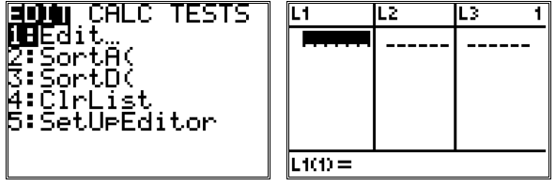
3. Create a list of 20 random integers (from 1 to 10) in L1.  Highlight L1.  Press MATH.  Select PRB.  Select #5:randInt(  Type 1,10,20.  Press ENTER. | 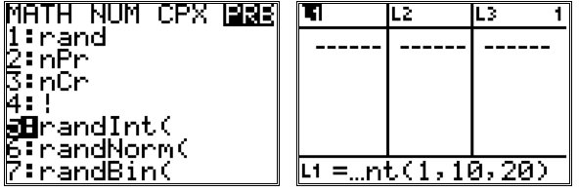
4. Create a list of 20 random integers (from 1 to 10) in L2.  Highlight L2.  Press MATH.  Select PRB.  Select #5:randInt(  Type 1,10,20.  Press ENTER. | 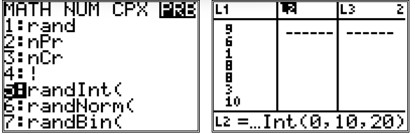
Interpretation of Simulation  Trial 1: Miss (0 pts)  Trial 2: Make, Make (2 pts)  Trial 3: Make, Make (2 pts)  Trial 4: Miss (0 pts)  Trial 5: Miss  Trial 6: Make, Make (2 pts)  Trial 7: Miss (0 pts) | 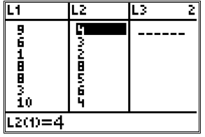

*You may want to have students re-seed their graphing calculators before they generate random numbers. Remember Make is represented by 1, 2, 3, 4, 5, and 6. Miss is represented by 7, 8, 9, and 10.

Name _____________________________________________ Date __________________________

Foolish Fouls
Adapted from the Connected Mathematics Project’s (2009) What Do You Expect?

Emma plays basketball for her middle school team. During a recent game, Emma was fouled as she was shooting a basket and earned two free throw shots. This means Emma will have the opportunity to try two shots uncontested. Emma’s free throw average is 60%.

1. Which of the following do you think is most likely to occur?
- Emma will score 0 points.
- Emma will score 1 point.
- Emma will score 2 points.

Record your prediction before you analyze the situation. Justify your response.

2. Plan a way to simulate this situation. Describe your plan.

3. Use your plan from #2 to simulate Emma’s 2-shot situation 20 times. Record your results.

4. Based on your results, what is the experimental probability that Emma will score 0 points? 1 point? 2 points?

P(0 points) = _______________

P(1 point) = _______________

P(2 points) = _______________

5. Use the grid to create an area model to calculate the theoretical probability for this situation. What is the theoretical probability that Emma will score 0 points? 1 point? 2 points?
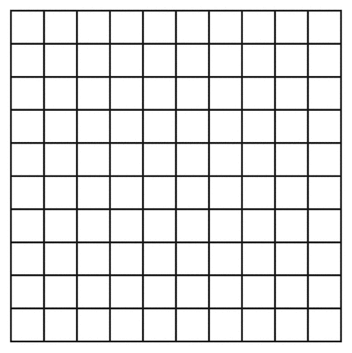

P(0 points) = _______________

P(1 point) = _______________

P(2 points) = _______________

6. How do the three theoretical probabilities compare with the three experimental probabilities?

7. LeBron James’s free throw average for the 2017-2018 season was 73%, and his career free throw average is 73.9%.

- If we estimate that his free throw average is 70%, use the grid to create an area model to calculate the theoretical probability for this situation. What is the theoretical probability that he will score 0 points? 1 point? 2 points?

P(0 points) = _______________

P(1 point) = _______________

P(2 point2) = _______________

- Use your area model to predict how many time Lebron James will score 2 points in 100 one-and-one situations.

Possible Strategies/Anticipated Responses:

- Answers will vary. While some students may accurately predict that Emma has a better chance of scoring 1 point than 2 points or 0 points, others will not. Justifications will vary.

- Answers will vary. There are many ways that students can simulate the situation. Here are some possibilities:
  - Use a spinner that is divided into 10 equal-sized sections. Label 6 of the sections make, and 4 of the sections miss. Spin the spinner twice, and record the results. For example, if the first spin lands on make and the second spin lands on make, then this represents 2 points. Alternatively, two spinners can be used to represent the first free throw and second free throw, when applicable.
  - Roll a 10-sided number generator (or number cube). Assign the digits 1, 2, 3, 4, 5, and 6 to represent a make, and 7, 8, 9, 10 to represent a miss. Roll the number cube twice, and record the results. For example, if the first spin lands on make and the second spin lands on miss, then this represents 1 point. Alternatively, two number cubes can be used to represent the first free throw and second free throw, when applicable.
  - Use Excel or some other spreadsheet, such as Google sheets, to randomly generate a digit between 1 and 10. Assign the digits 1, 2, 3, 4, 5, and 6 to represent a make, and 7, 8, 9, 10 to represent a miss. Randomly generate a number in a column to represent the first free throw, and randomly generate a number in the second column to represent the second free throw. As with the other plans, students will need to record whether situation results in 0, 1, or 2 points.
  - As in c, a graphing calculator may be used to generate random numbers in lists. Assign the digits 1, 2, 3, 4, 5, and 6 to represent a make, and 7, 8, 9, 10 to represent a miss. Determine whether each results in 0, 1, or 2 points.
  - Software and applets can also be used to simulate spinning a spinner (as in a) or rolling a number cube (as in b). Other technologies than spreadsheets can be used to generate random numbers.

- Answers will vary. Below are the results of simulating Emma’s two shot situation 20 times using a spreadsheet.

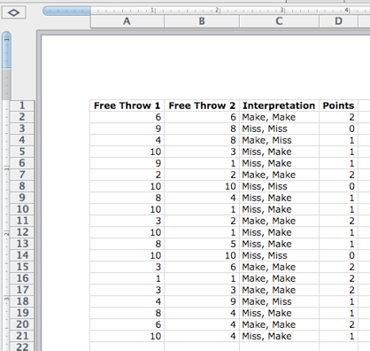
- Based on the results in #3, P(0 points) = 3/20 (or 15%), P(1 point) = 10/20 (or 50%), and the P(2 points) = 7/20 (or 35%).

- The theoretical probabilities are as follows: P(0 points) = 16/100 (or 16%), P(1 point) = 48/100 (or 48%), and the P(2 points) = 36/100 (or 36%). Below is an example of an area model that can be used to represent the likelihood of this situation.

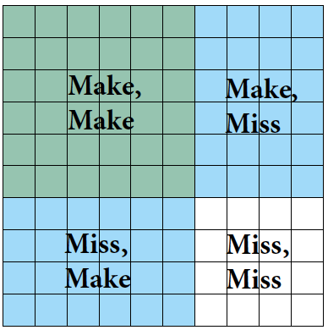

- Answers will vary. In this case the, the experimental and theoretical probabilities are very similar. This may not be the case for all students.

- If the free throw average is 70%, the theoretical probabilities are as follows: P(0 points) = 9/100 (or 9%), P(1 point) = 42/100 (or 42%), and the P(2 points) = 49/100 (or 49%). Some students may notice that the chances of scoring 1 point and 2 points are higher with a better free throw average (comparing a free throw average of 60% and 70%). While students may not write this, some may articulate this in small or whole class discussions. Below is an example of an area model that can be used to represent the likelihood of this situation. Out of 100 one on one free throw situations, students might predict he will score 2 points 49 times.

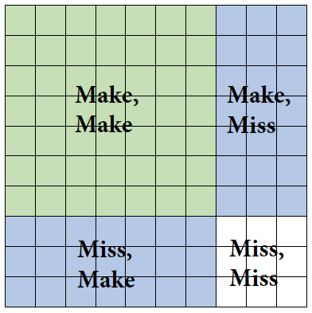

Red and White Game
Framework  Cluster | Probability Cluster
Standard(s) | NC.7.SP.8 Determine probabilities of compound events using organized lists, tables, tree diagrams, and simulation.  - Understand that, just as with simple events, the probability of a compound event is the fraction of outcomes in the sample space for which the compound event occurs.  - For an event described in everyday language, identify the outcomes in the sample space which compose the event, when the sample space is represented using organized lists, tables, and tree diagrams.  - Design and use a simulation to generate frequencies for compound events.  MP1 Make sense of problems and persevere in solving them.  MP2 Reason abstractly and quantitatively.  MP3 Construct viable arguments and critique the reasoning of others.  MP4 Model with mathematics.
Materials/Links | - Student sheet  - Experiments can be conducted with hands-on objects (such as marbles, linking cubes, spinners and two containers), graphing calculators, or software/applets.
Learning Goal(s) | - Make a prediction about the likelihood of a compound event  - Conduct an experiment to determine the experimental probability of a compound event  - Determine the theoretical probability of a compound event using organized lists, tables, tree diagrams, or other representations  - Compare the experimental and theoretical probabilities of a compound event  - Use probability to make decisions
Task Overview:
Students will consider whether a game will be profitable for a fundraiser using both experimental and theoretical probabilities. They will make predictions about the likelihood of each compound event, conduct an experiment to simulate the game 36 times, calculate experimental probabilities, calculate theoretical probabilities, and compare their experimental and theoretical probabilities.

This task is made of three parts. Depending on the amount of time it takes students to engage with the task, different parts may be completed on different days.

Teaching Notes:
Task launch:
- Have students read the scenario that describes how a player can win the game. Ask students to describe the outcomes for winning.
- Ask students to predict whether or not the school will make money. Have students explain their reasoning.
- Ask a student to simulate playing the game. Repeat this a few times (more, if necessary).
  - Ask the class if the student was a winner.
  - Ask the class to consider how much money the school made after the first game.

Note: The experiment can be done with hands-on objects (such as marbles, linking cubes, spinners and two containers), graphing calculators, or software/applets.

Directions:
- Assign students to work in pairs or trios for this task.
- Before pairs/trios conduct their experiments, discuss how the game will be simulated with the whole class. You may decide to allow students to design a plan and allow them to discuss different designs, or you choose the design and discuss the plan you have chosen with students. Here are some possible ways to simulate the experiment:
  - Use real marbles and any two bags (or containers) that are not transparent.
  - Use colored objects (same size and shape) other than marbles, such as linking cubes, and any two bags (or containers) that are not transparent.
  - Use two spinners. One spinner should be divided into 4 equal-sized sections (1 green, 1 white, 1 red, and 1 yellow), and the other spinner should be divided into equal-sized sections (1 green, 1 red, and 1 yellow). In this case, each section represents drawing the corresponding color from a bag.
  - Software/applets can be used to simulate the above.
  - Using software/applets or a graphing calculator, you can also assign each color a number and randomly generate a number to represent drawing the corresponding color from each bag.
- Allow student pairs/trios to conduct their simulations and calculate their experimental probabilities and complete Part 1.
- As a whole class, you may want students to discuss #4 from Part 1 before they begin Part 2.
- After pairs/trios have completed Part 2, as a whole class, have some pairs/trios share their representations that they used to determine the theoretical probability. Discuss different strategies that students used. Allow them to complete the remaining questions in Part 2 and then discuss #3 as a whole class.
- After pairs/trios have completed Part 3, as a whole class, have some pairs/trios discuss the comparisons of their experimental and theoretical probabilities.

Student sheets begin on next page.

Task adapted from: Lappan, G., Fitzgerald, W. M., Fey, J. T., Friel, S. N., & Phillips, E. D. (2009). Connected Mathematics Project: What do you expect? Boston, MA: Pearson.

Name _____________________________________________________ Date __________________________

Red and White Game
Adapted from the Connected Mathematics Project’s (2009) What Do You Expect?

Students at a local middle school designed games to raise money at their fall festival. Since their school colors are red and white, they created a game called the Red and White Game. To play, a player randomly selects a marble from two bags. The first bag contains the following marbles: 1 green, 1 white, 1 red, and 1 yellow. The second bag contains the following marbles: 1 green, 1 red, and 1 yellow.
To play the game, the player randomly chooses one marble from each of two bags. If the player selects a red and white marble, the player wins. The order does not matter (i.e., you can pick red, then white and win or white, then red and win). The cost of the game is $1. If the player wins, the player receives $3.

Part 1
- Before playing the Red and White Game, make a prediction about whether or not you think the school will make money. Explain your reasoning.

- Conduct an experiment, and play the Red and White Game 36 times. Record your results.

- Based on your results from playing the game, what is the experimental probability that a player will win the game?

- Did you make a good prediction in #1? Explain.
Part 2
- Use an organized list, table, tree diagram, or an area model to show the possible outcomes for the Red and White Game.

- What is the theoretical probability that a player will win the game? Explain.

- Suppose the game is played 36 times.
  - How much money do you expect the school to collect from everyone that plays the game?

  - How much money do you expect the school will pay to winners of the game?

  - Was the game profitable for the students trying to raise money? If yes, how much money did they make?

- Suppose one marble is selected from each bag. Find the probability for the following:
  - A green marble is selected from the first bag and a yellow is chosen from the second bag.

  - A white marble is not selected from either bag.

  - A player selects two white marbles.

  - A player selects at least one white marble.

  - A player selects two marbles of the same color.

Part 3
What do you notice about the experimental and theoretical probabilities that you calculated?

Possible Strategies/Anticipated Responses:
Part 1
- Answers will vary. Some students may reason since there is only one white marble in one bag and no white marble in another bag that it would be unlikely but not impossible to draw a red and white marble.

- Answers will vary. The table below shows the results of conducting an experiment where a marble was randomly drawn from two bags 36 times. This data was actually generated from a simulation using software, where a marble was randomly drawn from two bags 36 times. Students can conduct the experiment either using physical objects, such as marbles, cubes, spinners, etc., or they can simulate the experiment with software/applets or graphing calculators.

Game | First draw | Second draw | Outcome | Game | First draw | Second draw | Outcome
1 | yellow | green | yellow, green | 19 | white | green | white, green
2 | white | red | white, red (win) | 20 | yellow | yellow | yellow, yellow
3 | yellow | green | yellow, green | 21 | white | yellow | white, yellow
4 | white | red | white, red (win) | 22 | white | green | white, green
5 | white | yellow | white, yellow | 23 | white | yellow | white, yellow
6 | green | green | green, green | 24 | red | yellow | red, yellow
7 | red | green | red, green | 25 | yellow | green | yellow, green
8 | yellow | green | yellow, green | 26 | yellow | yellow | yellow, yellow
9 | yellow | green | yellow, green | 27 | green | green | green, green
10 | red | red | red, red | 28 | yellow | red | yellow, red
11 | red | yellow | red, yellow | 29 | yellow | green | yellow, green
12 | green | red | green, yellow | 30 | green | yellow | green, yellow
13 | yellow | red | yellow, red | 31 | white | green | white, green
14 | red | green | red, green | 32 | white | red | white, red (win)
15 | yellow | yellow | yellow, yellow | 33 | red | green | red, green
16 | green | red | green, red | 34 | white | green | white, green
17 | white | red | white, red (win) | 35 | green | red | green, red
18 | green | green | green, green | 36 | yellow | green | yellow, green

- The experimental probability of winning the game is 4/36.

- Answers will vary.
Part 2
- Answers will vary. Below is an example of a table that shows all the possible outcomes for playing the Red and White game.

First draw | Second draw | Outcome
green | green | green, green
green | red | green, red
green | yellow | green, yellow
white | green | white, green
white | red | white, red (player wins)
white | yellow | white, yellow
red | green | red, green
red | red | red, red
red | yellow | red, yellow
yellow | green | yellow, green
yellow | red | yellow, red
yellow | yellow | yellow, yellow

Another strategy that students might use to find all the possible outcomes is to create a tree diagram, as seen below.

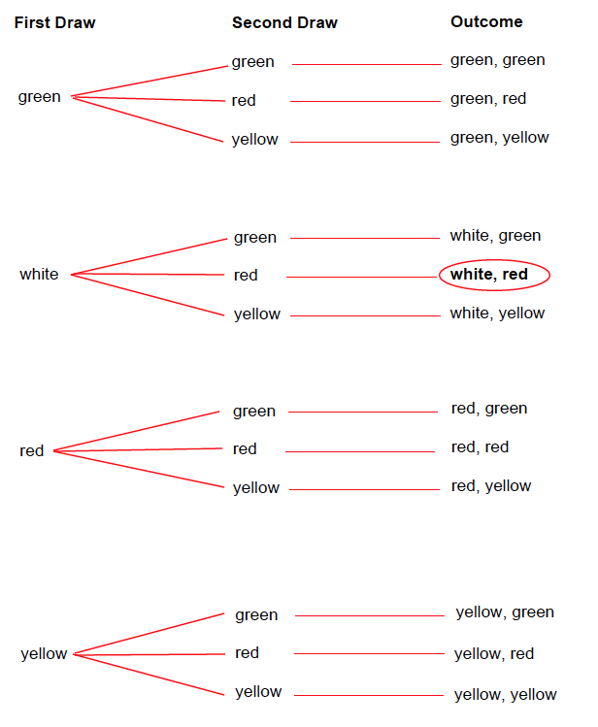

- The theoretical probability that a player will win is 1/12.

- If the game is played 36 times-
  - The school should collect $36 because $1(36) = $36. Each game costs $1.
  - The school should pay winners $9 since $3(3) = $9. If the theoretical probability of winning the game is 1/12 and 36 games are played, you would expect 3 players to win. A player wins $3.
  - Yes, the game should be profitable for the school. Since players would pay $36 and the school would pay $9 to the winners, the school would make $27. The likelihood of winning the game, 1/12, is very small; so, the game heavily favors the school. Some may also reason that for the school to lose money, they would need to increase the prize money for winning by a lot.

- Theoretical probabilities-
  - P(green from bag 1 and yellow from bag 2) = 1/12

  - P(white not selected) = 9/12.

Some students may also recognize that they can subtract the probability of selecting at least 1 white from 1 since the sum of the probabilities of selecting at least 1 white and not selecting a white is 1.
1 – P(at least 1 white) = 1 – 3/12 = 9/12

  - P(two white) = 0

  - P(at least 1 white) = 3/12

Some students may also recognize that they can subtract the probability of not selecting a white from 1 since the sum of the probabilities of selecting at least 1 white and not selecting a white is 1.
1 – P(white not selected) = 1 – 9/12 = 3/12

  - P(two same color) = 3/12

Part 3
Answers will vary. In this case the, the experimental and theoretical probabilities are very similar. The experimental probability of winning is 4/36, and the theoretical is 3/12. So, in the case of comparing 4/36 = 1/9 = 0.11 = 11% and 3/12 = 1/4 = 0.25 = 25%, the experimental is slightly greater but both are unlikely. Some students may also reason that if the theoretical probability of winning is 1/12, then if 36 games are played you can expect 1/12 of the 36 games to result in a win. So, you would expect 3 people to win. In the example provided 4 people won, which is only one more than what is expected from using the theoretical probability to approximate the likelihood. Some students may further reason or alternatively reason that the school would make $24 rather than $27, which is still a great profit. This may not be the case for all students, depending on the results of their experimental probabilities.

