Task 1: Finals Week

Framework  Cluster | Proportional Relationships
Standard(s) | NC.7.RP.1 Compute unit rates associated with ratios of fractions to solve real-world and mathematical problems.  SMP 1 Make sense of problems and persevere in solving them.  SMP 2 Reason abstractly and quantitatively.  SMP 3 Construct viable arguments and critique the reasoning of others  SMP 4 Model with mathematics
Materials/Link | - Dan Meyer - "Finals Week"  - Means of projecting the videos/images to students  - Calculators  - Student sheet (attached below)
Learning Goal | Compare quantities using ratios.
Task Overview:

This group task can be used as an introduction into complex fractions and unit rates that include both fractions and decimals. In this activity, students are given 5 different drinks and are asked to rank the caffeine concentrations. Students must determine what information would be needed to solve the problem, and eventually work towards finding a solution.
Prior to Lesson:

Students will need to have prior experience with comparing ratios using either unit ratios or other equivalent ratios.
Teaching Notes:

Task Launch:
- Students should be working in groups of 3-5.
- Show the video from Act I. Ask students to watch carefully and determine which drink they believe will have the strongest concentration of caffeine, independently. Then, have students rank the drinks from strongest concentration to weakest concentration, independently.

Directions:
- After students have their independent answers, have them discuss their answers in their group, and then facilitate a whole group discussion. Focus on the reasoning behind their choices (see anticipated student reasoning below to engineer discussion).
- Have students work on Act II independently for 1-2 minutes. Then, give them 1-2 minutes in their group to streamline their answers. Have them cross off any information they wrote that the group deems unnecessary, and add anything the group deems necessary that they may not have had. Facilitate a whole group discussion, and decide upon the things you would need to know.
- Provide students with the 3 images given in Act II (on the Dan Meyer website).
- Give them 10 - 15 minutes in their group to come to a solution. They must show all work in the given box.
- At the end of the time, have groups share out their solutions, and then reveal the correct answer. Discuss any common errors.
- EXTENSION: For advanced students, or just to continue the lesson, have students complete the sequel.

Student sheets begin on the next page.
Name: _____________________________________________________ Date: ____________________________

Finals Week
Act I

Which drink do you believe will have the strongest caffeine concentration and why?

Rank all of the drinks from strongest concentration to weakest concentration.

5: _________________________________________________ STRONGEST
4: _________________________________________________
3: _________________________________________________
2: _________________________________________________
1: _________________________________________________ WEAKEST

Act II

What information would helpful to know?

What information doesn’t matter, and why?

For use with Dan Meyer’s 3 Act Math Task “Finals Week” - http://threeacts.mrmeyer.com/finalsweek/

Work

Act III

Was your original hypothesis correct? Why or why not?

Were your mathematical calculations correct? If not, what were your mistakes?

Sequel

Which drink will get you the biggest bang for your buck?

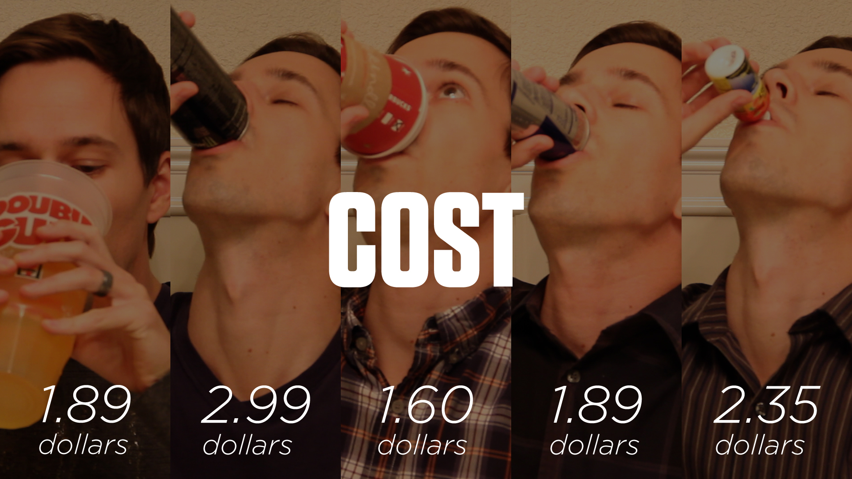

Work

Best Deal: _________________________________________

Possible Strategies/Anticipated Responses:

The word “concentration” may need to be defined so students understand that a ratio is needed.

Students may initially assume that the beverage with the most caffeine has the strongest concentration without linking it to the amount of the beverage.

Students may also believe that the beverage with the largest volume would have the strongest concentration.

Students may calculate the ratio of liquid to caffeine instead of caffeine to liquid. You may want to redirect their thinking, but also explain how they could still use that ratio to answer the question.

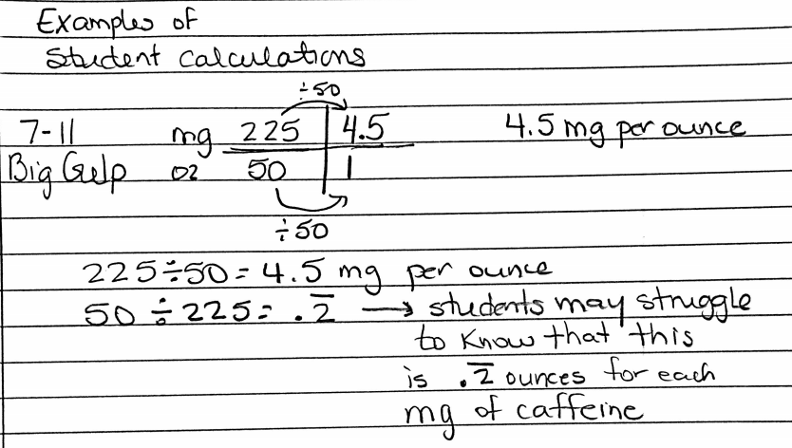

Some students may find a common denominator of 100 ounces and make percents to compare.

To find the best bang for your buck, students may compare 7-11 and Red Bull outright since they have the same price. They would cross out 7-11 because it has less caffeine than Red Bull. Now, they are down to four. They might make some comparisons and suggest 5-hour because it has the most caffeine and is not that much more money than the others. Or they can then cross out Monster because it is the highest price of the three left and has the least caffeine. They are down to two: Starbucks and 5-hour. For Starbucks, they may see that the caffeine amount isn’t even twice as much as the price and 5-hour has over 60 times the amount of caffeine for the price. Or students may find the amount of caffeine per dollar for each and make the same conclusion.

Task 2: Complex Fractions with Fraction Tiles

Framework  Cluster | Proportional Relationships
Standard(s) | NC.7.RP.1 Compute unit rates associated with ratios of fractions to solve real-world and mathematical problems.  SMP 2 Reason abstractly and quantitatively.  SMP 4 Model with mathematics  SMP 7 Look for and make use of structure  SMP 8 Look for and express regularity in repeated reasoning
Materials/Link | - 3 sets of fraction tiles per student/pair/group (printable version attached below)  - Student sheet (attached below)
Learning Goal | Develop a concrete understanding of unit rates associated with ratios of fractions, and use them to solve mathematical problems.
Task Overview:

In this task, students will work independently or in pairs using fraction tiles to replicate given ratios to solve problems involving unit rates. This will give students a concrete model of complex fractions to aid in their conceptual understanding of the content.
Prior to Lesson:

Students will need to be firm in their understanding of ratios and unit rates from sixth grade.
Teaching Notes:

Task Launch:
- Review the idea of a ratio with students using integers. For example, $3 per pound of apples, what does that mean?
- Replicate the ratio ($6 for 2 pounds of apples) and ask students what the ratios have in common.
- Ask them how they might write a ratio if it is 5 ½ gallons of milk feeds 20 $1/3$ people.
- If students seem to need more review, complete a few more examples.

Directions:
- Pass out the fraction tiles and student sheets. Explain the concept of a complex fraction to students.
- Tell them to read the sheet and ask questions if they are not sure what the columns mean. They might have difficulty understanding what it means to write a ratio.
- Students should work to complete the problems.

Student sheets begin on the next page.

Name: ________________________________________________ Date: ____________________________
Complex Fractions with Fraction Tiles
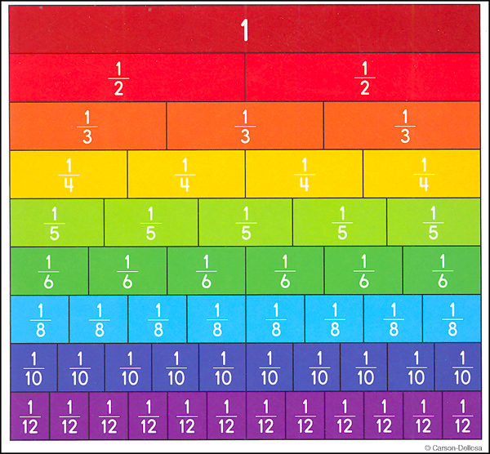

Directions: Fill in the table below each problem. In the first column write a ratio of the quantities in the problem. In the second column, show your calculations using either a ratio table, fractions or a picture of your fraction bars. In the final column write a sentence or two to explain your strategy.

- If ½ gallon of paint covers ⅙ of a wall, then how much paint is needed for the entire wall?

Ratio | Calculations using ratio table, fractions or fraction bars (drawn) | Explanation

- Mary made ⅕ of a batch of cookies in 1/10 of an hour. How many batches of cookies can she make in one hour?

Ratio | Calculations using ratio table, fractions or fraction bars (drawn) | Explanation

- Jackson eats ¼ part of a banana in ½ minute. How much time he will need to eat full banana?

Ratio | Calculations using ratio table, fractions or fraction bars (drawn) | Explanation

- Ethan types ⅕ of a page in ¼ minute. How much time does it take him to type a full page?

Ratio | Calculations using ratio table, fractions or fraction bars (drawn) | Explanation

- William fills ¼ of a water bottle in ⅙ of a minute. How much time will it take him to fill the bottle?

Ratio | Calculations using ratio table, fractions or fraction bars (drawn) | Explanation

6. Isaac used ¼ of an ounce of pecans to make 1/12 pound of a cake. How many ounces of pecans are needed to make a 1
pound cake?

Ratio | Calculations using ratio table, fractions or fraction bars (drawn) | Explanation

7. How would you solve the following problem:?

“Landon ran 4 ¾ miles in ⅔ of an hour, what was his speed in miles per hour?”

Show your work and then justify your answer.

Work | Explanation

Printable Fraction Tiles

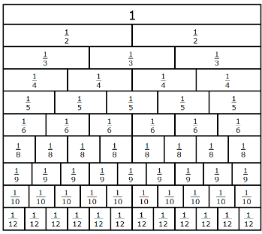

Possible Strategies/Anticipated Responses:

Students may have difficulty with problems with problems where they y-value is not written first (#3, #4, #5). Although they can still solve these problems correctly without placing the y-value as the numerator, it may confuse them when solving for the constant of proportionality and writing equations of proportional relationships. You may want to emphasize that a unit rate is a part-to-one ratio and get students in the habit of writing the value you are trying to get to one as the denominator.

Students may easily see that they can multiply by the denominator of the unit fraction to get to one. It is important to get them to understand how that relates to dividing by the fraction itself for one they get to denominators that are not unit fractions.

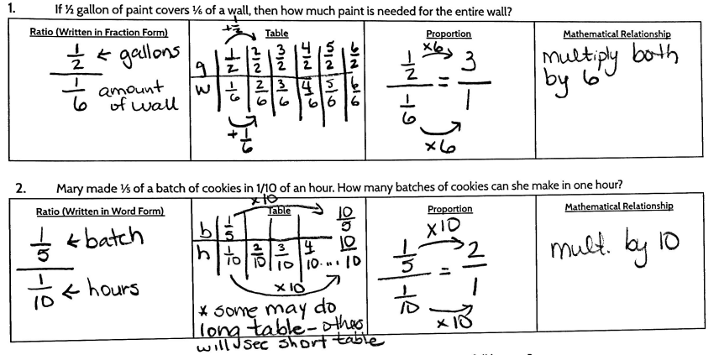
There are many possibilities for student solutions to the following problem: “Landon ran 4 ¾ miles in ⅔ of an hour, what was his speed in miles per hour?”.
- Since students have been solving problems involving unit fractions, they may divide the ratio in half to make 2 ⅜ miles in ⅓ of an hour, and multiply both by 3 to get 7 ⅛ miles in 1 hour.
- Another possibility is that students will try to make the hours into a whole number by multiplying by 3 first to get 14 ¼ miles in 2 hours, then dividing by 2 to get 7 ⅛ miles in 1 hour.
- Students may just perform the algorithm and multiply 4 ¾ by 3/2 to get 7 ⅛ miles in 1 hour.
- Despite the ways your students solve this problem, it is important to make the connection for the students that all of these possibilities are essentially the same mathematically.

Task 3: Mixing with MiO
Framework  Cluster | Proportional Relationships
Standard(s) | NC.7.RP.1 Compute unit rates associated with ratios of fractions to solve real-world and mathematical problems.  NC.7.RP.2 Recognize and represent proportional relationships between quantities.  - Understand that a proportion is a relationship of equality between ratios.  - Represent proportional relationships using tables and graphs.  - Recognize whether ratios are in a proportional relationship using tables and graphs.  - Compare two different proportional relationships using tables, graphs, equations, and verbal descriptions.  SMP 1 Make sense of problems and persevere in solving them.  SMP 2 Reason abstractly and quantitatively.  SMP 3 Construct viable arguments and critique the reasoning of others  SMP 7 Look for and make use of structure
Materials/Link | - Student sheet (attached below)  - MiO, water, and clear cups (not required)
Learning Goal | Compute unit rates associated with ratios of fractions to solve real-world problems.
Task Overview:

Students will be using their understanding of ratios that include fractions to solve real world problems involving the correct concentration of the MiO flavoring in water. MiO is a liquid water enhancer that is available in multiple flavors. Students will have to compare the concentrations with different amounts of water, different amounts of flavoring, as well as calculate how to correct mistakes in recipes.
Prior to Lesson:
Students should have a basic understanding of ratios that include fractions and how to compute with them.
Teaching Notes:

Task Launch:
- Review ratios, unit rates, and complex fractions with students. It may be helpful to do a few review problems prior to starting the activity.
- If students are not familiar with MiO, show a picture or short commercial to set the context. If you have MiO and water on hand, do a few demos and ask students about how the flavors would compare and how they would know.
  - Same water, different squeezes
  - Different water, same squeezes
  - Different water, different squeezes
If you don’t have any one hand, just provide students with the situations hypothetically, and question them.
Directions:
- Students can work independently or in partners on this activity and begin right away. Hand out only page one, have students explore, and then have a whole class, debrief discussion.
- Students should be showing their work and clearly labeling the mathematical relationships throughout the activity. This is important to emphasize the relationships.
- Have the students complete page two and then discuss as a whole class. Depending on your students, you might assign these to the more advanced students. Emphasize to students that on problems 7-10, it is imperative that they clearly label and communicate their work.

Student sheets begin on the next page

Name: __________________________________________________ Date: _________________________

Mixing with MiO
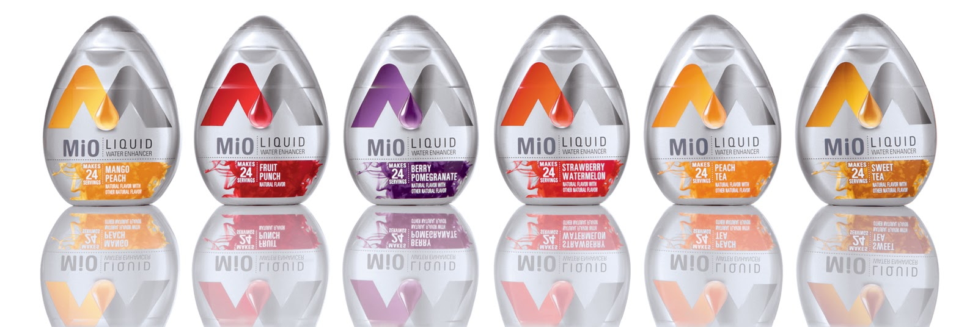
When prepared as directed, ½ teaspoon of MiO should be mixed with 8 fluid ounces of water.

Directions: Use the recommended serving above to answer the following questions. Clearly label and show all of your work.

- How many teaspoons of MiO should be mixed with 32 fluid ounces of water? | - How many teaspoons of Mio should be mixed with 96 fluid ounces of water? | - How many teaspoons of Mio should be mixed with 12 fluid ounces of water?
Work: | Work: | Work:
- How many fluid ounces of water should be mixed with 1 teaspoon of MiO? | - How many fluid ounces of water should be mixed with  1½ teaspoons of MiO? | - How many fluid ounces of water should be mixed with ¾ teaspoons of MiO?
Work: | Work: | Work:

- One squeeze of MiO is approximately ½ teaspoon. Jessica accidently put 3 squeezes of MiO in her 16 ounce water bottle. How much water should she add to the bottle in order to prepare it as directed?

- Daniel reached into his lunch box and had a 16.9 fluid ounce water bottle, and a bottle of MiO. He put
2 squeezes (1 teaspoon) of MiO in the water bottle. Will his flavor be stronger or weaker than if he prepared it as directed? How do you know?

- Sofia put 4 ¼ teaspoons of MiO in 34 fluid ounces of water. Chris put 3 ½ teaspoons of MiO in 26 fluid ounces of water. Whose flavor is more concentrated (more flavorful)? How do you know?

- Ava said that if she had twice the MiO, she would have twice the flavor. Give one example when that statement would be true, and give one example of when that statement would be false.

True | False
Possible Strategies/Anticipated Responses:

Some students may have issues initially formalizing their reasoning and work. If students are struggling, you may want to assign them a strategy instead of leaving it open ended (ex. solving with a proportion).
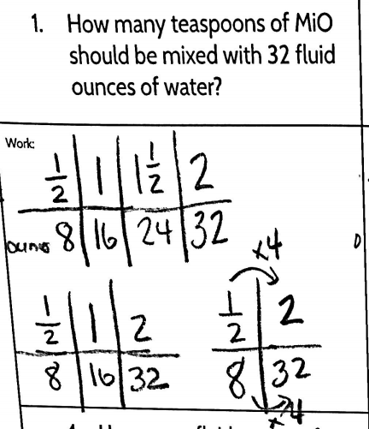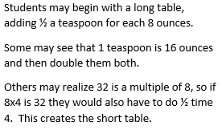

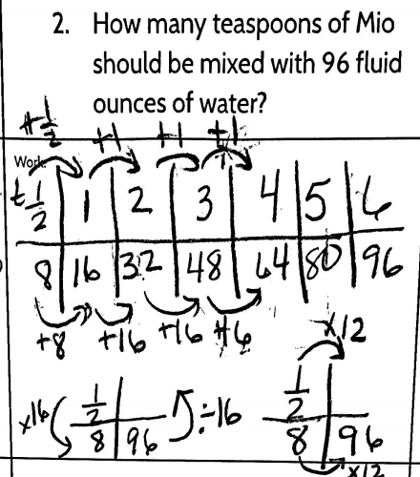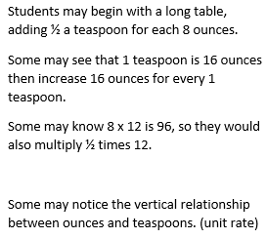

There will be similar strategies for problems 3-6. Students might also convert the MiO rule to a unit ratio 1/16 and use that throughout the rest of the problems.

The problem solving in questions 7-10 may prove difficult for students struggling or more inexperienced readers. Assigning students partners may help with that aspect.

