Task 1: Lemons and Mileage
Framework Cluster | Proportional Relationships
Standard(s) | NC.7.RP.1 Compute unit rates associated with ratios of fractions to solve real-world and mathematical problems.  NC.7.RP.2 Recognize and represent proportional relationships between quantities.  - Understand that a proportion is a relationship of equality between ratios.  - Represent proportional relationships using tables and graphs.  - Recognize whether ratios are in a proportional relationship using tables and graphs.  - Identify the unit rate (constant of proportionality) within two quantities in a proportional relationship using tables, graphs, equations, and verbal descriptions.  - Create equations and graphs to represent proportional relationships.  - Use a graphical representation of a proportional relationship in context to:  - Explain the meaning of any point (x, y).  - Explain the meaning of (0, 0) and why it is included.  - Understand that the y-coordinate of the ordered pair (1,y) corresponds to the unit rate and explain its meaning.  SMP 1 Make sense of problems and persevere in solving them.  SMP 4 Model with mathematics  SMP 7 Look for and make use of structure  SMP 8 Look for and express regularity in repeated reasoning
Materials/Link | - Student sheet (adapted from CMP3)  - Graph paper  - Calculator (optional)
Learning Goal | - Students will find unit rate and describe it in context.  - Students will explain the meaning of any point (x,y), (0,0) and (1,r).
Task Overview:

Students will use two different contextual situations to interpret unit rate in graphs, tables and equations
Prior to Lesson:

Students will need to be firm in their understanding of ratios and unit rates from sixth grade and previous work. They will also need to be proficient in graphing ordered pairs.
Teaching Notes:

Task Launch:
- Engage students by having a short discussion about how fruit is purchased at the grocery store. Students may suggest lemons are bought by the pound or in a bag but for this activity they are being sold at a rate of 10 for $2.
Directions:
- Give students time to explore 1-5 in Part 1 independently. Monitor and note strategies for completing the table. During the whole class discussion, share strategies for the table and emphasize the 2 ways to write the unit rate.
- Give students time to explore 6-9 in Part 1 independently or in small groups. During the whole class discussion make sure students understand the connection between unit rate and constant of proportionality.

- Give students time to explore Part 2 independently or in small groups and note strategies for answering questions, especially number 5. Depending on where this lesson is used, this may be the first time students see the proportion. During the whole class discussion it is important to make the connection between the proportion and the table.

Student sheets begin on next page.

Food Lion Lemons
Part 1

Food Lion has lemons on sale at 10 for $2.
- How many lemons can be bought with $1?
- How much does one lemon cost?

Complete the table below.

Number of lemons, n | 10 |  | 1 | 20 | 11
Cost, C | $2 | $1 |  |  |  | $2.60

3. Identify the two unit rates in your table.

4. How could using the unit rate help you find how many lemons you could buy for $5?

5. How could using the unit rate help you find the cost for 25 lemons?
EQUATIONS
There are two equations that can be written that relate the cost C, to the number of lemons, n.

n=5C C = 0.2n

- Identify the two unit rates from the equations. What information do the unit rates give you?

- Graph the 2 equations above on two coordinate planes. Show the values of n from 1-20.

- How can you use the graphs to find the unit rates?
- How can you use the graphs to find the constants of proportionality?

Crazy Car Chaos
Part 2

On a recent family vacation, Tom’s car used 20 gallons of gas to travel 640 miles.

  - Write two unit rates that related the number of miles drive and the number of gallons of gas used. Explain what each unit rate means in context of the situation.

  - The graph below shows the relationship between the distance driven d, and the gallons of gas g. Which unit rate shows up in the graph? Explain how you know.

  - Write an equation that the graph represents.

  - Name the ordered pair for:
- How far Tom can drive on 1 gallon
- How far Tom drives on zero gallons

  - Tom used the proportion $\frac{640}{20}$ = $\frac{x}{4}$ to calculate how far he could travel on 4 gallons of gas.

His brother, Troy, says he can use unit rate.

- Do you agree with Tom or with Troy? Explain.

- What other strategies can you use to find the number of miles Tom’s car can travel on 4 gallons of gas?

Possible Strategies/Anticipated Responses

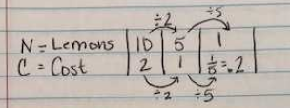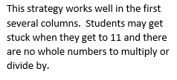
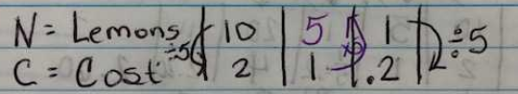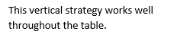

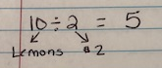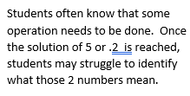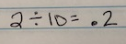

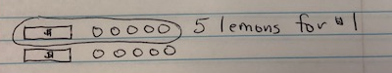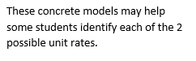

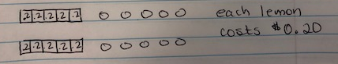

Task 2: Proportional Relationships with Pattern Blocks

Framework Cluster | Proportional Relationships
Standard(s) | NC.7.RP.2 Recognize and represent proportional relationships between quantities.  - Understand that a proportion is a relationship of equality between ratios.  - Represent proportional relationships using tables and graphs.  - Recognize whether ratios are in a proportional relationship using tables and graphs.  - Identify the unit rate (constant of proportionality) within two quantities in a proportional relationship using tables, graphs, equations, and verbal descriptions.  - Create equations and graphs to represent proportional relationships.  - Use a graphical representation of a proportional relationship in context to:  - Explain the meaning of any point (x, y).  - Explain the meaning of (0, 0) and why it is included.  - Understand that the y-coordinate of the ordered pair (1,y) corresponds to the unit rate and explain its meaning  SMP 1 Make sense of problems and persevere in solving them.  SMP 2 Reason abstractly and quantitatively.  SMP 4 Model with mathematics  SMP 7 Look for and make use of structure  SMP 8 Look for and express regularity in repeated reasoning
Materials/Link | - Pattern blocks OR pattern block template (attached below)  - Calculators  - Student sheet (attached below)
Learning Goal | - Recognize whether ratios are in a proportional relationship using tables and graphs.  - Compare and contrast proportional and non-proportional relationships.
Task Overview:

In Part 1 of this task, students will be using pattern blocks to create relationships that are both proportional and non-proportional. They will use tables, graphs, and equations to classify the relationships as either proportional or non-proportional. Once the rules are established, they will continue the patterns in Part 2, and must identify the relationship as proportional or non-proportional and justify their answers.
Prior to Lesson:

Students will need to know how to graph an ordered pair prior to this lesson.
Teaching Notes:

Task Launch:
- Review the idea behind a proportion, and ask students to make predictions about the qualities of a proportional relationships. Encourage students to back up their predictions with concrete mathematical evidence.
Directions:
This lesson may take two days depending on the ability of your students and your class time. Part 2 may need to be completed on a second day.
- Read directions of Part 1 to students and pass out/make available pattern blocks or the pattern block templates.
- Students should work either independently or with a partner to complete Part 1 of the activity. When finished, they should complete questions 3 and 4.
- At the end of the allotted time, return to whole group and discuss students’ answers to questions 3 and 4 and highlight the similarities and differences between proportional and non-proportional relationships. The Flocabulary video “Proportional Relationships” may help to reinforce the concept. (https://www.flocabulary.com/unit/proportional-relationships/)
- After the mini lesson, have students return and complete Part 2 of the activity.

Student sheets begin on the next page.
Name: _____________________________________________ Date: ___________________________
Proportional Relationships with Pattern Blocks
Part 1
Directions: Using the pattern blocks you were given, complete the 4th and 5th level of each pattern. Complete the table and then graph the ordered pairs.

- Level 1 Level 2 Level 3 Level 4 Level 5
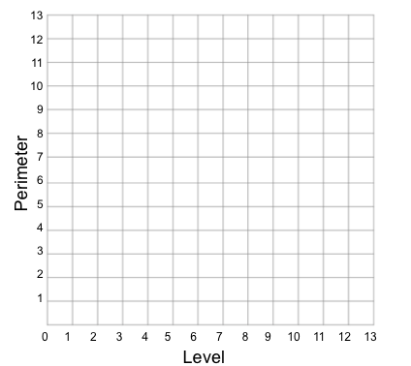
Level  (x) | Perimeter  (y)
1
2
3
4
5
Equation

Directions: Using the pattern blocks you were given, complete the 4th and 5th level of each pattern. Complete the table and then graph the ordered pairs.

- Level 1 Level 2 Level 3 Level 4 Level 5
Level  (x) | Perimeter  (y)
1
2
3
4
5
Equation

3. Compare the tables, the graphs, and the equations of these relationships. What do you notice is the same about the relationships and what is different?

Same | Different
4. Based on your observations and our discussions, what qualities would something need to possess to be considered a proportional relationship? What qualities would non-proportional relationships possess?

Proportional Relationships | Non-proportional Relationships

Name: ______________________________________________ Date: __________________________

Proportional Relationships with Pattern Blocks
Part 2
Directions: Complete the table and then graph the ordered pairs. Once you have completed the graph, write the equation of the relationship.

- Level 1 Level 2 Level 3
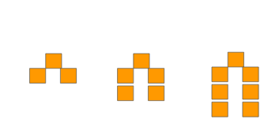
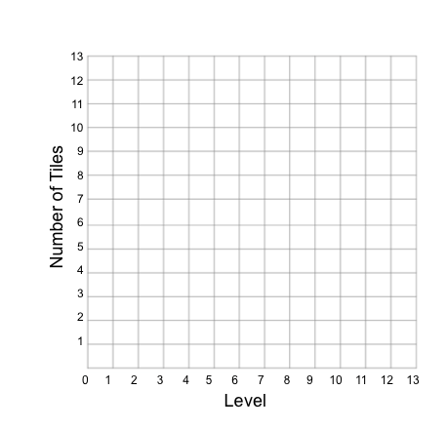

Level  (x) | # of tiles  (y)
1
2
3
4
5
Equation

Is this relationship proportional or non-proportional? Defend your position below.

- Level 1 Level 2 Level 3
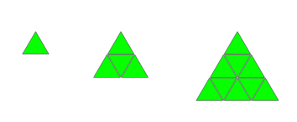

Level  (x) | perimeter  (y)
1
2
3
4
5
Equation

Is this relationship proportional or non-proportional? Defend your position.
- Level 1 Level 2 Level 3 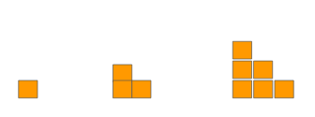
Level  (x) | perimeter  (y)
1
2
3
4
5
Equation

Is this relationship proportional or non-proportional? Defend your position.
- Level 1 Level 2 Level 3 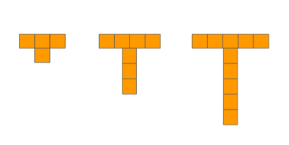
Level  (x) | # of tiles  (y)
1
2
3
4
5
Equation

Is this relationship proportional or non-proportional? Defend your position.

Pattern Block Template
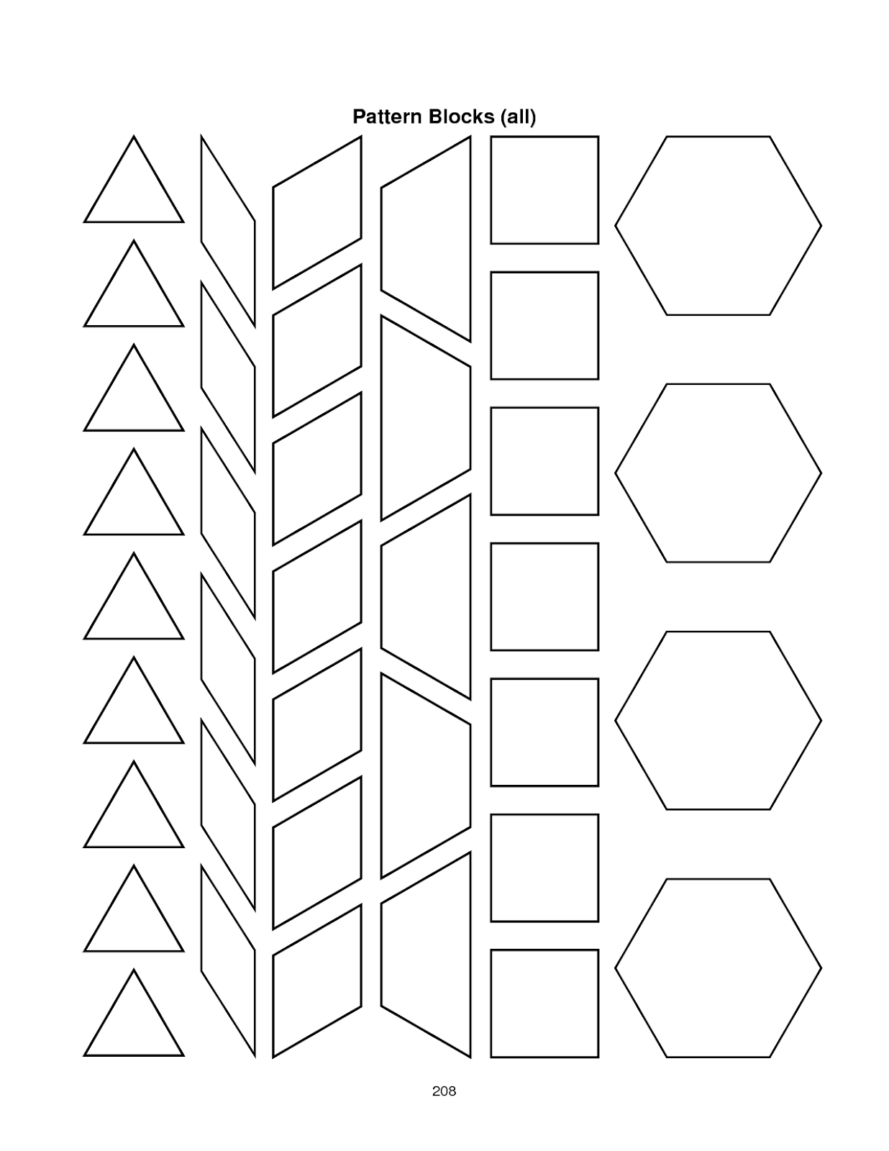

Possible Strategies/Anticipated Responses:

This activity works best with students in partners. Many students need to bounce ideas off of another in inquiry situations like this one.

You may have to help students count the perimeter initially, as many students may be confused as to how to do this.

Students may also struggle in writing the equation of non-proportional relationships. It may be helpful to reinforce to students that a straight line does indicate a constant relationship, and so if the graph is a straight line, it is possible to write an equation.

Task 3: Car Chaos
Framework Cluster | Proportional Relationships
Standard(s) | NC.7.RP.2 Recognize and represent proportional relationships between quantities.  - Understand that a proportion is a relationship of equality between ratios.  - Represent proportional relationships using tables and graphs.  - Compare two different proportional relationships using tables, graphs, equations, and verbal descriptions.  - Identify the unit rate (constant of proportionality) within two quantities in a proportional relationship using tables, graphs, equations, and verbal descriptions.  - Create equations and graphs to represent proportional relationships.  - Use a graphical representation of a proportional relationship in context to:  - Explain the meaning of any point (x, y).  - Explain the meaning of (0, 0) and why it is included.  - Understand that the y-coordinate of the ordered pair (1,y) corresponds to the unit rate and explain its meaning.  SMP 1 Make sense of problems and persevere in solving them.  SMP 2 Reason abstractly and quantitatively.  SMP 3 Construct viable arguments and critique the reasoning of others  SMP 4 Model with mathematics  SMP 8 Look for and express regularity in repeated reasoning
Materials/Link | - Rulers  - Calculators  - Student sheet (attached below)
Learning Goal | - Create graphs, tables and equations for a proportional relationship.  - Identify unit rate using a graph, table or equation.  - Explain the meaning of the points (1,r) and (0,0) in a proportional relationship.
Task Overview

Students will create and use graphs, tables and equations to determine which vehicle is the most fuel efficient.
Prior to Lesson:

Students will need to have a basic understanding of proportional relationships and how to calculate the constant of proportionality.
Teaching Notes:

Task Launch:
- Introduce the scenario at the top of the student sheet to launch the task. Give students an opportunity to ask questions. Some may need more information as to the meaning of “fuel efficient”.

Directions:
- Instruct students to work independently on Vehicle 1. Once sufficient time has been given allow students to discuss their solutions in small groups. Monitor and note various strategies for completing the graph and writing the equation. Select student to share their strategies.
- Instruct students to work in pairs/groups to complete the remaining vehicles. Again, monitor and note strategies to address in the whole class discussion.
- Instruct students to answer the “conclusion” questions. Monitor and note strategies.
- Begin the whole class discussion. During the discussion try to make connections between the representations of the data. For example, when discussing vehicle 3, ask students, “How is the unit rate represented in the graph? The table? The equation? Students should leave with an understanding that the ordered pair (1, r) is the unit rate.
- Make sure all students have correct equations before completing the part “Determining Cost Per Vehicle”
There are some excellent opportunities in this activity to review rounding.

Student sheets begin on the next page.

Name: _____________________________________________ Date: ___________________________
Vacation Time

The Smith Family is going on vacation. It is time to finalize their vacation budget, and they need to decide which family vehicle is the most economical to take on their vacation. To help them decide, three members of the family track their mileage and gasoline usage on errands leading up to the vacation. Each member of the family shared their data in a different form than the others (table, graph, equation). Use the data they collected to help them determine which car is the most fuel efficient.

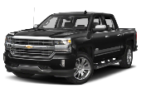
Vehicle 1 - Chevrolet Silverado

Dad reported back to the family with a table detailing the number of miles he could drive, y, on x gallons of gasoline.

Table | Graph | Equation
Gallons (x) Miles (y)  1.5 36  2.5 60  4 96 | 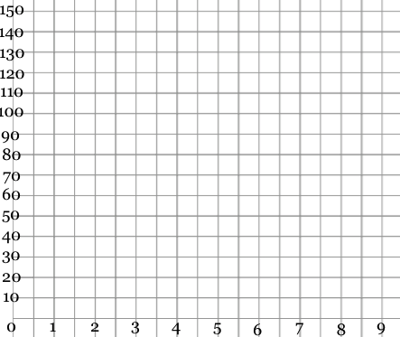
Vehicle 2 - Kia Optima
Mom reported back to the family with a graph detailing the number of miles she could drive, y, on x gallons of gasoline.
Table | Graph | Equation
Gallons (x) Miles (y) | 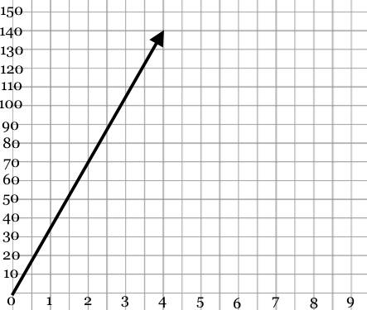

Vehicle 3 - Toyota Prius
Karli reported back to the family with an equation that could be used to determine the number of miles you could drive, y, on x gallons of gasoline.

Table | Graph | Equation
Gallons Miles |  | y = 53x
Conclusions
Which of the three cars is the most economical for the Smith family to drive, and why?

How could you decide which is the most fuel efficient by looking only at the shape of the graphs? What has to remain consistent among the graphs to allow you to do this?

Locate and plot the coordinate (1, y) on each graph, then circle it. Explain how you could use that point to compare the fuel efficiency between the vehicles.

What does the point (0, 0) mean on these graphs, and why is it appropriate to include?

Determining Cost Per Vehicle

The Smith Family decides to go from their home in North Carolina to Charleston, SC. The distance is 241.5 miles one-way. Determine the number of gallons the entire trip would take in each of the 3 vehicles. Round each number of gallons to the nearest tenth.

Vehicle | Equation | Number of Gallons Needed
Chevrolet Silverado

Kia Optima

Toyota Prius

Gas is currently $2.28 per gallon. How much would it cost the Smith Family to take each vehicle on the trip? You will need the information from the prior question to answer this question. Show your work in the “Total Cost” column.

Vehicle | Total Cost
Chevrolet Silverado

Kia Optima

Toyota Prius

What factors, other than cost, may influence the vehicle a family chooses to take on vacation?

Possible Strategies/Anticipated Responses:

Vehicle 1 - Students may set up a proportion using the information in the table to find the unit rate. Others may extend the table to find the amount of miles for 1 gallon.

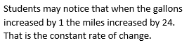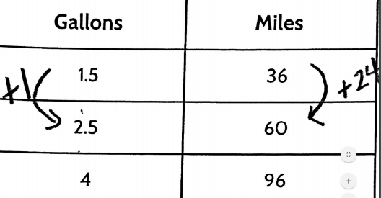

Vehicle 2 - Students may struggle with what to put in the table since few points on the graph are whole number ordered pair. Hopefully they can identify that 2 gallons resulted in 70 miles and thus calculate the rate of 35 miles per 1 gallon. Others may use strategies from Vehicle one to complete the table.

Vehicle 3 - Some students may recognize the constant of proportionality as 53. Others may substitute values for x (gallons) to get y (miles). Students might confuse the independent and dependent variables to get incorrect ordered pairs.

Conclusions - Some students may associate “most efficient” with smallest unit rate.

Determining Cost Per Vehicle - Some students may double the number of miles and use it in the equation from the beginning. Ex. 483 = 24x. Others may find the number of gallons for one way and then double it.

