Task 1: Percents as Ratios

Cluster | Proportional Reasoning
Standard(s) | NC.7.RP.3 Use scale factors and unit rates in proportional relationships to solve ratio and percent problems.  SMP 1 Make sense of problems and persevere in solving them.  SMP 2 Reason abstractly and quantitatively.  SMP 8 Look for and express regularity in repeated reasoning
Materials/Link | - Student activity sheets  - Calculator, if necessary
Learning Goal | Utilize an understanding of ratios and ratio tables to calculate percentages and percent increase/decrease.
Task Overview:

This activity is designed to build on students’ reasoning with ratios and proportions (particularly ratio tables) to solve problems with percents and percent increase/decrease.
Prior to Lesson:

Students will need experience with ratio tables.
Teaching Notes:

Task Launch:
Engage students in a discussion of fundraising events. Ask if they have ever participated in one or if they have noticed the school’s fundraising challenge (if applicable). If possible show a picture of a Red Cross (or other) “thermometer” gauge that keeps track of money on one side and percent on the other. Have students discuss the meaning of that picture. Suggest that a ratio table is just a money gauge turned on its side and is useful for answering questions about percentages of goals. In this activity, they will use a ratio table to answer each of the questions about the PTSA’s (Parent/Teacher/Student Association) fundraising activities.

Directions:
- Students should work in pairs or groups to complete PTSA fundraiser. They should record both their strategies and solutions on their paper and prepare to justify in class. Allow for multiple strategies.
- Have a whole class discussion about the problems.
- Then, move on to the We Will Rock You page. Let students explore and then have a WC discussion to follow up.
- Finally, discuss bargains and discounts, relating it to students’ experiences shopping for sales. Have them work through the Bargain Barn page and then have a WC debrief.

Student sheets begin on next page.

Name: _________________________________________________ Date: _________________________

FUNDRAISER
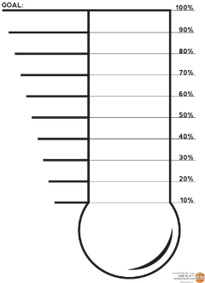
The PTSA’s fundraising goal this year is $5000.

In October, they had reached 20% of their goal. How much money have they made so far?

percent |  | 20% | 100% (goal)
money |  |  | $5000 (goal)

In March they had reached 60% of their goal. How much money have they made so far?

percent |  | 60% | 100% (goal)
money |  |  | $5000 (goal)

By May, they had made 40% OVER the original goal! How much have they made?

percent |  |  | 100% (goal) | 140%
money |  |  | $5000 (goal)

The Band wants to go to the State Competition in April. They have to raise $12,000 but have only raised 15% of their goal. How much money do they have?

percent |  |  | 100% (goal)
money |  |  | $12,000 (goal)

What percent will the Band have collected if they have raised $9000?

percent |  |  | 100% (goal)
money |  |  | $12,000 (goal)

What percent will the Band have collected if they have raised $14,000?

percent |  |  | 100% (goal)
money |  |  | $12,000 (goal)

Several of your classmates went bargain hunting at the Bargain Barn this weekend. Here are some of the purchases they made.

Mary bought a shirt on FRIDAY that cost $35. The shirt went on sale today for 30% off the ORIGINAL price. What is the SALE price today?

percent |  |  | 100% (original percent)
money |  |  | $35 (original price)

Juan bought a pair of jeans that were on sale for 20% off the ORIGINAL price. He paid $39.20 for the jeans. What was the ORIGINAL price?

percent |  |  | 100% (original percent)
money |  |  | ? (original price)

Elton paid $116.10 for a pair of in-line skates that were on sale. The ORIGINAL prices of the skates was $135. What percent of the original price is the sale price?

percent |  |  | 100% (original percent)
money |  |  | $135 (original price)

Possible Strategies/Anticipated Responses:

FUNDRAISER
Question 1:
Students may go from 100 to 1% ($50) and then scale up to 20% ($1000)

Others may scale right down to 20% by dividing by 5s.

Others may go to 10% and then to 20%

Others may argue that 5000 is 50 times bigger than 100% so multiply 20% by 50 to get $1000 (vertical scale factor).

Question 2:

Students might go straight to 60% with a scale factor of 1.666666666… ($3000)

Go to 1% or 10% and up by SF 60 or 6
Vertical multiplier (constant of prop) of 50

WE WILL ROCK YOU
Questions 1 & 2:
Various strategies that resemble the activity sheets previously.

Answers: $1800 and 75%

Question 3:

Students may say that this cannot be done because there is more money than 12,500.

Other students may figure the amount out by scaling a variety of ways.
BARGAIN BARN
The biggest difficulty students will have on these is deciding which percent goes with which money amount. Using the ratio table from there is not difficult and resembles the strategies used above.

Task 2: Dueling Discounts

Cluster | Proportional Reasoning
Standard(s) | NC.7.RP.3 Use scale factors and unit rates in proportional relationships to solve ratio and percent problems.  SMP 1 Make sense of problems and persevere in solving them.  SMP 2 Reason abstractly and quantitatively.  SMP 3 Construct viable arguments and critique the reasoning of others  SMP 4 Model with mathematics
Materials/Link | - Dan Meyer - "Dueling Discounts"  - Means of projecting the videos/images to students  - Student sheet (attached below)  - Calculators
Learning Goal | Utilize understanding of calculating discounts to reason logically about which type of discount is better in different situations.
Task Overview:

Students will use their understanding of calculating discounts to construct parameters for the use of dollar-off vs percent-off coupons. They will calculate both discounts for various items, and then use the data to reason the parameters.

Prior to Lesson:

Students should be able to understand and fluently calculate percentages, specifically discounts prior to this lesson.

Teaching Notes:

Task Launch:
- Ask students if they (or their parents) have ever had multiple coupons at a store, and had to decide which one to use? How would they decide? What information would be important?
- Students should be working in groups of 3-5.
- Show the image from Act I. Ask students to answer the question “Which coupon should I use?”, independently.

Directions:
- After students have their independent answers, have them discuss their answers in their group, and then facilitate a whole group discussion. Focus on the reasoning behind their choices.
- Have students work on Act II independently for 15 minutes, calculating each discount and deciding on the better deal.
- At the end of the time, have groups compare their answers and correct any mistakes. Then give them 5-10 minutes to work on Act III. They must construct the parameters for when to use each coupon.
- At the end of time, have groups share out their solutions, and then reveal the correct answer. Discuss any common errors.
- EXTENSION: For advanced students, or just to continue the lesson, tell students they are allowed to use both coupons and have them decide in which order they would want them to be taken off and why.

Student sheets begin on next page.

Name: _________________________________________________ Date: _________________________

Dueling Discounts
Act I
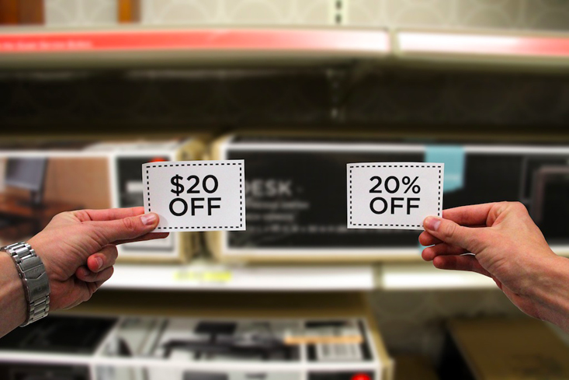

Look at the picture above. Which coupon should I use and why?

For use with Dan Meyer’s 3 Act Math Task “Dueling Discounts” - http://threeacts.mrmeyer.com/duelingdiscounts/

Act II

In what circumstances is each coupon a better deal?
Item | Sale Price for $20 Off | Sale Price for 20% Off | Better Deal?
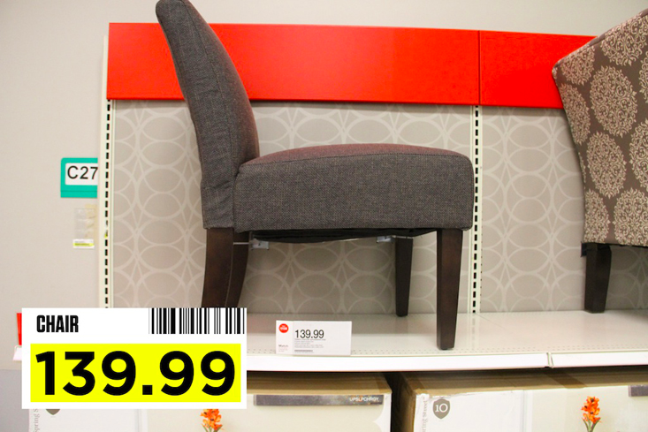

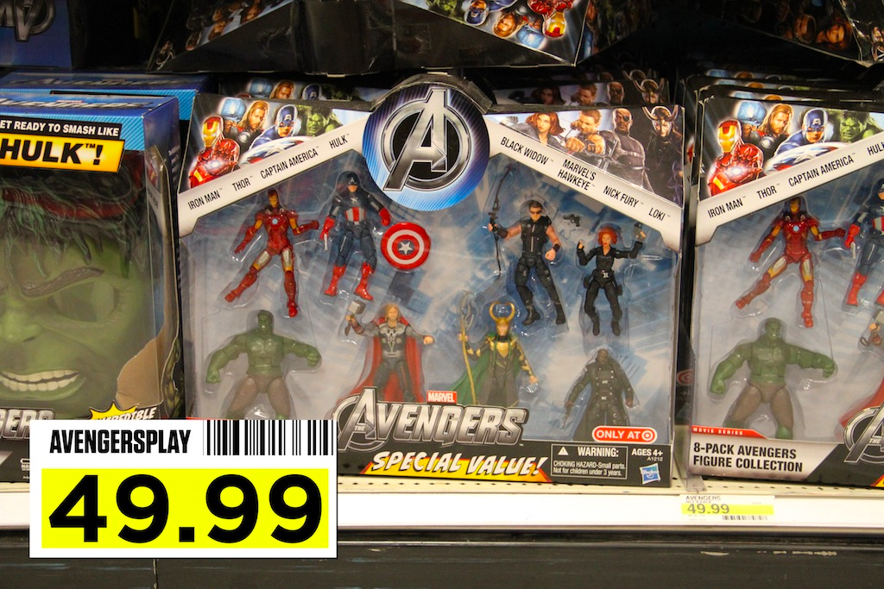

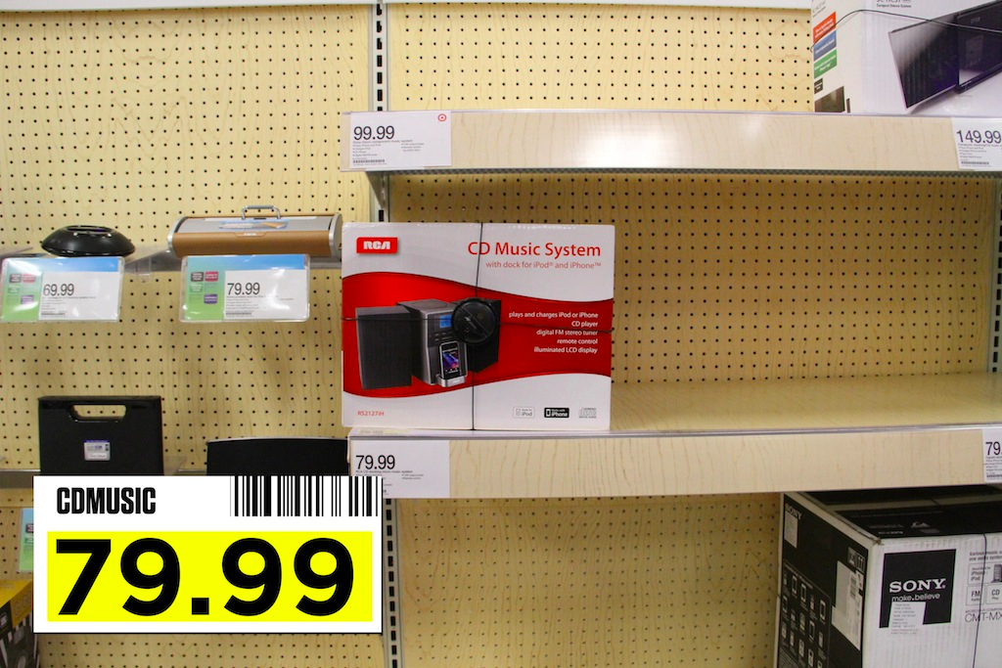

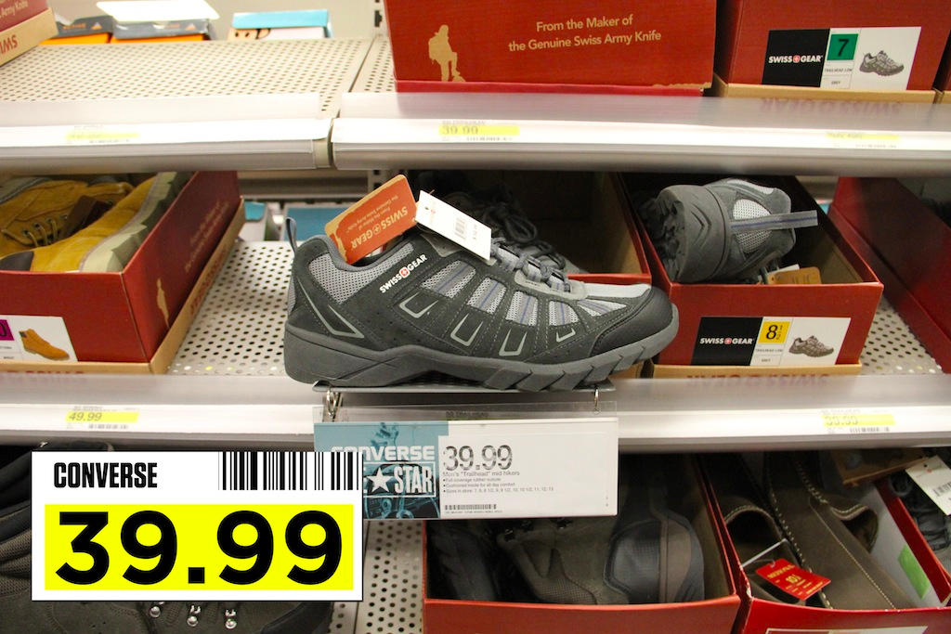

Item | Sale Price for $20 Off | Sale Price for 20% Off | Better Deal?
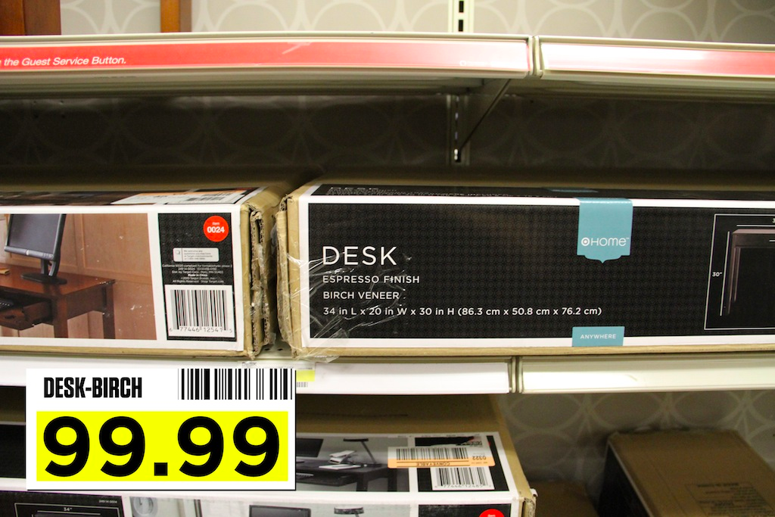

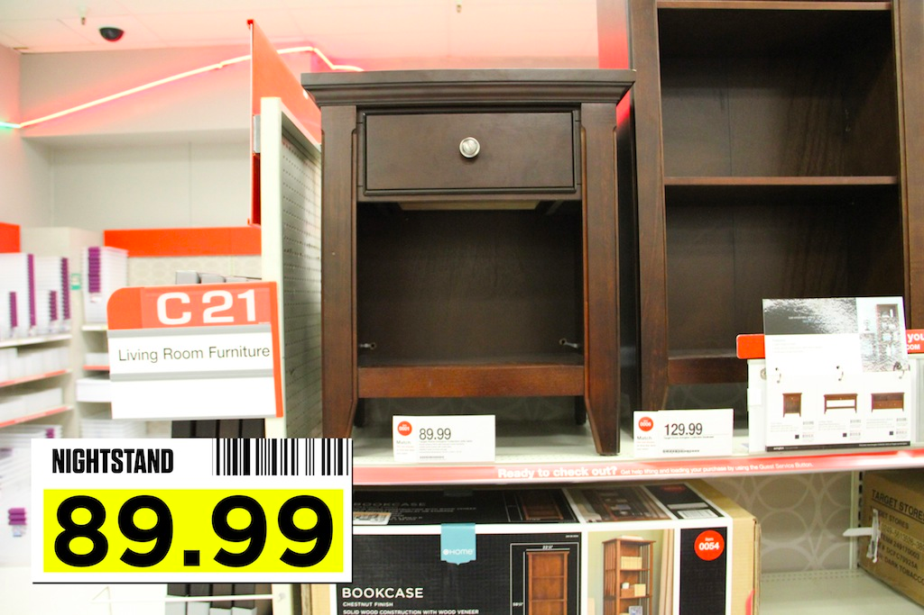

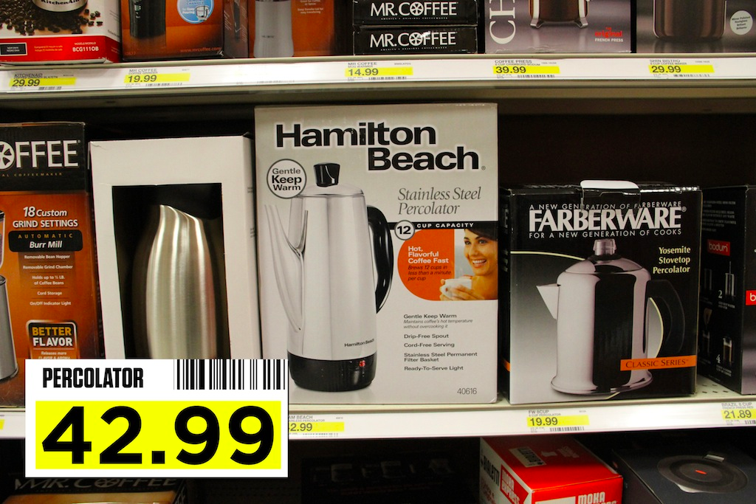

Act III

Are there certain circumstances in which each coupon a better deal? Use the information from the table to come up with a well-rounded answer.

Possible Strategies/Anticipated Responses:

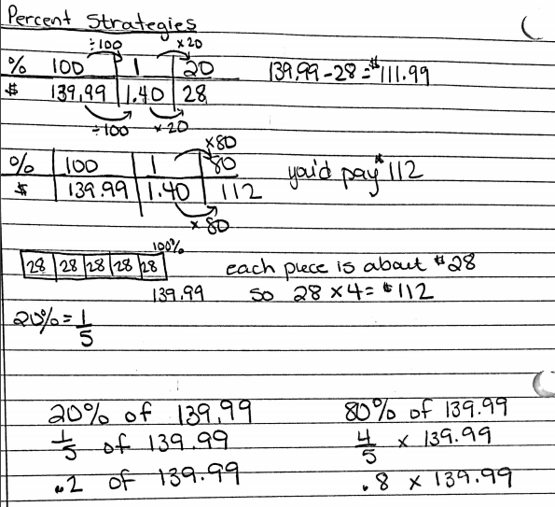

Some students may recognize that 20% means 20 out of 100 and conclude that anything over $100 would have a greater discount than $20.

Students may be confused about why $99.99 ends up being the point at which the discounts are equal. This may be a good time to have a conversation about rounding in money and why it is necessary. You may even consider having them find the range of numbers that end up calculating the same as $100 due to the rounding of change.

Task 3: Used Car Salesman
Cluster | Proportional Reasoning
Standard(s) | NC.7.RP.3 Use scale factors and unit rates in proportional relationships to solve ratio and percent problems.  SMP 3 Construct viable arguments and critique the reasoning of others  SMP 5 Use appropriate tools strategically  SMP 7 Look for and make use of structure  SMP 8 Look for and express regularity in repeated reasoning
Materials/Link | - Access to internet (1 device per student) OR various preprinted automobiles to have “on the lot”  - Calculators  - Student sheet (attached below)
Learning Goal | Solve multi-step percent problems that include both markup and commission.
Task Overview:

Students will pose as used car salesmen. They will acquire 10 different vehicles at 3 different price points. They will mark these vehicles up to create a profit, and then calculate their commission on the markup. After finding their potential commission, they will be asked reasoning questions that get them thinking about life in the real world.
Prior to Lesson:
Students should be able to calculate both markup and commission, and have a conceptual understanding of both.
Teaching Notes:

Task Launch:
- In order for students to understand the task at hand, they must first understand how most car salesmen make their money. If you are informed, it may be easier for you to explain it to the students, but if not, this video (https://www.youtube.com/watch?v=jCqw9lhsl1s) may give students the jist of what happens.
- After giving students the background on the task, you can present them with the situation at hand: Congratulations on accepting a job as a used car salesmen! Today, you will be negotiating the purchase of cars to sell at your dealership. Your smooth talking will allow you to sell the cars you acquire for 15% markup. Lucky for you, when you were hired, you agreed to 25% commission on the markup of each vehicle, so let’s get started making some money!

Directions:
- First, have students independently, or in pairs, acquire 10 different vehicles to sell.
  - If your students have access to devices connected to the internet, have them go to CARFAX to acquire their inventory.
  - If your students do not have access to devices connected to the internet, have pre-printed sheets of cars organized into the three price points detailed in the activity.
- Students should write down the year, color, make, and model of each vehicle.
- When they have acquired all 10 vehicles, they will need to first calculate the markup on the car. It is important to stress to students why dealerships markup the price, and how a profit is necessary to run a business.
- After they have calculated the markup, they can calculate their commission. Stress to students that their commission is only calculated on the markup amount, not the selling price of the car. Ask them to provide you with why that would be.
- After they have calculated their total commission, they should complete questions 1-3.
- At the end of the allotted time, come back together for a whole group conversation, focusing on question 1, and the students’ strategies for answering that question.

Student sheets begin on next page.

Name: _________________________________________________ Date: _________________________
Used Car Salesman
Congratulations on accepting a job as a used car salesmen! Today, you will be negotiating the purchase of cars to sell at your dealership. Your smooth talking will allow you to sell the cars you acquire for 15% markup. Lucky for you, when you were hired, you agreed to 25% commission on the markup of each vehicle, so let’s get started making some money!

Directions:
- Go to CARFAX (https://www.carfax.com) to find 10 cars that are within 200 miles of the zip code __________.
  - 2 cars must be between $5,000 and $10,000
  - 6 cars must be between $10,001 and $20,000
  - 2 cars must be > $20,000, but < 60,000
- Once you identify a car, you wish to acquire, write down the year, color, make, and model of the car. (Ex.: 2012 Red Toyota Corolla)
  - Write down the price you “bought” it for in the next column.
- Repeat this process for all 10 cars.
- After you have acquired all 10 cars, you will need to mark them each up 15% in order to put them on your lot and allow your dealership to make a profit.
- Once you have the markup amount, you will use that to calculate your 25% commission.
  - Remember, your commission is based on the markup amount, not the selling price of the vehicle.
- When you have done this for all 10 vehicles, calculate your total potential commission, and answer the questions on the back.

Name of Car  (Year, Color, Make, Model) | Price | Markup Amount | Selling Price  (Price + Markup Amount) | Commission Calculation | Commission
Total Potential Commission

1. The dealership you work for offers you the following choice: make a salary of $35,000 a year (paid monthly)
or make 25% commission on the markup of your vehicles. How fast would you have to sell your 10 cars to
make the commission a better choice?

Answer: ________________ months

2. What are the pros and cons of working for a salary or an hourly wage as opposed to working for commission?
You must list at least two pros and two cons.

Pros Cons

3. What personality traits would a person have to possess to thrive in a career that is based in commission, and
why?

Possible Strategies/Anticipated Responses:

Monitor students’ responses at the beginning. Many students may try to find their commission as a percent of the selling price, and not as a percent of the markup.
Students may also have difficulty solving question 1. If students are struggling, have them make a table. In the table, have students compare the total potential commission to what their salary would be that month, and circle the one that is a better deal for them. For example, if my total potential commission was $7,500. In month 1, my monthly salary would be about $2917. So if I sold my cars in one month, commission would be much better. In month 2, my salary would have totaled about $5,833, so commission would still be a better deal. However, in month 3, my salary would have totaled about $8750, so if it took me 3 months to sell my 10 vehicles, a salary would have been a better deal for me. Therefore, I would have to sell my cars in 2 months to make commission a better deal.

