Scatterplots Formative Assessments

Scatterplots Formative Assessment 1: That’s a Lotta Lettuce!
Link to Formative Assessment (if applicable): https://www.scholastic.com/content/dam/teachers/sponsored-content/Actuarial/17-18/Actuarial8_68_Worksheet2.1-2.3.pdf
(Adapted from Page 1 of Site)
Framework Cluster & Content Standards.  Statistical Reasoning Unit  NC.8.SP.1 Construct and interpret scatter plots for bivariate measurement data to investigate patterns of association between two quantities. Investigate and describe patterns such as clustering, outliers, positive or negative association, linear association, and nonlinear association. | Mathematical Practice Standards  3. Construct viable arguments and critique the reasoning of others  4. Model with mathematics  5. Use appropriate tools strategically
Learning Targets
- Construct a scatterplot that shows two-variable data.
- Investigate and describe patterns of association from scatterplot.
Timing
This assessment can be used after Task 1, the Desmos task Scatter Plot: Capture.
https://teacher.desmos.com/activitybuilder/custom/58cc26d4c722f106146a8310
Anticipated Solutions and Possible Conceptions
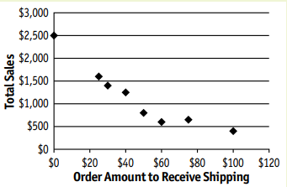
2. There is a negative correlation. The lower the order amount to receive free shipping, the higher the total sales.
3. The order amount to receive free shipping is the independent variable. Total sales is the dependent variable.
If students confuse the x and y axes in the table, graph, and context, it could lead them to analyze the context and answers to the questions incorrectly. Close read strategies could be encouraged to help students interpret the context to see what variable depends on what to graph and analyze the situation accurately.
That’s a Lotta Lettuce!

Middle school farmers Jennifer and Lucas Harris have a strong entrepreneurial spirit and want to update their operations by using modern business practices and technology.
One of their early ventures is growing specialty baby arugula that is shipped fresh to customers. While Lucas sells locally, Jennifer has been experimenting with offering free shipping on Internet orders. She tested different minimum order amounts to qualify for free shipping.

After eight weeks, she isn’t sure whether her program is working. While setting up their stand at the farmers’ market, she shares her questions, as well as a table of sales data, with Priscilla, owner of the Jammin’ Jam Shack. Priscilla suggests that a scatterplot might be a good way to determine whether or not the free shipping program was working.

Minimum Purchase to Receive Free Shipping | $50 | $75 | $100 | $30 | $25 | $40 | $0 | $60
Total Baby Arugula Sales | $800 | $650 | $400 | $1400 | $1600 | $1250 | $2500 | $600

- Create a scatterplot to display the data in the table.

- What type of pattern(s) of association do you notice between total baby arugula sales and the minimum purchase amount to receive free shipping? Explain your thinking.

- Which variable is independent and which is dependent? Explain your thinking.

Scatterplots Formative Assessment 2: Driving with Scatterplots
Link to Formative Assessment (if applicable):
https://eq.uen.org/emedia/file/690d9c7a-d070-476e-b1f8-8ad666cb21fd/1/8Ch6Student_Workbook.pdf (p.18)
Framework Cluster & Content Standards  NC.8.SP.1 Construct and interpret scatter plots for bivariate measurement data to investigate patterns of association between two quantities. Investigate and describe patterns such as clustering, outliers, positive or negative association, linear association, and nonlinear association.  NC.8.SP.2 Model the relationship between bivariate quantitative data to:  - Informally fit a straight line for a scatter plot that suggests a linear association.  - Informally assess the model fit by judging the closeness of the data points to the line | Mathematical Practice Standards  2. Reason abstractly and quantitatively.  5. Use appropriate tools strategically.  7. Look for and make use of structure.
Learning Targets
- Read and interpret a scatter plot.
- Describe patterns of association in a scatter plot.
- Informally draw a line that bests represents linear data.
Timing: This will fit after you have laid a foundation describing and interpreting scatterplots and how to draw a line through data points that appear to go in a linear direction.
Anticipated Solutions

a. 37.25 represents 37.25 million people living in a state, 23.75 represents how many millions of people in that same state that are licensed drivers in 2010
c. As the population of a state increases so does the number of licensed drivers.
d. Approximately 19 - 20 million
e. Approximately 18 – 18.5 million people
f. They have about the same population (even though B is slightly more) but A has about 3 million more people with licenses.
g. Plausible explanations may include: The public transit in NY is very good so people don’t need cars as much. New York roads are more congested so driving is not a great way to get around. New York is less spread out than Florida. Parking is more expensive in New York.

As in Formative Assessment 1, some students could misinterpret the x and y axes of the graph, leading to incorrect analyses. Also in this graph, students could be confused by the units in millions of people and the need to estimate. Teachers can reinforce the value of estimation to students and that the relationship between the points is the focus of this assessment.

Driving with Scatterplots

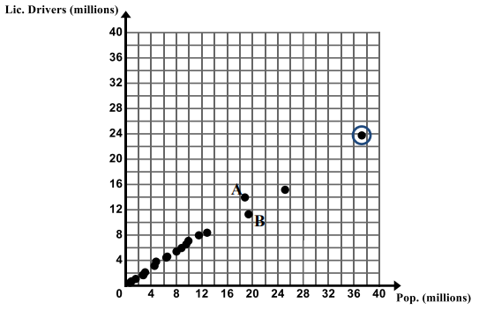
The U.S. Census Bureau collects data about the people and economy in the United States. The graph below shows the population (in millions) and the number of licensed drivers (in millions) for 20 different states for the year 2010.

- Draw a line that best fits the data. What does the circled data point (37.25, 23.75) represent in the context?

- In 2010, Texas had a population of approximately 25.15 million people and had approximately 15.2 million licensed drivers. Put a star by the data point that represents Texas.

- What does the graph show about the relationship between a state’s population and the number of licensed drivers in the state?

- If a state has a population of approximately 32 million people, approximately how many licensed drivers would you expect to find in the state based on the trend in the scatter plot? Explain.

- If a state has approximately 12 million licensed drivers in a state, what would you expect the population to be in that state based on the trend in the scatter plot? Explain.

- Data point A represents the state of Florida and data point B represents the state of New York. Provide an explanation as to why New York has more total people than Florida but fewer licensed drivers.

Scatterplots Formative Assessment 3: Interpreting Scatterplots
Framework Cluster & Content Standards  NC.8.SP.1 Construct and interpret scatter plots for bivariate measurement data to investigate patterns of association between two quantities. Investigate and describe patterns such as clustering, outliers, positive or negative association, linear association, and nonlinear association.  NC.8.SP.2 Model the relationship between bivariate quantitative data to:  - Informally fit a straight line for a scatter plot that suggests a linear association.  - Informally assess the model fit by judging the closeness of the data points to the line | Mathematical Practice Standards  3. Construct viable arguments and critique the reasoning of others.  4. Model with mathematics.  5. Use appropriate tools strategically.  7. Look for and make use of structure.
Learning Targets
- Students distinguish linear patterns from nonlinear patterns based on scatter plots.
- Students describe positive and negative trends in a scatter plot.
- Students identify and describe unusual features in scatter plots, such as clusters and outliers.
- Students will informally draw a line that best fits the data for linear associations.
Timing: This assessment will fit during instruction or after Task 3.
Anticipated Solutions
As students work through the graphs, they might struggle with the interpretations based on the axes. Potential guiding questions to help could ask them to identify the independent and dependent variables or to create a situation that the graph could represent.

Positive, linear  As temperature rises sales increase | Nonlinear | Positive, linear  The more you study the better the test grade
Positive, linear  The longer an eruption lasts from Old Faithful the longer it takes for the next one to begin | Negative, linear  As a car gets older the price decreases | No correlation  There is no relationship between how old someone is vs. their BMI number

Interpreting Scatterplots

Describe the pattern(s) of association in these scatterplots. Are they linear or nonlinear? Positive, negative, or no association? Strong or weak correlation? If the graph is linear, explain what the relationship is showing and draw a line of best fit for that data.

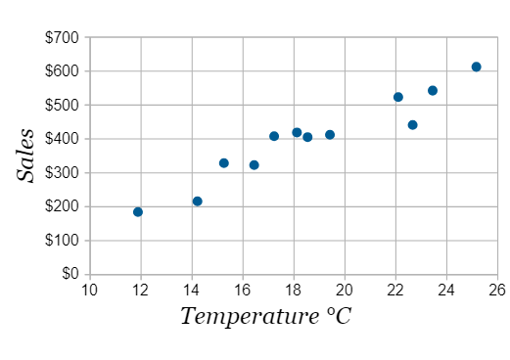  Explain: | 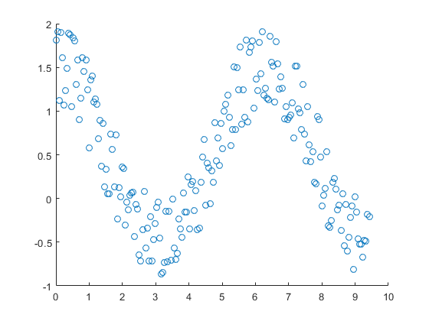  Explain: | 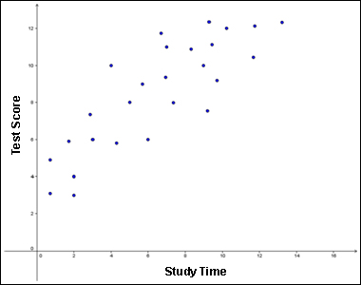  Explain:
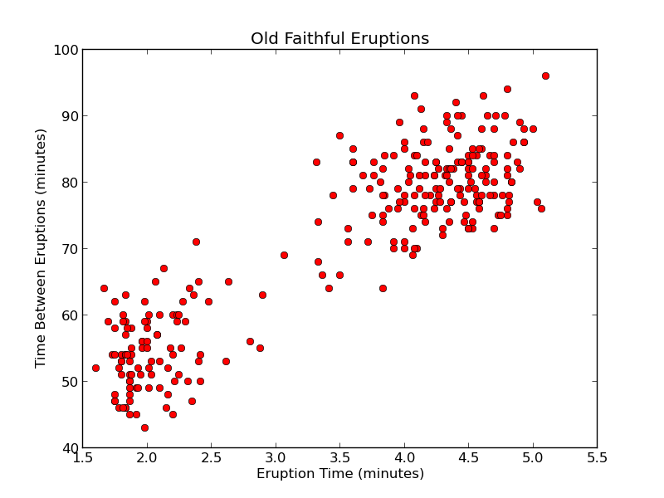  Explain: | 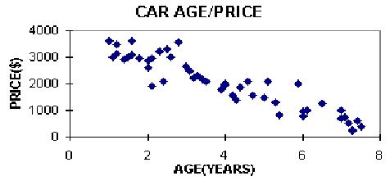  Explain: | 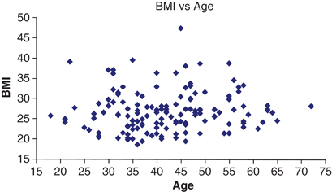  Explain:

