Scatterplots Task 1: Polygraph: Scatter Plots
Framework Cluster | Statistical Reasoning Unit
Standard(s) | NC.8.SP.1 Construct and interpret scatter plots for bivariate measurement data to investigate patterns of association between two quantities. Investigate and describe patterns such as clustering, outliers, positive or negative association, linear association, and nonlinear association.  MP 2 --Reason abstractly and quantitatively.  MP 3 - Construct viable arguments and critique the reasoning of others.
Materials/Links | Computer  https://teacher.desmos.com/polygraph/custom/560aa8c858fd074d1561808f
Learning Goal(s) | Describe a scatterplot using rich vocabulary such as clusters, linear and nonlinear, positive and negative associations.
Task Overview:
This Custom Polygraph is designed to spark vocabulary-rich conversations about scatter plots. Key vocabulary that may appear in student questions includes: strong association, weak association, no association, positive association, negative association, linear, non-linear, increasing, and decreasing.
In the early rounds of the game, students may notice graph features like strong and weak associations, even though they may not use those words to describe them. That’s where you can step in. After most students have played 2-3 games, consider taking a short break to discuss strategy, highlight effective questions, and encourage students in their use of increasingly precise academic language. Then ask them to play several more games, putting that precise language to work.
Prior to Lesson:
Students should know basic vocabulary concerning scatterplots.
Teaching Notes:
Task launch:
- Play a quick game of ‘I spy’ to show the importance of using good descriptions.
- Have students go to Student.desmos.com and give code.
Directions:
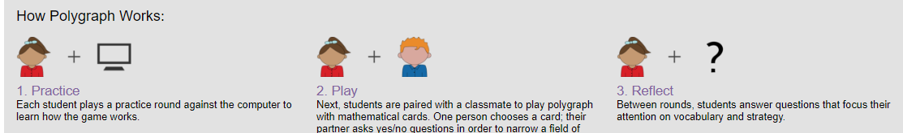
- The activity will automatically pair students to work in anonymous pairs. The Desmos site gives a lot of tips for how to effectively implement a Polygraph activity, and teachers should review the activity before using in class.
Possible Strategies/Anticipated Responses:

Before you put students on computers, make sure they understand the premise of the game. We do not recommend playing a sample round with the class, as the first round involves the computer asking questions of all of the students (a fact we do not reveal until they have finished the first round). You could easily, however, play a low-tech version—show the array, pick your card, have students ask questions aloud, respond, etc.

Starting in the second round, pair students with each other. One student picks the card and answers questions, the other student asks the questions and tries to identify the chosen card. Between rounds, students answer questions that focus their attention on vocabulary and strategy.

Some students might have initial trouble describing and asking questions about the graphs, just seeing them as groups of dots. As the teacher circulates, questions such as “What patterns do you see in the dots” can encourage student thinking around correlation.

Additionally, the vocabulary of correlation could confuse students especially if this task is used to introduce the concept. Allowing students to express the relationships in their own words, such as “the dots go up” or “the dots make a line,” is appropriate for the exploration phase of the polygraph, but a class discussion should follow to use the proper vocabulary associated with the correlation.

Student sheets begin on next page. (none needed)

Scatterplots Task 2: Scatter Plot Capture
Framework Cluster | Statistical Reasoning Unit
Standard(s) | NC.8.SP.1 Construct and interpret scatter plots for bivariate measurement data to investigate patterns of association between two quantities. Investigate and describe patterns such as clustering, outliers, positive or negative association, linear association, and nonlinear association.  MP1 - Make sense of problems and persevere in solving them  MP7 - Look for and make use of structure.
Materials/Links | Computer and Copy of Part 2 sheet.  Part 1 https://teacher.desmos.com/activitybuilder/custom/58cc26d4c722f106146a8310  Part 2 http://map.mathshell.org/tasks.php?unit=HA09&collection=9
Learning Goal(s) | - Use a computerized model to predict value intervals for data.  - Determine if points on a scatterplot have a linear association.  - Describe patterns of association in a scatterplot.  - Read and interpret data from a scatterplot.
Task Overview:
In this activity, students use observations about scatterplot relationships to make predictions about future points in the plot. In particular, students focus on linear vs nonlinear association, strong vs weak association, and increasing vs decreasing plots.
Prior to Lesson:
Students should comprehend how to recognize patterns of association in a scatterplot including clusters and outliers.
Teaching Notes:
Task launch: Revisit why someone would choose to use a scatterplot to look at data. What are the benefits? How does it help to be able to predict what data will look like with future decisions if you’re a business owner?
Directions:
- Students should work through the Desmos activity first by going to Student.desmos.com and giving the class code the teacher creates. They can work alone, in partners, or in small groups to discover the relationships using proper vocabulary. Possible places to stop the activity for class discussions are Slide 4, Slide 7, and Slide 13. See the Desmos Teacher Guide for more tips on the pedagogy of this task.
- After completing the Desmos task, students can work through the MARS task. This graph is not linear, but it forces students to notice the meaning of each point in the context of the axes. As the teacher circulates, Smith and Stein’s framework for implementing tasks can help guide the instruction and discussion.
Possible Answers:

Part 1: This is the link to the teacher guide with teacher tips for each slide in the activity.
https://teacher.desmos.com/activitybuilder/teacherguide/58cc26d4c722f106146a8310
Part 2
- Heaviest D , cheapest B
- C and E
- A and C
- C: price ÷ weight is smallest ratio

Student sheets begin on next page.

Sugar Prices

Part 2
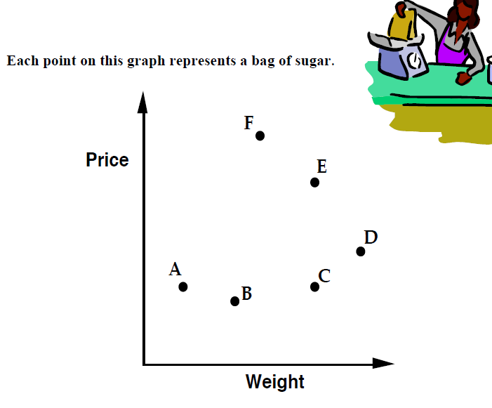

- Which point shows the heaviest bag? _____ Cheapest?______ Justify.

- Which points show bags with the same weight? ____________

- Which points show bags with the same price? _______ Explain your thinking.

- Which bag, F or C, gives the best value for money? ____________ How can you tell?

Scatterplots Task 3: Opening Weekend – Avengers: Infinity War
Framework Cluster | Statistical Reasoning Unit
Standard(s) | NC.8.SP.1 Construct and interpret scatter plots for bivariate measurement data to investigate patterns of association between two quantities. Investigate and describe patterns such as clustering, outliers, positive or negative association, linear association, and nonlinear association.  NC.8.SP.2 Model the relationship between bivariate quantitative data to:  - Informally fit a straight line for a scatter plot that suggests a linear association.  - Informally assess the model fit by judging the closeness of the data points to the line  MP 2 - Reason abstractly and quantitatively.  MP 4 - Model with mathematics.  MP 7 - Look for and make use of structure
Materials/Links | Task Recording sheet  https://www.yummymath.com/wp-content/uploads/Avengers-InfinityWar.pdf
Learning Goal(s) | - Construct a scatterplot that shows two-variable data.  - Investigate and describe patterns of association from scatterplot.  - Read and interpret a scatter plot.  - Informally draw a line that bests represents linear data.
Task Overview:
In this task, students will use data given in a table and construct a scatterplot to see if they can predict how much a movie’s total gross income is from its opening weekend gross income.
Prior to Lesson:
Students should have been taught how to recognize various patterns in a scatterplot such as linear vs. nonlinear, positive or negative including no association, clusters and outliers.
Teaching Notes:
Task launch:
- Show students the trailer to the movie to spark interest in the task. https://www.youtube.com/watch?v=QwievZ1Tx-8 Let them come up with possible math questions that could be asked based on the movie.
Directions:
- Separate students into groups of 3 or 4.
- Students will engage in mathematical discourse to complete the task.
- Questions 6-9 are for when students have learned how to write a linear regression. (NC.8.SP.3) or for those ready for a challenge. Students are not expected to use the calculator in 8th grade to write the equation, but they can select two points to write the equation of the line of best fit.
- As the teacher circulates, Smith and Stein’s framework for implementing tasks can help guide the instruction and discussion.
Possible Strategies/Anticipated Responses:

Watch for students who will mix up the independent and dependent variables. The horizontal axis will represent the opening weekend income of each film (suggestion: increments of $50 in millions). The vertical axis will be the final gross income of the movie (suggestion: increments of $100 in millions). Additional struggles could be seen in the units of the axes, as they represent millions of dollars.

Answers will vary depending on the movies students choose, but based on the 14 movies presented in the table, the equation will be about y = 2.27x + 138.88 (in millions of dollars). For The Avengers, the final total should be about $725 million. A class discussion could focus on why there might be different values for different movies, if the y-intercept is accurate in this context, and how removing outliers could change the equation.

Student sheets begin on next page.

This past weekend, Avengers: Infinity War had a tremendous opening weekend by earning more than 250 million dollars in the US.

In opening weekends, a movie’s opening gross income is often quoted as a way of measuring the movie’s eventual success. Can you predict a movie’s total gross income from its opening weekend gross income?

Here’s data on 14 movies that you might have seen (15 if you've already seen the new Avengers). We’ve included the gross amount that they earned on their opening weekend (U.S.) and the gross amount that they have earned (U.S.) in total at theatres. We've also included the new Avengers movie but did not give its long-term gross income.

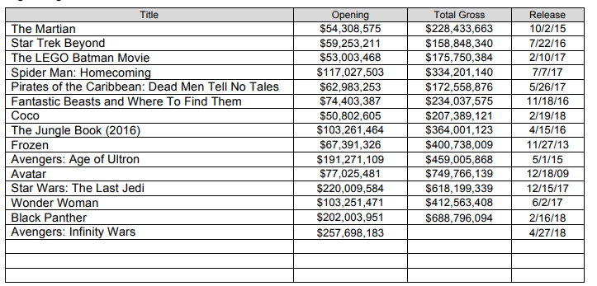

We wonder if you can predict what this movies total gross income will be by studying the opening weekend data. Maybe there is a pattern between the opening weekend data and the final gross total income of the movie. Let’s see if that is true.

[We’ve left a few blank lines in the chart above for you to add your favorite movies or other recent movies. You can find the opening weekend and final gross data at http://boxofficemojo.com/. ]

- Create a scatter plot. Plot the data from above on the scatterplot. Your teacher may also give you additional movie data from recent releases. If so, be sure to plot that data as well.

- Is the relationship between Opening weekend income and the film’s final income a linear association or something else? Describe the association between the two variables.

- Can you predict what Avengers: Infinity Wars will finally earn in U.S. theaters? What about any additional movies that you plotted?

- Based on the data, how much would you expect movies to make in gross that had opening weekends of $80 million, $100 million, $200 million and $250 million? How did you determine your estimates?

- Draw a line of best fit that models the data. How do you decide where to draw your line?

- Write the linear equation for your line of best fit. This equation should give a reasonable (yet rough) prediction of the amount of money a movie will gross for any opening weekend total. Please show or explain how you came to your rule.

- If future Avenger films beat the opening weekend numbers and make $300,000,000 or $400,000,000 in the U.S., how much might they make in total at theaters?

- For a film to make a billion dollars in U.S. theaters how much would it need to make during its opening weekend? Explain and justify your reasoning.

- Once the data is available (probably several weeks after opening) go back check and the actual data for Avengers. You can get this data from the Internet or your teacher may provide it for you. Describe how accurate your predictions were. Did the data follow the association or was this movie an outlier?

