Similarity Formative Assessment 1 - Are They Similar?
Link to Formative Assessment: https://www.illustrativemathematics.org/content-standards/8/G/A/4/tasks/1946 (Illustrative Math Site)
Cluster & Content Standards  What content standards can be addressed by this formative assessment?  8.G.4 - Use transformations to define similarity:  - Verify experimentally the properties of dilations that create similar figures  - Understand that a two-dimensional figure is similar to another if the second can be obtained from the first by a sequence of rotation, reflections, translations, and dilations  - Given two similar two-dimensional figures, describe a sequence that exhibits the similarity between them | Mathematical Practice Standards  What practice standards can be addressed by this formative assessment?  1. Make sense of problems and persevere in solving them.  3. Construct viable arguments and critique the reasoning of others.  4. Model with mathematics.
Learning Targets
What learning targets will be assessed?
- Students will apply properties of transformations to determine if an appropriate sequence exists to prove similarity between shapes.
- Students will use tools (protractor, patty paper, rules, etc.) to verify properties of shapes to determine similarity.

Timing: During or After Instruction/Tasks

Anticipated Solutions: See Illustrative Mathematics document for several solutions and strategies

Similarity Formative Assessment 1 - Are They Similar?
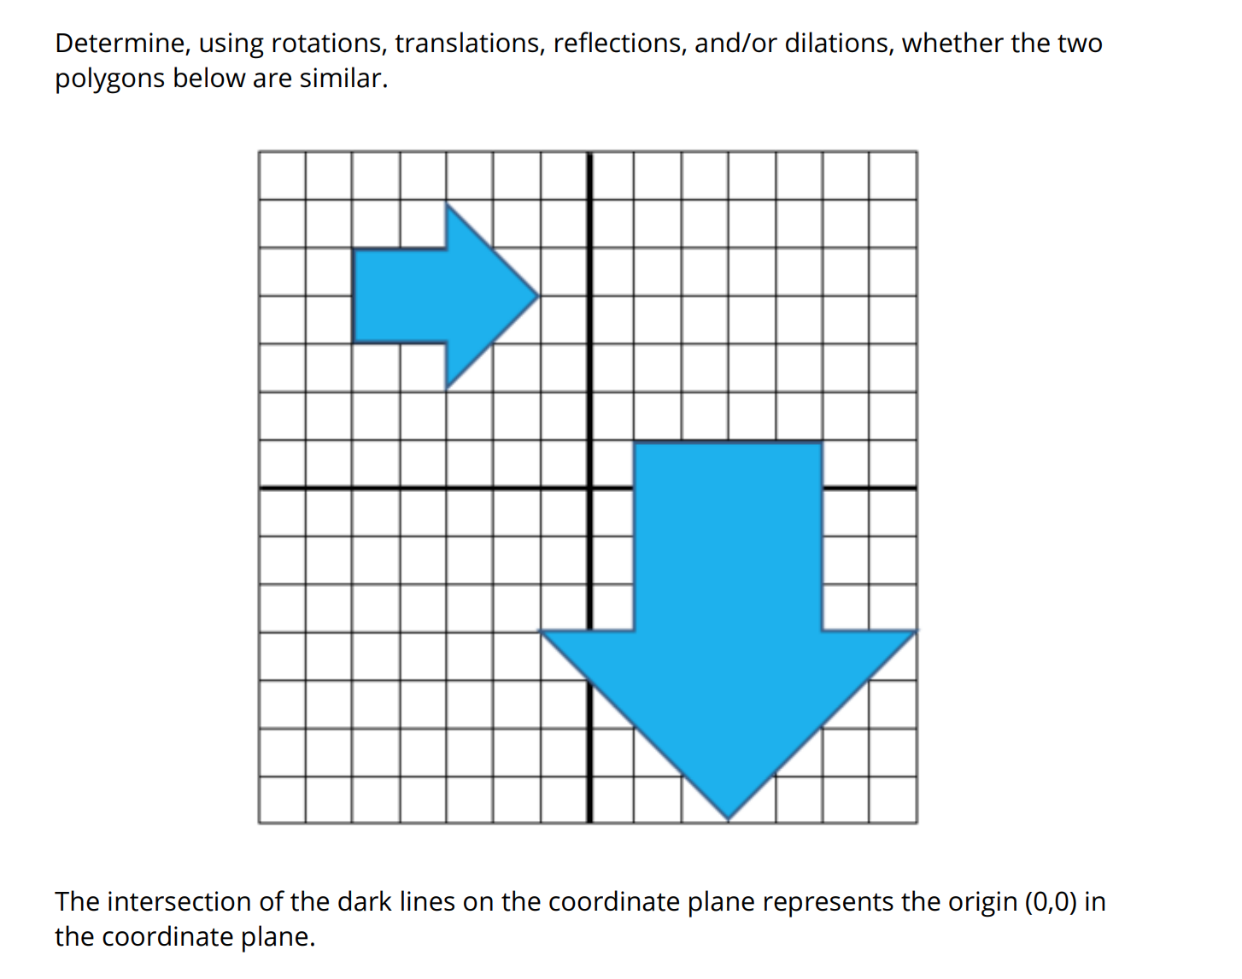

Similarity Formative Assessment 2 - Similar or Congruent?
Cluster & Content Standards  What content standards can be addressed by this formative assessment?  8.G.3 - Describe the effect of dilations about the origin, translations, rotation about the origin in 90 degree increments, and reflections across the x-axis and y-axis on two dimensional figures using coordinates | Mathematical Practice Standards  What practice standards can be addressed by this formative assessment?  3. Construct viable arguments and critique the reasoning of others.  4. Model with mathematics.  7. Look for and make use of structure.
Learning Targets
What learning targets will be assessed?
- Students will determine the difference between similarity and congruence transformations
- Students will map similar and congruent figures onto each other using sequences of transformations
Timing: After teaching all transformations to determine level of mastery

Solutions: Congruent: 2, 3, 6, 8
Similar: 5, 7
Possible Conceptions:
- Thinking that orientation matters when looking at congruence
- Only considering lengths of horizontal sides when looking at congruence
- Confusing reflections, rotations, translations, and dilations when sequencing the transformations

Similarity Formative Assessment 2 - Similar or Congruent?
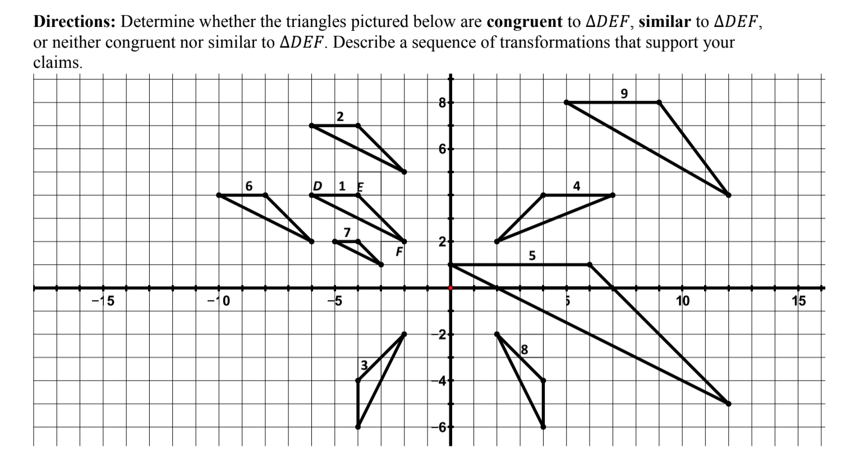

Similarity Formative Assessment 3 - Exploring Dilation and Scale Factor
Cluster & Content Standards  What content standards can be addressed by this formative assessment?  8.G.3 - Describe the effect of dilations about the origin, translations, rotation about the origin in 90 degree increments, and reflections across the x-axis and y-axis on two dimensional figures using coordinates  8.G.4 - Use transformations to define similarity:  - Verify experimentally the properties of dilations that create similar figures  - Understand that a two-dimensional figure is similar to another if the second can be obtained from the first by a sequence of rotation, reflections, translations, and dilations  - Given two similar two-dimensional figures, describe a sequence that exhibits the similarity between them | Mathematical Practice Standards  What practice standards can be addressed by this formative assessment?  1. Make sense of problems and persevere in solving them.  2. Reason abstractly and quantitatively.  3. Construct viable arguments and critique the reasoning of others.  6. Attend to precision.
Learning Targets
What learning targets will be assessed?
- Students will understand the relationship between scale factor and dilation on the coordinate plane.
- Students will calculate image points after dilations.

Timing: During or After Instruction/Tasks

Correct Answers:
- No. Sample explanation: The scale factor isn’t consistent for all coordinates. For the x-coordinates, A and B have a scale factor of 2, but C has a scale factor of 10/4 = 2.5.
- The error is in the x-coordinate of C. 3 • ½ = 1.5, not 1. In a dilation, every coordinate must have the same relationship with the scale factor, and point C does not.
- The scale factor is 3, as that is the ratio of the lengths of sides Q’R’ and QR. 9/3 = 3
- Lack of precision in calculations, Misunderstanding preimage and image in dilations

Similarity Formative - Exploring Dilation and Scale Factor

      - Triangle ABC with coordinates A (2, 4); B (2, 2); and C (4, 2) is transformed with the new coordinates of triangle A’B’C’ as follows: A’ (4, 10); B’ (4, 4); and C’ (10, 4). Is this transformation a dilation? Explain your answer using words or mathematical representation.

      - John claims that figure A’B’C’D’ is a dilation with a scale factor of one-half. He made an error when listing the coordinates of the points. Identify the error and make the appropriate correction. Explain your reasoning using words or mathematical representation.

- A (4, 2) A ʹ (2, 1)
- D (-6, -4) D ʹ (-3, -2)
- C (3, -8) C ʹ (1, -4)
- B (-6, 1) B ʹ (-3, 0.5)

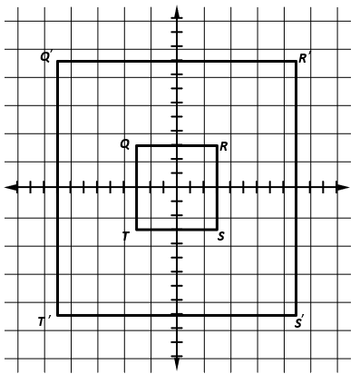
      - The image of figure QRST is figure Q’R’S’T’. What is the scale factor for this dilation? Explain your answer using words or mathematical representation.

