Similarity Task 1: Scale Factor and Similarity
Framework Cluster | Reasoning about Similarity and Transformations
Standard(s) | 8.G.4: Use transformations to define similarity.  - Verify experimentally the properties of dilations that create similar figures.  - Understand that a two-dimensional figure is similar to another if the second can be obtained from the first by a sequence of rotations, reflections, translations, and dilations.  - Given two similar two-dimensional figures, describe a sequence that exhibits the similarity between them.
Materials/Link | Copy of Task Below
Learning Goal | Student will discover a relationship between reciprocal scale factors and similar shapes.
Task Overview: Students are given two similar shapes with the lengths of two pairs of corresponding sides. They are asked to analyze the scale factor given “both ways,” as a ratio of the larger to smaller shape and smaller to larger shape, to determine which is “right,” ultimately realizing that both can be right depending on what an observer is looking for.
Prior to Task: No new 8th grade content needs to be taught before this task, as students are relying on their 7th grade understanding of scale factor and ratio in similar figures (7.G.1).
Teaching Notes: The questions here are intended for students to remember concepts of scale factor from 7th Grade and relate it to similarity in 8th Grade to prepare for dilation and similarity on the coordinate plane. The discussions produced by asking students what they notice or wonder about scaled rectangles, then introducing the debate on the reciprocal scale factors, can help students recall these concepts from 7th Grade.

Task Launch: This task is an introductory task for the similarity portion of the cluster. Give students the sheet and ask “What do you notice? What do you wonder?” about the image. This will activate their thinking about the relationships.

Directions:
- Consider giving individual think time before students discuss questions in groups
- Multiple groupings of students could be appropriate to allow students to get as many views as possible
- Teacher can use Smith and Stein 5 Practices to lead whole class discussion after the student discussions
- By the end of the task, students should understand the definition of scale factor and how reciprocal scale factors relate

Possible Strategies/Anticipated Responses:

Strategies Students May Use: Notice/Wonder - Potential Answers: Two rectangles, multiplicative relationship (scale factor), Hypotheses about diagonal, etc.

Scale Factor Question - Correct Answer: Both could be correct, depending on how they look at the dilation (large rectangle to small or small rectangle to large)

Possible Conceptions | Potential Follow-Up Questions from Teacher
Failing to view the similar figures as having two reciprocal scale factors | - What multiplies times the length of the green rectangle to get the length of the blue rectangle? What multiplies times the length of the blue rectangle to get the length of the green rectangle?
Thinking only one answer can be right | - Find someone in the class that had a different answer. How did they get their answer? Can you both be right?
Calculating area to try to determine scale factor | - To calculate area, how many times are you multiplying times the scale factor? Why?
Both could be correct, depending on how they look at the dilation (large rectangle to small or small rectangle to large) | - Does this always work? What is the relationship between the two scale factors?

Student task sheets begin on next page.

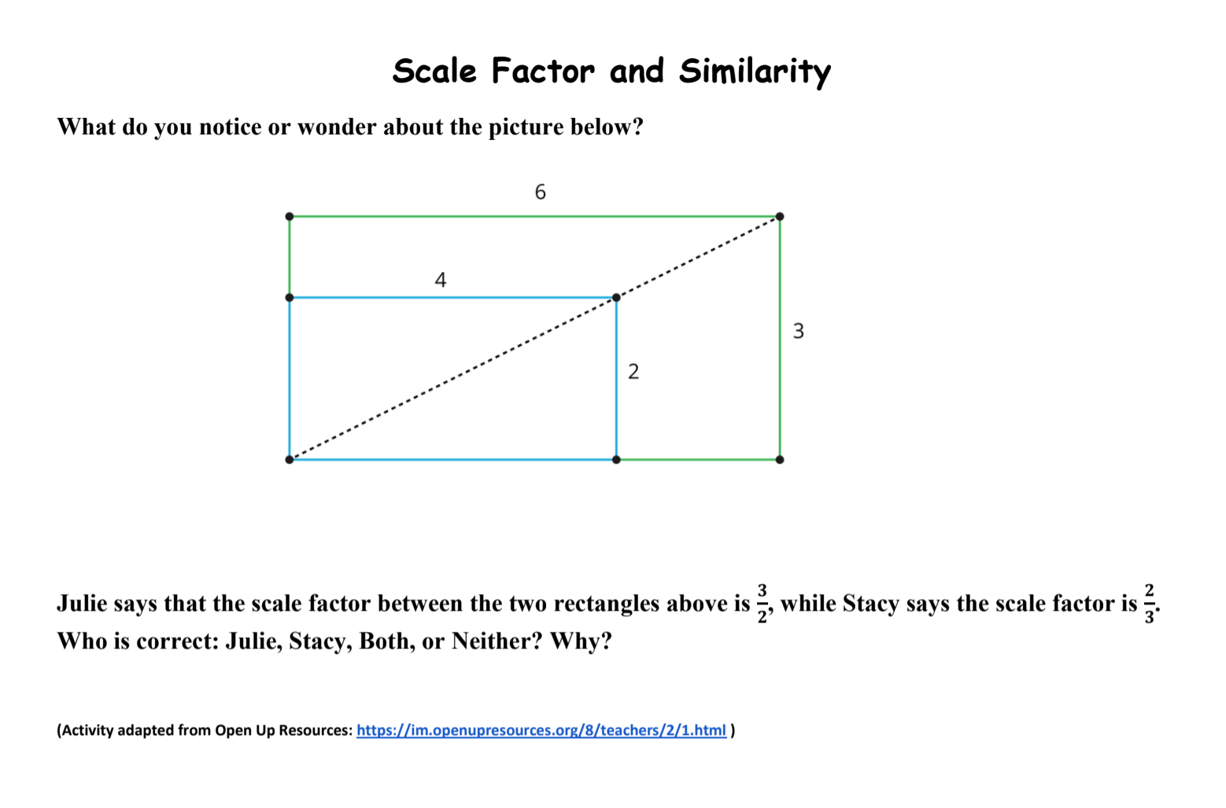

Similarity Task 2: Creating Similar Triangles
Framework Cluster | Reasoning about Similarity and Transformations
Standard(s) | 8.G.4: Use transformations to define similarity.  - Verify experimentally the properties of dilations that create similar figures.  - Understand that a two-dimensional figure is similar to another if the second can be obtained from the first by a sequence of rotations, reflections, translations, and dilations.  - Given two similar two-dimensional figures, describe a sequence that exhibits the similarity between them.
Materials/Link | Patty paper, protractors, rulers, poster board  https://www.illustrativemathematics.org/content-standards/8/G/A/4/tasks/1857 (Illustrative Mathematics Site Link)
Learning Goal | Students will build on their understanding of similarity to determine how to create similar figures from the altitude of a right triangle.
Task Overview: This task from Illustrative Mathematics allows students to experiment and discover how and why the altitude to the hypotenuse of an isosceles right triangle creates three similar triangles. Additionally, students can make the connection (with the teacher’s support if necessary) about similarity when two corresponding angles are equal.
Prior to Lesson: Students will need to know definitions and basic properties of angles and triangles (vertices, right angles, equal sides, etc.) and the basic concept of similarity and proportionality, learned in 7th grade and reviewed in Similarity Task 1.
Teaching Notes: Students have learned about similarity and proportionality, and they specifically explored scale factor as it relates to similar figures in Task 1. In this task, students will explore the properties of similar triangles and how they map onto each other. As students begin exploring the right triangles created by drawing segments from vertices to the opposite side (they don’t learn the term “altitude” yet, they will learn it in Math 2), there could be come frustration about not seeing the similar triangles because of the different orientation and appearance. Previewing the vocabulary around rigid motions could help with this frustration, but also allow them to struggle in figuring out why the triangles are similar and what properties they share.

Task Launch: A brief review of the pertinent vocabulary (right angle, equal sides, opposite sides, rigid motions, dilations, similar), possibly combined with a close read of the directions for the activity, could be appropriate to launch the activity. It is not recommended to draw an example segment for the students, as this would take away from their exploration of the concepts (including the legs being two of the segments they will draw).

Directions:
- After a brief introduction to the vocabulary and directions, allow students to struggle with the task and figure out the sequence of transformations in groups.
- One possibility for support is giving students an extra copy of the original triangle so they can cut out and manipulate the new triangles.
- Students can also use patty paper and rulers/protractors to compare angles and side lengths to help them notice the relationships in similar triangles.
- Students can recreate the triangle on poster board to present their findings or create more elaborate drawings/designs.
Possible Strategies/Anticipated Responses:

Strategies Students May Use:
Possible Conceptions | Potential Follow-Up Questions from Teacher
Students draw segments from vertices A or C to the opposite side, which are actually sides of the triangle. | - Why doesn’t vertex A or C work for this example?  - Can you draw another segment that would satisfy the directions that might create similar triangles?
Students not realizing the two new triangles are similar to triangle ABC. | - If you rotated, reflected, translated, and/or dilated the new triangles, could you get the preimage triangle ABC?
Different students or groups use different sequences of transformations to prove similarity. | - Try both orders for the transformation - can the image still map onto the preimage?
Once students notice the right angle and equal side lengths in the smaller triangles created by the vertical segment from B to the midpoint of AC, they could try several different strategies to map the similar triangles. While one will have to be dilation, it is not important where dilation actually fits into the sequence.

Student task sheets begin on next page.

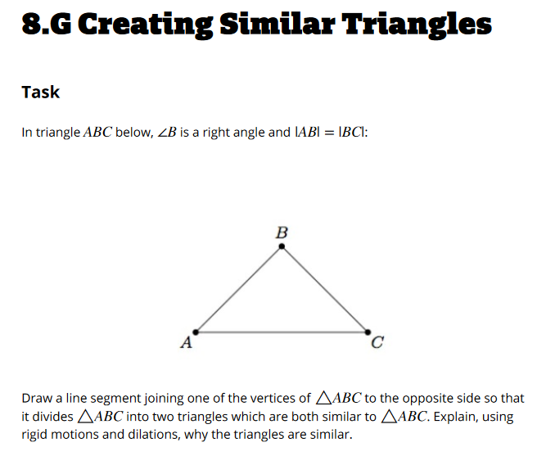

Similarity Task 3 - Dilation on the Plane
Cluster | Reasoning about Similarity and Transformations
Standard(s) | 8.G.3: Describe the effect of dilations about the origin, translations, rotation about the origin in 90 degree increments, and reflections across the x-axis and y-axis on two dimensional figures using coordinates.
Materials/Link | Ruler, Colored Pencils or Markers  https://drive.google.com/open?id=1x1-r_s6csKO6ycSFd_qN5mLpWdSxlXWM (Word)  https://drive.google.com/open?id=1CHa6GTS9zmazrneyztwGiI5gGJGxt4li (PDF)
Learning Goal | Students will discover, compare, and understand the effects of congruence and similarity transformations on the location, area, and perimeter of figures in the plane.
Task Overview: Students are given points to graph a rectangle, and then they are asked perform a dilation and translation to the same rectangle. They calculate lengths and areas on the plane and compare them based on the transformations they performed. Then, they summarize their understanding of the relationships between congruence, similarity, translations, and dilations.
Prior to Lesson: Students have already learned about how to perform transformations, the vocabulary around the transformations, and how the transformations are represented on the plane. Additionally for this task, students will need to review/remember the 6th grade concept of distance on the plane when the x or y coordinates of the endpoints are the same.
Teaching Notes: As students begin exploring how similarity and dilations on the coordinate plane relate, they will probably realize the relationships between lengths of line segments fairly quickly. This task allows them to discover the relationship between dilation and area and how it differs from the relationship between translations and area. It can be given in groups after the students learn the meaning and basic mathematics of dilation on the plane, but it should be given before students learn any “rules” about the relationship between scale factor, length, and area. Associated vocabulary will include rigid and non-rigid transformations and their relationships to congruence and similarity. Extension questions can ask students to hypothesize on the relationships formed by reflection and rotation - will they be more like the relationships to translation or dilation?

Task Launch: Graphing the initial rectangle ABCD would be an appropriate launch for this task, and the teacher could do a quick diagnostic check to ensure all students graphed it correctly. Students will not discover the appropriate relationships without having the initial graph correct, so using this as a launch will activate the students’ minds for graphing and give all students access.

Directions:
- After the launch, a possible teaching method could be to have students work in pairs, with one partner completing the translation and the other completing the translation. Then, they could explain the processes to each other and compare answers, noting the differences between the similarity and congruence.
- The final question allows students to express their understanding of the concepts. This could be implemented as a “write-pair-share”; online discussion through Canvas, Google Classroom, or another forum; or as an exit ticket.

Strategies students may use: Partner work (each partner performs one transformation to compare by discussion), Discovery Learning, Notice Wonder

Possible Conceptions | Potential Follow-Up Questions from Teacher
Using incorrect operations for dilations | - How does dilation differ from translation?  - What do you notice about how shapes look after a dilation transformation?
Incorrect signs when translating shapes (i.e. mistaking left for positive) | - On a number line, where are negative numbers located?  - On a thermometer, where are the negative degrees?
Recognizing patterns for perimeter and applying them to area in the table without performing calculations | - Great job finding patterns! Can you verify that the patterns apply for area as well as perimeter?
Confusing definitions of congruence and similarity | - What does similar mean in everyday life?

Student task sheets begin on next page.

Similarity Task - Dilation on the Plane
1. On the graph below, graph rectangle ABCD with A(3, 4), B(-1, 4), C(-1, -2), and D(3, -2).

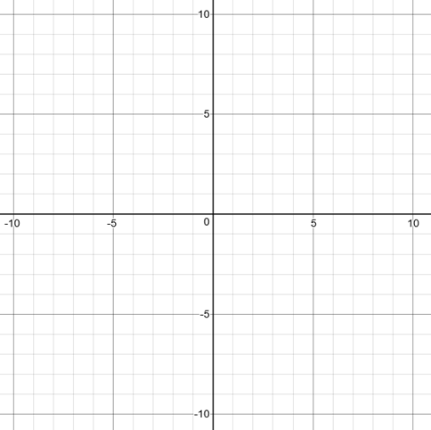

2. On the same graph in a different color, use the origin as the center to dilate ABCD by a scale factor of 2 and create A’B’C’D’. Label the new coordinates.

3. On the same graph in a different color, translate A’B’C’D’ down 5 units and left 3 units to create A’’B’’C’’D’’. Label the new coordinates.

4. Calculate the length, width, perimeter, and area of each rectangle.

 | Length | Width | Perimeter | Area
ABCD
A’B’C’D’
A’’B’’C’’D’’

5. What did you notice from your table? Make a conjecture about your data and try to determine whether it is always true.

