Formative Assessment #1: Solving Equations
Cluster & Content Standards  What content standards can be addressed by this formative assessment?  Analyze and solve linear equations and inequalities.  8.EE.7 Solve real-world and mathematical problems by writing and solving equations and inequalities in one variable.  - Recognize linear equations in one variable as having one solution, infinitely many solutions, or no solution.  - Solve linear equations and inequalities including multi-step equations and inequalities with the same variable on both sides. | Mathematical Practice Standards  What practice standards can be addressed by this formative assessment?  6. Attend to precision.  7. Look for and make use of structure.
Learning Targets
What learning targets will be assessed?
- Students can look at an equation and without solving the equation entirely determine whether it will have one solution, no solution, or infinite solutions just by examining the structure of the equation.
Timing:
- During or after instruction on solving equations with one solution, infinitely many solutions, or no solution.
Anticipated Solutions and Possible Misconceptions (Progression)
*The goal for this task is for students to simply identify the type of solutions the equation will have and thus the work provided by each student will vary. Some students will be able to see the structure of the equation very early in the simplification process and others will need to simplify completely.
Equation 3a = 4(2a – 1) – 5a
- Solution: No Solution
3a = 8a - 4 - 5a; 3a = 3a - 4 (Since coefficients of variables are the same on both sides of the equation but the constants are different, this equation will have no value of a that will make the equation true.)
- Other Potential Answer: Students may forget to distribute or have calculation errors due to signs.

Equation (½) (6x + 3) = 7 – (3x + 1)
- Solution: One Solution
3x + 3/2 = 7 - 3x – 1; 3x + 3/2 = -3x + 6
(Since coefficients of variables are different, this equation will have only one value of x that will make the equation true.)
- Other Potential Answers: Students may forget to distribute the negative through the group of (3x + 1) and thus come to the wrong conclusion that the coefficients of variables are the same and therefore conclude there is no solution.

Equation 9r – 6.5 = 4.5(2r -3) + r
- Solution: 9r - 6.5 = 9r - 13.5 + r (Since coefficients of variables are different, this equation will have only one value of r that will make 9r - 6.5 = 10r - 13.5 the equation true.)
- Other Potential Answer: Students may distribute correctly but then forget to include the + r.

Equation 11 – 5(n + 2) = -4n + 1 – n
- Solution: 11 - 5n - 10 = -4n + 1 – n; 1 - 5n = -5n + 1 (Since coefficients of variables are the same on both sides of the equation but the constants are different. This equation will have no value of a that will make the equation true.)
- Other Potential Answer: Students may have sign problems if they do not distribute the -5 correctly.

Equation Solutions Assessment

Determine if each of the following equations will have one solution, infinitely many solutions, or no solution. Don’t solve the entire equation; simplify it to a form that supports your conclusion. Then, explain how you know the number of solutions.

Equation | How Many Solutions?  (Zero, One, or Infinite) | Explanation:
3a = 4(2a – 1) – 5a

(½) (6x + 3) = 7 – (3x + 1)

9r – 6.5 = 4.5(2r -3) + r

11 – 5(n + 2) = -4n + 1 – n

Formative Assessment #2: Solving Equations
Link to Formative Assessment (if applicable): Adapted from Open Middle: http://www.openmiddle.com/category/grade-8/expressions-equations-grade-8/ (pages 1 and 2)
Cluster & Content Standards  What content standards can be addressed by this formative assessment?  Analyze and solve linear equations and inequalities.  8.EE.7 Solve real-world and mathematical problems by writing and solving equations and inequalities in one variable.  - Recognize linear equations in one variable as having one solution, infinitely many solutions, or no solution.  - Solve linear equations and inequalities including multi-step equations and inequalities with the same variable on both sides. | Mathematical Practice Standards  What practice standards can be addressed by this formative assessment?  6. Attend to precision.  7. Look for and make use of structure.
Learning Targets
What learning targets will be assessed?
- Students will write equations that have no solution, infinitely many solutions and one solution and justify their equations by simplifying and solving.
Timing: During or after instruction on solving equations with one solution, infinitely many solutions, or no solution.
Anticipated Solutions and Possible Misconceptions (Progression)

No Solution Equations:
There are many answers, but the coefficient of both x terms have to be the same and the constants must have different values. So, 2x + 3 = 2x + 4 is an answer because it is equivalent to 3 = 4, for which there is no solution.

Infinitely Many Solution Equations:
There are many answers, but the coefficient of both x terms have to be the same and the constants must also be the same values. So, 2x + 3 = 2x + 3 is an answer because it is equivalent to 3 = 3, for which there are infinitely many solutions.

Positive & Negative Solution Equations:
There are many solutions that would work.
- Example that would give a positive solution:
(1/2)(4x + 8) + 6x = 9x + 3 … here, x = 1
- Example that would give a negative solutions
(1/3)(6x + 9) + 2x = 5x + 7 … here, x = -4

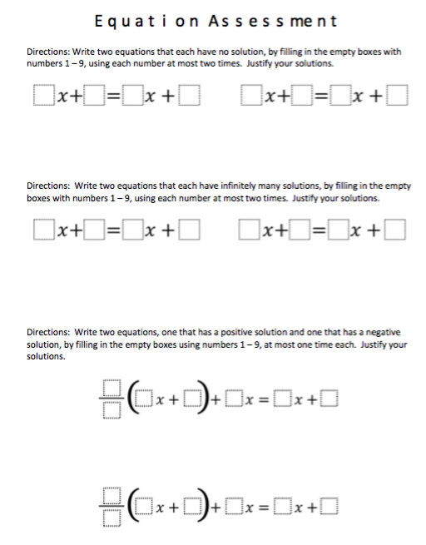

Formative Assessment #3: Solving Equations
Link to Formative Assessment (if applicable): Adapted from University of Utah Middle School Math Project http://utahmiddleschoolmath.org/

Cluster & Content Standards  What content standards can be addressed by this formative assessment?  Analyze and solve linear equations and inequalities.  8.EE.7 Solve real-world and mathematical problems by writing and solving equations and inequalities in one variable.  - Recognize linear equations in one variable as having one solution, infinitely many solutions, or no solution.  - Solve linear equations and inequalities including multi-step equations and inequalities with the same variable on both sides. | Mathematical Practice Standards  - Make sense of problems and persevere in solving them.  - Reason abstractly and quantitatively.  6. Attend to precision.
Learning Targets
What learning targets will be assessed?
- Students will create and solve a one variable equation with variables on both sides given a real world scenario.
Timing: After or during instruction with creating and solving equations from real world problems.
Assessment Rubric
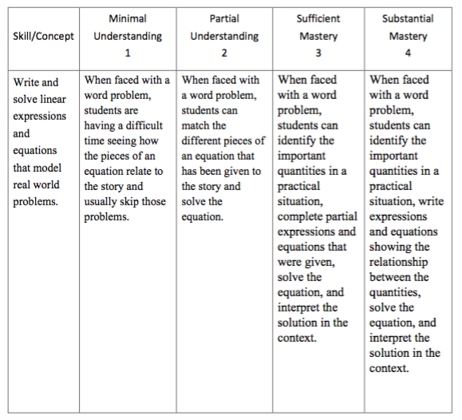

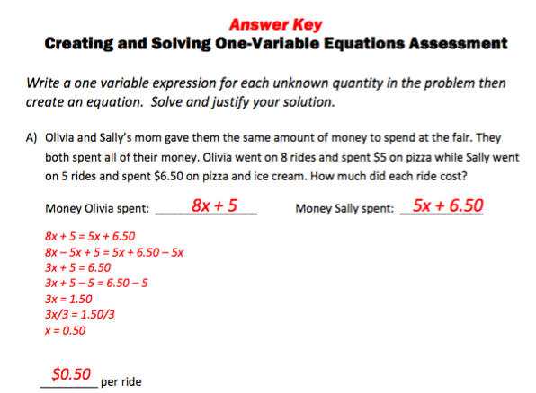

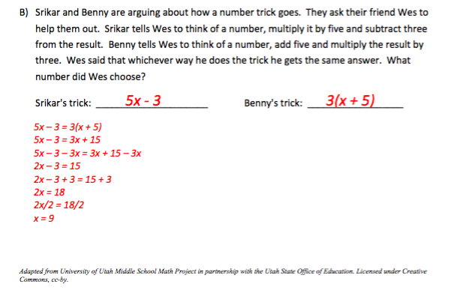

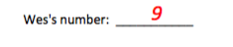

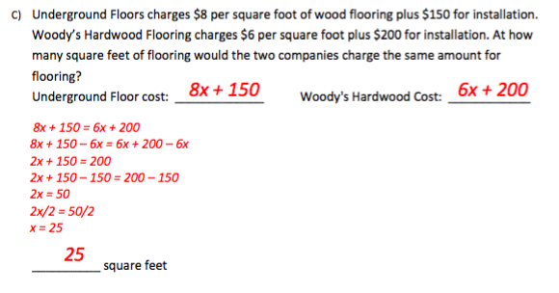
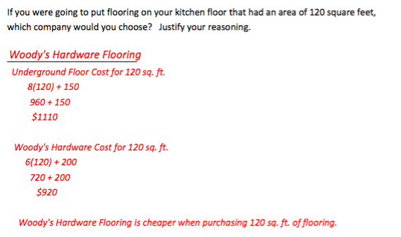

Creating and Solving One-Variable Equations Assessment

Write a one variable expression for each unknown quantity in the problem then create an equation. Solve and justify your solution.

- Olivia and Sally’s mom gave them the same amount of money to spend at the fair. They both spent all of their money. Olivia went on 8 rides and spent $5 on pizza while Sally went on 5 rides and spent $6.50 on pizza and ice cream. How much did each ride cost?

Money Olivia spent: ________________ Money Sally spent: _____________

__________ per ride

- Srikar and Benny are arguing about how a number trick goes. They ask their friend Wes to help them out. Srikar tells Wes to think of a number, multiply it by five and subtract three from the result. Benny tells Wes to think of a number, add five and multiply the result by three. Wes said that whichever way he does the trick he gets the same answer. What number did Wes choose?

Srikar's trick: _____________________ Benny's trick: __________________

Wes's number: ___________

- Underground Floors charges $8 per square foot of wood flooring plus $150 for installation. Woody’s Hardwood Flooring charges $6 per square foot plus $200 for installation. At how many square feet of flooring would the two companies charge the same amount for flooring?

Underground Floor cost: _____________ Woody's Hardwood Cost: ____________

__________ square feet

If you were going to put flooring on your kitchen floor that had an area of 120 square feet, which company would you choose? Justify your reasoning.

Adapted from University of Utah Middle School Math Project in partnership with the Utah State Office of Education. Licensed under Creative Commons, cc-by.

