Solving Equations Task 1
Always, Sometimes, or Never True?
Framework Cluster | Reasoning about Equations and Angles
Standard(s) | 8.EE.7 Solve real-world and mathematical problems by writing and solving equations and inequalities in one variable.  - Recognize linear equations in one variable as having one solution, infinitely many solutions, or no solution.  - Solve linear equations and inequalities including multi-step equations and inequalities with the same variable on both sides.
Materials/Links | Adapted from Mathematics Assessment Project: http://map.mathshell.org/lessons.php?collection=8&unit=8240  - Each student will need two copies of the assessment task When are the equations true? a mini-whiteboard, a pen, and an eraser and a copy of When are the equations true? (Revisited).  - Each small group of students will need Card Set: Equations, a pair of scissors, a pencil, a marker, a glue stick, and a large sheet of paper for making a poster.
Learning Goal(s) | - Solve equations with linear expressions on either or both sides including equations with one solution, infinitely many solutions, and no solutions.  - Give examples of and identify equations as having one solution, infinitely many solutions, or no solutions.
Task Overview:
This task contains both individual and collaborative partner/small group work.
- Students will initially complete an independent “exit ticket” prior to the lesson that provided the teacher with student conceptions regarding solving equations that should be used to facilitate instruction for each class of students.
- The next day, students will practice determining what variable values will make an equation true or false. This is described in the Task Launch portion of the lesson and introduces the idea that equations can always be true, sometimes be true, or never be true.
- Next students will work collaboratively with a partner or small group to create a poster from a provided set of equation cards where they will classify them as always, sometimes, or never true. Throughout this process, students are justifying their reasoning. The posters are then shared with classmates and provide time for others to critique their work by making comments on posters.
Prior to Lesson:
Before the lesson, students work individually on When are the equations true? This can be done as an exit ticket the day prior to the instruction. The purpose of this short task is to reveal student current understanding and misconceptions. Teacher should review student responses and create guiding questions for students to consider when improving their work.

Teaching Notes:
Task launch:
- Teacher should display a basic two-step equation on the board, such as 3x + 7 = 1. Ask students to write the equation on their individual white board and to provide a value for x that will make the equation false. Students should justify their solution by showing work on whiteboard.
Students should not struggle with finding an appropriate value for x. Most students will consider only whole numbers or positive numbers. However, all types of rational numbers should be considered. Spend some time discussing student responses and justification methods as well as any calculation errors.
- Teacher should now display the same two-step equation on the board. This time, ask students to provide a value for x that will make the equation true. Students should justify their solution by showing work on whiteboard.
Some students will struggle trying to find the value for x that makes the equation true if they simply guess-and-check. Reiterate that all types of rational numbers should be considered, including fractions and negative numbers. When students do find the appropriate value for x, encourage them to determine if this is the only value that makes the equation true or are there others?
- Now ask the following questions,
“Would we describe this equation as always true, never true or sometimes true? [Sometimes true.]
When is it true? [When x =-2]
Are there any other values for x that make the equation true? How do you know?
Directions:
- Provide each small group Card Set: Equations along with a pair of scissors, a large sheet of paper, a marker, and a glue stick. (Students should use pencils only when showing justifications on poster.) They will work in their small groups to produce a poster that will show each equation classified according to whether it is always, sometimes or never true. Instruct students to divide their poster paper into three columns with the headings of: ‘Always True’, ‘Sometimes True’, ‘Never True’.
- Next give the groups detailed instructions on their task. (Slide 4 of the linked materials provide these instructions.)
One partner should select an equation, cut it out and place it in one of the columns, explaining why he/she choose to put it there. If you think the statement is sometimes true, give values of x for which it is true. If you think the equation is always true or never true, explain how you can be sure this is the case. Your partner should then either challenge the explanation if they disagree, or if they agree, describe it in their own words. Once you all agree, stick the statement card on the poster and write an explanation next to the card. Explanations should be written in pencil. Swap roles and continue to take turns until all the equations have been placed.
- Once students have completed their posters, they critique each other's work. (Slide 5 of the linked materials provide these instructions.)
- The teacher will summarize findings through a structured whole class discussion, review what has been learned and explore the different methods of justification used when categorizing equations. Discussion should highlight at least one equation from each column.
- To encourage students to reflect on their work, return their “exit tickets” from the previous day, allow them read any comments you made, and ask them to spend a few minutes thinking about how they could improve their work. Provide students another copy of the same or similar task and ask them to show their understanding now based on what they have learned.
- For more practice, students can individually complete “Are the equations true?” (Revisited) assignment.
Possible Strategies/Anticipated Responses:
When are the equations true? Task (Prior to the Lesson, exit ticket)
- Anticipated Responses:
The equation 5 – x = 6 is only true when x = –1.
Amy has solved the equation 5 + x = 6 instead of 5 – x = 6. The second line should read: –x = 6 – 5 so x = –1.
Ben has not considered the effects of subtracting a negative number. He has not tried to substitute values for x or shown any algebraic manipulation.
Possible Strategies: See page T-3 of the linked task for possible student responses and suggested questions to guide student understanding.
2) Anticipated Responses: The equation 8x – 6 = 2x is only true when x = 1.
Amy has made a valid point about like terms, but has not looked beyond this to see if there is a value of x that makes this equation true.
Ben has found a solution for the equation using substitution. He has not proved that only one value for x satisfies the equation. In order to do this he needs to solve the equation.

Possible Strategies: See page T-3 of the linked task for possible student responses and suggested questions to guide student understanding.

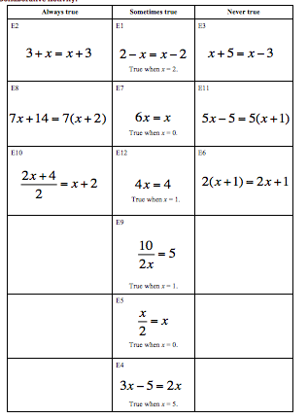

Are the Equations true? (revisited) assignment:
Anticipated Solutions:
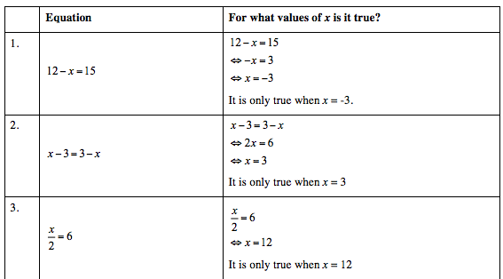

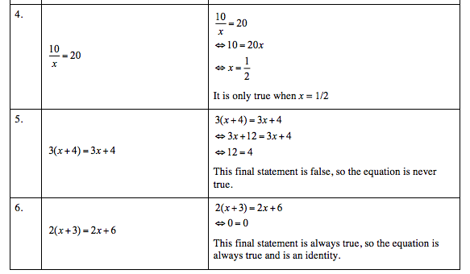

Student sheets begin on next page.

Name ______________________________________________ Date __________________________

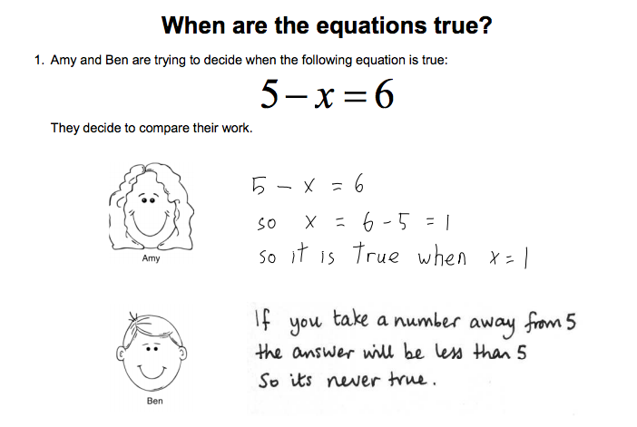
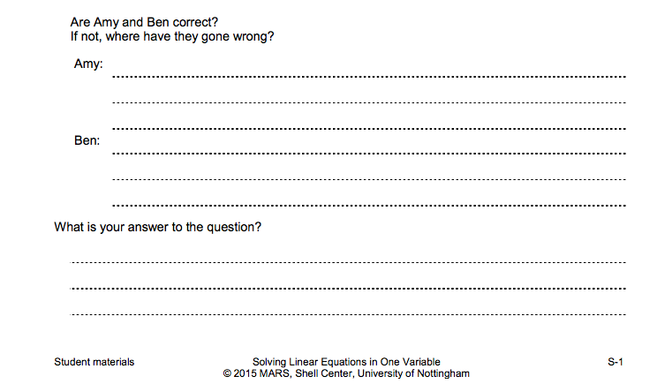

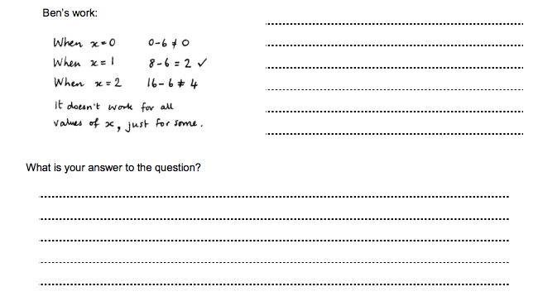
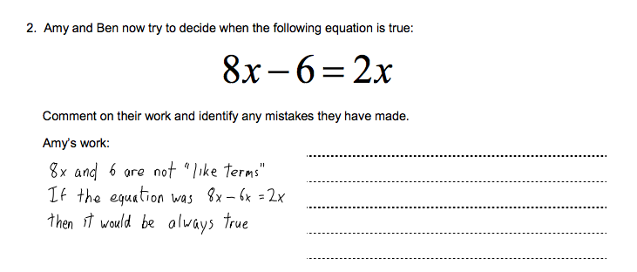

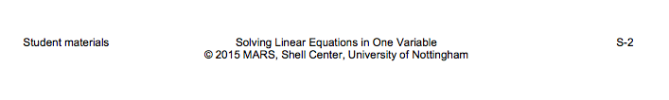

Card Set: Equations
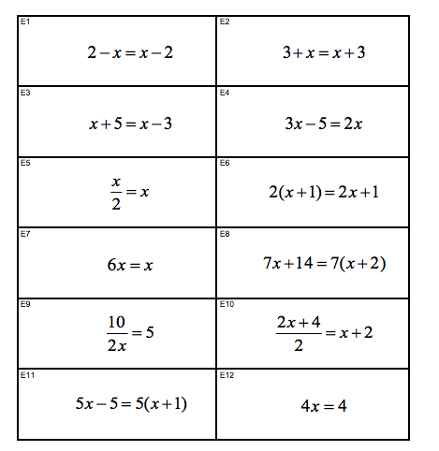

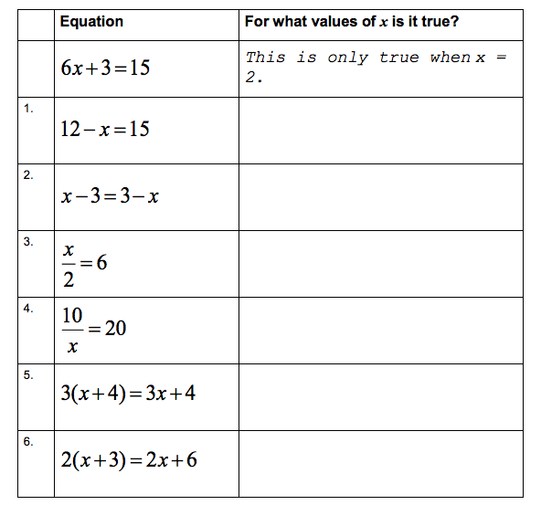

Solving Equations Task 2
Equation Solutions Foldable
Framework Cluster | Reasoning about Equations and Angles
Standard(s) | 8.EE.7 Solve real-world and mathematical problems by writing and solving equations and inequalities in one variable.  - Recognize linear equations in one variable as having one solution, infinitely many solutions, or no solution.  - Solve linear equations and inequalities including multi-step equations and inequalities with the same variable on both sides.
Materials/Links | Adapted from: http://everybodyisageniusblog.blogspot.com/2012/07/solving-special-case-equations.html  Equation Scales Worksheet and/or PowerPoint slide  paper/pencil
Learning Goal(s) | Students will build a conceptual understanding of equations with one, infinitely many, and no solution by starting with a visual model and creating the corresponding algebraic equation.
Task Overview:
This lesson includes collaborative work with partners and the creation of a foldable to support and document learning.
Prior to Lesson:
Students should have prior knowledge of solving multi-step equations with variables on both sides that have one solution.
Teaching Notes:
Task launch:
- This part of the lesson allows for productive struggle by students as they discover that not all equations have just one solution or a solution at all.
Provide students the Equation Scale worksheet and display to the whole class. Give the following directions to the class:
- These scales are all currently balanced. You must choose a number to fill into the boxes in each problem that will keep them balanced.
- Whatever number you choose for a problem, you may ONLY use that number.
- Teacher should monitor students as they work on these scales noting areas of ease and areas of struggle. Teacher should expect to be asked what types of numbers can be used. Confirm that students may use any number they like, including fractions, decimals, and negatives.
- Teacher should then facilitate a whole class discussion using student responses observed to guide discussion. Begin with scales #1 and #4 as most all students will realize that any number used will keep the scales balanced. Next focus on scales #2 and #5 that have only possible solution.
Finally, discuss scales #3 and #6 where students most likely struggle since no number will keep the scales balanced.

Directions:
- Instruct students to fold a sheet of paper into thirds so that it opens. The left column should be titled, “One Solution”. The middle column should be titled, “No Solution” and the right column, “Infinite Solutions.” In student friendly terms, students should explain what each of those solution means in the context of an equation.
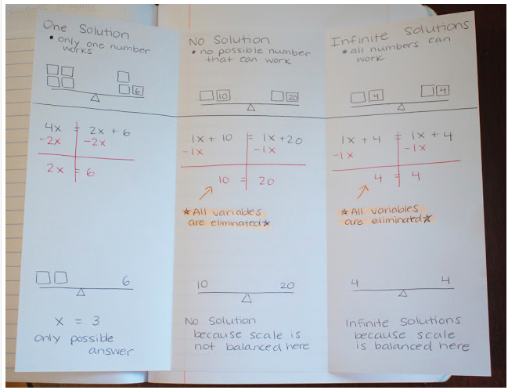

- Next, teacher should display another scale picture that has one solution to the class. After a class discussion where everyone agrees there is one solution, students should copy the scale onto their paper.
- Next, show the students how to convert the visual scale into an algebraic equation, where the boxes represent the variable. Students should solve the equation algebraically and then confirm their solution is correct by substituting the value in the boxes in the scale.
- Now the teacher should display a scale picture that has no solution. Encourage students to turn and talk to find the solution. After a class discussion where everyone agrees there is no number that will ever make the scale balanced, have the students draw the scale on their paper.
- Again, show the students how to convert the visual scale into an algebraic equation, where the boxes represent the variable. Students should see that by combining like terms and simplifying, the variables cancel out. However, the remaining constants are not equal and thus the scale will never balance.
- Finally, teacher should display an equation scale that has infinite solutions. After students turn and talk, sharing their solutions, lead a brief discussion as to why any number they choose will keep the scale balanced.
- Again, have the students copy the scale on their foldable, translate the visual picture into an algebraic equation and solve.
- Potential Movement Activity: Students could display their foldables, with their student-friendly explanations that they created, and have a gallery walk before the whole-class discussion to mold everyone’s ideas into a class understanding of the number of solutions and how they relate to the equations and balances.

Student sheets begin on next page.

Name _____________________________________________ Date __________________________

Equation Scales
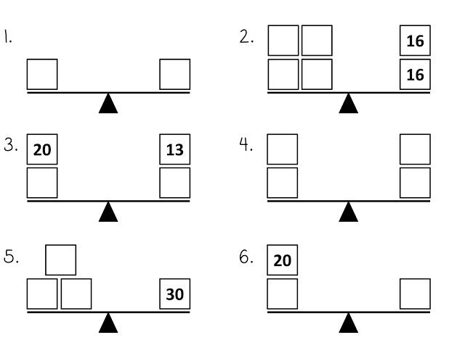

Solving Equations Task 3
Writing and Solving Real-World Equations
Framework Cluster | Reasoning about Equations and Angles
Standard(s) | 8.EE.7 Solve real-world and mathematical problems by writing and solving equations and inequalities in one variable.  - Recognize linear equations in one variable as having one solution, infinitely many solutions, or no solution.  - Solve linear equations and inequalities including multi-step equations and inequalities with the same variable on both sides.
Materials/Links | Adapted from: Utah Math Project  Creating and Solving Real World Equations handout  paper/pencil  Document Camera (if available)
Learning Goal(s) | - Students will create equations with variables on both sides from real-world contexts.  - Students will understand and explain the meanings of constant terms, variable terms, and the solutions of equations representing real-world contexts.
Task Overview:
This lesson includes collaborative work with partners and whole class discussions.
Prior to Lesson:
Students should have prior knowledge of solving multi-step equations with variables on both sides that have one solution.
Teaching Notes:
Task launch:
- Ask students to consider the following task:
“Think of a simple story that could represent the equation, 2x + 6 = 24.”
Possible response: Sally bought 2 fair tickets and paid $6 to park. She spent a total of $24. How much was each fair ticket?
- Instruct students to turn and talk with their partner to share their story, then have a few students share with the class.
- Now have students consider this similar task:
“Think of a simple story that could represent the equation, 2x + 6 = x + 24.”
Possible response: Sally and John went to the fair. Sally bought 2 fair tickets and paid $6 to park. John bought one ticket and spent $24 on food and drinks. They spent the same amount of money. How much did a fair ticket cost?
- Again, instruct students to turn and talk with their partner to share their new story. Most students will begin with the same story and adapt it to fit the new criteria. Have a few students share their new story with the class.
- Questions for students to consider:
  - How are the equations similar?
  - How are the equations different?
  - How did the second story problem change from the first? Why did it change?

Directions:
- Provide students with a copy of the “Creating and Solving Equations with Real World Problems” handout.
- Discuss the directions at the top of the handout for Part I to ensure all students understand the task.
- Instruct students to work with a partner for 3-5 minutes on the Birthday Party Problem to create one story that represents the scenario using the variables and equation provided.
- As students work, observe their struggle and make note of the stories you want shared with the class. Smith and Stein’s 5 Practices for Orchestrating Mathematical Discourse can help structure the task and discussion.
- Choose 2 or 3 stories and have the partners share them with the class. A document camera would be ideal for students to share their stories and solutions visually while they read aloud.
- As this is the first of the two stories, use the sharing of stories as a teaching moment to highlight misconceptions and different strategies.
- Now instruct students to work individually on the Money Saving Problem. Allow students 3 - 5 minutes to work then instruct them to share their story and solution with their partner.
- Again, observe and monitor as students work and choose 2 or 3 stories and solutions to be shared with the class.
- For Part II, students will write expression for unknowns given a scenario, write an equation based on the question, solve and justify solution. Discuss instruction for Part II with the class.
- Instruct students to work 3 - 5 minutes on the Cell Phone Problem then have them share their work with a partner.
- Finally, have students work individually on the Student Enrollment Problem.

Possible Strategies/Anticipated Responses:
- Page 1: The actual stories could vary, but they will likely be some form of:
  - Birthday Party Problem: For how many people attending the party would the costs be equal? (5)
  - Saving Money Problem: After how many weeks do they have the same amount of money? (2)
- Page 2:
  - Cell Phone: The equation would be 15 + 0.10x = 55, with x = 400 texts when the price is the same.
  - Class Enrollment: 80 + 4x = 120 - 6x, with x = 4 terms when the number of students is the same.

Struggles could come from students not understanding what the constant and variable terms are in each situation, especially when they are both not present (the birthday party has only a variable term in one expression, and the cell phone only has a constant term in one expression). Through the class discussion, this different can be brought out for students by asking about if/when the values will change.

Student sheets begin on next page.
