Systems of Equations Task 1
Desmos Polygraph: Linear Systems
Framework Cluster | Functional Reasoning/Systems
Standard(s) | NC.8.EE.8 Analyze and solve a system of two linear equations in two variables in slope-intercept form.  - Understand that solutions to a system of two linear equations correspond to the points of intersection of their graphs because the point of intersection satisfies both equations simultaneously.  - Solve real-world and mathematical problems leading to systems of linear equations by graphing the equations. Solve simple cases by inspection.
Materials/Links | Desmos Polygraph: Linear Systems, computers with internet access  Possible alternative to technology would be to create cards for students to use in pairs
Learning Goal(s) | This is the pre-work necessary to begin work with systems. It has students remember the different values of slope and how that effects linear graphs. Students will be familiar with the vocabulary needed to communicate about linear systems.
Task Overview: The purpose of the task is to develop a shared understanding of vocabulary related to Linear Systems and interpreting graphs. As you pose questions to the students, develop their reasoning to include appropriate vocabulary (slope, y-intercepts, intersection, parallel, quadrant, axes, solution, increasing, decreasing).
Prior to Task:
- Students will need to have experience having interpreted graphs with positive, negative, 0 or undefined slopes and how to identify the y-intercept in a linear function.
- Teacher will go to the Desmos site: https://teacher.desmos.com/polygraph/custom/560aa8dc58fd074d156181c3 and create a class code. Be sure and display the class code, or students can go to https://student.desmos.com/?prepopulateCode=89e4ku and type in the class code.
Teaching Notes:
- The purpose of the task is to develop a shared understanding of vocabulary related to Linear Systems. As you pose questions to the students, develop their reasoning to include appropriate vocabulary (slope, y-intercepts, intersection, parallel, quadrant, axes, solution, increasing, decreasing).
- The Polygraph: Linear Systems tasks is best used if all students have access to the internet. The task can be adapted by pairing up students or a teacher can use a computer with one other computer being used by the class. Cards could be made and pairs of students given a set.
Task launch:
- Students should play the practice game to get an idea of how the game works. The practice game is similar to the game Guess Who. Ask students if they have ever played Guess Who and discuss strategies they may have used.

Directions:
- Students should be encouraged to use correct vocabulary. As the students play the game teacher should take note of descriptions used by students. Teacher can use dashboard as a whole class discussion. Look at the descriptions as a class. Ask “What mathematical term could be used to describe that the lines do not intersect?”
- On the Desmos teacher link https://teacher.desmos.com/polygraph/custom/560aa8dc58fd074d156181c3, several strategies for incorporating Polygraph activities are described and presented. Teachers can review these directions for additional supports for their students.
Possible Strategies/Anticipated Responses:
Students may not use correct vocabulary. Pause between games and discuss best strategies for guessing the correct set of lines. As students discuss strategies talk about the vocabulary.

There is no student sheet for this activity. Screenshot of the Desmos Polygraph activity is shown below. Note this is the activity for linear functions and not systems, but it can be applied as an intro to systems in our context.

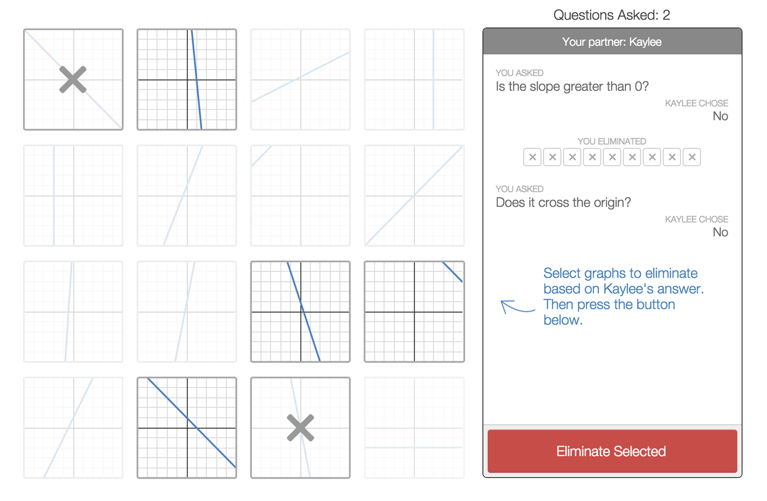

Systems of Equations Task 2: Swimming Pool Problem
Framework Cluster | Functional Reasoning/Systems
Standard(s) | NC.8.EE.8 Analyze and solve a system of two linear equations in two variables in slope-intercept form.  - Understand that solutions to a system of two linear equations correspond to the points of intersection of their graphs because the point of intersection satisfies both equations simultaneously.  - Solve real-world and mathematical problems leading to systems of linear equations by graphing the equations. Solve simple cases by inspection
Materials/Links | Swimming Pool Problem handout, Graph Paper or graphing calculator
Learning Goal(s) | Students will understand that creating graphs of systems of equations given context gives information about the solution.
Task Overview: Students will write and graph two equations, based on the context of charges at a swimming pool, and answer questions to help them better understand the graphs in context. Ultimately, the equations and graphs will lead to them solving a system to determine when the two prices are the same.
Prior to Lesson: From previous tasks in the module, students will have learned about writing and graphing one linear equation from context. From Tasks 1 and 2 of this set, students have learned about the solutions and graphs of systems of linear equations. This prerequisite knowledge can be assessed/reviewed in a warm-up or pre-lesson the day before.
Teaching Notes:
Task launch:
- Discuss with students memberships they might have, such as gym memberships or gaming memberships. Discuss how these memberships work, including potential pricing plans.
Directions:
- Students can work in groups to complete the task. An informal check after Question B and Question C will help set up a discussion and make sure students are on the right path to determining an answer.
- Smith and Stein’s 5 Practices for Implementing Math Tasks are appropriate for assessing student work and setting up a whole-class discussion.
- Students will need to create correct equations, graphs, and analysis to complete the task. Assessing each aspect of the task will allow for guided instruction and remediation throughout the rest of the unit.
Correct Solution:
Students may need help with setting up their axes if they graph on graph paper. Also, they could confuse the slopes and y-intercepts of each line, especially for the first situation that is proportional (with a y-intercept of 0).
- Answers will vary. Be sure students use the graphs to justify their answers. This can be discussed in a whole class discussion.
- After 10 days

Questions to ask as students work:
- What type of numbers could be solutions to the problem?
- Is there more than one solution?
- What does the slope of the lines tell you about the cost of the two options?
- What does the y-intercept tell you about the cost of the two options?
- What is the point of intersection? What does that point mean?
- How can you represent the $60 limit on the graph? Where does that line intersect the other lines? What are the x-coordinates on the lines? What do they represent?

The Swimming Pool Problem
A local swim center is making a special offer. Normally they charge $7 per day to swim at the pool. The special offer charges an enrollment fee of $30 and the daily pass will be $4 per day.
      - Which is the better deal? Put your evidence in the space below. Be ready to justify your conclusion.

      - You only have $60 to spend for the summer on visiting this pool. Which offer would you take? Why?

Systems of Equations Task 3 - Investigation: Systems of Equations
Framework Cluster | Functional Reasoning/Systems
Standard(s) | NC.8.EE.8 Analyze and solve a system of two linear equations in two variables in slope-intercept form.  - Understand that solutions to a system of two linear equations correspond to the points of intersection of their graphs because the point of intersection satisfies both equations simultaneously.  - Solve real-world and mathematical problems leading to systems of linear equations by graphing the equations. Solve simple cases by inspection.
Materials/Links | Investigation: 8th Grade Dance Handout, graphing calculator or graph paper  Adapted from Connected Mathematics Project 2
Learning Goal(s) | Students will analyze two linear equations to determine which is the best buy.
Task Overview: Students will analyze two T-shirt company prices for an 8th grade dance. They will then determine which of the students’ statements about the system of equations makes sense.
Prior to Lesson:
- Students should have solve Task 2 above.
- Students should be in groups. Be prepared to do think-pair-share.
Teaching Notes:
- Launch the task by asking students if they have ever helped to organize a school dance. Mention that Ms. Chang’s class is going to give t-shirts to students who come to the dance and they need to decide which company gives them the best price. Ms. Chang’s class analyzed the two equations and had different opinions. The students need to determine who they agree with, why and provide some evidence.
- Smith and Stein’s 5 Practices for Implementing Math Tasks are appropriate for assessing student work and setting up a whole-class discussion.
Correct Solutions:
Students may pick any one of Ms. Chang’s students. Before discussing, take a poll of the room and record on the board how many people pick each student. Ask for students to defend their position, focusing the discussion on the meaning of the coefficient of the n in Mighty Tee and what it tells you. Focus on the fact that it’s a combination of the y-intercept and the rate that help determine the best company so Maria is in fact correct. Students should make that argument, not the teacher. If the class does not determine the break-even point, ask students at what point the charges are the same (14 t-shirts).

8th Grade Dance

Ms. Chang’s class decides to give T-shirts to each person who comes to the 8th grade dance. They receive bids for the cost of the T-shirts from two different companies. Mighty Tee charges $49 plus $1 per T-shirt. No-Shrink Tee charges $4.5 0 per T-shirt. Ms. Chang writes the following equations to represent the relationship between cost and the number of T-shirts:

C_{Mighty} = 49 + n
C_{No-Shrink} = 4.5n

The number of T-shirts is n. C_{Mighty} is the cost in dollars for Mighty Tee and C_{No-Shrink} is the cost in dollars for No-Shrink Tee.

Which of Ms. Chang’s students below do you agree with and why?
Monica: We should use Mighty t-shirts because they only charge $49 no matter how many you buy.

Drew: I think we should choose Mighty Tee because they only charge $1 per t-shirt and No-Shrink Tee charges $4.50 a shirt.

Raheem: I think we should use No-Shrink Tee because Mighty Tee starts at $49! No-Shrink T Tee doesn’t have any beginning fee.

Maria: I think it depends on how many t-shirts we buy.

Adapted from Connected Mathematics Project 2

