Transformations Formative Assessment #1 - Translation Assessment
Cluster & Content Standards  What content standards can be addressed by this formative assessment?  8.G.3 Describe the effect of dilations about the origin, translations, rotations about the origin in 90ndegree increments, and reflections across the x-axis and y-axis on two-dimensional figures using coordinates. | Mathematical Practice Standards  What practice standards can be addressed by this formative assessment?  1. Make sense of problems and persevere in solving them.  6. Attend to precision.  8. Look for and express repeated regularity in repeated reasoning.
Learning Targets
What learning targets will be assessed?
- Given a pre-image and its image under a translation, describe the translation in words and using a coordinate rule.
- Perform a translation of a figure given a coordinate rule.

Timing:
During or after instructional tasks
Anticipated Solutions and Possible Misconceptions (Progression)

Correct Answers: I. a) R'(-10, -2), S'(-6, 1), T'(-1, -2)
b) Each vertex of the pre-image is moved 4 units to the right and then 6 units down.
c)
Pre-Image | Image
R(-14, 4) | R'(-10, -2)
S(-10, 7) | S'(-6, 1)
T(-5, 4) | T'(-1, -2)

d) Coordinate rule: (x + 4, y – 6)
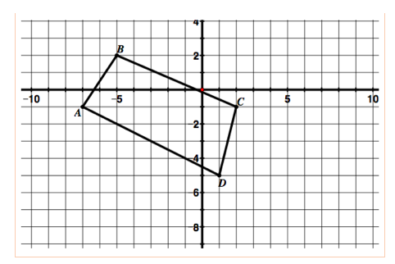

A'
B'
C'
D'

Possible Conceptions:
- Confusing positive and negative horizontal and/or vertical direction on the coordinate plane
- Confusing the pre-image and image shapes
- Miscounting and having a different shape as an image

Translation Assessment
- In the grid below, ∆RST has been translated to obtain ∆R’S’T’.

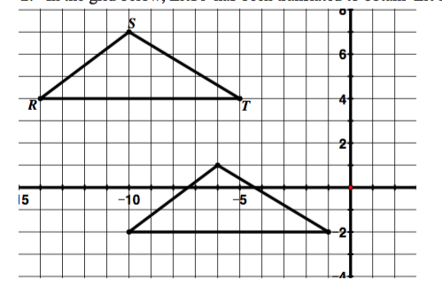

- Label the corresponding vertices of the image on the grid.
- Describe or show on the picture above how you would move on the coordinate plane to get from the vertices of the pre-image to the corresponding vertices of the image.
- Write the coordinates for the pre-image and the image in the table below:
Pre-Image | Image
- Write the coordinate rule that describes the translation.

.
II. Draw and label the image of the figure below for the translation (x, y) → (x + 5, y − 3).

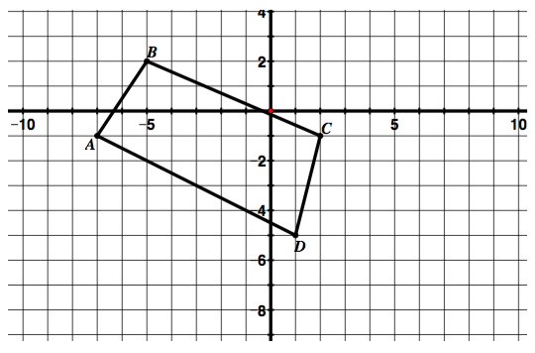

b. Is the new shape congruent to the original? Explain.

Adapted from the University of Utah Middle School Math Project

Transformation Formative Assessment #2 - Reflection Assessment
Cluster & Content Standards  What content standards can be addressed by this formative assessment?  8.G.3 Describe the effect of dilations about the origin, translations, rotations about the origin in 90ndegree increments, and reflections across the x-axis and y-axis on two-dimensional figures using coordinates. | Mathematical Practice Standards  What practice standards can be addressed by this formative assessment?  1. Make sense of problems and persevere in solving them.  6. Attend to precision.  8. Look for and express repeated regularity in repeated reasoning.
Learning Targets
What learning targets will be assessed?
- Given a pre-image and its image under a reflection, describe the reflection in words and using a coordinate rule.
- Perform a reflection of a figure given either the x or y axis as the line of reflection.
Timing:
During or after instructional tasks.
Correct Answer:
- a)
Pre-Image | Image
A(-6, 2) | A'(6, 2)
B(-3, 6) | B'(3, 6)
C(-3, -1) | C'(3, -1)

b) Coordinate rule: (-x, y)
c) The coordinate rule (-x y) will hold for any shape reflected over the y-axis. The x value of the new coordinate will always be the opposite of the x value of the pre-image and the y value will always remain constant because the figure does not move up or down, but instead, is flipped to the opposite side of the y-axis. So if the shape was 3 units to the left of the y-axis, it will now be flipped over the y-axis and be 3 units to the right of the y-axis.

II.

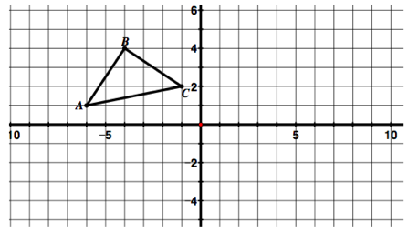

A'
C'

B'

Coordinate rule: (x, -y)
The coordinate rule (x, - y) will hold for any shape reflected over the x-axis. The y value of the new coordinate will always be the opposite of the y value of the pre-image and the x value will always remain constant because the figure does not move left or right, but instead, is flipped to the opposite side of the x-axis. So if the shape was 3 units above the x-axis, it will now be flipped over the x-axis and be located 3 units below the x-axis.

Pre-Image | Image
A(-6, 1) | A'(-6, -1)
B(-4, 4) | B'(-4, -4)
C(-1, 2) | C'(-1, -2)

Possible Conceptions:
- Confusing x and y axes
- Confusing the pre-image and image shapes

Reflection Assessment

- In the grid below, ∆ABC has been reflected over the y-axis to obtain ∆A’B’C’.
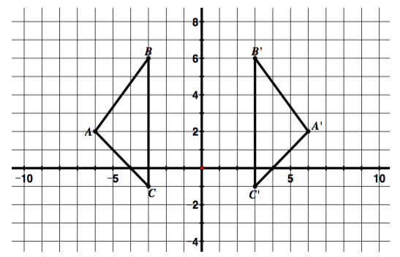
- In the table below, write the coordinates for the vertices of the pre-image and image.
Pre-Image | Image

- Write a coordinate rule to describe the reflection.

- Will this coordinate rule hold true for any figure reflected over the y-axis? Why or why not?

- Reflect ∆ABC across the x-axis and label the vertices of the image.
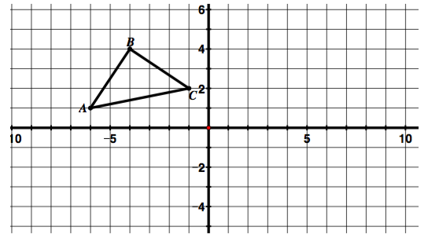
- In the table below, write the coordinates for the vertices of the pre-image and image.
Pre-Image | Image

- Write a coordinate rule to describe the reflection.

- Will this coordinate rule hold true for any figure reflected over the x-axis? Why or why not?

Adapted from the University of Utah Middle School Math Project
Transformations Formative Assessment #3 - Rotation Assessment
Cluster & Content Standards  What content standards can be addressed by this formative assessment?  8.G.3 Describe the effect of dilations about the origin, translations, rotations about the origin in 90 degree increments, and reflections across the x-axis and y-axis on two-dimensional figures using coordinates. | Mathematical Practice Standards  1. Make sense of problems and persevere in solving them.  6. Attend to precision.  8. Look for and express repeated regularity in repeated reasoning.
Learning Targets
What learning targets will be assessed?
- Given a pre-image and image under a rotation, describe the rotation in words and using a coordinate rule (all rotations to be centered at the origin only)
- Perform a rotation of a figure given its center of rotation at the origin, the angle of rotation in increments of 90 degrees, and a direction.
Timing:
During or after instructional tasks.
Correct answers:

a) angle of rotation: 90° clockwise, coordinate rule of rotation: (y, -x)

b) angle of rotation: 180° (clockwise or counter-clockwise),
coordinate rule of rotation: (-x, -y)
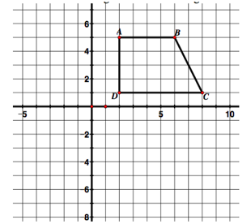
D'
A'
B'
C'
Pre-Image | Image
A(2, 5) | A'(5, -2)
B(6, 5) | B'(5, -6)
C(8, 1) | C'(1, -8)
D(2, 1) | D'(1, -2)

      - Coordinate rule: (y, -x)
      - This 90° clockwise rotation (y, -x) would be the same as a 270° counter-clockwise rotation.

Possible Conceptions/Strategies:
- Some students might need tracing paper or cut out to make these rotations
- Confusing x and y axes
- Confusing the pre-image and image shapes
- Confusing clockwise and counterclockwise
- Understanding of degree measures around a circle

Rotation Assessment

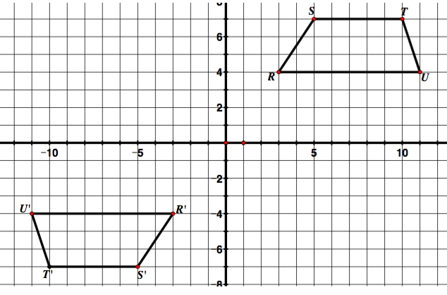
- For each rotation shown below, the center of rotation is the origin. Determine the angle of rotation and direction, then write a coordinate rule for the rotation.
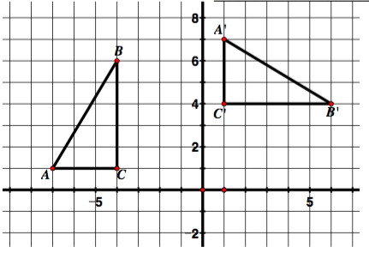
- b.

Angle of rotation and direction: ___________ Angle of rotation and direction: ___________

Coordinate rule for rotation: ______________ Coordinate rule for rotation: ______________

II. Rotate ABCD 90° clockwise with the center of rotation at the origin. Label the vertices of the image.

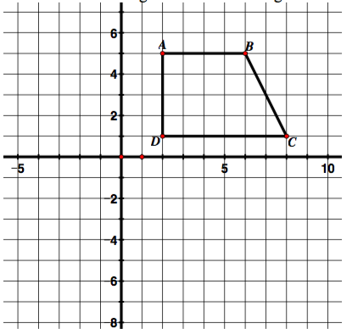
- In the table below, write the coordinates for the vertices of the pre-image and image.
Pre-Image | Image

- Write a coordinate rule for the rotation.

c. How would you describe this rotation in the counterclockwise direction?

Adapted from the University of Utah Middle School Math Project

Transformation Formative Assessment #4 - Dilation Assessment
Cluster & Content Standards  What content standards can be addressed by this formative assessment?  8.G.3 Describe the effect of dilations about the origin, translations, rotations about the origin in 90 degree increments, and reflections across the x-axis and y-axis on two-dimensional figures using coordinates. | Mathematical Practice Standards  What practice standards can be addressed by this formative assessment?  1. Make sense of problems and persevere in solving them.  6. Attend to precision.  8. Look for and express repeated regularity in repeated reasoning.
Learning Targets
What learning targets will be assessed?
- Given a pre-image and its image under a dilation, describe the dilation in words and using a coordinate rule.
- Perform a dilation of a figure given the center of dilation is at the origin.
Timing:
During or after instructional tasks.
Correct Answers:

      - Scale factor: $\frac{1}{3}$
      - Coordinate rule: ($\frac{1}{3}$x, $\frac{1}{3}$y)

Possible Strategies:
- Students might measure the length of each side with a ruler to make a comparison.
- Students might use a piece of paper to copy one side of the triangle and make a comparison to the corresponding side of the other triangle determining that 3 fit in the bigger triangle.
- Some students might report the scale factor as x3
- Some students might report the scale factor as .33333.
- Students might computer a dilation with the rigid/congruence transformations and expecting answers to be the same size

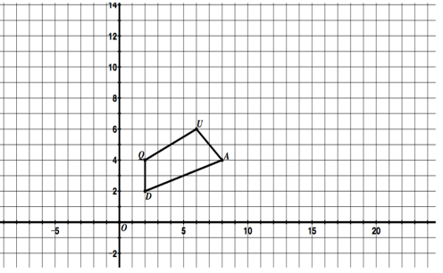
II.
To create a figure two times larger, one method used by students might be to multiple the coordinates of each vertex by two using the coordinate rule: (2x, 2y).
Q(2, 4) Q'(4, 8)
U(6, 6) U"(12, 12)
A(8, 4) A'(16, 8)
D(2, 2) D'(4, 4)
Another method might be to do double the distance each point is from the origin. For example, for point Q, the student might see that you move 2 right and 4 up. If that distance is doubled, the image of point Q would be located 4 right and 8 up from the origin. This could be done for each vertex.
U'

Q'
A'

D'
U"
Q"

A"

D"

b) To create a figure with side lengths ½ as large as the original figure, one method might be for students to multiple the original coordinates of each vertex by ½, using the coordinate rule ($\frac{1}{2}$x, $\frac{1}{2}$y).
Q(2, 4) $→$ Q"(1, 2)
U(6, 6) $→$ U"(3, 3)
A(8, 4) $→$ A"(4, 2)
D(2, 2) $→$ D"(1, 1)
Another method might be do relocate each vertex by cutting the distance from the origin in ½. For example, point Q is located 2 units to the right and
4 units up from the origin. The image of point Q that is one-half the distance from the origin is located 1 unit to the right and 2 units up.

Dilation Assessment

- In the triangle below, ∆ABC has been dilated to obtain ∆A'B'C'.

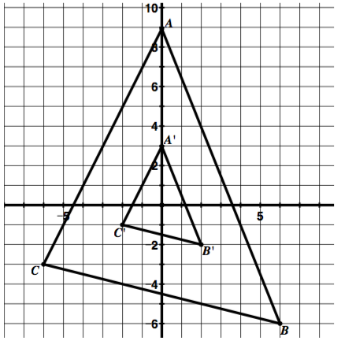

- Determine the scale factor used to dilate the pre-image ∆ABC to create the image ∆A'B'C'. Explain how you found it.

- Write a coordinate rule that describes the dilation.

- Figure QUAD is graphed below.
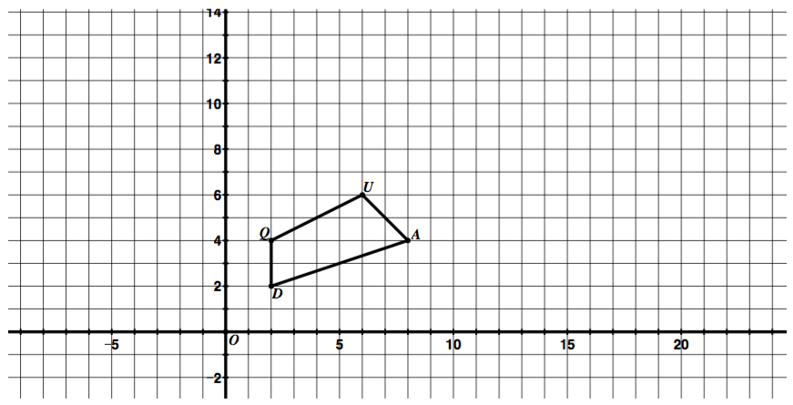

- Create a new quadrilateral, Q'U'A'D', with side lengths two times larger than the side lengths of figure QUAD. Use the origin as the center of dilation. Describe the method you used to create quadrilateral Q'U'A'D' and write the coordinate rule that describes the dilation.

- Now create another quadrilateral, Q"U"A"D", that has side lengths that are ½ the size of quadrilateral QUAD. Use the origin as the center of the dilation. Describe the method you used to create quadrilateral Q"U"A"D" and write the coordinate rule that describes the dilation.

©2014 University of Utah Middle School Math Project in partnership with the Utah State Office of Education. Licensed under Creative Commons, cc-by.

Translations Formative Assessment #5 – Identifying Transformations Exit Ticket
Cluster & Content Standards  What content standards can be addressed by this formative assessment?  8.G.3 Describe the effect of dilations about the origin, translations, rotations about the origin in 90 degree increments, and reflections across the x-axis and y-axis on two-dimensional figures using coordinates. | Mathematical Practice Standards  What practice standards can be addressed by this formative assessment?  1. Make sense of problems and persevere in solving them.  3. Construct viable arguments and critique the reasoning of others.
Learning Targets
What learning targets will be assessed?
- Students will identify the 4 different types of transformations: translations, reflections, rotations, and dilations.
Timing:
After "Say What You See" Dog task.
Possible Answers:
- Translations of triangle A include B and D. Others could be included if translations were combined with other transformations.
- Rotations of triangle A include F. Others could be included if the rotations were combined with other transformations.
- Reflections of triangle A include E and C. Others could be included if the reflections were combined with other transformations.
- Dilations of triangle A include G.

