Two Way Tables Task 1
Pets vs Birthday
Framework Cluster | Statistical Reasoning
Standard(s) | NC.8. SP.4 Understand that patterns of association can also be seen in bivariate categorical data by displaying frequencies and relative frequencies in a two way table.  - Construct and interpret a two-way table summarizing data on two categorical variables collected from the same subjects.  - Use relative frequencies calculated for rows or columns to describe possible association between the two variables.
Materials/Links | Board or large paper, Pets vs Birthday handout
Learning Goal(s) | Students will construct a two way frequency table and understand how it organizes bivariate categorical data.
Task Overview:
Students will complete a two way frequency table as a class and discuss what the information means.
Prior to Lesson: Teacher will set up a two way table on the board or on a large sheet of paper. The headings along the top would be Pet or No Pet. The headings along the side would be Jan-April, May-August, and Sept-Dec. Do not show students the table until after the task is launched.

 | Pets | No Pets
Jan-April
May-August
Sept-Dec

Teaching Notes:
Task launch:
- Have students discuss whether they have pets or no pets. Have them discuss the month of their birthday. Ask them the best way to organize all of the data. Students could work on a diagram.
Directions:
- Show students the table and let them know it is called a two way table. They should come up to the board and make a tally mark in the box that describes both whether they have a pet or not and the month of their birthday. Students will then fill in the table on their handout using numbers to represent the totals in each box instead of tally marks.
- After completing the table as a class, students will answer the questions on their handout. As students work, observe their struggle and make note of the stories you want shared with the class. Smith and Stein’s 5 Practices for Orchestrating Mathematical Discourse can help structure the task and discussion.
- When they have completed the questions, lead a class discussion about the answers and any relationships they discover in the table.
Possible Strategies/Anticipated Responses:
- Students may not understand the adaption from tally marks to numbers or they may count incorrectly.
- Show students that they can total the rows and total the columns and they should match.
- Students may use a highlighter to show rows, columns, and the intersection.

Pets vs Birthdays

 | Pets | No Pets
Jan-April
May-August
Sept-Dec

- Fill in the two way table above. Write in the number of tally marks for each category.

- How many students have a pet and are born in January-April?

- How many students do not own a pet and are born in September-December?

- How many students have a pet?

- How many students were born in May- August?

Two Way Tables Task 2
Looking for an Association
Framework Cluster | Statistical Reasoning
Standard(s) | NC.8. SP.4 Understand that patterns of association can also be seen in bivariate categorical data by displaying frequencies and relative frequencies in a two way table.  - Construct and interpret a two-way table summarizing data on two categorical variables collected from the same subjects.  - Use relative frequencies calculated for rows or columns to describe possible association between the two variables.
Materials/Links | Display of double bar graph (can be found https://im.openupresources.org/8/teachers/6/9.html#activity-1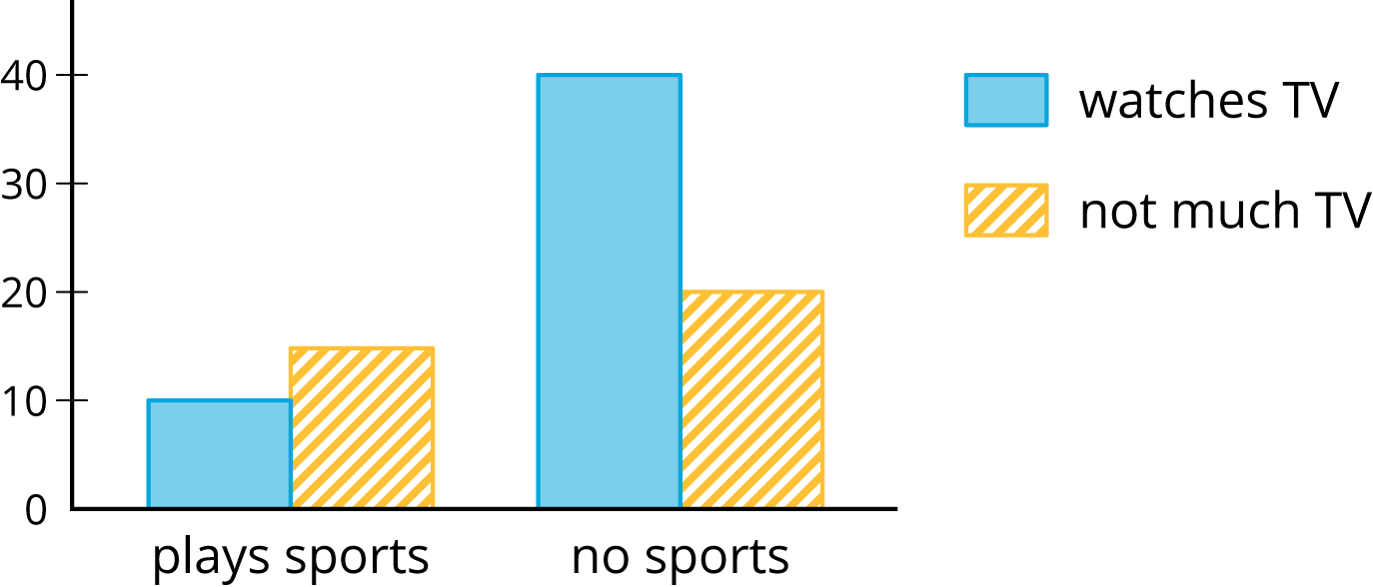  One set of cards for every two students (https://im.openupresources.org/8/teachers/materials/6/9/8-6-9-2-blackline_master.pdf)
Learning Goal(s) | - Display frequencies and relative frequencies in two-way tables, bar graphs, and segmented bar graphs.  - Use relative frequencies to identify possible associations between variables.
Task Overview:
Students will study categorical data displayed in two way tables, double bar graphs, and segmented bar graphs. By studying the different displays students will be able to visualize the frequency and relative frequency. Students should then be able to make a judgement on whether there is an association.
Prior to Lesson:
- Students need to be able to read a bar graph.
- Students need to be able to determine a percent given a part-whole relationship.
Teaching Notes:
Task launch: Display the two way table. Ask students what do they notice? What do they wonder?

 | Has cell phone | Does not have cell phone | Total
10 to 12 years old | 25 | 35 | 60
13 to 15 years old | 40 | 10 | 50
16 to 18 years old | 50 | 10 | 60
total | 115 | 55 | 170

Discuss why this is called a two way table? What does the 25 mean? What does 55 mean? What does the 170 mean?

Display the double bar graph.
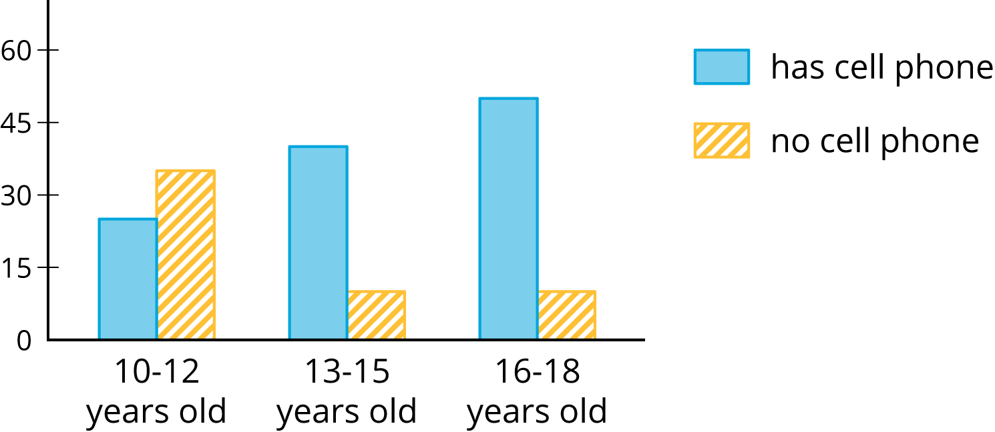
Discuss why this is called a double bar graph? What do the blue bars represent? Where is the 25 from the two way table represented on the double graph? 55? 170?

Display the segmented bar graph.
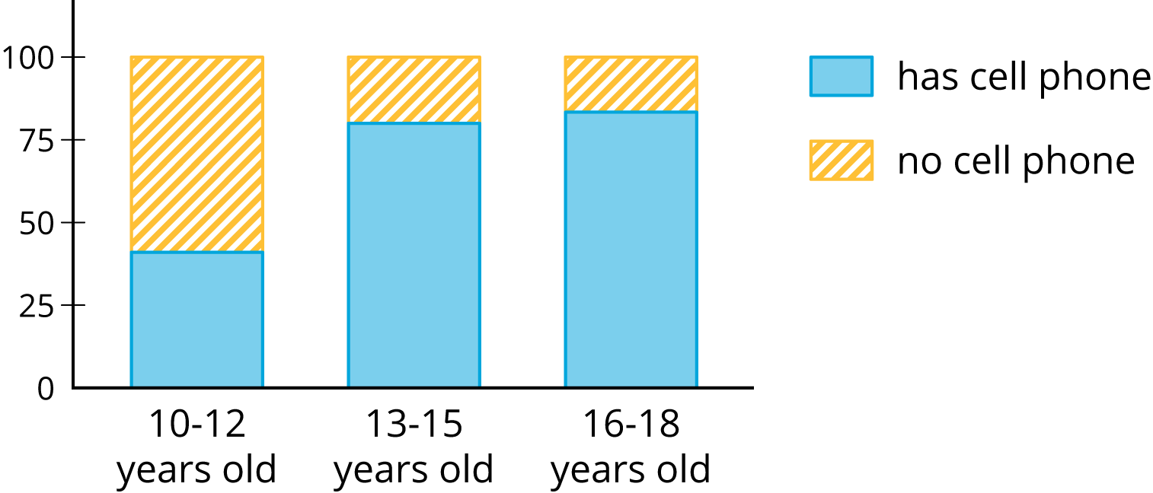
Discuss why this is called a segmented bar graph? What does the vertical axes represent? How is the 25 from the double bar graph displayed? How is the 55 from the double bar graph displayed?

Directions:
Distribute the pre-cut cards to each set of partners. Cards show two way tables, double bar graphs, and segmented bar graphs. One of the groups does not have a two-way table. Students will make a two-way table for the situation described by the graphs in the group. Students will label the bar graphs and segmented bar graphs so that the categories represented by each bar are indicated. Students will describe the kind of information shown by a segmented bar graph. One set of cards does not have a segmented bar graph. Students will create the segmented bar graph.

After students have had a chance to match and label the cards, a whole class discussion should be used to make the connection between frequency and relative frequency. Questions to use for the whole class discussion could include:
What were strategies used to match the cards? Were some cards easier to match then others? Explain.

Give students the segmented bar graph and ask them to create a two way table.

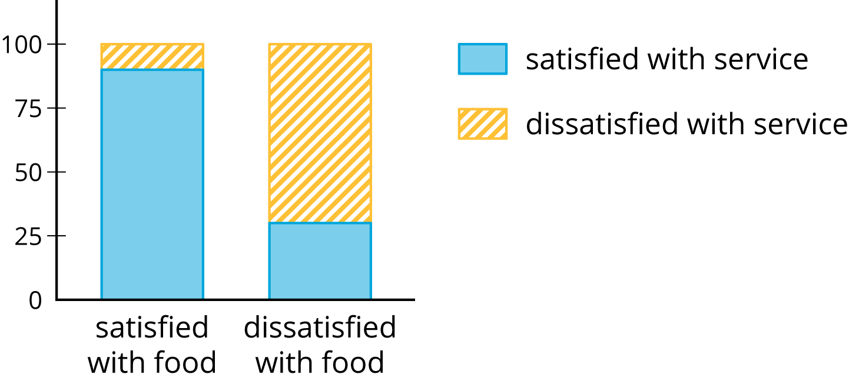

When completed ask them what strategies they used. What information does this segmented bar graph give? Why is the blue on the first bar so much greater than the second bar? What does that mean?

Possible Strategies/Anticipated Responses:

Solutions:
- The blackline master is the solution to the card match.
- One variation of the two way table students are required to create is

 | Ate breakfast | Skipped breakfast | total
male | 48 | 12 | 60
female | 48 | 16 | 64
total | 96 | 28 | 124

Students’ categories will vary. Be sure students use categorical data. There numbers may be slightly different since they are estimating the numbers from the bar graph. That is not a big deal. Their totals should be correct.
3. Students could label the graphs as follows:
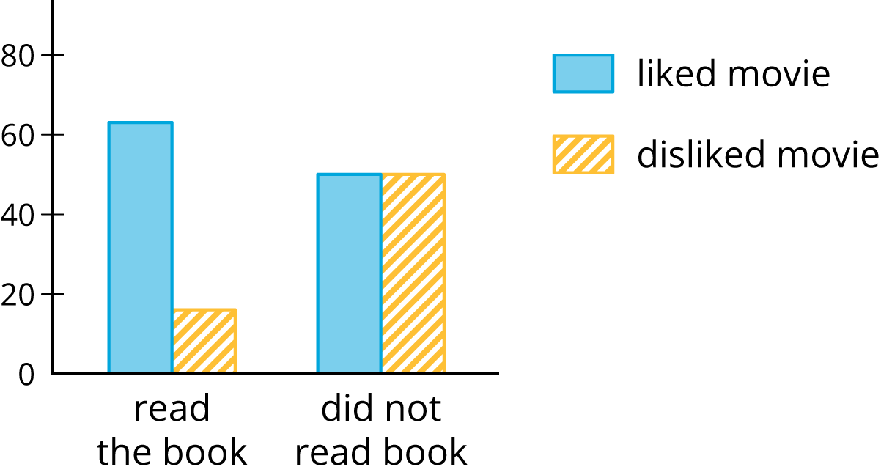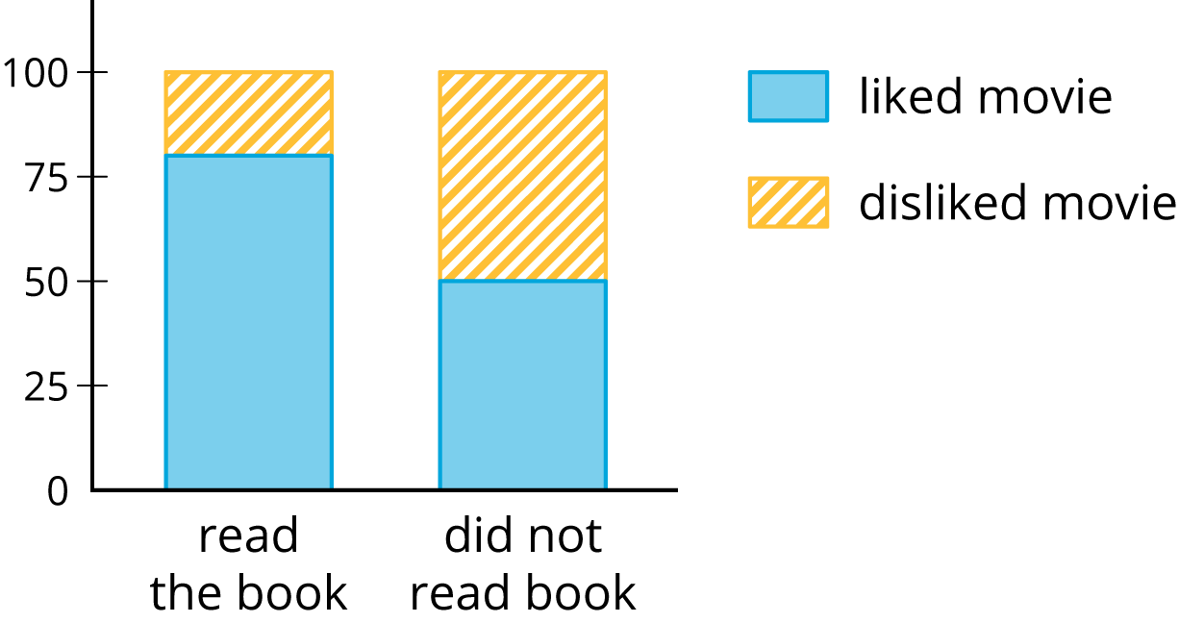

Activity #1
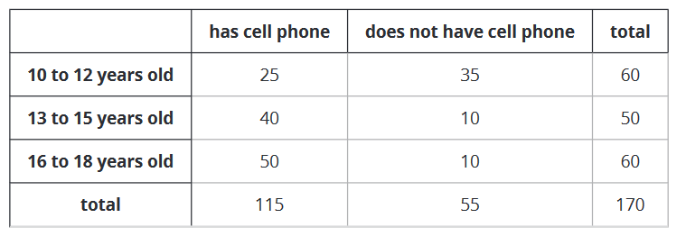

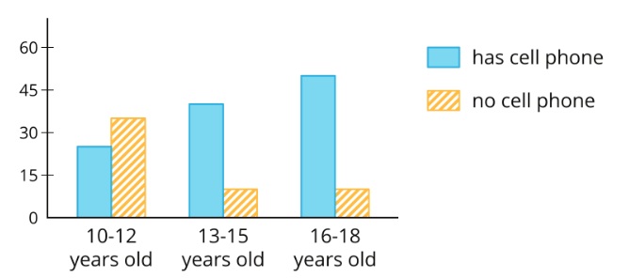

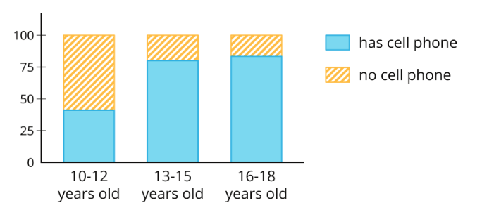

Activity #2 (Cards for Card Sort)

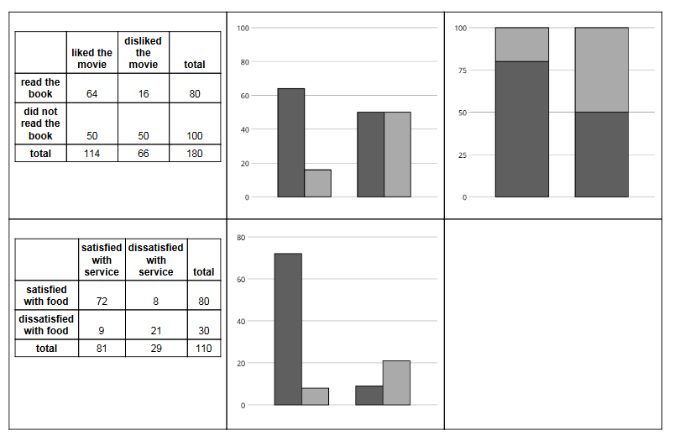
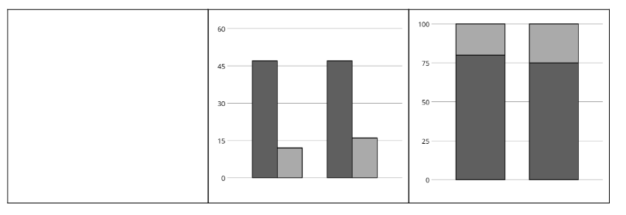

Two Way Tables Task 3
Building a Relative Frequency Table
Framework Cluster | Statistical Reasoning
Standard(s) | NC.8. SP.4 Understand that patterns of association can also be seen in bivariate categorical data by displaying frequencies and relative frequencies in a two way table.  - Construct and interpret a two-way table summarizing data on two categorical variables collected from the same subjects.  - Use relative frequencies calculated for rows or columns to describe possible association between the two variables.
Materials/Links | https://im.openupresources.org/8/teachers/6/9.html#activity-3  “Age and Cell Phone Use” handout.
Learning Goal(s) | - Display frequencies and relative frequencies in two-way tables, bar graphs, and segmented bar graphs.  - Use relative frequencies to identify possible associations between variables.
Task Overview:
Students will create a two way relative frequency table and look for patterns to determine if there is an association between categories.
Prior to Lesson:
Students should be familiar with creating a two way table as well as finding percentages.
Teaching Notes:
Task launch:

Display the following table. Ask students who is more likely to watch the news on a daily basis? Students may reply, “People younger than 18.” Students should then be asked to look at the totals and compare the total number of “younger than 18” to the total number of “18 or older.” Ask if that changes their answer. Create a relative frequency table together. Ask students again who is more likely to watch the news on a daily basis. Ask students how the percentages relate to the segmented bar graphs from the card sort task.

 | Watches news daily | Does not watch news daily | total
Younger than 18 | 30 | 80 | 110
18 or older | 10 | 5 | 15
total | 40 | 85 | 125

Directions:
- Students will complete the handout, “Age and Cell Phone Use.” Partner or small-group work is appropriate to allow students to discuss their responses.
- As students work, observe their struggle and make note of the stories you want shared with the class. Smith and Stein’s 5 Practices for Orchestrating Mathematical Discourse can help structure the task and discussion.
Possible Strategies/Anticipated Responses:
- Be sure students are using the correct numbers to find the percentage. They are finding the percent of 10-12 year olds who have a cell phone compared to the total number of 10-12 year olds 25/60 = 42%. Leaving off the total will help students remember that it is the total per row and not for all surveyed.

Solutions:

 | Has a cell phone | Does not have a cell phone | total
10-12 years old | 42% | 58% | 100%
13-15 years old | 80% | 20% | 100%
16-18 years old | 83% | 17% | 100%
- Segmented bar graphs were based on percentages. They totaled 100%. They compared two parts of one category. You could compare categories.
- They columns are not percentages in the same category. They do not equal 100%
- Yes, there is an association between age and cell phone use. A much higher percentage of children from 13 to 18 years old have cell phones than children from 10 to 12 years old do.

AGE and CELL PHONE USE

 | Has a cell phone | Does not have a cell phone | total
10 to 12 years old | 25 | 35 | 60
13 to 15 years old | 40 | 10 | 50
16 to 18 years old | 50 | 10 | 60
total | 115 | 55 | 170

 | Has a cell phone | Does not have a cell phone | total
10-12 years old | 42%
13-15 years old |  |  | 100%
16-18 years old |  | 17%
- Complete the table. In each row, the entries for “has cell phone” and “does not have cell phone” should have the total 100%. Round entries to the nearest percentage point.

- This is still a two-way table. Instead of showing frequency, this table shows relative frequency. How is this similar to a segmented bar graph?

- Two-way tables that show relative frequencies often don’t include a “total” row at the bottom. Why?

- Is there an association between age and cell phone use? How does the two-way table of relative frequencies help to illustrate this?

