Parts and Pieces
Frameworks Cluster | Reasoning with Area and Surface Area
Standards | NC.6.G.1 Create geometric models to solve real-world and mathematical problems to:  - Find the area of triangles by composing into rectangles and decomposing into right triangles.  - Find the area of special quadrilaterals and polygons by decomposing into triangles or rectangles.  SMP1 Make sense of problems and persevere in solving them.  SMP3 Construct viable arguments and critique the reasoning of others.  SMP7 Look for and make use of structure.
Materials/Links | - Tangrams - 1 set + 2 additional small triangles instead of the parallelogram for every 2 students, or paper sets from https://im.openupresources.org/6/teachers/materials/1/2/6-1-2-2-blackline_master.pdf (Note: you will need to create an account to access resources)  - Parts and Pieces Student Handouts (1 for every 2 students)
Learning Goal | Students will understand how to find the area of composite shapes made of triangles, squares, and rectangles by decomposing and/or enclosing the shape.
Task Overview:
This hands-on task requires students to compose polygons of various areas from triangles and squares taken from sets of tangrams.
Prior to Task:
- Students should have previously developed a conceptual understanding of finding the area of rectangles. Students should recall the definitions of polygon, quadrilateral, parallelogram, and trapezoid.
- Plan student pairs in advance.
Teaching Notes:

Task launch:

- Many students will have had experience with tangrams in elementary school, but may have forgotten about them. Show the class the pieces from a typical set, and explain that instead of having the parallelogram, they’ll get 2 additional small triangles, and give one of the modified tangram sets to each pair of students.
- Tell students to find 2 of the smallest triangles and the medium triangle in their set, and use those three triangles to create (1) a larger triangle, (2) a square, (3) a rectangle, (4) a parallelogram, and (5) a trapezoid. Allow students to work on this for about 5 minutes. It’s okay if the entire class doesn’t make all of the shapes; this is simply an introduction to the materials and the idea of putting the smaller shapes together to make a larger shape, as well as a means for reviewing the needed vocabulary.

Directions:

- Give each pair of students the following set of tangram pieces: 1 Square, 4 Small Triangles, 1 Medium Triangle, 2 Large Triangles. Note: the tangram pieces used here differ from a standard set in that two additional small triangles are used instead of a parallelogram. It’s important not to give them more than these pieces.
- Give students 2–3 minutes of individual think time for the first three questions on the student handout.
- When time is up, ask them to compare their solutions to their partner's. If they created the same shape for questions 2 and 3, ask them to create a different shape that has the same given area before moving on. Then, ask them to work with their partner to answer the remaining questions.
- Summarize the lesson by having a group discussion of solutions and strategies from questions 4-6 of the task. Consider using the Class Discussion Planner (https://tinyurl.com/discussion-planner) to guide the class discussion.

Lesson plan template adapted from Taking Action: Implementing Effective Mathematics Teaching Practices, NCTM, 2017

Student handouts begin on the next page.
Name ___________________________________________________________ Date _____________________

Parts and Pieces

- Suppose that the area of the square tangram piece is 1 square unit. Notice that you can put together two small triangles to make a square. What is the area of the square composed of two small triangles? Be prepared to explain your reasoning.
- Use your shapes to create a new shape with an area of 1 square unit that is not a square. Draw or trace your solution below and label each piece with its area.
- Use your shapes to create a new shape with an area of 2 square units. Draw or trace your solution below and label each piece with its area.

- Use your shapes to create a different shape with an area of 2 square units. Draw or trace your solution below and label each piece with its area.
- Use your shapes to create a new shape with an area of 4 square units. Draw or trace your solution below and label each piece with its area.
- Use any of the tangram pieces you have to create a rectangle, a parallelogram, and a trapezoid that all have the same area. Draw or trace your solutions below and label each piece with its area. Also state the overall area of each shape.

Possible Strategies/Anticipated Responses:

Task Launch:
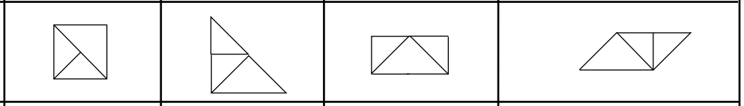
Parts and Pieces:
- The area of the square made from two small triangles is one square unit because it is identical to the given square that has an area of 1 square unit. “Identical” means you can put one on top of the other and they match up exactly.
- Any composite of two small triangles will have an area of 1 square unit. Sample responses: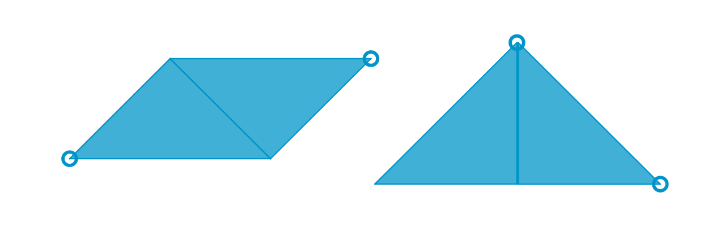
- Any composite of four small triangles; two small triangles and one medium triangle; one medium triangle and one square; or two small triangles and one square will have an area of 2 square units. Note that although the large triangle has an area of 2 square units, it is not an acceptable solution because it is not a composite shape. Sample responses:
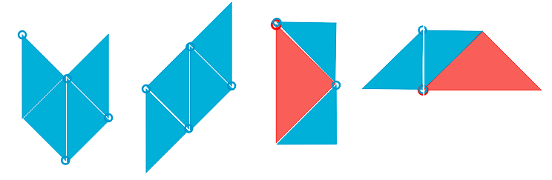
NOTE: It is acceptable for students to create shapes in which the sides of the individual shapes do not have the same lengths where they meet, but do not permit students to create shapes that have blank space in the middle. While the shape of the shaded region would still be the same, the question asks for the area of the shape created (which would include the open space). This rule allows the task to better fit the intention of the standard. Any small gaps between pieces in the sample responses are there only to make obvious the various smaller pieces composing the larger shape.

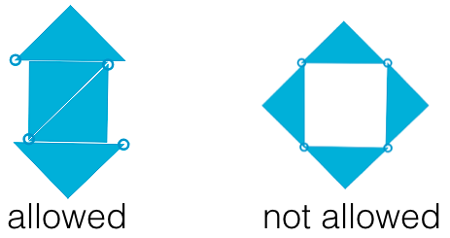
- Be sure that the solution is different from the student’s previous answer. Any composite of four small triangles; two small triangles and one medium triangle; one medium triangle and one square; or two small triangles and one square will have an area of 2 square units. See sample responses shown for #3.
- Any composite shape with an area of 4 square units, made up of smaller shapes which have areas less than 4: up to four small triangles (area = ½); up to 1 medium triangle (area = 1); up to 1 square (area = 1, up to 2 large triangles (area = 2). Sample responses: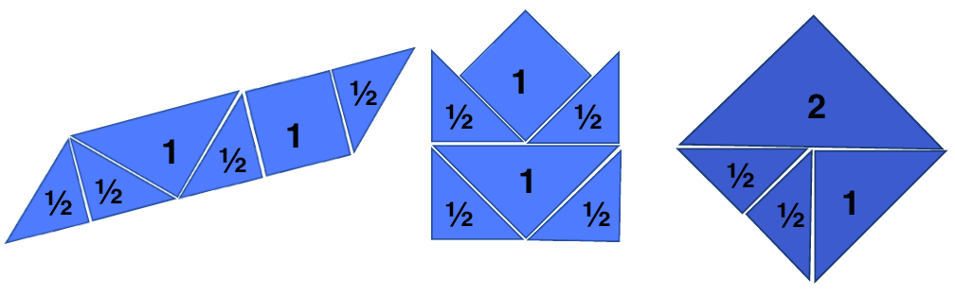
- Answers will vary. Some students may realize that it is sometimes possible to make slight changes to go between each of these shapes. Sample responses: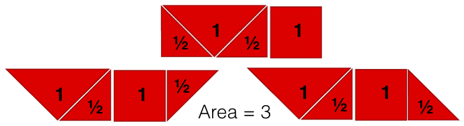
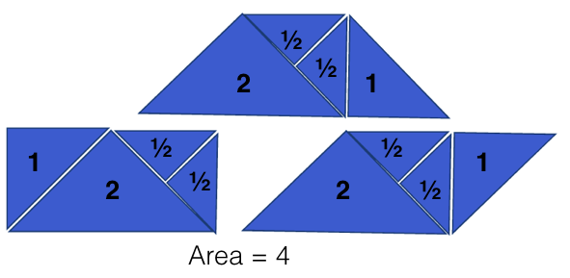
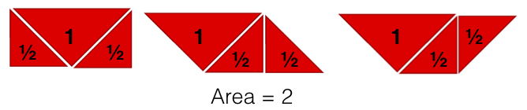
Possible misconceptions:
- Watch for students who are struggling to get started because they haven’t figured out that the area of each small triangle is ½. Guide them to this understanding by hands-on investigations with the square and two small triangles. You might also ask whether the other shapes have an area that is larger or smaller than the area of the square (small triangle has a smaller area; medium triangle has the same area; large triangle has a larger area).
- Students might believe the area of the shape is the number of pieces in the composite shape
- Students may confuse area for the number of sides or the perimeter of the composite shape
- Some students may know areas of the decomposed shapes but don’t know what operation to use to combine them into the area of the entire polygon. To prompt their reasoning rather than telling them what to do, ask them to draw a rectangle on grid paper (sides of the rectangle should follow the grid lines), then find the area. (Note whether students are counting individual squares or multiplying the length and width.) Now ask them to draw a line (again, on a grid line) separating the rectangle into two smaller rectangles or squares, and ask them to determine the area of each rectangle. Ask them what they notice about the area of the smaller rectangles compared to the larger rectangle they create. You may need to guide them through more examples or have them divide the smaller rectangles into even smaller rectangles, if they don’t realize that the sum of the areas of the smaller rectangles is equal to the area of the larger rectangle.

Area of Rectangles and Parallelograms
Frameworks  Cluster | Reasoning with Area and Surface Area
Standards | NC.6.G.1 Create geometric models to solve real-world and mathematical problems to:  - Find the area of triangles by composing into rectangles and decomposing into right triangles.  - Find the area of special quadrilaterals and polygons by decomposing into triangles or rectangles.  SMP 1 Make sense of problems and persevere in solving them.  SMP 4 Model with mathematics.  SMP 6 Use appropriate tools strategically.  SMP 7 Look for and make use of structure.
Materials/Links | For launch:  - One copy of launch sheet for each pair of students  - Dice  - Crayons  For task:  - One copy of recording sheet and figures for each student (copied separately)  - Scissors  - Glue sticks  - Crayons
Learning Goal(s) | Students will decompose and compose figures to develop a conceptual understanding of the connection between the area of a rectangle and the area of a parallelogram.
Task Overview:
This activity requires students to estimate the area of parallelograms and then manipulate the figures, by cutting and rearranging the figures, to derive the relationship between areas of parallelograms and rectangles.
Prior to Lesson:
- Students need to know the attributes of parallelograms and rectangles
- Students need to understand the concept behind determining the area of a figure (use the Task launch activity to build understanding or activate prior knowledge)
- Plan partner assignments in advance
Teaching Notes:

Task launch:
- Play Raging Rectangles (attached as last page of the student handout) for a short time
- This game will help students recall background knowledge of area being calculated by determining the number of unit squares it takes to tile a figure without gaps or overlaps.
Directions:
- Be ready to provide students with a pair of scissors and copy of both the recording sheet and figure sheet, handing out scissors after students approximate the areas.
- Instruct students to begin by writing the name of each shape on the recording sheet and approximating the area of each figure These approximations should be recorded on the Student Recording Sheet. Students should estimate by counting the square units inside each figure. Note that for the parallelograms, there will be partial squares enclosed by the shape’s edges. Allow students to come up with their own methods of estimating those sections rather than giving them a strategy to use.
- Have students determine the actual area. Encourage students to be as precise as possible when finding the actual areas by cutting and manipulating the shapes, but do not give students more directions than necessary. After students have had sufficient time to manipulate the parallelograms, with guidance, consider prompting with a question like, “You’ve found the areas of the rectangles more easily, how could you change this parallelogram into a rectangle?” or modeling how to cut the figure to rearrange it into a rectangle for students who are not yet on that path.
- After students have found the area of each shape, and answered the follow-up question at the end of the Student Recording Sheet, summarize the lesson through a whole-group discussion of various areas found, then focus on students’ methods for finding the area of parallelograms. Consider using the Class Discussion Planner (https://tinyurl.com/discussion-planner).

Note: As the next task in the progression is to find the area of triangles, you can use the decomposition in this lesson to begin investigating the relationship between the area of triangles and rectangles.

This lesson is intended to be followed by the “Area of Triangles” lesson, however, based on your teaching style/preference it is possible to use the “Area of Triangles” lesson first, followed by this lesson.

Lesson plan template adapted from Taking Action: Implementing Effective Mathematics Teaching Practices, NCTM, 2017

Student sheets begin on next page.
Name _________________________________________________________Date________________________

Area of Rectangles and Parallelograms
Student Recording Sheet

Figure A Figure B Figure C
Shape: _____________________ Shape: _____________________ Shape: ___________________
Estimated Area: _____________ Estimated Area: _____________ Estimated Area: ____________
Actual Area: ________________ Actual Area: ________________ Actual Area: _______________

Figure D Figure E Figure F
Shape: _____________________ Shape: _____________________ Shape: ____________________
Estimated Area: _____________ Estimated Area: _____________ Estimated Area: ____________
Actual Area: ________________ Actual Area: ________________ Actual Area: _______________

Figure G Figure H Figure I
Shape: _____________________ Shape: _____________________ Shape: ____________________
Estimated Area: _____________ Estimated Area: _____________ Estimated Area: ____________
Actual Area: ________________ Actual Area: ________________ Actual Area: _______________

Choose 1 rectangle and 1 parallelogram. Justify your estimation and the actual area. You may glue the shapes below to help in your explanation.

Rectangle _______: Parallelogram _______:

Based on your findings, how can you find the area of a parallelogram?

Student Figures Sheet
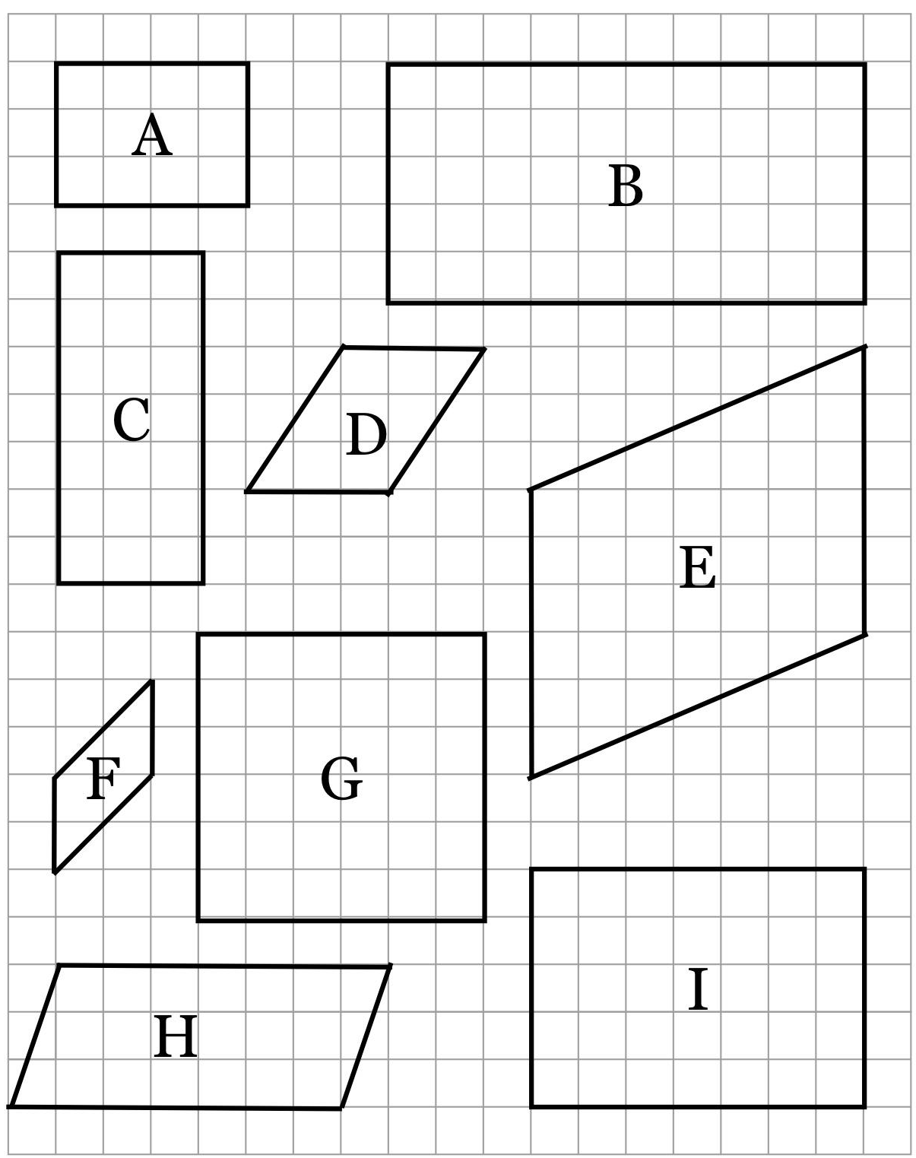
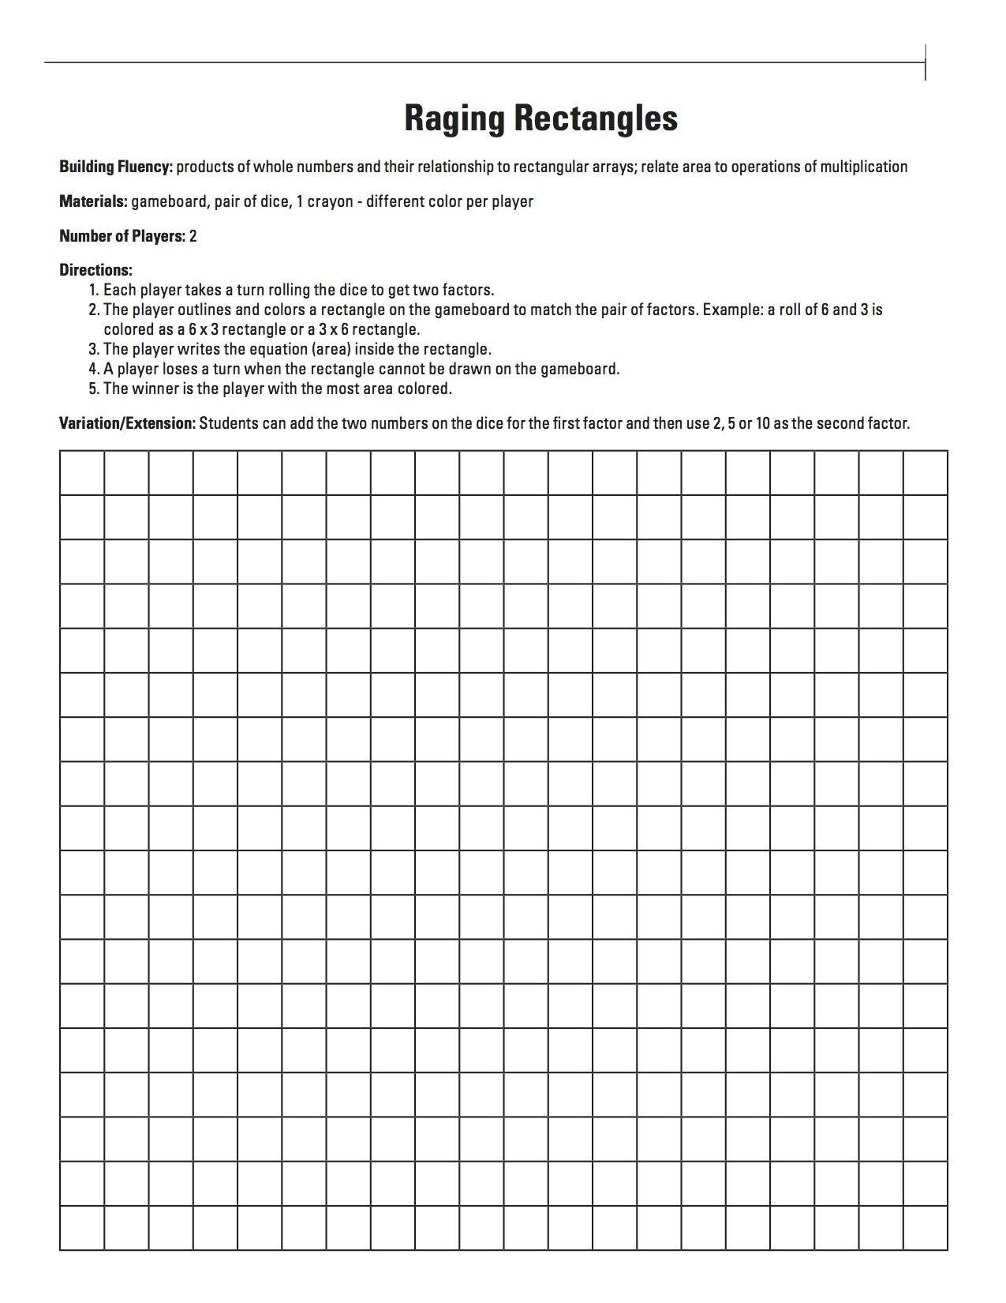

Possible Strategies/Anticipated Responses:

Shapes and Areas*:
- Figure A: Rectangle, 12 sq. units
- Figure B: Rectangle, 50 sq. units
- Figure C: Rectangle, 21 sq. units
- Figure D: Parallelogram, 9 sq. units
- Figure E: Parallelogram, 42 sq. units
- Figure F: Parallelogram, 4 sq. units
- Figure G: Square/Rectangle, 36 sq. units
- Figure H: Parallelogram, 21 sq. units
- Figure I: Rectangle, 35 sq units

*Keep in mind that technically all of the shapes are parallelograms, as the definition of a parallelogram is a flat shape with opposite sides parallel, but in these cases we are using the most specific shape name possible.

Strategies/Responses:

- Two ways that students may determine the area of the parallelograms are:
  - To “move” the triangle from one side to the other to create one large square (purple example, on the left).
  - To find the area of the central rectangle that already exists within the parallelogram, then find the area of the two triangles by combining them together to form another rectangle, then adding the two areas together (teal example, on the right).
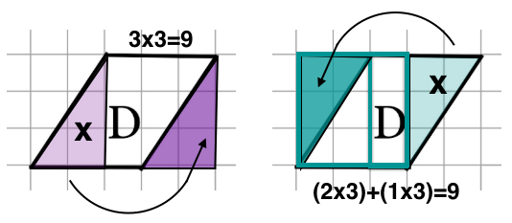
- Students may confuse area and perimeter, especially if the Task Launch activity or another method of activating prior knowledge is not used.
- Students may struggle to count the area of partial squares enclosed by the parallelograms, especially if they don’t realize they can reconfigure the shape into a rectangle.
- Often, when students find the area of composite figures, such as in the example on the right (above), where one 2x3 rectangle and one 1x3 rectangle are formed, they can accurately find the area of each rectangle, but don’t know what to do with those two areas to find the overall area (multiplying the areas of 6 and 3 to get an overall area of 18 is a common incorrect strategy).

Area of Triangles
Frameworks Cluster | Reasoning with Area and Surface Area
Standards | NC.6.G.1 Create geometric models to solve real-world and mathematical problems to:  - Find the area of triangles by composing into rectangles and decomposing into right triangles.  - Find the area of special quadrilaterals and polygons by decomposing into triangles or rectangles.  SMP 1 Make sense of problems and persevere in solving them.  SMP 4 Model with mathematics.  SMP 6 Use appropriate tools strategically.  SMP 7 Look for and make use of structure.
Materials/Links | - One copy of recording sheet for each student  - One copy of grid paper for each student  - Grid paper or gridded whiteboards with two different colored markers  - Scissors  - Colored pencils, including red and blue  - Glue sticks
Learning Goal | Students will generate a process for determining the area of a triangle.  *Note that the goal in 6th grade is NOT to teach the formula for the area of a triangle, instead it is to help students see the relationship between triangles and parallelograms (including rectangles).
Task Overview:
This hands-on activity walks students through the process of using triangles to derive the relationship between areas of triangles and parallelograms. This lesson should be used after the “Area of Rectangles and Parallelograms” lesson. After using this task, check for understanding using the “Area Comparison Justification” formative assessment.
Prior to Lesson:
- Prepare materials. *As you are printing/copying the student recording sheets and the grid paper, check to make sure that the size of the grids on the grid paper and on the recording sheet match.
- Complete the Task Launch to be sure students have the background knowledge needed to complete the task successfully.
- Plan partner assignments in advance.
Teaching Notes:

*Throughout this activity, students will be using blue to indicate the base of each triangle and red to indicate the height.

Task launch:
- Begin by asking students to draw a triangle with the base of 7 (in blue) and height of 4 (in red). Students could do this on coordinate grid paper or whiteboards with grid lines. Have students draw a second triangle with the blue base of 7 and red height of 4 that is different from the first one. As stated earlier, you may want to have the third side be a color different than the third side on the first triangle, so that students have an additional visual to keep track of their triangles or have them number each beside the figure. Repeat this process until students have drawn multiple triangles of these dimensions. This would be a good opportunity to review triangle vocabulary with students. Distinguish for students a triangle that is a right triangle and one that is not a right triangle. An answer key is at the end of this document.
- The purpose of the task launch is to help students review vocabulary (base and height) and for students to start to see the perpendicular relationship between these parts. The perpendicular relationship will become more noticeable throughout the task.
- During the task launch it will be essential for students to understand how to find the length between two vertical or horizontal points on a coordinate plane. Many students may count lines instead of spaces. Be sure students count spaces, as a student’s success during the task will depend on finding the length on a coordinate plane correctly.
- Use this task launch as an opportunity for incorporating obtuse triangles. If no students create obtuse triangles during the task launch, spark their thinking by showing one of the obtuse triangles found in the possible answers section and say “A student from last year created this triangle and argued that it, too, had a base of 7 and a height of 4. Do you think that student was correct? Why or why not?” and have students justify their answers, ultimately determining that the obtuse triangle does have a base of 7 and a height of 4. This, again, is an opportunity to reiterate the concept that when working with triangles, bases and heights have to be perpendicular.

Directions:
- Have students create and label triangles on grid paper using the following dimensions, making sure that at least one triangle is a right triangle and at least one triangle is not a right triangle:
Triangle A: Base of 3, height of 2
Triangle B: Base of 4, height of 5
Triangle C: Base of 5, height of 3
Triangle D: Base of 3, height of 3
Be sure students label the inside of their triangles with A, B, C, or D as they go. After students draw each triangle, have them compare the triangle they drew with their partner’s triangle. Students should color code the height of their triangle red and base of their triangle blue while working with their partner. This will allow students to justify how their triangle matches the description given. If students drew the same triangle they can work together to come up with another triangle. Allow about 2 minutes per triangle for these conversations. During this partner conversation would be an appropriate time to listen in to ensure students understand that two triangles can have the same height and same base but look different. If this does not come up in student conversations, a quick whole group conversation where you pose a question such as “Can two triangles have the same height and the same base but look different?" would be appropriate.
- Be sure students have the triangles’ dimensions labeled on the inside, so the label can be seen once they are cut out. Students should now cut out their 4 triangles.
- Pass out the student recording sheet. Have students place the triangles in the corresponding section of their sheet. Have students estimate the area of each of their triangles without letting their partner know their predictions.
- Allow students time to talk with their partner to predict whether their triangle and their partner’s triangles have the same area or not and justify their thinking about why their triangle will have a smaller area, the same area, or a larger area. Questions you may want to ask are:
  - How did you determine your estimate for your triangle’s area?
  - Compare your estimate of the area of the triangle to your partner’s estimate for the triangle with the same base and height dimensions. Are your estimates the same or different?
  - What would you estimate the area of your partner’s triangle to be?
  - What makes you believe your triangle is (larger/smaller/the same area)?
  - What would need to change about your triangle to convince you that your triangle has the same area as your partner’s?
- Have students use the triangles twice to create a parallelogram (which could be a rectangle, if the original triangle is a right triangle). Students should do this by drawing their triangle on the coordinate plane on their recording sheet and then reflecting the triangle over any of the sides (a larger page of grid paper is also included in this file, if the reflections don’t fit on the smaller grids). Students can do this by flipping their triangle and tracing it a second time. (See images below.) For any students are struggling to make parallelograms/rectangles with their triangles after being given time to figure it out on their own, consider modeling how to do this.

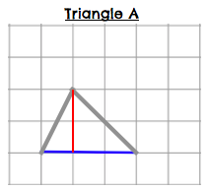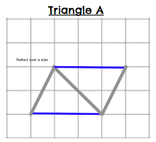
- Have students calculate the area of the parallelogram to then determine the area of the triangle. If students struggle to see the relationship between the parallelogram and the triangle, consider modeling the process using the class model located after the student reflection sheet. Show students the parallelogram. Cut the parallelogram in half diagonally so students can see that the triangle is half of the parallelogram by showing students that the 2 triangles are identical. Tell the students that the area of the parallelogram is 120 units squared, then ask what the area of the triangle would be to be sure students have the relationship correct. Have students revisit their predictions about the area comparison. Questions you may want to ask here are:
  - How well did your estimate strategy work when comparing it to the actual areas?
  - How does your actual area of a triangle compare to your estimate for the same triangle?
  - How does your actual area of a triangle compare to your partner’s actual area for the same triangle?
- After students have found the area of each triangle, summarize the lesson through a whole-group discussion of various areas found, focusing on students’ methods for finding the area of triangles. As students are responding, be sure that a discussion about the fact that the area of a triangle is half the area of the parallelogram it makes, takes place. Additionally, you may want to refer back to the “Area of Rectangles and Parallelograms” lesson to reiterate the relationship between finding the area of rectangles and finding the area of other parallelograms during this discussion. Consider using the Class Discussion Planner (https://tinyurl.com/discussion-planner) to guide your discussion.

This lesson should be used after the “Area of Rectangles and Parallelograms” lesson, however, based on your teaching style/preference, it is possible to use the “Area of Triangles” lesson first, followed by this lesson. After using this task, check for understanding using the “Area Comparison Justification” formative assessment.

Lesson plan template adapted from Taking Action: Implementing Effective Mathematics Teaching Practices, NCTM, 2017

Student sheets begin on next page.
Name _________________________________________________________Date________________________

Area of Triangles
Student Recording Sheet
Triangle A  Do you think that the triangle you made and the triangle your partner made have the same area? Yes No  Estimated Area of Triangle: _____________  Height: _____________  Base: ______________  Area of Parallelogram: ________________  Area of Triangle: ________________ | Triangle B  Do you think that the triangle you made and the triangle your partner made have the same area? Yes No  Estimated Area of Triangle: _____________  Height: _____________  Base: ______________  Area of Parallelogram: ________________  Area of Triangle: ________________
Triangle C  Do you think that the triangle you made and the triangle your partner made have the same area? Yes No  Estimated Area of Triangle: _____________  Height: _____________  Base: ______________  Area of Parallelogram: ________________  Area of Triangle: ________________ | Triangle D  Do you think that the triangle you made and the triangle your partner made have the same area? Yes No  Estimated Area of Triangle: _____________  Height: _____________  Base: ______________  Area of Parallelogram: ________________  Area of Triangle: ________________

Explain how you estimated the area of one of the triangles. You may draw a diagram or glue your triangle below to help in your explanation.

What do you notice about the relationship between the lines created by the height and the base of the triangles?

What relationship exists between the area of a parallelogram and the area of a triangle that both have the same base and height?

Based on your findings, how can you find the area of a triangle?

Use the grids below to draw two different triangles. Find the area of each of your triangles.
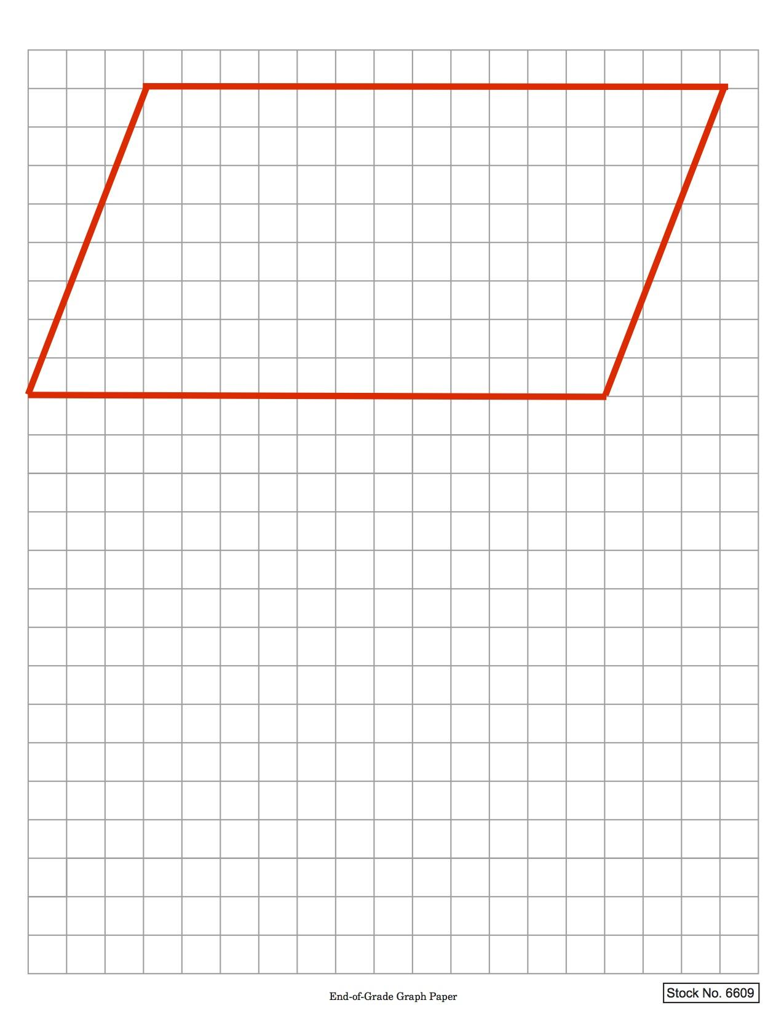
Class Model Diagram

Possible Strategies/Anticipated Responses:

Task Launch Possible Answers:
All triangles could be reflected or rotated.
*More obtuse triangles can be created.
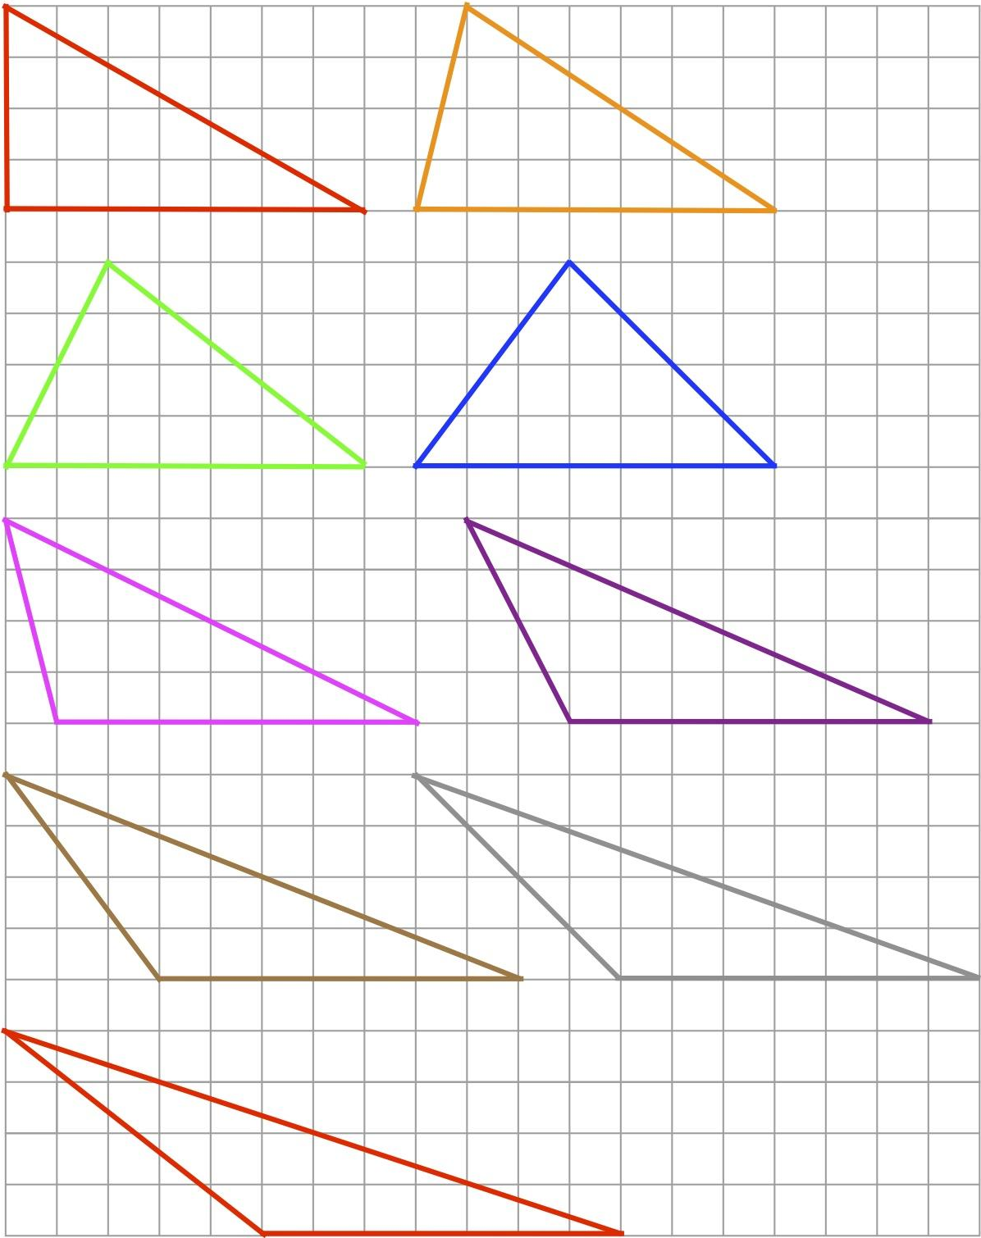

Student Recording Sheet Answer Key:
Dimensions and areas of the triangles:
- Triangle A: Height: 2 units, Base: 3 units, Parallelogram Area: 6 sq. units, Triangle Area: 3 sq. units
- Triangle B: Height: 5 units, Base: 4 units, Parallelogram Area: 20 sq. units, Triangle Area: 10 sq. units
- Triangle C: Height: 3 units, Base: 5 units, Parallelogram Area: 15 sq. units, Triangle Area: 7.5 sq. units
- Triangle D: Height: 3 units, Base: 3 units, Parallelogram Area: 9 sq. units, Triangle Area: 4.5 sq. units

* For triangles C and D, students will have to have the understanding that the area of the triangle is half of the area of its corresponding parallelogram to be able to calculate the area, since the area of the triangle created is not a whole number. This is intentional, and if it is too much of a challenge for your students you may want to spend more time on the relationship between the parallelogram and the triangle.

- Some students may draw their triangles with incorrect base and height lengths. If you see that a student is drawing their triangles wrong, be sure they are finding the lengths by counting the spaces on the coordinate plane and not counting the lines, and that they understand that the height of a triangle is not always one of the sides.
- Watch for students who label the height of non-right triangles as one of the non-base side lengths, rather than the distance from the highest point to the base, perpendicular to the base.
- Some students may not have a full understanding of the relationship between a parallelogram and a triangle. Some students may multiply the area by 2 instead of dividing by 2. If this happens, consider using the class model as discussed above in Step 6 of the directions, or have students label each triangle with the area to be sure the sum of the areas of two triangles is equivalent to their calculated area of the parallelogram.
- In question 1, look closely at students’ justifications. There are various levels of understanding, including those listed below (in order of level of understanding):
  - An estimate based on visual evidence, e.g. “it looks like…” a certain amount
  - An estimate based on students approximating how much area each of the partial squares cover
  - An estimate from trying to put parts of the squares together to create whole squares
  - An exact amount because the relationship between the parallelogram and triangle area is used

For students using any of the first three options, you will need to provide further practice and more guided exploration. This may include creating the rectangles or parallelograms first, then cutting and comparing the triangles that are created to see that triangles are half of the area of the parallelogram.

Lesson plan template adapted from Taking Action: Implementing Effective Mathematics Teaching Practices, NCTM, 2017

