This for That
Frameworks Cluster | Division of Fractions Conceptions Cluster
Standard(s) | NC.6.NS.1 Use visual models and common denominators to:  - Interpret and compute quotients of fractions  - Solve real-world and mathematical problems involving division of fractions  SMP 1 Make sense of problems and persevere in solving them  SMP 7 Look for and make use of structure.
Materials/Links | - Student Recording Sheet  - Fraction Tiles or online fraction tiles (requires Adobe Flash Player) at  http://www.glencoe.com/sites/common_assets/mathematics/ebook_assets/vmf/VMF-Interface.html
Learning Goal(s) | - Students will build upon their knowledge of creating equivalent fractions to model division as repeated subtraction using fraction tiles.  - Students will relate repeated subtraction to division.  - Students will recognize the relationship between a division problem and the question “How many ______ are in _______?”
Task Overview:
- Using fraction tiles, this activity will help students create common denominators to solve division of fraction problems.
Prior to Lesson:
- Students should be able to create equivalent fractions using fraction tiles.

Teaching Notes:
Task launch:
- Ask students to use fraction tiles to model $\frac{2}{3}-\frac{1}{6}$. Students should create a common denominator and write $\frac{2}{3}$ as $\frac{4}{6}$. Once students solve the subtraction problem, have students reset their $\frac{4}{6}$ and answer the question “How many $\frac{1}{6}$ are in $\frac{2}{3}$?”
- Have a class conversation about the relationship between repeated subtraction and division. This should include using an example like $6÷2$, where you can connect the language that has likely previously been used “how many 2s are in 6?” to discuss that $6÷2$ can be determined by repeatedly taking away groups of 2. This can then be extended into $6÷\frac{1}{2}$ which can be rephrased as “how many halves are in 6?” The solution to $6÷\frac{1}{2}$ can be determined by repeatedly taking away halves. You can connect this to a concrete model, such as chocolate bars, brownies, pizza, etc.
- Ask students to use their knowledge that division is repeated subtraction to do the following:
  - Build the fraction $\frac{3}{4}$. Take out the $\frac{1}{12}$ tile. How many $\frac{1}{12}$ fit into $\frac{3}{4}$?
- Before moving into the student partner/individual work, make sure that the students understand what the questions, “Build the fraction ___. Take out the ___ tile. How many ___ in ___?” mean. They need to understand that they first build the fraction given, then use the “Take out the ___ tile” fraction tile to create an equivalent fraction to then determine how many “fit” into the given fraction. For example, in the first question the students should build ¾ then make the equivalent fraction 9/12. Once they have used the tiles they can determine that nine 1/12 pieces fit into ¾.

Directions:
- Provide students with student recording sheet and fraction tiles.
- Instruct students to begin part 1 of the task. Consider providing students with a timer, so that partner discussions do not take the entire time. The whole class discussion will be needed to share strategies and make sense of the results.
  - The purpose of part 1 is for students to have the opportunity to work with fraction tiles to investigate division of fractions as repeated division. Consider using the Class Discussion Planner (https://tinyurl.com/discussion-planner) to plan student share outs.
  - At any point that you feel students need more direction and guidance, have other students share out. Perhaps create an additional problem similar to the one student(s) are struggling with and have peers walk them through how to solve. Additional similar questions can be found below, in step 7 of the directions.
  - Before beginning part 2, discuss the written response questions in part 1. Be sure students recognize that they must write the fractions as equivalent fractions.
- Ask students to build the fraction $\frac{2}{5}$. Instruct students to take out $\frac{7}{10}.$ How many $\frac{7}{10}$ fit into $\frac{2}{5}$? Ask students what the first step would be in in determining how many $\frac{7}{10}$ fit into $\frac{2}{5}$. Once the majority of students state they need to create common denominators, have students create the common denominators. Once that is done, ask students what they notice about the relationship between the two fractions. Guide the conversation for the students to realize that the divisor is larger than the dividend. Then use questioning to estimate what would be a reasonable solution.
Is there one $\frac{7}{10}$ in $\frac{4}{10}$? Since there is not a whole $\frac{7}{10}$, about how much of a $\frac{7}{10}$ is in $\frac{4}{10}$? (about half, but more than half, so that the solution should be close to, but more than a half)
Use fraction tiles for $\frac{4}{10}$lined up to the tiles for $\frac{7}{10}$, to show that $\frac{4}{10}$has 4 of the 7 pieces to make $\frac{7}{10}$. Thus, there is $\frac{4}{7 }$ of a $\frac{7}{10}$in $\frac{4}{10}$.
- Instruct students to begin part 2 of the task.
  - The purpose of part 2 is for students to have the opportunity to work with fraction tiles to investigate division of fraction problems when the divisor is greater than the dividend. Consider using the Class Discussion Planner (https://tinyurl.com/discussion-planner) to plan student share outs.
  - At any point that you feel students need more direction and guidance, pause the group have some students share out. Perhaps create an additional problem similar to the one student(s) are struggling with and have peers walk them through how to solve.
- Part 3 can be optional or for those students that need more of a challenge. The limitations that are on the student recording sheet are to ensure that students can complete their problems with the use of both partners’ set of fraction tiles.
- Summarize the lesson through a whole-group discussion of dividing fractions and the relationship between the quotient and the problem when the divisor is larger than the dividend and when the divisor is smaller than the dividend. Focus on students’ methods for finding solving these problems. Consider using the Class Discussion Planner. Also, it may be helpful to write each collection of solved equations in a list on the board, in order to have a final reflection on what these results are, and to notice the differences in thinking for the different problem types.

- If students need additional practice at the end of the lesson or throughout the lesson, consider using these problems:
Problems similar to part 1 that produce a whole number quotient:
- Build the fraction $\frac{2}{3}$. Take out the $\frac{1}{12}$. How many $\frac{1}{12}$ fit into $\frac{2}{3}$? ______ (Solution: 8)
- Build the fraction $\frac{3}{4}$. Take out the $\frac{1}{8}$. How many $\frac{1}{8}$ fit into $\frac{3}{4}$? ______ (Solution: 6)
- Build the fraction $\frac{5}{6}$. Take out the $\frac{1}{12}$. How many $\frac{1}{12}$ fit into $\frac{5}{6}$? ______ (Solution: 10)
Problems similar to part 1 that produce a non-whole number quotient:
- Build the fraction $\frac{7}{8}$. Take out the $\frac{3}{4}$. How many $\frac{3}{4}$ fit into $\frac{7}{8}$? ______ (Solution: 1$\frac{1}{6}$)
- Build the fraction $\frac{11}{12}$. Take out the $\frac{2}{3}$. How many $\frac{2}{3}$ fit into $\frac{11}{12}$? ______ (Solution: 1$\frac{3}{8}$)
- Build the fraction $\frac{5}{6}$. Take out the $\frac{1}{3}$. How many $\frac{1}{3}$ fit into $\frac{5}{6}$? ______ (Solution: 2$\frac{1}{2}$)
Problems similar to part 2:
- Build the fraction $\frac{1}{12}$. Take out the $\frac{2}{3}$. How many $\frac{2}{3}$ fit into $\frac{1}{12}$? ______ (Solution: $\frac{1}{8}$)
- Build the fraction $\frac{1}{8}$. Take out the $\frac{3}{4}$. How many $\frac{3}{4}$ fit into $\frac{1}{8}$? ______ (Solution: $\frac{1}{6}$)
- Build the fraction $\frac{1}{4}$. Take out the $\frac{7}{8}$. How many $\frac{7}{8}$ fit into $\frac{1}{4}$? ______ (Solution: $\frac{2}{7}$)
- Build the fraction $\frac{1}{3}$. Take out the $\frac{11}{12}$. How many $\frac{11}{12}$ fit into $\frac{1}{3}$? ______ (Solution: $\frac{4}{11}$)

This is the first in a series of division of fractions tasks. It can be followed by the fraction division sort task.

Lesson plan template adapted from Taking Action: Implementing Effective Mathematics Teaching Practices, NCTM, 2017

Student sheets begin on next page.
Name ________________________________________________________ Date __________________________
This for That
Part 1: Use fraction tiles to model division as repeated subtraction. Draw an illustration of your models.
Build the fraction $\frac{3}{4}$. Take out the $\frac{1}{12}$.  How many $\frac{1}{12}$ fit into $\frac{3}{4}$? ______ | Build the fraction $\frac{4}{5}$. Take out the $\frac{1}{10}$.  How many $\frac{1}{10}$ fit into $\frac{4}{5}$? _____

Build the fraction $\frac{8}{10}$. Take out the $\frac{1}{5}$.  How many $\frac{1}{5}$ fit into $\frac{8}{10}$? ______ | Build the fraction $\frac{8}{12}$. Take out the $\frac{1}{3}$.  How many $\frac{1}{3}$ fit into $\frac{8}{12}$? _____

Build the fraction $\frac{3}{10}$. Take out the $\frac{1}{5}$.  How many $\frac{1}{5}$ fit into $\frac{3}{10}$? ______ | Build the fraction $\frac{5}{6}$. Take out the $\frac{2}{3}$.  How many $\frac{2}{3}$ fit into $\frac{5}{6}$? _____

Solve $\frac{2}{3}÷\frac{1}{2}$. (How many $\frac{1}{2}$ are in $\frac{2}{3}$?)

In order to model division as repeated subtraction, what must you do before you can begin?

Part 2:
Build the fraction $\frac{1}{12}$. Take out the $\frac{1}{4}$.  How many $\frac{1}{4}$ fit into $\frac{1}{12}$? ______ | Build the fraction $\frac{1}{5}$. Take out the $\frac{3}{10}$.  How many $\frac{3}{10}$ fit into $\frac{1}{5}$? _____

Part 3: With a partner, create a division problem, write a “How many ______ fit into _____?” question to match the division problem, and then solve using the fraction tiles. Once you have solved the problem, use a calculator to check for accuracy.
- You may use mixed numbers but both the dividend and divisor should be less than 2.
- Be sure that the least common denominator is 12 or less.

Division Problem: ___________________ How many _________ fit into ________? Solution: _______________

Division Problem: ___________________ How many _________ fit into ________? Solution: _______________

Division Problem: ___________________ How many _________ fit into ________? Solution: _______________

Explain this process for dividing fractions.

What questions do you have about dividing fractions?

Possible Strategies/Anticipated Responses:
- Task Launch Solutions/Strategies:
  - $\frac{2}{3}-\frac{1}{6}$= $\frac{3}{6}$

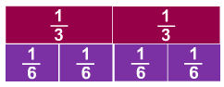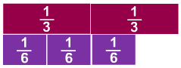
  - $\frac{2}{3 }$is equivalent to $\frac{4}{6}$. Once students have $\frac{2}{3}$written as $\frac{4}{6}$, they can subtract $\frac{1}{6}$. Students can continue to subtract $\frac{1}{6}$ 4 times. Therefore 4 is the answer to, “How many $\frac{1}{6}$ are in $\frac{2}{3}$?”
- Sample work:
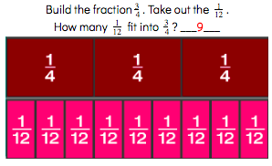
- Answers:

How many $\frac{1}{12}$ fit into $\frac{3}{4}$? 9 | How many $\frac{1}{10}$ fit into $\frac{4}{5}$? 8
How many $\frac{1}{5}$ fit into $\frac{8}{10}$? 4 | How many $\frac{1}{3}$ fit into $\frac{8}{12}$? 2
How many $\frac{1}{5}$ fit into $\frac{3}{10}$? 1.5 | How many $\frac{2}{3}$ fit into $\frac{5}{6}$? 2.5

Solve $\frac{2}{3}÷\frac{1}{2}$. (How many $\frac{1}{2}$ are in $\frac{2}{3}$?) $1\frac{1}{3}$

In order to model division as repeated subtraction, what must you do before you can begin? You must find common denominators

How many $\frac{1}{4}$ fit into $\frac{1}{12}$? $\frac{1}{3}$ | How many $\frac{3}{10}$ fit into $\frac{1}{5}$? $\frac{2}{3}$

- This task is dedicated to using manipulatives to begin learning about division. Students should work at finding equivalent fractions to better model the relationships between the numbers and do the division. Let them physically manipulate the pieces so that they can better see the relationships.

Fraction Division Sort
Frameworks Cluster | Division of Fractions Conceptions Cluster
Standard(s) | NC.6.NS.1 Use visual models and common denominators to:  - Interpret and compute quotients of fractions  - Solve real-world and mathematical problems involving division of fractions  SMP 4 Model with mathematics.  SMP 7 Look for and make use of structure.
Materials/Links | 1 set of cards per group. (Students should be in groups of 2 or 3 for this activity)  Alternative: give one card to each student
Learning Goal(s) | Students will see the relationship between a division of fractions problem, a fraction model, and the resulting quotient.
Task Overview:
This card sort will require students to determine the dividend, divisor, and quotient from a fraction model.
Prior to Lesson:
- Students should be exposed to drawing fraction models from a division problem prior to activity.
- Review division vocabulary including dividend, divisor, and quotient.
- Students should have a grasp of the 5th grade standards of dividing a unit fraction by a non-zero whole number and a whole number by a unit fraction.
Teaching Notes:
Task launch:
- Give students a division of fractions problem. Consider using one involving a unit rate to make connections back to 5th grade. Have students draw a diagram to show how they solve the problem and share out.
Directions:
- In this task, when the divisor is larger than the dividend these models take on the "how many in each group" division interpretation (partitive division), in which the dividend is divided up into fractional pieces so that the number of those pieces is a multiple of the divisor. Then the pieces can be “dealt out” in the fair share or partitive way. When the divisor is smaller than the dividend, the "How many groups" (quotative division) division interpretation is a good way of making sense of the problem.
- Option A: Pre-cut the cards. Give students the cards to put into groups. Extension: have students draw an alternative model for each set.
- Option B: Pre-cut the cards. Give each student one card and have the students work to find their group of three.
- You may also want to consider not giving all three parts of each question--take one out of each of the three cards out so that the students have to determine the third part.

You could extend this activity to have students make additional card sets for others to sort.

Prior to this lesson, students should complete the This for That activity, so that they are familiar with working with concrete fraction models and have a background for the models used in this activity. After completion, consider using Making Sense of Models formative assessment to assess how students are progressing on interpreting division of fraction models. After providing practice, consider using the task Hop to It.

Lesson plan template adapted from Taking Action: Implementing Effective Mathematics Teaching Practices, NCTM, 2017

Student sheets begin on next page.
Fraction Division Sort Cards

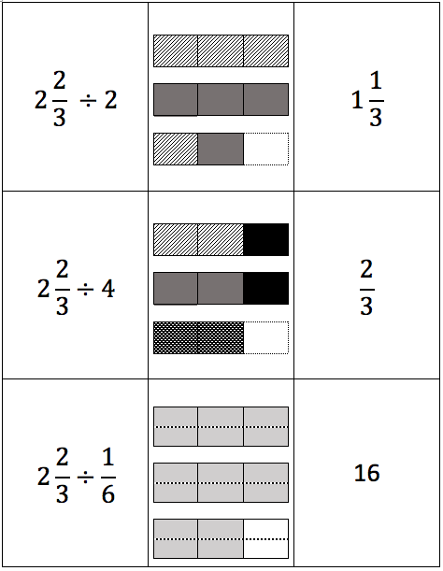

Fraction Division Sort Cards

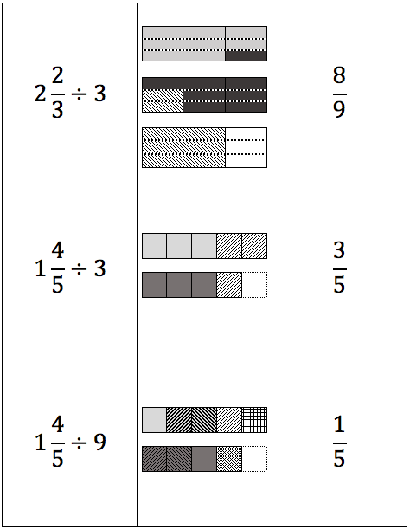

Fraction Division Sort Cards

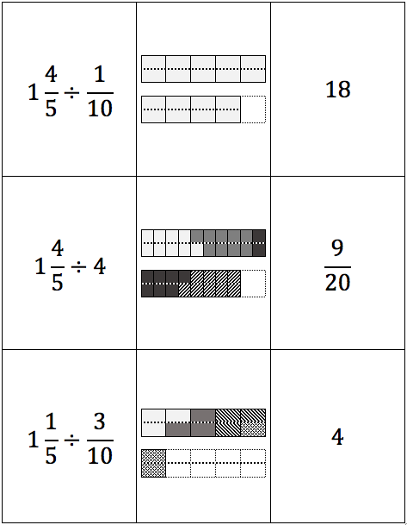

Possible Strategies/Anticipated Responses:

- Using common denominators for division links to using common denominators for subtraction. If students are struggling with the division of fractions, consider using fraction strips to find common denominators and do repeated subtraction.
- Consider using the phrasing “How many ____s are in ___?” when working with fraction division. Frequently when doing whole number division like “How many 4s are in 24?” are asked but the connection is not made when moving into fractions.
An extension to this is to have students create the number line representations that go along with the division problems or to create situations in which these problems would be how a solution is found.

Hop To It
Frameworks Cluster | Division of Fractions Conceptions Cluster
Standard(s) | NC.6.NS.1 Use visual models and common denominators to:  - Interpret and compute quotients of fractions  - Solve real-world and mathematical problems involving division of fractions  SMP 1 Make sense of problems and persevere in solving them  SMP 4 Model with mathematics.  SMP 5 Attend to precision  SMP 7 Look for and make use of structure.
Materials/Links | - Student recording sheet (see below)  - Document Camera (or some other method for students to share out)
Learning Goal(s) | - Students will be able to model division of fractions using number lines.  - Students will be able to use mental math in calculating quotients of fractions.
Task Overview:
This task is a gradual progression assignment, designed to teach students how to model division of fractions on a number line.
Prior to Lesson:
- Students should be exposed to creating drawings of fraction models from a division problem prior to this activity, using fraction tiles and pictures.
- Students should be able to create an appropriate number line using equal intervals.
- Students should be familiar with answering the question “How many __(unit fraction)__ are in __(whole number)__?” when working with unit fractions and whole numbers. (For example, how many $\frac{1}{4}$ are in 2?)
Teaching Notes:
Task launch:
- Pose the question $32÷4$and have students suggest situations in which this problem might occur, as well as how they would model it with concrete objects (two common possibilities: they could put one item into each of four groups repeatedly or they could pull groups of four and see how many groups they make).
  - You may want to show students these two ways through a model. Pose to students that you have 32 pieces of candy and you want to divide them into groups of 4 but that you can also divide the 32 pieces into 4 groups (how many fours vs. if four people shared 32 candies, how many candies would each get).

8 groups of 4 4 groups of 8

- Then ask students to draw a number line 0 to 32. Help students realize they can model division on a number line by trying to see how many groups of the given size are in a quantity. While students can model the division in two ways, partitive and quotative (see solutions on the last page), explain that this task is focused on “how many groups?” (quotative division) because this is the more accessible way to use the number line.
- Students should have a quality understanding of whole number division on a number line prior to moving into division with fractions on a number line.
- Some additional problems are:
  - 20$÷$5 (How many groups of 5 are in 20? or How many 5s are in 20?)
  - 15$÷$3 (How many groups of 3 are in 15? or How many 3s are in 15?)
  - 24$÷$8 (How many groups of 8 are in 24? or How many 8s are in 24?)
- As you are working with students use the phrases “How many groups…” as well as “How many ____ are in ____?” to help them with thinking about the division involved.
- Once students are comfortable expressing a division problem as a “How many groups?” question, ask students to draw a number line 0 to 5. Ask students to model 5$÷\frac{1}{2}$, and show how many halves are in 5. Discuss strategies that students may have used to solve this problem.

Directions:
- After completing the task launch, provide students with problems that are whole numbers divided by unit fractions so that they can begin to think through the relationships between these types of numbers (sample problems are: $7÷\frac{1}{2}=14$, $6÷\frac{1}{5}=30, 3÷\frac{1}{8}=24)$.
- After ample time with this, begin giving students problems with whole numbers divided by non-unit fractions that will wind up with whole number quotients so that they can extend their thinking to this extra step (i.e. $4÷\frac{2}{3}=6$because there are 12 thirds in four and when you put 12 into groups of two there are six groups (sample problems
are: $3÷\frac{3}{5}=5, 6÷\frac{3}{4}=8, 10÷\frac{5}{6}=12$)
- After ample time with step 2, give students problems with mixed numbers divided by fractions with related denominators that end in whole number quotients so that they can extend their thinking to an additional step (sample problems are: $1\frac{1}{3}÷\frac{1}{6}=10, 3\frac{3}{4}÷\frac{3}{8}=10$, 3$\frac{3}{5 }÷\frac{9}{10} =4$
- Instruct students to begin part 1 of the task. Consider providing students with a timer. Have students share out their work for these problems. The purpose of part 1 is for students to have the opportunity to work on their solutions to problems and justify their reasoning independently. The first problem is similar to the task launch while the rest of the problems are more complex. Be sure students understand how to model these problems before continuing.
- Take a break between part 1 and part 2 to come together as a class to solve problems that require division of mixed numbers by fractions that end in mixed number quotients but related denominators. (sample problems are 2$\frac{1}{2}÷\frac{3}{4}=3\frac{1}{3}$, $1\frac{1}{4}÷\frac{1}{2}=2\frac{1}{2}, 1\frac{1}{3}÷\frac{5}{6}=1\frac{3}{5}, 2\frac{3}{4}÷\frac{5}{8}=4\frac{2}{5}, 3\frac{2}{3}÷\frac{5}{9}=6\frac{3}{5}$). The challenge will be naming the fractional piece of the divisor. For example, in 2$\frac{1}{2}÷\frac{3}{4}=3\frac{1}{3}$ students can use an area model to see the 3 three fourths within two and a half, and have to name the remaining fourth as a third, since it is a third of the three fourths in $\frac{3}{4}$. Similarly, on a number line, counting up by $\frac{3}{4}$ and then looking at equivalent fractions to see that 3 of those jumps lands on $2\frac{1}{4}$, still requires naming that one fourth jump as a third of a full jump.
- Instruct students to begin part 2 of the task. As students complete part 2, use the Class Discussion Planner (https://tinyurl.com/discussion-planner) to plan student share outs.
- Take a break between part 2 and part 3 to come together as a class to solve problems that require division of mixed numbers by fractions, regardless of denominators.
- Instruct students to begin part 3 of the task. As students complete part 3, use the Class Discussion Planner (https://tinyurl.com/discussion-planner) to plan student share outs.
- After the class has worked through the class problems and the problems individually as well as the follow up questions, summarize the lesson through a whole-group discussion of dividing whole and mixed numbers by fractions, then focus on students’ methods for finding solving these problems. Consider using the strategies gathered in the Class Discussion Planner (https://tinyurl.com/discussion-planner) to summarize the work.

Use this task after the Fraction Division Sort task or other practice with concrete manipulatives like fraction bars. Provide sufficient time for students to practice division of fractions using models and number lines after using this activity. Consider using the task Zane’s Zoo Adventure for extra practice. Once students have had time to practice, continue with the Baking Cookies task.

Student sheets begin on next page.
Name ___________________________________________________________ Date __________________________
Hop To It
Part 1: Use a number line to model each of the division problems below. Use the number to show the strategy you used to solve the following problems.
3$÷\frac{1}{4}$= ______ | 6$÷\frac{2}{5}$= ______
4$\frac{1}{2}÷\frac{1}{4}$= ______ | 2$\frac{1}{4}÷\frac{3}{8}$= ______

Part 2: Use a number line to model each of the division problems below.
4$\frac{2}{3}÷\frac{5}{6}$= ______ | 2$\frac{3}{4}÷\frac{5}{12}$= ______
2$\frac{4}{5}÷\frac{3}{10}$= ______ | 5$\frac{1}{2}÷\frac{3}{8}$= ______

What do you notice about the denominators:

- In part 1?

- In part 2?

- And in the part 3 problems below?

Part 3: Use a number line to model each of the division problems below.
4$\frac{2}{3}÷\frac{1}{4}$= ______ | 3$\frac{1}{2}÷\frac{2}{3}$= ______
5$\frac{4}{7}÷\frac{2}{3}$= ______ | 4$\frac{1}{2}÷\frac{3}{7}$= ______

How can using a number line help you solve a division of fractions problem?

Which strategy do you prefer when dividing fractions, models or number lines? Do you change strategies for different problems? Why or why not?

Possible Strategies/Anticipated Responses:
- Task Launch Solutions/Strategies:
  - Quotitive Division- “How many groups?”
32$÷$ 4 (in each group) = 8 groups
0 4 8 12 16 20 24 28 32

4 4 4 4 4 4 4 4
1 2 3 4 5 6 7 8
  - Partitive Division - “How many in each group?”
32 $÷$ 4 (groups) = 8 in each group
0 8 16 24 32
8 8 8 8
1 2 3 4

    - Note that jumps on a number line are not necessarily the more common tool for modeling division, when using a partitive interpretation of division. However, a student may take a length of 32 and divide it into 4 equal lengths of 8. Thus, it is included here as a possible method. Using a number line for partitive division is not a requirement for completing this task.
  - 5 $÷\frac{1}{2}$
0 1 2 3 4 5
=10 hops

2 2 2 2 2 =10 hops

0 1 2 3 4 5

- Part 1: In part 1, the quotient will be a whole number. This has been placed first because it jives with what students already know and understand about division fairly well.
  - 3$÷\frac{1}{4}$= ______
0 1 2 3
=12 hops

0 1 2 3
4 4 4 =12 hops

  - $6÷\frac{2}{5}$= ______15 hops

  - $4\frac{1}{2}÷\frac{1}{4}$= ______ 18 hops
    - In this situation you may want to consider including discussion around things like, “there are four ‘hops’ in every one”, so four wholes would have 16 hops, and then two more for a total of 18. See the first question, $3÷\frac{1}{4}$ as an example of another illustration.
  - $5\frac{2}{3}÷\frac{1}{6}$= ______ 34 hops

  - $2\frac{1}{4}÷\frac{3}{8}$= ______ 6 hops

- Part 2: In part two, students are still using related denominators, however the quotients are going to be in fractional form. Students may struggle with this, but consider having them think about how many parts of a whole “hop” they have. If students are struggling with this concept you may want to return to the use of fraction tiles or cubes to review what such remainders can mean.
  - $4\frac{2}{3}÷\frac{5}{6}=5\frac{3}{5}$hops (This is $5\frac{3}{5}$because there are five complete hops/five complete ⅚, and on the last hop there are three of the five sixths needed to complete a hop, so that makes $5\frac{3 }{5}$hops)

  - $2\frac{3}{4}÷\frac{5}{12}=6\frac{3}{5}$hops (This is similar to the question above, as there are six complete 5/12 in $2\frac{3}{4}$ and there are 3 of the 5 twelfths needed to make a complete 5/12, for a total of $6\frac{3}{5}$).

  - $2\frac{4}{5}÷\frac{3}{10}=9\frac{1}{3}$ hops (There are 9 complete hops and one tenth out of the three tenths needed to make a complete hop, for a total of $9\frac{1}{3}$ hops.)

  - $5\frac{1}{2}÷\frac{3}{8}=14\frac{2}{3}$ hops (There are fourteen complete hops of three eighths, and then two of the three eights needed to make a fifteenth hop for a total of $14\frac{2}{3 }$ hops.)
- The denominators in part one and part two have related denominators, in that the denominators have a common factor relationship. In part three the numbers are not related in that way.
- Part 3: In part three, students will have to find a common denominator to divide by. The same concept as above holds true, however, careful thinking will be required to accurately name the parts “left over” that make a faction of a hop.
  - $4\frac{2}{3}÷\frac{1}{4}=18\frac{2}{3}$ hops
  - $3\frac{1}{2}÷\frac{2}{3}=5\frac{1}{4}$ hops
  - $5\frac{4}{7}÷\frac{2}{3}=8\frac{5}{14}$ hops
  - $4\frac{1}{2}÷\frac{3}{7}=10\frac{3}{6}$ or $10\frac{1}{2}$ hops

