Task 1: Intro to Scaling
Cluster | Proportional Relationships
Standard(s) | NC.7.G.1 Solve problems involving scale drawings of geometric figures by:  ● Building an understanding that angle measures remain the same and side lengths are proportional.  ● Using a scale factor to compute actual lengths and areas from a scale drawing.  ● Creating a scale drawing.
Materials/Links | - Students pages  - Instructions for “Rubber-band Stretcher”  - Right and left handed versions of logo  - Rubber bands - about 3 inches long and all same width (2 per student)  - Tape  - Blank paper  - Rulers  - Protractors  - Transparencies (optional)
Learning Goal(s) | Recognize that similar figures have the same angle measures and side lengths are proportional.
Task Overview:
Students will explore the characteristics of similar figures and use rubber bands to create a scale drawing of a figure.
Prior to Lesson:

Teaching Notes:
Task launch:
- Share the scenario about the Mystery Club from the student pages and direct attention to the photo.
- Suggested questions:
  - What information do we have?
  - What are we trying to find?
  - How does the real-life teacher differ from the teacher in the photo?
Note: Leave the task of finding the teacher’s height open so you can learn what your students think about similar figures. Do no push for exact measurements at this time.
Directions:
Part One - Solving a Mystery
- Give students a few minutes to estimate the teacher’s height.
- You expect a variety of strategies as students discuss methods in small groups.
- At this point only discuss measurements that unreasonable. Possible questions, “What is a reasonable range of heights for the mystery teacher? Is an answer is over 7 ft., is that reasonable? What about an answer under 4 ft.?”
Part Two - Enlarging the Image
- You will want to try enlarging a figure using the rubber-band method prior to doing this with students.
- Tell students you have a super machine called a stretcher that will help them draw a copy of the figure.
- Here is a diagram to help connect the rubber bands. Pass one band through the other and back through itself. Pull on the two ends, moving the knot so that each band forms half of the total rubber band.
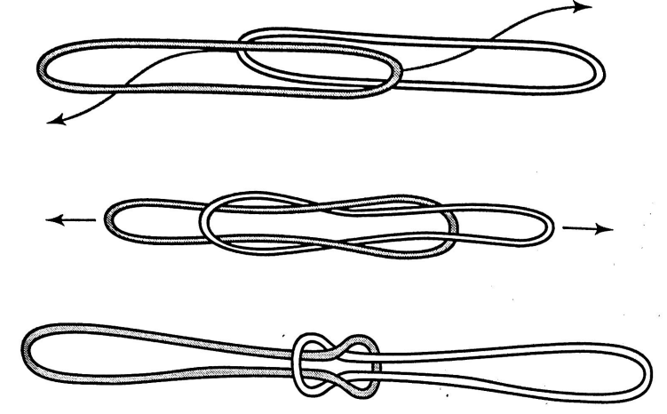
- Demonstrate how to use the rubber-band stretcher on the white board, chart paper, or using a document camera
- Encourage students to hold the pencil vertically and keep the rubber band close to the pencil tip
- Accuracy is not crucial, but encourage students to copy with the knot versus trying to freehand
- Give students ample time to create the image
- In small groups (3-4), have students complete questions
Whole Class Discussion
- Ask students what they noticed about the figures they drew.
- Ask students what is the relationship between the side lengths of the original figure and the side lengths of the image.
- Introduce the term corresponding.
- Ask students about the relationship between the measures of corresponding angles. (blank transparencies are helpful here)
- Ask what would happen if the anchor point was changed.
- Ask students what they think similar means mathematically.
Extension Questions
- What would happen if we made a stretcher out of three rubber bands?
- If we use the 2nd know of a three band stretcher, how much larger would our image be?

Student sheets begin on next page.

Solving a Mystery

The Mystery Club at P.I. Middle School meets monthly. Members talk about real-life mysteries, play games involving mysteries, watch videos, and discuss mystery novels. During a recent meeting, a member informed the group of a contest the school is having to identify a mystery teacher. Any student or team can pay $1 and submit a guess as to the identity of the mystery teacher.

The Mystery Club decides to work together. Each member agrees to bring a camera or use their phone to snap a picture of the mystery teacher.

Below is a picture Marcus captured of the mystery teacher in the library. Marcus has a copy of the mystery series on the bottom shelf and measures his copy of one of the books. It is 10 inches tall. Marcus thinks he can use the book and the picture to estimate the teacher’s height.

- What do you think Marcus has in mind? Use the picture and the information about the height of the book to estimate the teacher’s height. Explain your reasoning.

- The teacher advisor of the Mystery Club says that the picture is similar to the actual scene. What do you suppose the advisor means by similar? Is it different from saying two students in your class are similar?

Enlarging an Image

Marcus, Angela, and Miguel are the officers of the Mystery Club. Miguel designs this flier to attract new members.

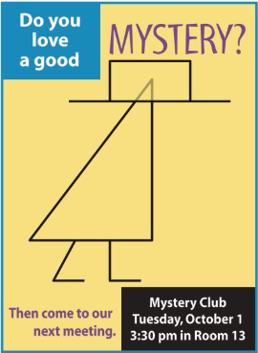
Angela wants to make a larger poster to hang in the cafeteria for more students to see. She wants to redraw the logo in a larger size.

Your teacher will show you how to build a super machine called a stretcher that will help you draw a larger copy of the figure.

Observations

Use your original figure and its enlarged image to complete the following:

1. Describe how the original figure and the image are alike and different. Compare these features:
  - The general shape of the two figures
  - The lengths of the line segments in the hats and bodies
  - The areas and perimeters of the hats and bodies
  - The angles in the hats and bodies
  - The distance of corresponding points on each figure from P
Explain each comparison you make. For example, you find that two lengths are different. Be sure to tell which lengths you are comparing and explain how they are different.

2. Use your rubber-band stretcher to enlarge another simple figure, such as a circle or square.
- Compare the general shapes, lengths, areas, perimeters, and angles of the original figure and its image.

- Would the comparisons change if the location of P were changed? Explain why or why not.

3. The original figure and its image are called similar figures. What do you think similar means in mathematical terms? What things are the same about these similar figures? Different?

Instructions for Stretching a Figure

- Make a “two-band stretcher” by tying the ends of two identical rubber bands together.

- Take the sheet with the figure you want to enlarge and tape it to your desk. Next to it, tape a blank sheet of paper. If you are right handed, put the blank sheet to the right. If you are left handed, put the blank sheet to the left (see diagram below).

- With your finger, hold down one end of the rubber-band stretcher on point P. Point P is called the anchor point. It must stay in the same spot.

- Put a pencil on the other end of the stretcher. Stretch the rubber bands with the pencil until the knot is on the outline of your picture.

- Keep the rubber band stretched. Move your pencil to guide the knot around the picture. Your pencil will draw a copy of the picture. The new picture is called the image of the original. It is also called a scale drawing of the original.

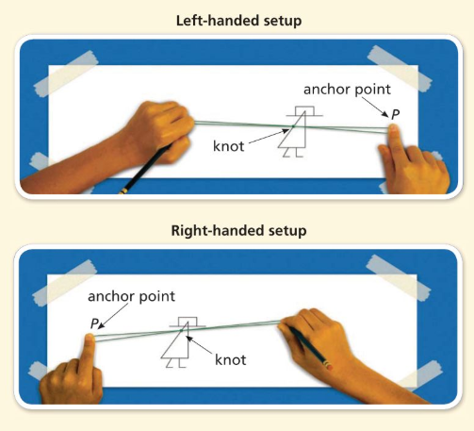

Right-Handed Version

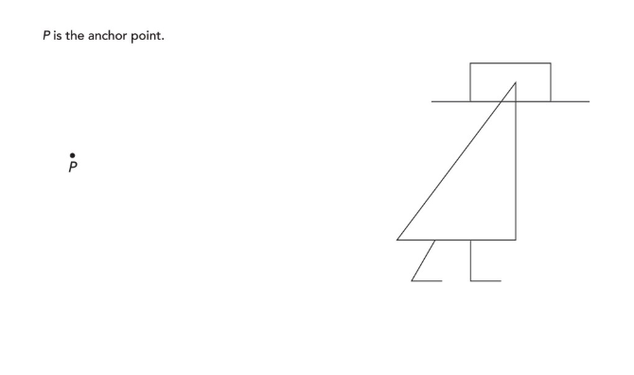
Left-Handed Version

Possible Strategies/Anticipated Responses:

Launch
  - What information do we have? (height of the real-life book, height of the book in photo, height of teacher in photo)
  - What are we trying to find? (the real-life height of teacher)
  - How does the real-life teacher differ from the teacher in the photo? (the real-life teacher is taller and wider than the one in the photo)

Solving the Mystery

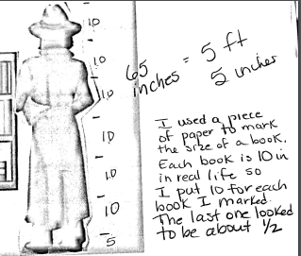

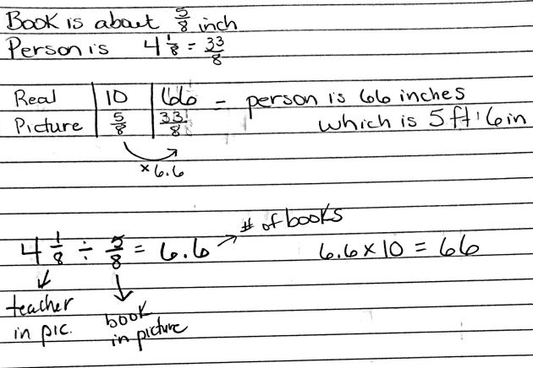
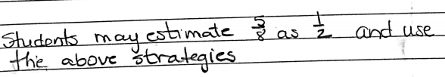
- Students may say things like, “look alike,” “same shape,” “different sizes”

Observations

- Some observations:
  - Shapes are same
  - Students may find different factors for the growth of the lengths but should be reasonable close to 2.
  - Perimeter is twice as big, area is 4 times as big. If students do not actually measure and calculate they will probably say area is twice as big as well.
  - The angles are the same measure
  - The distance of each point on the image is twice the distance from P as the original corresponding points are from P. Some students may connect the ratio of the distances is 2:1
Look for language such as ratios, rates, fractions, percentage, more than, less than as students express their comparisons.

2. Possible solutions
        - Same
        - The distances won’t change but the location of the image will. Some students may find this difficult to conceive. You could possibly have another example pre-made for this discussion.

3. Possible statements:
- Same shape, different sizes
- Shape and angle measures are the same
- Side lengths, areas, and perimeters are different

Task 2: Scale Drawing Stations

Framework  Cluster | Proportional Relationships
Standard(s) | NC.7.G.1 Solve problems involving scale drawings of geometric figures by:  ● Building an understanding that angle measures remain the same and side lengths are proportional.  ● Using a scale factor to compute actual lengths and areas from a scale drawing.  ● Creating a scale drawing.  SMP 2 Reason abstractly and quantitatively.  SMP 5 Use appropriate tools strategically  SMP 6 Attend to precision
Materials/Link | - Rulers  - Station signs (attached below)  - Student sheet (attached below)  - Calculators
Learning Goal | - Use proportional reasoning to identify unknown dimensions in a scale drawing  - Scale both one- and two- dimensional measurements
Task Overview:

In this lesson, students will work with a partner/group to complete various scale problems. They will work with pictures, blueprints, and maps to find missing dimensions. They will also work to scale both one- and two- dimensional measurements.

Prior to Lesson:

Students will need experience solving scale problems with proportional reasoning prior to this lesson.

Teaching Notes:

Task Launch:
- Since there are only 3 stations, depending on the number of students in your class, you will need multiple copies of each station. A maximum of 4 students per station is suggested.
  - Set up stations around the room and have materials out and ready for students.
- It may be helpful to review scale drawings and solving proportions given a scale and a missing measurement.
- Divide students into their groups and assign stations.
- If students are working effectively, they will need 5-10 minutes per station. It may be helpful to put a large timer on the board to keep students on task.

Directions:
- Students will begin at their assigned station and will rotate numerically when time is up.
- They should record all of their answers and work on the attached student sheet.
- At the end of the rotations, pick a few of the questions students may have had difficulty with to go over as a group (ex. the area problems from the blueprints).

Student sheets begin on next page.

Scale Drawing Stations
Station #1
Landmarks

In this station, you will be finding the height of 4 landmarks. You will investigate each landmark by measuring the height of a picture and determining the actual heights. Be precise in your measurement. Be sure to write the units of each measurement.

When measuring the landmarks, all measurements should be rounded to the nearest tenth of a centimeter.

Taj Mahal
Uttar Pradesh

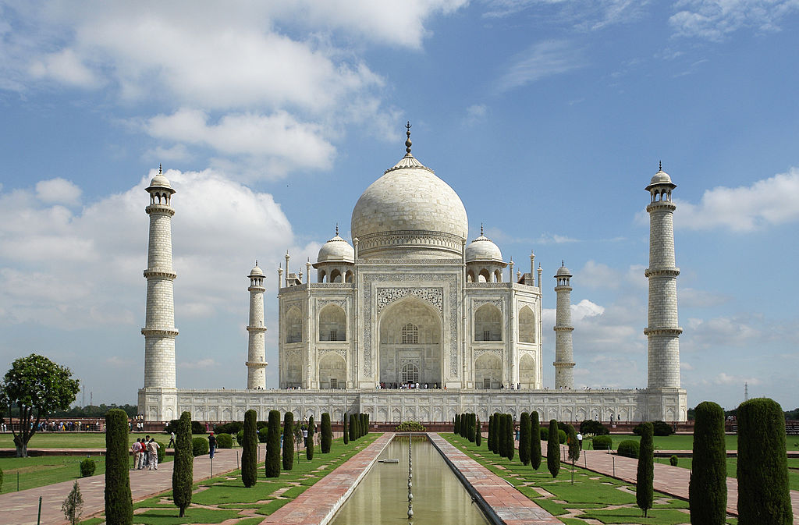
Scale: 2 cm = 87 ft.

What is the approximate height of the Taj Mahal? Explain your reasoning in complete sentences showing calculations when necessary.

The Elephant Tower
Bangkok Thailand

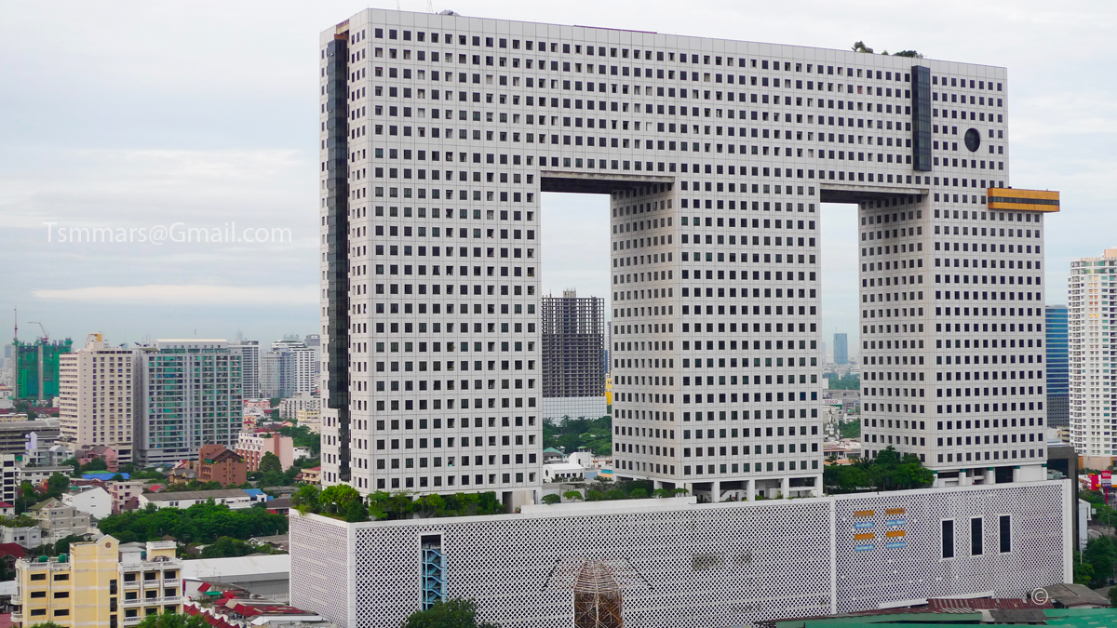
Scale: ½ cm = 17ft.

What is the approximate height of the Elephant Tower? Explain your reasoning in complete sentences showing calculations when necessary.

Cape Lookout
Outer Banks North Carolina
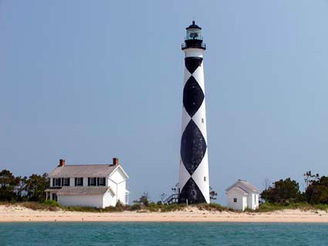
Scale: 1 cm = 26 ft.

What is the approximate height of the Cape Lookout Lighthouse? Explain your reasoning in complete sentences showing calculations when necessary.

Statue of Liberty
New York, New York
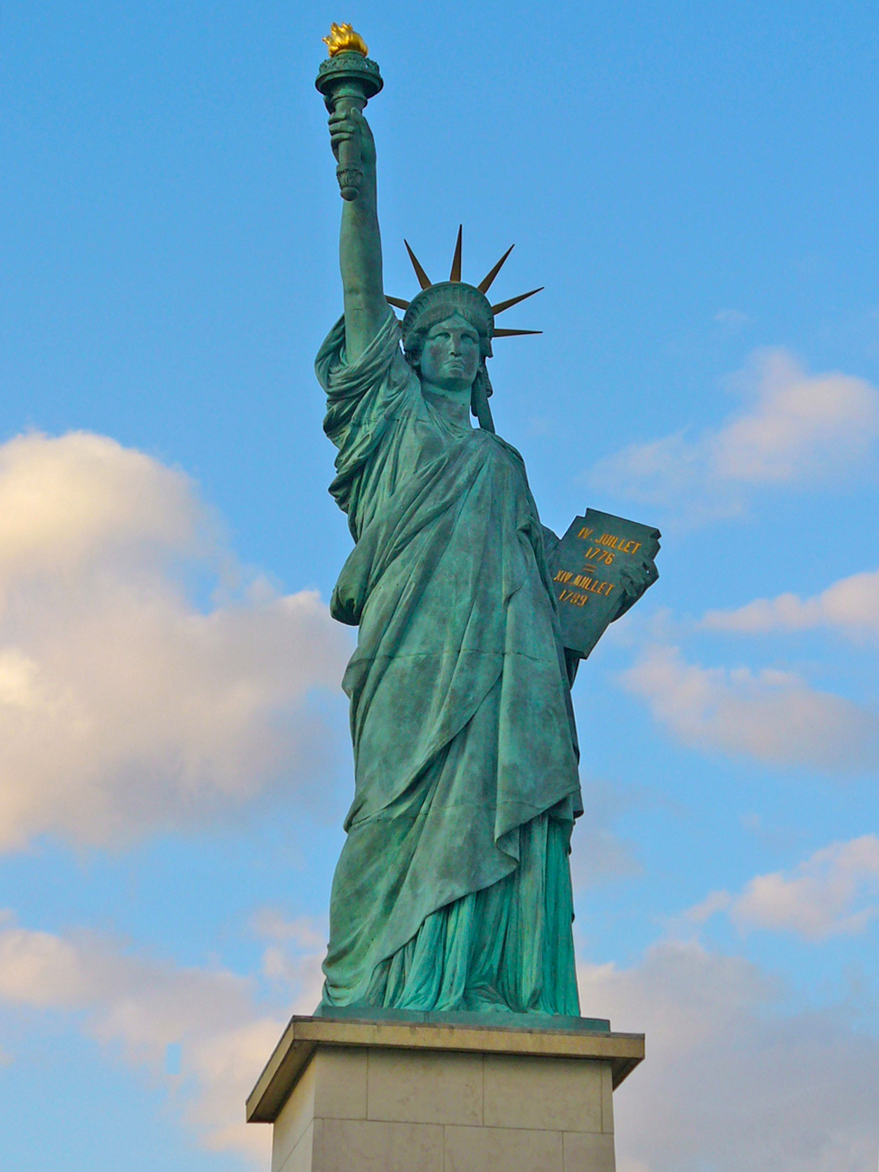
Scale: 5 cm = 56 ft.

What is the height of the Statue of Liberty? Explain your reasoning in complete sentences showing calculations when necessary.

Scale Drawing Stations
Station #2
House Plans

In this station, you will be finding the dimensions and areas of rooms on two different house plans. Be precise in your measurement. Be sure to write the units of each measurement.

When measuring the rooms, all measurements should be rounded to the nearest tenth of a centimeter.

House Plan #1
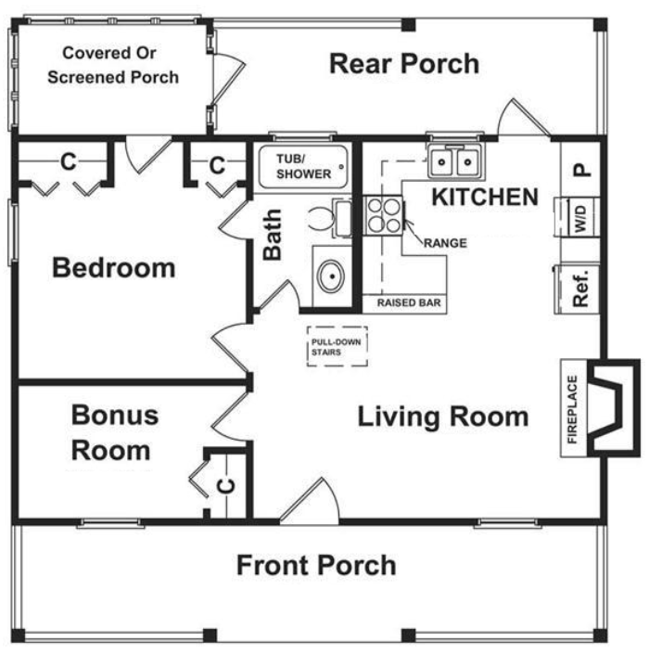
Scale: 1 cm = 1 ½ ft.

- What is the area of the ACTUAL front porch?

- What is the area of the ACTUAL rear porch?

- How much bigger is the front porch than the rear porch??

House Plan #2
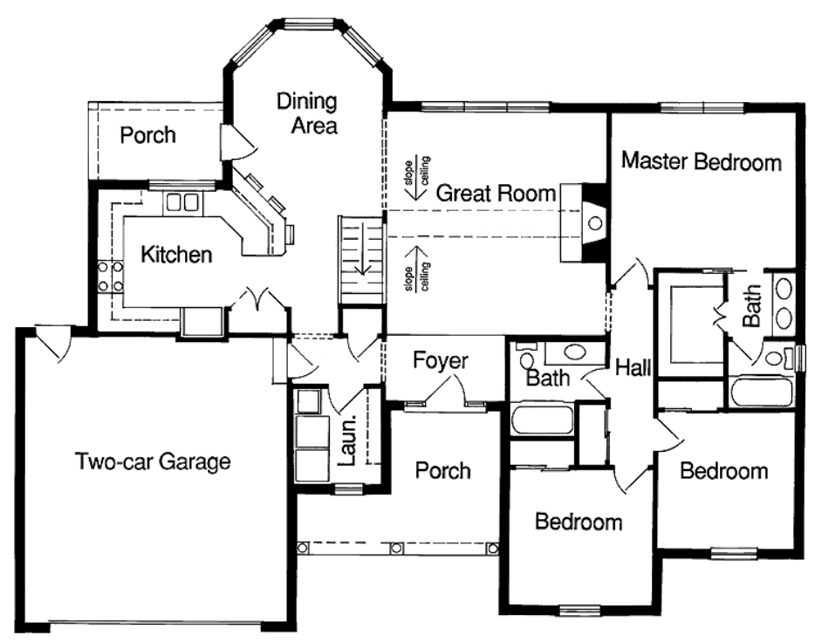

Scale: 1 cm = 2½ ft.

- What is the PERIMETER of the actual master bedroom?

- What is the AREA of the actual laundry room?

Scale Drawing Stations
Station #3
Reading a Map

In this station, you will find distances between cities on a North Carolina Map and on a United States Map. You will investigate each map and answer the associated questions. Be precise in your measurement. Be sure to write the units of each measurement.

When you are measuring the distances between cities, all measurements should be rounded to the nearest tenth of a centimeter.

Map #1 - North Carolina

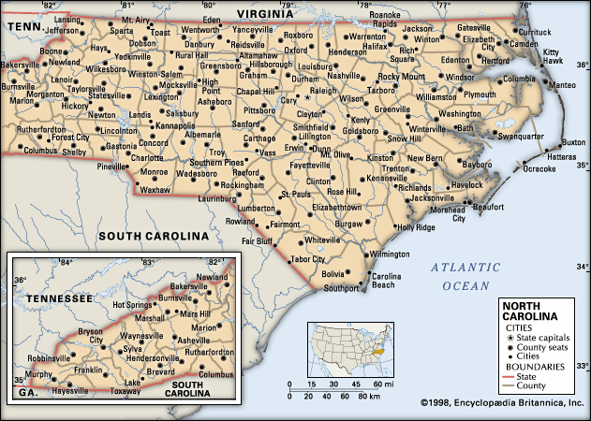

Scale: ½ cm = 10 mi.

- What is the ACTUAL distance between Sanford and Dunn?

- What is the ACTUAL distance between Charlotte and Raleigh?

- What is the ACTUAL distance between Fayetteville and Wilmington?

Map #2 - United States
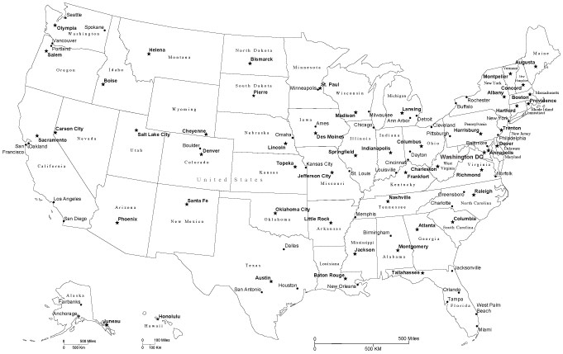

Scale: 3 cm = 500 mi.

- What is the ACTUAL distance between Oklahoma City, OK and Raleigh, NC?

- What is the ACTUAL distance between Jackson, MS and New York City, NY?

- What is the ACTUAL distance from the most western part of the U.S. to the most eastern part of the U.S.? Measure the distance with a straight line as if the U.S. was a rectangle and you were measuring the length. Use a dry erase marker to help you if you need to.

Name: _______________________________________________ Date: ________________________

Scale Drawing Stations
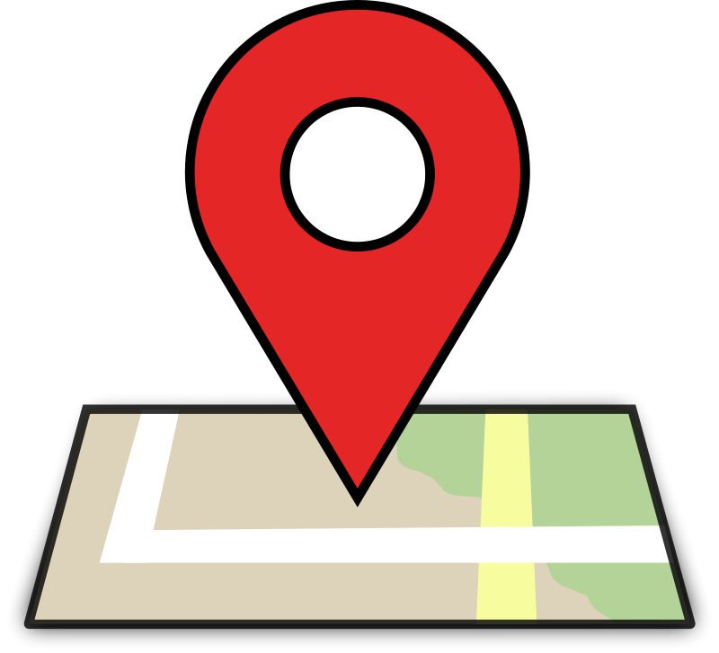
Station #1 - Landmarks

- Taj Mahal
Height in Picture  (Round to the Nearest Tenth) | Math Work | Approximate Actual Height  (Round to the Nearest Tenth)

- The Elephant Tower
Height in Picture  (Round to the Nearest Tenth) | Math Work | Approximate Actual Height  (Round to the Nearest Tenth)

- Cape Lookout
Height in Picture  (Round to the Nearest Tenth) | Math Work | Approximate Actual Height  (Round to the Nearest Tenth)

- Statue of Liberty
Height in Picture  (Round to the Nearest Tenth) | Math Work | Approximate Actual Height  (Round to the Nearest Tenth)

Station #2 - House Plans

House Plan #1

- Front Porch
Scale Drawing Measurement |  | Actual Measurement |  | Area of Actual Front Porch
Length | Width | Length | Width

Calculations:

- Rear Porch
Scale Drawing Measurement |  | Actual Measurement |  | Area of Actual Rear Porch
Length | Width | Length | Width

- How much bigger is the front porch than the rear porch? Explain.

- Amelia wonders, “Can’t you just find the area of each porch, and then scale it using the given scale?” What do you think? Explain below.

House Plan #2

      - Master Bedroom
Scale Drawing Measurement |  | Actual Measurement |  | Perimeter of Actual Master Bedroom
Length | Width | Length | Width

Calculations:

      - Laundry Room
Scale Drawing Measurement |  | Actual Measurement |  | Area of Actual Laundry Room
Length | Width | Length | Width

Calculations:

Station #3 - Reading Maps

Map 1 - North Carolina
1. Sanford to Dunn | 2. Charlotte to Raleigh | 3. Fayetteville to Wilmington
Map Distance | Map Distance | Map Distance
Math Work | Math Work | Math Work
Actual Distance | Actual Distance | Actual Distance
Map 2 - United States
4. Oklahoma City, OK to  Raleigh, NC | 5. Jackson, MS to New York City, NY | 6. Most Western Point to  Most Eastern Point
Map Distance | Map Distance | Map Distance
Math Work | Math Work | Math Work
Actual Distance | Actual Distance | Actual Distance

Possible Strategies/Anticipated Responses:

Station #1 - Students may use different spots on the picture to measure. For example, on the Taj Mahal, will the students go all the way to the top of the dome or to the top of the spire? What difference does it make in your estimate?

Also, students may set up a proportion, create a ratio table, repeatedly add or multply.

Station #2 – Students might find the area in cm² first, then try to scale up to feet. Some students may first try to change scale to feet and then find area. The answers will be different because when scaling area, you must multiply by SF squared. The same may happen on the Rear Porch calculations. To find the difference between the rear and front, some students may divide, some may find the additive difference.

For the second problem, some students may not want to consider the open doorways/closets as part of the perimeter and subtract or not count that amount in the full perimeter. For the laundry room area, it may not be clear to students where the boundaries are thus contributing to different answers.

Station #3 - Students may have difficulty identifying the most western and most eastern part of the United States. Students might set up a proportion, use a ratio table or multiply/divide.

Task 3: Similar Shapes

Framework  Cluster | Proportional Relationships
Standard(s) | NC.7.G.1 Solve problems involving scale drawings of geometric figures by:  ● Building an understanding that angle measures remain the same and side lengths are proportional.  ● Using a scale factor to compute actual lengths and areas from a scale drawing.  - ● Creating a scale drawing..  SMP 1 Make sense of problems and persevere in solving them.  SMP 2 Reason abstractly and quantitatively.  SMP 8 Look for and express regularity in repeated reasoning
Materials/Link | - OpenMiddle - "Similar Shapes"  - Student sheet (attached below)  - Calculators (optional)
Learning Goal | Utilize an understanding of similar figures to solve a problem requiring logical reasoning.
Task Overview:

This activity is designed to reinforce students’ understanding of similar figures and scale factors, while getting them to reason and problem solve. Students will be given the numbers 0-9, and two similar rectangles. They must use the digits 0-9, no more than one time each to create measurements that would, in fact, create two similar rectangles. They may combine the digits to make a number, for example, they may combine the digits 2 and 5 to make 25.
Prior to Lesson:

Students will need experience with scale factors and similar figures prior to this lesson. They must know that the scale factor for an enlargement must be greater than 1.
Teaching Notes:

Task Launch:
- It may be helpful for students to review the qualities of similar figures prior to attempting this task.
  - One possible resource would be the BrainPOP, “Similar Figures” (https://www.brainpop.com/math/geometryandmeasurement/similarfigures/)
- Explain the parameters of the activity to students and pass out the recording sheets.

Directions:
- Students should record all of their attempts whether they are correct or not. The main idea of this activity is for students to become more aware of their thinking and reasoning, and learning how mistakes are often necessary to reach a correct solution.
- After each attempt, students should answer the two questions, and bring their paper to you to score their attempt.
- This process should continue through a minimum of four attempts. Since there is more than one correct solution, students who get the right answer, can continue to try to find more correct solutions.

Student sheets begin on next page.

Name: _________________________________________________ Date: _________________________
Open Middle - Similar Shapes
Directions: Using the digits 0-9, at most one time each, fill in the boxes so that one rectangle is a scaled drawing of the other.
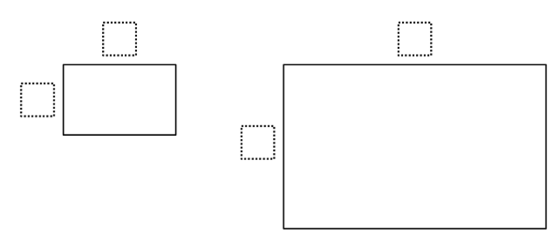

First Attempt:

What did you learn from this attempt? How will your strategy change on your next attempt?

Second Attempt:

What did you learn from this attempt? How will your strategy change on your next attempt?

For use with the OpenMiddle task “Similar Shapes” - http://www.openmiddle.com/similar-shapes/

Third Attempt: Points: ____/2 Attempt ____/2 Explanation

What did you learn from this attempt? How will your strategy change on your next attempt?

Fourth Attempt: Points: ____/2 Attempt ____/2 Explanation

What did you learn from this attempt? How will your strategy change on your next attempt?

Possible Strategies/Anticipated Responses:

(From OpenMiddle website)

Hints:
- Enlargements occur when the scale factor is greater than 1.
- How many times bigger is the second rectangle compared to the first rectangle?

There are many answers. Here are two of them:

First rectangle is 2 x 8
Second rectangle is 14 x 56
Scale factor would be 7.

First rectangle is 3 x 8
Second rectangle is 15 x 40.
Scale factor would be 5.

Task adapted from Connected Mathematics Project 2
Task adapted from Connected Mathematics Project 2

