Amelia’s Puzzle – Formative Assessment
Frameworks Cluster | Reasoning with Area and Surface Area
Standards | NC.6.G.1 Create geometric models to solve real-world and mathematical problems to:  - Find the area of triangles by composing into rectangles and decomposing into right triangles.  - Find the area of special quadrilaterals and polygons by decomposing into triangles or rectangles.  SMP2 Reasons abstractly and quantitatively  SMP3 Construct viable arguments and critique the reasoning of others  SMP6 Attend to precision
Materials | - Student task and recording sheets, one set per student (Task sheet with the tangram should be copied separately; question sheets can be copied 2-sided.)  - One set of Tangrams per student, either commercially made or printed on card stock and prepared ahead of time from the template provided  - Calculators, if desired (see note in Possible Strategies section)
Learning Goal | Students will show their understanding of the relationship between right triangles and special quadrilaterals, given the dimensions of a larger square that is decomposed into those shapes.
Task Overview
This formative assessment task provides the teacher an opportunity to determine students’ mastery of area of right triangles and special quadrilaterals, through their reasoning about the relationship the area of the shapes that make up the pieces of a tangram set.
Prior to Task:
- Students should have developed a conceptual understanding of the area of rectangles, parallelograms, triangles, and other quadrilaterals, using these lesson or other similar lessons: Parts and Pieces, Area of Rectangles and Parallelograms, Area Comparison Justification (formative assessment), and Area of Triangles.
- If you did not use the lesson Parts and Pieces, It may be helpful to have students make generalizations about area of tangram pieces (in comparison to each other) prior to this assessment.
Teaching Notes:
- Teachers are advised to work through the assessment prior to looking at the possible strategies in order to more deeply understand the student experience and anticipate responses and misconceptions.
- Give students a copy of the student recording sheets and a calculator, and have real tangrams available for students who need to manipulate the tangram pieces as they work on the task. Commercially made tangrams or teacher-made tangrams from the template provided should be used.
- Introduce the task by explaining, “You may use any of the strategies you have learned to find the area of the individual pieces to help Amelia with her Tangram project.”
- Some students may need help realizing that they can change the orientation of the triangles in the tangram by flipping, turning, or sliding to help them fit together into the shape of the large square or other smaller pieces, and that the shapes maintain the same dimensions, and therefore the same area.
- If some students are having trouble making sense of the task: ask students to try to make a square using only two, three, or four shapes. Then ask them what they know about the area of the squares created to the area of the individual shapes that compose the square.
- You may consider assigning this as a partner assessment, especially for struggling students.
- Task follow up: Review solutions with students through hands-on exploration and having students demonstrate their reasoning (an interactive whiteboard or document camera would be helpful). Focus on different strategies that students used to correctly determine the area of the same shapes, making connections between the strategies when appropriate. Consider using the Class Discussion Planner (https://tinyurl.com/discussion-planner) as a guide.
- After students have had sufficient practice with area of a triangles and parallelograms, this assessment can be followed up with the lesson Mosaic Area.
- Extension questions (optional):
  - If the large triangle has an area of 1 square unit, what would be the area of each of the other pieces?
  - If the small square has an area of 1 square unit, what would be the area of each of the other pieces?
  - You may substitute any desired numbers or Tangram shapes in the questions above, but be sure to work through the solutions ahead of time to be sure the resulting numbers are appropriate for the level of challenge intended.

Lesson plan template adapted from Taking Action: Implementing Effective Mathematics Teaching Practices, NCTM, 2017

Name __________________________________________________________________
Date ____________________
Amelia’s Puzzle

Amelia put the Tangram puzzle pieces into a 12 cm square. She wants to find the area of each individual shape so she can use them to build and design more puzzles.
- Use what you know about finding the area of polygons to help her determine the area of each piece.
- You may write or draw on this paper to help you find the area of each piece. When you’re finished, answer the questions on the other pages.

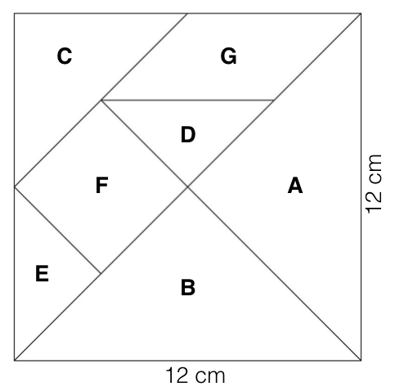

Name __________________________________________________________________
Date ____________________
Amelia’s Puzzle
- What are the areas of Amelia’s puzzle pieces?
Shape Letter | Area of Shape (in cm²) | Shape Letter | Area of Shape (in cm²)
A  (large triangle) |  | E  (small triangle)
B  (large triangle) |  | F  (square)
C  (medium triangle) |  | G  (parallelogram)
D
(small triangle)

When answering the following questions, explain using terms like tangram, length, width, area, base, height, dimension, isosceles triangle, right triangle, square, parallelogram, compose, decompose, and polygon
- What was the first piece you chose to find the area of? How did you find its area?
- Explain how you found the area of one shape that is a different shape from the first piece you found the area of.

- Explain how you found the area of one other shape that is either a different size or a different shape from the pieces you chose for questions 2 and 3.

- Describe the relationship between the area of the whole square and the area of a large triangle (A or B).
- Besides the two small triangles and the two large triangles, are there other shapes in the tangram have the same area? How do you know?

Tangram Template

Possible Strategies/Anticipated Responses:
- Note that the goal of this assessment is to determine what students know about determining area and the relationships between the areas of shapes, not on calculation. Therefore, calculator use is reasonable. However, if calculators are allowed, students should be required to write the numbers and operations they’re entering into the calculator so that the teacher and others can follow their logic.
- Students should not use rulers to measure the dimensions of each Tangram piece; rather, they should use reasoning and logic to find the area of each piece based on the information given.
- The Pythagorean Theorem, which is introduced in 8th grade, is needed to determine any diagonal lengths in the tangram puzzle (for example, the side lengths of piece F, the small square). Therefore, 6th grade students will not be able to use any non-horizontal/vertical dimensions of side lengths in their calculations.

- Area of Amelia’s Puzzle Pieces (See image below for strategies students might use.)
Shape & Letter | Area of Shape( in cm²)
Large Triangle - A | 36 cm²
Large Triangle - B | 36 cm²
Medium Triangle - C | 18 cm²
Small Triangle - D | 9 cm²
Small Triangle - E | 9 cm²
Square - F | 18 cm²
Parallelogram - G | 18 cm²
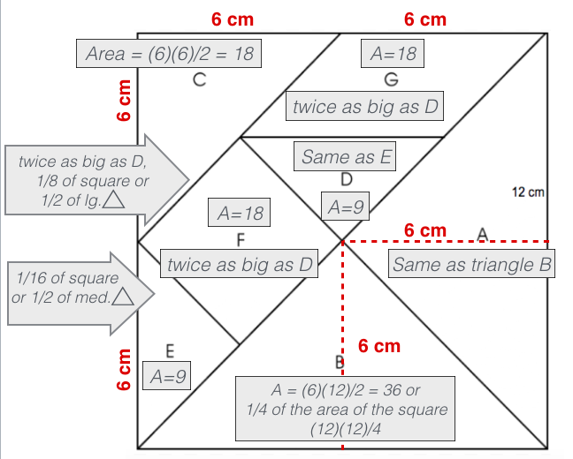
Students can use a variety of strategies to find the areas of each shape within the Tangram puzzle, including several shown in the diagram on the left.

Another strategy is to decompose the entire puzzle into the smallest triangle size (D and E), realizing that the square could be made of 16 of those triangles, so the area of each triangle is (12)(12)/16 = 9 cm², and then use that area to find the area of the other shapes. For example, square F can be decomposed into 2 small triangles, so its area is (2)(9)=18.

Although the formula (b x h)/2 or ½ bh may be used, the intent of this task is to assess students’ reasoning about area using the decomposed square, and composing smaller shapes into larger shapes to investigate area, not the mastery of area formulas.

- What was the first piece you chose to find the area of? How did you find its area?
Answers will vary. See the diagram on the previous page for possible solution methods, but be open to others.
- Explain how you found the area of one shape that is a different shape from the first piece you found the area of.
Answers will vary. See the diagram on the previous page for possible solution methods, but be open to others.
- Explain how you found the area of one other shape that is either a different size or a different shape from the pieces you chose for questions 2 and 3.
Answers will vary. See the diagram on the previous page for possible solution methods, but be open to others.
- Describe the relationship between the area of the whole square and the area of a large triangle (A or B).
Answers will vary. (The whole square is 4 times the area of a large triangle; the area of 4 large triangles equals the area of the whole square; the area of the large triangle is ¼ the area of the whole square, etc.)
- Besides the two small triangles and the two large triangles, are there other shapes in the tangram have the same area? How do you know?
The medium triangle (C), square (F), and parallelogram (G) have the same area (18 cm2). However, students should justify how they know that those shapes have the same area (such as explaining that each can be created using two small triangles), rather than just saying that they all have an area of 18 cm2.

Misconceptions and difficulties to watch for:
- It is important for students to understand that the base and height of any shape meet at right angles. For students who are struggling to identify base or height, encourage them to rotate the paper to view the shapes from other perspectives. Often students “see” base and height more easily when the base is horizontal in relationship to the student view.
- Students may not understand that the height of a triangle is not always the length of one of its sides (this is only true for right triangles, where the base and height are the sides that are perpendicular to each other). If this happens, students may think that they know the side length of the square, or other non-horizontal or vertical lines in the figure. If this happens, ask the student to identify the base and height of the small triangle on an actual tangram piece, then physically compare the base or height to the side length of the square or the shorter side of the parallelogram to the base or height of the small triangle. (Note that these square/parallelogram sides are longer, so they can’t be the same length.)
- Even after correctly finding the area of some shapes, some students may struggle to find the area of other shapes because they don’t see the connections between non-identical pieces. Encourage these students to investigate the relationships between pieces using actual tangram pieces that go with the area they know and the area they’re trying to determine.

