Formative Assessments
Proportional Reasoning Cluster
Assessment One

Cluster & Content Standards  What content standards can be addressed by this formative assessment?  Ratio and Proportional Reasoning  NC. 7. RP. 2 Recognize and represent proportional relationships between quantities.  1. Understand that a proportion is a relationship of equality between ratios.  - Represent proportional relationships using tables and graphs.  - Recognize whether ratios are in a proportional relationship using tables and graphs. | Mathematical Practice Standards  What practice standards can be addressed by this formative assessment?  MP1 Make sense of problems and persevere in solving them.  MP2 Reason abstractly and quantitatively.  MP3 Construct viable arguments and critique the reasoning of others.  MP4 Model with mathematics.  MP7 Look for and make use of structure.
Learning Targets
What learning targets will be assessed?
Unit Rates
Recognizing and representing proportional relationships
Timing: During Instruction

ASSESSMENT ONE

    - A can of concentrated fruit punch includes instructions “Mix one can of concentrate with 3 cans of cold water.”

Find the missing value in each situation below. Provide evidence for your answers.

6 cans of concentrate : ______________ cans of water | 24 cans of water : __________________ cans of concentrate
$31/2$ cans of concentrate : ____________ cans of water | 10 cans of concentrate : _______________cans of fruit punch

    - Jim is a member of the student council and is in charge of the “Welcome Back to School” dance. Jim wanted to figure out how many cans of concentrate he would need if he was responsible for beverages at the 7th grade “Welcome Back to School” dance. He knew that the coolers he planned to use could hold 144 cups of “stuff” (1 cup of water = 1 can of water). He used the following strategy to figure out how many cans of concentrate he needed. Jamie was also on this committee, but she used a similar strategy but came up with a different amount of concentrate needed. Who do you agree with? Explain why you agree with this person.

Jim  I wrote a series of equivalent fractions using a ratio table  Cans of concentrate 1 2 4 48  Cans of water 3 6 12 144  Jim says that 48 cans of concentrate are needed for the punch at the dance. | Jamie  I also wrote a series of fractions using a ratio table  Cans of concentrate 1 3 36  Cans of “stuff” 4 12 144  Jamie says that the committee needs to buy 36 cans of concentrate for the dance.

Think of an alternate way to help Jim and Jamie to figure out how many cans of concentrate they need to buy for the dance.

Anticipated Student Reasoning

8 cans

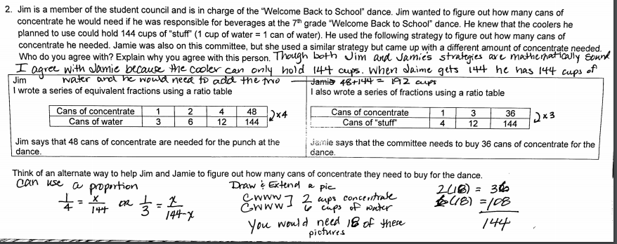

Formative Assessments
Proportional Reasoning Cluster
Assessment Two

Cluster & Content Standards  What content standards can be addressed by this formative assessment?  Ratios and Proportional Reasoning  NC. 7. RP.1 Compute unit rates associated with ratios of fractions to solve real-world and mathematical problems.  NC. 7. RP. 2 Recognize and represent proportional relationships between quantities.  1. Understand that a proportion is a relationship of equality between ratios.  - Represent proportional relationships using tables and graphs.  - Recognize whether ratios are in a proportional relationship using tables and graphs.  - Compare two different proportional relationships using tables, graphs, equations, and verbal descriptions.  - Identify the unit rate (constant of proportionality) within two quantities in a proportional relationship using tables, graphs, equations, and verbal descriptions.  - Create equations and graphs to represent proportional relationships.  - Use a graphical representation of a proportional relationship in context to:  - Explain the meaning of any point (x, y).  - Explain the meaning of (0, 0) and why it is included.  - Understand that the y-coordinate of the ordered pair (1, r) corresponds to the unit rate and explain its meaning. | Mathematical Practice Standards  What practice standards can be addressed by this formative assessment?  MP2 Reason abstractly and quantitatively.  MP3 Construct viable arguments and critique the reasoning of others.  MP4 Model with mathematics.
Learning Targets
What learning targets will be assessed?
Recognizing and representing proportional relationships
Representing and recognizing proportional relationships in tables
Representing and recognizing proportional relationships in graphs
Timing: During Instruction

ASSESSMENT TWO

- Write your own word problem that must be solved using ratios and proportions.

- Create a table of values and a graph that models your “real-world” situation.

- Pick one of your points in your table of values and explain its meaning in the context of your situation.

- Explain how you know that your situation is proportional?

Anticipated Responses/Strategies:
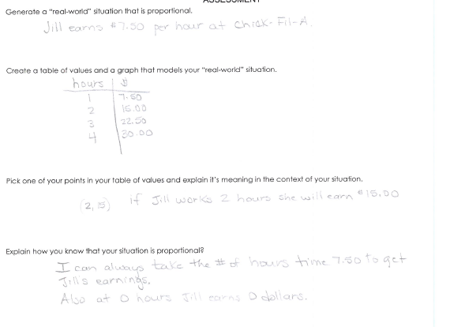

Formative Assessments
Proportional Reasoning Cluster
Assessment Three

Cluster & Content Standards  What content standards can be addressed by this formative assessment?  Ratios and Proportional Reasoning  NC. 7. RP.1 Compute unit rates associated with ratios of fractions to solve real-world and mathematical problems.  NC. 7. RP. 2 Recognize and represent proportional relationships between quantities.  1. Understand that a proportion is a relationship of equality between ratios.  - Represent proportional relationships using tables and graphs.  - Recognize whether ratios are in a proportional relationship using tables and graphs.  - Compare two different proportional relationships using tables, graphs, equations, and verbal descriptions.  - Identify the unit rate (constant of proportionality) within two quantities in a proportional relationship using tables, graphs, equations, and verbal descriptions.  - Create equations and graphs to represent proportional relationships.  - Use a graphical representation of a proportional relationship in context to:  - Explain the meaning of any point (x, y).  - Explain the meaning of (0, 0) and why it is included.  - Understand that the y-coordinate of the ordered pair (1, r) corresponds to the unit rate and explain its meaning. | Mathematical Practice Standards  What practice standards can be addressed by this formative assessment?  MP1 Make sense of problems and persevere in solving them.  MP2 Reason abstractly and quantitatively.  MP3 Construct viable arguments and critique the reasoning of others.  MP4 Model with mathematics.  MP6 Attend to precision.
Learning Targets
What learning targets will be assessed?
Unit Rates
Constants of Proportionality
Identify proportional relationships within tables, graphs, and equations.

Timing: During Instruction

ASSESSMENT THREE

    - A local market sells 4 tomatoes for $3.20.
      - Complete the table below.
number of tomatoes (t) | 1 | 2 | 3 | 4 | 5
Cost (C)

      - How much would it cost you to buy 100 tomatoes? Explain how you arrived at your answer.

      - How many tomatoes could you buy for $12? Explain how you arrived at your answer.

      - Sketch and describe a graph of what your data would look like. Name a point on your graph and describe that points meaning in the context of this situation.

      - What is the constant of proportionality? Explain how you know?

      - Write an equation that relates the number of tomatoes, t, to the cost, C.

Problem #2

Emily leaves her house at exactly 8:25 am to bike to her school, which is 3.42 miles away. While she passes the post office, which is $3/4$ of a mile away from her home, she looks at her watch and sees it is 30 seconds past 8:29 am.
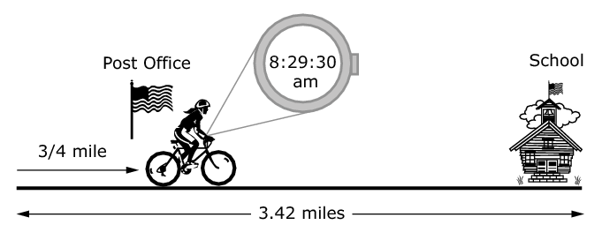

If Emily’s school starts at 8:50 am, can Emily make it to school on time without increasing her rate of speed? Show and/or explain the work necessary to support your answer.

Problem #2 taken from SBAC Mathematics Practice Test item #3286

Anticipated Responses/Strategies:
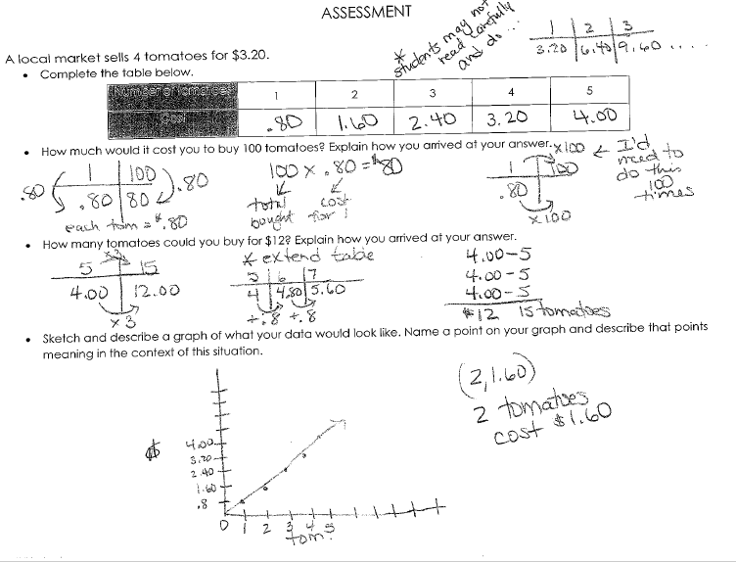
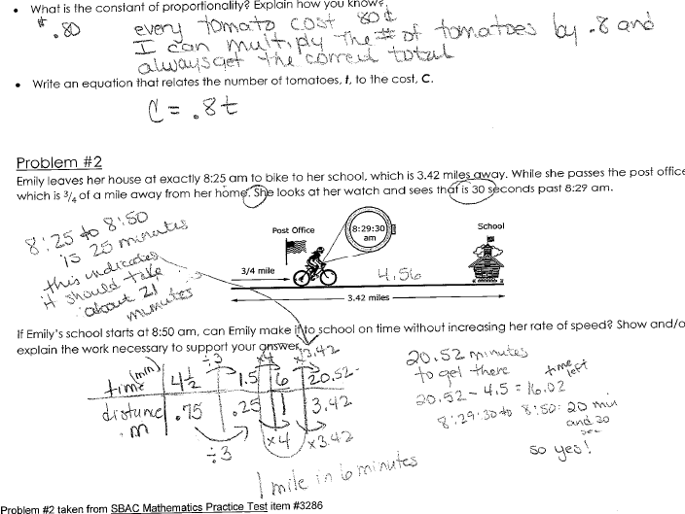

Formative Assessments
Proportional Reasoning Cluster
Assessment Four

Cluster & Content Standards  What content standards can be addressed by this formative assessment?  Ratios and Proportional Reasoning  NC. 7. RP.1 Compute unit rates associated with ratios of fractions to solve real-world and mathematical problems.  NC. 7. RP. 2 Recognize and represent proportional relationships between quantities.  1. Understand that a proportion is a relationship of equality between ratios.  - Represent proportional relationships using tables and graphs.  - Recognize whether ratios are in a proportional relationship using tables and graphs.  - Compare two different proportional relationships using tables, graphs, equations, and verbal descriptions.  - Identify the unit rate (constant of proportionality) within two quantities in a proportional relationship using tables, graphs, equations, and verbal descriptions.  - Create equations and graphs to represent proportional relationships.  - Use a graphical representation of a proportional relationship in context to:  - Explain the meaning of any point (x, y).  - Explain the meaning of (0, 0) and why it is included.  - Understand that the y-coordinate of the ordered pair (1, r) corresponds to the unit rate and explain its meaning. | Mathematical Practice Standards  What practice standards can be addressed by this formative assessment?  MP1 Make sense of problems and persevere in solving them.  MP2 Reason abstractly and quantitatively.  MP3 Construct viable arguments and critique the reasoning of others.  MP4 Model with mathematics.  MP6 Attend to Precision  MP7 Look for and make use of structure.
Learning Targets
What learning targets will be assessed?
Unit Rates
Proportional relationships in tables, graphs, and equations
Timing: During Instruction

Assessment Four

Jimmy, Elvis, and Ricky all have after-school jobs at a local-fast food restaurant. They each have the money they earned last week.
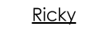
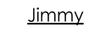
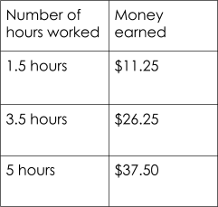
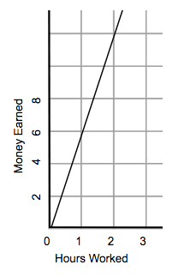
Ricky makes $7 per hour.

- Who makes more money for working 8 hours? Explain or show your work.

- Draw a graph that represents the money (y) Ricky would earn for working x hours. On the same axes, draw a graph that represents the money Jimmy would earn for working x hours. Compare the graphs of Jimmy and Ricky. Can you tell who makes the most money JUST by looking at the graphs? Explain your answer.

- Write an equation showing the amount of money EACH PERSON would earn, y, for working x hours. From looking at the equations, explain how you know who makes the most money for working the same amount of hours.

Anticipated Responses/Strategies:

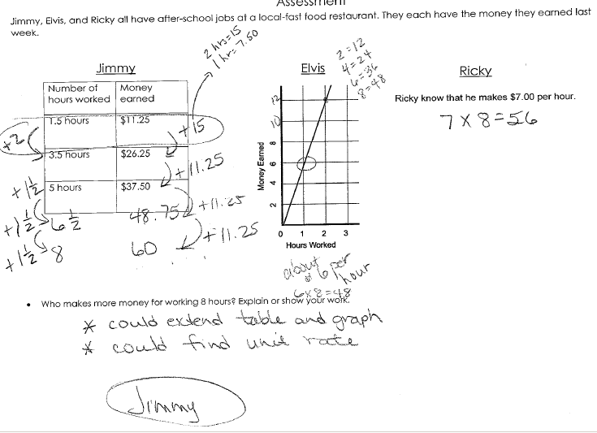
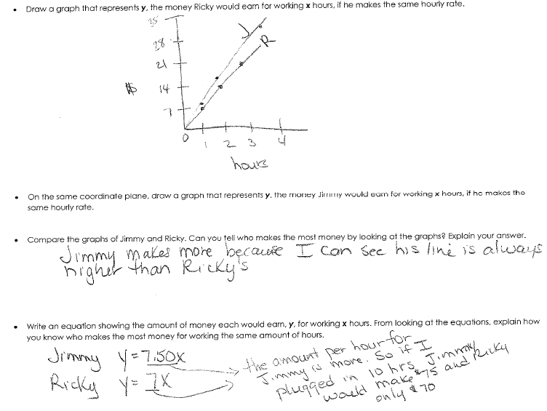

Formative Assessments
Proportional Reasoning Cluster
Assessment Five

Cluster & Content Standards  What content standards can be addressed by this formative assessment?  Ratios and Proportional Reasoning  NC.7.RP.3 Use scale factors and unit rates in proportional relationships to solve ratio and percent problems. | Mathematical Practice Standards  What practice standards can be addressed by this formative assessment?  MP2 Reason abstractly and quantitatively.  MP3 Construct viable arguments and critique the reasoning of others.  MP4 Model with mathematics.  MP6 Attend to precision.
Learning Targets
What learning targets will be assessed?
Unit Rates
Percents (discounts, sales tax, and commission)
Timing: During Instruction

Assessment Five
Question #1
Jimmy bought a $29 meal. He knows that sales tax in his state is 5%. Jimmy knows that sales tax can be calculated several different ways, which are listed below. Which of Jimmy’s methods is correct? Please give evidence for supporting why these methods are correct.
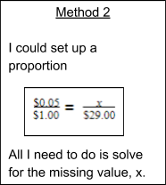
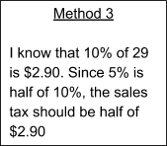
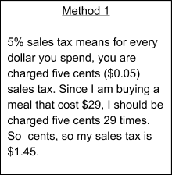

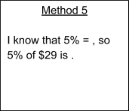
Method 4
1% of 29 is $0.29, so 5%
would be 5 times $0.29.

Of the correct methods, which one makes the most sense to you? Explain your choice.

Question #2
Jimmy purchased three video games for his X-box. The video games all cost the same amount. He paid 8% sales tax. He could see on receipt that $9.36 was added to his purchase. What was the cost of 1 video game, not including tax? Show your work below.

Question #3
Alfonso went to Sam’s Famous Appliance Store and purchased a refrigerator and a stove. The sales price of the refrigerator was 40% off the original price and the sales price of the stove was 20% off the original price.

Which statement must be true to conclude that Alfonso received a 30% discount on the refrigerator and stove together? Explain why the statement is correct.

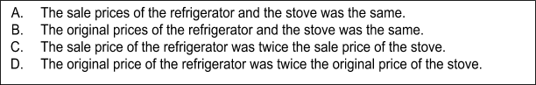

Problem #2 taken from SBAC Mathematics Practice Test item #3635

Anticipated Responses/Strategies:

