Which of the shapes are similar to Shape A?

**SHAPE A**

Copy Machine Chaos

Ms. Ortiz wanted to make copies of these pictures for her students, but the copy machine went crazy. Can you find the image below that is similar to Ms. Ortiz’s original? Defend your choice.

Image A

10

27

j0212957

Original

5

9

j0212957

Image B

7.5

18

j0212957

Image C

j0212957

2.5

27

Image D

j0212957

2.5

4.5

Face Off



6

8

Image C

Original

3

4



Image B

12

3



Image A

2

9



Image D

4

3

For my Dad’s birthday present this year, I wanted to take a picture of my son, Tai, and make a bigger framed picture as well as a smaller wallet size picture. The original picture is below. Which of the following pictures will make a reasonable looking picture? You can choose more than one.

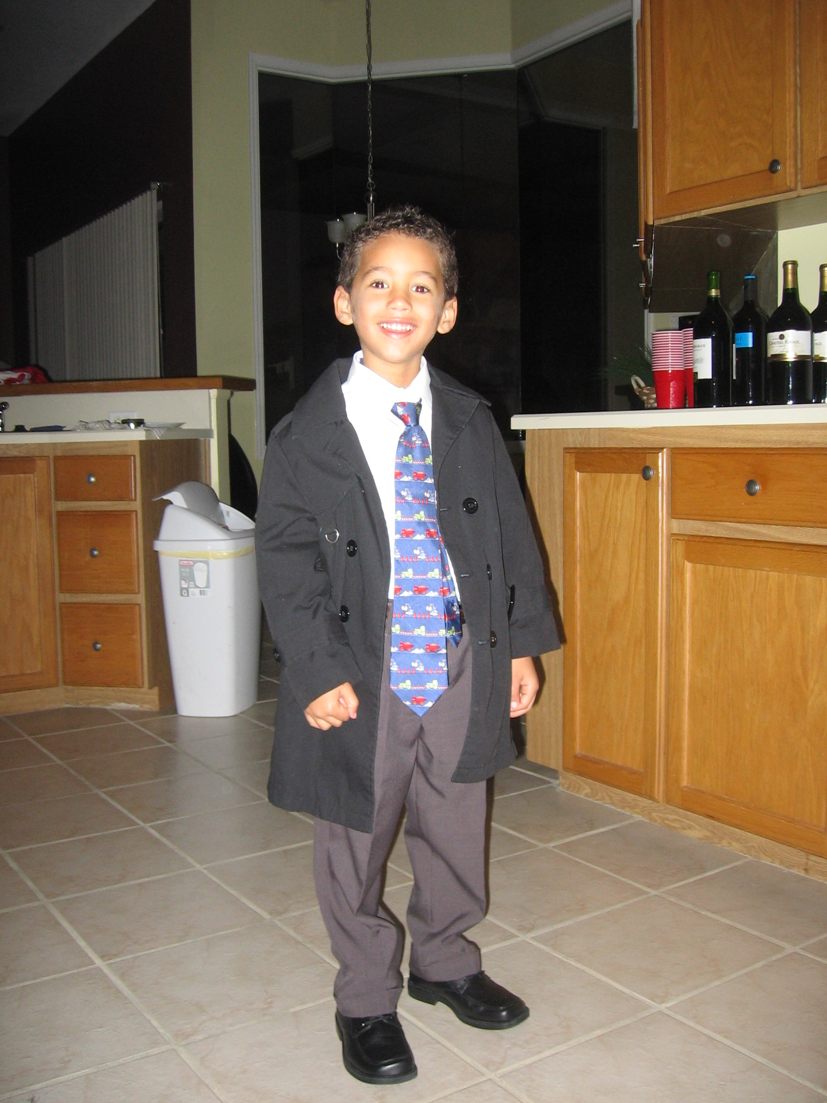

4 in

Image

A

2.25 in

1.5 in

1.5 in

Image

B

4.5 in

Original Picture

3in

Image

C

8 cm

6 in

Image

D

3.6 in

12 in

12 cm

4.5 in

Triangle Trauma

B

Triangle A is similar to Triangle B. What is the scale factor?

1 cm

A

Face Off Again

Which of the following images are similar to the original? The faces on the photos have been erased, so be careful. There may be more than one.

3

3

3

Image A

1.5

6

Image B

1.5

6

Original

3

6

Image D

12

Image C

8

8

4

16

Original

Image A

2

8

4

Image B

16

Image C

6

12

Image D

Ratios Again?

We have learned that a ratio is a comparison of two objects that have the same units. Write a ratio of the height to width of the following picture.

height width

=

8 cm

10 cm

MCj04282910000[1]

We have also learned that a proportion is when two ratios are equivalent or they both fit in the same table.

Which of the following pictures would be proportional or equivalent to the picture above?

MCj04282910000[1]

MCj04282910000[1]

MCj04282910000[1]

3 cm

8cm

5 cm

6 cm

3 cm

4cm

Which picture is similar to the picture above?

The Long and Short of It

Buzzy decided it would be easier to use a ratio table to determine the similarity of two shapes:

3 in

2 in

1.5 in

1 in

|  |  |  |  |  |  |
| --- | --- | --- | --- | --- | --- |
|  | Original | Image A | Image B | Image C | Image D |
| Short side | 1 inch | 2 inches | 4 inches |  |  |
| Long side | 1.5 inch | 3 inches |  | 7.5 inches | 15 inches |

1. What are the missing side lengths of the other similar shapes, B, C, and D?
2. Find the missing side lengths in the tables below.

|  |  |  |
| --- | --- | --- |
| Short side | 3 cm | .5 cm |
| Long side | 6 cm | x cm |

Your teacher will give you grid paper in order to draw both the original and image rectangle on your paper.

|  |  |  |
| --- | --- | --- |
| Short side | 8 cm | x cm |
| Long side | 6 cm | 3 cm |

|  |  |  |
| --- | --- | --- |
| Short side | 4 cm | 5 cm |
| Long side | 5 cm | x cm |

Photo Spill

Dr. Stephan accidentally spilled her photographs on the floor. Which photos are similar to each other? **Sort** these photos into “similar” piles.

3

9

3

G

H

F

E

C

D

B

A

2

6

.5

1.5

3

1

* 3

7

12

4

6

18

18

2

Similarity Smorgasbord

1. Are the two shapes similar? What’s your proof?

1.2 in

0.4 in

0.2 in

0.6 in

1. The two shapes are similar. Find the missing side length.

x

0.6 in

1.4 in

0.3 in

3. Are the two shapes similar? What’s your proof?

1.05 in

0.35 in

4. The two shapes are similar. Find the missing side length and angle measure.

25°

y°

4.6 cm

x

30°

Checking for similarity

2.5 cm

5 cm

15

10

2

3

1

2

3

4

Are any of these shapes similar?

Prove it!

SIMILAR FIGURES AND SCALE FACTOR

The triangles below are similar. What is the length of the missing side “s”? _____________

What is the scale factor?______

20cm

s

12cm

10 cm

18cm

17 cm

The following two trapezoids are similar. What is the length of side “k”? ________

What is the scale factor? ___________

16 in. 4 in.

28in.

k

Are they similar?

Suppose a student draws the pairs of figures below. The student says each of the two shapes is similar. Check each pair and decide which pair or pairs are similar. Be prepared to defend your conclusion.

x 1.5

15

A.

6

10

x 1.5

4

x 2

6

x 2

6

3

3

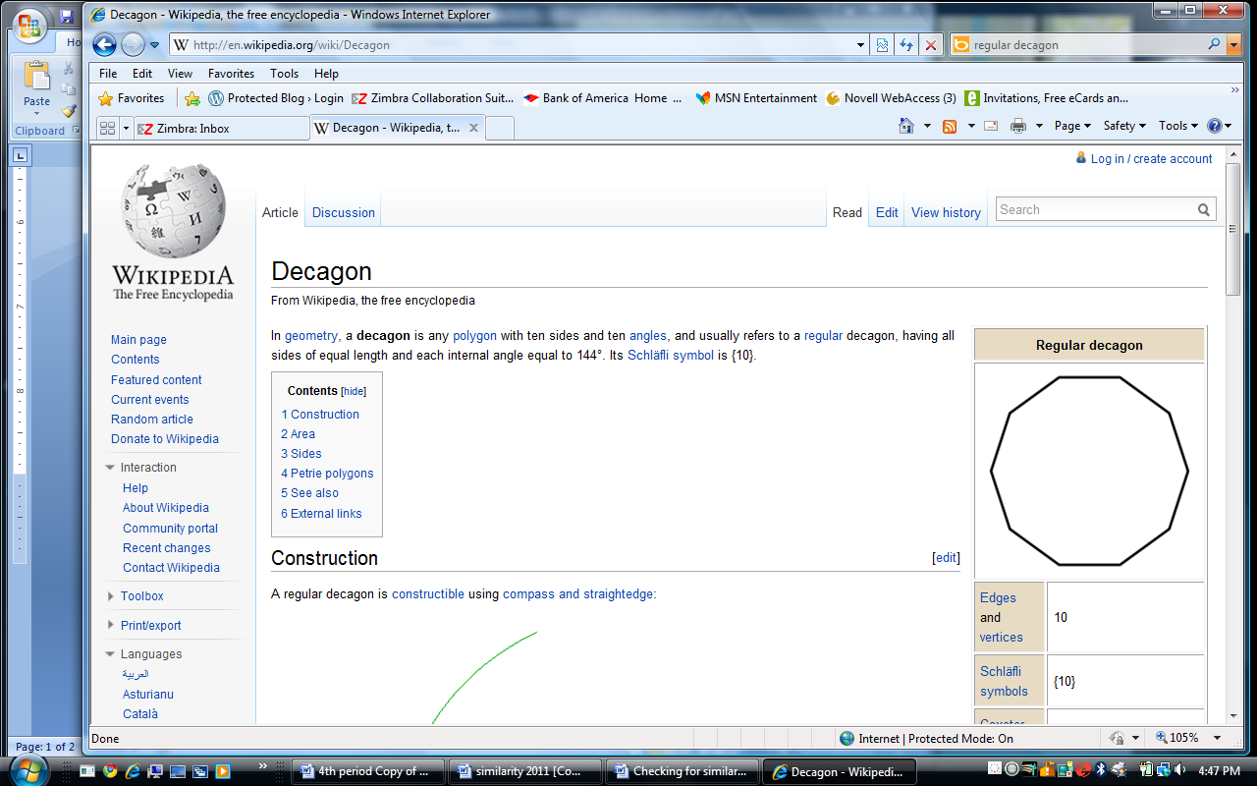

B.

6

C.

x 1.33

6.66

5

x 1.33

8

D.

Are they similar?

Calvin’s teacher told the class to draw two shapes that are similar but different size. Calvin drew the two figures below. He says the shapes are similar because the angles are the same. The angles of the first rectangle are the same as the angles in the same position on the second rectangle. Do you agree with Calvin? Defend your position.

4cm

2cm

6cm

6cm

***Shape set A***

1. Each of the shapes in the shapes sets below are similar find the missing measurement?

**4.5 cm**

**3 cm**

**9 cm**

**x cm**

**3 cm**

***Shape set B***

**x cm**

**7 cm**

**1 cm**

2. Based on the given measurements of the shapes below, determine if the shapes are similar and explain why?

***Shape set A***

***Shape set B***

Max’s Mirror Method

**??**

5 feet

18 feet

3 feet

mirror

Sarah’s Shadow Method

*SUN’S RAYS*

**??**

6 feet

15 feet

3 feet

Palm Reading

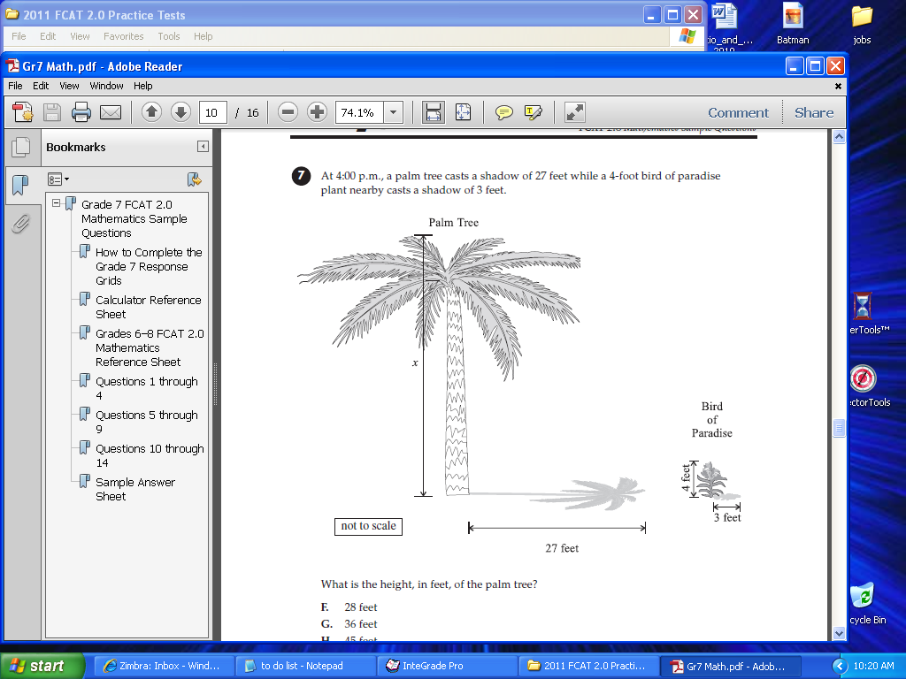

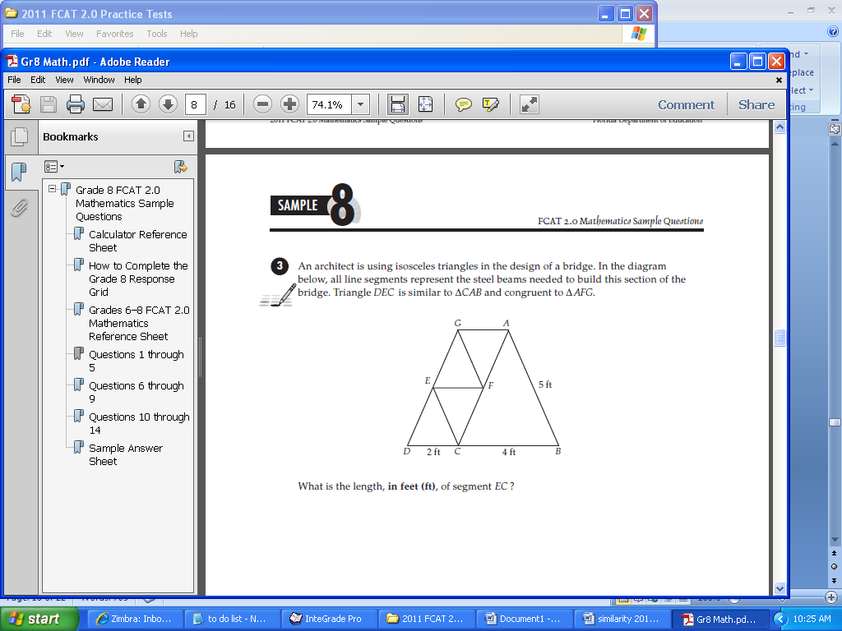

Shapes in Shapes

Find the missing measurement in each shape below:

B

C

B

3.5 mm

D

9 mm

E

D

10 cm

D

4.5

mm

F

6.25 cm

5 cm

E

A

C

A

∆ ABC ~ ∆ FDE ∆ ABE ~ ∆ CDE

1. How long is AC? B. How long is DE?

B

D

B

D

10 m

H

12 m

15 m

6 m

F

E

10 m

9 m

G

C

E

A

C

A

∆ ABC ~ ∆ ADE ∆ FEB ~ ∆ GEH

C. How long is DE? D. How long is HE?

Find the measure of DAE.

Tile Mania

Use the orange tiles at your desk to explore the following questions:

1. What would happen to the perimeter of the figure if you increase the height and width by a scale factor of 2?

Perimeter Original:

Perimeter Image:

1. What would happen to the area?

Area Original:

Area Image:

Use other tiles at your desk to investigate what happens to the perimeter and area of a shape when you use a scale factor of 3.

1. Enlarge the photo’s height and length below by a scale factor of 2.

***Original***

**3 cm**

**6 cm**

2. Enlarge the photo’s height and length below by a scale factor of 3.5.

***Original***

**4 cm**

3. Reduce the photo’s height and length below by a scale factor of ½.

***Original***

**5 cm**

**10 cm**

1. Juanita enlarged the photo’s height and width by a scale factor of 2. Find the area of the original photo.
2. Predict the area of the photo image.
3. Draw the image on the grid paper below to find the actual area. Did it match your prediction?

***Original***

**SF**

**x 2**

**4 cm**

**8 cm**

1. Carla enlarged the photo’s height and width by a scale factor of 2. Find the area of the original photo.
2. Predict the area of the photo image.
3. Draw the image on the grid paper below to find the actual area. Did it match your prediction?

***Original***

**SF**

**x 2**

1. Cedric enlarged the photo’s height and length by a scale factor of 3. Find the area of the original photo.
2. Predict the area of the photo image.
3. Draw the image on your own grid paper to find the actual area. Did it match your prediction?

***Original***

**SF**

**x 3**

**5 cm**

**6 cm**

5. Grace shrunk the photo’s height and width by a scale factor of 1/2. Find the area of the original photo.

1. Predict the area of the photo image.
2. Draw the image on the grid paper below to find the actual area. Did it match your prediction?

***Original***

**SF**

**x 1/2**

A

Fill out the table below. Draw Rectangles B, C, and D on grid paper above if you need to.

|  |  |  |  |  |  |
| --- | --- | --- | --- | --- | --- |
| RECTANGLE | Scale Factor | Short Side | Long Side | Perimeter | Area |
| A | 1 | 1 | 4 |  |  |
| B | 2 |  |  |  |  |
| C | 3 |  |  |  |  |
| D | 4 |  |  |  |  |