Bird Patterns Task Sequence
Framework Cluster | Functional Reasoning  This min-unit was created by Michelle Stephan and adapted from Mathematics in Context
Standard(s) | NC.8.F.3 Identify linear functions from tables, equations, and graphs.  NC.8.F.4 Analyze functions that model linear relationships.  - Understand that a linear relationship can be generalized by y = mx + b.  - Write an equation in slope-intercept form to model a linear relationship by determining the rate of change and the initial value, given at least two (x, y) values or a graph.  - Construct a graph of a linear relationship given an equation in slope-intercept form.  - Interpret the rate of change and initial value of a linear function in terms of the situation it models, and in terms of the slope and y-intercept of its graph or a table of values.
Materials/Link | Paper/pencil, activity sheet (1 at a time)  For students with disabilities, have chips available
Learning Goal | Students will write equations from spatial patterns and eventually solve for equations given a number. They will learn that the rate of change is the coefficient of the variable and that the constant number represents the y-intercept.
Task Overview

Students will use real world problems about bird patterns and determine the number of birds in the P^{th} pattern. They will write equations for the P^{th} pattern as well as evaluate the number of birds a given pattern number. This leads to organizing the numbers is a table and interpreting the slope and y-intercept from a table. This also includes writing an equation from a table.

Prior Work
In 6th and 7th grade, students have studied variable and have written expressions from word problems. They have also worked with solving multi-step equations. In 8th grade, it is possible (but not necessary) that they have studied Next-Now equations.

Task Launch:
- Introduce the task by engaging students in a story about flying patterns of birds (you can use a video or ask students if they have ever seen geese flying in the sky).
- Hand out the first bird pattern page that looks like Vs. Do NOT draw the next pattern on the board or ask students to describe how many birds in the 5th pattern.
- Give students 5 minutes to explore independently. Then, ask them to work with their partners to compare solutions or create solutions. Remind students to write evidence on their papers and be ready to justify their strategy.
- Give students 20-25 minutes to work.
- While students are working, collect data on which students are using the following anticipated student reasoning:

Anticipated student thinking:

100th pattern: Students will use their spatial patterns above to solve the problem using arithmetic or drawing lines for dots and labeling them. Some students may start to draw 100th pattern and stop.

Equations:

T = 2P + 1; 2P + 1; T = P2 + 1; T = (P+1) + P; T = P +P + 1
Students might also create a recursive equation (or Next-Now):
Next = Now + 2.

Facilitating the Task
- In whole class discussion focus on the strategies like next-now first as a way to motivate efficient strategies. Students who have figured out a way to structure the bird patterns efficiently should present their way of writing the 10th and 100th pattern. Showing pictures and explaining how the pattern number appears in the picture will be helpful.
- Discuss equations last, differentiating between expressions and equations (2P + 1 versus T = 2P + 1) if students wrote those. Also, differentiate between T = 2P + 1 and T = P2 + 1 (leaderbird versus wifi). Differentiate between T = 2P + 1 and T = (P + 1) + P (leaderbird versus no leaderbird). If appropriate ask students to figure out why doubling the 5th pattern does not determine the 10th pattern.
- Students should figure out there is a leaderbird in many of these patterns and capitalize on that since it will become a metaphor for the y-intercept.

Follow up Task
- Give students the X pattern and go through another cycle if time. If there is no more class time, give it as an exit slip or homework.

#1
#2
#3
#4

Draw the 5th bird pattern. How many birds will be in the 10th pattern? Put some evidence on your paper to prove it.

How many birds will be in the 100th pattern? Put some evidence on your paper to prove it.

Write an equation for the total number of birds (T) in the P^{th} pattern.

#1
#2
#3
#4
Draw the fifth pattern. How many birds will be in the 10th pattern? Put some evidence on your paper to prove it.

How many birds will be in the 100th pattern? Put some evidence on your paper to prove it.

Write an equation for the total number of birds (T) in the P^{th} pattern.
Anticipated Student Thinking:
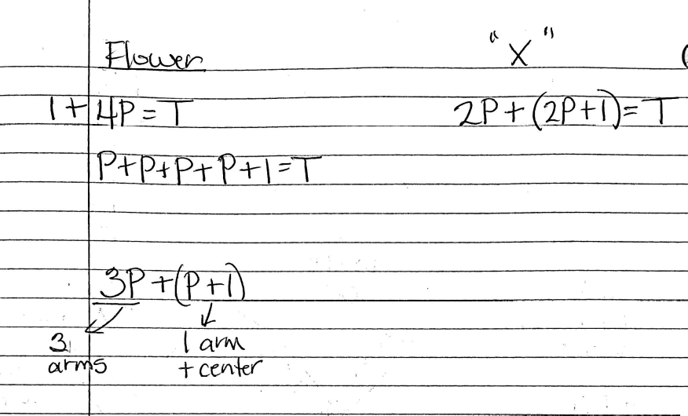

#1
#2
#3

How many birds will be in the 100th pattern?
Write an equation for the total number of birds (T) in the P^{th} pattern.

Anticipated Student Thinking:

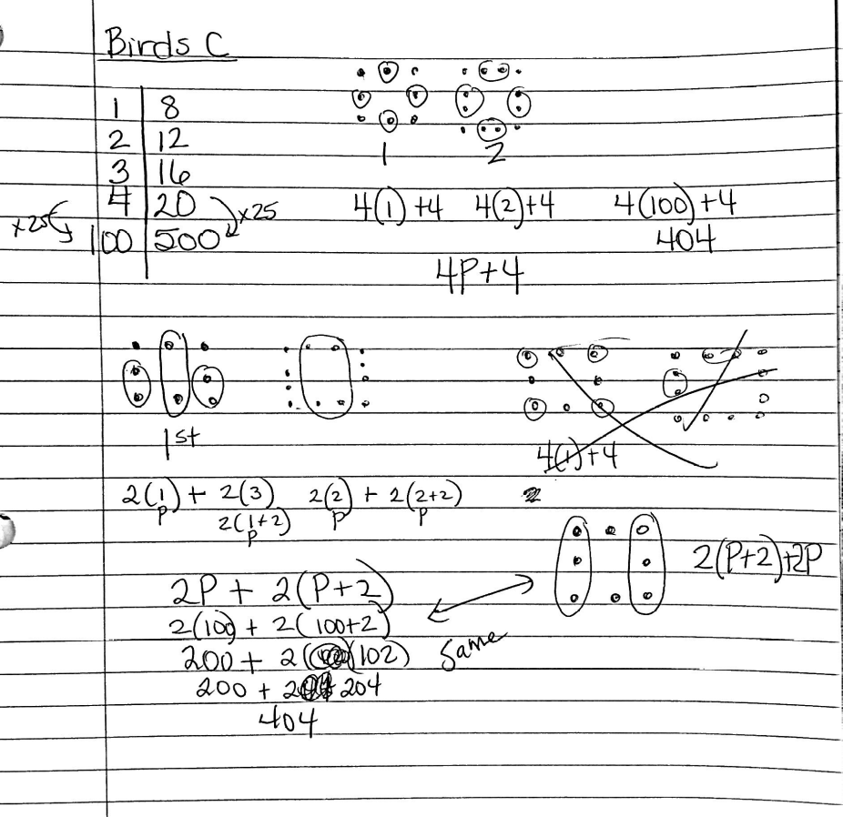

#1
#2
#3
#4

Use the CROSS bird pattern above to fill in the missing values in the table:

Pattern # | # of Dots
1 | ?
2 | ?
3 | ?
4 | ?
5 | 21
6 | ?
7 | ?
10 | ?
? | 77
100 | ?
P | Formula?

Caitlyn’s Conjecture:

Name ANY odd number of dots and I can make a CROSS bird pattern with that number of dots.

Prove or disprove Caitlyn’s conjecture.

Anticipated Student Thinking:

Table: 1---5, and goes up by four…5, 9, 13, 17, 21…

Some students may notice the birds going up by 4 in the picture and some may notice it in the table. In either case, be sure to represent the increase of 4 with an arrow from row to row and a +4 beside each arrow.

Some students may notice the leaderbird from the picture to get their equation of T = 4P + 1 or some equivalent. If students do not do so automatically, prompt them by asking where the leaderbird shows up in the table (0 pattern is 1 leaderbird). Ask them where the four new birds shows up in the table.

Some students may double the 5th pattern in the table to get the 10th.

Some students may need to create every pattern in between in order to find the 10th pattern and the pattern number for 77 birds. Others may use their equation or, for 77, subtract 1 for the leaderbird and divide by 4.

Anticipated Student Thinking:

#1
#2
#3

#4

Use the W bird pattern above to fill in the missing values in the table:

Pattern # | Total # of birds
1 | ?
2 | ?
3 | ?
4 | 17
5 | ?
6 | ?
7 | ?
10 | ?
? | 97
100 | ?
P | Formula?

Tim makes the following conjecture:

The numbers in the T column must ALWAYS be odd numbers.

Prove Tim’s conjecture right or disprove it.

Use the X bird pattern above to fill in the missing values in the table:

Pattern # | Total # of birds
1 | ?
2 | ?
3 | ?
4 | 19
5 | ?
6 | ?
7 | ?
10 | ?
? | 203
100 | ?
P | Formula?

Tim makes the following conjecture:

The numbers in the T column must ALWAYS be odd numbers.

Prove Tim’s conjecture right or disprove it.

Regina filled in her table like this:

Pattern # | Total # of birds
1 | 3+4
2 | 3+4+4
3 | 3+4+4+4
4 | 3+4+4+4+4
5 | 3+4+4+4+4+4
6 | 3+4+4+4+4+4+4
7 | 3+4+4+4+4+4+4+4
10 | ?
100 | ?
P | 3+4+4+4 +4+4…

- How would Regina fill in the missing numbers?

- What does the 3 in the T column stand for each time? Why are there four of the same number added each time?
Lost Pattern!!!
Pattern # | Total # of birds
1 | 8
2 | 11
3 | 14
4 | 17
5 | 20
6 | 23
7 | 26
10 | 35
28 | 89
100 | 305
P | Formula?

Farshid was trying to find the formula for the bird pattern last night for homework, but he lost the picture of the bird pattern. Rather than get discouraged, Farshid said, “I don’t need the picture. I can find out the formula without it!”

- How many birds are in the leader position?

- What is the formula for the Lost Pattern?
Anticipated Student Thinking:

The difference in this page is that there is no spatial pattern for students to rely on. This pushes them to abstract the notion of rate of change and constant (y-intercept) to a table if they haven’t already.

