Paper Clip Comparisons
Frameworks Cluster | Ratio Reasoning
Standards | NC.6.RP1 Understand the concept of a ratio and use ratio language to:  - Describe a ratio as a multiplicative relationship between two quantities.  - Model a ratio relationship using a variety of representations.  NC.6.RP.3 Use ratio reasoning with equivalent whole-number ratios to solve  real-world and mathematical problems by  - Creating and using a table to compare ratios.  - Finding missing values in the tables.  - Using a unit ratio.  - Converting and manipulating measurements using given ratios.  - Plotting the pairs of values on the coordinate plane.  SMP 2 Reason abstractly and quantitatively  SMP 4 Model with mathematics  SMP 8 Look for and express regularity in repeated reasoning
Materials/Links | - One copy of the student recording sheet for each pair of students  - Paper clips: 15 jumbo and 20 standard size for each pair of students  - Classroom items to measure (a variety of lengths, from 1 to 12 jumbo paper clips)  - Chart paper (optional; see Task Launch for details)
Learning Goals | - Students will use ratio reasoning to represent ratios on a graph and on a double number line  - Students will analyze data in ratio tables to identify patterns and calculate unit rates
Task Overview:
Students will work with a partner to measure classroom objects with standard and jumbo paper clips. They will then represent the data using ratio tables, graphs, and double number lines, and analyze the data to identify the proportional relationship between the measurements.
Prior to Lesson:
- Decide which students to pair together for the task in advance.
- Students should have had prior experience creating ratio tables and graphing data from ratio tables.
- Question #3 on the handout asks students to represent their data on a double number line. If students do not have prior experience with double number lines, use this opportunity to introduce the concept by completing that question as a whole group.
- You may choose to gather items for students to measure, or you can allow students to find their own classroom objects to measure.
- Prepare a table for use at the beginning of the task (either on the board or on chart paper), set up this way:

Object | Length in jumbo paper clips | Length in standard paper clips

Teaching Notes:
Task launch:
- Show students a regular paper clip and a jumbo paper clip, or project an image of the two sizes of paper clips.
- Ask students, What do you notice? What do you wonder? about the two paper clips.
  - Possible student “notice” statements:
    - There are two paper clips
    - The paper clips are silver/metal
    - One is bigger (or smaller) than the other
    - One must be heavier (or lighter) than the other, because it’s bigger (or smaller)
  - Possible student “wonder” statements:
    - Why are you showing us paper clips?
    - Why do manufacturers make two different sizes?
    - How much longer is the larger paper clip than the shorter paper clip?
- Pose these questions:
  - What tools do we usually use to measure length? (ruler, measuring tape, yardstick)
  - What are some standard units for measurement? (inches, feet, centimeters, meters)
  - Name some conversions between those standard units (1 foot = 12 inches, 100 cm = 1 m, 3 feet = 1 yard, etc.)
Directions:
- Give each pair of students 15 jumbo paper clips and 20 standard paper clips. Ask students to make two paper clip chains, one for each size of paper clip. One partner will measure objects with the jumbo paper clip chain; the other partner will measure the same objects with the standard size paper clip chain.
- Allow time for student pairs to measure 2 or 3 objects (using both paper clip chains) before moving on to the rest of the lesson. Students should record their measurements on the table you’ve prepared on the board or on chart paper.
- Note: if students measure items that don’t exactly match the length of the paper clip chain, they may not know what to do. Students may choose to estimate the fractional part of the paper clip lengths or they may choose to round to the nearest whole number of paper clips. These inconsistencies can be addressed during the whole group discussion after students have completed the tasks.
- Pose the key question (at the top of the handout) and direct students to work through the handout tasks with their partners.
- Monitor students as they work through the tasks on the handout. For the first task, they should lay the chains side-by-side with ends matching to observe and record equivalent lengths.
- As students are working, you might ask, “Looking at your table of data, how many times larger is the standard paper clip length than the jumbo paper clip length, when measuring the same item?” (Do not wait for an answer; use this as prompt for partner groups to investigate on their own.)
- Leave 10-15 minutes at the end of the class period for a whole group discussion of the task, guided by the questions below. Prompt students to use the measurements gathered at the beginning of the lesson to help explain their logic. Some mistakes in initial measurements may be identified during the discussion.
  - Looking at your table of data, how many times larger is the standard clip number than the jumbo clip number (when measuring the same item)? Does the answer to that question depend on which item you measured?
  - What patterns did you see in the table? In the graph? In the double-number line?
  - How can you use the patterns you found to determine the length of an object in standard paper clips if you know its length in jumbo paper clips?
  - What are some types of measurement conversions that might be more practical than jumbo and standard paper clips? (possible answers include feet and inches, yards and feet, or centimeters and millimeters)
Extensions (optional):
- The task can be extended by repeating the same exercises but using other standard-size units; for example, they may compare paper clips to snap cubes or snap cubes to Cuisenaire rods. Alternately, students could complete the same exercise using two different conventional units of measurement, such as inches and feet, feet and yards, or inches and centimeters. This would provide good practice for creating double number lines.
- If time allows, students may measure larger classroom objects by joining their paper clip chains together.
- If you wish to extend the task to show connections to the Expressions and Equations domains, you can ask students to write an equation to express the length of an object in standard paper clips in terms of the length in jumbo paper clips (s=1.5j, where s=the length in standard clips and j=the length in jumbo clips) or to write an equation to express the length of an object in jumbo paper clips in terms of the length in standard paper clips (j=2/3s).

Task adapted from Paper Clip Comparisons, a lesson in North Carolina Department of Public Instruction’s 6th grade Lessons for Learning
Lesson plan template adapted from Taking Action: Implementing Effective Mathematics Teaching Practices, NCTM, 2017

Student sheets begin on next page.

Name _________________________________________________________ Date _______________________
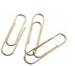Paper clip comparisons

Mario has a chain of jumbo paper clips, and his friend Luigi has a chain of standard size paper clips.
Their teacher has asked them to measure classroom objects using their paper clip chains, but unfortunately Luigi lost his paper clip chain! If Mario measures the length of an object using his jumbo paper clip chain, how can Luigi determine the length in standard paper clips?

- Complete the table of values by building chains of jumbo paper clips and standard paper clips.

Number of Jumbo Paper clips | Number of standard paper clips
0
2
4
6
8
10
12

- Describe a pattern you see in the table.
- Represent the data (from #1) on a double number line.
- Describe a pattern you see in the double number line.

- Make a coordinate graph of your data. Be sure to label the x-axis and the y-axis.
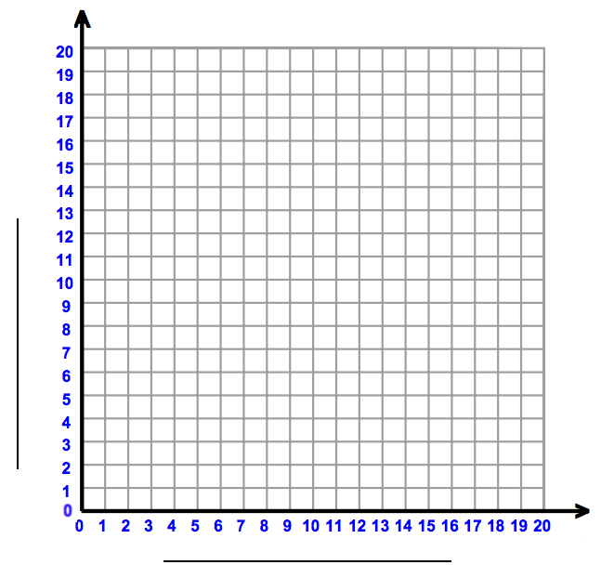
- Describe a pattern you see in the graph.
- How do the patterns you found in the table and in the double number line show up on the graph?
- Explain how you could use the patterns you found to determine the length of an object in standard paper clips if you know its length in jumbo paper clips.
- Use a jumbo paper clip chain to measure an item in the classroom that is longer than 8 jumbo paper clips. Determine the item’s length in standard paper clips using your strategy from #8.

Object | Length in jumbo paper clips | Length in standard paper clips
Now check your answer with a standard paper clip chain. Was the length you calculated above accurate?

Possible Strategies/Anticipated Responses:

Info about paper clips
https://study.com/academy/answer/what-is-the-length-of-a-paper clip.html

Solutions:

As they work through the task, students should discover that 3 standard paper clips have the same length as 2 jumbo paper clips, which means the ratio of standard : jumbo clips is 3:2. As a unit ratio this would be 1½ : 1. Multiplying the number of jumbo paper clips by 1½ gives the length in standard clips. The ratio for jumbo : standard clips is 2:3, making the unit rate 1 : ⅔.

- Complete the table of values by building chains of jumbo paper clips and standard paper clips.

Number of Jumbo Paper clips | Number of standard paper clips
0 | 0
2 | 3
4 | 6
6 | 9
8 | 12
10 | 15
12 | 18

- Describe a pattern you see in the table.
  - Answers will vary. Some possible answers:
    - The jumbo clips go up by 2 every time; the standard clips go up by 3 every time
    - For every 2 jumbo clips there are 3 standard clips
    - Multiply the jumbo clip number by 1 ½ to get the standard clip number
- Represent the data (from #1) on a double number line. 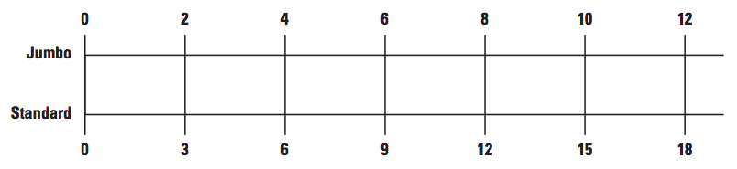
- Describe a pattern you see in the double number line.
  - The numbers match the numbers in the ratio table. Answers will vary. Some possible answers:
    - The jumbo clips go up by 2 every time; the standard clips go up by 3 every time
    - For every 2 jumbo clips there are 3 standard clips
    - Multiply the jumbo clip number by 1 ½ to get the standard clip number

- Make a coordinate graph of your data. Be sure to label the x-axis and the y-axis.
- Note: Graphs may not look the same, depending on which axis is used for each type of paper clip. Explain that in some situations, such as this one, there is not a variable that must be on the x axis (representing the independent variable). Therefore, either representation is appropriate.
- If jumbo paper clips are on the x axis and standard paper clips are on the y axis, there should be points at (0,0), (2,3), (4, 6), (6, 9), (8,12), (10,15), (12,18)
- If standard paper clips are on the x axis and jumbo paper clips are on the y axis, there should be points at (0,0), (3,2), (6,4), (9,6), (12,8), (15,10), (18,12)
- Describe a pattern you see in the graph.
- Answers will vary. The points make a straight line.
- How do the patterns you found in the table and in the double number line show up on the graph?
- Answers will vary. Encourage meaningful connections between the numbers in the ratio and the graphical representation. Note that students’ descriptions will depend on how they set up their graph (which size paper clip is on the x and y axes).
- Explain how you could use the patterns you found to determine the length of an object in standard paper clips if you know its length in jumbo paper clips.
- Answers will vary. Some possible answers:
  - Multiply the jumbo number by 1.5 or 1½
  - Multiply the jumbo number by 3 and divide by 2
  - Divide the jumbo number by 2 and multiply by 3
  - Use the line from the graph
- Use a jumbo paper clip chain to measure an item in the classroom that is longer than 8 jumbo paper clips. Determine the item’s length in standard paper clips using your strategy from #8.
- Answers will vary depending on the object measured.

Recipe Ratios
Cluster | Ratio Reasoning
Standard(s) | NC.6.RP.3. Use ratio reasoning with equivalent whole-number ratios to solve real-world and mathematical problems by:  - Creating and using a table to compare ratios  - Finding missing values in the tables.  - Using a unit ratio.  - Converting and manipulating measurements using given ratios.  - Plotting the pairs of values on the coordinate plane.  SMP 1 Make sense of problems and persevere in solving them  SMP 2 Reason abstractly and quantitatively  SMP 4 Model with mathematics
Materials/Links | - One copy of the student handout per student or group, depending on your preference  - Snap cubes  - Centimeter graph paper if students draw their own graphs for question 10.  - Projector or interactive whiteboard (if using Task Launch)  - Illustrative Math’s Perfect Purple Paint problem I http://bit.ly/Purplepaint  - Teaching Channel video of Perfect Purple Paint I http://bit.ly/2ICWZjr  - Optional Cooperative Groups Ratio Task Cards for an extension https://goo.gl/1ywpxT
Learning Goals | - Students will use multiple representations (such as manipulatives, ratio tables, tape diagrams, and double number lines) to solve rate and ratio problems.  - Students will make and interpret tables involving equivalent ratios.  - Students will plot equivalent ratios on the coordinate plane to answer questions about the ratio relationships.
Task Overview:
This activity provides a real-world context for students to reason about equivalent ratios and solve problems involving the ratio between sugar and water to make hummingbird food and blue and red paint to make a certain shade of purple paint. The tasks are designed to allow for more or less scaffolding through the use of concrete models and moving on to diagrams, tables, and to the more abstract model of a graph.
Prior to the task:
- It is recommended that the teacher completes both tasks and considers different ways that students might approach them, anticipating misconceptions that might occur. Watching the Teaching Channel video (http://bit.ly/2ICWZjr) will shed light on possible misconceptions.
- If using this as a partner or group task, determine group assignments in advance.
- Before teaching this lesson, students should have experience with creating ratio tables and tape diagrams to represent ratio relationships.
Teaching the Lesson:
- The launch and lesson are guided by the slides in this Google presentation: http://bit.ly/2tGavhz (You will be asked to make a copy.)
Task launch:
- This launch is intended to offer several visual models for representing ratio relationships. Additionally, it will help students begin think about how part to part ratios relate to the whole, which will be explored more in the main part of the lesson.
- If your school allows access to Youtube, you might begin by showing a video of a hummingbirds feeding at a feeder as a hook to the hummingbird food launch activity. This video http://bit.ly/2tH0Ya3 is only a minute long.
- Discuss what students know about hummingbirds. (Hummingbird facts http://bit.ly/2MzUBwo) Call students’ attention to the clear liquid that was in the feeders in the video. Ask if they have seen hummingbird “food” in a store (Lowes and others sell this). Ask if they know that it can be easily made at home.
- Use the slides of the Google presentation to guide the lesson ( http://bit.ly/2tGavhz), along with the teacher notes below.
  - Slide 1 - Show students the “recipe” for hummingbird food. Briefly discuss what “parts” means (any unit of measurement can be used, as long as it is consistent for all “parts” -- cups, tablespoons, gallons, etc.)
  - Slide 2 (Q1 on the student handout) - After students give their answers, four ways of writing ratios can be clicked through (1 to 4, 1:4, ¼, one to four) This is a good place to remind students about the importance of order. What does each numeral represent in the situation? Is 4:1 the same as 1:4? Note that the unpacking document cautions teachers about using fraction notation as students are developing an understanding of ratio relationships, as students may misinterpret the ratio as part to whole (as all fractions are, but only some ratios are).
  - Slide 3 (Q2) - Students can make any model they choose (cubes can be connected or separate), as long as there is one cube of one color and 4 cubes of another. Their diagram should represent what they made.
  - Slide 4 (Q3) - Click through the slide animation to show the way that students should have labeled the bar model shown. Ask:
    - How many parts of sugar and water are represented?
    - How many total parts are represented?
    - How many batches of nectar are represented?
  - Slide 5 and 6 (Q4) - Answers will vary. Possible questions include:
    - How many parts sugar?
    - How many parts water?
    - How many batches were made? How can you know how many batches?
    - How many total parts are there?
  - Slide 7 (Q6) - Click through the animation to show the way that students should have labeled the bar model shown, asking:
    - How many parts of sugar and water are represented?
    - How many total parts are represented?
    - How many batches of nectar are represented? (Be sure that students see that since there are two batches, twice as much of each ingredient is needed resulting in twice as much total nectar.)
  - Slide 8 (Q8) - Click through slide animation to reveal the missing elements of the number lines. Students may need some help comprehending this representation. Help them to see the vertical relationships between the sugar and the water (multiplied by 4) and the total amount of ingredients (sugar + water). Also help them to notice the horizontal relationship. It helps to draw arrows connecting sugar to water (and writing x4 to show that in every case, the amount of water can be found by multiplying the amount of sugar by 4), or sugar to sugar and water to water for different sized batches (and writing x____ (scale factor))
    - Some questions you might pose to help students recognize those connections:
      - How does the new amount of water compare with the original amount when the amount of sugar was increased to 3?
      - What do you notice about the amount of the total of the ingredients each time sugar and water increase?
    - Be aware that at this point in their understanding of ratio relationships, many students struggle to move beyond additive reasoning (e.g., “the amount of sugar goes up one every time; the amount of water goes up by 4 every time”). Helping students make connections between sugar and water for the same batch, and amounts of sugar and water for different sized batches, will help students move toward multiplicative reasoning.
  - Slide 9 (Q9) - Click through the animation on the slide to reveal the plotted points. Be sure to have students name the ordered pairs using their coordinates. Some questions you might pose:
    - What does the point (0,0) represent?
    - What does each ordered pair on the coordinate plane represent?
    - If the parts of sugar and water are cups, how many cups of food are made in one batch? 3 batches? (Etc.)
    - Explain the relationship between the number of batches and the amount of food made?
    - Why were the sugar amounts put on the x axis and the water amounts on the y axis?
    - What would the graph look like if parts of sugar were on the y-axis and water on the x-axis?
    - What do you notice about the coordinate plane and the triple number line? How are they related? (if you turn the number line for water into a vertical position, you have the x and y axes)
  - Slide 10 - Answers will vary. Possible responses:
    - The amount of water is four times the amount of sugar in each new batch
    - The total amount (“whole”) can be found by adding the ingredients (“parts”) together.
  - Slide 11 - Link to “Perfect Purple Paint” Task from Illustrative Mathematics, which is the student task for the remainder of the lesson.

Directions:
- The last slide presents the Perfect Purple Paint task from Illustrative Mathematics (http://bit.ly/Purplepaint).
- The “Perfect Purple Paint” task is well described on the Illustrative Math task page, so be sure to read the IM Commentary prior to teaching the lesson, and review the sample solutions after you’ve had a chance to work through the task yourself.
- Allow students to work on this task individually, in pairs, or in small groups, circulating among them in order to hear their thinking and facilitate their work.
- As you move around the room, note the various strategies students are using, in preparation for a group discussion.
- Allow for time at the end to summarize the lesson, selecting specific students/groups to share their thinking based on the work you saw while circulating. Consider using the Classroom Discussion Planner (http://bit.ly/DiscussionPlanner) as a guide.
- At the end of the lesson, some students or classes may be ready to connect the ratio of sugar to water and the graphed points to an equation representing the relationship.
- Extensions (optional):
  - Cooperative Group Problem Solving Tasks can be found in this folder http://bit.ly/Groupcards
  - Illustrative Math’s Perfect Purple Paint II http://bit.ly/2MxWTfi is similar to Perfect Purple Paint I, but it involves a fraction to fraction ratio, and therefore is aligned to 7th grade standards. However, the proportional reasoning required to answer the question is similar to the original task.

Lesson plan template adapted from Taking Action: Implementing Effective Mathematics Teaching Practices, NCTM, 2017

Student sheets begin on next page.

Name __________________________________________ Date __________________

Recipe Ratios - Hummingbird Food - Introduction and review

To make your own hummingbird “food” you need two ingredients: sugar and water. These two ingredients will be mixed using a ratio of one-part sugar to four parts water.

- How would you write that ratio?

- Use snap cubes to model this ratio if one batch of hummingbird food is made. Draw a diagram of your model.

- Without taking apart your model, complete the tape diagram below with correct labels to represent the same information your snap cube model shows.
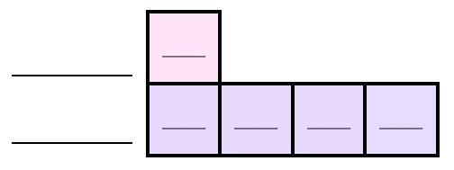
4. Combine your snap cube model with a classmate’s model to make two batches. Write at least two questions can you ask and answer by looking at this new model.

5. Suppose each of the cubes represents one cup of sugar. How many cups of water would you need to make a batch of nectar? How many total cups would there be?

6. Without adding any boxes, complete the labeling of this tape diagram to model the information shown by your snap cube model.
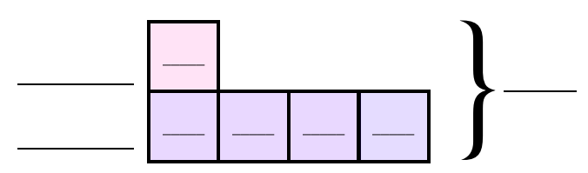

7. Complete the table:
Sugar (cups) | Water (cups) | Food (cups)
1 | 4 | 5
2
What patterns do you notice in the table?

8. Complete the triple number line below.
2
8
10
Cups sugar
Cups water
Cups food
1
4
5

9. Using the graph paper your teacher has given you, create a graph like the one below. Graph the values for parts of sugar and water on your graph or on the coordinate grid below
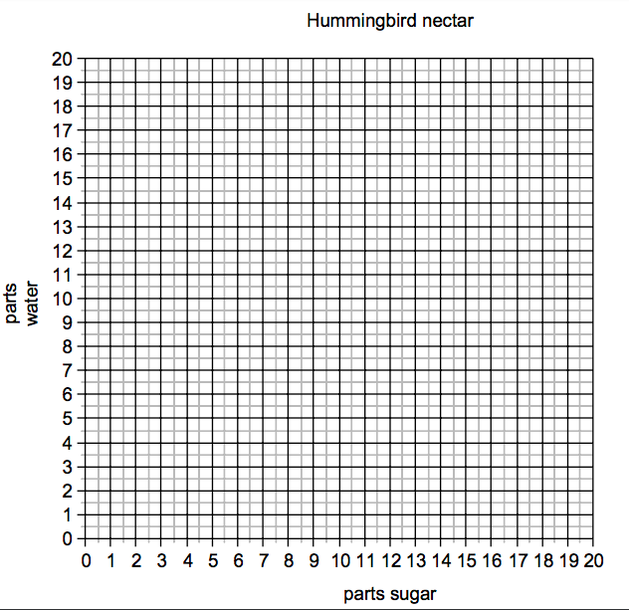

What do you notice about the points you have graphed?

What other ratio relationships can you see on the graph?

Possible Strategies/Anticipated Responses:

Hummingbird Food: (Task Launch)

- One-part sugar to four parts water 1:4, 1 to 4, or $\frac{ 1 }{4}$(Note that the unpacking document cautions teachers about using fraction notation when students are developing an understanding of ratio relationships, as students may misinterpret the ratio as part to whole (as all fractions are, but only some ratios are). Watch for students who may have reversed the ratio, and revisit the reason why the numbers in their ratio must follow the order of the words in the recipe.
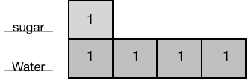
- Students might have many diagrams which should show represent 1 part of sugar to 4 parts water. Discuss how the diagrams they draw are alike and how are they different. The indication that every time 1-part sugar and 4 parts water are combined, another batch of 5 total cups is important here and teacher should guide students to that.
3. See comment above.

4. Possible questions/answers:
- How many total parts are in one batch? (5)
- How many total parts in two batches? (10)
- What is the pattern? (you can multiply the number of batches you want to make by 5 to know how many total parts)
- How many total parts of sugar are in two batches? (2)
- How many total parts of water are in two batches? (8)
- Is there a pattern? (you can multiply the number of batches you want to make by 4 to know how many parts of water you need), etc...

5. Possible questions/answers:
4 cups of water; 5 total cups of nectar
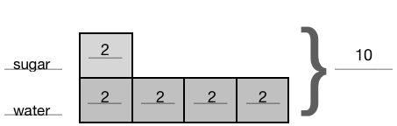
6.

7.
Sugar (cups) | Water (cups) | Food (cups)
1 | 4 | 5
2 | 8 | 10
3 | 12 | 15
4 | 16 | 20

Possible answers:
- The total amount of food is always 5 times the amount of sugar.
- The amount of sugar determines the number of batches.
- If you need to make 20 cups of food, you will need 4 cups of sugar and 16 cups of water
(It is likely that many students will still be thinking additively when looking at this table, “e.g., cups of water go up by 4.” Work to redirect their thinking toward multiplicative relationships by referring back to the original recipe.)
2
8
10
Cups sugar
Cups water
Cups food
1
4
5
3
4
5
12
15
20
25
20
16
8.

- (1,4) (2,8) (3,12) (4,16) (5,20)

- Students should notice that a line can be drawn connecting the points as this is continuous data.
- It would be good to guide them to see that with this graph, fractions of units can be seen, so ratios such as ½ to 2 are revealed.
- Perfect Purple Paint also has examples of possible student thinking
(http://bit.ly/Purplepaint)

Mixing Lemonade: Sweet and Sour
Frameworks  Cluster | Ratio Reasoning
Standards | NC.6.RP.3. Use ratio reasoning with equivalent whole-number ratios to solve real-world and mathematical problems by:  - Creating and using a table to compare ratios  - Finding missing values in the tables.  - Using a unit ratio.  - Converting and manipulating measurements using given ratios.  - Plotting the pairs of values on the coordinate plane.  SMP 2 Reason abstractly and quantitatively  SMP 4 Model with Mathematics  SMP 7 Look for and make use of structure
Materials/Links | - One can of frozen lemonade concentrate, 2 clear cups, liquid measuring cup, and spoon (if using the Task Launch)  - One copy of Part 1 student handout per pair of students  - (Optional) Copies of the visual representation of the mixtures from Part 1, for students who need the task scaffolded using a more visual approach.  - One copy of Part 2 student handout per individual or pair of students (depending on your plan for use)  - Plenty of copies of centimeter grid paper and blank double number lines  - 10 yellow and 10 white snap cubes for each pair of students  - Calculators (optional, but helpful for students not fluent with multiplication and division)
Learning Goal | Students will apply proportional reasoning solve problems using their choice of ratio representations and/or models.
Task Overview:
In part 1 of this task, students collaborate with a partner to compare various lemonade mixtures to determine which one has the stronger lemon flavor. They will be required to justify their answer using words, numbers, and models/diagrams. Part 2 extends the task to larger (but still “friendly”) numbers in the ratios, and can be used as a partner task, an individual task, or a formative assessment. Depending on the length of your class periods, you may need 2 days for this task.
Prior to Task:
- Students should have completed Paper Clip Comparisons and Recipe Ratios, or similar tasks, prior to this lesson. They should have had practice with ratio tables, double number lines, tape diagrams, and other methods of scaling and comparing ratios.
- Use of the task launch is highly recommended, because it demonstrates mixing lemonade concentrate with various amounts of water in order to be sure students understand the basis of this task (mixing ingredients to make lemonade that is too weak, just right, or too strong).
- Determine student partner assignments in advance.
Teaching Notes:
Key Vocabulary: scale, scale factor, ratio table, tape diagram, ratio table, unit ratio, double number line

Task Launch:
- Note: allowing the can of frozen lemonade concentrate to thaw prior to the lesson will make mixing the liquids faster and easier. One unsweetened KoolAid lemonade packet mixed with ½ cup water, can be substituted for the frozen lemonade concentrate, if desired.
- Display 2 small clear glasses or clear plastic cups for all students to see, and fill with water, pouring water ¼ cup at a time, in these amounts:
  - Lemonade mixture A: ¼ cup water
  - Lemonade mixture B: ¾ cup water
- Measure ¼ cup lemonade concentrate to add to each cup, stirring to mix the liquids after adding the concentrate.
- Ask students, “What do you notice? What do you wonder?” Answers will vary. Possible responses may include:
  - Notice:
    - Each cup started with a different amount of water.
    - The same amount of lemonade concentrate was mixed into each cup.
    - The lemonade mixtures in each cup look different.
  - Wonder:
    - Why does the lemonade concentrate have to be mixed with water?
    - Does one of the cups have the “right” combination of water and lemonade concentrate?
    - Which lemonade mixtures tastes best?
- Pose the question, “Without taste-testing each one, which of the lemonade mixtures has the stronger (or weaker) lemon flavor, and how do you know?“ Follow up with a brief discussion of students’ answers. It’s important for students to realize that in this demonstration, the same amount of lemonade concentrate was added to two different amounts of water. The mixture that had more water (B) will have the weaker lemon flavor, while the mixture that had less water (A) will have the stronger lemon flavor. This is because each mixture has same amount of lemonade concentrate, so the lemon flavor gets more ‘watered down’ the more water is added.

Directions - Part 1:
- Pose the challenge: “In this task, you will compare lemonade mixtures to determine which one has the strongest lemon flavor. In some cases, the mixtures might have the same amount of lemonade concentrate (as in the Task Launch activity) or the same amount of water, but in other cases the amounts of water and lemonade concentrate will both be different in the mixtures you’re comparing. You may use any strategy you’ve learned, but you must record your thinking on paper.”
- Distribute student handouts (one handout for each pair of students)
- Do not direct students to use any particular tool or strategy, but have the following tools available for students to use during this task:
  - Yellow and white cubes (no more than 10 of each color for each pair of students)
  - Blank grid paper
  - Blank double number line sheets
  - Copies of the visual representation of the mixtures being compared (for students who need this scaffold)
- Circulate as students work, listening to their thinking and facilitating their work. As you move around the room, note the various strategies students are using, in preparation for a group discussion. See extension ideas for early finishers.
- Summarize the lesson by selecting specific students/groups to share their thinking based on the work and strategies you saw while circulating. Look for opportunities to make connections between different strategies students used. Consider using the Classroom Discussion Planner (http://bit.ly/DiscussionPlanner) as a guide.
  - Possible questions to use during the discussion:
    - How is this strategy similar to this (other) strategy? How is it different?
    - Where is this information (one of the ratios shown in the strategy) found in this (other) strategy?
    - Looking at all of the comparisons you made, is there a strategy for determining the stronger lemonade flavor that was more efficient than others? Why?
    - Did the strategy you selected depend on the numbers in the ratios you were comparing?
- Extension (optional):
  - Out of all of the lemonade mixtures compared, which one(s) make the strongest tasting lemonade? Which one makes the weakest tasting lemonade?
  - Dan Meyer’s Nana’s Chocolate Milk 3-act task (http://threeacts.mrmeyer.com/nana/ )

Directions - Part 2:
- Note: this part of the lesson extends the task to larger (but still “friendly”) numbers in the ratios, and can be used as a partner task, an individual task, or a formative assessment.
- Pose the question at the top of the Part 2 handout. You may wish to project the recipes and representations from the top of the handout for students to see while you’re explaining the task.
- Distribute student handouts
- Do not direct students to use any particular tool or strategy, but have the following tools available for students to use during this task:
  - Yellow and white cubes (no more than 10 of each color for each pair of students)
  - Blank grid paper
  - Blank double number line sheets
- Circulate as students work, listening to their thinking and facilitating their work. As you move around the room, note the various strategies students are using, in preparation for a group discussion. See extension ideas for early finishers.
- Summarize the lesson by selecting specific students/groups to share their thinking based on their work and strategies. Look for opportunities to share as many different strategies as possible, and make connections between those strategies. Consider using the Classroom Discussion Planner (http://bit.ly/DiscussionPlanner) as a guide.
  - Possible questions to use during the discussion:
    - How is Part 2 of this task similar to Part 1? How is it different?
    - Did you choose different strategies for these comparisons than you did in part 1? Why?
- Extensions (optional):
  - Noelle has a pitcher that can hold up to 1800 mL of liquid. If she and Daniella want to make a pitcher of lemonade that is as close to full as possible, without spilling over, how much lemonade concentrate and how much water should Daniella use?
  - Challenge students to determine the stronger lemonade using Nrich’s Mixing Lemonade interactivity (https://nrich.maths.org/6870), which randomly generates two mixtures to compare.
  - Dan Meyer’s Nana’s Lemonade 3-act task (http://www.101qs.com/3043)

- This task can be followed by the formative assessment Mixing Lemonade: Sweet and Sour.

Task adapted from MEDIAN blog post: Orangier (https://donsteward.blogspot.com/2016/03/orangier.html)
and NRICH Mixing Lemonade (https://nrich.maths.org/6870)

Lesson plan template adapted from Taking Action: Implementing Effective Mathematics Teaching Practices, NCTM, 2017

Name ________________________________________________________ Date _________________________
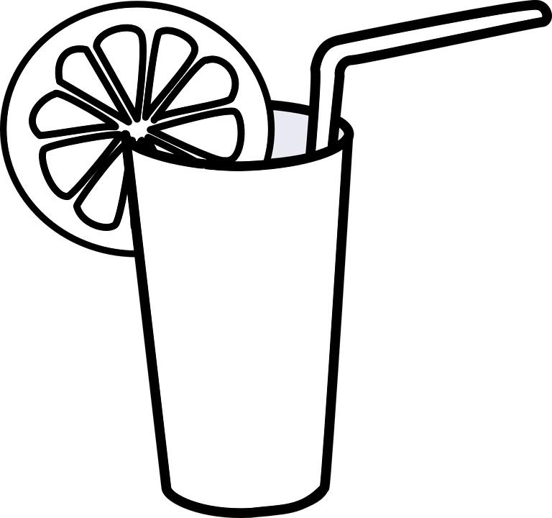

Mixing Lemonade: Sweet and Sour
Part 1

Daniella can’t remember how much lemonade concentrate to mix with water to make the right tasting lemonade, so she makes two different mixtures at a time and tastes them to see which one has a stronger lemonade flavor. Her friend Xavier says that he can figure out which mixture has the stronger flavor using what he learned in math class, without having to make and test them. Use what you’ve learned in this unit to help Daniella compare each pair of mixtures.
For each pair of mixtures, circle the one with the stronger lemon flavor. You may use any strategy, but you must show your thinking (using words, numbers, and drawings of models, if used) to justify your answer.
#1
Mixture | Lemonade concentrate (cups) | Water (cups)
A | 1 | 2
B | 1 | 3

#2
Mixture | Lemonade concentrate (cups) | Water (cups)
A | 2 | 2
B | 3 | 2

#3
Mixture | Lemonade concentrate (cups) | Water (cups)
A | 2 | 1
B | 3 | 2

#4
Mixture | Lemonade concentrate (cups) | Water (cups)
A | 1 | 3
B | 2 | 5

#5
Mixture | Lemonade concentrate (cups) | Water (cups)
A | 5 | 4
B | 3 | 2

#6
Mixture | Lemonade concentrate (cups) | Water (cups)
A | 2 | 3
B | 3 | 4

#7
Mixture | Lemonade concentrate (cups) | Water (cups)
A | 6 | 3
B | 4 | 2

#8
Mixture | Lemonade concentrate (cups) | Water (cups)
A | 5 | 4
B | 4 | 3
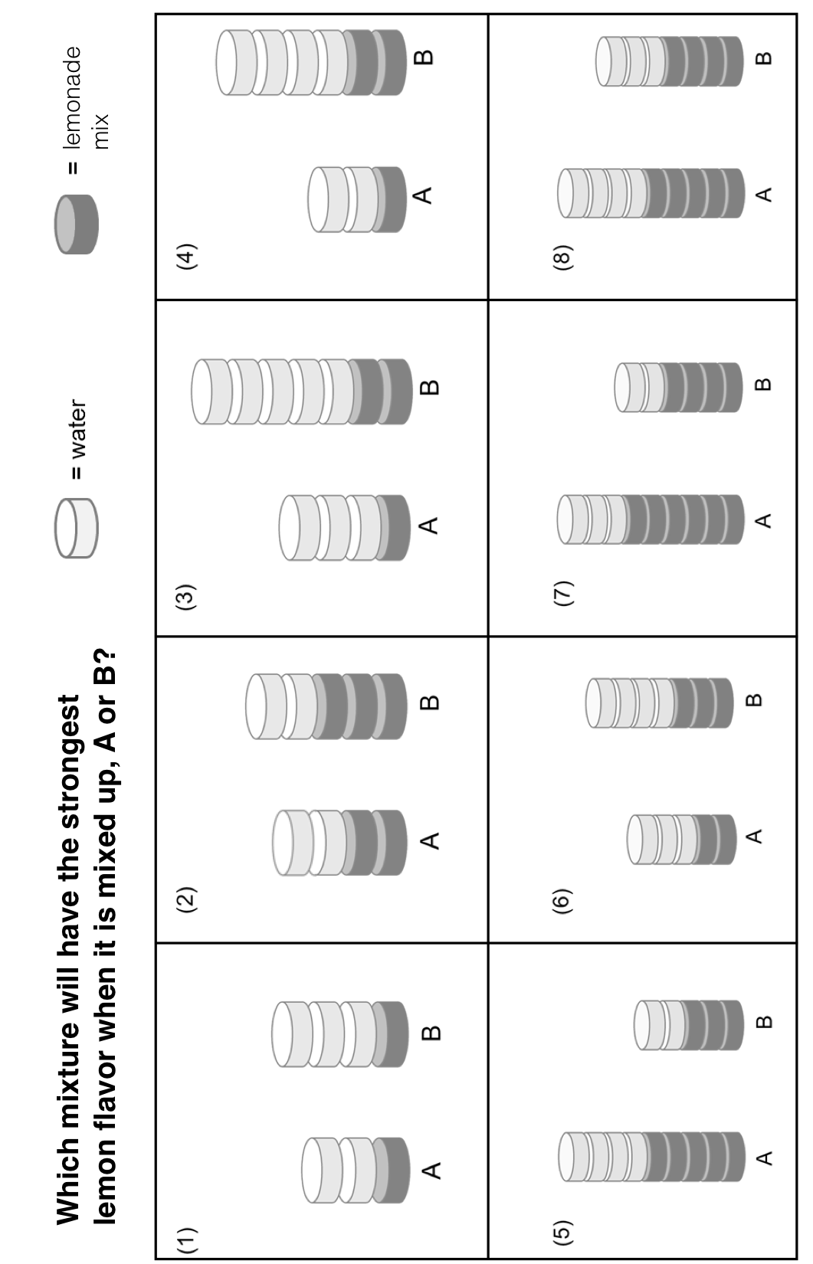

Name _______________________________________________________ Date __________________________
Mixing Lemonade: Sweet and Sour
Part 2

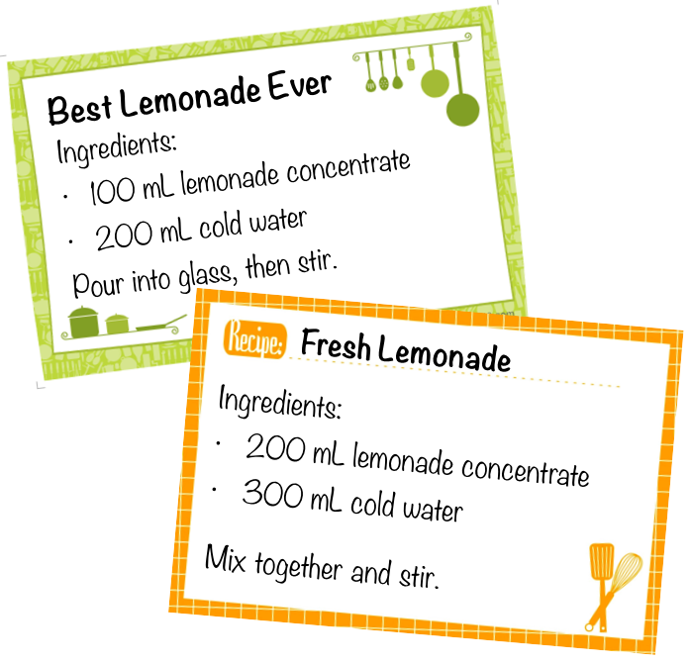
Daniella’s friend Noelle is from France, where liquids are measured in milliliters (mL), not cups. She shows Daniella two recipes for lemonade. Daniella isn’t used to measuring liquids using metric measurements, so she asks Noelle to draw a diagram to represent the amount of lemonade concentrate and water in each recipe to help her determine which recipe would make a stronger tasting lemonade.
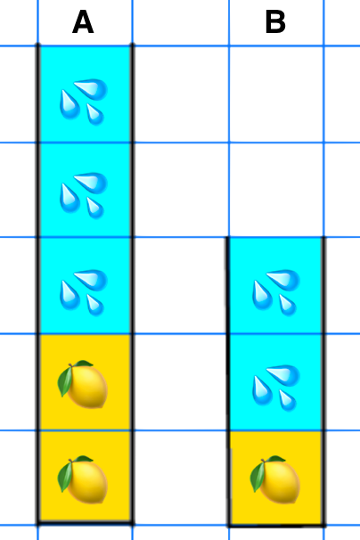

Noelle’s diagram helps, but Daniella is still a bit confused. She isn’t sure which recipe is represented by mixture A and which recipe is represented by mixture B. Help her match the recipes to the mixtures, and explain how you know.
- Best Lemonade Ever is represented by mixture ___ , because _______________________ ____________________________________________________________________________.
- Fresh Lemonade is represented by mixture ____, because ___________________________
_____________________________________________________________________________.
Why didn’t Noelle need to draw hundreds of little squares for her diagrams?

Which of Noelle’s recipes makes the stronger tasting lemonade? Justify your answer using two different methods.

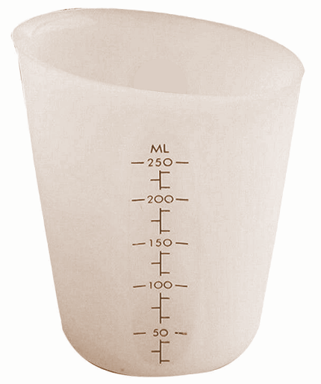
Daniella was at Noelle’s house when she finally remembered her recipe for lemonade. It uses 1 cup of lemonade concentrate for every 3 cups of water. Noelle asked Daniella to make a pitcher of lemonade for them to drink, but Noelle’s family only has measuring cups that show mL, not cups.
Help Daniella determine which of these combinations of lemonade concentrate and water would be too weak, too strong, and just right (like her recipe). Justify your answers.

Recipe A | Recipe B | Recipe C
90 mL lemonade concentrate | 60 mL lemonade concentrate | 70 mL lemonade concentrate
240 mL water | 190 mL water | 210 mL water

Possible Strategies/Anticipated Responses

Note: it is important to only give students enough cubes to get started modeling (10 of each color), but not enough to be used to compare every set of two batches. This creates the need to use other (more efficient and sophisticated) strategies.

Part 1:

Anticipated responses:

Question # | Mixture A |  | Mixture B |  | Stronger mixture
 | Lemonade concentrate | Water | Lemonade concentrate | Water
1 | 1 | 2 | 1 | 3 | A
2 | 2 | 2 | 3 | 2 | B
3 | 2 | 1 | 3 | 2 | A
4 | 1 | 3 | 2 | 5 | A
5 | 5 | 4 | 3 | 2 | B
6 | 2 | 3 | 3 | 4 | B
7 | 6 | 3 | 4 | 2 | A and B (tie)
8 | 5 | 4 | 4 | 3 | B

Students may compare the mixtures in various ways, including:
- Comparing equivalent recipes when they have the same amount of lemonade concentrate
- Comparing equivalent recipes when they have the same amount of water
- Comparing equivalent recipes when they have the same amount total liquid

Strategies that students may use include:
- Ratio table
- Ratio boxes
- Double number lines
- Tape diagram
- Unit ratio
- Getting from one ratio to another in 2 steps by multiplying (scaling up) and then dividing (scaling down)
- Comparing graphs showing lemonade concentrate on one axis and water on the other axis

Watch for these struggles and misconceptions:
- Only comparing the amount of lemonade concentrate, not considering the amount of water it is mixed with (e.g. 5 cups of lemonade concentrate and 4 cups of water is not as strong as 4 cups of lemonade mix and 3 cups of water, even though 5>4 cups of lemonade concentrate)
- Misunderstanding the ratio of lemonade concentrate to water to be a part-to-whole relationship, (e.g. thinking that 1 cup of lemonade concentrate and 2 cups of water makes the mixture ½ lemonade concentrate, rather than ⅓ – 1 cup of lemonade concentrate out of a total of 3 cups of liquid)
- Struggling to move beyond additive reasoning with ratios. Watch for students who consistently want to physically model making multiple “batches” of lemonade, or use ratio tables that always start with the given ratio and then repeatedly add additional batches rather than using the scale factor to scale up to a desired number or the unit ratio to calculate equivalent ratios. For these students summarizing the lesson, including comparing additive strategies (such as a ratio table that was created by adding one batch at a time) to other strategies (such as ratio tables, double number lines, or tape diagrams that use multiplication by scale factors to scale the recipes up to a common amount, or use unit ratios to determine the relationship between the amount of one ingredient amount to the other)
- Even with calculators, students struggle with non-integer relationships (e.g. 2 cups of lemonade concentrate to 3 cups of water, which can be taken to a unit ratio of 1 cup of lemonade for 1½ cups of water, or ⅔ cup of lemonade concentrate to 1 cup of water)
- Students using a unit ratio approach often have difficulty deciding which unit ratio to use (e.g. 1 cup of lemonade concentrate to 2 cups of water, or ½ cup of lemonade concentrate to 1 cup of water)

At the end of this document are examples of strategies and sample solutions from Part 1 (some showing methods for question 1 and others for question 2, but the same methods can be used for any question). For the purpose of illustrating possible student solutions, many strategies and solution methods are shown, but students should be allowed to choose their preferred method. The teacher should look for opportunities to make connections between solution methods during the Summarize portion of the lesson.

Part 2:

Anticipated responses and strategies:
- Best Lemonade Ever is represented by Mixture B (reasoning will vary).
- Fresh Lemonade is represented by Mixture A (reasoning will vary).
- Fresh Lemonade is a stronger tasting lemonade (reasoning and strategies will vary).
- For the last question, Recipe A is the stronger, Recipe C is next, and Recipe B is weaker.

- Solution methods from Part 1 can also be used for Part 2.
- Students may choose to compare two recipes at a time.

Watch for these struggles and misconceptions:
- Students may struggle more with Part 2 than Part 1, due to the larger numbers (even though they are all multiples of 10). As they are forming their understanding of ratio relationships, students often regress to additive reasoning when dealing with numbers that are less “friendly.” For example, watch for students to say that Recipe A has 150 mL more water than lemonade concentrate; Recipe B has 150 mL more water than lemonade concentrate, and Recipe C has 140 mL more water than lemonade -- erroneously believing Recipe C would be the strongest, with Recipes A and B tied for weakest.
- The same student struggles and misconceptions from Part 1 also apply to Part 2.

A few solution methods are shown below.

Comparing a common amount of lemonade concentrate:

 | Recipe A | Recipe B | Recipe C
Lemonade concentrate | 90 / 9 = 10 mL | 60 / 6 = 10 mL | 70 / 7 = 10 mL
Water | 240 / 9 = 26⅔ mL | 190 / 6 = 31⅔ mL | 210 / 7 = 30 mL

Comparing unit ratios:

 | Recipe A | Recipe B | Recipe C
Lemonade concentrate | 90 / 90 = 1 mL | 60 / 60 = 1 mL | 70 / 70 = 1 mL
Water | 240 / 90 = 2⅔ mL | 190 / 60 = 3⅙ mL | 210 / 70 = 3 mL

Note: alternately, students could divide by 240, 190, and 210, respectively, to find the other unit ratio (the amount of lemonade concentrate per 1 mL of water)

Comparing two recipes at a time (in this example, using the ‘common amount” method):

 | Recipe A | Recipe B
Lemonade concentrate | 90 / 3 = 30 mL | 60 / 2 = 30 mL
Water | 240 / 3 = 80 mL | 190 / 2 = 95 mL

Recipe A is stronger, because for the same amount of lemonade concentrate, Recipe A has less water.

 | Recipe A | Recipe C
Lemonade concentrate | 90 / 8 = 11¼ mL | 70 / 7 = 10 mL
Water | 240 / 8 = 30 mL | 210 / 7 = 30 mL

Recipe A is stronger, because for the same amount of water, Recipe A has more lemonade concentrate.

 | Recipe B | Recipe C
Lemonade concentrate | 60 / 6 = 10 mL | 70 / 7 = 10 mL
Water | 190 / 6 = 31⅔ mL | 210 / 7 = 30 mL

Recipe C is stronger, because for the same amount of lemonade concentrate, Recipe B has more water.

Therefore, Recipe A is strongest, Recipe C is the next strongest, and Recipe B is the weakest.

