WHAT HAPPENED TO YOU? BOOK READ
Facilitator’s Guide

Empathy journal
Each participant should be given a physical journal or an empathy e-journal so they can keep track of their thoughts and reflections through each of the steps.
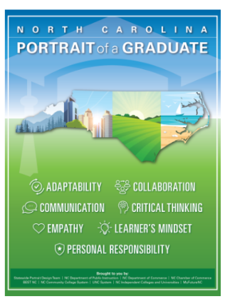
Frame the learning experience
One of the Competencies of NC DPI Portrait of a Graduate is empathy which recommends developing and supporting empathy in our graduates. One of the ways to teach students empathy is by Instructional Leaders and Teachers modeling what empathy is for students. In addition, engaging in empathic interactions with students can promote a sense of belonging in math class for each and every student.

Common Book Read
We recommend starting with What happened to you? Conversations on trauma, resilience, and healing, by neuroscientist Dr. Bruce D. Perry and Oprah Winfrey (nice to have an electronic or hard copy to take notes on but also great on audible because it is read by the two authors)

Other books/videos if you liked this one:
- The empathy effect: Seven neuroscience-based keys for transforming the way we live, love, work, and connect across differences by neuroscientist Dr. Helen Reiss
- Videos: The Power of Empathy by Dr. Helen Reiss; Reimagining empathy: The transformative nature of empathy by Paul Parkin

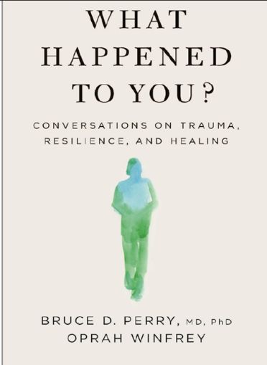
Suggested pacing
Session 1  90 minutes | Intro & Chapters 1-3
Session 2  90 minutes | Chapters 4 & 5
Session 3  90 minutes | Chapters 6 & 7
Session 4  90 minutes | Chapters 8-10

NOTE: Facilitators can adjust the reading schedule and questions to fit the participants and the schedule.
Facilitation
Begin by asking participants to read the first page of the Discussion Group Guide. Set the ground rules collaboratively by either having participants reflect on them in their journals or aloud, offering new ones as appropriate.
Participants can take notes on each chapter's reflection questions in their empathy journal or the facilitator can ask them during the meeting. It can be helpful to have the questions beforehand and/or while reading for participants who like to be prepared.

